Supplementary Material: Stem cell derived neurosphere assay highlights the effects of infection on human cortical development

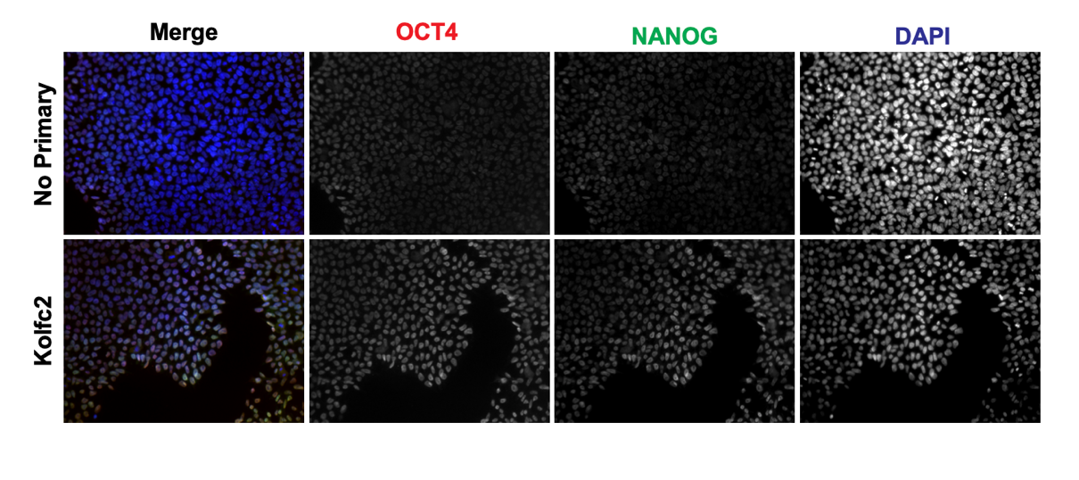
Supplementary figure 1: Immunostaining for pluripotency markers OCT4 and NANOG in iPSC line Kolfc2. The bottom panel shows that Top panel does not contain the primary antibodies.

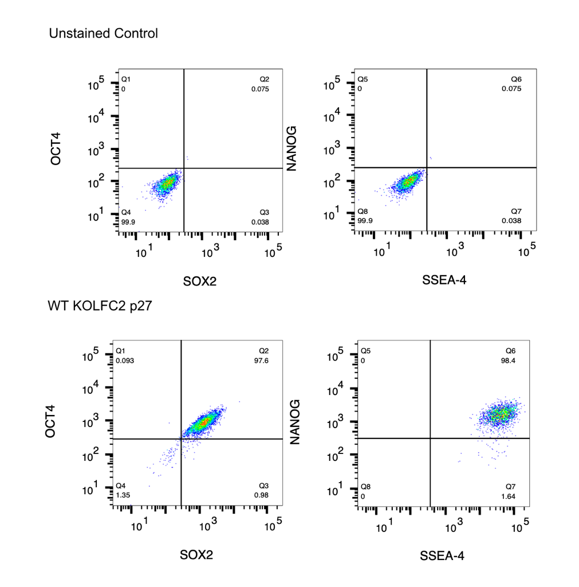
Supplementary figure 2: Flow cytometry analysis of iPSCs stained with antibodies for pluripotency markers. The iPSC line Kolfc2 expresses pluripotency markers OCT4, SOX2, NANOG and SSEA-4.

Supplementary table 1: Neuronal Maintenance Medium
Component | Final Concentration | Supplier | Catalogue no.
DMEM/F12 | 1 X | Thermo Fisher/Gibco | 10565018
N2 supplement | 1 X | Thermo Fisher/Gibco | 17502048
Insulin | 5µg/ml | Sigma-Aldrich | I9278
GlutaMAXTM | 1 X | Thermo Fisher/Gibco | 35050061
Non-essential amino acids | 1 X | Thermo Fisher/Gibco | 11140050
2-mercaptoethanol | 100µM | Thermo Fisher/Gibco | 21985023
Sodium Pyruvate | 1mM | Sigma | P4562
B27 supplement | 1 X | Thermo Fisher/Gibco | 17504044
Neurobasal medium | 1 X | Thermo Fisher/Gibco | 12348017

Supplementary table 2: Neural Induction Medium
Component | Final Concentration | Supplier | Catalogue no.
Neuronal Maintenance Medium | 1 X
SB431542 | 10µM | Tocris Bioscience | 1614
Dorsomorphin | 1µM | Bio-Techne | 3093/10

Supplementary table 3: Live cell imaging channel details
Component | DNA (SPY-555) | Tubulin (SiR)
Laser | 561nm (8% power) | 640nm (10% power)
Exposure time | 150 ms | 200 ms
Dichroic | Quad pass 405/488/561/640 | Quad pass 405/488/561/640
Emission filter | Barrier 617/73 | Barrier 685/40

Supplementary table 4: Fixed cell imaging details
Component | DAPI - DNA | CTIP2/TBR2 | NESTIN/TUJ1
Laser | 405nm (30% power) | 488nm (60% power) | 561 (70% power)
Exposure time | 50 ms | 100 ms | 120 ms
Dichroic | Quad pass 405/488/561/640 | Quad pass 405/488/561/640 | Quad pass 405/488/561/640
Emission filter | Barrier 447/60 | Barrier 525/50 | Barrier 685/40

Supplementary table 5: Details of antibodies used in immunofluorescence experiments
Antibody | Dilution | Supplier | Catalogue no.
NANOG | 1:800 | Cell Signaling Technology | 3580S
OCT4 | 1:200 | Cell Signaling Technology | 75463S
PAX6 | 1:200 | Cell Signaling Technology | 60433
NESTIN | 1:1600 | Cell Signaling Technology | 33475
TBR2 | 1:400 | Cell Signaling Technology | 81493
β3-Tubulin | 1:200 | Cell Signaling Technology | 4466
CTIP2 | 1:200 | Cell Signaling Technology | 12120
BRN2 | 1:200 | Cell Signaling Technology | 12137

Supplementary videos 1-3: Please see separate attachments of video files.

