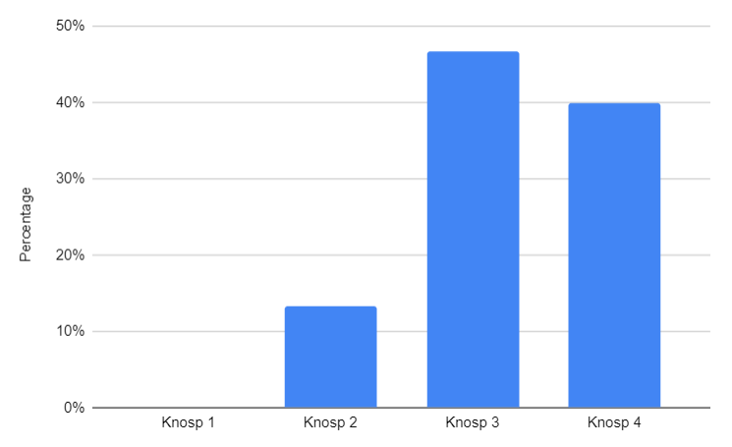

Chart 1: Knosp Graduation

