Appendix A3

Table A3. Butterfly and burning moth trait groups and traits considered in this publication.
Trait group | Trait | Number of species | Comments
Habitat nutrient conditions | Oligotrophic | 109 | Nitrogen deficit habitats
Habitat nutrient conditions | Eutrophic | 9 | Habitats with higher nitrogen availability
Habitat demands of Imago | Alpine meadows | 42 | Open landscapes above 2000 m
Habitat demands of Imago | Hygrophilic | 10
Habitat demands of Imago | Xerothermic | 33
Habitat demands of Imago | Ubiquistic | 12
Habitat preference of Imago | Forests | 13 | Forest and woodland dwelling
Habitat preference of Imago | Grasslands, open landscapes | 82 | Not alpine (lowland) grassland and open landscape dwelling
Habitat preference of Imago | Hedges, shrubs, forest edges | 16
Dispersal ability | Dispersive | 47 | Mobile, migratory, dispersive species
Niche width | Specialists | 104 | Habitat specialists with monophagous larvae
Endangerment | Endangered | 83 | IUCN categories: vulnerable, threatened, endangered
Endangerment | Least concern | 83 | IUCN category: least concern
Upper elevation limit | Below 1000 m | 48
Upper elevation limit | Above 1000 m | 70 | Excluding alpine species

Table A4. Coefficients of determination r² (recalculated from the ANOVA F statistics) of two-way ANOVA with species group and levels of rarity (rare – common) as fixed effects for the species group × rarity interaction term.

Species group | df_{effect} | 1951 | 1952 | 1953 | 1954 | 1955 | 2014 | 2015 | 2016 | 2017 | 2018
Habitat nutrient richness | 2 | 0.03 | <0.01 | 0.01 | 0.05* | 0.02 | <0.01 | 0.10** | 0.07* | 0.04 | 0.08*
Habitat demands | 5 | 0.04** | 0.01 | 0.01 | 0.01 | 0.01 | 0.01 | 0.02 | 0.01 | 0.02 | 0.01
Habitat Imago | 6 | 0.06** | 0.01 | 0.01 | 0.01 | 0.01 | 0.02 | 0.02 | 0.02 | 0.03* | 0.01
Dispersal ability | 1 | 0.01 | <0.01 | 0.01 | 0.05* | 0.01 | 0.03 | 0.04* | 0.06** | 0.03 | 0.05*
Generalists/Specialists | 1 | 0.01 | 0.01 | <0.01 | 0.01 | 0.01 | 0.01 | 0.02 | 0.02 | 0.04 | 0.03
Endangerment | 1 | <0.01 | 0.00 | <0.01 | 0.01 | 0.01 | 0.02 | 0.02 | 0.02 | 0.01 | 0.01

Table A5. Proportions of species and total numbers of species recorded for important butterfly guilds in the Salzburg region 1951-1955 and 2014-2018.
Type | Proportion of records
 | 1951 | 1952 | 1953 | 1954 | 1955 | 2014 | 2015 | 2016 | 2017 | 2018
Eutrophic habitats | 0.04 | 0.05 | 0.04 | 0.05 | 0.06 | 0.23 | 0.32 | 0.30 | 0.25 | 0.26
Oligotrophic habitats | 0.71 | 0.67 | 0.66 | 0.61 | 0.60 | 0.44 | 0.26 | 0.30 | 0.37 | 0.27
Alpine meadows | 0.24 | 0.18 | 0.37 | 0.14 | 0.16 | 0.05 | 0.05 | 0.05 | 0.09 | 0.04
Hygrophilic species | 0.04 | 0.12 | 0.03 | 0.07 | 0.09 | 0.05 | 0.07 | 0.03 | 0.03 | 0.07
Ubiquistic species | 0.05 | 0.08 | 0.06 | 0.07 | 0.09 | 0.25 | 0.38 | 0.37 | 0.31 | 0.37
Xerothermic species | 0.25 | 0.18 | 0.11 | 0.17 | 0.16 | 0.11 | 0.04 | 0.08 | 0.11 | 0.04
Forests | 0.10 | 0.10 | 0.14 | 0.22 | 0.15 | 0.24 | 0.22 | 0.18 | 0.17 | 0.19
Grasslands | 0.49 | 0.53 | 0.38 | 0.53 | 0.54 | 0.34 | 0.27 | 0.30 | 0.39 | 0.34
Hedges/Shrubs | 0.07 | 0.07 | 0.09 | 0.11 | 0.14 | 0.17 | 0.12 | 0.15 | 0.10 | 0.12
Dispersive species | 0.32 | 0.33 | 0.40 | 0.39 | 0.34 | 0.56 | 0.65 | 0.64 | 0.62 | 0.68
Specialist species | 0.62 | 0.61 | 0.47 | 0.55 | 0.51 | 0.35 | 0.21 | 0.20 | 0.24 | 0.22
Endangered species | 0.48 | 0.48 | 0.35 | 0.39 | 0.36 | 0.26 | 0.12 | 0.12 | 0.17 | 0.18
Least concern species | 0.20 | 0.16 | 0.12 | 0.21 | 0.20 | 0.04 | 0.07 | 0.09 | 0.07 | 0.10
Upper elevation <1000 | 0.11 | 0.17 | 0.16 | 0.31 | 0.19 | 0.25 | 0.25 | 0.26 | 0.19 | 0.24
Upper elevation >1000 | 0.50 | 0.61 | 0.44 | 0.48 | 0.58 | 0.68 | 0.68 | 0.68 | 0.69 | 0.71
Total number of records | 367 | 464 | 609 | 352 | 373 | 1979 | 1037 | 880 | 1046 | 727

Table A6. Proportions of species and total numbers of species recorded for important butterfly guilds in the Salzburg region 1951-1955 and 2014-2018.
Type | Proportion of species
 | 1951 | 1952 | 1953 | 1954 | 1955 | 2014 | 2015 | 2016 | 2017 | 2018
Eutrophic habitats | 0.07 | 0.07 | 0.06 | 0.08 | 0.08 | 0.08 | 0.10 | 0.08 | 0.07 | 0.10
Oligotrophic habitats | 0.59 | 0.63 | 0.61 | 0.58 | 0.59 | 0.57 | 0.54 | 0.59 | 0.59 | 0.49
Alpine meadows | 0.24 | 0.18 | 0.27 | 0.10 | 0.20 | 0.18 | 0.19 | 0.16 | 0.20 | 0.12
Hygrophilic species | 0.04 | 0.07 | 0.05 | 0.07 | 0.07 | 0.08 | 0.09 | 0.08 | 0.07 | 0.10
Ubiquistic species | 0.09 | 0.09 | 0.08 | 0.09 | 0.09 | 0.10 | 0.12 | 0.10 | 0.10 | 0.13
Xerothermic species | 0.14 | 0.19 | 0.15 | 0.19 | 0.19 | 0.14 | 0.10 | 0.13 | 0.14 | 0.11
Forests | 0.16 | 0.13 | 0.18 | 0.20 | 0.16 | 0.17 | 0.18 | 0.15 | 0.15 | 0.19
Grasslands | 0.44 | 0.51 | 0.43 | 0.52 | 0.46 | 0.49 | 0.44 | 0.48 | 0.48 | 0.47
Hedges/Shrubs | 0.10 | 0.10 | 0.09 | 0.12 | 0.12 | 0.09 | 0.11 | 0.11 | 0.09 | 0.13
Dispersive species | 0.32 | 0.30 | 0.28 | 0.33 | 0.29 | 0.30 | 0.33 | 0.31 | 0.31 | 0.33
Specialist species | 0.51 | 0.56 | 0.54 | 0.54 | 0.51 | 0.53 | 0.46 | 0.48 | 0.54 | 0.48
Endangered species | 0.36 | 0.42 | 0.38 | 0.43 | 0.41 | 0.39 | 0.33 | 0.38 | 0.40 | 0.39
Least concern species | 0.70 | 0.68 | 0.66 | 0.71 | 0.71 | 0.65 | 0.81 | 0.76 | 0.62 | 0.80
Upper elevation <1000 | 0.17 | 0.21 | 0.25 | 0.30 | 0.26 | 0.21 | 0.19 | 0.25 | 0.21 | 0.22
Upper elevation >1000 | 0.53 | 0.56 | 0.46 | 0.55 | 0.49 | 0.57 | 0.58 | 0.56 | 0.53 | 0.63
Species recorded | 107 | 110 | 114 | 106 | 106 | 115 | 93 | 99 | 121 | 94

Figure A1: Box and Whiskers plots showing the difference in relative richness (the proportion of the total annual number of species) of 12 butterfly guilds between the years 1951-1955 (green) and 2014-2018 (yellow). Oligotrophic (a) and eutrophic (b) habitats; habitat demands: Alpine meadows (c), hygrophilic (d) and xerothermic (e) habitats; occurrence: ubiquistic (f), mainly forests (g), grasslands (h), hedges and shrubs (i); dispersive (j) species; habitat specialist (k) species; endangered (threatened, endangered, vulnerable)(l) and least concern species (o); upper occurrence boundary below (m) and above (n) 1000 m asl. H-values of Kruskal Wallis tests and significance levels: ‘: P < 0.10, *: P < 0.05, **: P < 0.01.

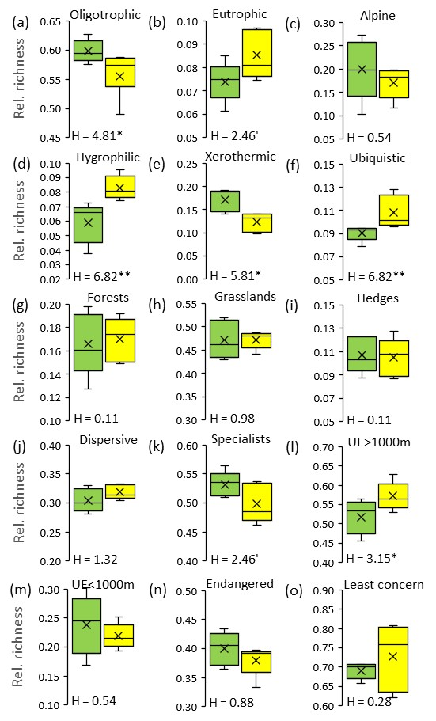

Figure A2. Unconstraint seriation returned significant (Monte Carlo randomization: Z = -3.51, P < 0.001) structural changes in faunal composition between the years 1951-1955 and 2014-2018. Species in green were found only in the earlier time period, species in yellow in the later period. Blue species were found in at least 9 of the 10 study years

