Supplementary Information for
SlGT11 Controls Floral Organ Identity and Floral Reversion in Tomato

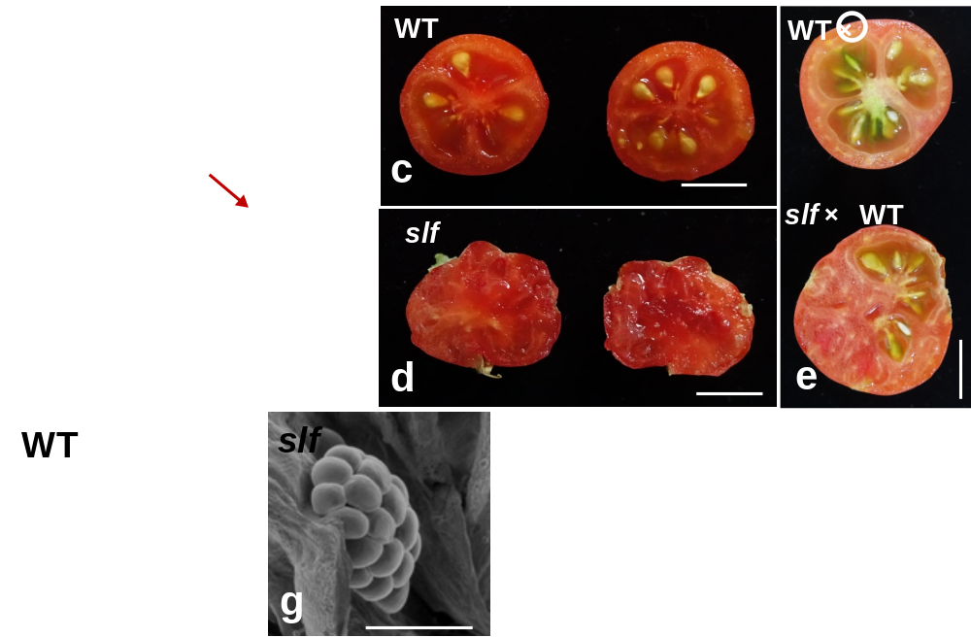

Fig. S1 Phenotype of ovary and fruit in WT and slf
The ovary of (a) WT and (b) slf, red arrow indicate the stamen fuse with ovary.
The crosscutting views of fruit show the seed production in WT (c) and slf (d) without pollination. The slf fruit forms seeds after cross-pollination (e bottom)
(f) SEM analysis the ovule in (f) WT and (g) slf.
Scale bars: (a and b) 1 mm; (c, d and e) 1cm; f and g 500 μm.

Fig. S2 Phylogenetic analysis of SlGT11 and its homologs.
The neighbor-joining phylogenetic tree of SlGT11 and 60 homologs that share high similarities with SlGT11 across different plants species. The abbreviations of species name and the gene bank ID is listed for each homology. SlGT11 and AtGT11 are marked in the green and red oval, respectively.

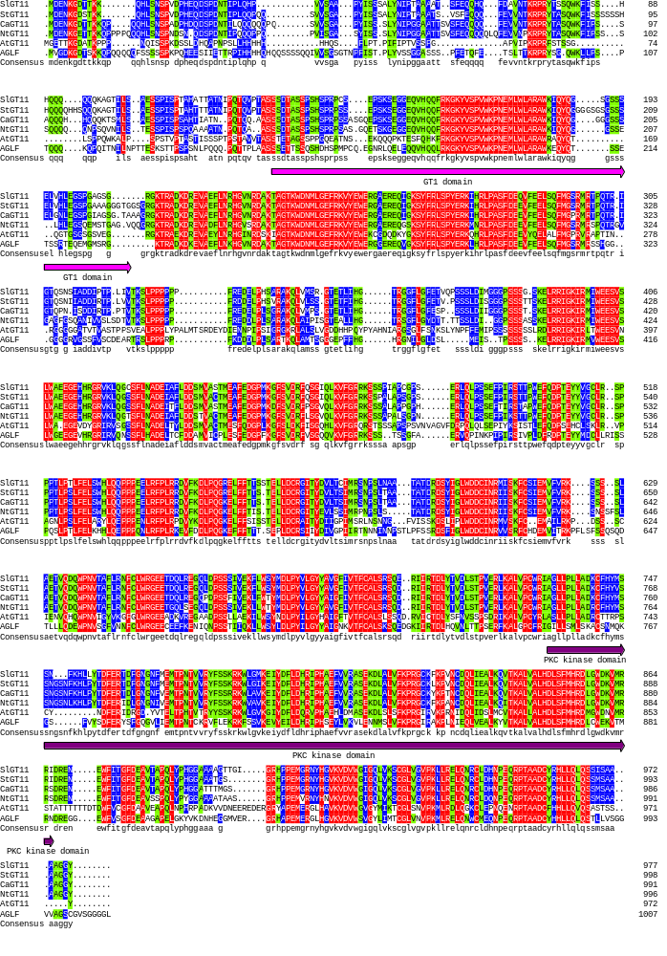
Fig. S3 Multiple alignment of SlGT11 and its homologs.
Multiple alignment of SlGT11 and five homologs from Solanum tuberosum L (StGT11), Nicotiana tabacum (NtGT11), Capsicum annuum L (CaAGLF), Medicago truncatula (AGLF), and Arabidopsis thaliana (AtGT11) carried out with DNAMAN. The GT1 domain is indicated by a pink underline; the partial kinase domain is indicated by a purple underline.

Fig.S4. Yeast two-hybrid assays.
Yeast two-hybrid showing no heteromeric interactions for SlGT11 and TPI, TPIB, TAP3, TM6, TAG1, TAGL1, TM29.
L, leucine; T, tryptophan; H, histidine; A, Adenine; -,negative control; +， positive control; PGBKT7, empty vector.

Fig.S5. Yeast one-hybrid assays. Yeast one-hybrid assays showing no interactions for SlGT11 and the promoter of TPI, TPIB, TAP3, TM6, TAG1, TAGL1 and TM29.
T, tryptophan; U, uracil; JG4-5, empty vector.

