Climate Dynamics
Supplementary Information for
More positive North Atlantic Oscillation cools the subpolar North Atlantic in the past century
Yifei Fan¹, Wei Liu², Pengfei Zhang¹, Ru Chen³, Laifang Li^{1,4,5,*}
¹Department of Meteorology and Atmospheric Science, Pennsylvania State University,
University Park, PA, USA
²Department of Earth and Planetary Sciences, University of California Riverside,
Riverside, CA, 92521
³School of Marine Science and Technology, Tianjin University, Tianjin, China
⁴Institute of Computational and Data Science, Pennsylvania State University,
University Park, PA, 16802
⁵Earth and Environmental Sciences Institute, Pennsylvania State University,
University Park, PA, 16802
*Correspondence to: lfl5240@psu.edu

Figure S1. (a) to (e) The linear trends (K/century) of annual mean SSTA in five observation datasets. (f) to (j) As similar to (a) to (e) but for linear trends of January-February-March (JFM) mean SSTA.

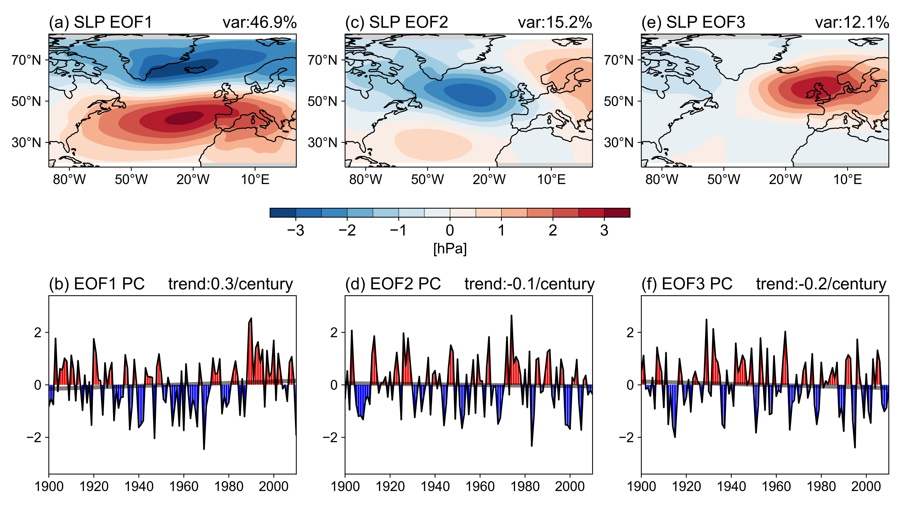

Figure S2. Similar to Figure 2, but for EOF modes of JFM mean North Atlantic SLP.

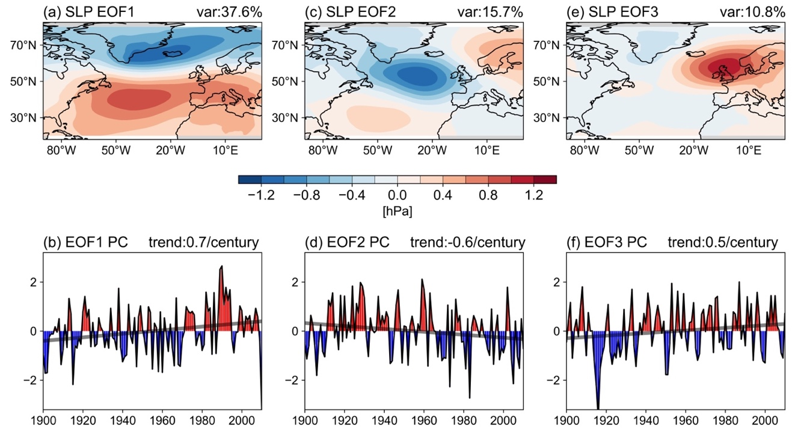

Figure S3. EOF modes of annual mean North Atlantic SLP in 20CR v3. PC is scaled to unit variance. Trends of EOF1 PC and EOF2 PC are statistically significant (p<0.05).

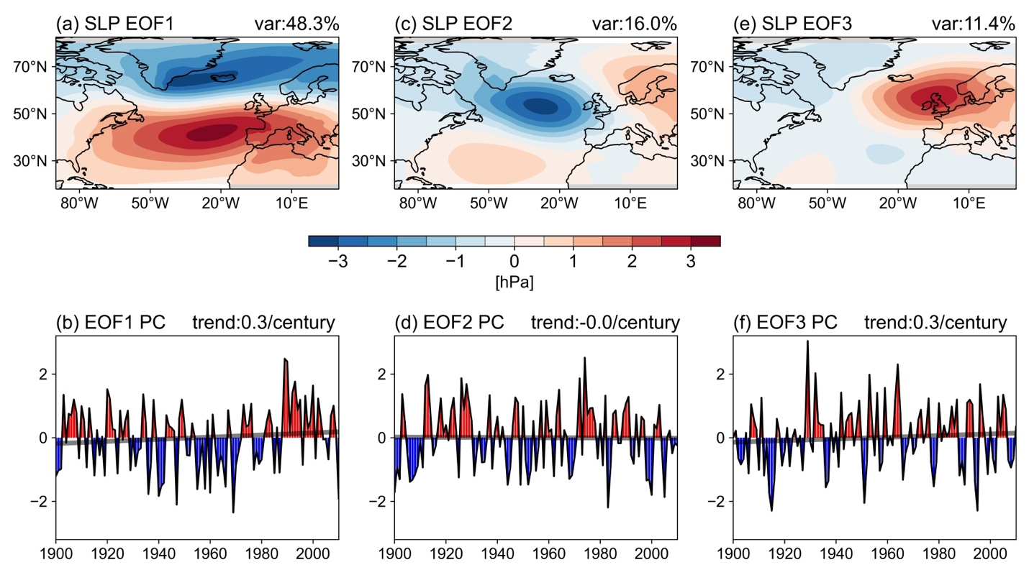
Figure S4. Similar to Figure S3, but for EOF modes of JFM mean North Atlantic SLP.

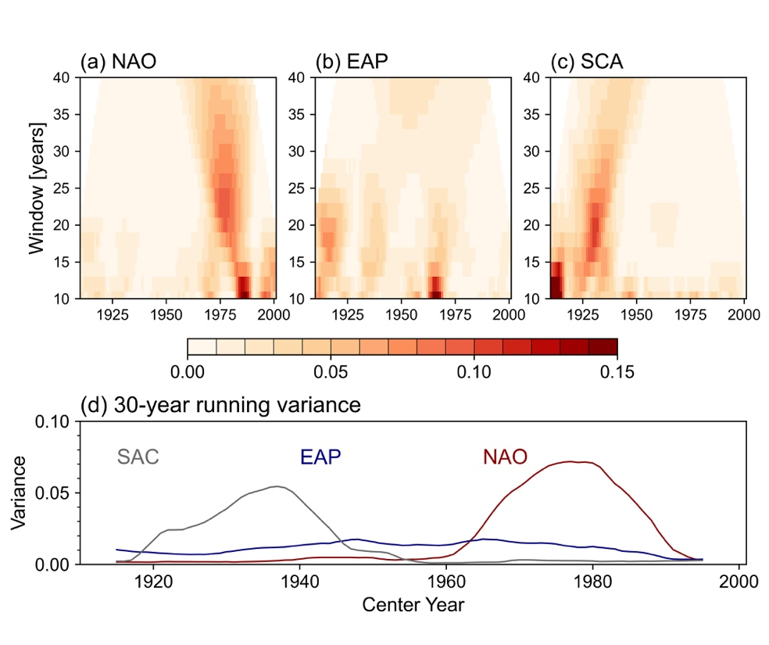
Figure S5. Running variance of PC time series of the first three modes. Similar to Figure 4, but using 20CR v3.

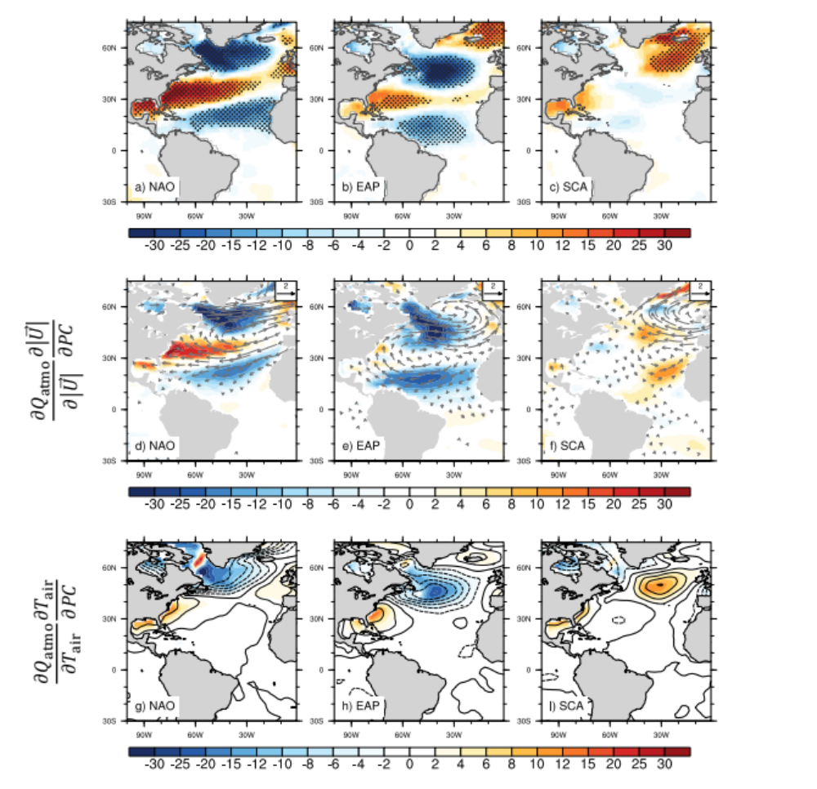

Figure S6. The same as Figure 5 but for regression based on the JFM data.

