Supplemental Material and Methods
Animal studies. All animal procedures were performed under a project licence (PPL P94B395E0) approved by the U.K. Home Office under the Animals (Scientific Procedures) Act 1986 and the University of Aberdeen ethics review board. Studies were performed following the recommendations in the ARRIVE guidelines under guidance by the Veterinary Surgeon and Animal Care and Welfare Officers of the institutional animal research facility. Thus, all methods were performed in accordance with the relevant guidelines and regulations.
Immunoblotting.
Tissues were prepared as previously described in materials and methods. Blots used in figures are all compliant with the digital image and integrity policies of Nature publishing and Scientific Reports journal. Western blot membranes were cut at approximate molecular weight ( +/- 20 kDa ) of target protein before incubation of primary antibodies. Equal numbers of representative samples from all treatment groups were run on multiple gels/blots to accommodate all samples. Images obtained were minimally processed. Image analysis and quantification with normalisation to loading control protein was performed within the same membrane and then data combined for graphical representation. No direct quantitative comparisons between samples on different gels/blots were performed.
Membranes were probed for the following additional proteins;
Cell Signaling Technology
phospho-p38 (The 181/Tyr 182, cat: 4581),
total p-38 (cat: 8690), phospho-eif2α (Ser 51, cat: 3398),
total eif2α (cat: 5321),
beclin 1 (cat: 3495) and
GAPDH (cat: 5174,),

or Santa Cruz Biotechnology
IR β-chain (cat: sc-373975),
Bip (sc166490) and
CHOP (sc-7531; all).

Supplemental Tables and Figures
Supplemental Table 1: qPCR primer details.
Gene | Forward primer (5’-3’) | Reverse Primer (5’-3’)
Abca1 | AAAACCGCAGACATCCTTCAG | CATACCGAAACTCGTTCACCC
Abcc3 | CTGGGTCCCCTGCATCTAC | GCCGTCTTGAGCCTGGATAAC
Abcg1 | GTGGATGAGGTTGAGACAGACC | CCTCGGGTACAGAGTAGGAAAG
Acadm | AGGGTTTAGTTTTGAGTTGACGG | CCCCGCTTTTGTCATATTCCG
Acox1 | TAACTTCCTCACTCGAAGCCA | AGTTCCATGACCCATCTCTGTC
Adiponectin | TGTTCCTCTTAATCCTGCCCA | CCAACCTGCACAAGTTCCCTT
Apoa1 | GGCACGTATGGCAGCAAGAT | CCAAGGAGGAGGATTCAAACTG
Apoa2 | GCAGACGGACCGGATATGC | GCTGCTCGTGTGTCTTCTCA
Apoc3 | TACAGGGCTACATGGAACAAGC | CAGGGATCTGAAGTGATTGTCC
Apoe | CTGACAGGATGCCTAGCCG | CGCAGGTAATCCCAGAAGC
Cd36 | GAACCACTGCTTTCAAAAACTG G | TGCTGTTCTTTGCCACGTCA
Cd68 | TGTCTGATCTTGCTAGGACCG | GAGAGTAACGGCCTTTTTGTGA
Cers2 | AAGTGGGAAACGGAGTAGCG | ACAGGCAGCCATAGTCGTTC
Cers6 | CGGCTGGGCATATTTCCTCT | GTCATCCTTGGATACCTTGCCT
Col1a1 | CCAAAGGTGCTGATGGTTCT | ACCAGCTTCACCCTTGTCAC
Col4a1 | GCTCTGGCTGTGGAAAATGT | CTTGCATCCCGGGAAATC
Cpt1a | CTCCGCCTGAGCCATGAAG | CACCAGTGATGATGCCATTCT
Cyp26A1 | TTCGGGTTGCTCTGAAGACT | TCCTCCAAATGGAATGAAGC
Degs1 | TCCCTACTCGCGGATGAAGA | TTTGAAGCCGTGGACAGGAA
Dgat | TCCGTCCAGGGTGGTAGTG | TGAACAAAGAATCTTGCAGACGA
G6Pase | ATGAACATTCTCCATGACTTTGGG | GACAGGGAACTGCTTTATTATAGG
Glut4 | GGAAGGAAAAGGGCTATGCTG | TGAGGAACCGTCCAAGAATGA
Hmgcr | GATTCTGGCAGTCAGTGGGAA | GTTGTAGCCGCCTATGCTCC
Hsd17b13 | ATTCCCCGGAGAAGGAAATCT | CAGCCTGCCTATTCCGTGT
Il-10 | GCTCTTACTGACTGGCATGAG | CGCAGCTCTAGGAGCATGTG
Il1β | GCAACTGTTCCTGAACTCAACT | ATCTTTTGGGGTCCGTCAACT
Il-6 | TAGTCCTTCCTACCCCAATTTCC | TTGGTCCTTAGCCACTCCTTC
Lrat | CCGTCCCTATGAAATCAGCTC | ATGGGCGACACGGTTTTCC
Lxrα | CTCAATGCCTGATGTTTCTCCT | TCCAACCCTATCCCTAAAGCAA
Lxrβ | GCCTGGGAATGGTTCTCCTC | AGATGACCACGATGTAGGCAG
Mcp-1 | TTAAAAACCTGGATCGGAACCAA | GCATTAGCTTCAGATTTACGGGT
Mmp2 | CAAGTTCCCCGGCCATGTC | TTCTTGGTCAAGCTCACCTGTC
Mmp9 | GCGTCGTGATCCCCACTTAC | CAGGCCGAATAGGAGCGTC
Mogat1 | TGGACGCCAGTTTGGTTCCAG | TGCTCTGAGGTCGGGTTCA
Nono | GCCAGAATGAAGGCTTGACTAT | TATCAGGGGGAAGATTGCCCA
Pepck | GAGATAGCGGCACAAT | TTCAGAGACTATGCGGTG
Pnpla3 | TCACCTTCGTGTGCAGTCTC | CCTGGAGCCCGTCTCTGAT
Pparα | ACGATGCTGTCCTCCTTGATG | GTGTGATAAAGCCATTGCCGT
Pparγ | AGTGGAGACCGCCCAGG | GCAGCAGGTTGTCTTGGATGT
Rarα | CGC CAA GGG AGC TGA ACG GG | GGG TGG CTG GGC TGC TTC TG
Rarβ | CGCGAGCCCTTCCTCCTGC | AAAAGCCCTTGCACCCCTCGC
Resistin | AAGAACCTTTCATTTCCCCTCCT | GTCCAGCAATTTAAGCCAATGTT
Rpb4 | ACGAGTCCGTCTTCTGAGCAACTG | GCACAGCTCCTCCTGCCGTT
Rxrα | ATGGACACCAAACATTTCCTGC | CCAGTGGAGAGCCGATTCC
Rxrβ | CCACCTCTTACCCCTTCAGC | TGGAAGAACTGATGACTGGGA
Smpd1 | TGGGACTCCTTTGGATGGG | CGGCGCTATGGCACTGAAT
Smpd3 | ACACGACCCCCTTTCCTAATA | GGCGCTTCTCATAGGTGGTG
Srebp1c | GATGTGCGAACTGGACACAG | CATAGGGGGGGTCAAACAG
Tgf1β | AGCCCGAAGCGGACTACTAT | CTGTGTGAGATGTCTTTGGTTTTC
Timp1 | GCAACTCGGACCTGGTCATAA | CGGCCCGTGATGAGAAACT
Timp2 | TCAGAGCCAAAGCAGTGAGC | GCCGTGTAGATAAACTCGATGTC
Tm6sf2 | AGTTTCGGCGTTCTCACAGC | GCATAGAGAGGGTCGTAGGTG
Tnfα | CCCTCACACTCAGATCATCTTCT | GCTACGACGTGGGCTACAG
Vldlr | GGCAGCAGGCAATGCAATG | GGGCTCGTCACTCCAGTCT
Ywaz | GAAAAGTTCTTGATCCCCAATG C | TGTGACTGGTCCACAATTCCTT

Supplemental Figure 1: WAT and skeletal muscle analysis in LDLR^{-/-} mice. Genetic analysis of (A, D) WAT in LDLR^{-/-} mice (n=8 per group) as analysed by qPCR using SYBR green and LightCycler 480 (Roche). (B) Western blot of skeletal muscle from LDLR-/- mice and quantification shown in (C). Data are represented as mean + S.E.M. and analysed by one-way ANOVA followed by Bonferroni multiple comparison t-tests where *p≤0.05 (control compared to HFD) or #p≤0.05 (HFD compared to FEN-HFD).

Supplemental Figure 2: Fenretinide alters pro-inflammatory and fibrotic genes and RBP4 levels in male and female ApoE-/- mice. (A, B) Genetic analysis of hepatic tissues in male and female ApoE^{-/-} mice (control n=4, HFD n=5, FEN-HFD n=5). (C) Western blot analysis of RPB4 levels in serum and hepatic tissues from female (upper left panels) and male (lower left panels) and quantification (right panels). Data are represented as mean + S.E.M. and analysed by one-way ANOVA followed by Bonferroni multiple comparison t-tests where *p≤0.05, **p≤0.01 and ****p≤0.0001 (compared to control) or #p≤0.05, ##p≤0.01, ### p≤0.001 and #### p≤0.0001 (HFD compared to HFD-FEN).

Supplemental Figure 3: Fenretinide increases dihydroceramide species in hepatic tissues of male and female ApoE^{-/-} mice. Lipidomic analysis of Ceramide (A), Dihydroceramide (B) and total (C) species in hepatic tissues. Data are represented as mean + S.E.M. and analysed by one-way ANOVA followed by Bonferroni multiple comparison t-tests where *p≤0.05, **p≤0.01, ***p≤0.001 and ****p≤0.0001 (control compared to HFD) or #p≤0.05 and ## p≤0.01, ### p≤0.001 and #### p≤0.001 (HFD compared to FEN-HFD).

Supplemental Figure 4: Fenretinide alters hepatic ER Stress but not autophagy. (A, C) Western blot analysis of hepatic tissues probed for BIP, Beclin-1 p-eif2α (Ser51), total eif2α, p-p38 (Thr 180/Tyr 182), total p38 or CHOP. GAPDH was used as a loading control. (B, D) Quantification of proteins shown in (A, B). Data are represented as mean + S.E.M. and analysed by one-way ANOVA followed by Bonferroni multiple comparison t-tests where **p≤0.01 (control compared to HFD) or #p≤0.05 (HFD compared to FEN-HFD).
Supplemental Figure 5: Fenretinide increases atherosclerotic plaque formation in female ApoE^{-/-} mice. The descending aorta was prepared en face from (A) female ApoE^{-/-} mice and stained with Sudan IV and quantified using Image J. Representative images are shown. Genetic analysis of Smpd3 levels in hepatic tissue of female (B) and male (C) ApoE^{-/-} mice. Data are represented as mean $±$ S.E.M. (n=3-5 per group) and analysed by one-way ANOVA followed by Bonferroni multiple comparison t-tests where *p≤0.05 and ****p≤0.0001 (compared to control) or # p≤0.05 and ### p≤0.001 (HFD compared to HFD-FEN).

A
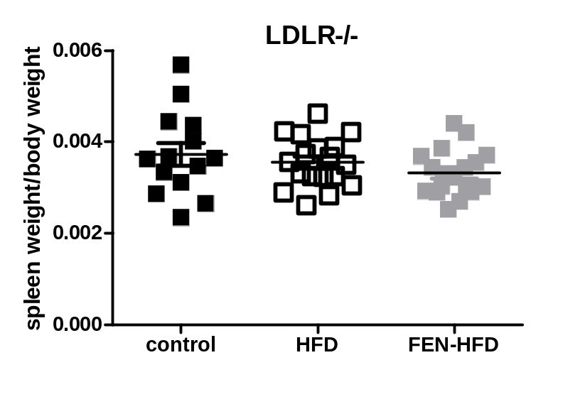
B
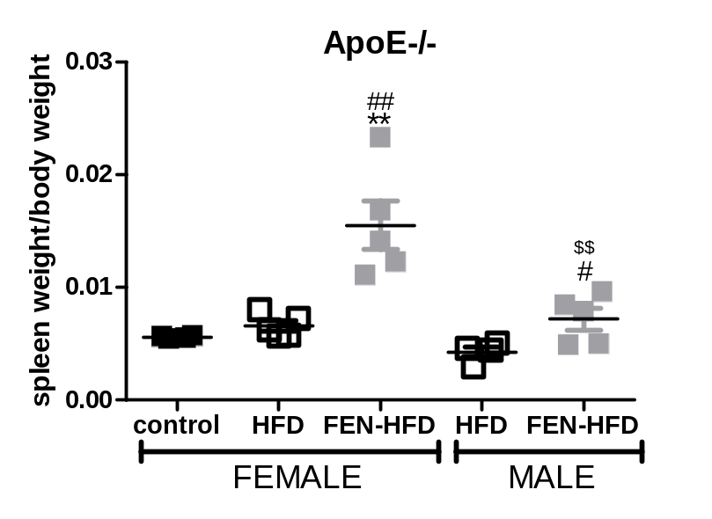
Supplemental Figure 6: Fenretinide does not induce splenomegaly in LDLR^{-/-} but does in ApoE^{-/-} mice. Individual spleens were weighed and normalised for body weight of individual mice. Data are represented as mean $±$ S.E.M. (A. n=14-18 per group LDLR^{-/-} mice; B. n=4-5 per group ApoE^{-/-} mice) and analysed by one-way ANOVA followed by Bonferroni multiple comparison t-tests where **p≤0.01 (compared to control), # p≤0.05 and ## p≤0.01 (HFD compared to HFD-FEN) and $$ p≤0.01 (ApoE^{-/-} FEN-HFD, male compared to female).
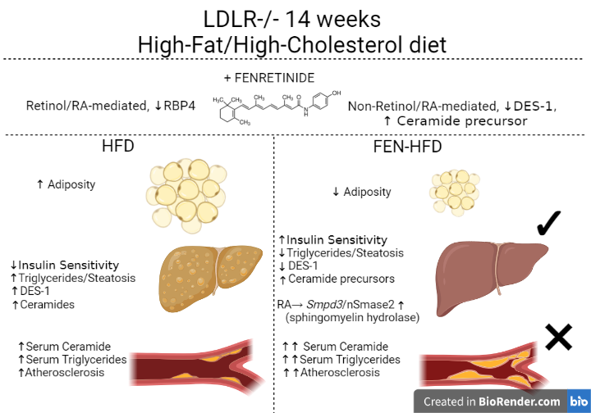
Supplemental Figure 7: Working Model of Fenretinide Action.
A graphical representation demonstrating the effects of FEN on multiple metabolic complications using LDLR^{-/-} mice fed high-fat/high-cholesterol diet +/- FEN as a model of atherosclerosis and non-alcoholic fatty liver disease (NAFLD). FEN treatment prevented excess weight gain and adiposity, improved insulin sensitivity and completely inhibited hepatic triglyceride accumulation, ballooning and steatosis. In association, FEN decreased the expression of hepatic genes driving NAFLD, inflammation and fibrosis e.g., Hsd17b13, Cd68 and Col1a1. The mechanisms of FEN’s beneficial effects in association with decreased adiposity were mediated by suppression of ceramide synthesis, via hepatic DES1 protein, leading to increased ceramide precursors (i.e. dihydroceramides). However, FEN treatment in LDLR^{-/-} mice enhanced circulating triglycerides and accelerated aortic plaque formation. FEN increased hepatic sphingomyelinase Smpd3 expression, via a retinoic acid mediated mechanism, linking induction of an alternative ceramide generation pathway (via sphingomyelin hydrolysis) to a novel mechanism of increased atherosclerosis. Pharmacological treatment of both DES1 and Smpd3/nSMase2 may be a novel, more potent therapeutic approach for the treatment of metabolic syndrome.

