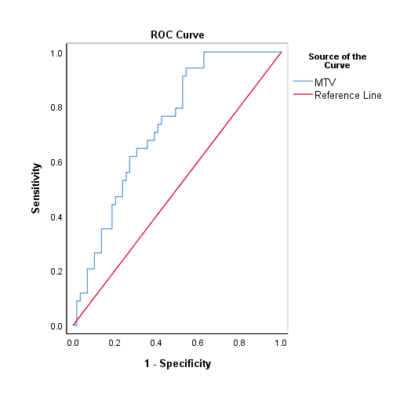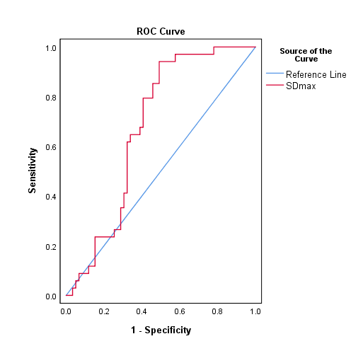
A B
Figure S1: optimal cutoff values of TMTV and SDmax for PFS prediction tested by Receiver Operating Curve (ROC)

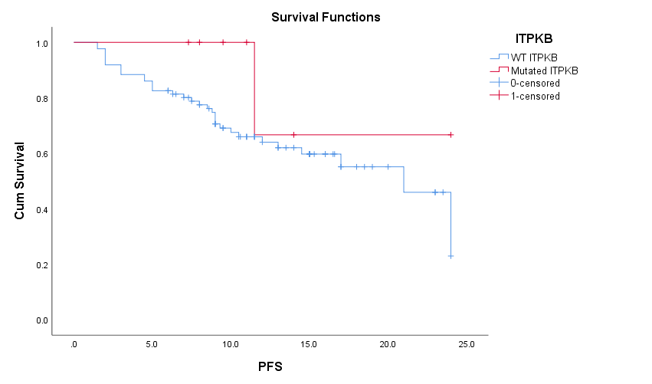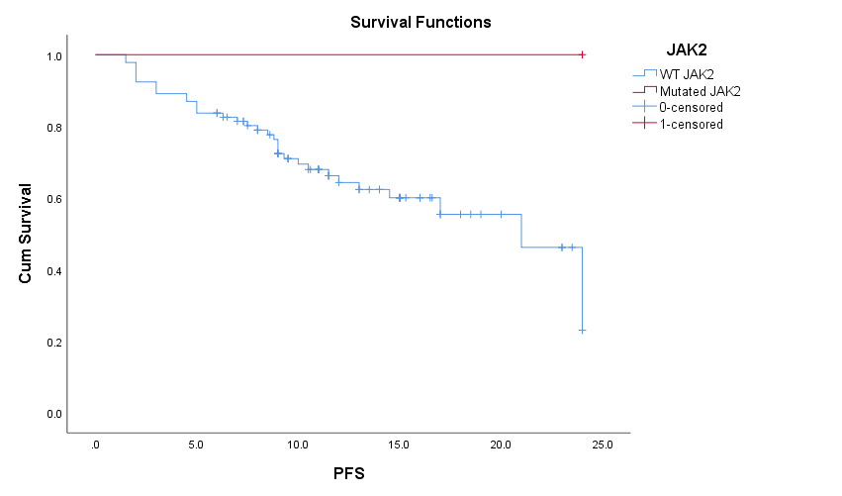
A B
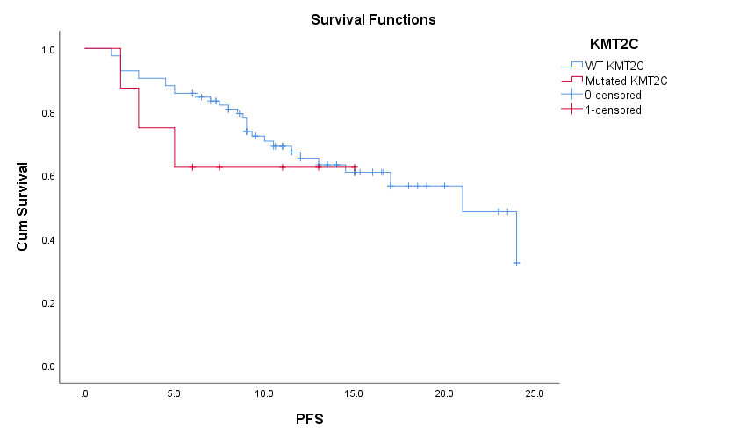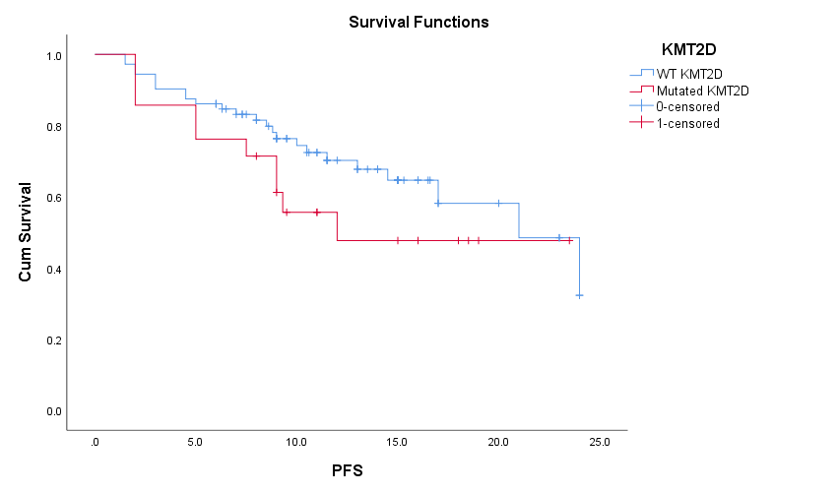
C D
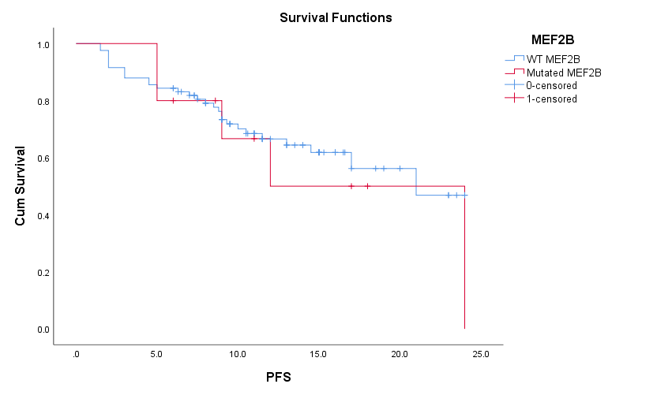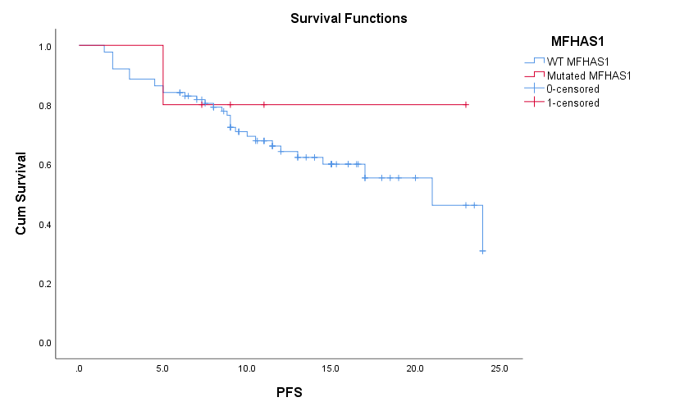
E F
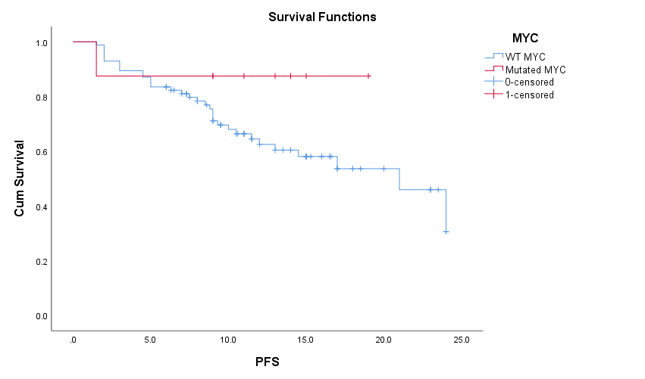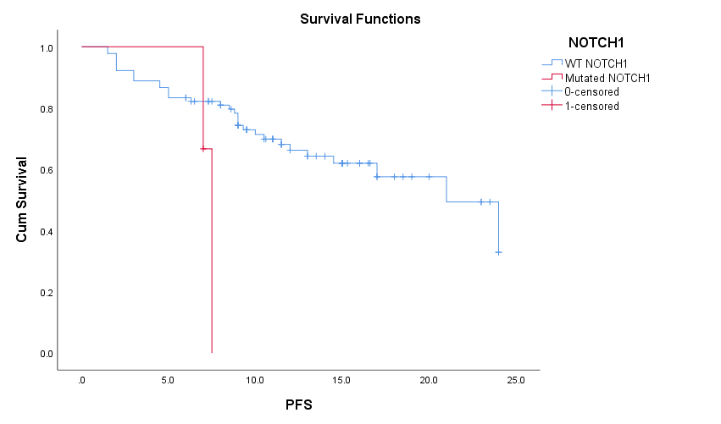
G H

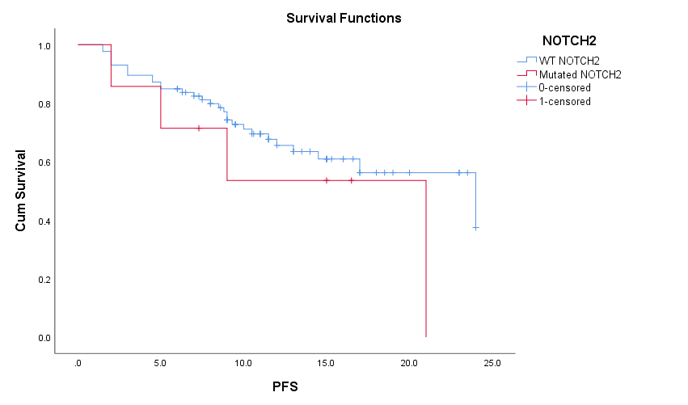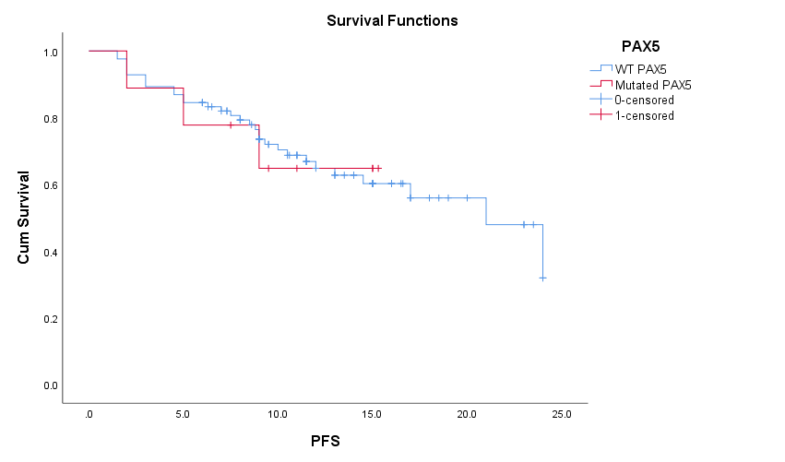
I J
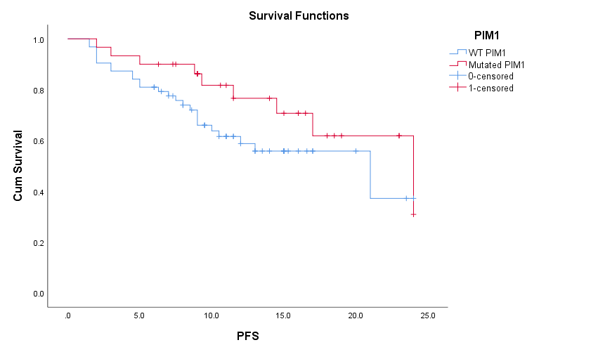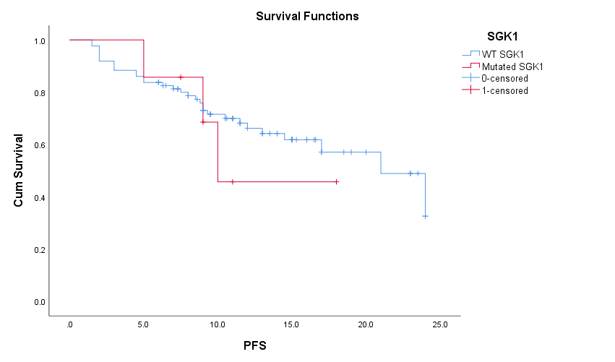
K L

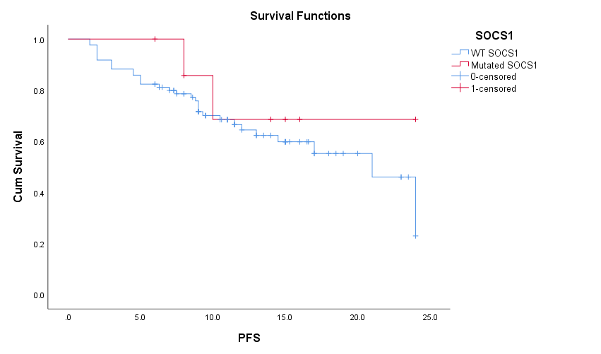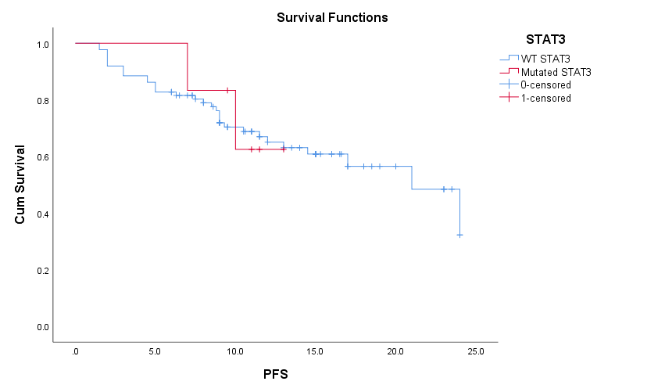
M N

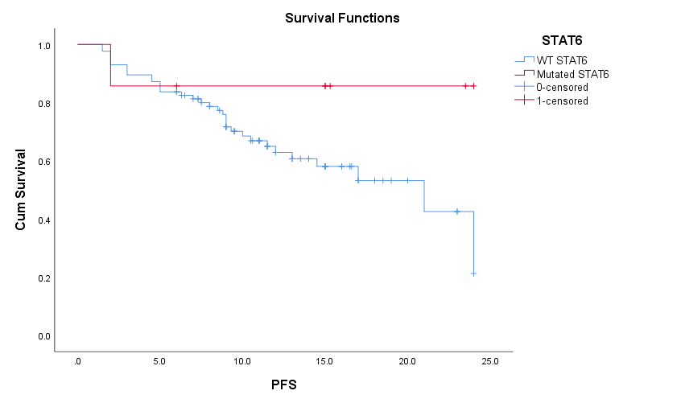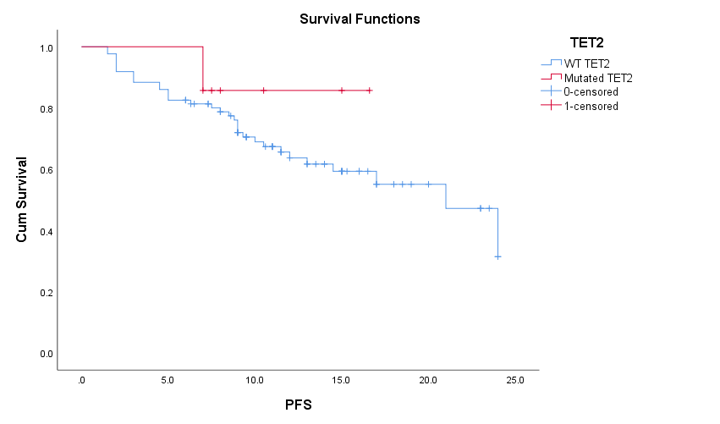
O P

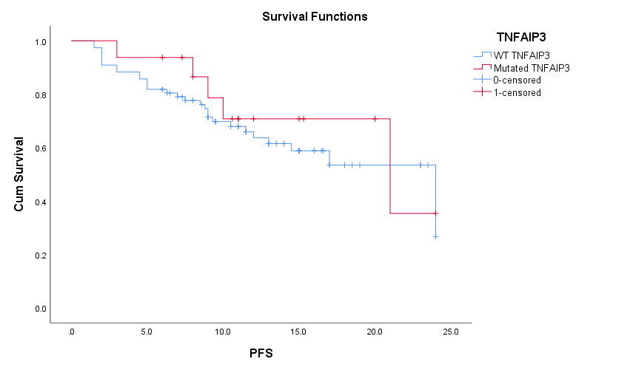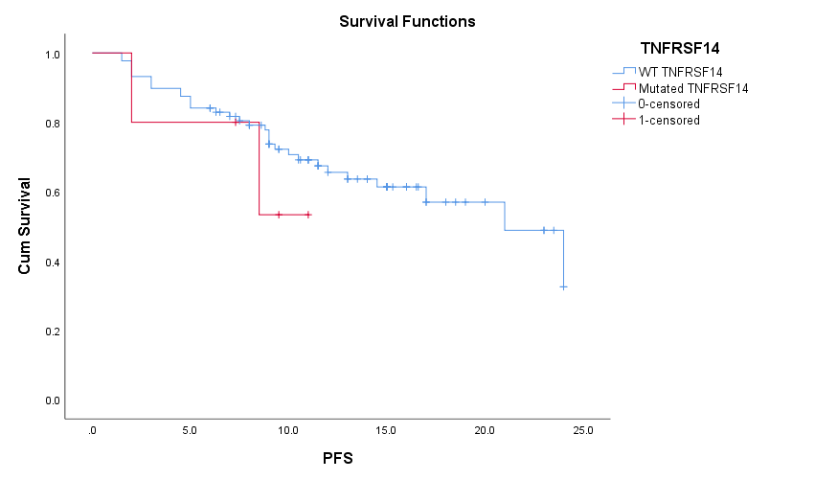
Q I

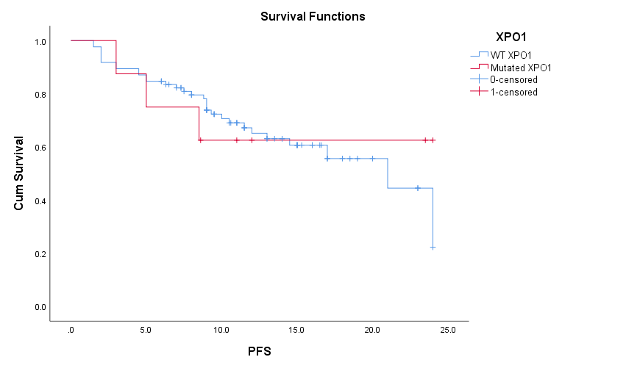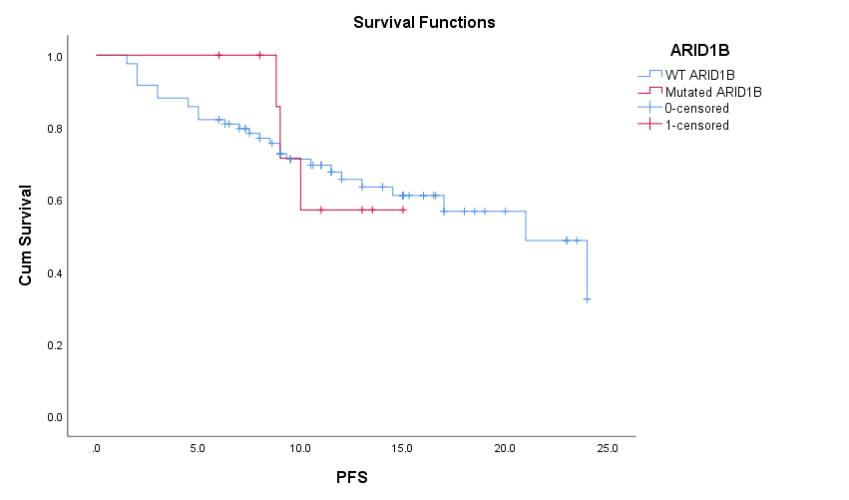
S T

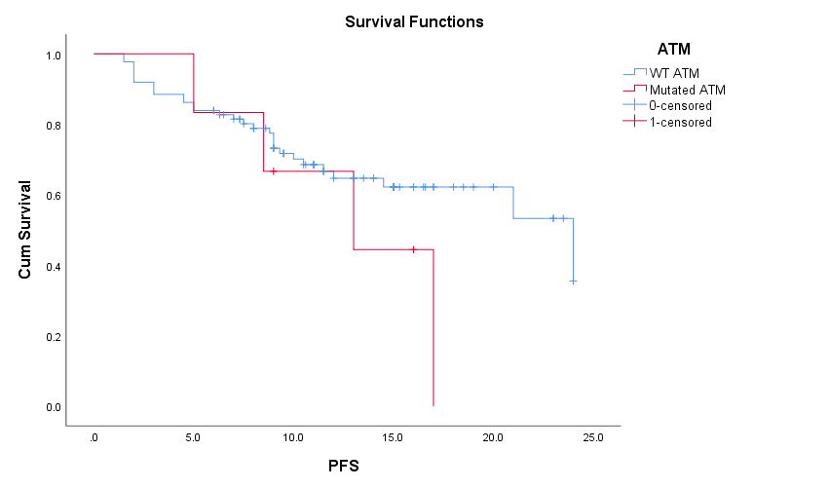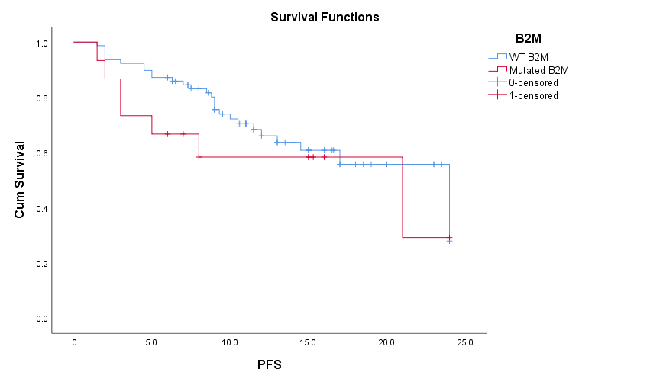
U V

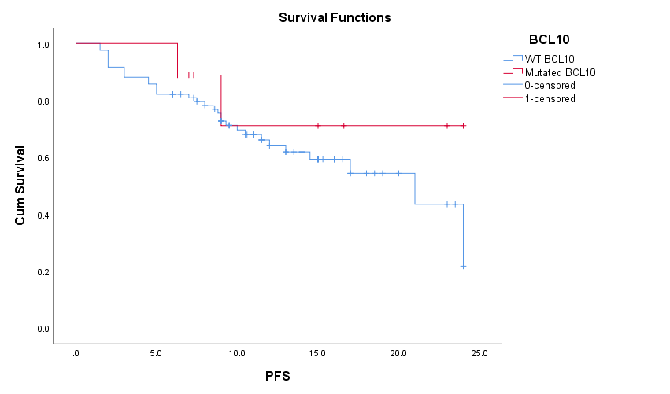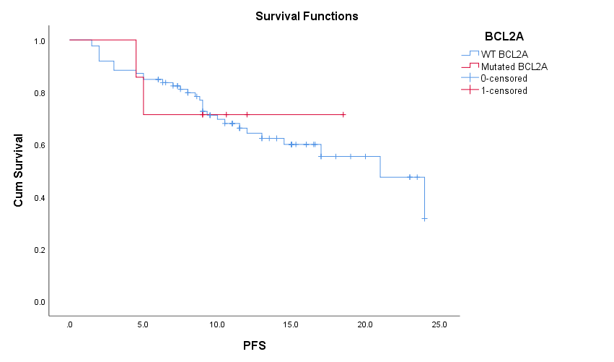
W X

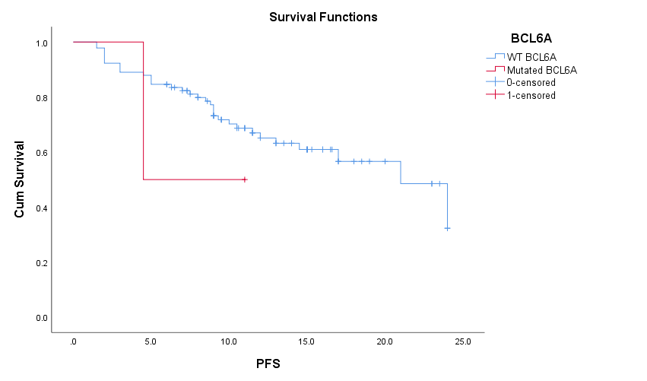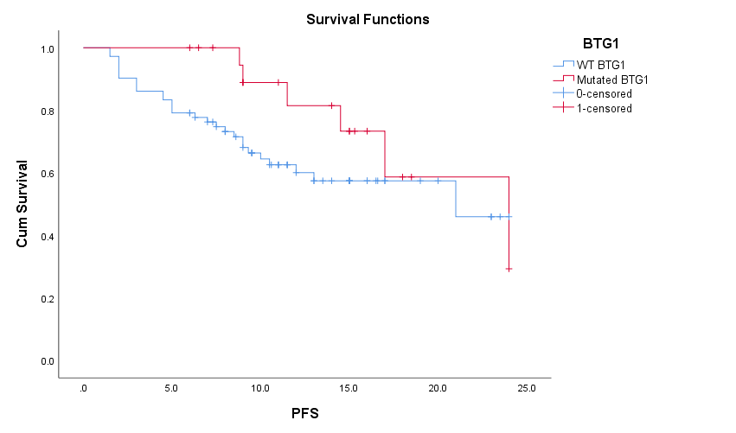
Y Z

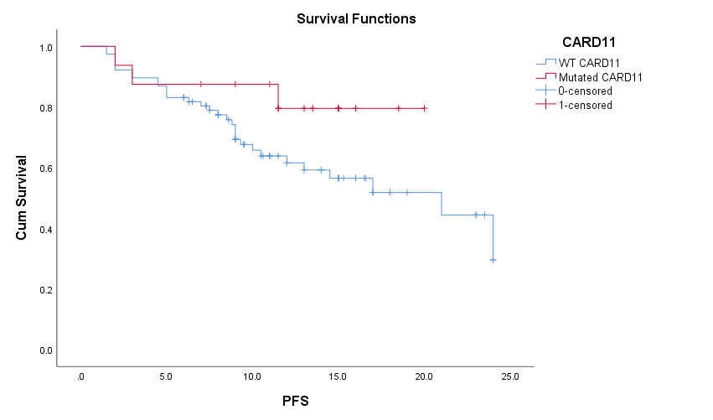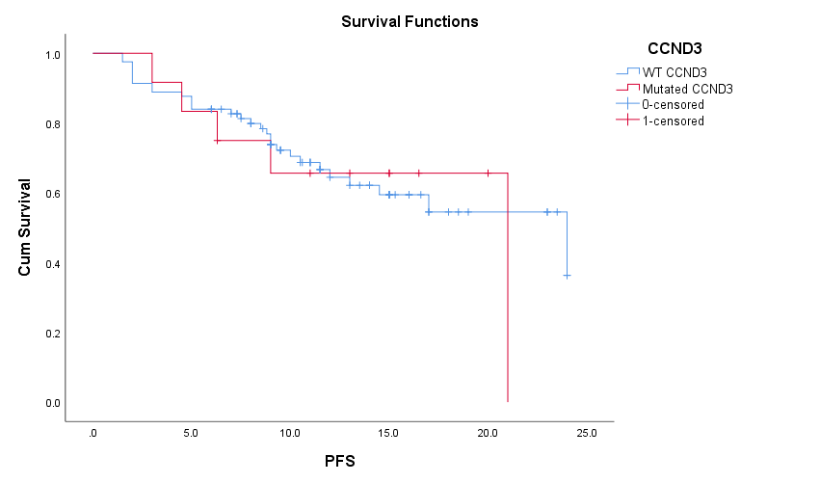
AA AB

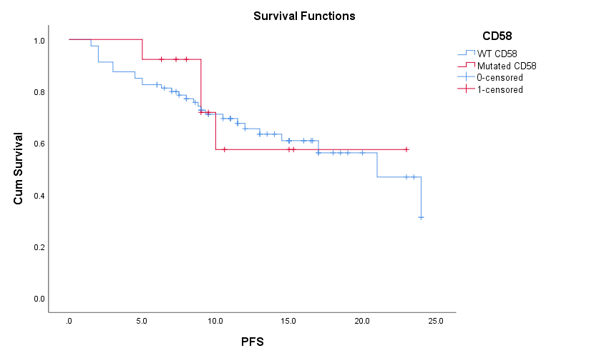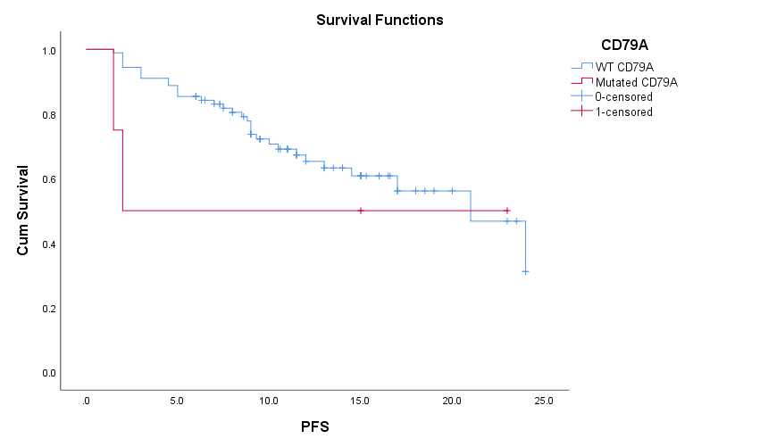
AC AD

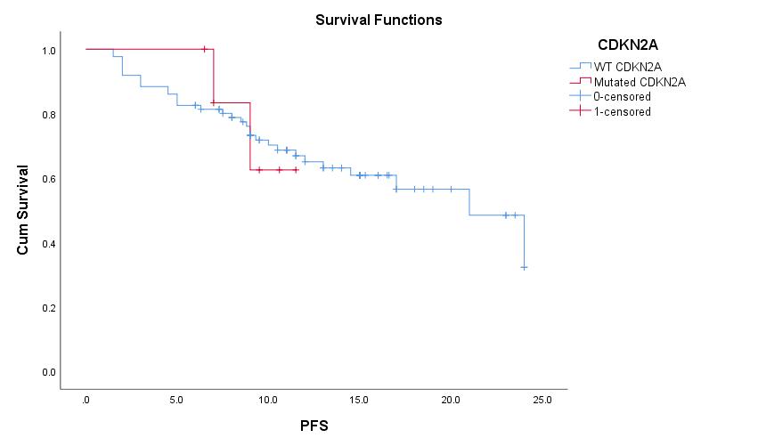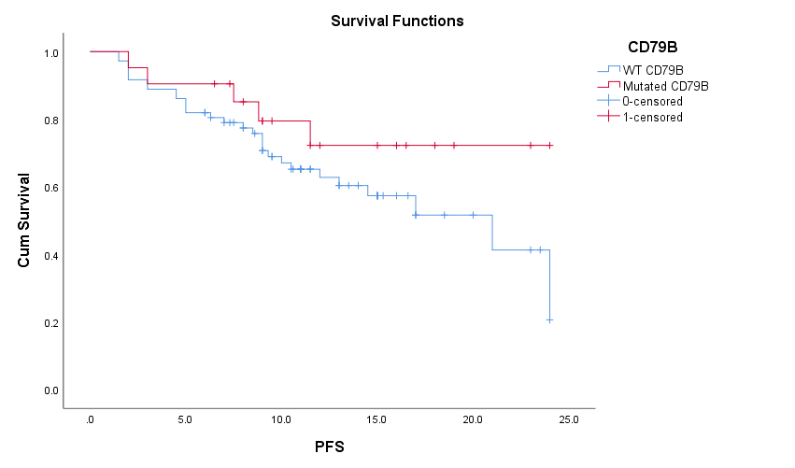
AE AF
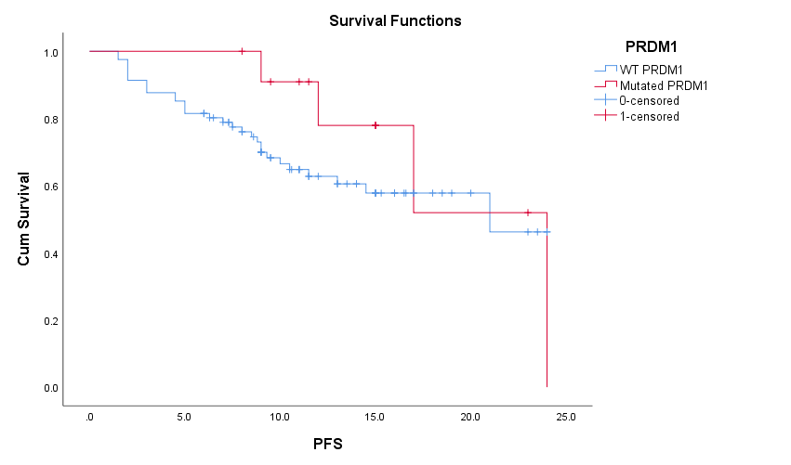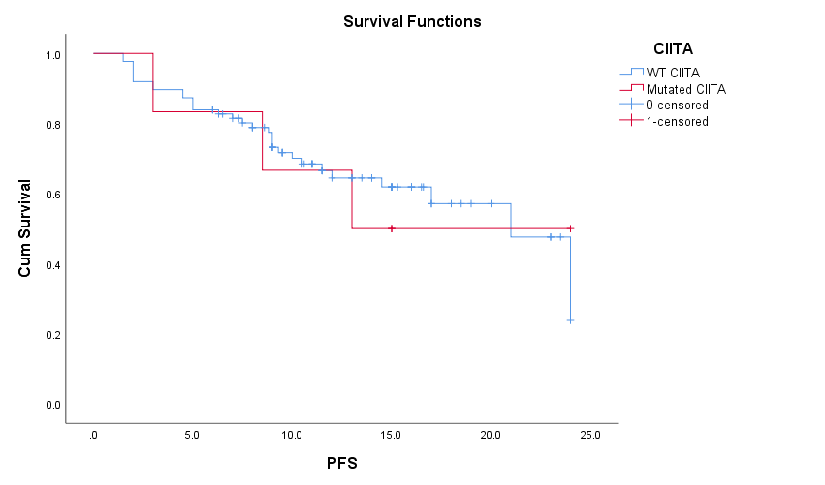
AG
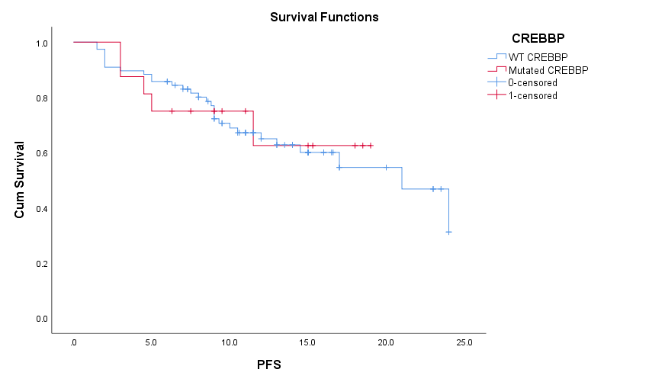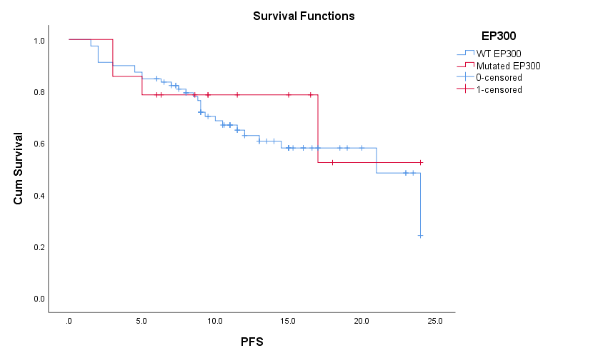

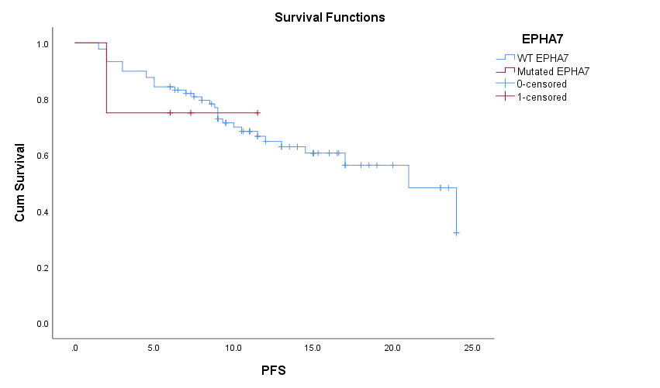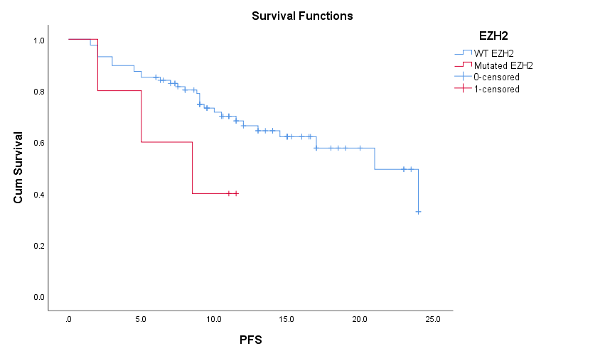

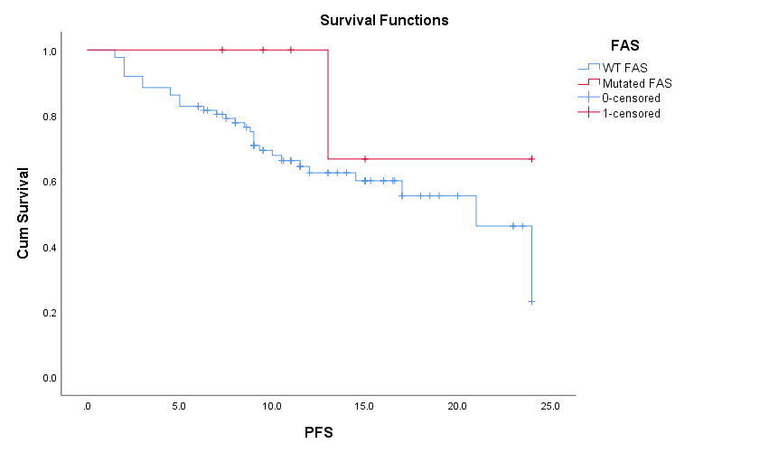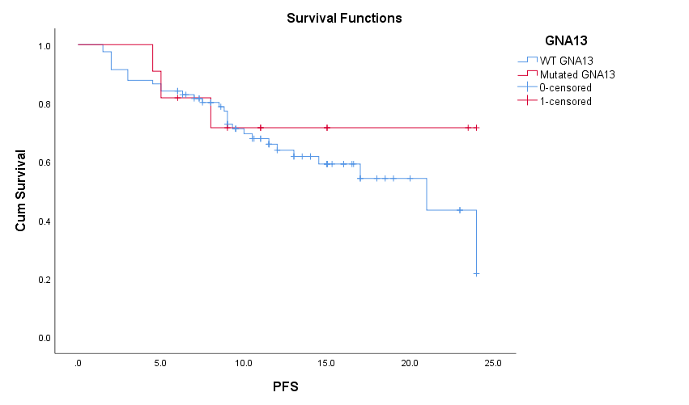

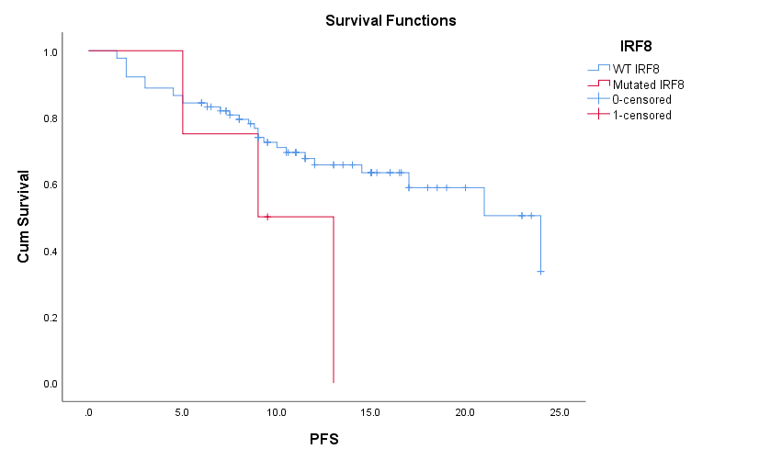
Figure S2. Kaplan–Meier estimates of PFS according to the gene mutations except P53 and MYD88. There was no significant difference in PFS according to this gene mutations:ARID1B, ATM, B2M, BCL10, BCL2, BCL6, BTG1, CARD11, CCND3, CD58, CD79A, CD79B, CDKN2A, CIITA, CREBBP, EPHA7, EZH2, EP300, FAS, GNA13, IRF8, ITPKB, JAK2, KMT2C, KMT2D, MEF2B, MFHAS1, MYC, NOTCH1, NOTCH2, PAX5, PIM1, PPM1D, SOCS1, SGK1, STAT3, STAT6, TET2, TNFAIP3, TNFRSF14, and XPO1.

Gene | Mutation frequency(%) | sampleName | cDnaHGVS | proteinHGVS | Sequencing depth
ARID1B | 51 | HT21TC2834 | NM_001371656:exon2:c.338G>A | p.S113N | 2383X
ARID1B | 47.1 | HT21TC2834 | NM_001371656:exon4:c.2003C>A | p.T668K | 3818X
TP53 | 5.2 | HT21TC2537 | NM_000546:exon8:c.818G>A | p.R273H | 2133X
FAS | 18.9 | HT21TC2537 | NM_000043:exon9:c.826C>T | p.Q276* | 1942X
TNFAIP3 | 21.3 | HT21TC2537 | NM_006290:exon4:c.563_576delinsTCACTCACTGGAG | p.Y188fs | 2492X
EPHA7 | 19.7 | HT21TC2537 | NM_004440:exon15:c.2722A>G | p.S908G | 836X
MFHAS1 | 19.1 | HT21TC2537 | NM_004225:exon1:c.869C>T | p.A290V | 3415X
NOTCH2 | 44.8 | HT21TC2537 | NM_024408:exon3:c.178G>A | p.E60K | 482X
TNFAIP3 | 20.7 | HT21TC2537 | NM_006290:exon4:c.605T>A | p.I202N | 2067X
CD58 | 36.3 | NL22DT18322 | NM_001779:exon3:c.454C>T | p.R152* | 2247X
PRDM1 | 33.6 | NL22DT18322 | NM_001198:exon5:c.1214_1215delinsA | p.S405Yfs | 2297X
PIM1 | 7.4 | NL22DT18322 | NM_002648:exon2:c.83G>A | p.G28D | 2000X
PIM1 | 5.9 | NL22DT18322 | NM_002648:exon3:c.208G>T | p.E70* | 2864X
MFHAS1 | 23.6 | NL22DT18322 | NM_004225:exon1:c.2054A>G | p.D685G | 3482X
PIM1 | 6.9 | NL22DT18322 | NM_002648:exon4:c.241C>A | p.P81T | 3475X
PIM1 | 25.4 | NL22DT18322 | NM_002648:exon4:c.544C>T | p.L182F | 2854X
PRDM1 | 9.2 | NL22DT18322 | NM_001198:exon2:c.44C>T | p.A15V | 2629X
MYD88 | 73 | HT21TC0663 | NM_002468.4:exon5:c.794T>C | p.L265P | 1737X
B2M | 55.3 | HT21TC0663 | NM_004048:exon1:c.1A>G | p.M1? | 1447X
CD79B | 41.7 | HT21TC0663 | NM_000626:exon5:c.587A>G | p.Y196C | 1817X
CIITA | 30.1 | HT21TC0663 | NM_000246:exon8:c.727delA | p.I243fs | 2082X
PRDM1 | 55.7 | HT21TC0663 | NM_001198:exon2:c.285_289del | p.S95fs | 1063X
CD79B | 38.8 | HT21TC0663 | NM_000626:exon3:c.188T>A | p.M63K | 1726X
CIITA | 33.6 | HT21TC0663 | NM_000246:exon19:c.3370G>C | p.D1124H | 1187X
PIM1 | 36.5 | HT21TC0663 | NM_002648:exon1:c.21C>G | p.N7K | 3220X
MYD88 | 27.8 | HT21TC0188 | NM_002468.4:exon5:c.794T>C | p.L265P | 2590X
CD79B | 29 | HT21TC0188 | NM_000626:exon5:c.587A>C | p.Y196S | 2965X
BTG1 | 21.6 | HT21TC0188 | NM_001731:exon2:c.197G>A | p.G66D | 2513X
BTG1 | 23.3 | HT21TC0188 | NM_001731:exon1:c.128G>C | p.S43T | 2463X
CARD11 | 27.9 | HT21TC0188 | NM_032415:exon5:c.377G>A | p.G126D | 2337X
CREBBP | 25.1 | HT21TC0188 | NM_004380:exon31:c.5338_5346del | p.V1780_A1782del | 3514X
ITPKB | 27.9 | HT21TC0188 | NM_002221:exon2:c.737C>A | p.S246* | 3352X
PIM1 | 29.1 | HT21TC0188 | NM_002648:exon4:c.248G>A | p.G83D | 2676X
BCL10 | 22.8 | HT21TC0420 | NM_003921:exon1:c.41C>T | p.T14I | 2702X
MYD88 | 20.3 | HT21TC0420 | NM_002468:exon3:c.617C>G | p.S206C | 4180X
TET2 | 21.7 | HT21TC0420 | NM_001127208:exon9:c.4133G>A | p.C1378Y | 2728X
TNFAIP3 | 41.3 | NL23DT00187 | NM_006290:exon3:c.425G>A | p.W142* | 1793X
CARD11 | 33 | NL23DT00187 | NM_032415:exon15:c.1876G>A | p.E626K | 1499X
CCND3 | 23.5 | NL23DT00187 | NM_001760:exon5:c.811delC | p.R271fs | 1500X
MYD88 | 10.6 | HT21TC0926 | NM_002468.4:exon5:c.794T>C | p.L265P | 2307X
BTG1 | 11.2 | HT21TC0926 | NM_001731:exon1:c.114G>C | p.Q38H | 2979X
ITPKB | 11.7 | HT21TC0926 | NM_002221:exon2:c.287G>C | p.S96T | 2067X
PIM1 | 11.4 | HT21TC0926 | NM_002648:exon3:c.237G>C | p.E79D | 2285X
PIM1 | 10.9 | HT21TC0926 | NM_002648:exon4:c.520C>G | p.L174V | 2153X
CD79B | 44.7 | NL22DT19629 | NM_000626:exon5:c.587A>G | p.Y196C | 1279X
BTG1 | 41.7 | NL22DT19629 | NM_001731:exon1:c.136G>A | p.E46K | 1248X
JAK2 | 62.8 | NL22DT19629 | NM_004972:exon15:c.1952_1953del | p.L651fs | 549X
PIM1 | 20 | NL22DT19629 | NM_002648:exon1:c.3G>A | p.M1? | 1422X
TP53 | 76 | HT21TC2102 | NM_000546:exon8:c.818G>A | p.R273H | 1092X
MYD88 | 78.8 | HT21TC2102 | NM_002468:exon4:c.656T>C | p.M219T | 1314X
XPO1 | 34.9 | HT21TC2102 | NM_003400:exon15:c.1711G>A | p.E571K | 1757X
EP300 | 38.2 | HT21TC2102 | NM_001429:exon5:c.1244T>C | p.L415P | 2221X
MEF2B | 75 | HT21TC2102 | NM_001145785:exon2:c.29G>A | p.R10H | 679X
MYD88 | 50.8 | HT21TC1848 | NM_002468.4:exon5:c.794T>C | p.L265P | 2498X
CD79B | 41.8 | HT21TC1848 | NM_000626:exon5:c.586T>C | p.Y196H | 2987X
EP300 | 28.5 | HT21TC1848 | NM_001429:exon30:c.4879C>T | p.R1627W | 3482X
FAS | 26.8 | HT21TC1848 | NM_000043:intron7:c.652-2A>G | - | 768X
CREBBP | 45.9 | HT21TC1848 | NM_004380:exon19:c.3692A>G | p.Q1231R | 1704X
IRF8 | 48.4 | HT21TC1848 | NM_002163:exon7:c.865G>A | p.V289I | 3952X
PAX5 | 48.2 | HT21TC1848 | NM_016734:exon8:c.961C>T | p.P321S | 2817X
PRDM1 | 26.6 | HT21TC1848 | NM_001198:exon4:c.511_517delinsG | p.Q171_L173delinsV | 2794X
KMT2D | 38.1 | HT21TC0186 | NM_003482:intron27:c.5867+1G>C | - | 2181X
CD79B | 73.7 | HT21TC0186 | NM_000626:exon5:c.587A>T | p.Y196F | 1978X
PIM1 | 37.7 | HT21TC0186 | NM_002648:exon3:c.202C>T | p.H68Y | 2301X
PIM1 | 72.2 | HT21TC0186 | NM_002648:exon3:c.237G>C | p.E79D | 2320X
PIM1 | 32.3 | HT21TC0186 | NM_002648:exon4:c.241C>T | p.P81S | 1968X
PIM1 | 32.3 | HT21TC0186 | NM_002648:exon4:c.291C>G | p.S97R | 2339X
BTG1 | 31.9 | HT21TC0186 | NM_001731:exon2:c.250G>T | p.A84S | 1477X
CREBBP | 35.7 | HT21TC0186 | NM_004380:exon24:c.4051C>A | p.H1351N | 2222X
EP300 | 52.3 | HT21TC0186 | NM_001429:exon14c.2636A>C | p.H879P | 3424X
MEF2B | 36.3 | HT21TC0186 | NM_001145785:exon2:c.52C>G | p.Q18E | 2116X
PIM1 | 36.6 | HT21TC0186 | NM_002648:exon4:c.437G>A | p.S146N | 1973X
SGK1 | 33.6 | HT21TC0186 | NM_005627:exon6:c.503C>T | p.T168I | 761X
MYC | 36.4 | HT21TC1443 | NM_002467:exon1:c.19G>C | p.V7L | 1224X
GNA13 | 14.8 | HT21TC1443 | NM_006572:exon4:c.1028A>G | p.Y343C | 1633X
MYC | 3.8 | HT21TC1443 | NM_002467:exon2:c.760G>A | p.V254M | 1303X
PAX5 | 43.2 | HT21TC1443 | NM_016734:exon5:c.571A>C | p.S191R | 1683X
PAX5 | 40.9 | HT21TC1443 | NM_016734:exon5:c.544A>G | p.S182G | 2050X
PAX5 | 41.5 | HT21TC1443 | NM_016734:exon5:c.536A>C | p.Y179S | 2061X
STAT3 | 1.7 | HT21TC2553 | NM_139276:exon21:c.1981G>T | p.D661Y | 1941X
CDKN2A | 51.6 | HT21TC2553 | NM_000077:exon1:c.122C>A | p.P41Q | 2371X
CARD11 | 41 | HT21TC1081 | NM_032415:exon8:c.1078A>G | p.M360V | 2442X
KMT2C | 6.6 | HT21TC1081 | NM_170606:exon15:c.2633C>T | p.A878V | 2549X
STAT3 | 30.1 | HT21TC1081 | NM_139276:exon22:c.2140A>G | p.T714A | 2989X
MEF2B | 28.5 | HT21TC2763 | NM_001145785:exon3:c.248A>C | p.D83A | 1742X
TP53 | 35.2 | HT21TC2763 | NM_000546:exon4:c.326T>C | p.F109S | 2066X
BTG1 | 26.1 | HT21TC2763 | NM_001731exon2:c.250G>A | p.A84T | 3246X
EPHA7 | 25.4 | HT21TC2763 | NM_004440:exon11:c.2035T>G | p.F679V | 1113X
CD79B | 11.7 | HT21TC0478 | NM_000626:exon5:c.587A>G | p.Y196C | 2007X
EP300 | 9.8 | HT21TC0478 | NM_001429:exon6:c.1426C>T | p.Q476* | 2357X
NOTCH2 | 8.7 | HT21TC0478 | NM_024408:exon34:c.6909dupC | p.I2304fs | 2786X
PIM1 | 9.7 | HT21TC0478 | NM_002648:exon4:c.241C>T | p.P81S | 2935X
CCND3 | 10.1 | HT21TC0478 | NM_001760:exon5:c.838C>T | p.Q280* | 2176X
MYD88 | 55.1 | HT21TC1668 | NM_002468.4:exon5:c.794T>C | p.L265P | 1809X
P53 | 26.5 | HT21TC1668 | NM_000546:exon7:c.724T>C | p.C242R | 1260X
ET2 | 47.2 | HT21TC1668 | NM_001127208:exon3:c.829G>A | p.A277T | 2080X
ET2 | 49.5 | HT21TC1668 | NM_001127208:exon11:c.4630C>A | p.P1544T | 2587X
TP53 | 28.1 | HT21TC1668 | NM_000546:exon7:c.736A>C | p.M246L | 1281X
MYD88 | 54.3 | HT21TC1445 | NM_002468.4:exon5:c.794T>C | p.L265P | 1655X
CARD11 | 40.7 | HT21TC1445 | NM_032415:exon6:c.688G>A | p.D230N | 595X
EP300 | 34.5 | HT21TC1445 | NM_001429:exon28:c.4585C>T | p.R1529* | 684X
EZH2 | 5.9 | HT21TC1445 | NM_004456:exon16:c.1937A>G | p.Y646C | 731X
STAT3 | 39.9 | HT21TC1445 | NM_139276:exon20:c.1846G>A | p.E616K | 1124X
CD79B | 88 | HT21TC1445 | NM_000626:exon6:c.596T>C | p.L199P | 1367X
CARD11 | 35.3 | HT21TC1622 | NM_032415:exon5:c.368G>A | p.G123D | 3062X
FAS | 23 | HT21TC1622 | NM_000043:exon9:c.696dup | p.I233fs | 1538X
KMT2C | 7.6 | HT21TC1622 | NM_170606:exon30:c.4531A>T | p.K1511* | 1373X
KMT2C | 36.7 | HT21TC1622 | NM_170606:intron25:c.3962-1G>A | - | 1228X
PIM1 | 12.2 | HT21TC1622 | NM_002648:exon2:c.83G>A | p.G28D | 2365X
PIM1 | 22 | HT21TC1622 | NM_002648:exon4:c.291C>G | p.S97R | 3593X
SGK1 | 14.9 | HT21TC1622 | NM_005627:exon9:c.839G>A | p.W280* | 2535X
SGK1 | 12.9 | HT21TC1622 | NM_005627:intron3:c.228+1G>C | - | 1522X
STAT3 | 24.7 | HT21TC1622 | NM_139276:intron23:c.2257+2T>G | - | 1625X
TP53 | 32.8 | HT21TC1622 | NM_000546:exon5:c.470T>A | p.V157D | 2781X
ARID1B | 15.3% | HT21TC1622 | NM_020732:exon1:c.275_298del | p.H92_H99del | 1987X
BTG1 | 22.9 | HT21TC1622 | NM_001731:exon1:c.33G>A | p.M11I | 3391X
EZH2 | 34 | HT21TC1622 | NM_004456:exon8:c.787A>G | p.N263D | 2340X
GNA13 | 25.7 | HT21TC1622 | NM_006572:exon4:c.977T>C | p.L326P | 3312X
ITPKB | 13.2 | HT21TC1622 | NM_002221:exon2:c.1547C>T | p.A516V | 3256X
ITPKB | 12.5 | HT21TC1622 | NM_002221:exon2:c.896G>C | p.S299T | 3347X
ITPKB | 32.1 | HT21TC1622 | NM_002221:exon2:c.172T>G | p.F58V | 2713X
KMT2D | 23 | HT21TC1622 | NM_003482:exon8:c.1108A>G | p.S370G | 2076X
PIM1 | 22.4 | HT21TC1622 | NM_002648:exon3:c.198C>G | p.I66M | 3356X
STAT3 | 24.6 | HT21TC1622 | NM_139276:exon23:c.2176A>C | p.M726L | 2093X
STAT3 | 23.3 | HT21TC1622 | NM_139276:exon23:c.2158A>T | p.N720Y | 1684X
TNFAIP3 | 29.3 | HT21TC1622 | NM_006290:exon3:c.377T>C | p.L126P | 3988X
TNFRSF14 | 43.1 | HT21TC1622 | NM_003820:exon3:c.286T>G | p.C96G | 1691X
TP53 | 35.5 | HT21TC1622 | NM_000546:exon5:c.444T>G | p.D148E | 2487X
MYD88 | 67.5 | HT21TC0623 | NM_002468.4:exon5:c.794T>C | p.L265P | 4672X
CD79B | 45.7 | HT21TC0623 | NM_000626:exon5:c.587A>G | p.Y196C | 2674X
KMT2D | 50.1 | HT21TC0623 | NM_003482:exon3:c.277delC | p.R93fs | 3464X
ATM | 46.1 | HT21TC0623 | NM_000051:exon62:c.8920C>T | p.P2974S | 2640X
BTG1 | 29.1 | HT21TC0623 | NM_001731:exon1:c.145G>C | p.A49P | 3038X
PIM1 | 42.7 | HT21TC0623 | NM_002648:exon4:c.295G>T | p.G99C | 2951X
FAS | 20.6 | HT21TC0755 | NM_000043:intron1:c.31-1G>T | - | 1112X
BTG1 | 16.3 | HT21TC0755 | NM_001731:exon1:c.145G>C | p.A49P | 473X
CD79A | 14.1 | HT21TC0755 | NM_001783:exon2:c.95C>G | p.A32G | 313X
GNA13 | 50 | HT21TC0755 | NM_006572:exon4:c.1078C>T | p.R360C | 1591X
PAX5 | 16.5 | HT21TC0755 | NM_016734:exon1:c.29C>T | p.P10L | 949X
STAT6 | 47.8 | HT21TC0755 | NM_003153:exon7:c.610T>A | p.W204R | 1250X
ARID1B | 20.1 | HT21TC1041 | NM_020732:exon1:c.1044_1071del | p.A349fs | 3147X
CARD11 | 37.4 | HT21TC1041 | NM_032415:exon8:c.1135C>T | p.R379W | 3160X
B2M | 11.1 | HT21TC1334 | NM_004048:exon2:c.285dup | p.D96fs | 2089X
B2M | 22 | HT21TC1334 | NM_004048:intron2:c.346+2T>G | - | 1204X
GNA13 | 35.4 | HT21TC1334 | NM_006572:exon1:c.5_8delinsTC | p.A2fs | 1210X
SOCS1 | 19.3 | HT21TC1334 | NM_003745:exon2:c.296_313delinsTC | p.G99fs | 1973X
SOCS1 | 20.5 | HT21TC1334 | NM_003745:exon2:c.87_90del | p.S30fs | 2360X
TNFAIP3 | 11.5 | HT21TC1334 | NM_006290:exon3:c.400_401del | p.D134fs | 2550X
TNFAIP3 | 18.3 | HT21TC1334 | NM_006290:exon7:c.1315_1336del | p.R439fs | 1934X
B2M | 20.5 | HT21TC1334 | NM_004048:exon2:c.332A>T | p.K111M | 1417X
B2M | 30.3 | HT21TC0888 | NM_004048:exon2:c.204dupA | p.V69fs | 2033X
B2M | 16.1 | HT21TC0888 | NM_004048:exon2:c.254dupT | p.L85fs | 2088X
CCND3 | 32.5 | HT21TC0888 | NM_001760:exon5:c.848C>T | p.T283I | 3596X
NOTCH2 | 85.1 | HT21TC0888 | NM_024408:exon34:c.7198C>T | p.R2400* | 14423X
TNFAIP3 | 54 | HT21TC0888 | NM_006290:exon7:c.1468C>T | p.Q490* | 1651X
MYD88 | 49.9 | HT21TC0888 | NM_002468:exon3:c.620T>C | p.I207T | 3997X
CCND3 | 37.3 | HT21TC0747 | NM_001760:exon5:c.826C>T | p.Q276* | 2802X
PRDM1 | 30.9 | HT21TC0747 | NM_001198:exon2:c.237_238dup | p.E80fs | 1972X
CARD11 | 37.7 | HT21TC0747 | NM_032415:exon5:c.645_647delinsCAT | p.K215_N216delinsNI | 2059X
EP300 | 47.1 | HT21TC0747 | NM_001429:exon8:c.1666A>G | p.M556V | 2310X
CDKN2A | 37.2 | HT21TC1401 | NM_000077:exon2:c.203_205delinsT | p.A68fs | 1459X
MYD88 | 26.5 | HT21TC1401 | NM_002468:exon4:c.689G>A | p.S230N | 2310X
MYD88 | 29.5 | HT21TC0664 | NM_002468.4:exon5:c.794T>C | p.L265P | 3734X
TP53 | 77.1 | HT21TC0664 | NM_000546:exon8:c.818G>A | p.R273H | 1240X
CARD11 | 60.6 | HT21TC0664 | NM_032415:exon9:c.1157G>A | p.R386Q | 3083X
CCND3 | 50.5 | HT21TC1528 | NM_001760:exon5:c.826C>T | p.Q276* | 2589X
MYD88 | 25.3 | HT21TC1528 | NM_002468:exon4:c.689G>A | p.S230N | 2112X
TNFAIP3 | 28.5 | HT21TC1528 | NM_006290:exon2:c.260_266del | p.R87fs | 3102X
TP53 | 22.3 | HT21TC1528 | NM_000546:exon8:c.830G>T | p.C277F | 1855X
XPO1 | 15.5 | HT21TC1528 | NM_003400:exon15:c.1711G>A | p.E571K | 2547X
BCL6 | 23.4 | HT21TC1528 | NM_001706:exon9:c.1934T>C | p.L645P | 2624X
CREBBP | 24.6 | HT21TC1528 | NM_004380:exon18:c.3592T>A | p.Y1198N | 2283X
MEF2B | 60.5 | HT21TC1528 | NM_001145785:exon3:c.177C>A | p.S59R | 1726X
B2M | 36.8 | HT21TC1726 | NM_004048:exon1:c.64C>T | p.Q22* | 1498X
EP300 | 27.4 | HT21TC1726 | NM_001429:exon31:c.6815C>T | p.P2272L | 1523X
B2M | 21.3 | HT21TC0611 | NM_004048:exon2:c.337_340del | p.V113fs | 320X
SOCS1 | 4.5 | HT21TC0611 | NM_003745:exon2:c.364_391delinsAGACC | p.G122fs | 1058X
CD79B | 9.8 | HT21TC0611 | NM_000626:intron4:c.549+1G>C | - | 429X
PIM1 | 8.2 | HT21TC0611 | NM_001243186:exon1:c.272G>A | p.G91E | 1478X
TP53 | 21.7 | 997141 | NM_000546:exon4:c.155_164del | p.Q52fs | 2361X
B2M | 30.9 | 997141 | NM_004048:exon2:c.82C>T | p.Q28* | 1309X
TP53 | 27.9 | 997141 | NM_000546:exon8:c.815T>G | p.V272G | 2189X
PAX5 | 28.4 | 997141 | NM_016734:exon1:c.16A>C | p.N6H | 1472X
CD79B | 41.6 | NL22DT21672 | NM_000626:exon5:c.586T>C | p.Y196H | 2820X
MYD88 | 81.7 | NL22DT21672 | NM_002468.4:exon5:c.794T>C | p.L265P | 2373X
BCL10 | 37.8 | NL22DT21672 | NM_003921:exon3:c.531delA | p.E178fs | 3787X
BCL10 | 36.7 | NL22DT21672 | NM_003921:exon3:c.682C>T | p.R228C | 2671X
CD79B | 37.2 | NL22DT21672 | NM_000626:exon6:c.596T>C | p.L199P | 1996X
PIM1 | 62.6 | NL22DT21672 | NM_002648:exon1:c.21_23delinsGTG | p.N7_S8delinsKW | 1543X
PIM1 | 22.3 | NL22DT21672 | NM_002648:exon1:c.54_71del | p.N18_T23del | 1888X
PIM1 | 43.3 | NL22DT21672 | NM_002648:exon1:c.63C>G | p.H21Q | 1787X
PIM1 | 51.5 | NL22DT21672 | NM_002648:exon2:c.87G>C | p.K29N | 1270X
PIM1 | 49.9 | NL22DT21672 | NM_002648:exon2:c.88G>T | p.E30* | 1286X
PIM1 | 44.1 | NL22DT21672 | NM_002648:exon2:c.111G>T | p.Q37H | 2493X
PIM1 | 32.2 | NL22DT21672 | NM_002648:exon2:c.155_163del | p.V52_S54del | 2819X
PIM1 | 24.7 | NL22DT21672 | NM_002648:exon3:c.202C>G | p.H68D | 2076X
PIM1 | 44.1 | NL22DT21672 | NM_002648:exon3:c.224C>A | p.S75Y | 1990X
PIM1 | 41.9 | NL22DT21672 | NM_002648:exon3:c.230G>T | p.W77L | 1912X
PIM1 | 32 | NL22DT21672 | NM_002648:exon3:c.235G>A | p.E79K | 1830X
PIM1 | 37.3 | NL22DT21672 | NM_002648:exon3:c.240+1G>A | - | 1722X
PIM1 | 24.2 | NL22DT21672 | NM_002648:exon4:c.241-1_280del | - | 1212X
PIM1 | 55.6 | NL22DT21672 | NM_002648:exon4:c.290G>C | p.S97T | 1218X
PIM1 | 50.2 | NL22DT21672 | NM_002648:exon4:c.341_360del | p.D114fs | 1463X
PIM1 | 5.9 | NL22DT21672 | NM_002648:exon4:c.451G>C | p.V151L | 2361X
PIM1 | 27.6 | NL22DT21672 | NM_002648:exon4:c.600_607+4del | - | 3182X
MYD88 | 33.4 | HT21TC0526 | NM_002468.4:exon5:c.794T>C | p.L265P | 1852X
CD79B | 38.1 | HT21TC0526 | NM_000626:exon5:c.586T>C | p.Y196H | 1959X
CIITA | 33.7 | HT21TC0526 | NM_000246:exon11:c.1615C>T | p.R539* | 1633X
CIITA | 30.7 | HT21TC0526 | NM_000246:exon12:c.2701C>T | p.Q901* | 1518X
PIM1 | 33.9 | HT21TC0526 | NM_002648:exon1:c.4C>T | p.L2F | 2081X
TNFAIP3 | 51.5 | HT21TC0526 | NM_006290:intron4:c.634+2T>C | - | 1169X
CARD11 | 31.1 | HT21TC0526 | NM_032415:exon8:c.1071C>G | p.D357E | 1857X
CCND3 | 29.5 | HT21TC0526 | NM_001760:exon5:c.766_776del | p.R256fs | 1946X
CREBBP | 46.6 | HT21TC0526 | NM_004380:exon14:c.2757G>C | p.Q919H | 2021X
EP300 | 51.9 | HT21TC0526 | NM_001429:exon8:c.1666A>G | p.M556V | 1793X
PIM1 | 32.6 | HT21TC0526 | NM_002648:exon2:c.87G>C | p.K29N | 1641X
PIM1 | 29.9 | HT21TC0526 | NM_002648:intron3:c.241-1G>A | - | 2650X
ATM | 38.1 | 1631795158 | NM_000051:exon27:c.4098_4099del | p.C1366* | 2164X
CD58 | 16.4 | 1631795158 | NM_001779:exon3:c.553dupA | p.I185fs | 2456X
MEF2B | 16.3 | 1631795158 | NM_001145785:exon3:c.122G>A | p.C41Y | 2615X
NOTCH2 | 49 | 1631795158 | NM_024408:exon34:c.6833C>G | p.T2278S | 3048X
PAX5 | 45.5 | 1631795158 | NM_016734:exon10:c.1169G>A | p.R390H | 2097X
PIM1 | 15.6 | 1631795158 | NM_002648:exon1:c.29C>T | p.A10V | 3137X
PIM1 | 14.8 | 1631795158 | NM_002648:exon1:c.38G>A | p.R13H | 3001X
PIM1 | 15.7 | 1631795158 | NM_002648:exon2:c.157T>C | p.Y53H | 2533X
SGK1 | 18.7 | 1631795158 | NM_005627:exon5:c.337C>T | p.L113F | 2732X
SGK1 | 16 | 1631795158 | NM_005627:exon3:c.205A>G | p.M69V | 2887X
SGK1 | 16.3 | 1631795158 | NM_005627:exon3:c.201G>C | p.E67D | 2915X
SGK1 | 14.1 | 1631795158 | NM_005627:exon3:c.163C>T | p.Q55* | 2671X
SGK1 | 10.6 | 1631795158 | NM_005627:exon2:c.151C>G | p.H51D | 1573X
SGK1 | 11.8 | 1631795158 | NM_005627:exon2:c.148A>T | p.K50* | 1631X
XPO1 | 12 | 1631795158 | NM_003400:exon17:c.1897_1899delinsGTG | p.F633V | 2363X
TP53 | 79.2 | HT21TC1860 | NM_000546:exon8:c.818G>A | p.R273H | 510X
KMT2D | 59 | NL23DT00531 | NM_003482:exon10 :c.2296G>T | p.E766* | 1474X
MYD88 | 66.1 | NL23DT00531 | NM_002468.4:exon5:c.794T>C | p.L265P | 1665X
KMT2D | 38.7 | NL23DT00531 | NM_003482:exon34:c.9831_9833dup | p.Q3282dup | 1386X
PIM1 | 60.2 | NL23DT00531 | NM_002648:exon2:c.94G>T | p.E32* | 1417X
B2M | 47.5 | HT21TC0685 | NM_004048:exon1:c.2T>G | p.M1? | 2112X
PAX5 | 23.2 | HT21TC0685 | NM_016734:exon5:c.586A>T | p.K196* | 2427X
TNFAIP3 | 48.2 | HT21TC0685 | NM_006290:exon2:c.64delC | p.R22fs | 3214X
BTG1 | 48.9 | HT21TC0685 | NM_001731:exon1:c.108G>C | p.Q36H | 3127X
BTG1 | 23.5 | HT21TC0685 | NM_001731:exon1:c.8C>T | p.P3L | 2803X
CD58 | 44.5 | HT21TC0685 | NM_001779:exon2:c.241G>A | p.V81I | 1271X
CREBBP | 21.1 | HT21TC0685 | NM_004380:exon15:c.2911A>G | p.R971G | 2453X
STAT6 | 53.4 | HT21TC0685 | NM_003153:exon13:c.1330G>A | p.E444K | 1971X
STAT6 | 55.2 | HT21TC0685 | NM_003153:exon12:c.1249A>T | p.N417Y | 1711X
BCL2 | 2.4 | HT21TC1607 | NM_000633:exon2:c.392C>A | p.A131D | 3919X
CD58 | 17.4 | HT21TC1607 | NM_001779:exon2:c.128dup | p.H44fs | 912X
PIM1 | 16.1 | HT21TC1607 | NM_002648:exon1:c.4C>T | p.L2F | 2195X
PIM1 | 5.5 | HT21TC1607 | NM_002648:exon2:c.83G>A | p.G28D | 1009X
PIM1 | 4.1 | HT21TC1607 | NM_002648:exon2:c.101_110del | p.L34fs | 1250X
PIM1 | 4.3 | HT21TC1607 | NM_002648:exon2:c.114C>A | p.Y38* | 1316X
PIM1 | 13.3 | HT21TC1607 | NM_002648:exon2:c.115C>T | p.Q39* | 1435X
PIM1 | 30 | HT21TC1607 | NM_002648:intron2:c.189+1G>A | - | 1426X
PIM1 | 15.3 | HT21TC1607 | NM_002648:intron3:c.240+1G>A | - | 1747X
PIM1 | 18.7 | HT21TC1607 | NM_002648:exon4:c.241C>T | p.P81S | 1351X
PIM1 | 14.1 | HT21TC1607 | NM_002648:exon4:c.379C>T | p.Q127* | 1618X
PIM1 | 17.3 | HT21TC1607 | NM_002648:intron4:c.607+1G>T | - | 1136X
TNFAIP3 | 16.5 | HT21TC1607 | NM_006290:exon5:c.666del | p.N223fs | 1075X
CDKN2A | 17.8 | HT21TC1607 | NM_058195:exon1:c.1A>G | p.M1V | 1060X
PIM1 | 16.1 | HT21TC1607 | NM_001243186:exon1:c.195C>A | p.S65R | 2534X
PIM1 | 14.8 | HT21TC1607 | NM_001243186:exon1:c.230G>A | p.S77N | 2335X
PIM1 | 15.5 | HT21TC1607 | NM_002648:exon2:c.87G>T | p.K29N | 1068X
PIM1 | 15.1 | HT21TC1607 | NM_002648:exon2:c.97C>T | p.P33S | 1150X
PIM1 | 12.5 | HT21TC1607 | NM_002648:exon2:c.143G>A | p.G48D | 1612X
PIM1 | 15.4 | HT21TC1607 | NM_002648:exon3:c.224C>A | p.S75Y | 1885X
PIM1 | 13.6 | HT21TC1607 | NM_002648:exon4:c.365G>A | p.R122K | 1636X
PIM1 | 16.4 | HT21TC1607 | NM_002648:exon4:c.413C>T | p.A138V | 1570X
PIM1 | 15.5 | HT21TC1607 | NM_002648:exon4:c.543G>C | p.E181D | 1800X
PIM1 | 16.3 | HT21TC1607 | NM_002648:exon4:c.544C>T | p.L182F | 1816X
PIM1 | 16.6 | HT21TC1607 | NM_002648:exon4:c.550C>T | p.L184F | 1777X
CD79B | 36.8 | HT21TC1200 | NM_000626:intron4:c.549+1G>A | - | 853X
ARID1B | 30 | HT21TC1200 | NM_020732:exon1:c.373C>A | p.Q125K | 1440X
BTG1 | 32.8 | HT21TC1200 | NM_001731:exon2:c.202C>T | p.R68C | 1608X
PIM1 | 23.9 | HT21TC1200 | NM_002648:exon2:c.87G>C | p.K29N | 1079X
PIM1 | 52.6 | HT21TC1200 | NM_002648:exon4:c.286G>A | p.V96M | 1985X
MYD88 | 74.4 | HT21TC1876 | NM_002468.4:exon5:c.794T>C | p.L265P | 2363X
CD58 | 55.9 | HT21TC1876 | NM_001779:intron3:c.628+2T>G | - | 1101X
EP300 | 72.3 | HT21TC1876 | NM_001429:exon30:c.4879C>T | p.R1627W | 2938X
KMT2D | 37.6 | HT21TC1876 | NM_003482:exon8:c.1100del | p.P367fs | 1889X
ITPKB | 46.6 | HT21TC1876 | NM_002221:exon2:c.179C>A | p.P60Q | 2399X
KMT2D | 49 | HT21TC1876 | NM_003482:exon44:c.14093A>T | p.D4698V | 1943X
TNFRSF14 | 45.2 | HT21TC1876 | NM_003820:exon4:c.416G>A | p.R139H | 2189X
CD79B | 15.4 | HT21TC2141 | NM_000626:exon5:c.586T>C | p.Y196H | 1040X
MYC | 8.2 | HT21TC2141 | NM_002467:exon1:c.4_6delinsAA | p.D2fs | 1272X
PIM1 | 7.3 | HT21TC2141 | NM_002648:intron1:c.82+1G>C | - | 1062X
TP53 | 18.1 | HT21TC2141 | NM_000546:exon7:c.716A>G | p.N239S | 783X
BTG1 | 13.3 | HT21TC2141 | NM_001731:exon2:c.316G>A | p.V106I | 2190X
CD79B | 15.6 | HT21TC2141 | NM_000626:exon5:c.560A>G | p.K187R | 1041X
MYD88 | 54.9 | HT21TC2053 | NM_002468.4:exon5:c.794T>C | p.L265P | 1407X
BTG1 | 27.6 | HT21TC2053 | NM_001731:exon1:c.75_84del | p.F25fs | 2695X
KMT2D | 23.2 | HT21TC2053 | NM_003482:exon13:c.4114A>T | p.K1372* | 1076X
PIM1 | 4.4 | HT21TC2053 | NM_002648:exon4:c.403G>T | p.E135* | 1882X
ATM | 21.8 | HT21TC2053 | NM_000051:exon5:c.445A>C | p.I149L | 1233X
BCL2 | 29.2 | HT21TC2053 | NM_000657:exon2:c.608G>A | p.S203N | 1793X
CREBBP | 50.2 | HT21TC2053 | NM_004380:exon31:c.6658G>A | p.G2220S | 1779X
MYC | 4.2 | HT21TC2053 | NM_002467:exon2:c.162_165delinsT | p.E54_L55delinsD | 1602X
PIM1 | 13.7 | HT21TC2053 | NM_002648:exon2:c.83_94del | p.G28_K31del | 1184X
PIM1 | 19.6 | HT21TC2053 | NM_002648:exon2:c.136_144del | p.S46_G48del | 1493X
PIM1 | 25.2 | HT21TC2053 | NM_002648:exon3:c.238C>G | p.L80V | 1602X
MYD88 | 34.4 | HT21TC2732 | NM_002468.4:exon5:c.794T>C | p.L265P | 3776X
CARD11 | 34.9 | HT21TC2732 | NM_032415:exon6:c.688G>A | p.D230N | 2616X
PIM1 | 34.7 | HT21TC2732 | NM_002648:exon1:c.3G>T | p.M1? | 4937X
PIM1 | 33.5 | HT21TC2732 | NM_002648:exon2:c.83G>A | p.G28D | 2277X
PIM1 | 35.1 | HT21TC2732 | NM_002648:exon2:c.111G> | p.Q37H | 2971X
PIM1 | 56.2 | HT21TC2732 | NM_002648:exon4:c.241C>T | p.P81S | 2073X
SGK1 | 34.7 | HT21TC2732 | NM_001143678:exon1:c.13C>T | p.Q5* | 2095X
BCL2 | 17.4 | HT21TC2732 | NM_000633:exon2:c.564_581del | p.W188_G194delinsC | 5996X
BTG1 | 36.4 | HT21TC2732 | NM_001731:exon1:c.8C>T | p.P3L | 3278X
CREBBP | 37.3 | HT21TC2732 | NM_004380:exon27:c.4496T>G | p.L1499R | 3808X
MYC | 35.5 | HT21TC2732 | NM_002467:exon2:c.653G>A | p.S218N | 3929X
PIM1 | 36 | HT21TC2732 | NM_001243:186:exon1:c.195C>G | p.S65R | 5352X
PIM1 | 34.5 | HT21TC2732 | NM_001243186:exon1:c.254C>T | p.A85V | 5305X
PIM1 | 35.5 | HT21TC2732 | NM_002648:exon2:c.94G>A | p.E32K | 2626X
PIM1 | 33.7 | HT21TC2732 | NM_002648:exon2:c.97C>T | p.P33S | 2649X
PIM1 | 54.2 | HT21TC2732 | NM_002648:exon4:c.316C>T | p.L106F | 2838X
PIM1 | 41.8 | HT21TC2732 | NM_002648:exon4:c.418C>T | p.Q140* | 3525X
PIM1 | 24 | HT21TC2732 | NM_002648:exon4:c.438C>G | p.S146R | 3766X
PIM1 | 36.0 | HT21TC2732 | NM_002648:exon4:c.473_475delinsACT | p.C158_H159delinsYY | 4071X
PIM1 | 30.9 | HT21TC2732 | NM_002648:exon4:c.511G>A | p.E171K | 4485X
PIM1 | 32.8 | HT21TC2732 | NM_002648:exon4:c.550C>T | p.L184F | 4449X
MYD88 | 23.5 | HT21TC2642 | NM_002468.4:exon5:c.794T>C | p.L265P | 2779X
BTG1 | 23.6 | HT21TC2642 | NM_001731:exon2:c.250G>C | p.A84P | 4309X
PIM1 | 20.9 | HT21TC2642 | NM_002648:exon2:c.96G>C | p.E32D | 2182X
PIM1 | 22.3 | HT21TC2642 | NM_002648:exon2:c.183C>G | p.N61K | 2520X
MYD88 | 39.4 | HT21TC2764 | NM_002468.4:exon5:c.794T>C | p.L265P | 1733X
CD58 | 33.7 | HT21TC2764 | NM_001779:exon2:c.274_289del | p.I92fs | 2150X
CD79B | 39.3 | HT21TC2764 | NM_000626:exon5:c.587A>C | p.Y196S | 1415X
PIM1 | 36.1 | HT21TC2764 | NM_002648:exon4:c.241C>T | p.P81S | 1780X
BCL2 | 39.7 | HT21TC2764 | NM_000633:exon2:c.39G>C | p.E13D | 2044X
GNA13 | 43 | HT21TC2764 | NM_006572:exon1:c.82C>T | p.Q28* | 2018X
PIM1 | 20.4 | HT21TC2764 | NM_002648:exon1:c.73C>G | p.L25V | 1374X
PIM1 | 38.6 | HT21TC2764 | NM_002648:exon2:c.90G>C | p.E30D | 1527X
PIM1 | 38.4 | HT21TC2764 | NM_002648:exon2:c.112_117del | p.Y38_Q39del | 1676X
PIM1 | 38.8 | HT21TC2764 | NM_002648:exon4:c.320T>G | p.L107R | 2425X
PIM1 | 38.1 | HT21TC2764 | NM_002648:exon4:c.412G>A | p.A138T | 2439X
FAS | 21 | HT21TC0607 | NM_000043:exon7:c.630dupT | p.E211* | 2194X
IRF8 | 20.4 | HT21TC0607 | NM_002163:exon9:c.1253dupT | p.R419fs | 2592X
ATM | 27.4 | HT21TC0607 | NM_000051:exon22:c.3190A>G | p.M1064V | 2029X
CIITA | 22.5 | HT21TC0607 | NM_000246:exon11:c.2335G>C | p.A779P | 2139X
B2M | 8.4 | HT21TC2761 | NM_004048:exon1:c.1A>G | p.M1? | 1923X
SOCS1 | 6.5 | HT21TC2761 | NM_003745:exon2:c.413_429del | p.D138fs | 2097X
TNFAIP3 | 7 | HT21TC2761 | NM_006290:exon4:c.588_589del | p.F197fs | 2210X
B2M | 8.3 | HT21TC2761 | NM_004048:exon1:c.17C>A | p.A6D | 2078X
EP300 | 6.7 | HT21TC2761 | NM_001429:exon9:c.1866_1867delinsGC | p.A623P | 1858X
GNA13 | 9 | HT21TC2761 | NM_006572:exon4:c.965T>A | p.V322D | 2879X
GNA13 | 8 | HT21TC2761 | NM_006572:exon1:c.79C>T | p.Q27* | 2485X
KMT2C | 36.5 | HT21TC2761 | NM_170606:exon16:c.2758G>C | p.V920L | 1551X
SOCS1 | 10.3 | HT21TC2761 | NM_003745:exon2:c.483G>A | p.M161I | 1720X
STAT6 | 9.2 | HT21TC2761 | NM_003153:exon12:c.1249_1255delinsTACCAAA | p.N417_  D419delinsYQN | 1340X
XPO1 | 11.5 | NL22DT20433 | NM_003400:exon15:c.1711G>A | p.E571K | 4406X
EZH2 | 44.2 | NL22DT20433 | NM_004456:exon16:c.1937A>T | p.Y646F | 3698X
ATM | 56.3 | NL22DT20433 | NM_000051:exon55:c.8120C>G | p.S2707C | 2778X
CIITA | 16.1 | NL22DT20433 | NM_000246:exon11:c.1135G>A | p.E379K | 2378X
TNFRSF14 | 26.3 | NL22DT20433 | NM_003820:exon2:c.106G>A | p.A36T | 1195X
CREBBP | 17.4 | HT21TC2421 | NM_004380:exon10:c.1958T>A | p.L653* | 1886X
TET2 | 31.4 | HT21TC2421 | NM_001127208:exon3:c.1859dup | p.Y620* | 3899X
TET2 | 14.2 | HT21TC2421 | NM_001127208:exon11:c.4552del | p.S1518fs | 2983X
KMT2C | 50.8 | HT21TC2421 | NM_170606:exon36:c.6424G>C | p.V2142L | 3873X
PAX5 | 15.8 | HT21TC2421 | NM_016734:exon1:c.20A>C | p.Y7S | 1853X
PIM1 | 19.4 | HT21TC2421 | NM_001243186:exon1:c.170G>A | p.S57N | 4692X
PIM1 | 19.3 | HT21TC2421 | NM_001243186:exon1:c.230G>A | p.S77N | 4450X
SGK1 | 21 | HT21TC2421 | NM_005627:exon3:c.224C>T | p.P75L | 1708X
GNA13 | 42.9 | NL22DT14276 | NM_006572:exon4:c.1036T>C | p.F346L | 2337X
KMT2D | 29 | NL22DT14276 | NM_003482:exon51:c.16162T>G | p.Y5388D | 1906X
STAT6 | 58.9 | NL22DT14276 | NM_003153:exon12:c.1255G>T | p.D419Y | 1427X
XPO1 | 54.1 | NL22DT14276 | NM_003400:exon7:c.577C>T | p.H193Y | 2092X
BCL10 | 24.7 | HT21TC2446 | NM_003921:exon3:c.438dup | p.L147fs | 2043X
BTG1 | 26.9 | HT21TC2446 | NM_001731:exon1:c.138del | p.E46fs | 3287X
CD58 | 26.6 | HT21TC2446 | NM_001779:exon2:c.222_244del | p.F74fs | 1601X
MYD88 | 3.2 | HT21TC2446 | NM_002468:exon3:c.617C>G | p.S206C | 3494X
PIM1 | 27.1 | HT21TC2446 | NM_002648:exon2:c.111G>C | p.Q37H | 3342X
TNFRSF14 | 30.3 | HT21TC2446 | NM_003820:exon3:c.283C>T | p.Q95* | 2878X
BCL10 | 11.9 | HT21TC2446 | NM_003921:exon2:c.173G>A | p.R58Q | 2544X
BTG1 | 30 | HT21TC2446 | NM_001731:exon2:c.472A>G | p.T158A | 2775X
BTG1 | 27.9 | HT21TC2446 | NM_001731:exon2:c.250G>C | p.A84P | 4046X
ITPKB | 27.3 | HT21TC2446 | NM_002221:exon2:c.260G>C | p.G87A | 4589X
PIM1 | 28.4 | HT21TC2446 | NM_001243186:exon1:c.268G>A | p.V90I | 5139X
MYD88 | 36.5 | HT21TC1191 | NM_002468.4:exon5:c.794T>C | p.L265P | 3807X
TP53 | 21.3 | HT21TC1191 | NM_000546:exon4c.335del | p.G112fs | 2826X
SOCS1 | 17.1 | HT21TC1191 | NM_003745:exon2:c.7G>A | p.A3T | 2071X
MYC | 22.7 | HT21TC1191 | NM_002467:exon2:c.62G>C | p.S21T | 4152X
MYD88 | 40.8 | HT21TC2653 | NM_002468.4:exon5:c.794T>C | p.L265P | 3342X
CD79B | 81.6 | HT21TC2653 | NM_000626:exon5:c.587A>G | p.Y196C | 3099X
CDKN2A | 79.6 | HT21TC2653 | NM_000077:exon2:c.238C>T | p.R80* | 3678X
BTG1 | 39.4 | HT21TC2653 | NM_001731:exon1:c.109C>A | p.L37M | 3027X
B2M | 47.6 | HT21TC2285 | NM_004048:exon1:c.43_44del | p.L15fs | 1461X
CD58 | 25.7 | HT21TC2285 | NM_001779:exon3:c.454C>T | p.R152* | 1650X
CD58 | 14.5 | HT21TC2285 | NM_001779:exon1:c.52_61del | p.C18fs | 1351X
ARID1B | 21.9 | HT21TC2285 | NM_020732:exon18:c.4348G>A | p.G1450S | 2032X
ITPKB | 25.7 | HT21TC2285 | NM_002221:exon2:c.218G>A | p.G73E | 1902X
SOCS1 | 28.3 | HT21TC2285 | NM_003745:exon2:c.263_283del | p.G88_R94del | 1093X
TET2 | 51.1 | HT21TC2285 | NM_001127208:exon3:c.2137T>C | p.F713L | 2443X
- | - | HT21TC0402 | - | - | -
B2M | 65.6 | NL23DT00188 | NM_004048:exon2:c.340A>T | p.K114* | 3304X
CREBBP | 47.7 | NL23DT00188 | NM_004380:exon13:c.2414C>T | p.A805V | 2587X
KMT2D | 49.4 | NL23DT00188 | NM_003482:exon39:c.11989C>T | p.L3997F | 3253X
MFHAS1 | 32.6 | NL23DT00188 | NM_004225:exon1:c.1175T>C | p.I392T | 2817X
MYD88 | 41.8 | HT21TC1568 | NM_002468.4:exon5:c.794T>C | p.L265P | 1464X
KMT2D | 22 | HT21TC1568 | NM_003482:exon11:c.3754C>T | p.R1252* | 1103X
PRDM1 | 32.2 | HT21TC1568 | NM_001198:exon5:c.1633G>T | p.E545* | 1421X
MFHAS1 | 52.5 | HT21TC1568 | NM_004225:exon1:c.422A>C | p.N141T | 960X
TP53 | 44.5 | HT21TC2037 | NM_000546:exon5:c.524G>A | p.R175H | 877X
B2M | 52.4 | HT21TC2037 | NM_004048:exon1:c.2T>C | p.M1? | 471X
CREBBP | 32 | HT21TC2037 | NM_004380:exon18:c.3525T>A | p.Y1175* | 1066X
KMT2D | 31.1 | HT21TC2037 | NM_003482:exon11:c.2987T>C | p.V996A | 1075X
XPO1 | 39 | HT21TC2037 | NM_003400:exon18:c.2161T>A | p.Y721N | 876X
TP53 | 52.9 | HT21TC2448 | NM_000546:exon4:c.335dup | p.F113fs | 565X
BCL10 | 33.3 | HT21TC2448 | NM_003921:exon3:c.438del | p.K146fs | 1416X
CCND3 | 31.7 | HT21TC2448 | NM_001760:exon5:c.811dup | p.R271fs | 1301X
TP53 | 31.7 | HT21TC1307 | NM_000546:exon8:c.818G>A | p.R273H | 1303X
PIM1 | 21.4 | HT21TC1307 | NM_002648:exon4:c.241C>T | p.P81S | 2232X
PIM1 | 7.7 | HT21TC1307 | NM_002648:exon4:c.403_410del | p.E135fs | 2603X
PRDM1 | 29.7 | HT21TC1307 | NM_001198:exon4:c.555C>G | p.Y185* | 2463X
BTG1 | 23.7 | HT21TC1307 | NM_001731:exon1:c.91C>T | p.L31F | 2797X
MEF2B | 22.5 | HT21TC1307 | NM_001145785:exon3:c.239C>T | p.T80I | 1615X
PIM1 | 25.1 | HT21TC1307 | NM_002648:exon3:c.224C>T | p.S75F | 2477X
PIM1 | 11.4 | HT21TC1307 | NM_002648:exon4:c.490C>T | p.L164F | 2290X
B2M | 32.3 | NL22DT18062 | NM_004048:exon1:c.64C>T | p.Q22* | 2994X
EP300 | 23 | NL22DT18062 | NM_001429:exon29:c.4636A>T | p.K1546* | 4562X
FAS | 34.6 | NL22DT18062 | NM_000043:exon8:c.652-1G>A | - | 2127X
TNFAIP3 | 66.7 | NL22DT18062 | NM_006290:exon2:c.249dupC | p.N84fs | 4388X
B2M | 35 | NL22DT18062 | NM_004048:exon1:c.2T>C | p.M1T | 3160X
BCL10 | 48.5 | NL22DT18062 | NM_003921:exon3:c.460T>C | p.Y154H | 2863X
CIITA | 64.3 | NL22DT18062 | NM_000246:exon17:c.3223C>T | p.R1075W | 1873X
GNA13 | 72.4 | NL22DT18062 | NM_006572:exon4:c.673G>A | p.G225S | 3808X
ITPKB | 37.4 | NL22DT18062 | NM_002221:exon8:c.2817G>A | p.M939I | 91X
SOCS1 | 60.2 | NL22DT18062 | NM_003745:exon2:c.424G>A | p.E142K | 2706X
SOCS1 | 62.6 | NL22DT18062 | NM_003745:exon2:c.259C>T | p.H87Y | 2360X
SOCS1 | 58.9 | NL22DT18062 | NM_003745:exon2:c.160C>G | p.H54D | 2471X
STAT6 | 60.1 | NL22DT18062 | NM_003153:exon15:c.1640T>C | p.V547A | 3777X
STAT6 | 57.5 | NL22DT18062 | NM_003153:exon13:c.1330G>A | p.E444K | 3347X
XPO1 | 37.1 | NL22DT18062 | NM_003400:exon17:c.1936G>T | p.D646Y | 3192X
CD79B | 44.5 | NL23DT01174 | NM_000626:exon5:c.586T>C | p.Y196H | 2674X
MYD88 | 63.2 | NL23DT01174 | NM_002468.4:exon5:c.794T>C | p.L265P | 3264X
PIM1 | 41.4 | NL23DT01174 | NM_002648:exon2:c.83G>A | p.G28D | 1436X
CD79B | 44.9 | NL23DT01174 | NM_000626:exon4:c.532_533del | p.F178fs | 1813X
CREBBP | 42.8 | NL23DT01174 | NM_004380:exon27:c.4480C>A | p.P1494T | 2623X
KMT2D | 45.6 | NL23DT01174 | NM_003482:exon31:c.6562C>T | p.R2188C | 2491X
MYC | 49.4 | NL23DT01174 | NM_002467:exon3:c.1070G>T | p.C357F | 3169X
PIM1 | 43.1 | NL23DT01174 | NM_002648:exon1:c.47C>A | p.P16H | 2720X
PIM1 | 27.8 | NL23DT01174 | NM_002648:c.91_96dup | p.K31_E32dup | 1468X
PIM1 | 40.6 | NL23DT01174 | NM_002648:exon2:c.88G>A | p.E30K | 1760X
PIM1 | 46 | NL23DT01174 | NM_002648:exon2 :c.97C>T | p.P33S | 1830X
PIM1 | 39.8 | NL23DT01174 | NM_002648:exon2:c.111G>C | p.Q37H | 2110X
PIM1 | 40.8 | NL23DT01174 | NM_002648:exon4:c.376G>A | p.V126M | 3267X
CDKN2A | 18.4 | NL23DT00603 | NM_058195:exon1:c.137dupT | p.L47fs | 2850X
NOTCH1 | 17.1 | NL23DT00603 | NM_017617:exon34:c.6936_6937del | p.R2313fs | 2826X
TET2 | 12.6 | NL23DT00603 | NM_001127208:exon3:c.3400_3404del | p.R1134fs | 2998X
TET2 | 22.1 | NL23DT00603 | NM_001127208:exon3:c.2314G>T | p.E772* | 3749X
TET2 | 45 | NL23DT00603 | NM_001127208:intron5 :c.3594+1G>C | - | 2116X
STAT3 | 20.6 | NL23DT00603 | NM_139276:exon20:c.1846G>A | p.E616K | 2754X
BCL10 | 28.7 | HT21TC2762 | NM_003921:exon3:c.653_654del | p.S218* | 2744X
CD58 | 29.1 | HT21TC2762 | NM_001779:exon1:c.49_65del | p.V17fs | 1153X
CREBBP | 30.8 | HT21TC2762 | NM_004380:exon14:c.2826_2827del | p.Q943fs | 3148X
EP300 | 32 | HT21TC2762 | NM_001429:exon31:c.6703C>T | p.Q2235* | 3192X
PIM1 | 21.1 | HT21TC2762 | NM_002648:exon2:c.161C>G | p.S54* | 1884X
PIM1 | 21.2 | HT21TC2762 | NM_002648:exon2:c.150_151delinsG | p.S51fs | 1863X
PIM1 | 14.6 | HT21TC2762 | NM_002648:exon4:c.475_490dup | p.L164fs | 2588X
CCND3 | 34 | HT21TC2762 | NM_001760:exon5:c.811dup | p.R271fs | 3459X
PIM1 | 34 | HT21TC2762 | NM_001243186:exon1:c.155C>G | p.A52G | 3367X
PIM1 | 30.2 | HT21TC2762 | NM_001243186:exon1:c.267G>C | p.E89D | 3208X
PIM1 | 31.5 | HT21TC2762 | NM_002648:exon1:c.73C>G | p.L25V | 1950X
PIM1 | 29.9 | HT21TC2762 | NM_002648:exon2:c.96G>C | p.E32D | 1661X
PIM1 | 28.5 | HT21TC2762 | NM_002648:exon2:c.117G>C | p.Q39H | 1875X
PIM1 | 20.8 | HT21TC2762 | NM_002648:exon2:c.176C>G | p.S59C | 1792X
PIM1 | 47.6 | HT21TC2762 | NM_002648:exon3:c.202C>G | p.H68D | 1486X
PIM1 | 65.6 | HT21TC2762 | NM_002648:exon4:c.291C>G | p.S97R | 2582X
PIM1 | 30.2 | HT21TC2762 | NM_002648:exon4:c.296G>C | p.G99A | 2755X
PIM1 | 31.7 | HT21TC2762 | NM_002648:exon4:c.356T>G | p.I119S | 3012X
PIM1 | 31.4 | HT21TC2762 | NM_002648:exon4:c.544C>T | p.L182F | 2818X
PIM1 | 33.2 | HT21TC2762 | NM_002648:exon4:c.550C>T | p.L184F | 2727X
Table S1:Validated variants.

