Supplementary Material
Fourier Analysis of AMR Signals
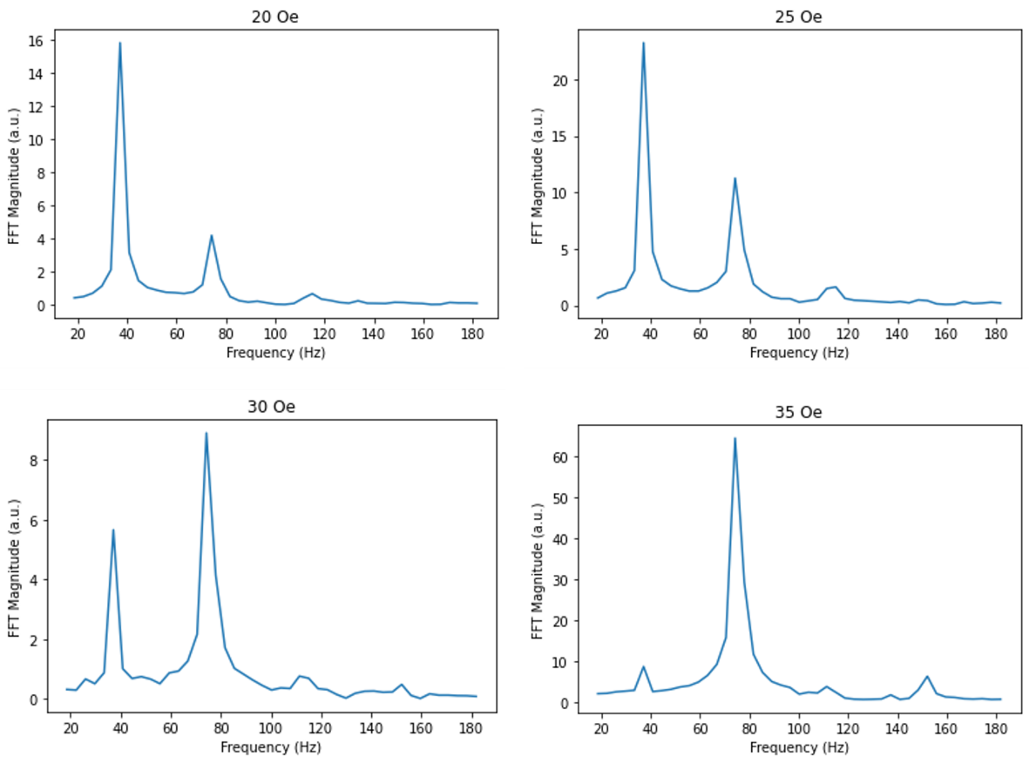
Figure S1- Fast-Fourier transformation of AMR signals over 20 rotations of applied rotating fields of magnitude (top left to bottom right) 20, 25, 30, and 35 Oe at 37Hz, with peaks at 37 Hz (1f) and 74 Hz (2f).
Memory Comparison between Reservoir Configurations
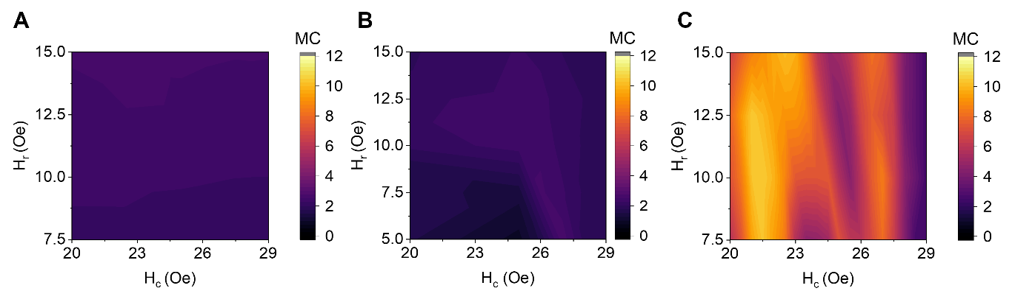
Figure S2- Comparison of linear memory capacity between the three reservoir configurations, (A) signal sub-sample reservoir, (B) Single dynamical node reservoir, and (C) rotating neurons reservoir.
Pre-Processing of Spoken Digit Recognition Data
The speech data was taken from a subsample of the TI-46 database¹, where each of five female speakers provided ten utterances of each digit. Audio features were extracted from the raw-audio waves using a Mel-Frequency Cepstral filter² which produced a discrete-time power response in 13 frequency bands across 50 ms windows. This produced an unmasked signal of length [13, τ], where τ is equal to the number of windows generated by a given utterance. These signals were time-multiplexed using the masking procedure described previously and a mask of size [13, 50], producing a 1D input vector of length $48*τ$. The number of virtual nodes was kept at 50 as a compromise between providing a thorough mix of input dimensions, while keeping the number of datapoints low. The process was repeated for each of the 500 raw input signals, which were then normalised against the maximum value from the resulting pre-processed dataset.

SpaRCe
While simple linear regression techniques like ridge regression can be used to analytically find the weights that provide the least-squares difference between training data and target labels, more advanced learning rules are able to converge to different sets of output weights which provide a more robust classification platform. One such learning rule that has been demonstrated to be effective for RC is SpaRCe³ - a bio-inspired algorithm that utilises learnable thresholds on output neurons to introduce sparse representations of data and promote more specialised features. SpaRCe has been shown to improve classification accuracy in common benchmark tasks, as well as alleviating the problem of catastrophic forgetting associated with online learning of sequential tasks/classes³. It is an on-line algorithm, which is likely more suited to real-world implementations of RC where the system learns continuously as new data is presented, rather than through storing many input patterns before changing parameters.

The SpaRCe algorithm was also trained in an online manner using the sigmoid cross-entropy loss function outlined earlier. Additionally, a learnable threshold,${\hat{θ}}_{k}$, was applied to each output neuron k (thereby doubling the number of trainable parameters), and was updated according to a pair of opposing update rules:
$$∆{\hat{θ}}_{k}= η_{θ}\left[∆{θ_{k}}^{\left(1\right)}+∆{θ_{k}}^{\left(2\right)}\right]$$

$$∆{{\hat{θ}}_{k}}^{\left(1\right)}= \sum_{j=1}^{N_{classes}}{\sum_{l=1}^{N}{\left[W_{jl}^{0}x_{l}\right]\left[W_{jk}^{0} sign\left(x_{k}\right)\right]}}$$

$$∆{{\hat{θ}}_{k}}^{\left(2\right)}= -W_{\tilde{j}k}^{0} sign\left(x_{k}\right)$$

where $η_{θ}$ represents the threshold learning rate, $\tilde{j}$ represents the correct output class for the sample considered, and sign represents the sign function. $∆{θ_{k}}^{\left(1\right)}$ is designed as a measure of the correlation between the outputs of different nodes, and as such will increase the threshold (thus reducing output node activity) when output nodes are correlated. $∆{θ_{k}}^{\left(2\right)}$ is determined by the activity of the output node corresponding to the correct output class, and hence reduces the threshold (promotes node activity) in the case where the output is contributing to the correct classification of the input pattern.

The output for each thresholded node,${\hat{x}}_{k}$, is given from its activity, $x_{k}$, via

$${\hat{x}}_{k}=sign\left(x_{k}\right) ReLU\left\{\left|x_{k}\right|-θ_{k}\right\}$$

$$θ_{k}=P_{n}\left(\left|x_{k}\right|\right)+ {\hat{θ}}_{k}$$

where ReLU represents the rectified linear unit, and $P_{n}\left(\left|x_{k}\right|\right)$ is defined as the percentile n of the activity of neuron k across the inputs, computed across the training data. The choice of n provides an initial sparsity level for the thresholds. $P_{n}\left(\left|x_{k}\right|\right)$ remains constant throughout training since node output $x_{k}$with respect to input is constant for RC. Hyperparameters of starting percentile and learning rate were selected by choosing the best performance on the training data set, with reported accuracies given by 10-fold cross validation.

1. Liberman, M. et al. TI 46-Word Corpus. Preprint at (1993).
2. Molau, S., Pitz, M., Schlüter, R. & Ney, H. Computing mel-frequency cepstral coefficients on the power spectrum. in ICASSP, IEEE International Conference on Acoustics, Speech and Signal Processing - Proceedings vol. 1 73–76 (2001).
3. Manneschi, L., Lin, A. C. & Vasilaki, E. SpaRCe: Improved Learning of Reservoir Computing Systems Through Sparse Representations. IEEE Trans Neural Netw Learn Syst (2021) doi:10.1109/TNNLS.2021.3102378.

