Supplement 2 – Study specific instruments of the P.E.L.I.O.N. trial

Risk for Surgical Site Occurrencies (SSO) according to Ventral Hernia Working Group (VHWG). Taken from Breuing K, Butler CE, Ferzoco S, Franz M, Hultman CS, et al. Surgery. 2010 Sep;148(3):544–58.

EHS-QoL questionnaire. Muysoms FE, et al. Surgery. 2016 Nov;160(5):1344–57
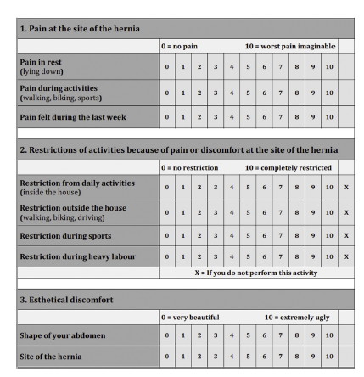

Hernie Recurrence Inventory. Tastaldi L, et al. Hernia. 2020 Feb 1;24(1):127–35.
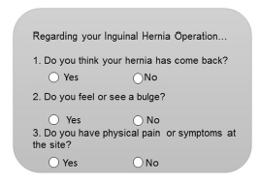

Charlson comorbidity index in its updated version described by Quan et al. (39)

