SYNOPSIS TOC

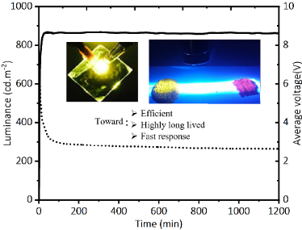
Highly stable yellow and orange LEC based on iridium (II) complexes with phenanthroimidazole as ancillary ligand were introduced with the lifetime over 2100 h and EQE of 3%. Moreover, by introduce an ionic tethered moiety the response time improved exceeding 80%.

