Supplementary Tables
Supplementary Table 1: Subcellular localization and virulent factor prediction of HPs
UniProt ID (str. Ikeda) | Virulent | Predict Score | PSORTb localization | Predict Score | CELLO2GO localization | Predict Score
WP_012460725.1 | Virulent | 1.0254 | Cytoplasmic | 5.48 | Cytoplasmic | 2.484
WP_012461321.1 | Virulent | 1.3673 | Cytoplasmic | 5.48 | Cytoplasmic | 4.619
WP_012461881.1 | Virulent | 1.2887 | Cytoplasmic | 2.00 | Cytoplasmic | 3.579
WP_148141062.1 | virulent | 1.0739 | Cytoplasmic | 8.96 | Cytoplasmic | 6.111
WP_012461281.1 | Virulent | 1.5621 | Cytoplasmic | 8.96 | Extracellular | 4.813
WP_012460800.1 | Virulent | 1.5621 | Outer membrane | 9.52 | Extracellular | 2.840
WP_012461135.1 | Virulent | 1.08 | Extracellular | 2 | Extracellular | 5.153
WP_012461997.1 | Virulent | 1.2734 | Cytoplasmic | 8.96 | Cytoplasmic | 4.921
WP_012461351.1 | Virulent | 1.1976 | Cytoplasmic | 8.96 | Cytoplasmic | 3.235
WP_012461228.1 | Virulent | 1.1379 | Cytoplasmic | 8.96 | Cytoplasmic | 3.713
WP_012461021.1 | Virulent | 1.8075 | Cytoplasmic | 8.96 | Cytoplasmic | 3.204
WP_012460858.1 | Virulent | 1.0126 | Cytoplasmic | 8.96 | Cytoplasmic | 6.360
WP_012462112.1 | Virulent | 1.2028 | Outer membrane | 2 | Outer membrane | 1.513
WP_012461347.1 | Virulent | 1.1681 | Cytoplasmic membrane | 2 | Inner membrane | 4.358
WP_148141095.1 | Virulent | 1.3716 | Extracelluar | 2 | Extracelluar | 3.466
WP_012461943.1 | Virulent | 1.2472 | cytoplasmic | 8.96 | cytoplasmic | 6.879
WP_012461162.1 | Virulent | 1.0955 | Cytoplasmic | 2 | cytoplasmic | 4.771
WP_012460904.1 | Virulent | 1.2598 | Cytoplasmic | 8.96 | cytoplasmic | 6.551
WP_012461016.1 | Virulent | 1.2329 | Outer membrane | 2 | Outer membrane | 2.460
WP_148141080.1 | Virulent | 1.0631 | Cytoplasmic | 2 | Cytoplasmic | 3.197
WP_012461311.1 | Virulent | 1.2815 | Cytoplasmic membrane | 2 | Cytoplasmic membrane | 3.416
WP_012461954.1 | Virulent | 1.1303 | Cytoplasmic | 8.96 | Cytoplasmic | 6.314
WP_041621571.1 | Virulent | 1.1087 | cytoplasmic membrane | 9.82 | Inner membrane | 4.623
WP_012460929.1 | Virulent | 1.021 | Cytoplasmic membrane | 9.82 | Inner membrane | 4.526
WP_041621571.1 | Virulent | 1.1087 | Inner membrane | 9.82 | Inner membrane | 4.623
WP_012462056.1 | Virulent | 1.0142 | Cytoplasmic | 9.82 | Inner membrane | 4.381
WP_012460860.1 | Virulent | 1.1097 | Cytoplasmic | 2 | Cytoplasmic | 2.690
WP_012460970.1 | Virulent | 1.0145 | extracellular | 2 | extracellular | 1.905
WP_012460860.1 | Virulent | 1.1097 | Periplasmic | 2 | Periplasmic | 1.842
WP_012461734.1 | Virulent | 1.0798 | Inner membrane | 2 | Inner membrane | 3.396
WP_012461088.1 | Virulent | 1.1623 | Cytoplasmic | 2 | Cytoplasmic | 2.613
WP_109455758.1 | Virulent | 1.0413 | Cytoplasmic | 2 | Cytoplasmic | 5.478
WP_012460817.1 | Virulent | 1.0772 | Cytoplasmic | 8.96 | Cytoplasmic | 4.660
WP_012460817.1 | Virulent | 1.0772 | Cytoplasmic | 8.96 | Cytoplasmic | 4.660
WP_012462058.1 | Virulent | 1.1108 | Cytoplasmic | 8.96 | Cytoplasmic | 4.859
UniProt ID (str. Boryong) | Virulent | Predict Score | PSORTb localization | Predict Score | CELLO2GO localization | Predict Score
WP_011944727.1 | Virulent | 1.3115 | Outer membrane | 9.49 | Cytoplasmic | 3.292
WP_011944721.1 | Virulent | 1.0371 | Cytoplasmic | 5.48 | Cytoplasmic | 2.348
WP_011944362.1 | Virulent | 1.2794 | Outer membrane | 2.11 | Cytoplasmic | 3.452
WP_011944936.1 | Virulent | 1.3579 | Cytoplasmic | 5.48 | Cytoplasmic | 4.998
WP_011944825.1 | Virulent | 1.0398 | Cytoplasmic | 8.96 | Cytoplasmic | 5.180
WP_011944348.1 | Virulent | 1.1852 | Cytoplasmic | 8.96 | Cytoplasmic | 5.832
WP_011944919.1 | Virulent | 1.5068 | Cytoplasmic | 8.96 | Extracellular | 5.029
WP_011944458.1 | Virulent | 0.9603 | Outer membrane | 9.52 | Extracellular | 2.802
WP_011944998.1 | Virulent | 1.0835 | Outer membrane | 2.17 | Extracellular | 4.536
WP_011944623.1 | Virulent | 0.9583 | Cytoplasmic | 8.96 | Cytoplasmic | 6.901
WP_011944623.1 | Virulent | 0.9583 | Cytoplasmic | 8.96 | Cytoplasmic | 6.901
WP_011944252.1 | Virulent | 0.9383 | Cytoplasmic | 8.96 | Cytoplasmic | 3.058
WP_011944913.1 | Virulent | 1.0294 | Outer membrane | 2.76 | Cytoplasmic | 4.176
WP_011944782.1 | Virulent | 1.1944 | Inner membrane | 1.75 | Cytoplasmic | 3.715
WP_011944739.1 | Virulent | 1.0107 | Cytoplasmic membrane | 9.86 | Inner membrane | 4.018
WP_011944280.1 | Virulent | 1.4605 | Extracellular | 2.31 | Extracellular | 3.753
WP_011944379.1 | Virulent | 1.0305 | Extracellular | 2.29 | Extracellular | 2.751
WP_011944255.1 | Virulent | 1.332 | Outer membrane | 1.91 | Cytoplamsic | 3.431
WP_011944827.1 | Virulent | 1.1148 | Cytoplasmic | 2 | Inner membrane | 4.149
WP_011944767.1 | Virulent | 1.1754 | Cytoplasmic | 8.96 | Cytoplasmic | 6.882
WP_011944853.1 | Virulent | 1.4305 | Cytoplasmic | 8.96 | Cytoplasmic | 2.196
WP_011944262.1 | Virulent | 1.2162 | Cytoplasmic membrane | 2.15 | Cytoplasmic | 3.661
WP_011944578.1 | Virulent | 1.0156 | Extracellular protein | 2.15 | Inner membrane | 2.552
WP_011945090.1 | Virulent | 1.0384 | Cytoplasmic | 8.96 | Cytoplasmic | 4.908
WP_011944861.1 | Virulent | 1.3005 | Cytoplasmic | 2.518 | Cytoplasmic | 3.973
WP_011944388.1 | Virulent | 1.0076 | Cytoplasmic membrane | 9.46 | Inner membrane | 5.622

Supplementary Table 2: Secondary structure predictions of HPs
HP name | α - helix | β - barrel | Coil-coil region
OTT_0508 | 43.61% | 26.87% | 24.23%
OTT_0690 | 32.49% | 19.78% | 47.72%
OTT_0732 | 36.71% | 17.83% | 45.45%
OTT_0680
OTT_0464 | 48.40% | 12.10% | 39.50%
OTBS_0057 | 40..40% | 19.53% | 40.07%
OTBS_0096 | 46.71% | 10.27% | 43.02%
OTBS_0161 | 52.80% | 7.79% | 39.42%
OTBS_0787 | 34.42% | 0.79% | 64.866%
OTBS_0806 | 45.97% | 9.48% | 44.55%
OTBS_0856 | 47.22% | 14.81% | 37.96%
OTBS_0946 | 34.10% | 24.14% | 41.76%
OTBS_0999
OTBS_1110 | 58.66% | 13.63% | 27.71%
OTBS_1546 | 32.45% | 20.39% | 47.17%

Supplementary Table 3: Bioinformatics tools used in the identification and functional annotation of HPs
Sequence retrieval | NCBI | http://www.ncbi.nlm.nih.gov/genome
Protein sequence retrieval | Uniprot | http://www.uniprot.org/
Physicochemical properties | ExPASy’s ProtParam | http://web.expasy.org/protparam/
Virulent prediction | Virulentpred  VCIMPred | http://bioinfo.icgeb.res.in/virulent/  http://crdd.osdd.net/raghava/vicmpred/submission.html
Functional domain | SMART  InterproScan  ProFunc | http://smart.embl-heidelberg.de/  http://www.ebi.ac.uk/interpro/  http://www.ebi.ac.uk/thornton-srv/databases/ProFunc/
Subcellular localization | PSLPred  CELLO  PROSA | http://www.imtech.res.in/raghava/pslpred/  http://cello.life.nctu.edu.tw/  http://www.psort.org/psortb/
domain architecture | Ebi-Interpro  Pfam | http://www.ebi.ac.uk/interpro/  http://pfam.sanger.ac.uk/
Secondary structure | PSIPRED  SOPMA | http://globin.bio.warwick.ac.uk/psipred/  https://npsa-prabi.ibcp.fr/cgi-bin/npsa_automat.pl?page=/npsa/npsa_sopma.html
Active site prediction | CASTp | http://sts.bioe.uic.edu/castp/calculation.html
Homology modeling | SWISS-MODEL | http://swissmodel.expasy.org
Homology model verification | SAVES (Verify3D, ERRAT, PROCHECK) | https://saves.mbi.ucla.edu/
Ramachandran plot | SWISS-MODEL | http://swissmodel.expasy.org
Protein-protein interaction | STRING | http://string-db.org/

Supplementary Figures:
Supplementary Figure 1: Cartoon model of Secondary structure analysis showing α-helix, β-sheet and coil-coil region of HPs.

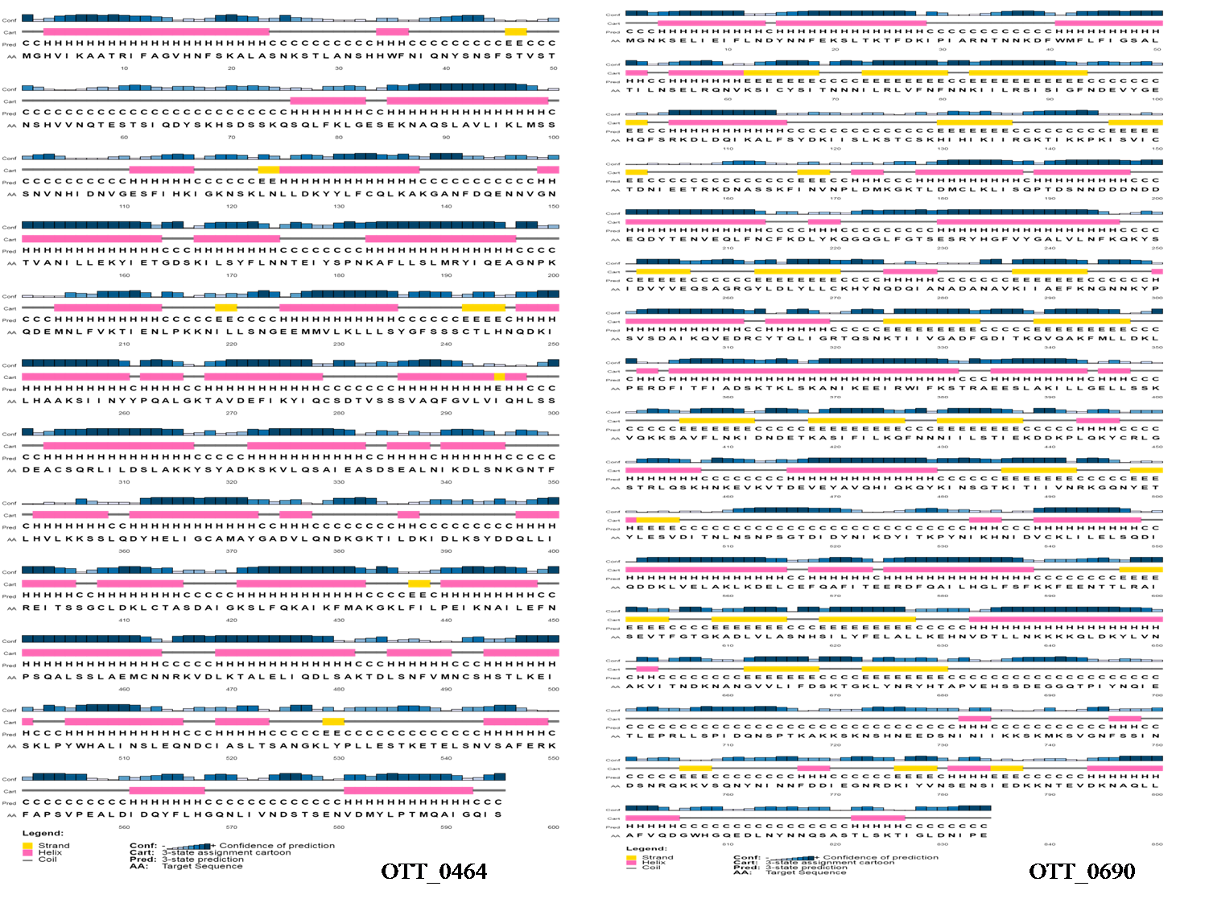

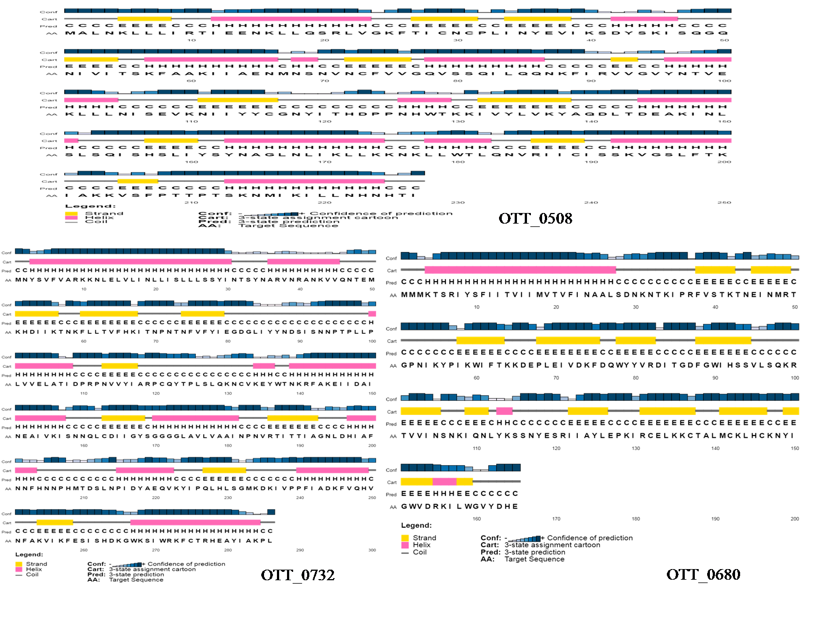

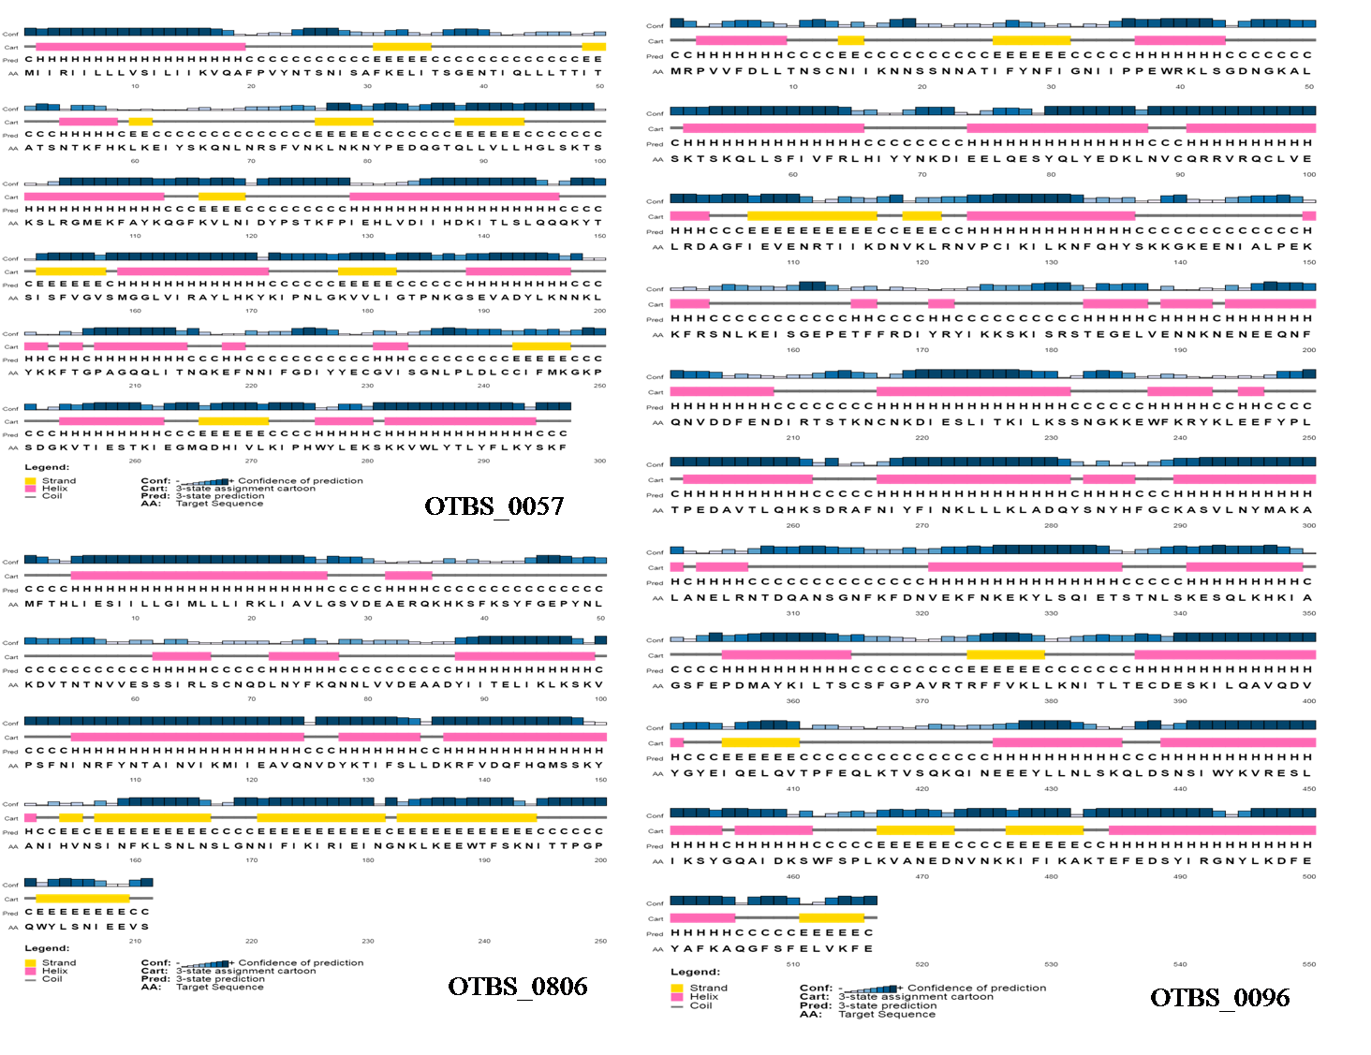

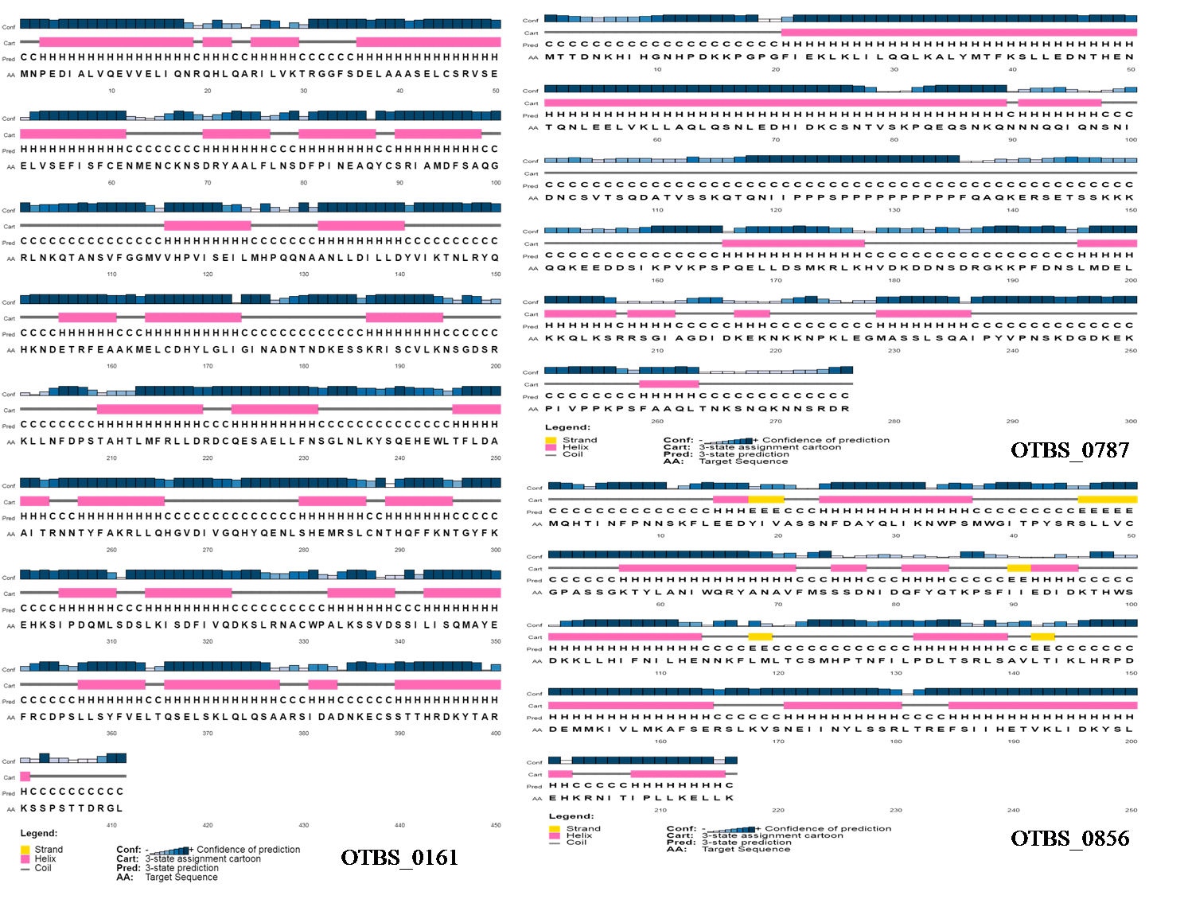

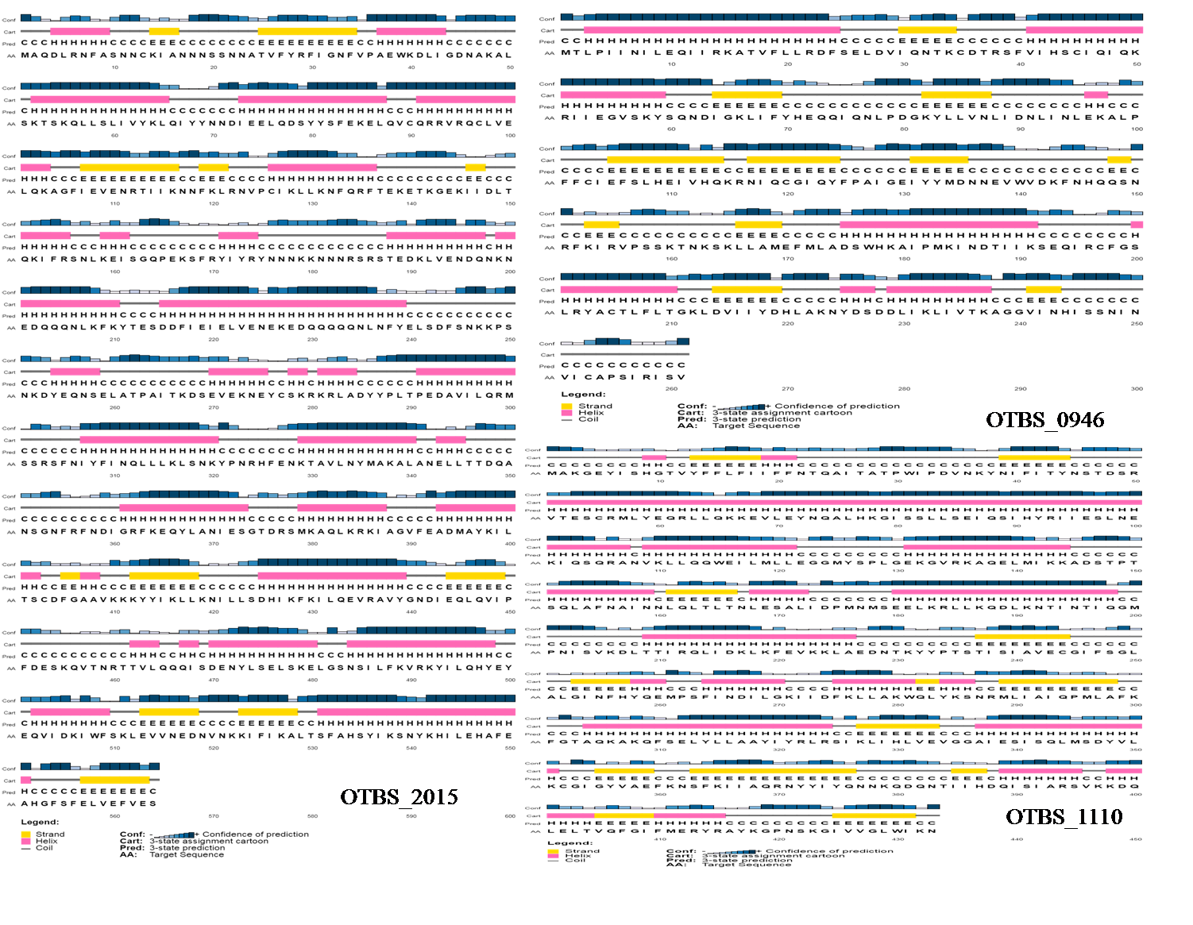
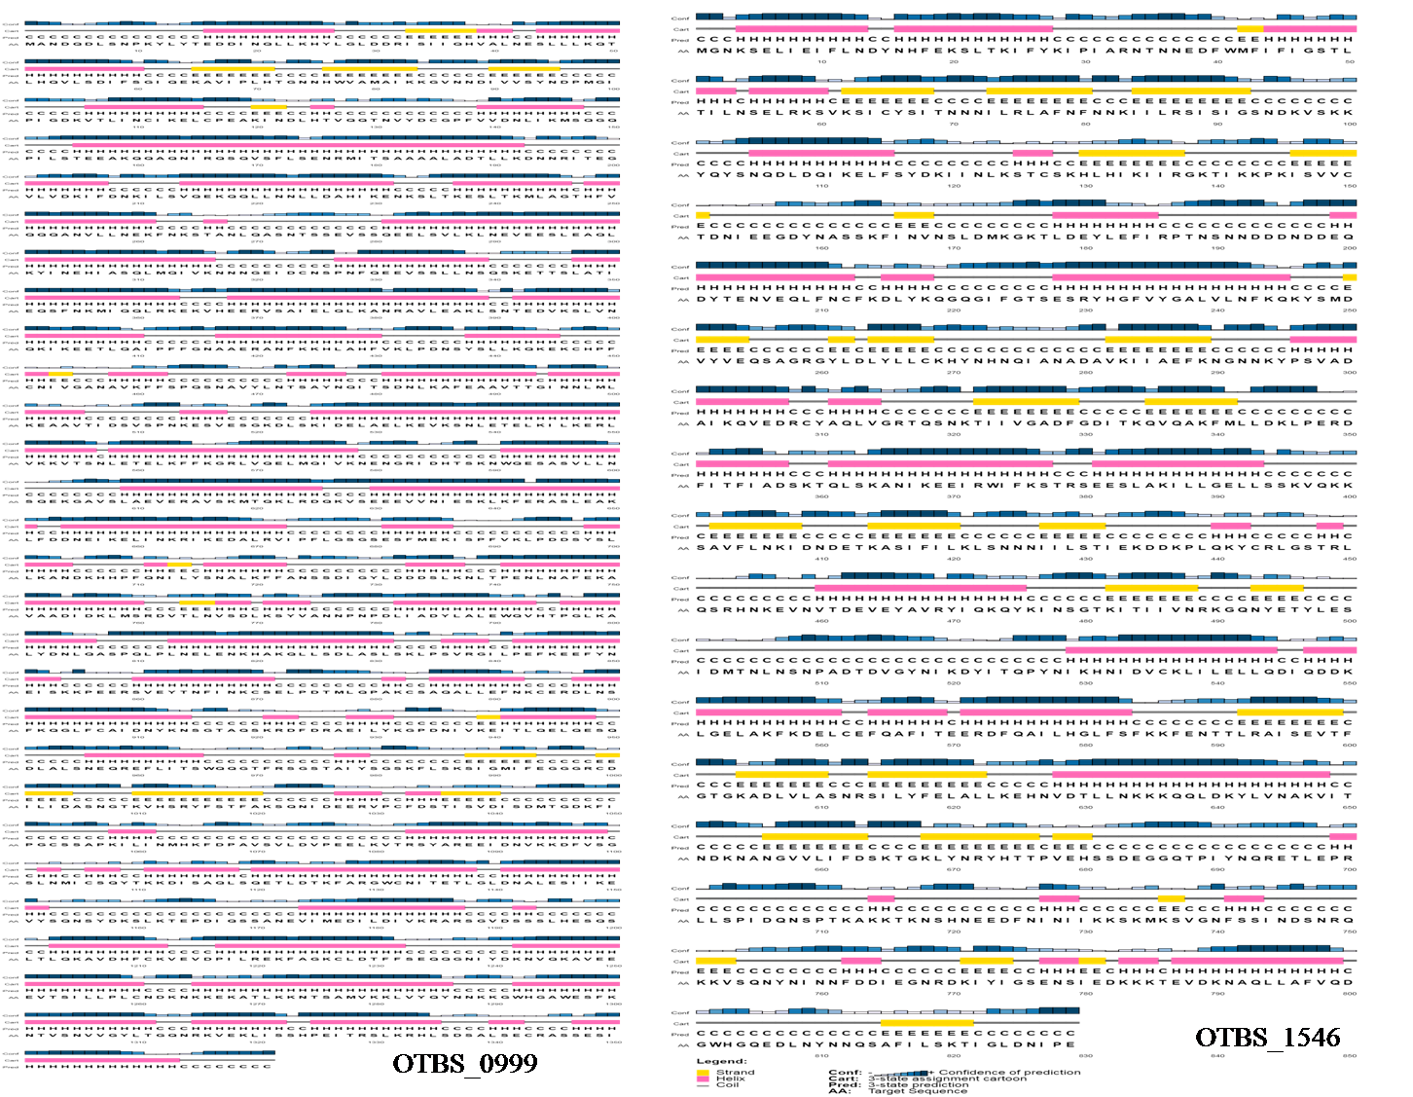

Supplementary Figure 2: Quality assessment QMEAN prediction of HPs.
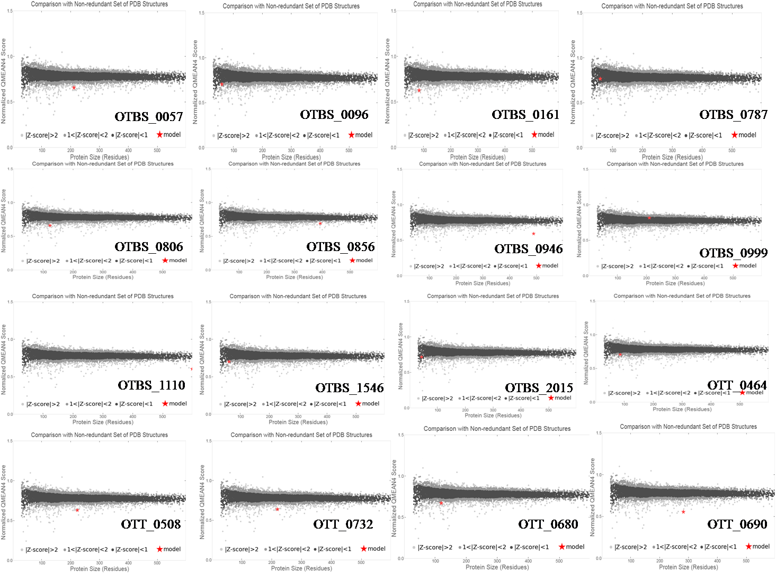

Supplementary Figure 3: Z-score analysis of 3D structures from Orientia tsutsugamushi HPs
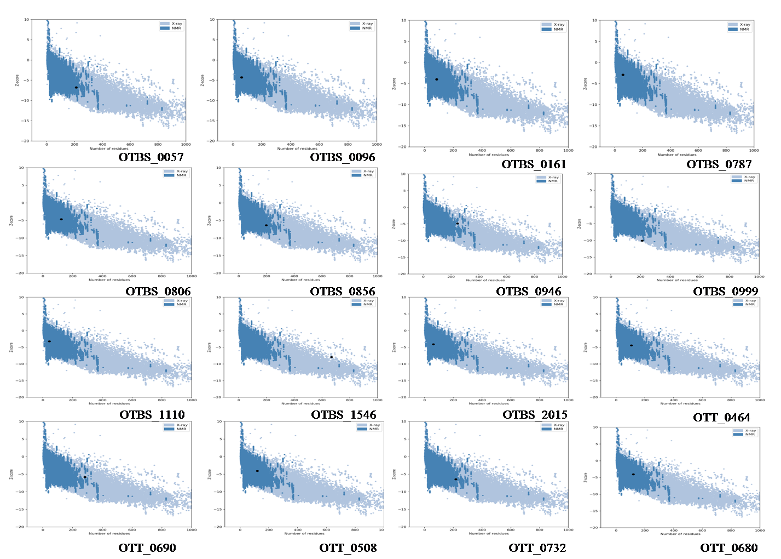

Supplementary Figure 4: Ramachandran plot showing the amino acid residues of HPs present in favored and outlier regions
