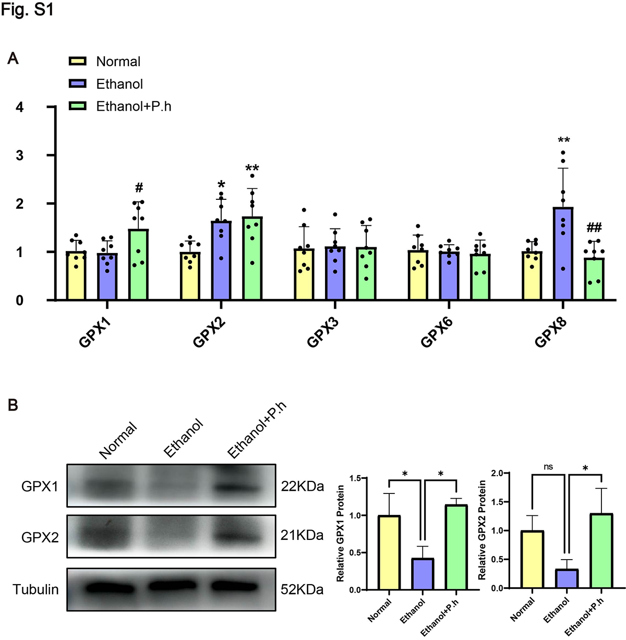
Fig. S1 The effects of P. histicola on the expression of GPX1-3, 6 and 8. (.docx)
(A) The mRNA expression of GPX1,2,3,6 and 8. (B) Western blot analysis of GPX1 and GPX2. Data were presented as mean ± SD. (n = 7-8/group for qRT-PCR, n= 3/group for Western blot). Statistical significance by one-way ANOVA. *P<0.05, **P<0.01 vs. Normal. #P < 0.05, ##P < 0.01 vs. Ethanol

