Dimeric Her2-specific affibody mediated cisplatin-loaded nanoparticles
for tumor enhanced chemo-radiotherapy

Haijun Wang^{2,4,#}, Dianlong Jia^{3,#}, Dandan Yuan⁵, Xiaolei Yin⁴, Fengjiao Yuan⁶, Feifei Wang³, Wenna Shi¹, Hui Li¹, Li-Min Zhu^{2*}, Qing Fan^{1*}

¹ Department of Pharmacy, Shandong Cancer Hospital and Institute, Shandong First Medical University and Shandong Academy of Medical Sciences, Jinan 250117, China
² College of Chemistry, Chemical Engineering and Biotechnology, Donghua University, Shanghai 201620, China
³ Laboratory of Drug Discovery and Design, School of Pharmacy, Liaocheng University, Liaocheng 252000, China
⁴ School of Life Sciences, Shandong First Medical University and Shandong Academy of Medical Sciences, Taian 271016, China
⁵ Department of Digestive Oncology, Shandong Cancer Hospital and Institute, Shandong First Medical University and Shandong Academy of Medical Sciences, Jinan 250117, China
⁶ Joint Laboratory for Translational Medicine Research, Liaocheng People’s Hospital, Liaocheng 252000, China

*Corresponding authors: E-mail address: lzhu@dhu.edu.cn (Li-Min Zhu); qingfan0708@yahoo.com (Qing Fan)
# These authors contributed equally.
Fig. S1. (a) N₂ adsorption/desorption isotherms of mPDA NPs and (b) the corresponding pore-size distribution curves. (c) Zeta potential values of cisplatin, mPDA, Pt@mPDA, Pt@mPDA/MnO₂ and Pt@mPDA/MnO₂/PDA NPs dispersed in water (pH 7.4).

Fig. S2. (a) XPS full survey spectra and (b) Mn 2p XPS spectra of mPDA/MnO₂/PDA NPs.

Fig. S3. UV-Vis absorption spectra of Pt@mPDA/MnO₂/PDA NPs in (a) blank PBS (pH 7.4) and PBS (pH 7.4) containing (b) 1 mM H₂O₂, (c) 1 mM H₂O₂ + 2 mM GSH, and (d) 1 mM H₂O₂ + 2 mM GSH at different time points; (e) the absorption spectra comparison and (f) relative photographic image of NPs aqueous dispersion after 14 d at different conditions.

Fig. S4. DLS size of Pt@mPDA/MnO₂/PDA and Pt@mPDA/MnO₂/PDA-Z_{Her2} NPs in water.

Fig. S5. FCM data for (a) MCF-7 or (b) SKOV-3 cells after treated with PBS, 2 or 4 μg/mL of FITC-labelled anti-Her2 antibody for 2 h and corresponding quantified fluorescence intensity. (c) Fluorescence images for MCF-7 or SKOV-3 cells after treated with PBS, 2 or 4 μg/mL of FITC-labelled anti-Her2 antibody for 2 h.

Fig. S6. (a) CLSM images of MCF-7 and SKOV-3 cells 2 h incubation with FAM-Z_{Her2}. (b) Flow cytometry data for: untreated SKOV-3 cells; SKOV-3 cells incubated for 2 h with FAM-Z_{Her2}, and cells pre-incubated with Z_{Her2} for 1 h before being exposed to FAM-Z_{Her2} for 2 h, and corresponding quantified fluorescence intensity.
Fig. S7. (a) Flow cytometry data for: untreated SKOV-3 cells; SKOV-3 cells incubated for monomeric (in the presence of 2-ME) or dimeric (in the absence of 2-ME) FAM-Her2 affibody at 37 °C for 2 h. (b) MTT viability results for HUVECs treated with mPDA/MnO₂/PDA-Z_{Her2} NPs. Data are shown as the mean ± S.D. from three independent experiments.

Fig. S8. Biodistribution of Pt@mPDA/MnO₂/PDA or Pt@mPDA/MnO₂/PDA-Z_{Her2} NPs at 24 h post-injection.

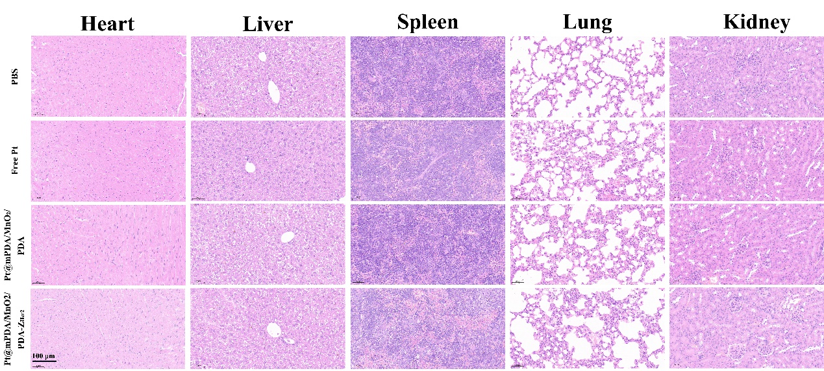
Fig. S9. Representative H&E stained images of the major organs collected on day 14.

Fig. S10. Blood biochemical analyses of the mice treated with different formulations.

