Supplementary Material (Johnson et al.)

Appendix A
Table A1. Indicators and criteria for coral reefs with those highlighted in grey having available data and non-highlighted indicators not being applied due to lack of data.
 |  | Low=1 | Medium=2 | High=3
Exposure | SST+ projected (°C) | < 1.5 | 1.5 - 2.0 | > 2.0
Exposure | SST+ historic exposure | last 10 years (SST+ inducing bleaching) | last 5 years (SST+ inducing bleaching) | last 1 year (SST+) or multiple exposures in last 5 years
Exposure | aragonite saturation zone | 4+ (optimal for calcificatioin) | 3.5 (sub-optimal for calcification) | 3 (marginal for calcification)
Exposure | Salinity decline | 0 | 0.01-0.05 psu | > 0.05 psu
Exposure | Altered large-scale currents: micro-currents & productivity | no change | small to medium change in current direction or magnitude | large change in current direction or magnitude
Exposure | Intense cyclones/storms | no change | more intense but no change or decline in frequency | more intense and more frequent
Exposure | Nutrient and sediment exposure | more than every 5 year delivery of land-based pollutants (flood plumes) | once every 5 year delivery of land-based pollutants (flood plumes) | annual delivery of land-based pollutants (flood plumes)
Sensitivity | coral cover | High (> 30%) | Medium (10-30%) | Low (< 10%)
Sensitivity | bleaching resistance (impact history) | no exposure to thermal stress in past 10 years and/or no bleaching impacts | low bleaching impacts in past 10 years if exposed to thermal stress | high bleaching impacts in past 10 years if exposed to thermal stress
Sensitivity | current condition (health) | Healthy | moderate condition or status unknown | Poor condition
Sensitivity | Coral diversity | high species diversity | moderate species diversity | low species diversity
Sensitivity | rugosity | high | moderate | low
 |  | Low=1 | Medium=2 | High=3
Adaptive Capacity | Replenishment potential - coral growth & recruitment | slow growth rate (e.g. Porites dominated)/ >10 years | moderate growth rate/3-10 years | fast growth rate (e.g. Acropora dominated)/ ≤ 2 years
Adaptive Capacity | connectivity | >1,000 km between reefs | 10-1,000 km between reefs | <10 km between reefs
Adaptive Capacity | macroalgae cover | High (> 30%) | Medium (10-30%) | Low (< 10%)
Adaptive Capacity | non-climate pressures | chronic pressures (e.g. poor water quality, disease, development) | some acute pressures (e.g. cyclones, storms, floods) | no or minimal other pressures
Adaptive Capacity | herbivore fish biomass (g/m2) | < x kg/ha | x - y kg/ha | > y kg/ha
Adaptive Capacity | unoccupied habitat/substrate | none available or suitable | limited available or moderately suitable to meet species requirements (not both) | readily available and suitable to meet species requirements
Adaptive Capacity | management regime/governance | no formal management (not within an existing MPA) | within existing MPA but without enforcement or compliance | within existing MPA with effective enforcement and compliance

Table A2. Indicators and criteria for seagrass meadows with those highlighted in grey having available data and non-highlighted indicators not being applied due to lack of data.
 |  | Low=1 | Medium=2 | High=3
Exposure | SST+ projections (°C) | < 1.5 | 1.5 - 2.0 | > 2.0
Exposure | SST+ historic exposure | last 10 years (SST+) | last 5 years (SST+) | last 1 year (SST+) or multiple exposures in last 5 years
Exposure | Rainfall and turbidity increase | Decreasing rainfall to <5% increase | 5-10% increase | >10% increase
Exposure | Sea level rise | < 0.4 m | 0.4 to 0.5 m | >0.5 m
Exposure | Altered large-scale currents: micro-currents & productivity | no change | small to medium change in current direction or magnitude | large change in current direction or magnitude
Exposure | More intense cyclones/storms | no change | more intense but no change or decline in frequency | more intense and more frequent
Exposure | Solar radiation decrease | no change | <5% | >5%
Exposure | Nutrient and sediment exposure | more than every 5 year delivery of land-based pollutants (flood plumes) | once every 5 year delivery of land-based pollutants (flood plumes) | annual delivery of land-based pollutants (flood plumes)
Sensitivity | seagrass cover (density) | High (> 60%) | Medium (30-60%) | Low (< 30%)
Sensitivity | thermal resistance (impact history) | no exposure to thermal stress in past 10 years and/or no impacts | low to moderate thermal impacts in past 10 years if exposed | high thermal impacts in past 10 years if exposed
Sensitivity | current condition (health) | Healthy | moderate condition or status unknown | Poor condition
Sensitivity | Seagrass diversity | high species diversity | moderate species diversity | low species diversity
 |  | Low=1 | Medium=2 | High=3
Adaptive capacity | Replenishment potential - growth & recruitment | slow growth rate/ > 10 years | moderate growth rate/3-10 years | fast growth rate/ ≤ 2 years
Adaptive capacity | connectivity | isolated seagrass meadows | patchy network of seagrass meadows (5-20 km between) | network of seagrass meadows (<5 km between)
Adaptive capacity | epiphyte cover | High (> 30%) | Medium (10-30%) | Low (< 10%)
Adaptive capacity | non-climate pressures | chronic pressures (e.g. poor water quality, disease, development) | some acute pressures (e.g. cyclones, storms, floods) | no or minimal other pressures
Adaptive capacity | herbivore biomass (g/m2) | < x kg/ha | x - y kg/ha | > y kg/ha
Adaptive capacity | unoccupied habitat/substrate | none available or suitable | limited available or moderately suitable to meet species requirements (not both) | readily available and suitable to meet species requirements
Adaptive capacity | management regime/governance | no formal management (not within an existing MPA) | within existing MPA but without enforcement or compliance | within existing MPA with effective enforcement and compliance

Table A3. Indicators and criteria for mangrove forests with those highlighted in grey having available data and non-highlighted indicators not being applied due to lack of data.
 |  | Low=1 | Medium=2 | High=3
Exposure | Air temp projection (°C) | < 3.0 | 3.0 to 4.0 | > 4.0
Exposure | Rainfall | Increasing rainfall to <5% decrease | 5-10% decrease | >10% decrease
Exposure | Sea level rise | < 0.4 m | 0.4 to 0.5 m | >0.5 m
Exposure | Altered large-scale currents: micro-currents & productivity | no change | small to medium change in current direction or magnitude | large change in current direction or magnitude
Exposure | More intense cyclones/storms | no change | more intense but no change or decline in frequency | more intense and more frequent
Exposure | Altered riverflow/ nutrient supply | no change | 5-10% change (+/-) | >10% change (+/-)
Sensitivity | mangrove canopy cover | Continuous canopy (90-100% cover) | Gaps in canopy (30-90% cover) | Broken canopy (<30% cover)
Sensitivity | current condition (health) | Healthy | moderate condition or status unknown | Poor condition
Sensitivity | Mangrove diversity | high species diversity | moderate species diversity | low species diversity
 |  | Low=1 | Medium=2 | High=3
Adaptive capacity | Replenishment potential - growth & recruitment | slow growth rate/ > 10 years | moderate growth rate/3-10 years | fast growth rate/ ≤ 2 years
Adaptive capacity | connectivity | isolated mangrove forests | patchy network of mangroves (5-20 km between) | network of mangroves (<5 km between)
Adaptive capacity | non-climate pressures | chronic pressures (e.g. poor water quality, disease, development) | some acute pressures (e.g. cyclones, storms, floods) | no or minimal other pressures
Adaptive capacity | unoccupied land inland to migrate | none available or suitable | limited available or moderately suitable to meet species requirements (not both) | readily available and suitable to meet species requirements
Adaptive capacity | management regime/governance | no formal management (not within an existing MPA) | within existing MPA but without enforcement or compliance | within existing MPA with effective enforcement and compliance

Table A4. Species exposure indicators and criteria.
 |  | Low = 1 | Medium = 2 | High = 3
Exposure | SST increase | Adult spends <50% of time in surface (<25 m) waters | Adult spends 50-80% of time in surface (<25 m) waters | Adult spends 80-100% of time in surface (<25 m) waters
Exposure | Changes in rainfall | Spends no time in estuarine or freshwater habitats during any life history phase | Spends <50% of time in estuarine or freshwater habitats; no critical (larvae, juvenile, spawning) life history phase in these habitats | Spends >50% of time or has critical (larvae, juvenile, spawning) part of life cycle in estuarine or freshwater habitats
Exposure | pH decline | Open ocean or deep-water species | Continental shelf species | Inshore or estuarine species
Exposure | Salinity decline | Open ocean or deep-water species | Continental shelf species | Inshore or estuarine species
Exposure | Habitat changes (loss of productivity, structure or function) (nb. this incorporates sea level rise) | Species with wide habitat preferences | Species dependent on pelagic or mangrove/estuarine habitats | Species dependent on seagrass or coral reef habitats
Exposure | Altered large-scale currents | Live young/egg bearers or no dependence on large-scale wind/current for larval dispersal/settlement | Proximate dispersal/settlement of young not entirely dependent on large-scale wind/current dispersal | Dispersal/settlement of young 100% dependent on large-scale wind/currents
Exposure | More intense cyclones/storms | Deep water or highly mobile species | Shallow water (< 25 m) and moderately mobile species | Shallow water (< 25 m) or low mobility species
Exposure | Altered river low/nutrient supply | Spends no time in estuarine or freshwater habitats during any life history phase | Spends <50% of time in estuarine or freshwater habitats; no critical (larvae, juvenile, spawning) life history phase in these habitats | Spends >50% of time or has critical (larvae, juvenile, spawning) part of life cycle in estuarine or freshwater habitats

Table A5. Species sensitivity indicators and criteria.
 |  |  | Low = 1 | Medium = 2 | High = 3
Sensitivity | Abundance | Fecundity – egg production | >20,000 eggs/year | 100-20,000 eggs/year | <100 eggs/year or live young
Sensitivity | Abundance | Average age at maturity (females) | ≤2 years | 3-10 years | >10 years
Sensitivity | Abundance | Generalist v. specialist (food & habitat) | Reliance on neither habitat or prey for any life history stage | Reliance on either habitat or prey for any life history stage | Reliance on both habitat and prey for any life history stage
Sensitivity | Distribution | Capacity for larval dispersal or larval duration – hatching to settlement (benthic species), hatching to yolk sac re-adsorption (pelagic species). | >8 weeks | 2-8 weeks | <2 weeks or no larval stage
Sensitivity | Distribution | Physiological tolerance - latitudinal coverage of adult species as a proxy of environmental tolerance. | Threshold unlikely to be exceeded for any climate variable; > 20° latitude | Physiological thresholds may be exceeded; 10-20° latitude | Threshold likely to be exceeded for one or more climate variable; < 10° latitude
Sensitivity | Phenology | Environmental driver as a phenological cue (for spawning, breeding or settlement) | No apparent correlation to environmental variable | Weak correlation to environmental variable | Strong correlation to environmental variable
Sensitivity | Phenology | Potential for timing mismatch of life cycle events (duration of spawning, moulting or breeding season) | Continuous duration; >4 months | Moderate duration; 2-4 months | Brief duration; <2 months

Table A6. Species adaptive capacity indicators and criteria.
 |  |  | Low = 1 | Medium = 2 | High = 3
Adaptive Capacity | Ecological | Stock status | Overfished or on the verge of overfishing | Undefined | Sustainably fished
Adaptive Capacity | Ecological | Replenishment potential | Late maturing (>6 years), slow growth or few young | Matures at 3-6 years, moderate growth or moderate numbers of young | Early maturing, fast growth or many young
Adaptive Capacity | Ecological | Suitable alternate habitat availability | Low availability of habitat outside range or currently near northern edge of range | Some availability of habitat outside range or currently near middle of range | High availability of habitat outside range and currently near middle of range
Adaptive Capacity | Ecological | Species mobility | Low mobility; can travel <2 km/day | Moderately mobile; can travel 2-10 km/day | Highly mobile; can travel >10 km/day
Adaptive Capacity | Ecological | Non-fishing pressures on stock | Multiple chronic pressures (eg. poor water quality, disease, incidental catch) | Some acute pressures (eg. cyclones, storms, floods) | No or minimal other pressures
Adaptive Capacity | Socio-economic | Resource dependence (food) | No alternate species and/or significant gear/practice modifications required to target other species | Some alternate species that could be targeted with minor gear/practice modifications | Multiple alternate target species that could be targeted without any gear/practice modifications
Adaptive Capacity | Socio-economic | Resource dependence (livelihoods) | No alternate livelihood options and/or significant costs/technical (training, equipment, infrastructure) needs required to develop new livelihoods | Some alternate livelihood options that could be developed with moderate costs/technical (training, equipment, infrastructure) needs | Alternate livelihood options that could be developed with minimal costs/technical (training, equipment, infrastructure) needs
Adaptive Capacity | Socio-economic | Ability to change fishing practices | Not able to change | Able to change with support | Able to change without support
Adaptive Capacity | Socio-economic | Climate change awareness | Unaware | Aware and no planning steps taken | Aware and has taken preparatory action
Adaptive Capacity | Socio-economic | Governance | Inflexible or non-existent | Flexible or adaptive (not both) | Flexible and adaptive

Table A7. Marine habitats input layers for mapping coral reefs and seagrass vulnerability across the ATS region
 | Input Layers | Coral Reefs |  | Seagrass
Exposure | Projected SST increase  (by 2050-2079 under CMIP6 SSP5-8.5) | - Data from (NOAA 2020) at 0.05-degree resolution  - Anomaly layer was generated by subtracting the 2019 annual average SST from the projected 2070 SST  - 2019 SST was the average of the four seasonal SST rasters: Dec-Feb, Jun-Aug, Mar-May, Sep-Nov  - 2019 SST data was resampled from ~500m resolution (World Cylindrical Equal Area projection) to 0.05 dd (WGS84)  - 2019 SST resampled layer was interpolated at the edges using focal statistics to replace no data values within the raster with a value statistically derived from neighboring cell values (in this case the mean within a 5x5 pixel rectangle of surrounding cells).  - Normalised for the ATS area on a scale of 0 to 1.
Exposure | Projected annual severe bleaching (ASB) year  (under CMIP6 SSP5-8.5) | - Data provided has been statistically downsampled from CMIP6 model resolution to 0.05 dd resolution as described in (UNEP 2020)  - Normalised for the ATS area on a scale of 0 to 1. |  | N/A
Exposure | Projected rainfall change  (Combined BMKG projected precipitation % anomaly, available only as far as 12°S, with smoothed NOAA CMIP6 % precipitation change from the NOAA climate portal (1-deg raw resolution) used to fill pixels below 12°S) | N/A |  | - Data from NOAA (2020) at 1-degree resolution: % change in annual average precipitation (2040-2069) under CMIP6 SSP5-8.5 compared to historical climate (1955-1984)  - Resampled to 0.05 dd resolution using simple smoothing (bilinear resampling) in ArcGIS  - BMKG (2019) data on % rainfall change at 0.1 dd resolution, representing the change in annual average (2041-2070) under CMIP5 RCP 8.5 compared to the historical reference period 1976-2005.  - Resampled to 0.05 dd resolution using simple smoothing (bilinear resampling) in ArcGIS
Exposure | Warm season temperature variability  (from the NOAA Coral Reef Watch Coral Temp dataset (1985-2019) | - Data from NOAA (2020) at 1-degree resolution  - Resampled to 0.05 dd resolution using simple smoothing (bilinear resampling) in ArcGIS  - Normalised for the ATS area on a scale of 0 to 1. | N/A
Exposure | Projected pH decline  (by 2050-2099 under CMIP5 RCP8.5 | - Data from NOAA (2020) at 1-degree resolution  - Resampled to 0.05 dd resolution using simple smoothing (bilinear resampling) in ArcGIS  - Normalised for the ATS area on a scale of 0 to 1. | N/A
Exposure | Exposure -Final Layer | Exposure was calculated from the normalised input layers as follows: projected SST increase plus (+) projected ASB year plus (+) Projected pH decline minus (-) warm season variability  - Raw exposure was re-normalised on a scale from 0 to 1 (i.e. [(pixel value minus raster minimum)/(raster maximum minus raster minimum)]) |  | - Exposure was calculated from the normalised input layers as follows: projected SST increase plus (+) % rainfall change (such that an increase in rainfall = increased exposure)  - Raw exposure was re-normalised on a scale from 0 to 1 (i.e. [(pixel value minus raster minimum)/(raster maximum minus raster minimum)])
Sensitivity | History of severe coral bleaching conditions  (Number of events ≥ 8 degree heating weeks (DHWs) in the NOAA Coral Reef Watch Coral Temp dataset (1985-2019) | - Data from NOAA (2020) at 0.05 dd resolution.  - Normalised by dividing by the maximum number of events. |  | N/A
Sensitivity | Coral condition proxy index (Integrated anthropogenic threats layer used as a proxy for coral condition | - See methodology for anthropogenic threats layer |  | N/A
Sensitivity | Coral diversity  (Number of zooxanthellate coral species by ecoregion from Veron et al. (2016) | - Ecoregion boundaries digitized manually in ArcGIS  - Species counts (“Total species number”) obtained from the Ecoregion Factsheets  - Converted from polygon to raster in ArcGIS at 0.05dd resolution and masked to our coral reef pixels  - Normalised on a scale of 0 (= 0 species) to 1 (= 545 species, max for the ATS region), i.e. normalised by dividing by the max number of species. |  | N/A
Sensitivity | Sensitivity -Final Layer | - Sensitivity was calculated from the normalised input layers as follows: Number of events ≥ 8 DHWs 1985-2020 minus (-) coral diversity minus (-) coral condition proxy index  - Raw sensitivity was re-normalised on a scale from 0 to 1. |  | - No sensitivity layer included for seagrass
Potential Impacts | Potential Impacts = Exposure x Sensitivity | • Potential impacts calculated by multiplying the normalised exposure and sensitivity layers, then renormalizing on a scale from 0 to 1.
Adaptive Capacity | Anthropogenic threats  (Corals: Integrated Local Threat from Reefs at Risk Revisited combined with data on destructive fishing, aquaculture, shipping, sand mining, fishing grounds, and human population; Seagrass: sand mining (10km) plus aquaculture (10km) + RARR integrated local threat plus coastal development + WQ sedimentation) | - Integrated local threat from Reefs and Risk Revisited (Burke et al. 2012) was resampled to 0.05 dd resolution and normalised by dividing by the maximum value.  - Spatial data on individual local threats was converted to a binary raster layer of resolution 0.05dd (i.e. 1=presence, 0 = absence): fishing grounds, shipping lanes, destructive fishing, aquaculture, and sand mining. These layers were averaged and normalised to a maximum value of 1 by dividing by the largest value.  - Human population within 100km of each reef pixel was calculated using the Gridded Population of the World (GPW), v4 raster (CIESIN 2018) in ArcGIS and normalised by dividing by the max pixel value.  - Anthropogenic threat was calculated as the average of integrated local threat from RARR, combined individual local threats, and human population within 100km of reef pixels, normalised on a 0-1 scale. | - Integrated local threat from Reefs and Risk Revisited (Burke et al. 2012) was resampled to 0.05 dd resolution, masked to seagrass pixels, and normalised by dividing by the maximum value. Coastal development threat and “watershed based pollution” (land-based sediment runoff) threat from RARR were resampled and normalised in the same way. These three layers were then averaged and normalised on a 0-1 scale.  - Spatial data on individual local threats was converted to a binary raster layer of resolution 0.05dd (i.e. 1=presence, 0 = absence): aquaculture, and sand mining. These layers were averaged and normalised to a maximum value of 1 by dividing by the largest value.  - Anthropogenic threat was calculated as the average of the re-weighted integrated local threat from RARR, and combined individual local threats (aquaculture and sand mining), normalised on a 0-1 scale.
Adaptive Capacity | Water quality  (WQ index combined the annual average 2019 surface chlorophyll-a concentration and the land-derived sediment layer from Reefs at Risk Revisited) | - 2019 chlorophyll-a concentration was the average of the four seasonal chlorophyll-a rasters: north-east monsoon, southeast monsoon, transition 1, and transition 2  - 2019 annual average chl-a was normalised by dividing by the maximum value  - The “watershed-based pollution” layer from Reefs at Risk Revisited was resampled to 0.05dd and normalised by dividing by the maximum value.  - Our WQ index was the average of these two layers, normalised by dividing by the maximum value.
Adaptive Capacity | Marine Protected Areas  (Currently designated MPAs as provided to the project team) | - Existing MPAs were converted from polygon to 0.05 dd raster in ArcGIS using “cell centre” as the cell assignment type. For the MPAs the pixel has to be mostly MPA for it to be considered an MPA pixel  - The MPA layer was normalised to 1 or 0 based on the presence or absence of protection within the pixel.
Adaptive Capacity | Adaptive Capacity -Final Layer | - Adaptive capacity was calculated from the normalised input layers as follows: Marine Protected Areas minus (-) anthropogenic threat minus (-) water quality.  - Raw adaptive capacity was re-normalised on a scale from 0 to 1. |  | - Adaptive capacity was calculated from the normalised input layers as follows: Marine Protected Areas minus (-) anthropogenic threat minus (-) water quality  - Raw adaptive capacity was re-normalised on a scale from 0 to 1.
Vulnerability | Vulnerability = Potential impacts x [(1-Adaptive capacity) x 0.5*] | - Vulnerability was calculated by multiplying the normalised potential impacts layer with an inverted adaptive capacity layer (1-AC), re-scaled by a ‘potential management effectiveness factor’ of 0.5.  - The final raw vulnerability layer was then re-normalised on a scale from 0 to 1.

Appendix B
Table B1. Species selected for the vulnerability assessment for Timor Leste based on expert knowledge.
Family name | Common name | Scientific name
Scombridae | Short-bodied mackerel | Rastrelliger brachysoma
Clupeidae | Spotted sardinella | Amblygaster sirm
Caesionidae | Fusiliers | Pterocaesio tile/Caesio teres/C. luris/Paracaesio xanthura
Lutjanidae | Ruby snapper/Crimson snapper/Rusty jobfish | Etelis carbunculus/Pristipomoides filamentosus/Aphareus rutilans
Mobulidae | Reef Manta ray | Mobula alfredi
Scombridae | Frigate tuna | Auxis thazard
Scombridae | Narrow-barred Spanish mackerel | Scomberomorus commerson
Dugongidae | Dugong | Dugong dugon
Cheloniidae | Green turtle | Chelonia mydas
Carcharhinidae | Whitetip reef shark | Triaenodon obesus
Carangidae | Bluefin trevally | Caranx melampygus
Lutjanidae | Midnight snapper/Black & white snapper | Macolor macularis/M. niger
Serranidae | Flowery cod | Epinephelus fuscoguttatus
Siganidae | Forktail rabbitfish/Orange-spotted spinefoot | Siganus argenteus/S. guttatus
Serranidae | Black-tipped rockcod | Epinephelus fasciatus
Scombridae | Yellowfin tuna | Thunnus albacares
Order Octopoda | Octopus | Octopus
Lethrinidae | Ornate emperor | Lethrinus ornatus
Lutjanidae | Yellow lined snapper | Lutjanus rufolineatus
Lutjanidae | Mangrove red snapper | Lutjanus argentimaculatus
Acanthuridae | Striated surgeonfish | Ctenochaetus striatus
Menidae | Moonfish | Mene maculata
Lutjanidae | Blubberlip snapper/Maori snapper | Lutjanus rivulatus

Table B2. Species selected for the vulnerability assessment for Indonesia/Arafura based on expert knowledge.
Family name | Common name | Scientific name
Holothuriidae | Black teatfish | Holothuria whitmaei
Rhinidae | Wedgefish | Rhynchobatus australiae
Lutjanidae | Red emperor | Lutjanus sebae
Lutjanidae | Mangrove red snapper | Lutjanus argentimaculatus
Cheloniidae | Hawksbill turtle | Eretmochelys imbricata
Serranidae | Coral trout - passionfruit | Plectropomus areolatus
Lutjanidae | Ruby snapper | Etelis carbunculus
Serranidae | Yellowspotted rockcod | Epinephelus areolatus
Palinuridae | Scalloped spiny lobster | Panulirus homarus
Cheloniidae | Green turtle | Chelonia mydas
Lutjanidae | Saddletail snapper | Lutjanus malabaricus
Lutjanidae | Crimson snapper | Lutjanus erythropterus
Penaeidae | Green (Grooved) tiger prawn | Penaeus semisulcatus
Serranidae | Coral trout - common | Plectropomus leopardus
Carcharhinidae | Whitetip reef shark | Triaenodon obesus
Carcharhinidae | Common blacktip shark | Carcharhinus limbatus
Tegulidae | Trochus | Trochus niloticus
Penaeidae | White banana prawn | Fenneropenaeus merguiensis
Haemulidae | Painted sweetlip | Diagramma labiosum
Lethrinidae | Blue-lined emperor | Lethrinus laticaudis
Latidae | Barramundi | Lates calcarifer
Carangidae | Mackerel scads | Decapterus spp.
Carcharhinidae | Silky shark | Carcharhinus falciformis
Dugongidae | Dugong | Dugong dugon
Portunidae | Mud crab | Scylla serrata
Loliginidae | Indian Ocean squid | Uroteuthis duvaucelii

Table B3. Species selected for the vulnerability assessment for western PNG based on literature and expert knowledge.
Family name | Common name | Scientific name
Cheloniidae | Green turtle | Chelonia mydas
Latidae | Barramundi | Lates calcarifer
Sciaenidae | Black jewfish | Protonibea diacanthus
Dugongidae | Dugong | Dugong dugon
Portunidae | Mud crab | Scylla serrata
Carcharhinidae | Whitetip reef shark | Triaenodon obesus
Holothuriidae | Black teatfish | Holothuria whitmaei

Table B4. Species selected for the vulnerability assessment for the Gulf of Carpentaria based on previous research and expert elicitation.
Family name | Common name | Scientific name
Latidae | Barramundi | Lates calcarifer
Penaeidae | White banana prawn | Fenneropenaeus merguiensis
Penaeidae | Brown tiger prawn | Penaeus esculentus
Penaeidae | Green (Grooved) tiger prawn | Penaeus semisulcatus
Portunidae | Mud crab | Scylla serrata
Scombridae | Grey mackerel | Scomberomorus semifasciatus
Polynemidae | King threadfin | Polydactylus macrochir
Polynemidae | Blue threadfin | Eleutheronema tetradactylum
Dugongidae | Dugong | Dugong dugon
Cheloniidae | Green turtle | Chelonia mydas
Carcharhinidae | Blacktip sharks | Carcharhinus limbatus/C. tilstoni
Scombridae | Narrow-barred Spanish mackerel | Scomberomorus commerson
Lutjanidae | Mangrove red snapper | Lutjanus argentimaculatus
Lutjanidae | Saddletail snapper | Lutjanus malabaricus
Lutjanidae | Crimson snapper | Lutjanus erythropterus
Lutjanidae | Red emperor | Lutjanus sebae
Lutjanidae | Golden snapper | Lutjanus johnii
Sphyrnidae | Scalloped hammerhead | Spyhrna lewini

Table B5. Species selected for the vulnerability assessment for Northern Australia based on previous research and expert elicitation.
Family name | Common name | Scientific name
Latidae | Barramundi | Lates calcarifer
Penaeidae | White banana prawn | Fenneropenaeus merguiensis
Penaeidae | Brown tiger prawn | Penaeus esculentus
Penaeidae | Green (Grooved) tiger prawn | Penaeus semisulcatus
Portunidae | Mud crab | Scylla serrata
Scombridae | Grey mackerel | Scomberomorus semifasciatus
Polynemidae | King threadfin | Polydactylus macrochir
Dugongidae | Dugong | Dugong dugon
Cheloniidae | Green turtle | Chelonia mydas
Carcharhinidae | Blacktip sharks | Carcharhinus limbatus/C. tilstoni
Scombridae | Narrow-barred Spanish mackerel | Scomberomorus commerson
Lutjanidae | Mangrove red snapper | Lutjanus argentimaculatus
Lutjanidae | Saddletail snapper | Lutjanus malabaricus
Lutjanidae | Crimson snapper | Lutjanus erythropterus
Lutjanidae | Red emperor | Lutjanus sebae
Lutjanidae | Golden snapper | Lutjanus johnii
Sphyrnidae | Scalloped hammerhead | Spyhrna lewini
Sciaenidae | Black jewfish | Protonibea diacanthus
Lutjanidae | Goldband snapper | Pristipomoides multidens

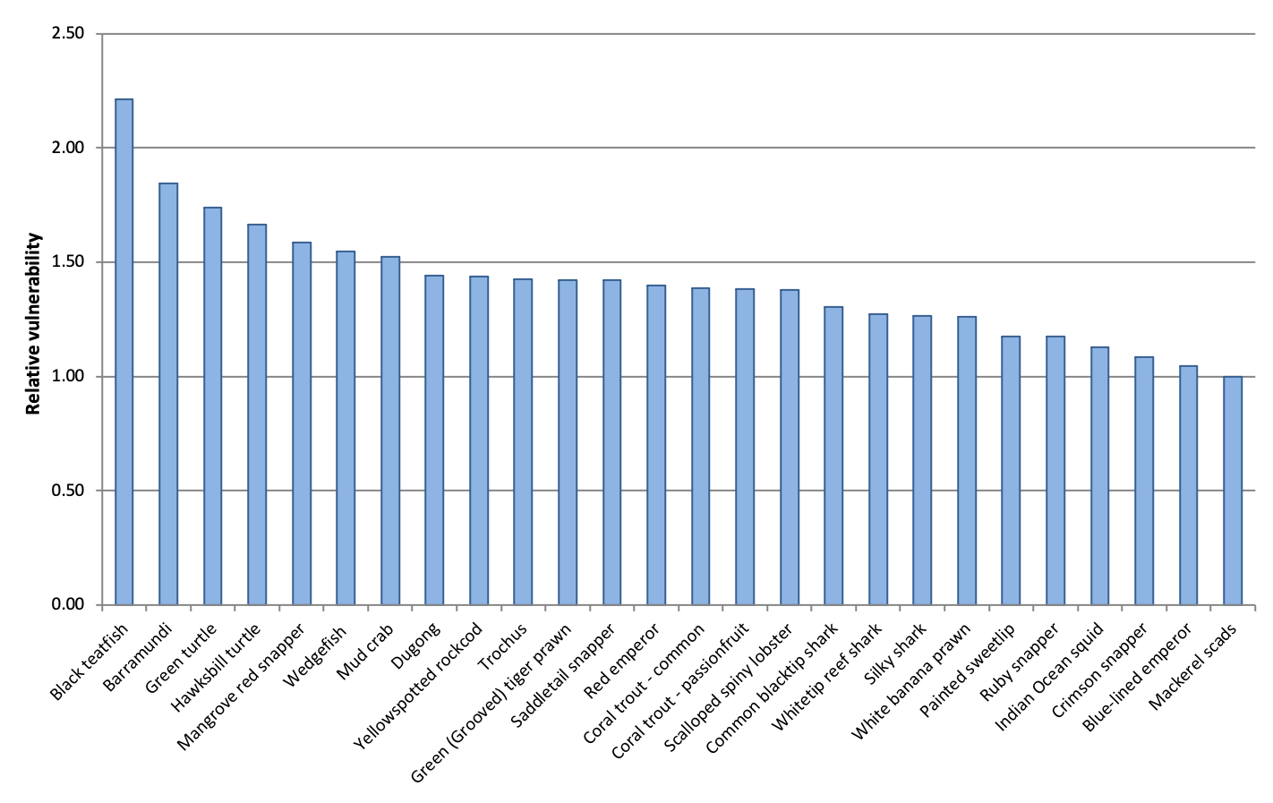Figure B1. Relative vulnerability of key species from the Indonesia/Arafura sub-region.

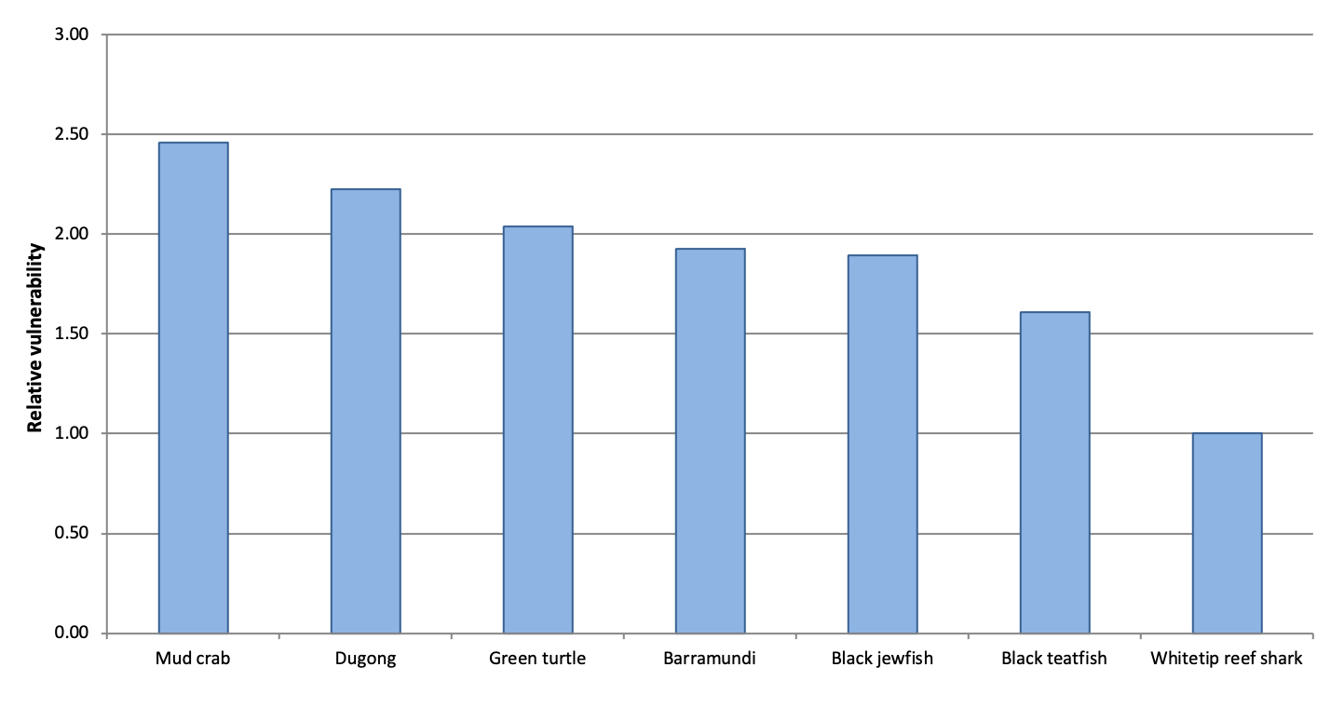Figure B2. Relative vulnerability scores for key species from the western PNG sub-region.
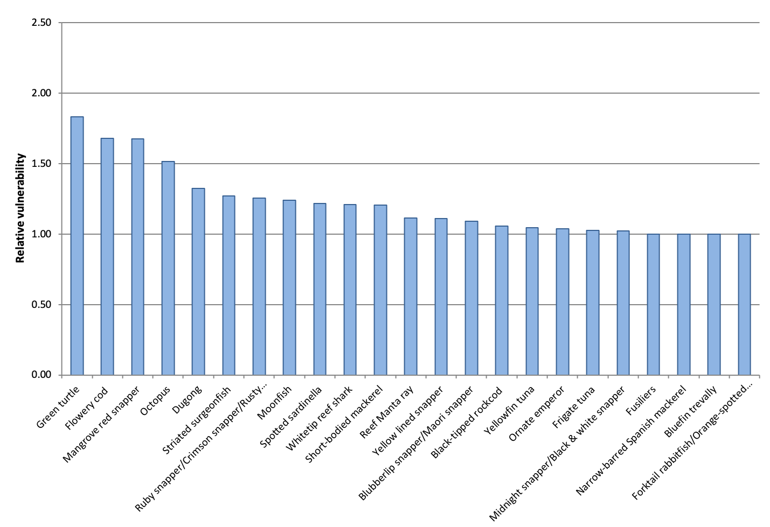Figure B3. Relative vulnerability of key species from the Timor Leste sub-region.

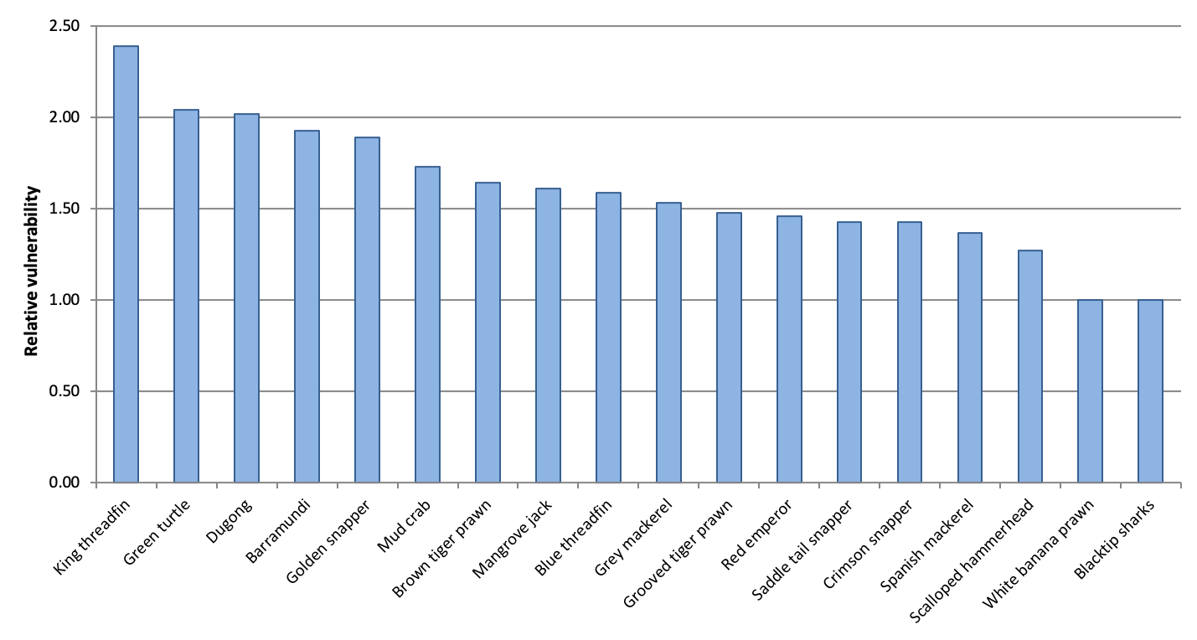Figure B4. Relative vulnerability of key species from the Gulf of Carpentaria sub-region.
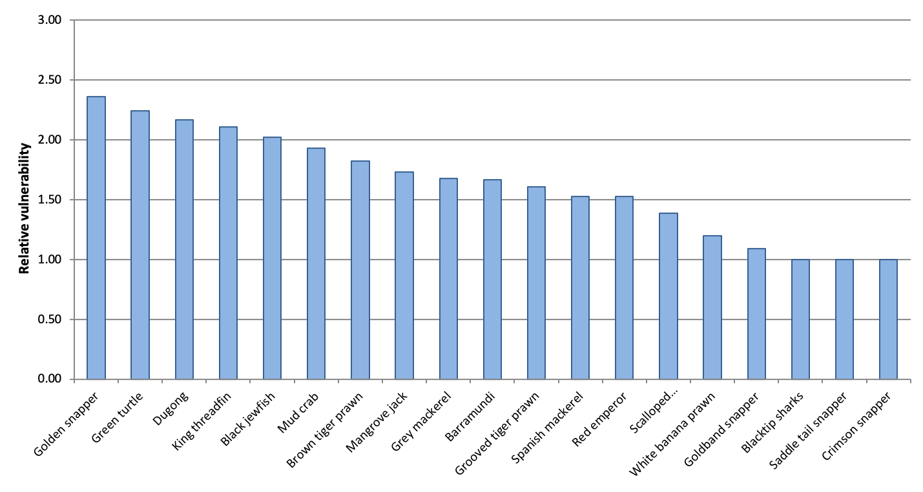Figure B5. Relative vulnerability of key species from the northern Australia sub-region.

