Supplementary online material
Figure S1. Sample diversity across space and time. Regional (indicated in subplot headings) variation in BIN richness (y-axes) vs absolute latitude (top), mean distance to all other sampling locations (middle) and month of sampling (bottom). Boxplots showing the distribution of the data with the whiskers representing the first and third quartiles, and the points shown for samples outside this range. Colors correspond to those used to differentiate regions in Figure 1.

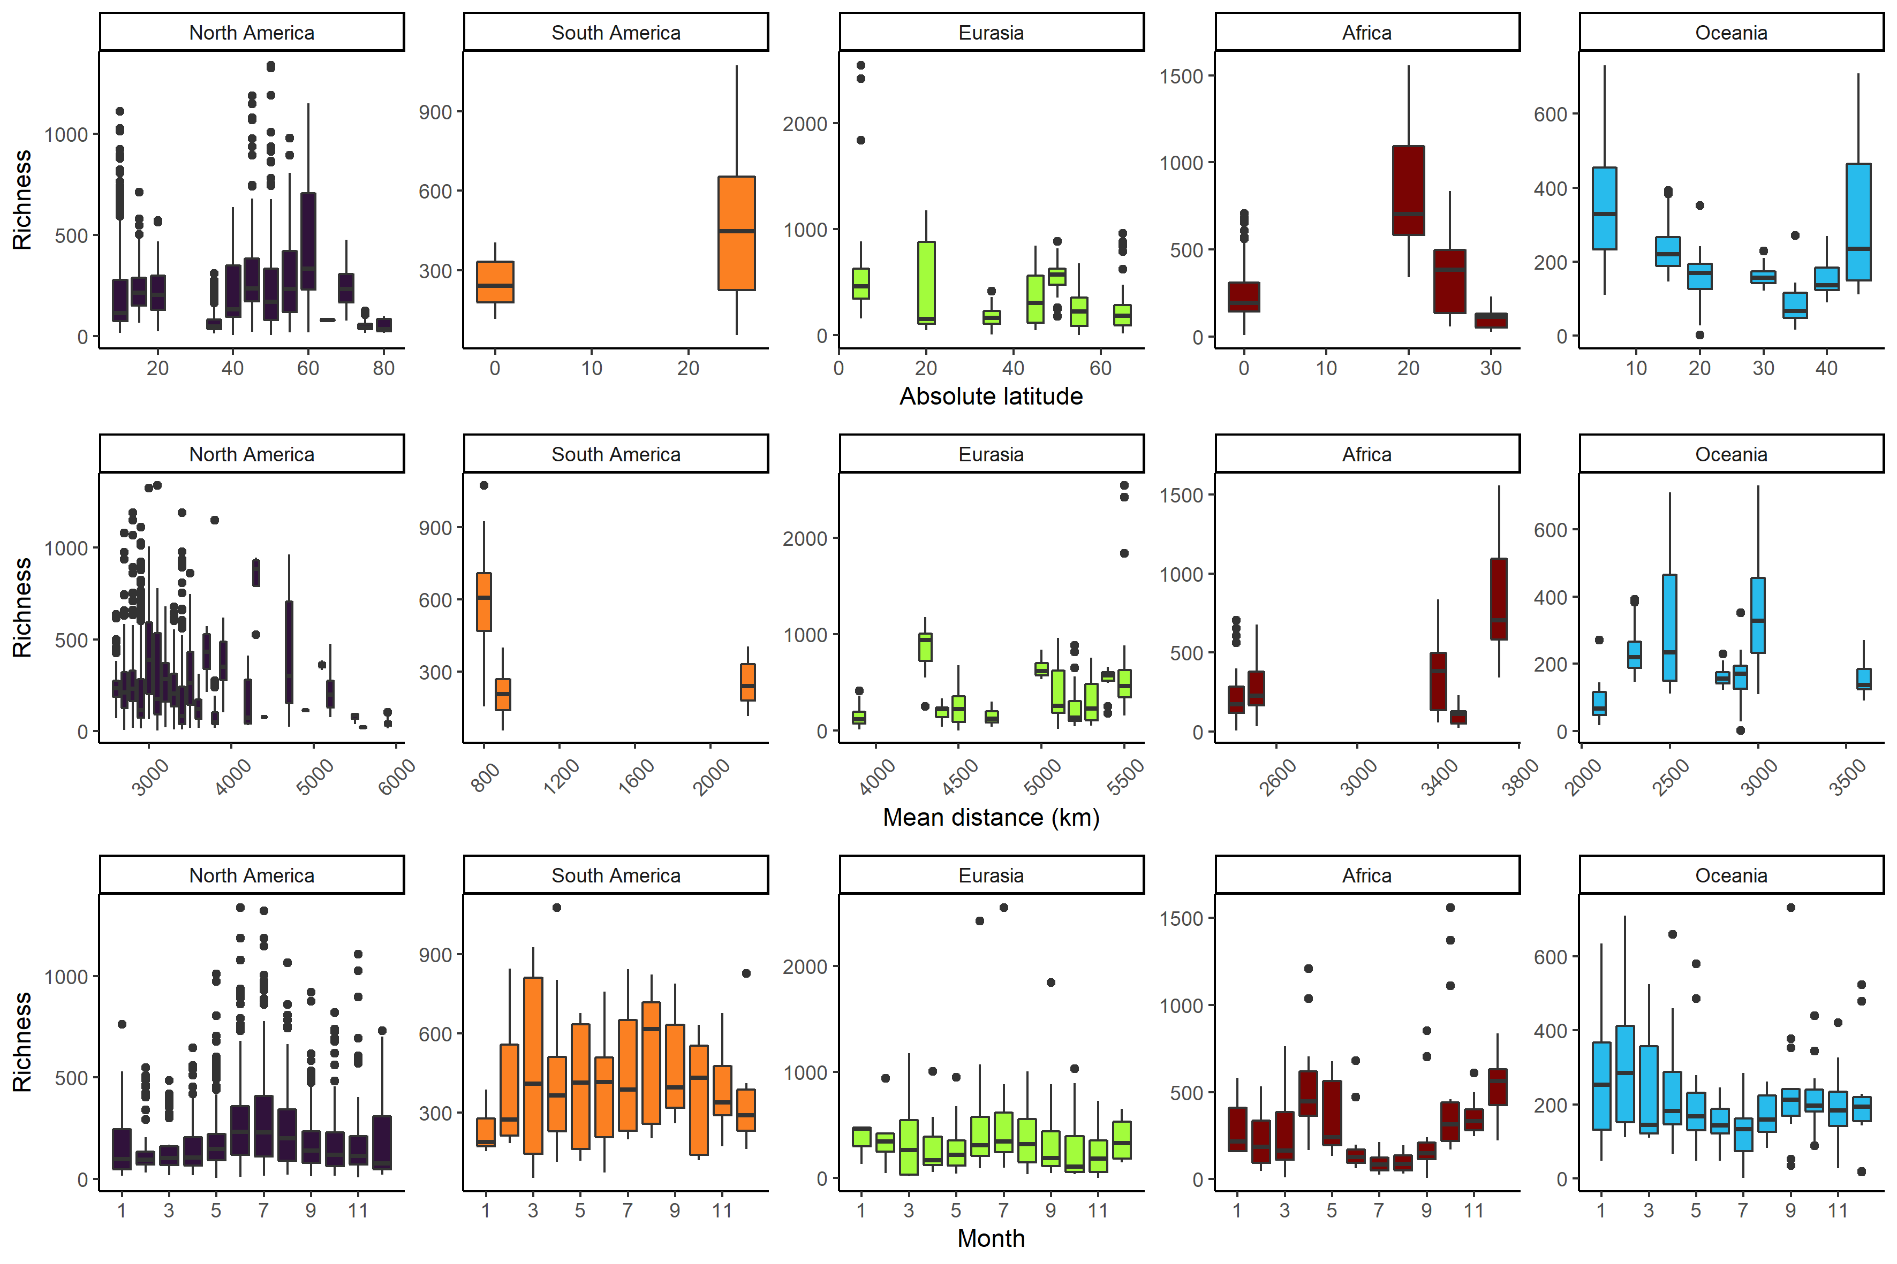

Figure S2. Beta diversity and it’s compositions by region. Regional (indicated in subplot headings) variation in Beta-diversity (Jaccard dissimilarity) (y-axes) and it’s compositional components richness different (RichDiff) and replacement (Repl). Each point represents a unique site pairing within the respective regional group.
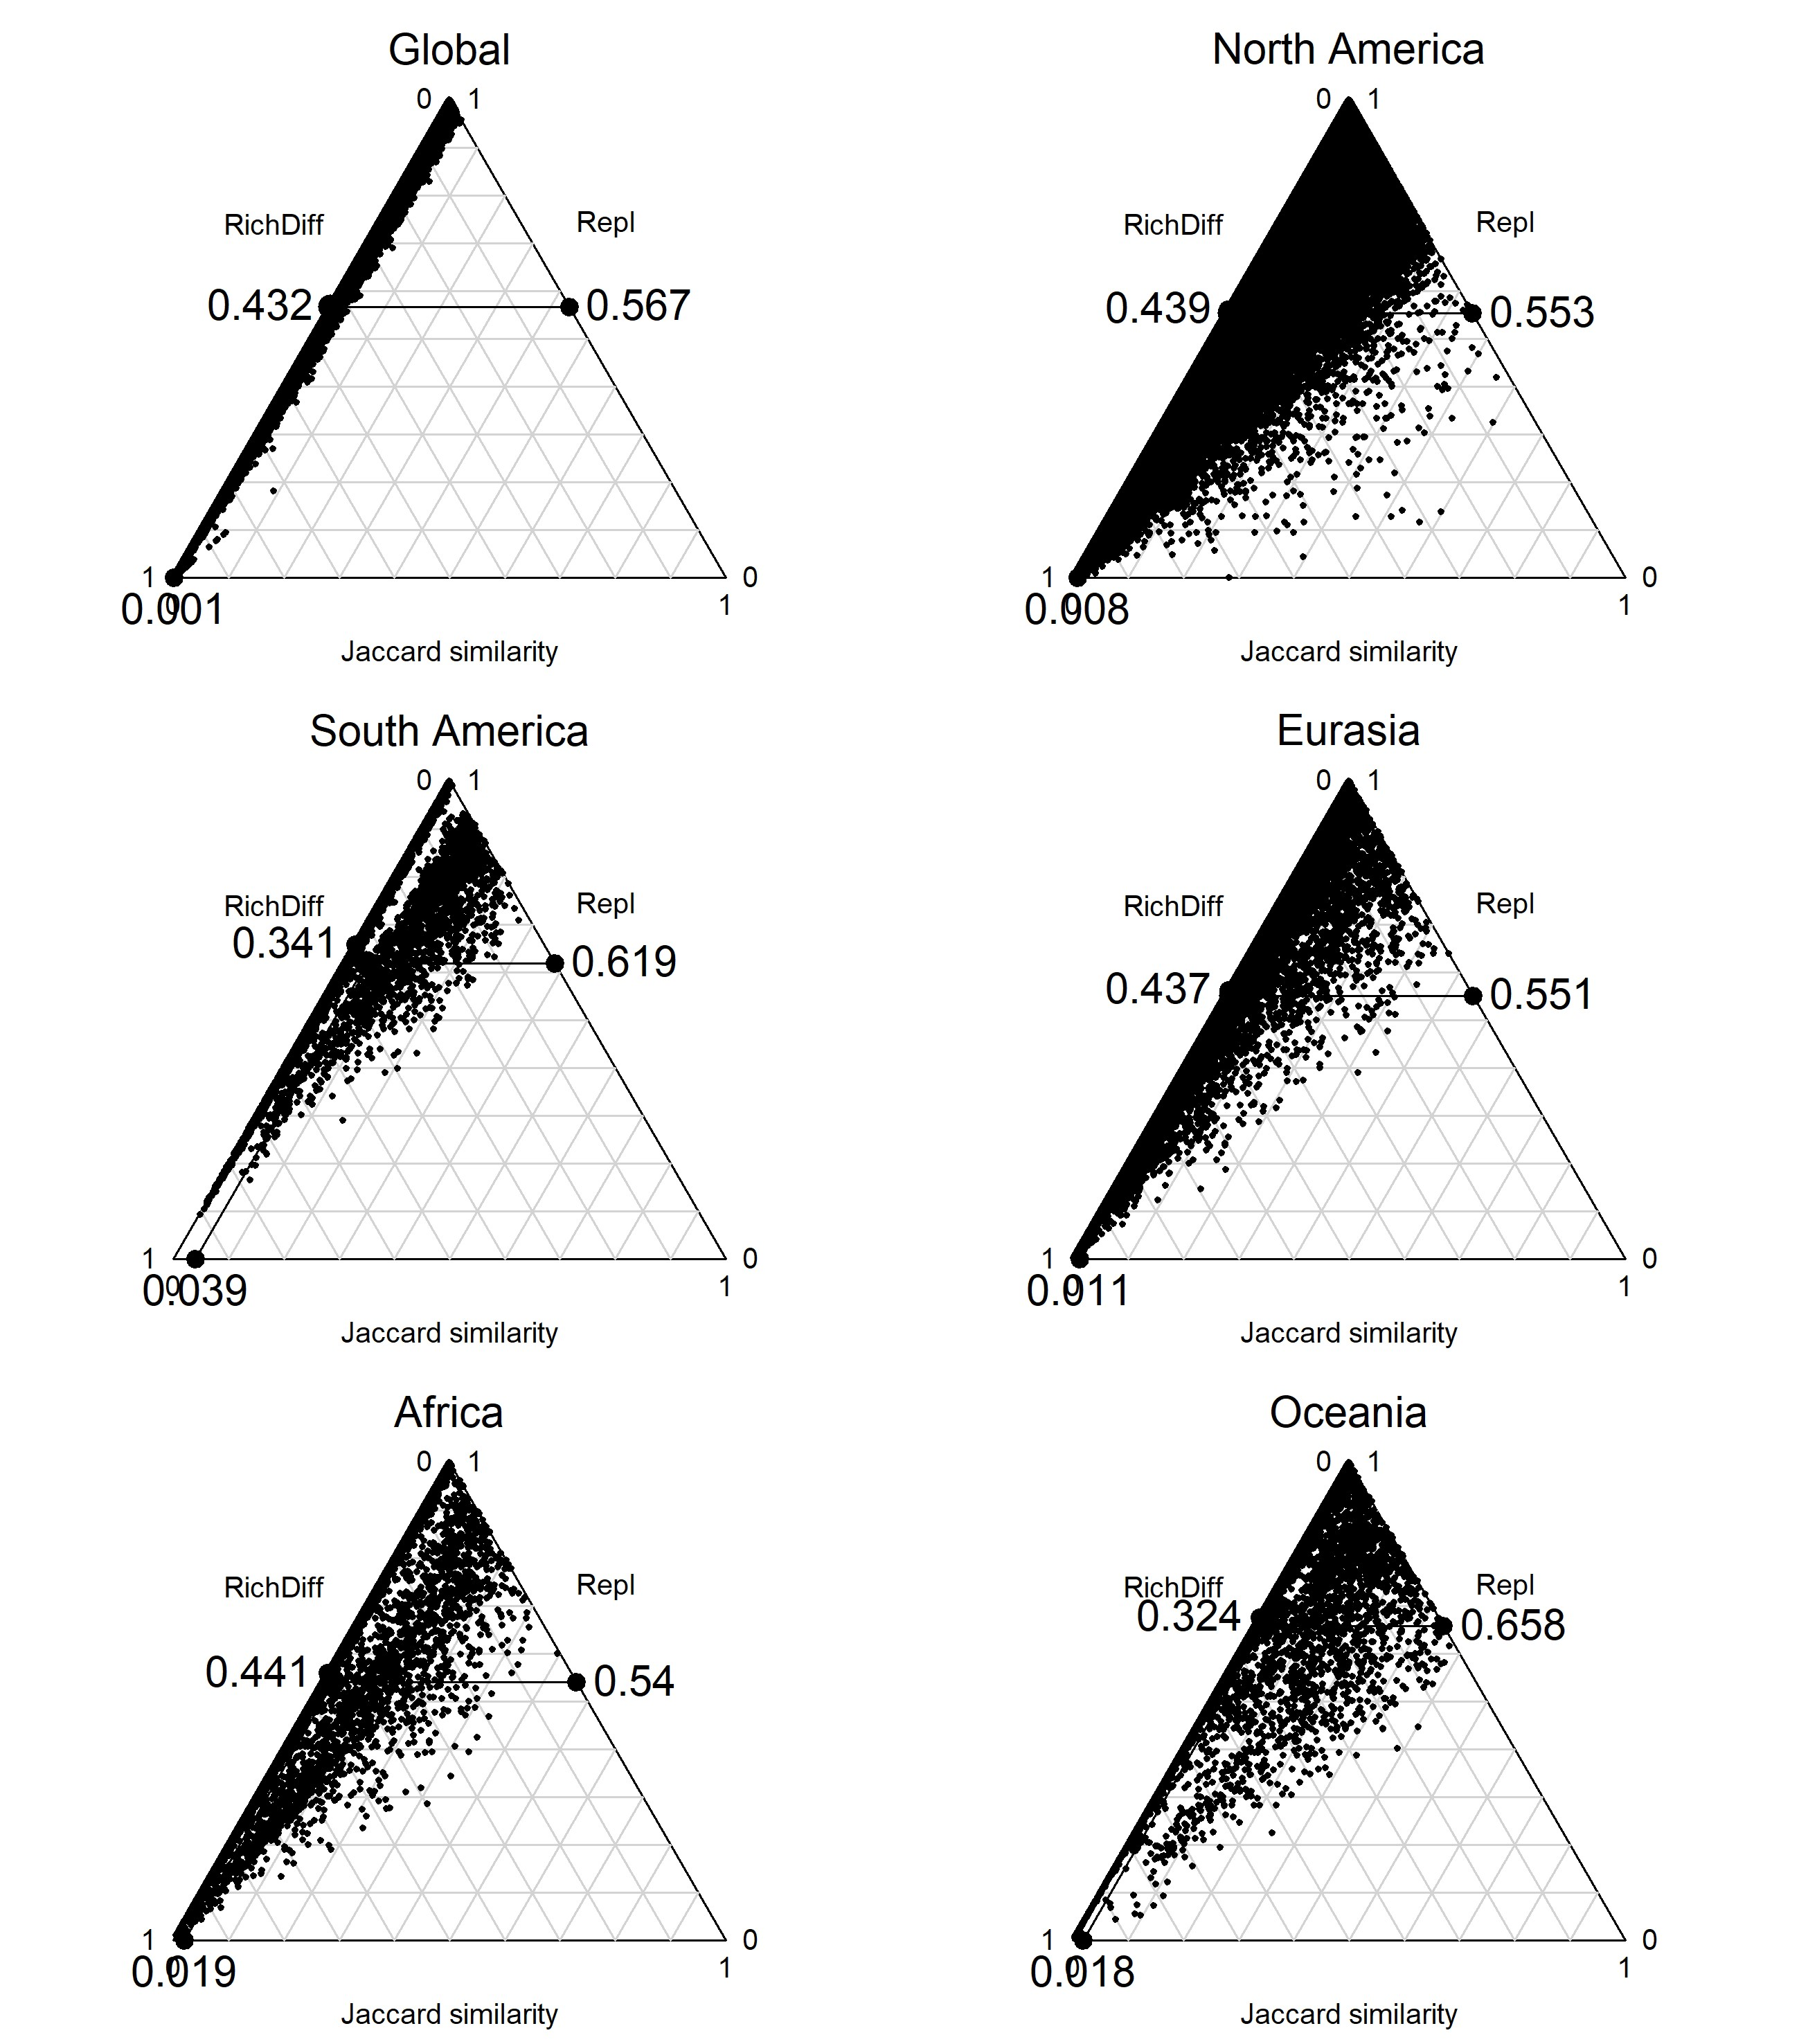

Figure S3. Standardized model coefficients (y-axis) for total beta-dviersity (top), species replacment (middle) and richness replacement (bottom) across all regions.

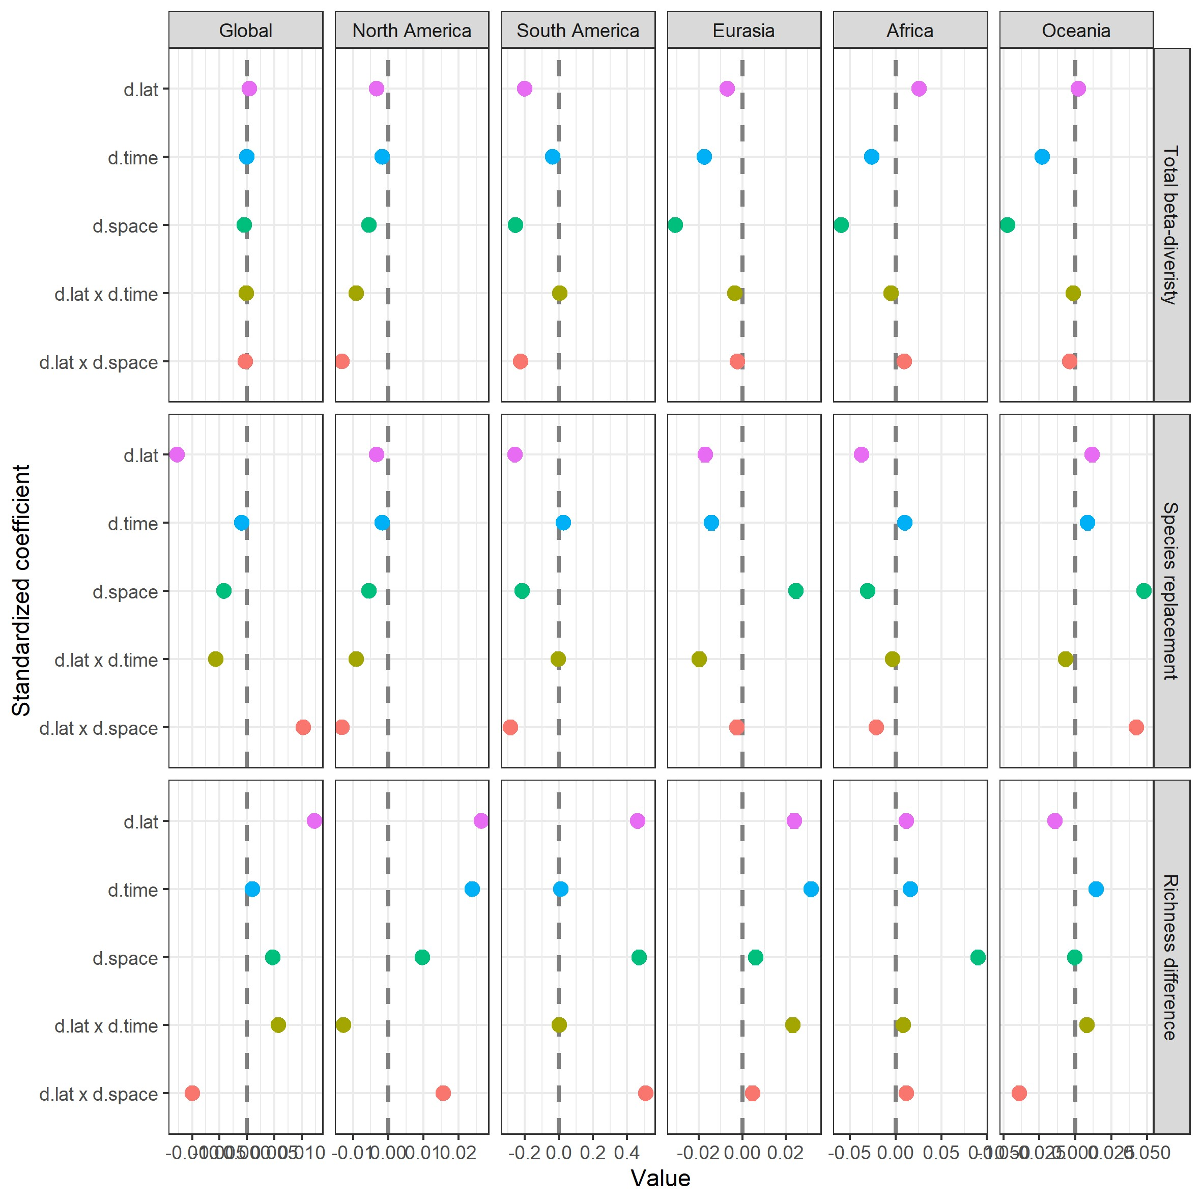

Figure S4. Beta-diversity trends for latitude (top), time (middle) and distance (bottom) for all regions (individuals panels). Trend lines are liner model fitted lines of formula x ~ y for the repsective panel and are for illustarative purposes.

