Supplementary Figure Legends
Supplementary Figure 1. Linear regression analysis of operation time against case number. The red line indicates the regression line (Y = 286.9 + 0.223X).
Supplementary Figure 2. a) Change in urinary function (IPSS). *p < 0.05 for differences in mean scores between groups. †p < 0.05 for differences in mean scores between baseline and each point. b) Change in urinary function (IPSS score). c) Comparison of IPSS scores between laparoscopic and robotic surgery 12 months after the operation. An IPSS of ≥8 points was classed as moderate-to-severe symptoms. The chronological change in IPSS score was evaluated between laparoscopic and robotic surgery, and the statistical analysis was performed using MANOVA. IPSS, International Prostate Symptom Score; MANOVA, multivariate analysis of variance; QOL, quality of life.
Supplementary Figure 3. a) Change in erectile function (IIEF – erection score) in male patients. *p < 0.05 for differences in mean scores between groups. †p < 0.05 for differences in mean scores between baseline and each point. b) Change in erectile function (IIEF – erection score) in male patients. IIEF, International Index of Erectile Function.
Supplementary Figure 4. a) Change in ejaculation function (IIEF – ejaculation score). *p < 0.05 for differences in mean scores between groups. †p < 0.05 for differences in mean scores between baseline and each point. b) Change in ejaculation function (IIEF – ejaculation score). IIEF, International Index of Erectile Function.
Supplementary Figures
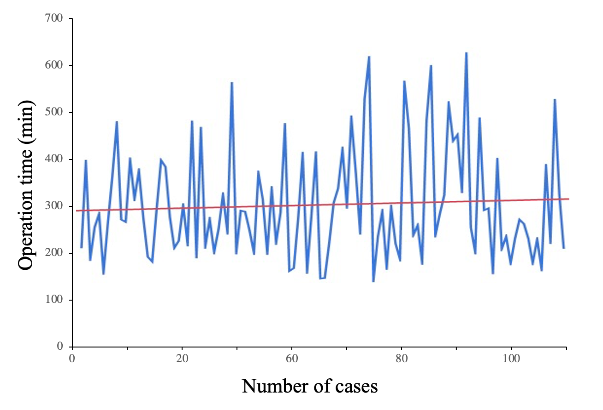Supplementary Figure 1.
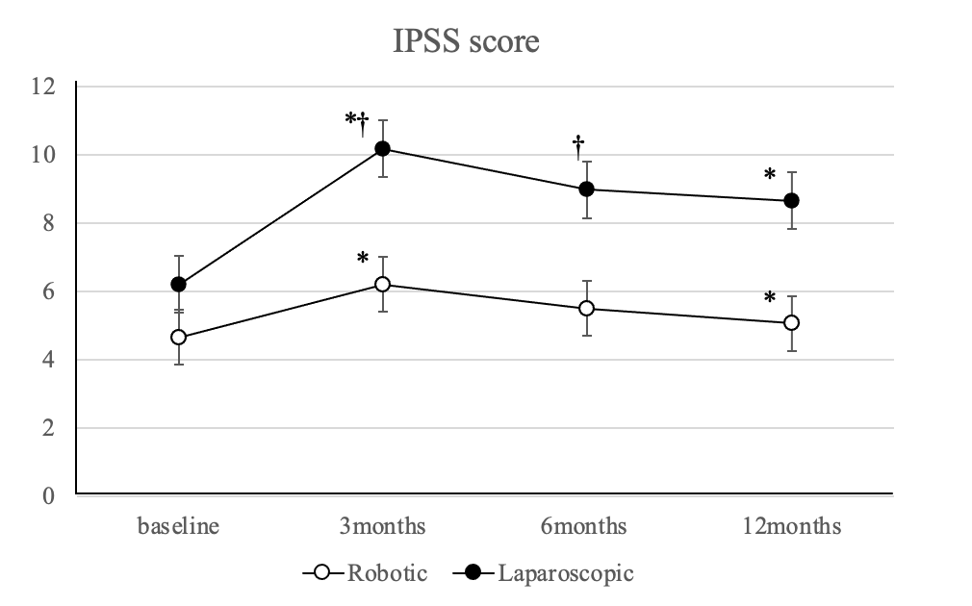
Supplementary Figure 2a.
 |  | Baseline |  | 3 months | 6 months |  | 12 months
Robot-assisted laparoscopic surgery (n = 56)  Conventional laparoscopic surgery (n = 61)  p value |  | 4.66 ± 0.719  6.20 ± 0.712  0.129 |  | 6.21 ± 0.928  10.18 ± 0.964  0.004 | 5.51 ± 0.922  8.99 ± 0.912  0.087 |  | 5.06 ± 0.837  8.66 ± 0.764  0.002
Supplementary Figure 2b.
 | Conventional laparoscopic surgery |  | Robot-assisted laparoscopic surgery |  |  | p value
n  IPSS at 12 months  IPSS ≥ 8  IPSS QOL score  MANOVA | 61  8.66 ± 0.764  28 (45.9%)  2.41 ± 0.177 |  | 56  5.06 ± 0.837  11 (19.6%)  1.97 ± 0.175 |  |  | 0.0020.0120.083  0.013
Supplementary Figure 2c.
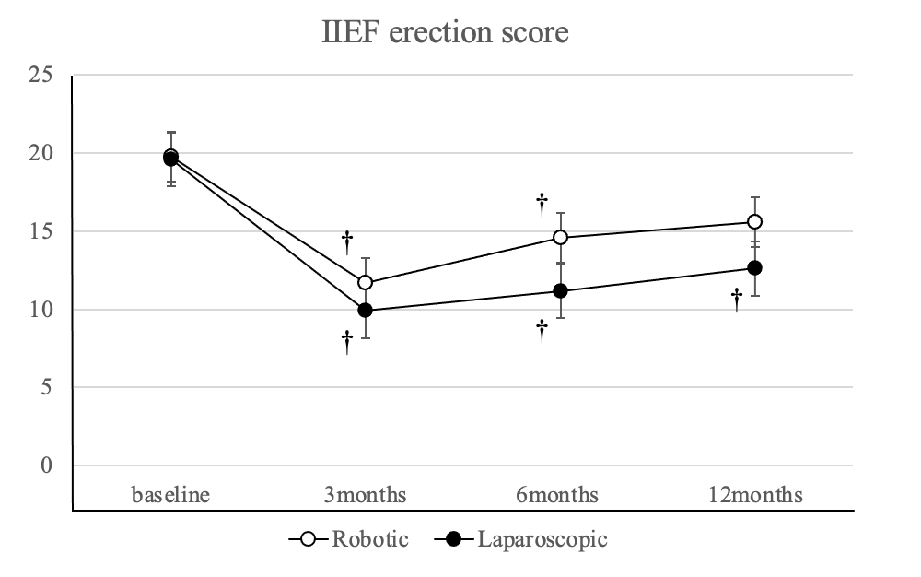
Supplementary Figure 3a.
 | Baseline | 3 months | 6 months | 12 months
Robot-assisted laparoscopic surgery (n = 25)  Conventional laparoscopic surgery (n = 26)  p value | 19.79 ± 1.27  19.6 ± 1.244  0.914 | 11.71 ± 1.69  9.89 ± 01.69  0.451 | 14.56 ± 1.67  11.14 ± 1.71  0.159 | 15.59 ± 1.68  12.61 ± 1.72  0.226
Supplementary Figure 3b.
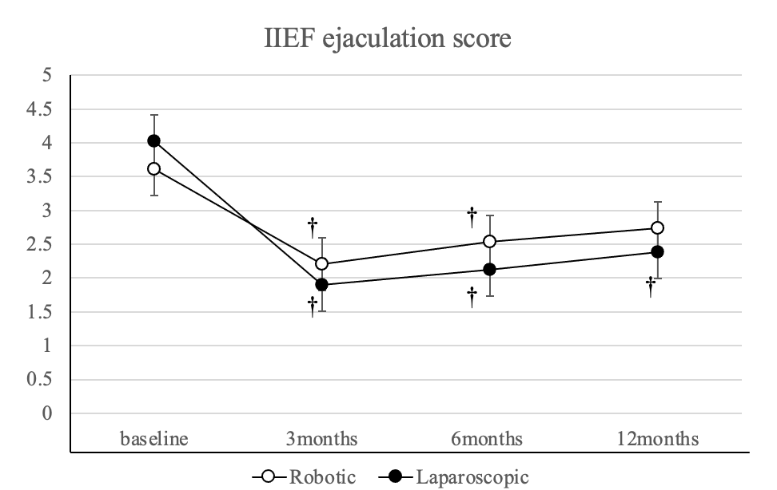
Supplementary Figure 4a.
 | Baseline | 3 months | 6 months | 12 months
Robot-assisted laparoscopic surgery (n = 24)  Conventional laparoscopic surgery (n = 24)  p value | 3.61 ± 0.268  4.02 ± 0.268  0.283 | 2.21 ± 0.372  1.90 ± 0.372  0.560 | 2.54 ± 0.380  2.12 ± 0.389  0.4377 | 2.74 ± 0.393  2.38 ± 0.384  0.514
Supplementary Figure 4b.

