Online Resource 1
Retention of absorbed fog by Pinus thunbergii saplings under different soil drought conditions

Shogo Imada, Hideki Kakiuchi, Masaru Nagai

Corresponding author: Shogo Imada
Department of Radioecology, Institute for Environmental Sciences, 1-7 Ienomae, Obuchi, Rokkasho, Kamikita, Aomori 039-3212, Japan
Email: shogo.imada@ies.or.jp

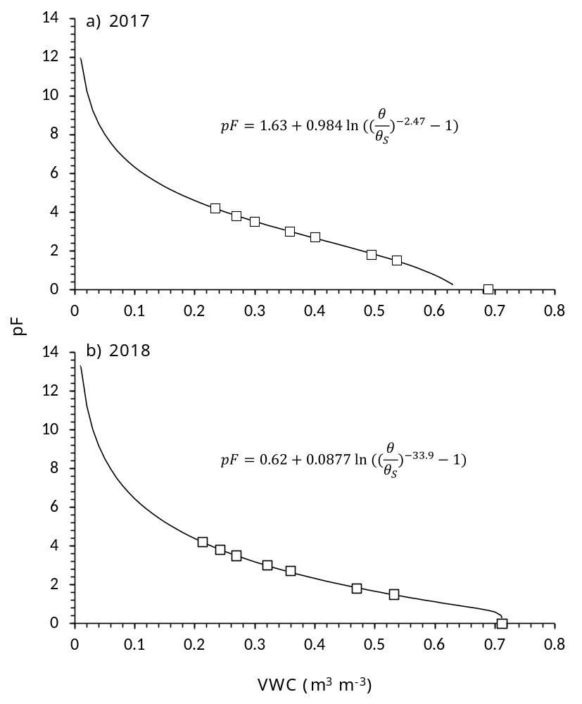

Fig. S1 Relationships between volumetric water content (VWC) and pF of soil in 2017 (a) and 2018 (b). The line indicates the soil water retention curve fitted by a model proposed by Fink and Jackson (1973): pF = 1.63 + 0.984 ln {(θ/θ_{S})^{–2.47}–1}, where θ and θ_{S} represent VWC and saturated VWC, respectively

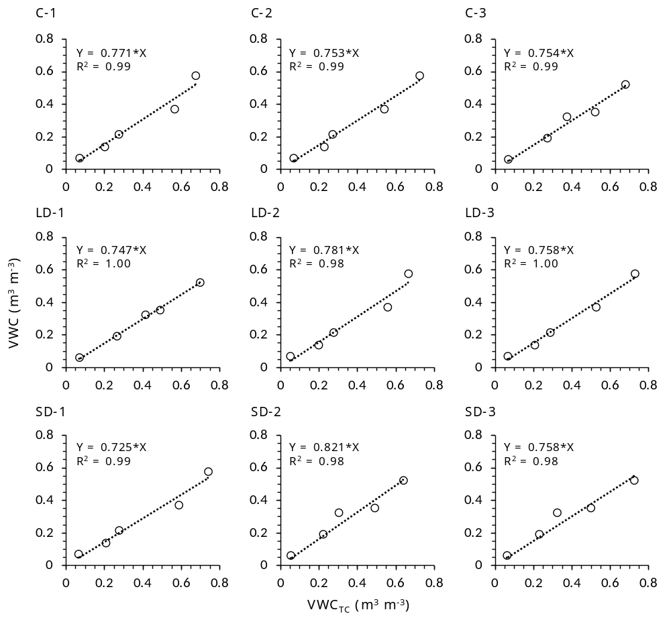

Fig. S2 Relationships between temperature-corrected volumetric water content (VWC_{TC}) in each censor and VWC measured using 100 cm³ cylinder samples in the control (C), low (LD), and severe drought (SD) treatments

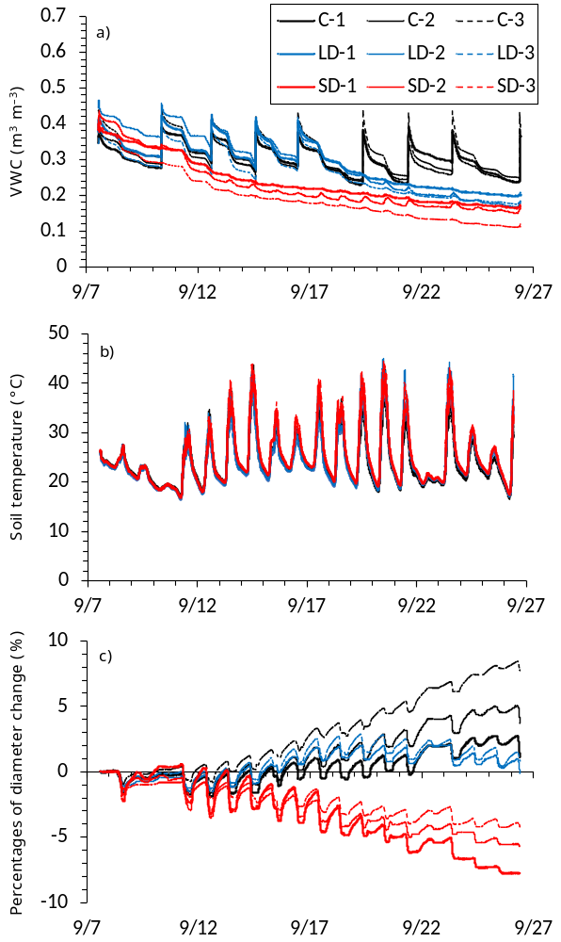

Fig. S3 Temporal variations in volumetric water content (VWC) (a) and soil temperature at 0–5-cm depth (b), as well as percentage change in the stem diameter of trees in the control (C), low (LD), and severe drought (SD) treatments from September 7 (day 0) to September 19, 2018 (c)
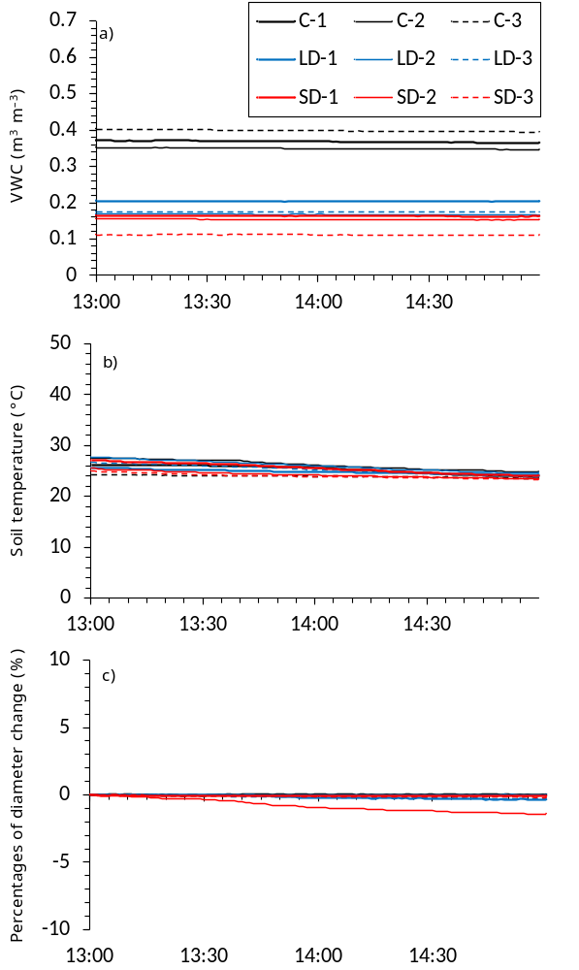

Fig. S4 Temporal variations in volumetric water content (VWC) (a) and soil temperature at 0–5-cm depth (b), as well as percentage change in the stem diameter of trees in the control (C), low (LD), and severe drought (SD) treatments before and during pure-water and deuterium-enriched fog exposures for 2 h on September 19, 2018 (c)
Table S1 Environmental conditions in the chamber during and before exposure of P. thunbergii saplings to pure-water and deuterium-enriched fog

Exposure | Time | Air temperature | Relative humidity | CO₂
 |  | (°C) | (%) | (μL L^{–1})
Before | 13:10 | 17.1 | 59 | 478
 | 13:15 | 17.0 | 59 | 466
 | 13:20 | 17.2 | 63 | 457
 | 13:25 | 17.2 | 62 | 447
Pure-water fog | 13:30 | 17.2 | 63 | 439
 | 13:35 | 17.2 | 85 | 437
 | 13:40 | 17.5 | 90 | 427
 | 13:45 | 17.6 | 90 | 421
 | 13:50 | 17.6 | 91 | 416
 | 13:55 | 17.6 | 91 | 408
Deuterium-enriched fog | 14:00 | 17.7 | 91 | 400
 | 14:05 | 17.4 | 92 | 410
 | 14:10 | 17.4 | 93 | 422
 | 14:15 | 17.4 | 94 | 426
 | 14:20 | 17.1 | 95 | 429
 | 14:25 | 17.2 | 96 | 427
 | 14:30 | 17.2 | 96 | 424
 | 14:35 | 17.1 | 97 | 421
 | 14:40 | 17.2 | 97 | 418
 | 14:45 | 17.2 | 97 | 415
 | 14:50 | 17.1 | 98 | 411
 | 14:55 | 17.3 | 98 | 408

Table S2 The δ²H values of the atmospheric water in the chamber during 1 h of deuterium-fog exposure, those of the water in current and old needles, current and old branches (including stem), and roots of P. thunbergii saplings as well as soil under control, low drought (LD), and severe drought (SD) treatments 48 h after fog exposure experiment (c)

 | δ²H (‰)
 | Deuterium-fog exposure | 48 h after exposure
 |  | Control | LD | SD
Atmosphere | 525,580
Current needles |  | 1336 ± 773 ^{b} | 22278 ± 5411 ª | 25337 ± 10530 ª
Old needles |  | 4730 ± 6469 ^{b} | 19368 ± 5771 ª | 13704 ± 3126 ^{ab}
Current branches |  | 243 ± 106 ^{b} | 2183 ± 1128 ª | 4011 ± 704 ª
Old branches |  | –3.2 ± 20.4 ^{b} | 82.6 ± 20.2 ^{b} | 271.9 ± 88.1 ª
Roots |  | –16.2 ± 4.8 ^{b} | –7.5 ± 5.7 ^{ab} | 13.1 ± 18.1 ª
Soil |  | –44.3 ± 2.7 ª | –38.3 ± 1.3 ª | –17.5 ± 24.8 ª
One-way ANOVA followed by Tukey HSD test was performed for each plant organ or soil (P < 0.05). The error bars denote ± S.D. (n = 3)

