Electronic Supplementary Information

Paper microfluidic device enables rapid and on-site wastewater surveillance in community settings

Yuwei Pan^{1,2}, Baojun Wang³, Jonathan M. Cooper², Zhugen Yang^{1*}

¹ School of Water, Energy and Environment, Cranfield University, Bedford, MK43 0AL, UK
² James Watt School of Engineering, University of Glasgow, Glasgow, G12 8LT, UK
³College of Chemical and Biological Engineering & ZJU-Hangzhou Global Scientific and Technological Innovation Center, Zhejiang University, Hangzhou, 310058, China

Table of Contents

Supplementary Materials

- Optimization of paper device with high through-put detection (Figure S1)
- Real-time RT-qPCR assay for the detection of 3 SARS-CoV-2 genes (Figure S2)
- Real-time RT-qPCR assay for the detection of 3 influenza genotypes (Figure S3)
- Optimization of the concentration ratio of calcein to Mn²⁺ for LAMP assay (Figure S4)
- Real-time RT-LAMP assay for the detection of 3 genes on SARS-CoV-2 (Figure S5)
- Real-time RT-LAMP assay for the detection of 3 influenza genotypes (Figure S6)
- Equipment, consumables, and reagents needed for paper-based RT-LAMP assay for on-site virus detection in wastewater (Figure S7)
- Schematic of the wastewater concentration process during field testing at a hotel near Heathrow Airport in London (Figure S8)
- Schematic of the paper-based LAMP assay process during field testing at a hotel near Heathrow Airport (Figure S9)
- Illustration of the whole process from sample introduction to target detection (Figure S10)
- Photos of the basement of a hotel used for field testing near Heathrow Airport (Figure S11)

Experimental Section

- LAMP primers for Brucella, ORF1ab, S, N, H1N1, H7N9, influenza B, PRRSV and mtDNA (Table S1)
- PCR primers for in vitro transcription of ORF1ab, S, N, H1N1, H7N9 and influenza B (Table S2)
- qPCR primers for ORF1ab, S, N, H1N1, H7N9, influenza B, PRRSV and mtDNA (Table S3)

Figure S1. Optimization of paper device with high-throughput detection. Real-time PCR assay of a model DNA on paper device with (a) and (d) various pore size (3.0 mm-5.0 mm), with (b) and (e) various channel width (1.0 mm-3.0 mm), or with (c) and (f) various channel length (1.0 mm-3.0 mm). C_{t} as a function of target concentration. The optimized results of the pore size, channel width and channel length of the paper device are 4 mm, 1.5 mm, and 2.5 mm, respectively. The results are averages of three independent experiments. (g) (h) (i) Repeatability test of each layer of the paper device from the fold-unfolding pattern from Figure 1 (b). Paper-based PCR assay of model organism on paper device with various layers (Number 1-16).

Figure S2. Real-time RT-qPCR assay for the detection of 3 genes on SARS-CoV-2. (a) Standard curves of real-time RT-qPCR assay and (d) agarose gel electrophoresis of ORF1ab amplification product with various template concentration. (b) Real-time RT-qPCR assay and (e) agarose gel electrophoresis of S amplification product with various template concentration. (c) Real-time RT-qPCR assay and (f) agarose gel electrophoresis of N amplification product with various template concentration.

Figure S3. Real-time RT-qPCR assay for the detection of 3 influenza genotypes. (a) Real-time RT-qPCR assay and (d) agarose gel electrophoresis of H1N1 amplification product with various template concentration. (b) Real-time RT-qPCR assay and (e) agarose gel electrophoresis of H7N9 amplification product with various template concentration. (c) Real-time RT-qPCR assay and (f) agarose gel electrophoresis of influenza B amplification product with various template concentration.

Figure S4. Optimization of the concentration ratio of calcein to Mn²⁺ for LAMP assay. (a) The LAMP assay products with various concentration ratio of calcein to Mn²⁺ (1:30; 1:25; 1:20; 1:15; 1:10) under ultraviolet light. (b) The relationship between T_{t} and the concentration ratio of calcein to Mn²⁺. (c) The relationship between the fluorescence ratio (defined as the fluorescence intensity ratio of the positive control and the negative control) and the concentration ratio of calcein to Mn²⁺.

Figure S5. Real-time RT-LAMP assay for the detection of 3 SARS-CoV-2 genes. (a) Real-time RT-LAMP assay, (d) the image of RT-LAMP amplicons under ultraviolet light and (g) agarose gel electrophoresis of ORF1ab amplification product with various template concentration. (b) Real-time RT-LAMP assay, (e) the image of RT-LAMP amplicons under ultraviolet light and (h) agarose gel electrophoresis of S amplification product with various template concentration. (c) Real-time RT-LAMP assay, (f) the image of RT-LAMP amplicons under ultraviolet light and (i) agarose gel electrophoresis of N amplification product with various template concentration.

Figure S6. Real-time RT-LAMP assay for the detection of 3 influenza genotypes. (a) Real-time RT-LAMP assay, (d) the image of RT-LAMP amplicons under ultraviolet light and (g) agarose gel electrophoresis of H1N1 amplification product with various template concentration. (b) Real-time RT-LAMP assay, (e) the image of RT-LAMP amplicons under ultraviolet light and (h) agarose gel electrophoresis of H7N9 amplification product with various template concentration. (c) Real-time RT-LAMP assay, (f) the image of RT-LAMP amplicons under ultraviolet light and (i) agarose gel electrophoresis of influenza B amplification product with various template concentration.

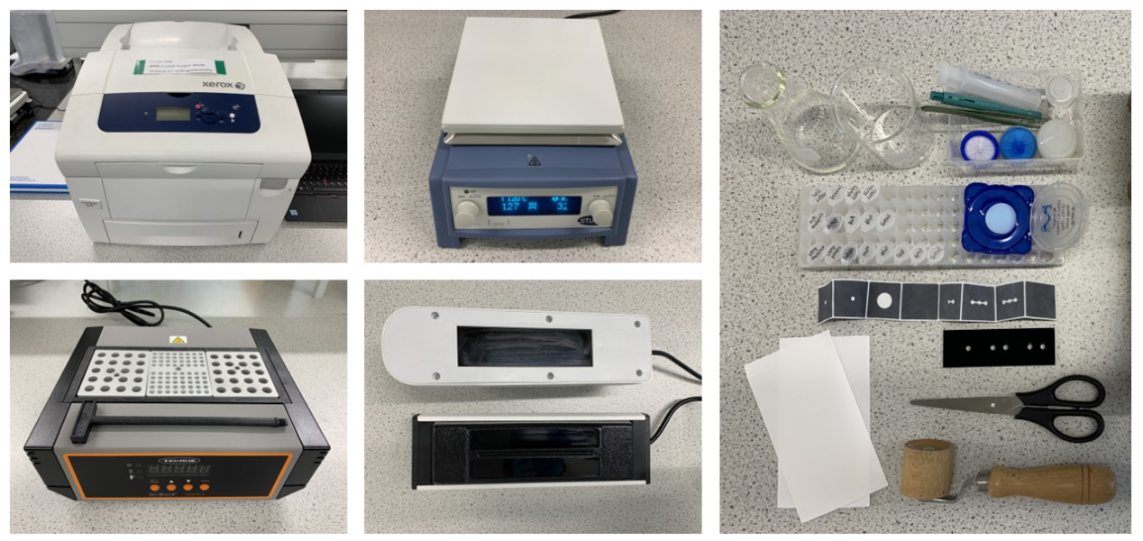
Figure S7. Equipment, consumables, and reagents needed for paper-based RT-LAMP assay for on-site virus detection in wastewater, including wax printer, hot plate, heat blocker, UV torch, Eppendorf tubes with reagents, paper device, blackboard, conical flask, beaker, syringe, puncher, tweezers, syringe filter, Swinnex filter holder, filter membrane, scissors, roller, filter paper and optical adhesive film.

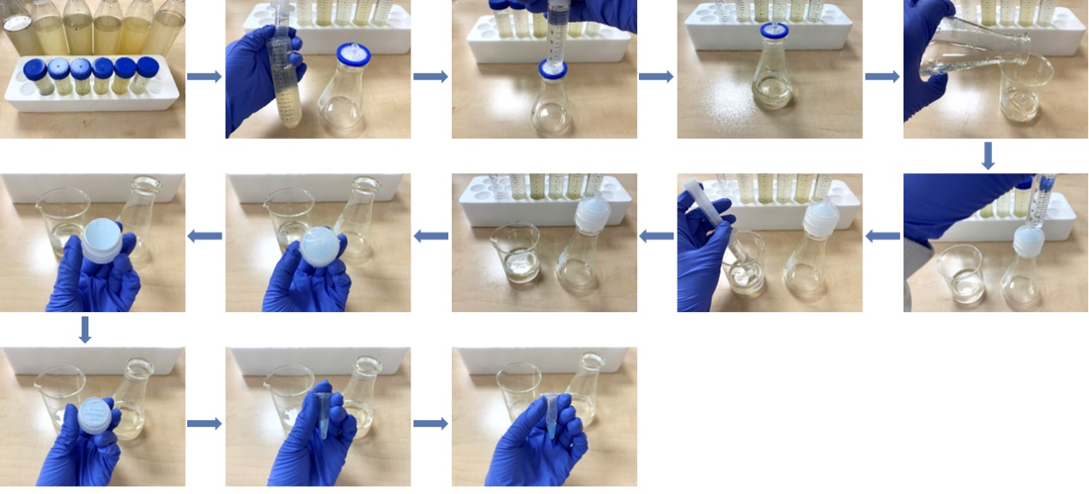
Figure S8. Schematic of the wastewater concentration process during field testing at a hotel near Heathrow Airport in London.

Figure S9. Schematic of the paper-based LAMP assay process during field testing in hotels at Heathrow Airport.

Figure S10. Illustration of the whole process from sample introduction to target detection.

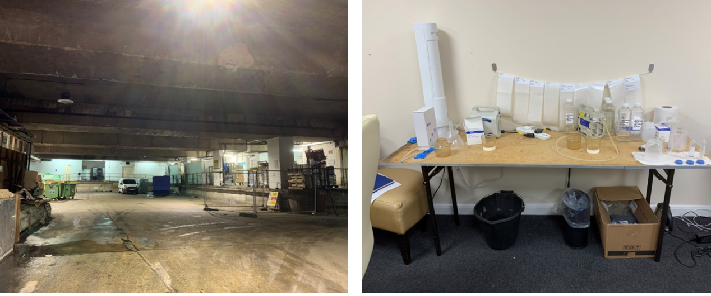Figure S11. Photos of the hotel basement used for field testing near Heathrow Airport.

Table S1. LAMP primers for Brucella, ORF1ab, S, N, H1N1, H7N9, influenza B, PRRSV and mtDNA.
Target | primer | Sequence (5’-3’)
ORF1ab | ORF1ab 1F3 | TGCTTCAGTCAGCTGATG
ORF1ab | ORF1ab 1B3 | TTAAATTGTCATCTTCGTCCTT
ORF1ab | ORF1ab 1FIP | TCAGTACTAGTGCCTGTGCCCACAATCGTTTTTAAACGGGT
ORF1ab | ORF1ab 1BIP | TCGTATACAGGGCTTTTGACATCTATCTTGGAAGCGACAACAA
ORF1ab | ORF1ab 1LF | CTGCACTTACACCGCAA
ORF1ab | ORF1ab 1LB | GTAGCTGGTTTTGCTAAATTCC
S | S F3 | TCTATTGCCATACCCACAA
S | S B3 | GGTGTTTTGTAAATTTGTTTGAC
S | S FIP | CATTCAGTTGAATCACCACAAATGTGTGTTACCACAGAAATTCTACC
S | S BIP | GTTGCAATATGGCAGTTTTTGTACATTGGGTGTTTTTGTCTTGTT
S | S LF | ACTGATGTCTTGGTCATAGACACT
S | S LB | TAAACCGTGCTTTAACTGGAATAGC
N | N 1F3 | TGGCTACTACCGAAGAGCT
N | N 1B3 | TGCAGCATTGTTAGCAGGAT
N | N 1FIP | TCTGGCCCAGTTCCTAGGTAGTCCAGACGAATTCGTGGTGG
N | N 1BIP | AGACGGCATCATATGGGTTGCACGGGTGCCAATGTGATCT
N | N 1LF | GGACTGAGATCTTTCATTTTACCGT
N | N 1LB | ACTGAGGGAGCCTTGAATACA
H1N1 | H1N1 F3 | GCTAAGAGAGCAATTGAGC
H1N1 | H1N1 B3 | ATGTAGGATTTGCTGAGCT
H1N1 | H1N1 FIP | CGAGTCATGATTGGGCCATGACAGTGTCATCATTTGAAAGGTTT
H1N1 | H1N1 BIP | AAGGTGTAACGGCAGCATGTCCGAATTTCCTTTTTTAACTAGCCAT
H1N1 | H1N1 LF | ACTTGTCTTGGGGAATATCTC
H1N1 | H1N1 LB | ATGCTGGAGCAAAAAGCT
H7N9 | H7N9 F3 | GCGGGTTTCATTGAAAATGG
H7N9 | H7N9 B3 | CTACCTCATTGAATTCATTGTCT
H7N9 | H7N9 FIP | TCCCTCTCCCTGTGCATTCTATGGGAAGGCCTAATTGATG
H7N9 | H7N9 BIP | ACTGCTGCAGATTACAAAAGCACTGGTTGGTTTTTTCTATAAGCC
H7N9 | H7N9 LF | TCTGAAACCATACCAAC
H7N9 | H7N9 LB | TCAATCGGCAATTGATCAAATA
influenza B | Flu B F3 | AGGGACATGAACAACAAAGA
influenza B | Flu B B3 | CAAGTTTAGCAACAAGCCT
influenza B | Flu B FIP | TCAGGGACAATACATTACGCATATCGATAAAGGAGGAAGTAAACACTCA
influenza B | Flu B BIP | TAAACGGAACATTCCTCAAACACCACTCTGGTCATAGGCATTC
influenza B | Flu B LF | TCAAACGGAACTTCCCTTCTTTC
influenza B | Flu B LB | GGATACAAGTCCTTATCAACTCTGC
PRRSV | PRRSV F3 | GCCTGAGAAGCCACATTT
PRRSV | PRRSV B3 | AATCAGGCGCACTGTATG
PRRSV | PRRSV FIP | CTGRATCGATTGCAAGCARAGCTSCTGAAGATGACRTYCG
PRRSV | PRRSV BIP | TTYAATCAAGGCGCWGGAACTGGCAGCATRAACTCAACCT
PRRSV | PRRSV LF | GYTCRGTCTGGGTGAGRTG
PRRSV | PRRSV LB | GCTTTCATCCAGYGGGAA
mtDNA | mtDNA F3 | CAGCAGCCATTCAAGCAATC
mtDNA | mtDNA B3 | GGTGGAGACCTAATTGGG
mtDNA | mtDNA FIP | GGTCTCATGAGTTGGAGTGTAGGCTATACAACCGTATCGGCGATATC
mtDNA | mtDNA BIP | GCCCTTCTAAACGCTAATCCAAGCTGATTTGCCTGCTGCTGCTAG
mtDNA | mtDNA LF | CCACCCACTACTAGGCC
mtDNA | mtDNA LB | CTAAGGCGAGGATGAAACC
Brucella | Brucella F3 | TGGATGAGCCGGGTTCTG
 | Brucella B3 | GGAACGAGCGAAATACCGT
 | Brucella FIP | GTCCCGGCTTCAGGTGTTCAGATCGTTCTTGAAGCCTACGG
 | Brucella BIP | GGCGAGAGGCTGAAAGATGGTGCCAGTTCCGAGATTGCG
 | Brucella LPF | CCTTGATATCGTCTTCCGTGAGG
 | Brucella LPB | TGGACGCCTATTTCTTTGTGG

Table S2. PCR primers for in vitro transcription of ORF1ab, S, N, H1N1, H7N9 and influenza B.
Target | primer | Sequence (5’-3’)
ORF1ab | ORF1ab-T7-F | TAATACGACTCACTATAGGGCCCTGTGGGTTTTACACTTAA
ORF1ab | ORF1ab-T7-R | TAATACGACTCACTATAGGGGGTATGATTTTGTAGAAAACCCA
S | S-T7-F | TAATACGACTCACTATAGGGTCTTTCACACGTGGTGTT
S | S-T7-R | TAATACGACTCACTATAGGGCCTACTAAATTAAATGATCTCTGCTTTACT
N | N-T7-F | AATTCTAATACGACTCACTATAGGGCCAAATTGGCTACTACCGAAGAGCTAC
N | N-T7-R | CACAGTTTGCTGTTTCTTCTGTCTCTGCGG
H1N1 | H1N1-T7-F | TAATACGACTCACTATAGGGGCTAAGAGAGCAATTGAGC
H1N1 | H1N1-T7-R | CGGGACATTCCTCAATCCTGTGGC
H7N9 | H7N9-T7-F | TAATACGACTCACTATAGGGGCGGGTTTCATTGAAAATGG
H7N9 | H7N9-T7-R | CCCGAAGCTAAACCAAAGTATC
influenza B | Flu B-T7-F | TAATACGACTCACTATAGGGGGAGCAACCAATGCTAC
influenza B | Flu B-T7-R | CAAGTTTAGCAACAAGCCT

Table S3. qPCR primers for ORF1ab, S, N, H1N1, H7N9, influenza B, PRRSV and mtDNA.
Target | primer | Sequence (5’-3’)
ORF1ab | ORF1ab F | CCCTGTGGGTTTTACACTTAA
ORF1ab | ORF1ab R | ACGATTGTGCATCAGCTGA
ORF1ab | ORF1ab P | HEX-CCGTCTGCGGTATGTGGAAAGGTTATGG-BHQ1
S | S F | CCTACTAAATTAAATGATCTCTGCTTTACT
S | S R | CAAGCTATAACGCAGCCTGTA
S | S P | HEX-CGCTCCAGGGCAAACTGGAAAG-BHQ1
N | N F | GGGGAACTTCTCCTGCTAGAAT
N | N R | CAGACATTTTGCTCTCAAGCTG
N | N P | FAM-TTGCTGCTGCTTGACAGATT-TAMRA
H1N1 | H1N1 F | GTGCTATAAACACCAGCCTCCCA
H1N1 | H1N1 R | CGGGACATTCCTCAATCCTGTGGC
H1N1 | H1N1 P | FAM-CAGAATATACATCCGATCACAATTGGAAAA-BHQ1
H7N9 | H7N9 F | TCACAGCAAATACAGGGAAGAG
H7N9 | H7N9 R | CCCGAAGCTAAACCAAAGTATC
H7N9 | H7N9 P | FAM–TGACCCAGTCAAACTAAGCAGCGG–BHQ1
influenza B | Flu B F | GGAGCAACCAATGCTAC
influenza B | Flu B R | GTTTAGGCGGTCTTGACCGG
influenza B | Flu B P | FAM-ATAAACTTTGAAGCAGGAAT-BHQ1
PRRSV | PRRSV F | CAGGACTTCGGAGCCTCGT
PRRSV | PRRSV R | AGCAACTGGCACAGTTGATTGA
PRRSV | PRRSV P | FAM-ACGAGCTGTTAAACGAGGA-BHQ1
mtDNA | mtDNA F | CAGCAGCCATTCAAGCAATGC
mtDNA | mtDNA R | GGTGGAGACCTAATTGGGCTGATTAG
mtDNA | mtDNA P | FAM-TATCGGCGATATCGGTTTCATCCTCG-BHQ1

