Supplementary Data:

Supplementary Figure 1: Cumulative relapse-free survival rates of patients with Crohn’s disease according to anti-tumor necrosis factor (anti-TNF) therapy naïve or switch group.

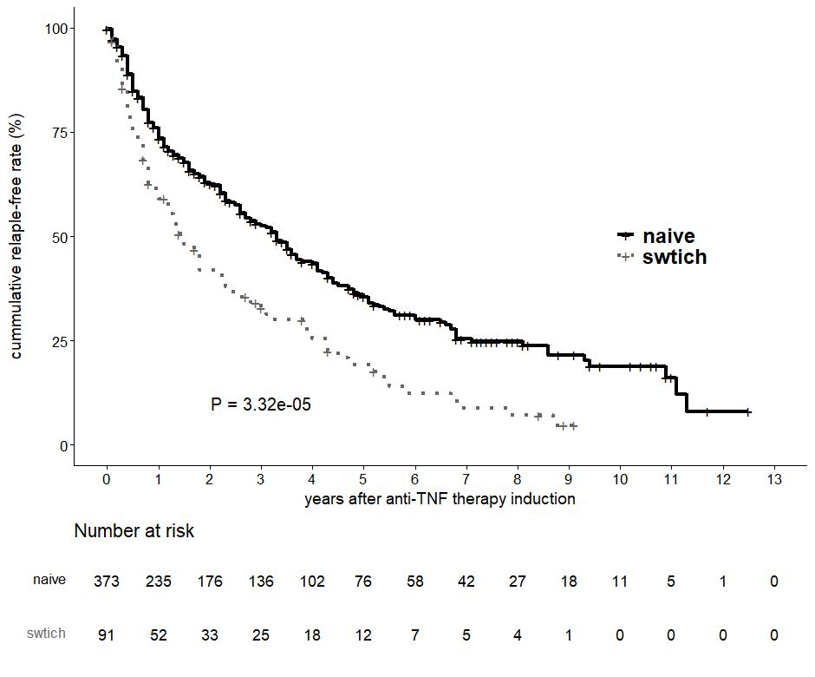
Supplementary Figure 2: Cumulative relapse-free survival rates of patients with Crohn’s disease in anti-tumor necrosis factor (anti-TNF) therapy switch group according to each clinical factor.
(a) Cumulative relapse-free survival rates for anti-TNF switch order.
(b) Cumulative relapse-free survival rates for disease behavior.
(c) Cumulative relapse-free survival rates for history of previous intestinal resection.
(d) Cumulative relapse-free survival rates for serum albumin level.
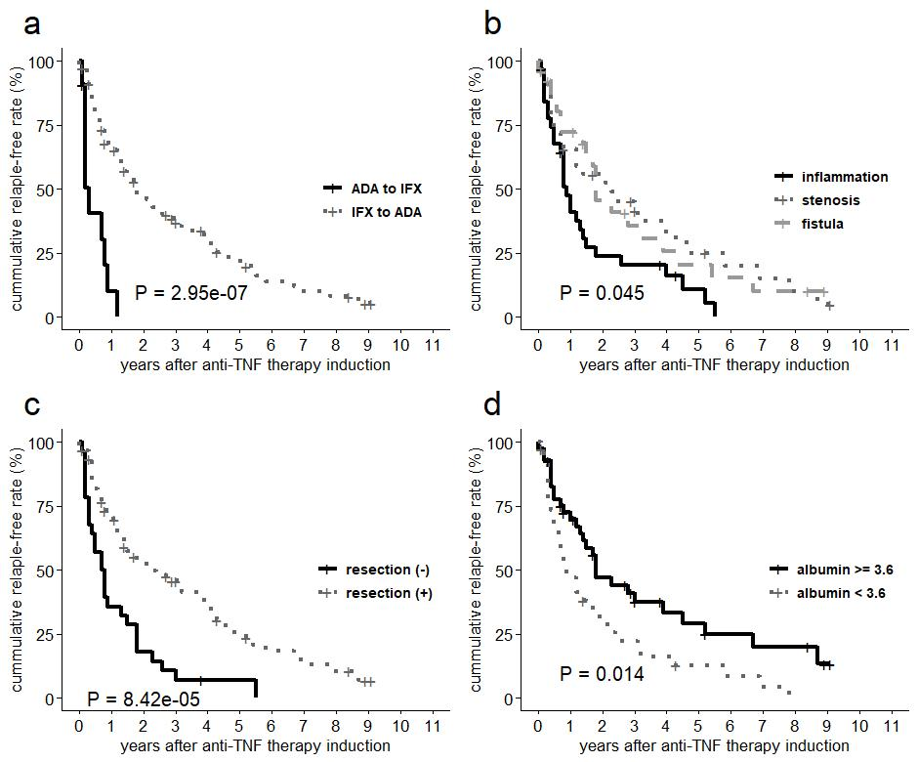

Supplementary Figure 3: Cumulative relapse-free survival rates of patients with Crohn’s disease in anti-tumor necrosis factor therapy naïve group according to each genetic factor.
(a) Cumulative relapse-free survival rates for rs12613485.
(b) Cumulative relapse-free survival rates for rs1029898.
(c) Cumulative relapse-free survival rates for rs338887.

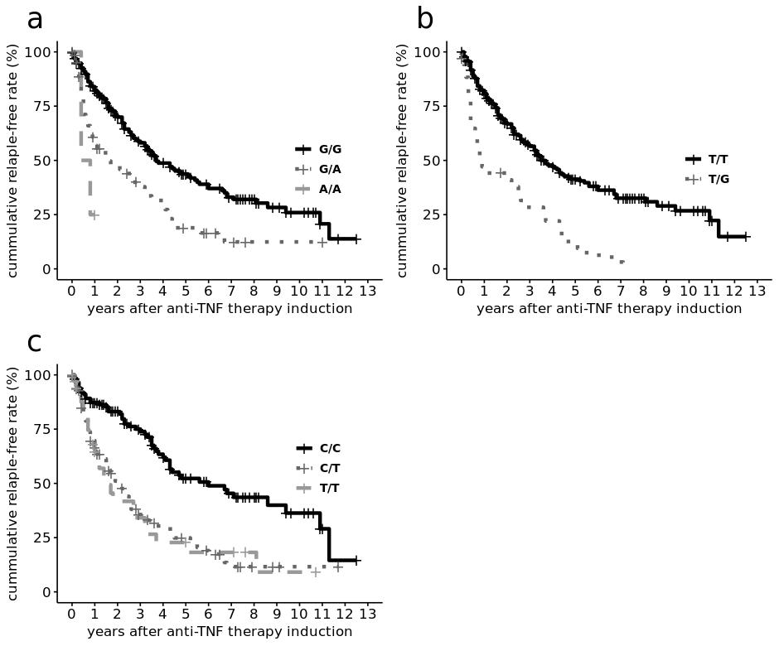

Supplementary Table 1: Association between previously reported SNPs and cumulative relapse-free rates in this study.

References | rsID | Genes | CHR | Position | A1 | A2 | AF_A2 | P-value | HR (95％ CI)
Matsukura et al. | rs3397 | TNFRSF1B | 1 | 12207235 | C | T | 0.34 | 6.13E-01 | 1.07 (0.82-1.39)
 | rs1061624 | TNFRSF1B | 1 | 12207208 | A | G | 0.48 | 6.64E-01 | 0.95 (0.75-1.21)
Urabe et al. | rs766748 | IL-17F | 6 | 52238101 | C | T | 0.26 | 7.05E-01 | 1.05 (0.81-1.35)
 | rs1883136 | TRAF3IP2 | 6 | 111585820 | C | A | 0.39 | 7.52E-01 | 1.04 (0.8-1.35)
Matsuoka et al. | rs1799724 | TNF | 6 | 31574705 | C | T | 0.18 | 3.95E-01 | 0.88 (0.65-1.19)
 | rs767455 | TNFRSF1A | 12 | 6341779 | T | C | 0.15 | 6.20E-01 | 1.09 (0.78-1.52)
 | rs976881 | TNFR1SF1B | 1 | 12173697 | C | T | 0.16 | 5.18E-01 | 1.1 (0.83-1.46)
 | rs1061622 | TNFRSF1B | 1 | 12192898 | T | G | 0.11 | 9.42E-01 | 1.01 (0.69-1.48)
 | rs1801274 | FCGR2A | 1 | 161509955 | A | G | 0.18 | 1.97E-02 | 1.41 (1.06-1.88)
 | rs396991 | FCGR3A | 1 | 161544752 | A | C | 0.27 | 3.82E-01 | 0.89 (0.69-1.15)
Park et al. | rs2158962 | TRAP1 | 16 | 3688026 | G | A | 0.35 | 5.91E-01 | 0.94 (0.73-1.19)
Sazonovs et al. | rs2097432 | HLA-DQA1*05 | 6 | 32622994 | T | C | 0.11 | 4.47E-01 | 0.86 (0.57-1.28)
Endo et al. | rs6478109 | TNFSF15 | 9 | 114806486 | G | A | 0.23 | 2.32E-01 | 0.84 (0.64-1.12)

Abbreviations: SNP, single-nucleotide polymorphism; CHR, chromosome number; AF_A2, minor allele frequency of A2 allele in our cohort; HR, hazard ratio;
Positions are based on the Genome Reference Consortium human build 38 (GRCh38)

Supplementary Table 2: Results of pathway analysis.

Dataset | Pathways | Number of Genes | P-value
REACTOME | Signaling by TGFb family members | 100 | 3.06E-04
REACTOME | Signaling by TGF beta receptor complex | 73 | 7.79E-04
REACTOME | IRAK1 recruits ikk complex | 12 | 1.73E-03
REACTOME | Selective autophagy | 76 | 1.73E-03
KEGG | Basal transcription factors | 32 | 2.67E-03
REACTOME | RHOC gtpase cycle | 68 | 3.28E-03
Wikipathways | Nipbl role in DNA damage cornelia de lange syndrome | 7 | 3.58E-03
REACTOME | Reactions specific to the complex n glycan synthesis pathway | 10 | 3.83E-03
REACTOME | Downregulation of TGF beta receptor signaling | 26 | 3.97E-03
REACTOME | Lectin pathway of complement activation | 8 | 5.20E-03

