Supplemental Digital Content 3
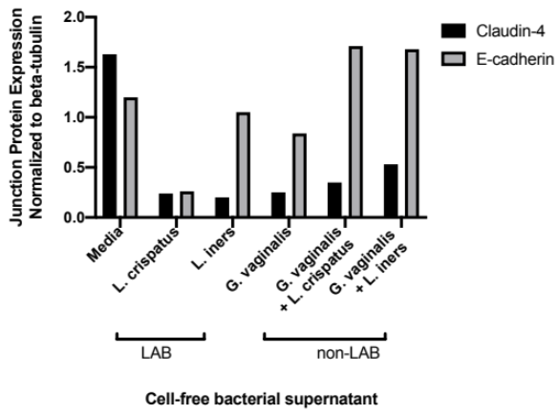  A | 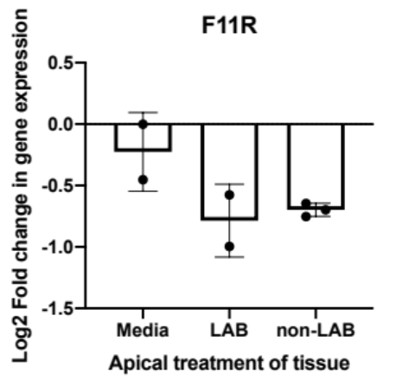  B
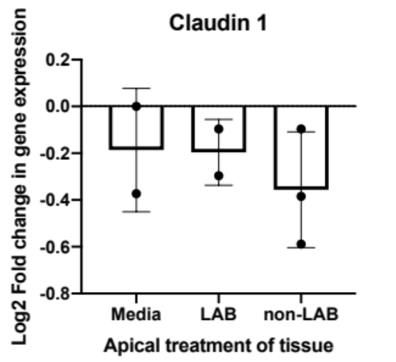  C | 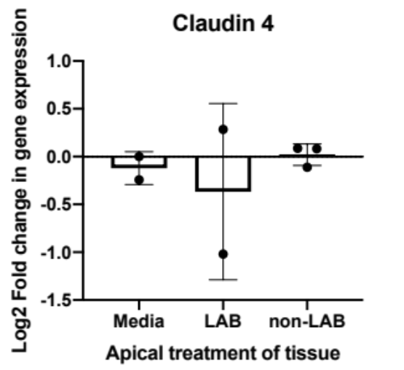  D
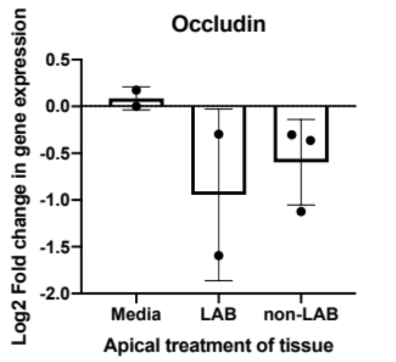  E | 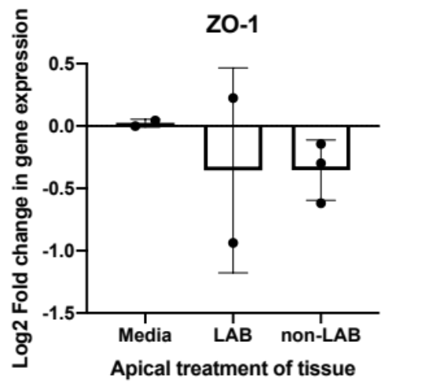  F
Figure S2: Expression of tight junction proteins in response to cell-free bacterial supernatants. A shows the levels of junction proteins, claudin-4 and E-cadherin, in relation to beta tubulin as measured by western blot. Protein bands (not shown) were quantified by the gel analyzer tool in the Fiji distribution of ImageJ (version 1.52p). B-F show the change in mRNA levels of the tight junctions F11R, claudin-1 and 4, occludin and ZO-1 respectively, due to treatment of vaginal epithelial tissues with bacterial cell-free supernatant. LAB was L. iners and L. crispatus cell-free supernatant and non-LAB was G. vaginalis only and G. vaginalis combined with either L. iners or L. crispatus. When treatments were compared to media or between each other, there was no statistically significant difference.

