Supplemental Table S3 Major bacterial species (TOP and BOTTOM) associated with CBCL domains determined by balance method
- For CBCL depression
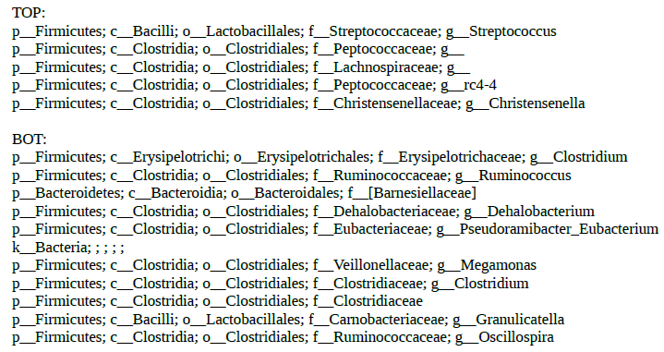

- For CBCL anxiety
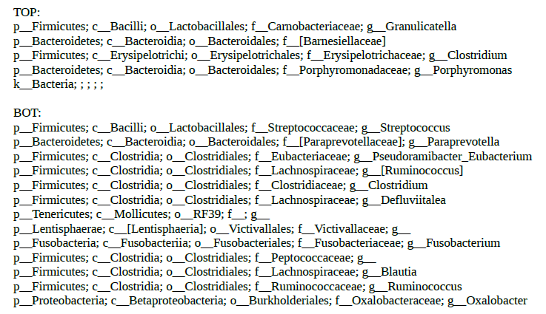
- For CBCL autism
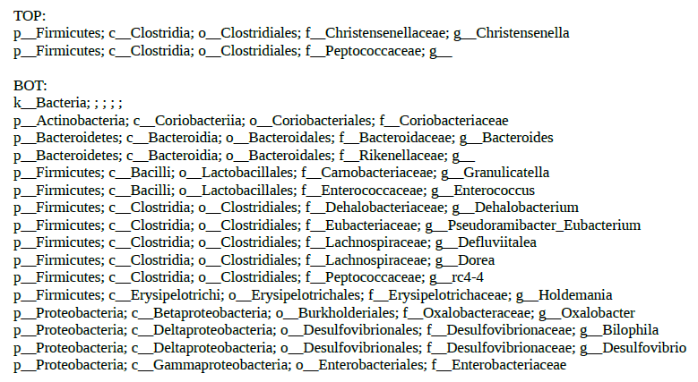

- For CBCL ADHD
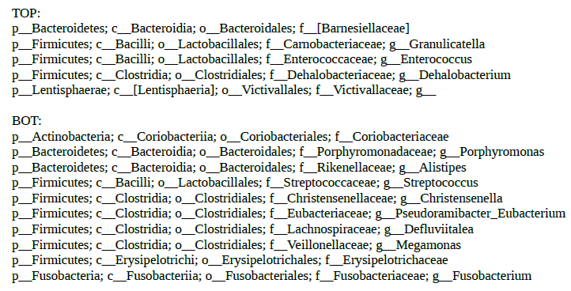

- For CBCL oppositional

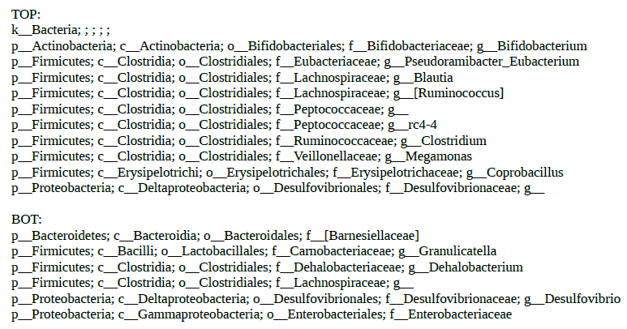

- For CBCL externalizing score
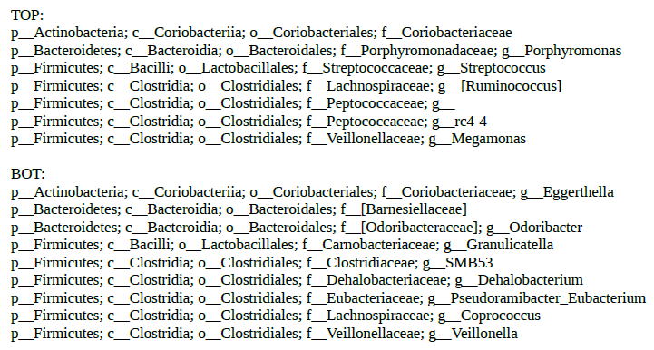

- For CBCL internalizing score

