Morphological plasticity of six tree species with different light demands growing in multi-layered deciduous forests in Central Europe

Leszek Bartkowicz^{1*}, Jarosław Paluch¹
¹ Department of Silviculture, Faculty of Forestry,University of Agriculture, Cracow, Al. 29 Listopada 46, 31-425, Poland
*Corresponding author: Tel. +12 662 53 72; Fax +12 411 97 15; leszek.bartkowicz@urk.edu.pl;

Table S1
Location and site characteristics of the sample plots.
Plot no. | Location | Soil¹ | Forest association² | N/ha | Basal area  (m²ha⁻¹) | Volume  (m³ha⁻¹) | Species composition³  (% of basal area)
1. | 50.093°N  20.364°E | Stagnosol | oak-hornbeam | 450 | 35.5 | 471 | Oa41-Pi25-Li21-Ho13
2. | 50.096°N  20.378°E | MollicCambisol | oak-hornbeam | 422 | 31.7 | 395 | Li39-Oa26-Pi18-Ho17
3. | 50.088°N  20.364°E | Cambisol | oak-hornbeam | 448 | 28.9 | 358 | Li34-Oa33-Ho30-Pi3
4. | 50.083°N  20.389°E | Stagnosol | oak-hornbeam wet variant | 236 | 32.6 | 488 | Oa54-Ho30-Li16
5. | 50.086°N  20.388°E | Stagnosol | oak-hornbeam  wet variant | 248 | 30.4 | 430 | Oa48-Li34-Ho18
6. | 50.089°N  20.356°E | MollicCambisol | oak-hornbeam  wet variant | 344 | 36.8 | 473 | Oa33-Li27-Ho22-Al18
7. | 50.007°N  20.418°E | Stagnosol | oak-hornbeam  wet variant | 253 | 25.6 | 345 | Oa87-Li9-Ho3-Al1
8. | 50.112°N  20.425°E | Stagnosol | oak-hornbeam  wet variant | 567 | 27.9 | 302 | Oa65-Li17-Ho9-As7-o2
9. | 50.110°N  20.373°E | MollicCambisol | oak-hornbeam wet variant | 500 | 35.6 | 527 | As46-Oa34-Ho17-Pi3
10. | 50.101°N  20.355°E | MollicCambisol | oak-hornbeam/  riparian | 436 | 32.4 | 471 | Oa42-As39-Li12-Ho4-o3
11. | 50.109°N  20.352°E | MollicCambisol | oak-hornbeam/  riparian | 373 | 30.6 | 477 | Oa48-As37-Al7-o5-El3
12. | 50.064°N  20.375°E | Gleysol | riparian | 317 | 38.1 | 497 | Oa61-Al14-Ho14-El6 -Oa4-Pi1
13. | 50.103°N  20.381°E | Stagnosol | riparian | 286 | 35.8 | 518 | Oa57-El22-Al16-Ho4-Li1
14. | 50.079°N  20.366°E | Stagnosol | riparian | 344 | 35.3 | 464 | Al36-El35-Oa19-Ho10
15. | 50.079°N  20.375°E | Stagnosol | riparian | 278 | 41.4 | 577 | Al46-Oa22-El21-Ho9-Li2
16. | 50.082°N  20.369°E | Stagnosol | riparian  wet variant | 583 | 35.4 | 406 | Al52-El21-Oa11-Li8-Ho5-o3
17. | 50.008°N  20.417°E | Stagnosol | riparian  wet variant | 305 | 33.5 | 464 | Oa72-Al25-Ho2-o1
Notes:
¹according to IUSS Working Group WRB (2015)
²according to Matuszkiewicz (2001): oak-hornbeam(Tilio-Carpinetumtypicum), oak-hornbeam − wet variant (Tilio-Carpinetumstachyetosum), riparian forest (Ficario-Ulmetumminoris), riparian − wet variant (Fraxino-Alnetum)
³species: Al–alder Alnus glutinosa(L.) Gaertner, Oa –oak Quercus roburL., As –ash Fraxinus excelsior L., Pi –pine Pinus sylvestris L., Li – lime Tilia cordata Miller, Ho –hornbeam Carpinus betulus L., El – elms Ulmuslaevis Pall. and Ulmus minor Miller, o–others.

Table S2
Number of trees used for modelling of morphological parameters.

Species | Lowerlayer | Upperlayer
Alder | 169 | 114
Oak | 236 | 140
Ash | 166 | 24
Elm | 183 | 20
Lime | 370 | 31
Hornbeam | 763 | 6
Total | 1887 | 335

Table S3
Estimated parameters ofthe analysed allometric relationships for trees from the lower stand layer.
Variable | Param. estimate | Std. error | t stat. | p-value | F stat | df | p-value | Adj. R²
Dbh (cm)
Intercept | 1,9036 | 0,0312 | 61,1 | 0,000 | 1085.4 | 1874 | <0,001 | 0.87
H*Al | 0,0743 | 0,0017 | 43,0 | 0,000
H*Oa | 0,0780 | 0,0014 | 57,6 | 0,000
H*As | 0,0552 | 0,0024 | 23,1 | 0,000
H*El | 0,0734 | 0,0020 | 36,8 | 0,000
H*Li | 0,0767 | 0,0015 | 50,0 | 0,000
H*Ho | 0,0747 | 0,0016 | 48,2 | 0,000
CI*Al | -0,1061 | 0,0168 | -6,3 | 0,000
CI*Oa | -0,1330 | 0,0123 | -10,8 | 0,000
CI*As | -0,1139 | 0,0116 | -9,9 | 0,000
CI*El | -0,0895 | 0,0074 | -12,2 | 0,000
CI*Li | -0,0799 | 0,0058 | -13,8 | 0,000
CI*Ho | -0,1034 | 0,0041 | -25,1 | 0,000
Crown length (m)
Intercept | 2,7444 | 0,3237 | 8,5 | 0,000 | 290.9 | 1874 | <0,001 | 0.65
H*Al | 0,3295 | 0,0180 | 18,3 | 0,000
H*Oa | 0,3351 | 0,0141 | 23,8 | 0,000
H*As | 0,4558 | 0,0249 | 18,3 | 0,000
H*El | 0,5406 | 0,0207 | 26,1 | 0,000
H*Li | 0,4866 | 0,0159 | 30,5 | 0,000
H*Ho | 0,5750 | 0,0161 | 35,7 | 0,000
CI*Al | -0,8299 | 0,1742 | -4,8 | 0,000
CI*Oa | -1,1223 | 0,1280 | -8,8 | 0,000
CI*As | -0.6988 | 0.1200 | -5.8 | 0.000
CI*El | -0.5569 | 0.0765 | -7.3 | 0.000
CI*Li | -0.3323 | 0.0600 | -5.5 | 0.000
CI*Ho | -0.5528 | 0.0428 | -12.9 | 0.000
Crown width (m)
Intercept | 1,7246 | 0,0314 | 54,9 | 0,0000 | 255.7 | 1874 | <0.001 | 0.62
H*Al | 0,0142 | 0,0017 | 8,1 | 0,0000
H*Oa | 0,0283 | 0,0014 | 20,7 | 0,0000
H*As | 0,0171 | 0,0024 | 7,1 | 0,0000
H*El | 0,0222 | 0,0020 | 11,0 | 0,0000
H*Li | 0,0305 | 0,0015 | 19,7 | 0,0000
H*Ho | 0,0333 | 0,0016 | 21,3 | 0,0000
CI*Al | -0,1277 | 0,0169 | -7,5 | 0,0000
CI*Oa | -0,2294 | 0,0124 | -18,5 | 0,0000
CI*As | -0,1548 | 0,0117 | -13,3 | 0,0000
CI*El | -0,0551 | 0,0074 | -7,4 | 0,0000
CI*Li | -0,0736 | 0,0058 | -12,6 | 0,0000
CI*Ho | -0,0593 | 0,0042 | -14,3 | 0,0000
Crown volume (m³)
Intercept | 4,0761 | 0,0879 | 46,4 | 0,0000 | 363.9 | 1874 | <0.001 | 0.70
H*Al | 0,0739 | 0,0049 | 15,2 | 0,0000
H*Oa | 0,1024 | 0,0038 | 26,8 | 0,0000
H*As | 0,0993 | 0,0067 | 14,7 | 0,0000
H*El | 0,1105 | 0,0056 | 19,6 | 0,0000
H*Li | 0,1206 | 0,0043 | 27,9 | 0,0000
H*Ho | 0,1370 | 0,0044 | 31,3 | 0,0000
CI*Al | -0,4133 | 0,0473 | -8,7 | 0,0000
CI*Oa | -0,6761 | 0,0347 | -19,5 | 0,0000
CI*As | -0,4439 | 0,0326 | -13,6 | 0,0000
CI*El | -0,1832 | 0,0208 | -8,8 | 0,0000
CI*Li | -0,1985 | 0,0163 | -12,2 | 0,0000
CI*Ho | -0,1929 | 0,0116 | -16,6 | 0,0000
Notes: The models had a general form:
$Y_{i}=b_{0}+b_{1i}H+b_{2i}CI+e$,
where Y denotes a response variable, $H$ is tree height, $CI$ is competition index, $b_{0}$ is non-specific intercept, $b_{1}$ and $b_{2}$are species-specific slope parameters describing the effect of height and competition, and e terms model error. To stabilize the variances,
dbh, crown width and crown volume were introduced in the logarithmic form. Species: Al – alder Alnus glutinosa(L.) Gaertner, Oa – oak Quercus roburL., As – ash Fraxinus excelsior L., Pi – pine Pinus sylvestris L., Li – lime Tilia cordata Miller, Ho – hornbeam Carpinus betulus L., El – elms Ulmuslaevis Pall. and Ulmus minor Miller, o – others. Tree species are ordered according to increasing shade tolerance.

Table S4
Estimated parameters of the analysed allometric relationships for trees from the upper stand layer.
Variable | Param. estimate | Std. error | t stat. | p-value | F stat | df | p-value | Adj. R²
Dbh
Intercept | 3,5587 | 0,1453 | 24,5 | 0,0000 | 61.2 | 322 | <0.001 | 0.68
H*Al | 0,0160 | 0,0051 | 3,1 | 0,0019
H*Oa | 0,0304 | 0,0046 | 6,6 | 0,0000
H*As | 0,0299 | 0,0040 | 7,5 | 0,0000
H*El | 0,0352 | 0,0053 | 6,7 | 0,0000
H*Li | 0,0276 | 0,0058 | 4,8 | 0,0000
H*Ho | 0,0352 | 0,0125 | 2,8 | 0,0051
CI*Al | -0,1579 | 0,0261 | -6,0 | 0,0000
CI*Oa | -0,2719 | 0,0413 | -6,6 | 0,0000
CI*As | -0,3116 | 0,0583 | -5,3 | 0,0000
CI*El | -0,3831 | 0,0680 | -5,6 | 0,0000
CI*Li | -0,2604 | 0,0735 | -3,5 | 0,0005
CI*Ho | -0,5895 | 0,3117 | -1,9 | 0,0595
Crown length
Intercept | 7.1330 | 2.2601 | 3.2 | 0.0018 | 23.4 | 322 | <0.001 | 0.45
H*Al | 0.1907 | 0.0797 | 2.4 | 0.0173
H*Oa | 0.2895 | 0.0714 | 4.1 | 0.0001
H*As | 0.3220 | 0.0620 | 5.2 | 0.0000
H*El | 0.2312 | 0.0820 | 2.8 | 0.0051
H*Li | 0.2708 | 0.0902 | 3.0 | 0.0029
H*Ho | 0.4926 | 0.1942 | 2.5 | 0.0117
CI*Al | -1.1571 | 0.4062 | -2.8 | 0.0047
CI*Oa | -2.8221 | 0.6418 | -4.4 | 0.0000
CI*As | -2.0568 | 0.9072 | -2.3 | 0.0240
CI*El | 0.4940 | 1.0572 | 0.5 | 0.6406
CI*Li | 0.5371 | 1.1432 | 0.5 | 0.6388
CI*Ho | 1.1719 | 4.8491 | 0.2 | 0.8092
Crown width
Intercept | 2,3677 | 0,1612 | 14,7 | 0,0000 | 74.7 | 322 | <0.001 | 0.73
H*Al | -0,0043 | 0,0057 | -0,8 | 0,4521
H*Oa | 0,0141 | 0,0051 | 2,8 | 0,0060
H*As | 0,0171 | 0,0044 | 3,9 | 0,0001
H*El | 0,0130 | 0,0059 | 2,2 | 0,0270
H*Li | 0,0110 | 0,0064 | 1,7 | 0,0893
H*Ho | 0,0240 | 0,0139 | 1,7 | 0,0844
CI*Al | -0,1958 | 0,0290 | -6,8 | 0,0000
CI*Oa | -0,2430 | 0,0458 | -5,3 | 0,0000
CI*As | -0,2598 | 0,0647 | -4,0 | 0,0001
CI*El | -0,2783 | 0,0754 | -3,7 | 0,0003
CI*Li | -0,1039 | 0,0816 | -1,3 | 0,2036
CI*Ho | -0,3356 | 0,3459 | -1,0 | 0,3326
 | 2,3677 | 0,1612 | 14,7 | 0,0000
Crown volume
Intercept | 6,0449 | 0,4335 | 13,9 | 0,0000 | 68.6 | 322 | <0.001 | 0.71
H*Al | 0,0113 | 0,0153 | 0,7 | 0,4593
H*Oa | 0,0550 | 0,0137 | 4,0 | 0,0001
H*As | 0,0596 | 0,0119 | 5,0 | 0,0000
H*El | 0,0481 | 0,0157 | 3,1 | 0,0024
H*Li | 0,0461 | 0,0173 | 2,7 | 0,0082
H*Ho | 0,0894 | 0,0372 | 2,4 | 0,0170
CI*Al | -0,5432 | 0,0779 | -7,0 | 0,0000
CI*Oa | -0,7695 | 0,1231 | -6,3 | 0,0000
CI*As | -0,6687 | 0,1740 | -3,8 | 0,0001
CI*El | -0,5231 | 0,2028 | -2,6 | 0,0103
CI*Li | -0,1967 | 0,2193 | -0,9 | 0,3704
CI*Ho | -0,7067 | 0,9301 | -0,8 | 0,4479
Notes as per Table S3

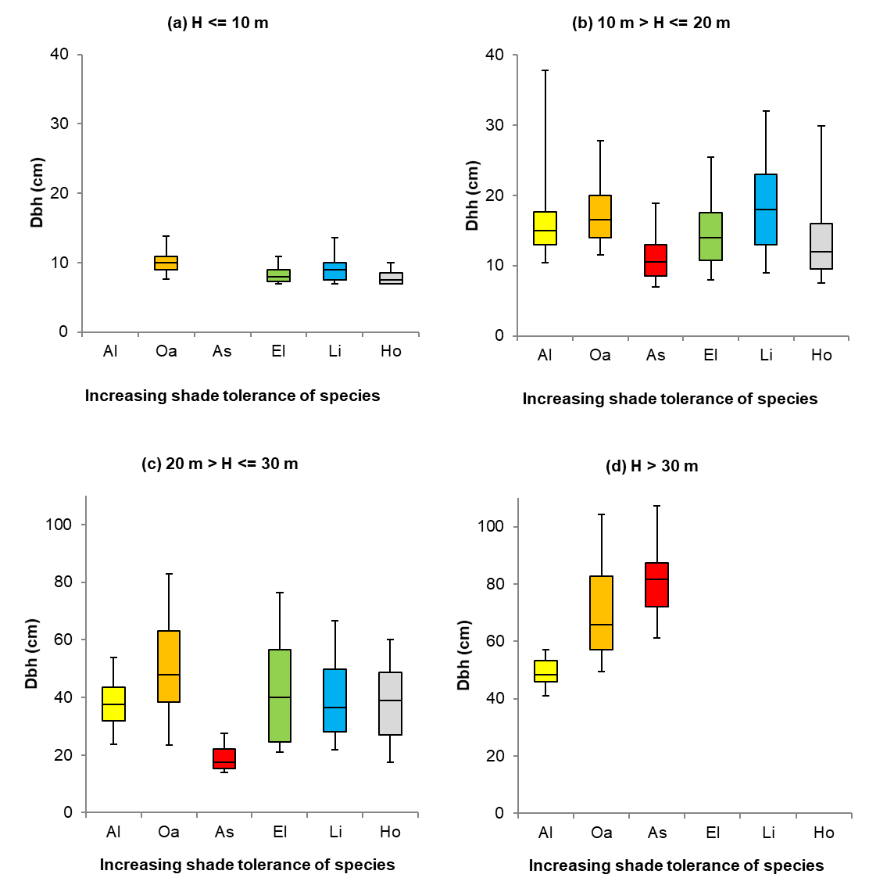
Fig. S1 Variation in dbh depending on species and tree height
Notes: The boxes and whiskers display 5, 25, 50, 75, 95th percentiles. For the height classes with less than 10 observations the results were not shown. Species: alder (Al), oak (Oa), ash (As), elm (El), lime (Li), hornbeam (Ho)

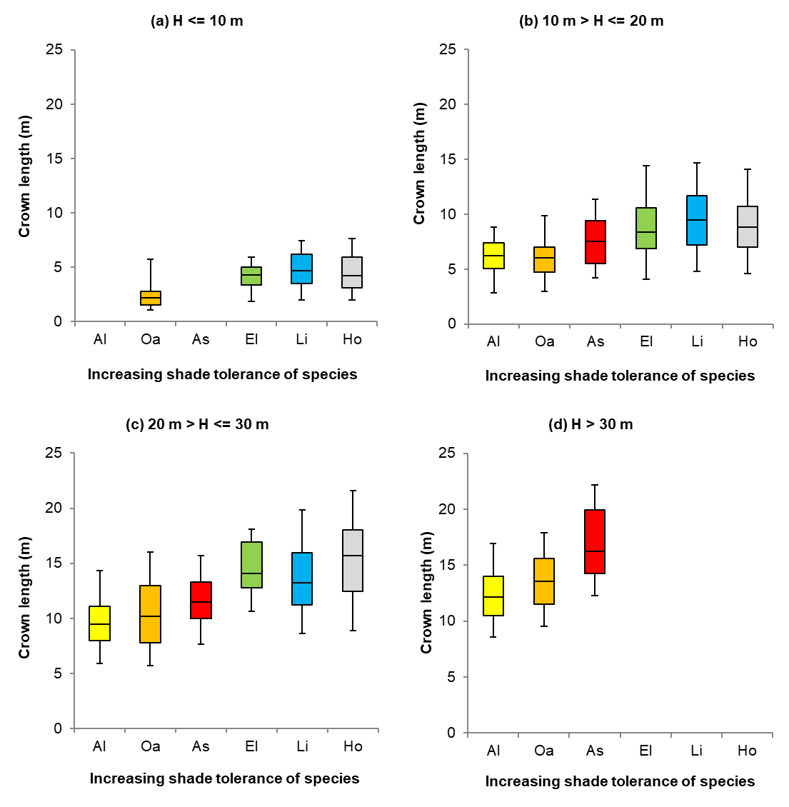
Fig. S2 Variation in crown length depending on species and tree height
Notes as per Fig. S1

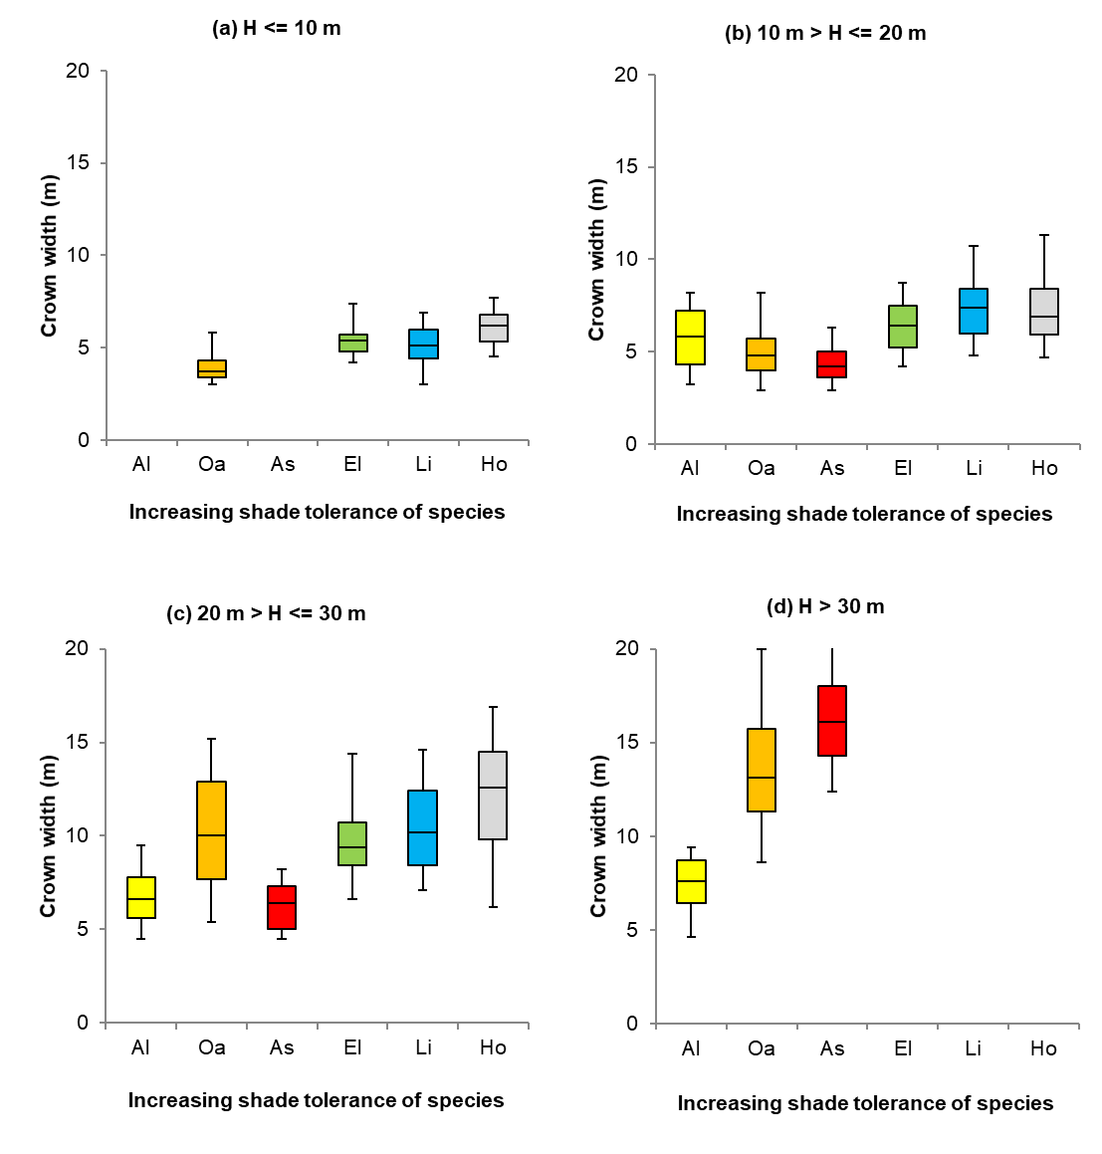
Fig. S3 Variation in crown width depending on species and tree height
Notes as per Fig. S1

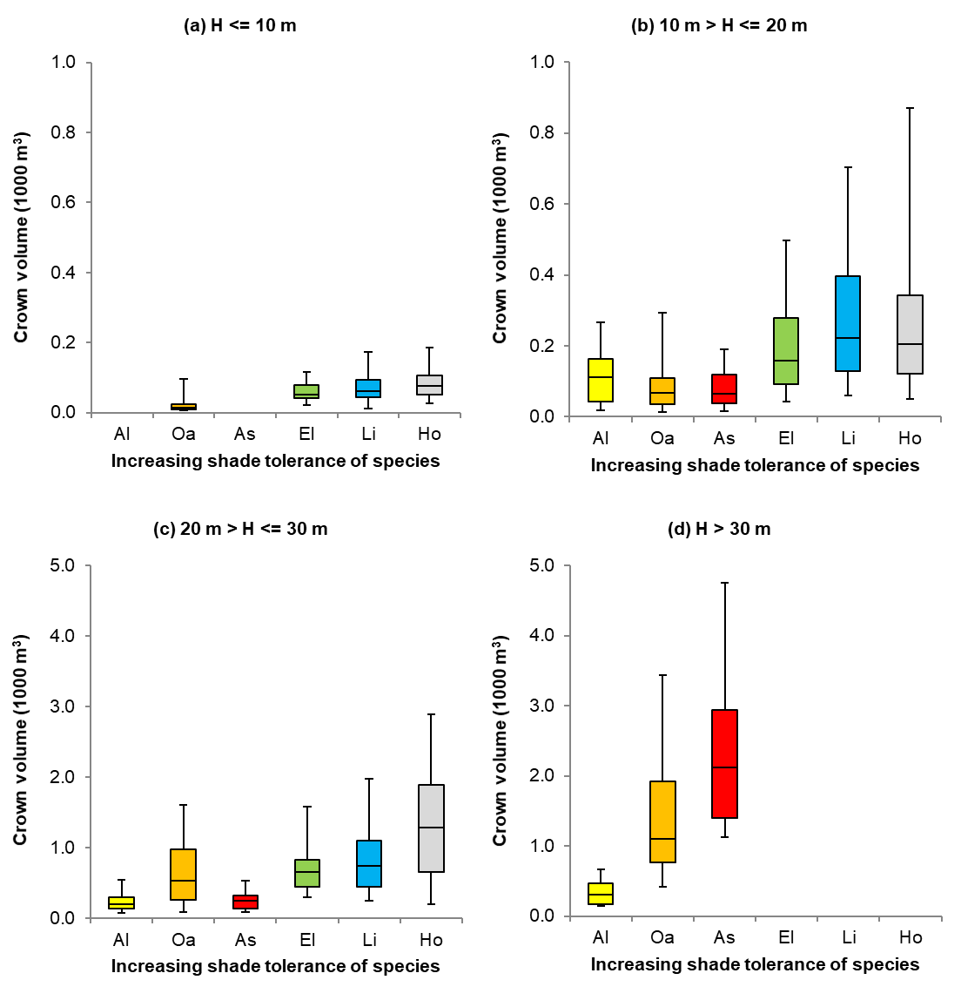
Fig. S4 Variation in crown volume depending on species and tree height
Notes as per Fig. S1
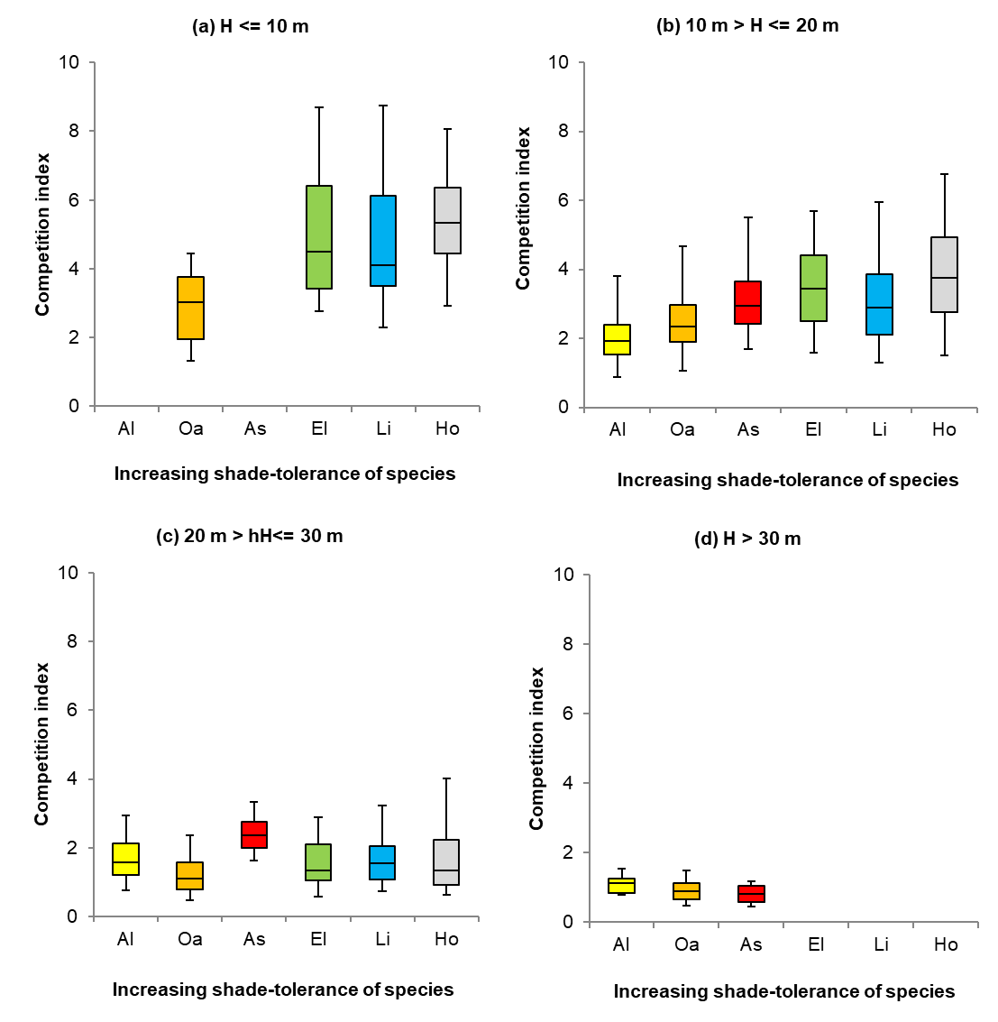
Fig. S5 Variation in competition index depending on species and tree height
Notes as per Fig. S1

