SUPPLEMENTARY INFORMATION

Step engineering for nucleation and domain orientation control in WSe₂ epitaxy on c-plane sapphire

Haoyue Zhu,^{1*} Nadire Nayir,^{1,2,3*} Tanushree H. Choudhury,^{1,4*} Anushka Bansal,⁵ Benjamin Huet,¹ Kunyan Zhang,⁶ Alexander A. Puretzky,⁷ Saiphaneendra Bachu,⁵ Krystal York,⁸ Thomas V. Mc Knight,⁵ Nicholas Trainor,⁵ Ke Wang,¹⁰ Robert A. Makin,⁸ Steven M. Durbin,⁸ Shengxi Huang,^{6,9} Nasim Alem,^{1,5} Vincent H. Crespi,^{1,11} Adri C.T. van Duin,^{1,3} Joan M. Redwing^{1,5}

¹2D Crystal Consortium Materials Innovation Platform, Materials Research Institute, The Pennsylvania State University, University Park, PA
²Department of Physics, Karamanoglu Mehmetbey University, Karaman 70000, Turkey
³Department of Mechanical Engineering, The Pennsylvania State University, University Park, PA
⁴ Department of Metallurgical Engineering and Materials Science, Indian Institute of Technology Bombay, Powai, Mumbai 400076
⁵Department of Materials Science and Engineering, The Pennsylvania State University, University Park, PA
⁶Department of Electrical Engineering, The Pennsylvania State University, University Park, PA
⁷Center for Nanophase Materials Sciences, Oak Ridge National Laboratory, Oak Ridge, TN
⁸Department of Electrical Engineering, Western Michigan University, Kalamazoo, MI
⁹Department of Electrical and Computer Engineering, Rice University, Houston, TX
¹⁰Materials Research Institute, The Pennsylvania State University, University Park, PA
¹¹Department of Physics, The Pennsylvania State University, University Park, PA

- Sample Data
Growth and characterization data associated with the samples produced in this study is available at https://m4-2dcc.vmhost.psu.edu/list/data/9. This includes substrate preparation and recipe data for samples grown by MOCVD in the 2DCC-MIP facility and standard characterization data including AFM images, Raman/PL spectra and FESEM images on the samples. The sample numbers associated with figures in the main manuscript are as follows:
Figure 1 MCV1-200316A-HZ, MCV1-200814A, MCV1-200813A, MCV200313A
Figure 2 MCV2-200914A-TM, 2009004A-TM
Figure 3 MCV1-200311A-HZ, MCV1-200310A-HZ
Figure 4 MCV2-210722A-KY, MCV1-210722B-KY
Figure 5 MCV1-200311A-HZ, MCV1-200316A-HZ, MCV1-200309A-HZ
Figure 6 MCV1-200722A-HZ
- Crystallographic planes of WSe₂ and α-Al₂O₃ and step structure of miscut sapphire.
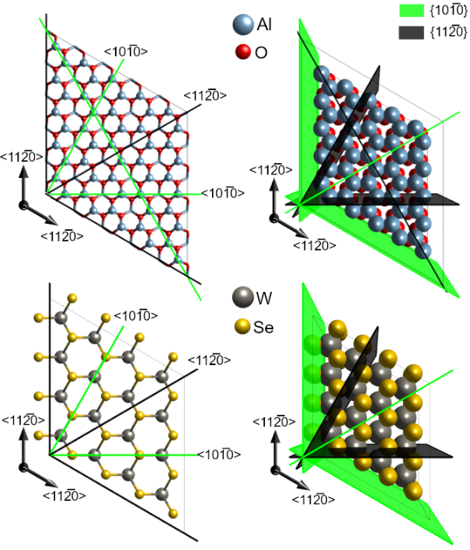
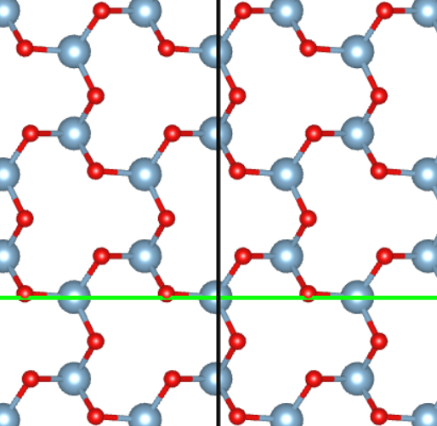
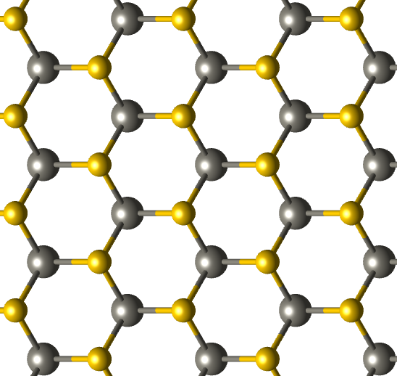
The substrates used in this study were 2” diameter double-side polished c-plane sapphire miscut 0.2° ± 0.1° toward the M(101̅0) plane – Figure S1 depicts the <101̅0> and <11$\overline{2}$0> directions of a c-plane sapphire and WSe₂. An AFM image (Fig. S2a) and height profile (Fig. S2b) of the miscut sapphire surface after annealing in H₂/H₂Se showing steps with ~0.2 nm height. For the simulations, an idealized step structure with the dimensions of 9×24×30 Å³ was constructed from a flat and five layer-thick c-plane α-Al₂O₃ (of which top four layers were allowed to relax while the bottom one was frozen) built by applying miscut towards M(101̅0) plane pointing toward the <101̅0> crystallographic direction, (Figure S2c-d) in alignment with experiments and previous works.,,
[101̅0]
[112̅0]
[101̅0]
[112̅0]
Figure S1. Schematic illustrations of the crystallographic directions and planes of c-plane sapphire and WSe_{2.}

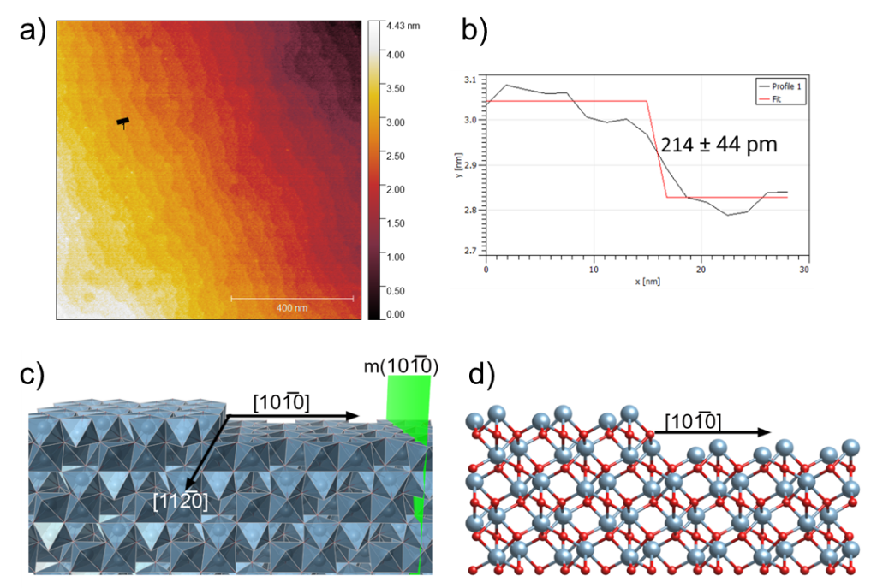
Figure S2. (a) AFM image of surface steps on c-plane sapphire after annealing in H₂/H₂Se; (b) step profile obtained from black line in (a) indicating a step height of ~0.2 nm; (c,d) Step edge structure of vicinal c-plane sapphire with miscut applied towards m-plane (101̅0).

- Three-step process used for MOCVD growth of WSe₂
The WSe₂ films were grown by MOCVD using two systems that are part of the 2D Crystal Consortium MIP facility at Penn State (http://www.mri.psu.edu/2d-crystal-consortium/user-facilities). The first system includes a cold-wall, horizontal reactor with inductive heating (MOCVD1) and the second is a multi-module system that includes a cold-wall vertical reactor with resistive heating (MOCVD2). In both systems, tungsten hexacarbonyl (W(CO)₆) and hydrogen selenide (H₂Se) were used as the metal and chalcogen precursors, respectively, with hydrogen (H₂) as the carrier gas. W(CO)₆ was kept in a stainless-steel bubbler held at a constant temperature (10-20 ℃) and pressure (760 Torr), and H₂ gas was passed through it to transport the precursor vapor to the reactor. Two-inch epi-ready c-plane sapphire ((0001)α-Al₂O₃) wafers with nominal miscut of 0.2° toward the m-axis were used as substrates for the growth without additional pre-treatment. The reactor pressure was kept constant at 200 Torr in MOCVD1 and was varied from 50-700 Torr in MOCVD2. For the growth of WSe₂, a modified three-step process (nucleation, ripening, lateral growth) was employed as illustrated in Figure S3.^{2,}
In MOCVD1, the inlet gas flow rates of W(CO)₆ were in the range of 6.4×10⁻⁵ to 1.3×10⁻⁴ sccm, and H₂Se was fixed with a flow rate of 75 sccm. Additional H₂ gas was introduced to achieve a total gas flow rate of 4.5 slpm through the reactor. In MOCVD2, the inlet gas flow rates of W(CO)₆ were in the range of 1.0×10⁻⁴ to 6.0×10⁻⁴ sccm, and H₂Se was fixed with a flow rate of 200 sccm. Additional H₂ gas was introduced to achieve a total gas flow rate of 10.1 slpm through the reactor. The c-plane sapphire substrate was first heated to a nucleation temperature of 850-875 ℃ in a H₂ atmosphere. W(CO)₆ and H₂Se were simultaneously introduced into the inlet gas stream to initiate growth. W(CO)₆ was initially introduced into the reactor at a higher flow rate (∼1.3 × 10⁻⁴ sccm for MOCVD1 and ∼6.0 × 10⁻⁴ sccm for MOCVD2) for 30 s to drive nucleation on the sapphire surface. Immediately after the nucleation step, the W(CO)₆ flow was removed from the inlet gas stream and the sample was annealed in H₂Se for 20 min while the susceptor temperature was ramped to 650-1050 ℃ for the lateral growth stage. The W(CO)₆ was then re-introduced into the inlet gas at a lower flow rate than the nucleation step (∼6.4 × 10⁻⁵ sccm for MOCVD and ∼1.0 × 10⁻⁴ sccm for MOCVD2) to limit further nucleation and promote lateral growth of the domains for times ranging from 1 to 60 mins. After growth, the sample was cooled to 300 ℃ under a flow of H₂ and H₂Se to avoid WSe₂ decomposition. After the temperature decreased below 200 ℃, the H₂ flow was stopped, the reactor was evacuated to 3×10⁻³ Torr, and a reactor purging procedure using N₂ was initiated to remove any residual H₂Se from the reactor before the sample was unloaded. The sample was then stored in a N₂-purged glovebox to avoid exposure to moisture and oxygen.

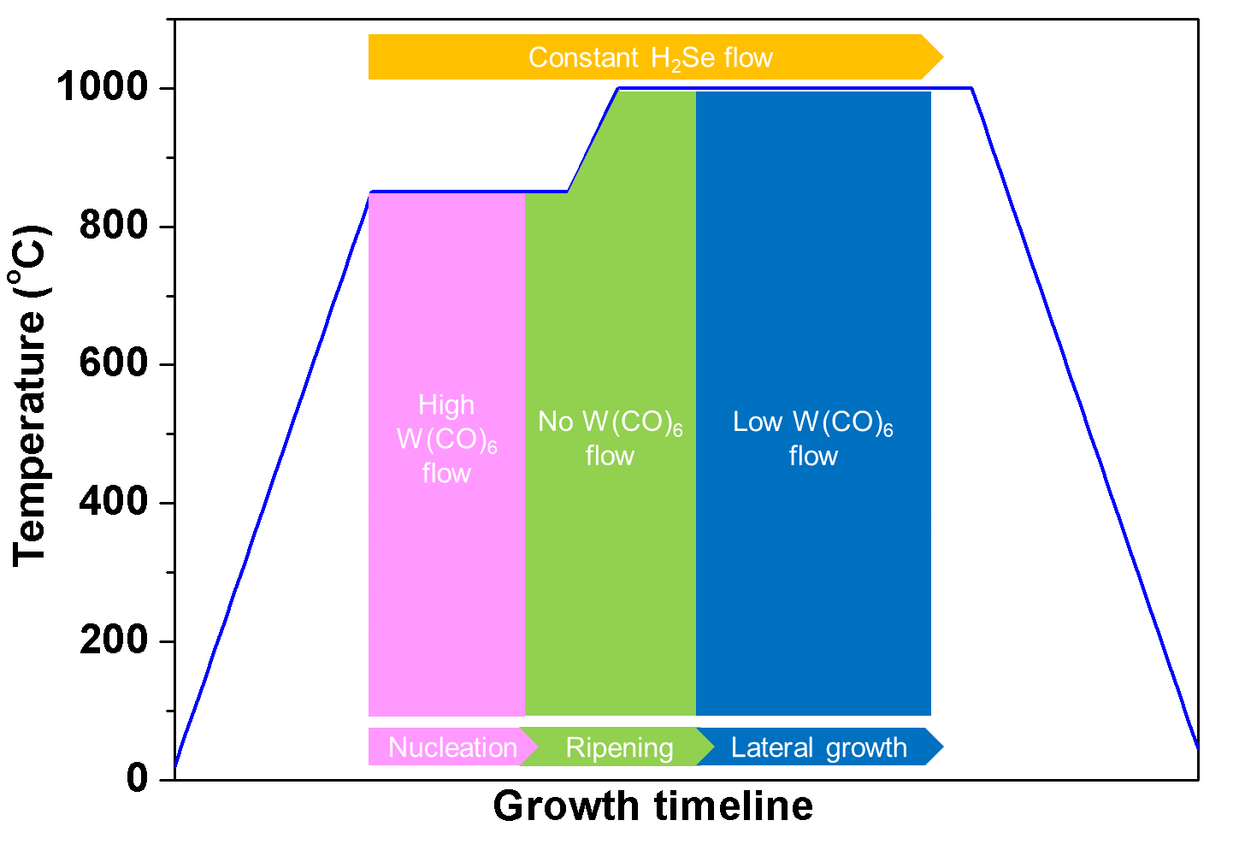
Figure S3. Schematic illustration of modified three-step process used for MOCVD growth of WSe₂ on sapphire.

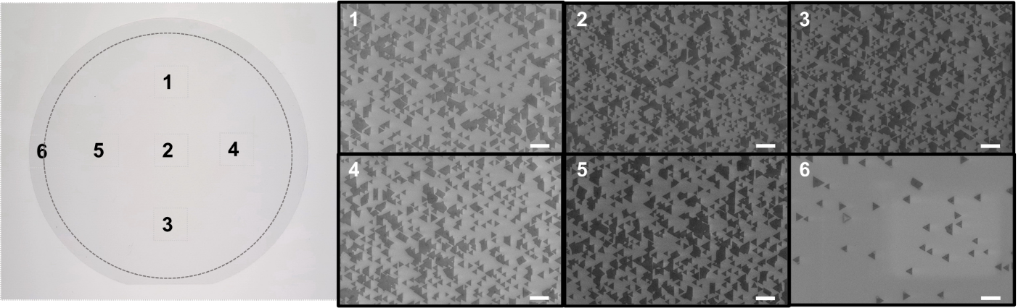
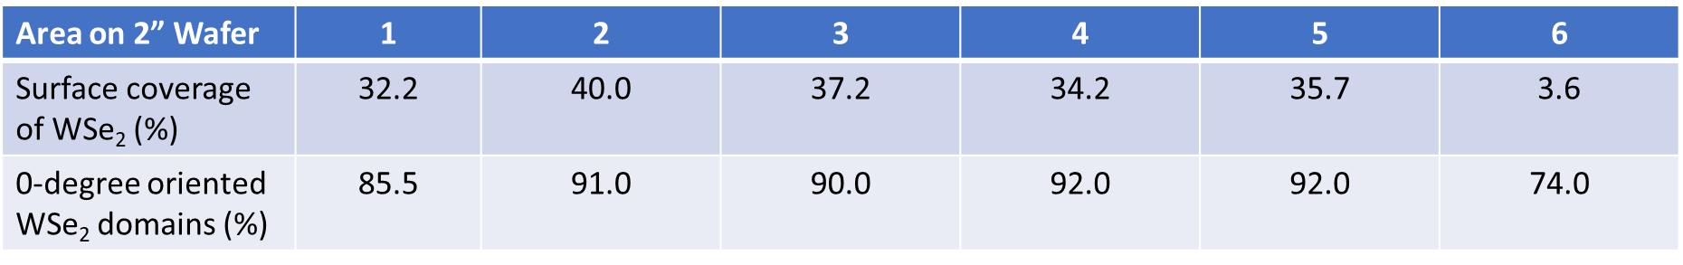
- Uniformity of 0° orientation of WSe₂ across 2” diameter c-plane sapphire
Figure S4. FESEM images of WSe₂ domains at six different locations across 2” diameter sapphire substrate and corresponding surface coverages and percentage of 0° oriented domains. Scale bar in all images is 1 μm.
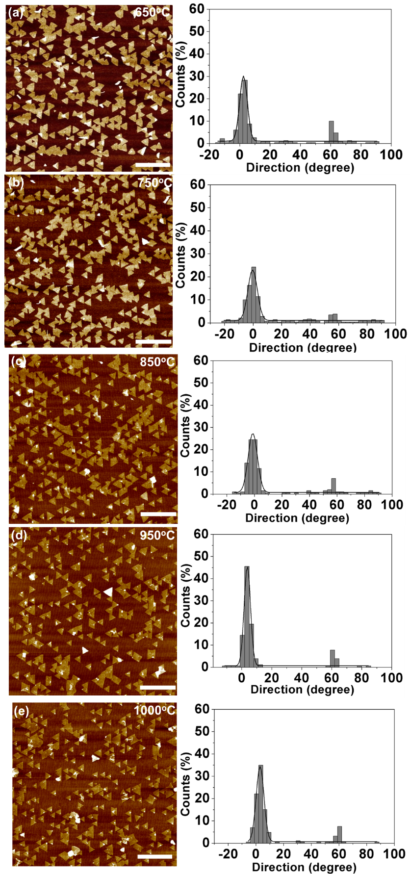
- Orientation of WSe₂ domains as a function of lateral growth temperature

- Kink-flow growth of WSe₂ step edge
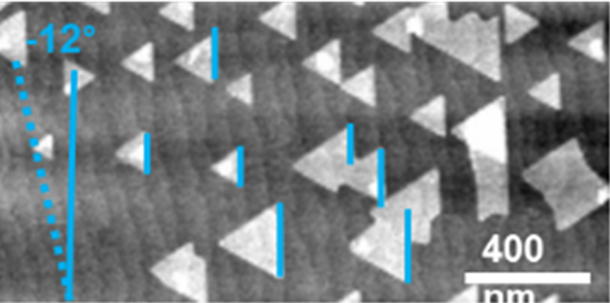
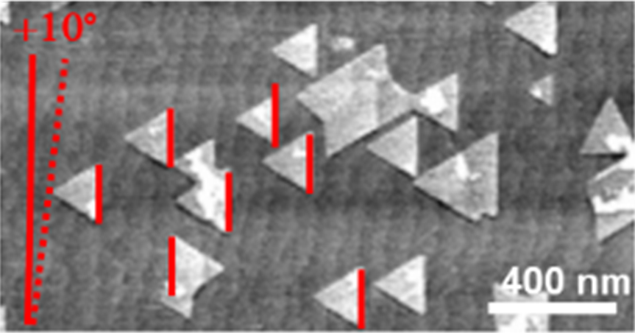
In a chalcogen-rich environment, the growth rate of Se-terminated zigzag edges is expected to be the slowest. On the other hand, slanted edges with kinks are a less stable edge structure with a higher growth rate than a linear zigzag edge because of the presence of the W under coordinated atoms located on the kinks which serve as an active site where the atoms can easily attach to/detach from with a negligible formation energy. However, the zigzag-edges in the Se-rich reservoir are usually fully saturated by Se atoms which requires a long time to complete its linear formation. This means that, at an early stage of growth, slanted edges should appear quickly and interact strongly with step edges. However, they should also quickly disappear during the kink flow growth of the edge, which eventually leads to the completion of the linear zigzag edge which remains perpendicular to the M-axis and the outgrowth of WSe₂ as depicted in Figure S6.
Step edge
Step edge
<1120>

<1120>
Figure S6. Kink flow growth mechanism. The completion of the linear zigzag edge of WSe₂ (white triangle) on sapphire with steps (gray background) which are oriented at +10º (blue dashed line) and -12º (red dashed line) relative to the A-axis of the sapphire. The linear zig-zag edge of the WSe₂ domains remains perpendicular to the M-axis (highlighted with solid blue and red lines).

- Passivation layer between WSe₂ and sapphire
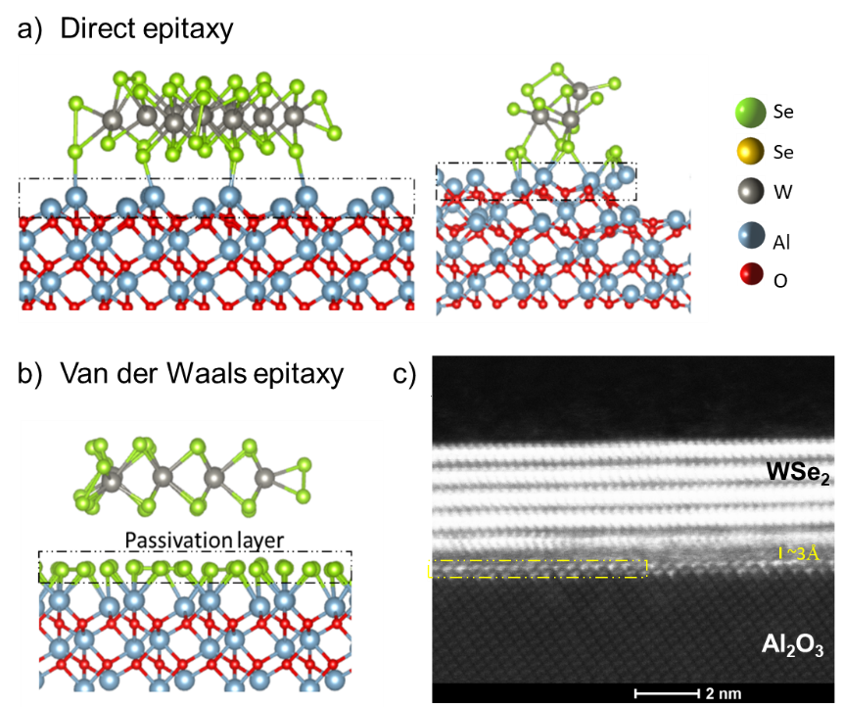
Direct growth on the top of the Al-terminated sapphire destroys the van der Waals nature of the interface and WSe₂ epilayer (Direct Epitaxy - Fig. S7a) while WSe₂ interacts with sapphire through weak van der Waals forces in the existence of a Se passivation layer (van der Waals Epitaxy – Fig. S7b). This result emphasizes the necessity of a passivation layer between epilayer and substrate to maintain the van der Waals nature of the WSe₂/sapphire interface.
Figure S7. Optimized configurations of triangle shaped WSe₂ on (a) Al- (direct epitaxy) and (b) Se-terminated sapphire (van der Waals epitaxy). (c) High angle annular dark-field (HAADF) TEM image of cross-section of WSe₂ multilayer film grown by MOCVD on c-plane sapphire showing a van der Waals gap consistent with the presence of a Se-passivation layer (dashed box) at the film/substrate interface.

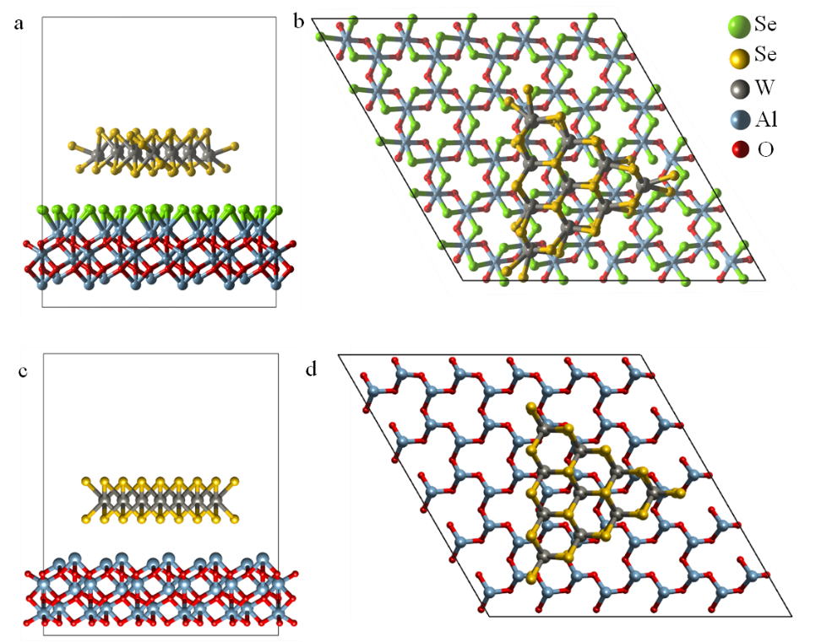
Two different surface terminations (Al and Se) were considered to investigate the epitaxy type of WSe₂ on sapphire (Fig. S8). A triangle shaped WSe₂ was deposited on the top of sapphire by leaving 3.2 Å between the epilayer and substrate surface in both models, and structurally relaxed.
Figure S8. Initial configurations of 0º/60º oriented triangle WSe₂ on c-plane (a, b) Se- and (c, d) Al-terminated sapphire. Note that the orientations of 0°/60° of WSe₂ are taken with respect to the step direction which corresponds to the [112̅0] direction of sapphire

- Epitaxial relation between WSe₂ and a flat c-plane sapphire
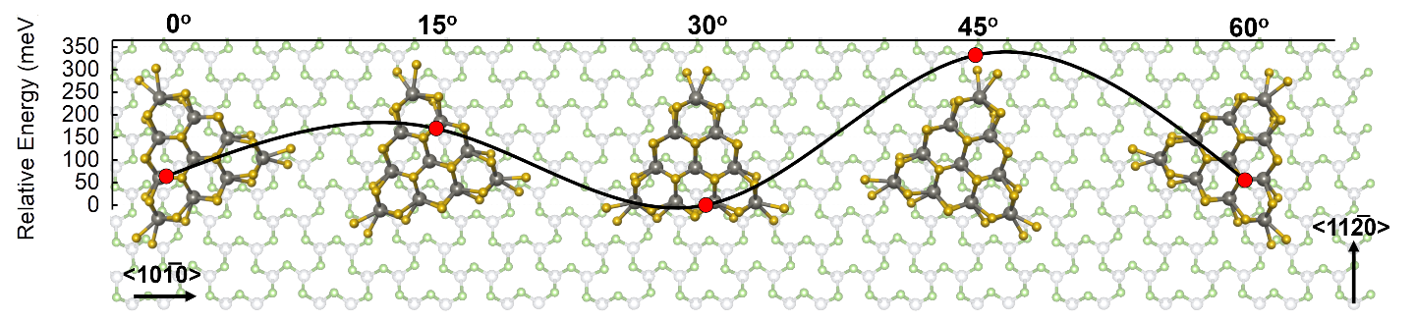
The preferential orientation of WSe₂ on a c-plane sapphire with Se termination was investigated. The relative total energy was computed by rotating a triangle WSe₂ cluster with a dimension of 13.16 Å on a 24.03×24.03×5.71 Å² substrate with respect to the <101̅0> direction of sapphire as shown in Figure S1 where 30º → <101̅0>WSe₂ ₍₀₀₀₁₎//<112̅0>Al₂O₃ ₍₀₀₀₁₎ and 0º → <101̅0>WSe₂ ₍₀₀₀₁₎//<101̅0>Al₂O₃ ₍₀₀₀₁₎ (Figure S9). The inter-distance between the cluster and substrate was kept at 3.2 Å and a vacuum spacing of 20 Å was left along the z-direction. During the calculations, the top two layers of a three layer-thick sapphire were allowed to relax while the bottom layer was frozen. Note that the distance between the WSe₂ cluster and sapphire surface optimized at the angle of 0° was used for all the rotation angles and step edge calculations. As depicted in Figure S9, the 30° orientation is found as the most stable configuration where the triangle WSe₂ domain is aligned with one of its side parallel to M<10$\overline{1}$0> direction of the underlying sapphire substrate, followed by the 0°/60° alignments. This configuration is most stable only for an atomically flat surface. The presence of steps modifies the interaction between WSe₂ and the underlying sapphire substrate.
Figure S9. DFT based WSe₂ alignment on sapphire as a function of orientation angle.

- Step-edge model of WSe₂ on c-plane sapphire
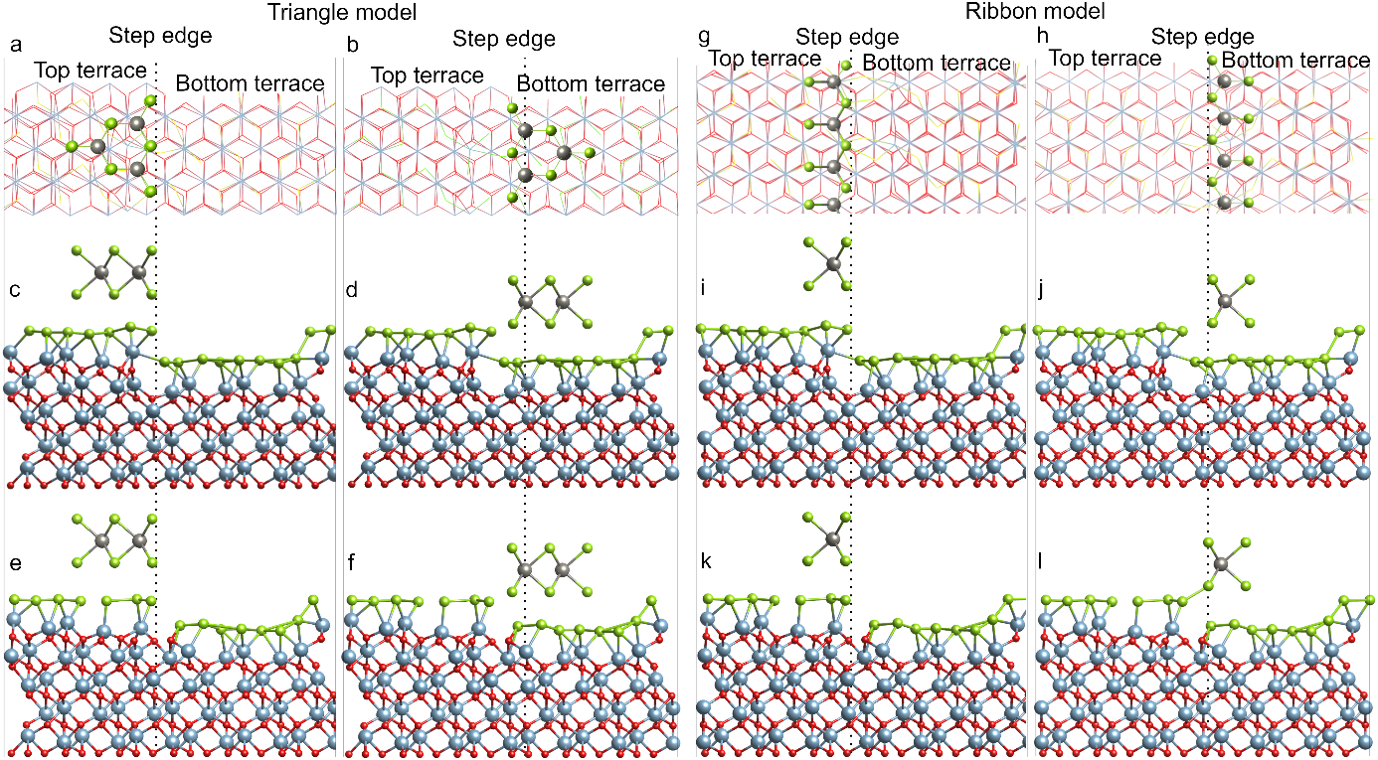
The step model was saturated by Se and/or O atoms or OH groups. After the structural relaxation, ribbon (2.88 × 6.65 Å²) and triangle (6.65 Å) shaped 2D-WSe₂ were deposited at the 0° alignment (Fig. S8) on the top and bottom terraces of the Se/O or Se terminated substrate as illustrated in Figures S10. Figures S11-15 depict the optimized models at the DFT levels. Finally, following the analysis of the coupled impact of the step-edge and surface chemistry of idealized step models on the WSe₂ alignment, a comparison between models and experiments was done to provide deeper insight into the epitaxial relationship between WSe₂ and sapphire.
Mixed Se/O step
Single Se step
Figure S10. Initial configurations of (a-f) triangle and (g-l) ribbon shaped WSe₂ on sapphire with a step edge. Top views of (a, b) triangular and (g, h) ribbon WSe₂ on sapphire. (c, d) Triangular and (i, j) ribbon WSe₂ on a single Se stepped sapphire. (e, f) Triangular and (k, l) ribbon WSe₂ on a mixed Se/O stepped sapphire.

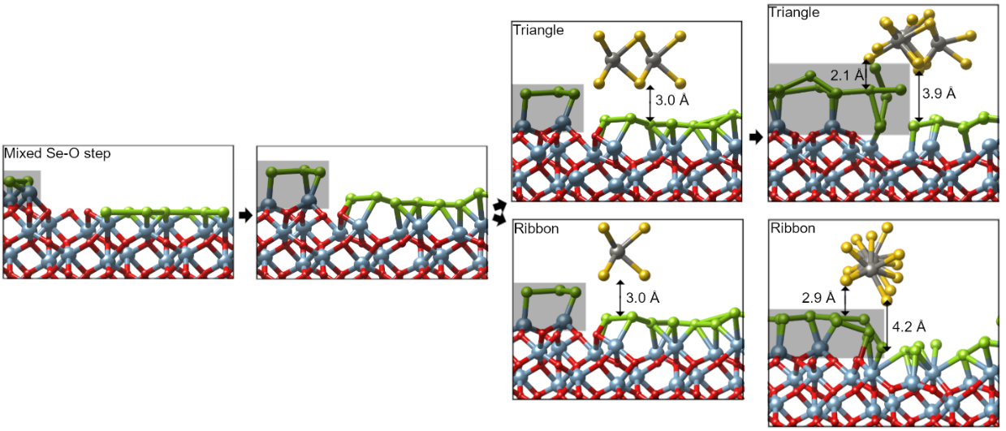
Figure S11. A ribbon and triangular WSe₂ on a mixed Se-O stepped sapphire. During the relaxation, the existence of O-remnant leads to the step edge reconstruction (highlighted with a gray background, then the movement of WSe₂ from the bottom to the top terrace.

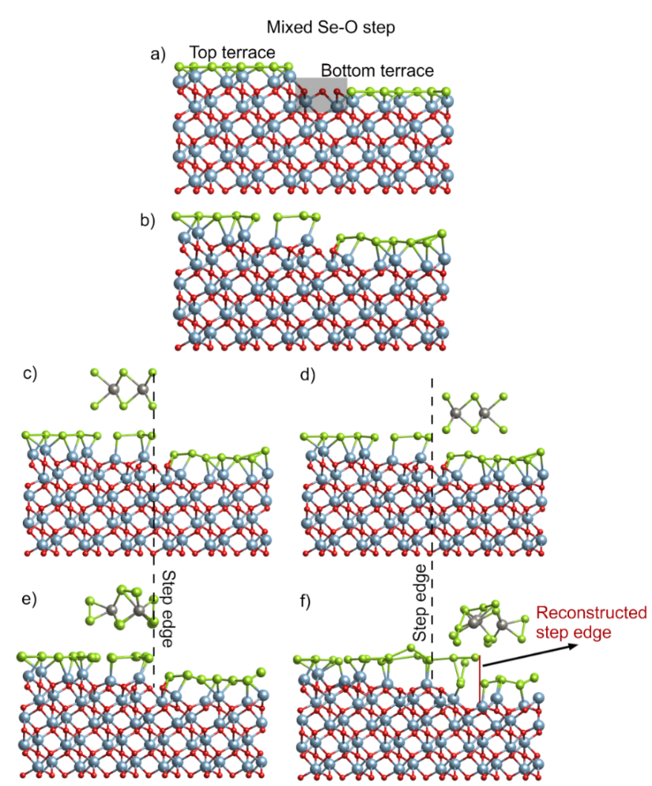
Figure S12. (a) Initial and (b) optimized configurations of a mixed Se-O stepped sapphire with oxidized region (highlighted with a gray background) on the bottom terrace next to the step edge. (c, d) Initial and (e, f) optimized configurations of a triangle shaped WSe₂ on (c, e) the TOP and (d, f) BOTTOM terraces of the optimized sapphire in (b). Step edge linking bottom and top terraces is indicated with black dash lines in (c- f). During the relaxation, the existence of O-remnant leads to the step edge reconstruction (indicated with a red solid line in (f)), then the movement of WSe₂ from the bottom (d) to the top terrace (f)

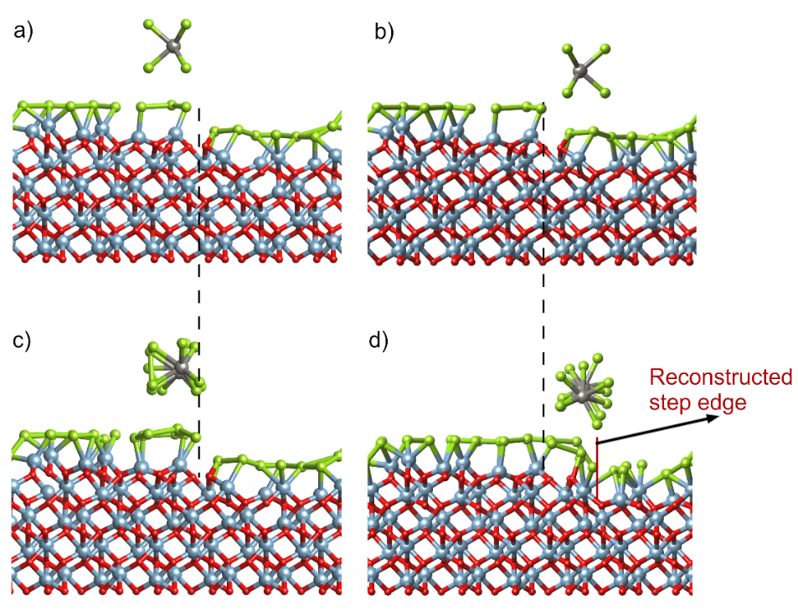
Figure S13. (a, b) Initial and (c, d) optimized configurations of a ribbon WSe₂ on (a, c) TOP and (b, d) BOTTOM terraces of the optimized and mixed Se-O stepped sapphire in Fig. S12(b). Step edge linking bottom and top terraces is indicated with black dash lines in (a-d). During the relaxation, the existence of O-remnant leads to the step edge reconstruction (indicated with a red solid line in (d)), then the movement of WSe₂ from the bottom (b) to the top terrace (d)

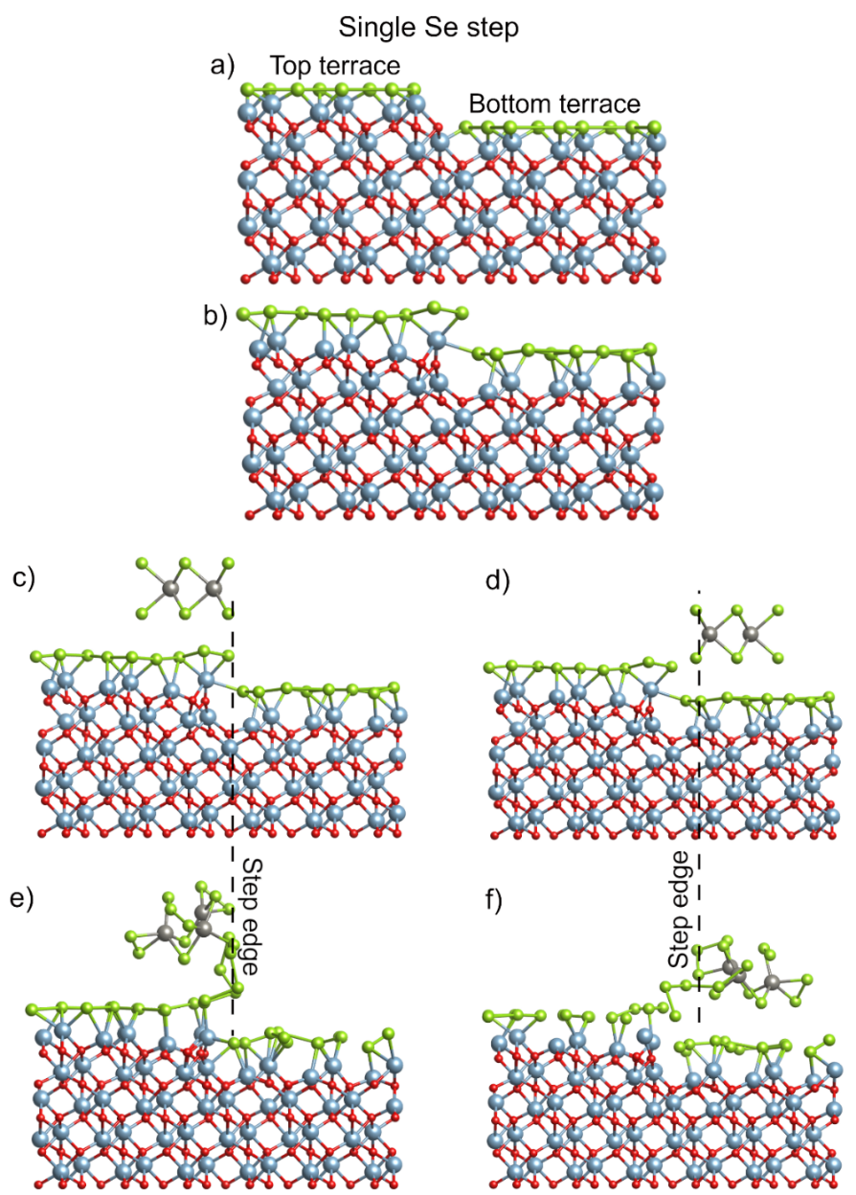
Figure S14. (a) Initial and (b) optimized configurations of a single Se stepped sapphire (no-O remnant considered in this case). (c, d) Initial and (e, f) optimized configurations of a triangular WSe₂ on (c, e) TOP and (d, f) BOTTOM terraces of the optimized sapphire in (b). Step edge linking bottom and top terraces is indicated with black dash lines in (c- f). During the relaxation, NO-step reconstruction was observed, WSe₂ thermodynamically prefers to stay at the BOTTOM terrace.

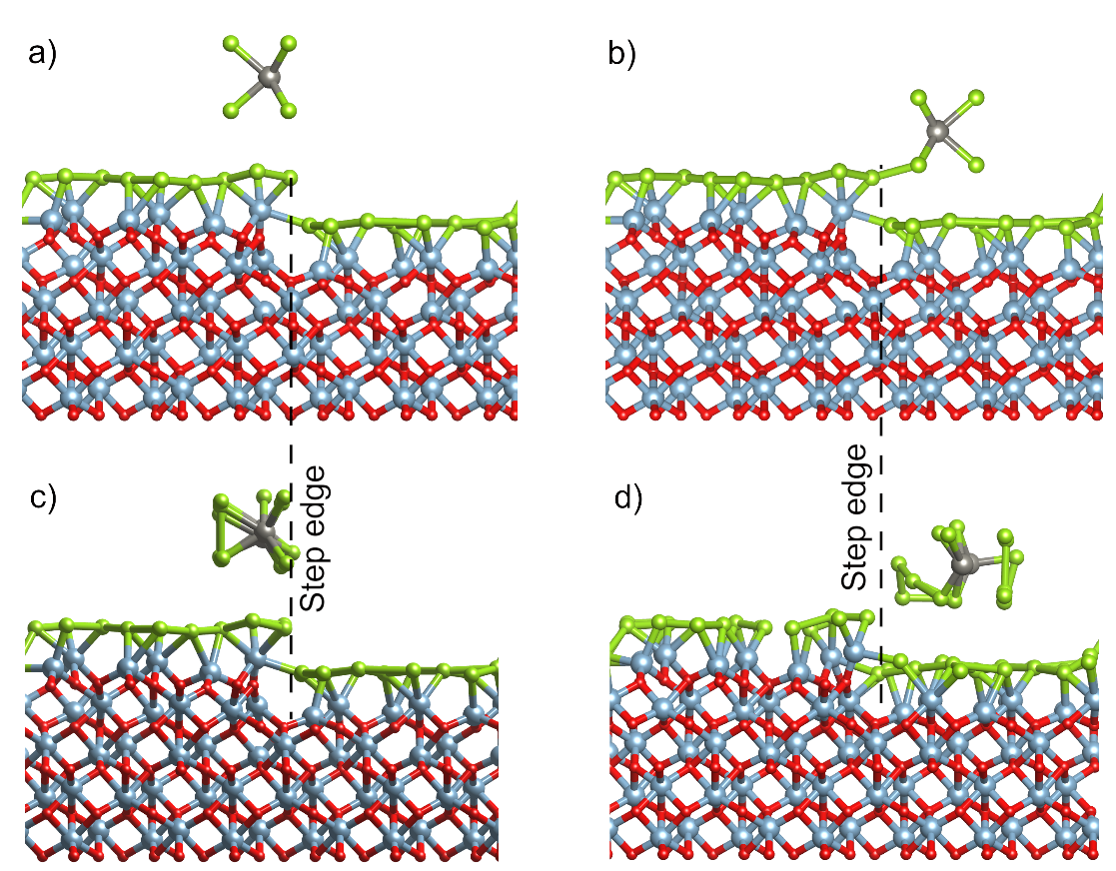
Figure S15. (a, b) Initial and (c, d) optimized configurations of a ribbon WSe₂ on (a, c) TOP and (b, d) BOTTOM terraces of an optimized and single stepped sapphire in Fig. S14b. Step edge linking bottom and top terraces is indicated with black dash lines in (a-d). During the relaxation, NO-step reconstruction was observed, WSe₂ thermodynamically prefers to stay at the BOTTOM terrace.
- Surface Chemistry of c-plane sapphire
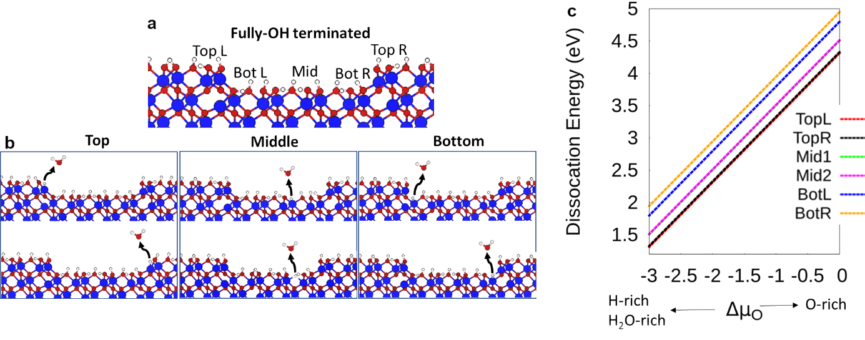
Oxygen removal from the stepped c-plane sapphire surface was explored assuming an idealized step-and-terrace sapphire structure with 100% OH coverage. In all calculations, the number of H atoms that saturate the surface was kept the same. The allowed range of O-chemical potential was computed by using the equations of 2µ_{H} + µ_{O} = µ_{H2O} and μ_{H2O(gas)}−2_{μH(gas)} < μ_{O} < μ_{O(gas).} Figure S16 shows the atomic structure of the model adopted in the calculations where four pathways were followed for the water-desorption. Note that during the simulations, a H₂ gas-molecule in vacuum was considered. Based on the results, O-dissociation from the top terrace is energetically more favorable than that from middle and bottom terraces, meaning that, during H₂ annealing of the vicinal sapphire surface, O atoms are expected to first leave the top terrace next to the step edges (1.24 eV), then the middle terrace (1.28 eV) and lastly, the bottom terrace next to the step edges (1.73 eV). This result suggests the existence of an O-remnant at the bottom terrace next to the step edge after H₂ annealing and the mixed Se/O step nature of the sapphire surface before growth, which induces the preferential alignment of WSe₂ on the top terrace of sapphire.
Figure S16. (a) Atomic illustration of top-left and right (TopL and TopR), bottom-left and right (BottomL and BottomR), middle (Mid) terraces of a full-OH passivated sapphire. (b) O-removal as H₂O from top, bottom and middle terraces of a full-OH terminated sapphire and (c) the associated dissociation energies.
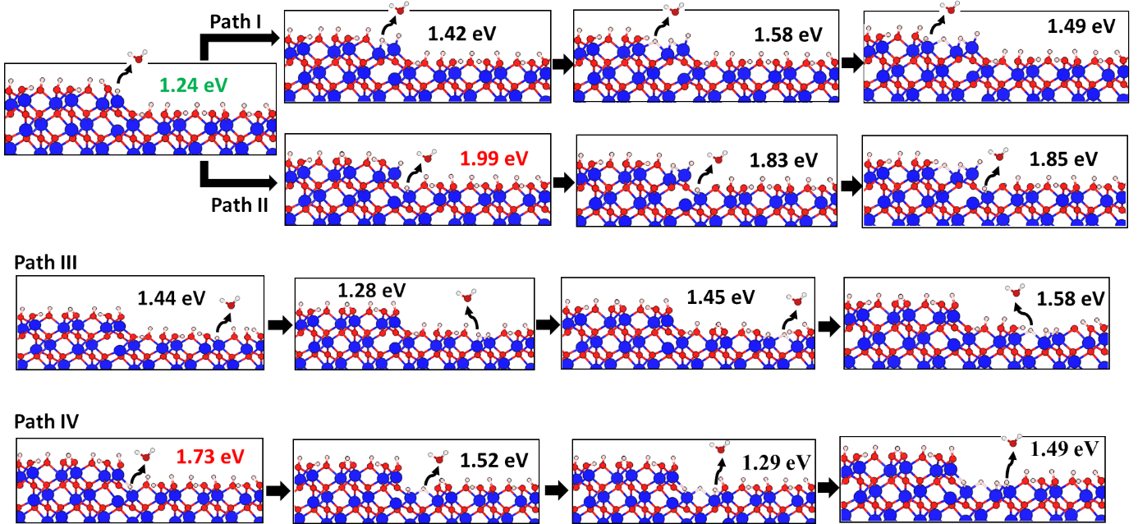
Figure S17. (a) Atomic illustration of top-left and right (TopL and TopR), bottom-left and right (BottomL and BottomR), middle (Mid) terraces of a full-OH passivated sapphire. (b) O-removal as H₂O from top, bottom and middle terraces of a full-OH terminated sapphire.
- Coalescence of 0° orientation WSe₂ on 2” diameter c-plane sapphire
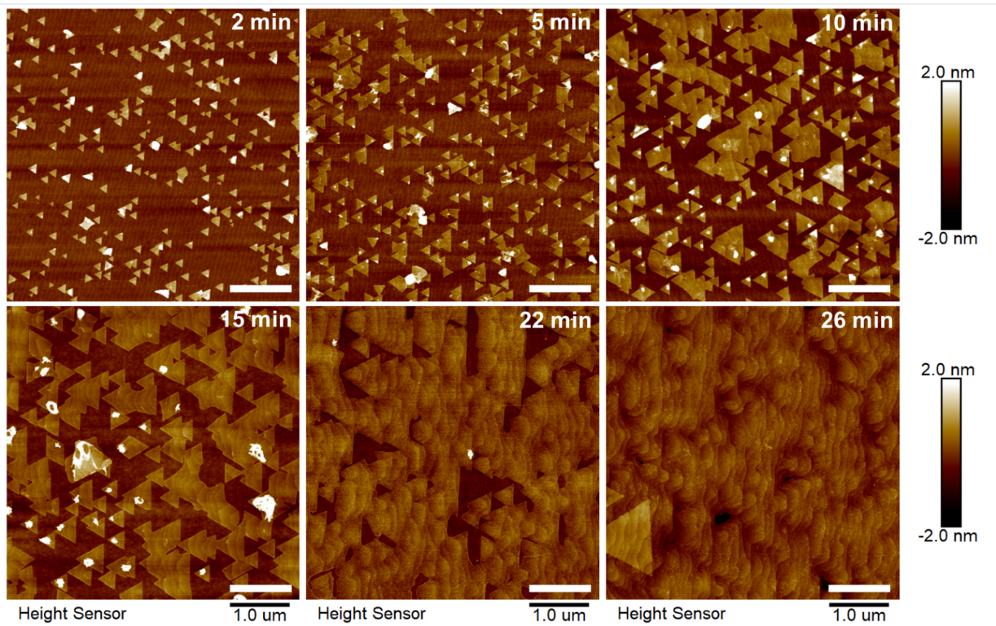
To achieve a coalesced WSe₂ monolayer across the 2” sapphire, the lateral growth time was increased from 2 mins to 26 mins while maintaining a lateral growth temperature of 1000℃ and reactor pressure of 200 Torr (Fig. S18). Nanoscale WSe_{x} clusters (white features in Fig. S18) are present on the top surface of the small isolated WSe₂ domains but are significantly reduced in number as the domains coalesce, likely due to the ability of adsorbed precursors to diffuse greater distances on a larger van der Waals surface. FESEM was used to assess the uniformity of the WSe₂ coverage across the 2” diameter substrate for the sample grown with 26 min lateral growth time (Fig. S19). The coverage is highest at the center of the 2” wafer (95%) and decreases radially toward the wafer edge. The areal coverage of bilayers is <10% in all cases.
Figure S18. AFM images of WSe₂ on c-plane sapphire grown at 1000 °C lateral growth temperature and 200 Torr reactor pressure as the lateral growth time was varied from 2 mins to 26 mins. The scale bar is 1 μm.

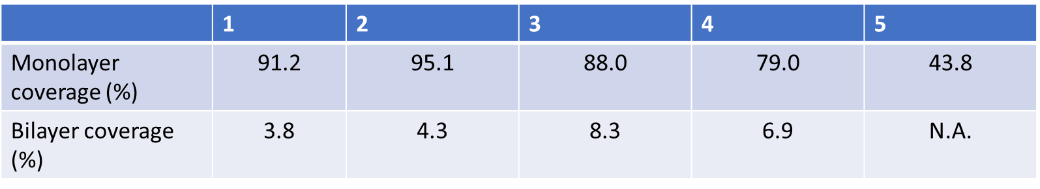
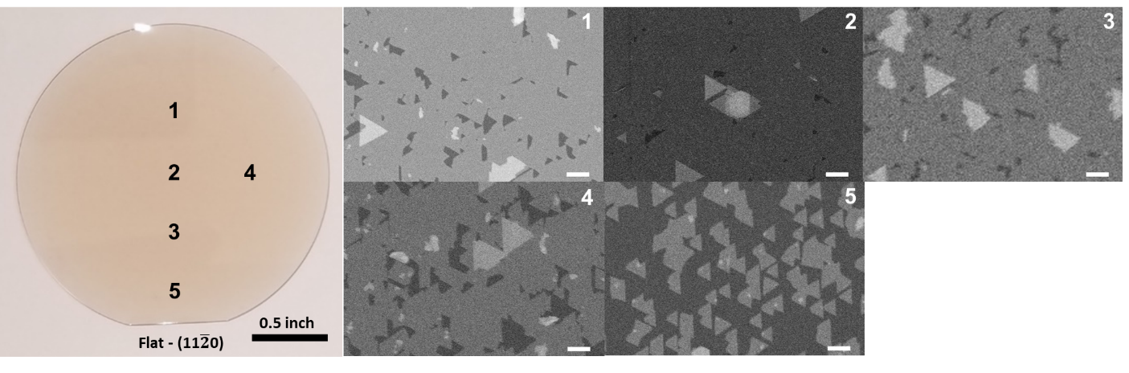
Figure S19. Photo of WSe₂ on 2” sapphire with 26 min lateral growth time and FESEM images of surface in locations noted on the photo along with the % monolayer and bilayer surface coverages. The scale bar in the FESEM images is 1 μm.
- Raman and photoluminescence spectroscopy of WSe₂ transferred to oxidized Si
To study the uniformity and properties of the deposited film, an entire 2-inch WSe₂ monolayer was transferred off of the sapphire and onto a 3inch 90 nm-thick SiO₂/Si wafer (see Fig. S20a) using a PMMA based transfer process (see Methods). In order to achieve a fully coalesced film and hence avoid voids and WSe₂ domain edges, a relatively long growth time was selected (i.e. 30 min). This long growth time inevitably resulted in the formation of bilayer domains which decrease in density from the center of the wafer to the edge, similar to Figure S19. The density of bilayer is quite low within a few mm from edges of the sample (see optical microscope image in Fig. S20b) and increase in number moving away from the edge (see Fig. S20c) toward the wafer center (see Fig. S20d).
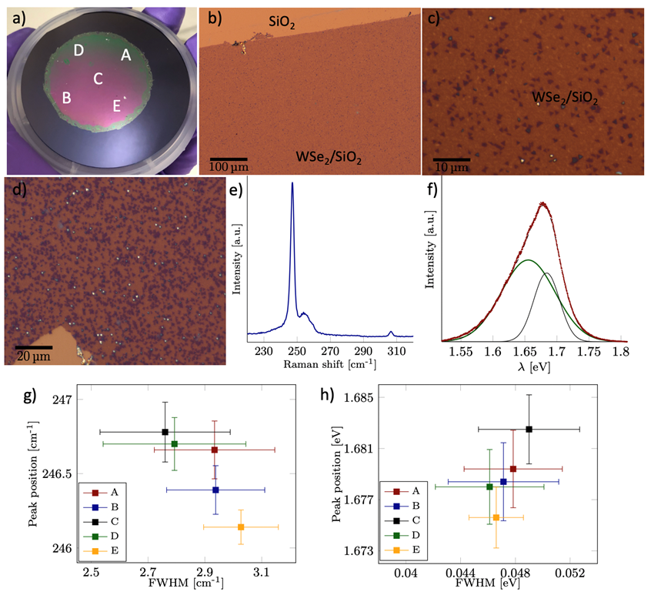
Figures S20e and S20f show representative Raman and photoluminescence (PL) spectra, respectively, obtained on the transferred WSe₂ film. Peak fitting was performed to extract peak characteristics such as the FWHM and position. The most prominent Raman features E¹_{2g} were well fitted with a single Lorentzian function while the PL peaks were deconvoluted using two Gaussian functions corresponding to the neutral exciton and the negatively charged exciton (trion) peaks. The B_{2g} Raman mode (located at about 308 cm⁻¹) corresponding to the vibration between layers is present but exhibits a much lower intensity than E¹_{2g} (located at about 246 cm⁻¹), thus indicating that the WSe₂ film contains a small amount of bilayer islands.
Figure S20. (a) Photograph of the 2 in. PMMA/WSe₂ film transferred onto a 3 in. 90 nm thick SiO₂/Si substrate. The optical microscope images (b), (c), and (d) show the continuity of the WSe₂ film after transfer onto SiO₂/Si and the gradual increase of the bilayer fraction when going from the wafer (b-c) edge/periphery to the (d) center. Room temperature characteristic (e) Raman and (f) PL spectra. Average and standard deviation of the peak positions and full width at half maximums for (g) the predominant $E_{2g}^{1}$ Raman peak and (h) the PL peak corresponding to the neutral exciton acquired in various locations indicated by the letters A, B, C, D, E in (a).
To obtain a statistically robust data set, PL and Raman maps (10×10 points, 10×10 μm²) were acquired in various locations of the wafer (labelled A, B, C, D, E) on WSe₂ in a controlled environment (<100ppm O₂, <5ppm H₂O) at room temperature. Figures S20g and S20h compare the peak position and FWHM in each of the 5 locations shown in Fig. S20a. The data points and the error bars correspond to the average and the standard deviation of 100-point maps acquired in each location. Room temperature measurements show negligible variations in the position and FWHM from one location to another. The very little or no change in the optoelectronic properties of WSe₂ thus suggests a good deposition uniformity across the whole wafer, which is consistent with the presented AFM and SEM data. In the case of Raman, the E¹_{2g} peak position is lower or comparable to previously reported data acquired on exfoliated WSe₂ flakes and CVD films.,, The FWHM ranging from 2.6 to about 3.1 cm⁻¹ is lower than the values typically reported in the literature. The low E¹_{2g} frequency and linewidth reflect a low stress level and a very high structural quality.

- SHG Measurements
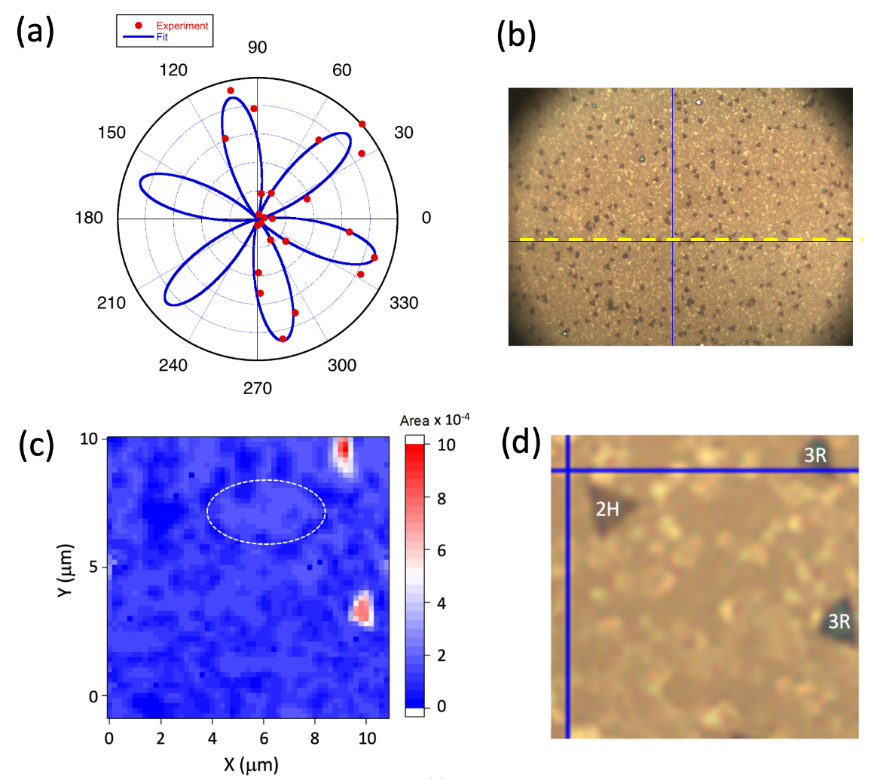
SHG measurements can reveal many important features of 2D crystals including crystal orientations, layer stacking configurations, size of single-crystal domains, strain, and grain boundaries. This is especially important for continuous single crystal films grown by MOCVD in this work. Figure S21a shows the polar plot of the second harmonic intensity versus WSe₂ film orientation relative to the incident laser polarization, which in this case is chosen to be parallel to the SHG polarization selected by an analyzer. This polarization diagram can reveal the crystal orientation of the monolayer patches and prove that all multiple patches have the same crystal orientations. The local armchair direction determined from the SHG polarization diagram in Fig. S21a is marked by a dotted line in optical microscope image shown in Fig. S21b. An SHG map demonstrating monolayer crystal patches and grain boundaries is shown in Fig. S21c. The average size of these patches is ~ 2-4 μm. Note that this sample has multiple seeds of bilayers, which appear as ~ 1 μm dark spots in the optical microscope image that in some cases exhibit well defined triangular shape (Fig. S21b). The SHG measurements allow determination of the number of layers in these seeds based on their SHG intensity ratio relative to that from monolayer patches and their stacking configurations. In the case of 2H bilayer stacking configuration, nonlinear polarizations of each layer are cancelling each other resulting in zero SHG intensity as indicated in the SHG maps shown in Figs. S21c and S21d. For 3R stacking configuration, addition of the nonlinear polarizations of the individual layers leads to 4 time increase in the SHG intensity compared to that of a monolayer as can be seen from Fig. S21c.
Figure S21. Characteristics of WSe₂ film synthesized by MOCVD and characterized by SHG.
(a) SHG polarization diagram reveals a local monolayer crystal orientation showing the armchair WSe₂ crystal direction at the angles corresponding to the maxima of the six lobes. The red dots and the blue solid line show the experimental points and fit with sin²(3(φ + φ0)), respectively. The incident laser polarization is parallel to the SHG polarization selected by an analyzer. Measuring similar SHG polarization diagrams at other point confirms same monolayer crystal orientation over relatively large mm-distances (b) Optical microscope image of a WSe₂ crystal transferred from a sapphire to a SiO₂/Si substrate used for the SHG polarization diagram measurements shown in (a). The dotted line shows the armchair direction of the overall crystal. Note that the initial position of the substrate used for the SHG measurement is rotated by 12º counterclockwise to get an optical image in (b). (c) SHG map showing monolayer WSe₂ crystal regions with a typical size of 2-4 μm one of which is marked by a dotted line for clarity. This map also reveals WSe₂ bilayer seeds in different stacking configurations (2H and 3R) as labeled in the corresponding optical microscope image in (d).

Figure S22 shows grain boundaries within the WSe₂ monolayer revealed by SHG imaging. It reveals that second layer nucleation occurs in these grain boundaries that results in bilayer formation in 2H (blue regions) and 3R (red region) at the bottom of Fig. S22a. Interestingly, this sample exhibits preferential formation of bilayers in 2H stacking configuration.
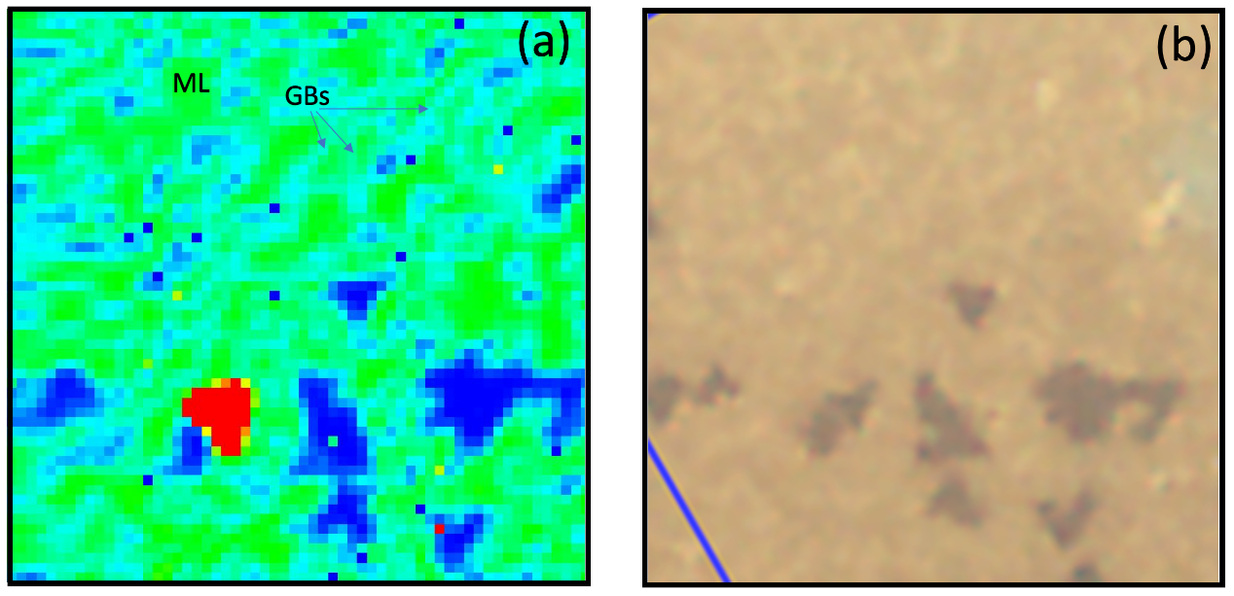
Figure S22. Revealing grain boundaries (GBs) using SHG. (a) 12μm x 12 μm map of a monolayer (ML) WSe₂ crystal grown by MOCVD on a sapphire substrate and transferred to a SiO₂/Si substrate measured with 0.2 μm steps. The map shows multiple grain boundaries with many second layer seeds developing along them. (b) A corresponding optical microscope image is shown in (b).

- TEM Characterization
Figure S23a is a selected area electron diffraction (SAED) pattern obtained from the bottom right Quantifoil hole in Figure 6b highlighting the single crystal nature of the monolayer film. An objective aperture is placed over a (101̅0) reflection in the SAED pattern (blue circle) to obtain the DFTEM image in Figure S23b. The area near the mirror twin boundary (MTB) is enlarged and shown in the inset. On the contrary, the bright field TEM (BFTEM) image taken by placing the objective aperture over the direct beam (red circle) does not show any contrast from the MTB, as shown in Figure S23c. An atomic-resolution annular dark field-scanning TEM (ADF-STEM) image taken at the MTB (Figure S23d) reveals the atomic structure of the boundary to be made of 4- and 8- member rings separating the 0° and 60° domains., The negligible contrast difference between 0° and 60° domains of WSe₂ is attributed to the small atomic number difference between W and Se₂ atomic columns.
Figure S23. (a) SAED pattern obtained from the bottom right Quantifoil hole in Figure 6b; (b) DFTEM image obtained from a (101̅0) reflection in the SAED pattern (blue circle); (c) BFTEM image obtained from the direct beam in the SAED pattern (red circle); inset shows a magnified view of the MTB and (d) atomic-resolution ADF-STEM image taken at the MTB.

- Low temperature photoluminescence measurements

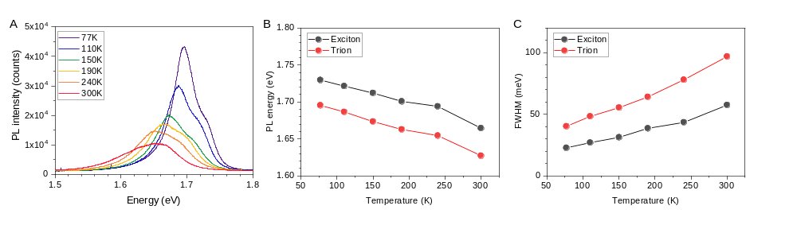
Figure S24. (A) Linear-polarized PL spectra of transferred WSe₂ at different temperatures. (B) PL energy and (C) full width at half maximum (FWHM) of exciton and trion as a function of temperature.
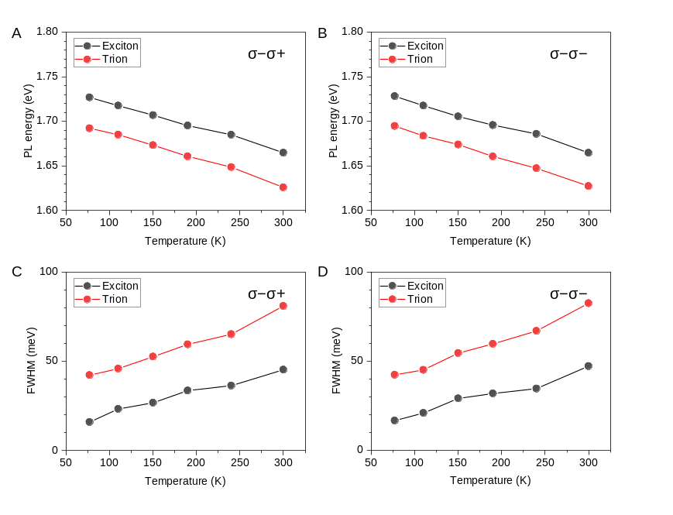
Figure S25. (A-B) PL energy and (C-D) FWHM of exciton and trion of transferred WSe₂ for σ₋σ₊ and σ₋σ₋ polarizations.

References

Dumcenco, D. et al. Large-Area Epitaxial Monolayer MoS2. ACS Nano 2015, 9, 4611–4620. https://doi.org/10.1021/acsnano.5b01281
Zhang, X.; Choudhury, T. H.; Chubarov, M.; Xiang, Y.; Jariwala, B.; Zhang, F.; Alem, N.; Wang, G. C.; Robinson, J. A.; Redwing, J. M. Diffusion-Controlled Epitaxy of Large Area Coalesced WSe2 Monolayers on Sapphire. Nano Lett. 2018, 18 (2), 1049–1056. https://doi.org/10.1021/acs.nanolett.7b04521.
Curiotto, S. & Chatain, D. Surface morphology and composition of c-, a- and m-sapphire surfaces in O2 and H2 environments. Surf. Sci. 2009, 603 (17), 2688–2697. https://doi.org/10.1016/j.susc.2009.07.004.
Chubarov, M.; Choudhury, T. H.; Hickey, D. R.; Bachu, S.; Zhang, T.; Sebastian, A.; Bansal, A.; Zhu, H.; Trainor, N.; Das, S.; Terrones, M.; Alem, N.; Redwing, J. M. Wafer-Scale Epitaxial Growth of Unidirectional WS2 Monolayers on Sapphire. ACS Nano 2021, 15 (2), 2532–2541. https://doi.org/10.1021/acsnano.0c06750.
Hickey, D.R., Nayir, N., Chubarov, M., Choudhury, T.H., Bachu, S., Miao, L., Wang, Y., Qian C., Crespi, V.H., Redwing, J.M., van Duin, A.C.T., Alem, N. “Illuminating Invisible Grain Boundaries in Coalesced Single-Orientation WS2 Monolayer Films”, Nano Letters 2021, 21 (15), 6487-6495. https://doi.org/10.1021/acs.nanolett.1c01517.
Terrones, H., Corro, E., Feng, S. et al. New First Order Raman-active Modes in Few Layered Transition Metal Dichalcogenides. Scientific Reports 2014, 4, 4215. https://doi.org/10.1038/srep04215.
Wu, Z., Zhao, W., Jiang, J., Zheng, T., You, Y., Lu, J., Ni. Z., Defect Activated Photoluminescence in WSe2 Monolayer, The Journal of Physical Chemistry C 2017 121 (22), 12294-12299. https://doi.org/10.1021/acs.jpcc.7b03585.
Li, Z., Wang, Y., Jiang, J. et al. Temperature-dependent Raman spectroscopy studies of 1–5-layer WSe2. Nano Res. 2020, 13, 591–595. https://doi.org/10.1007/s12274-020-2669-0.
Van Der Zande, Arend M., et al. Grains and grain boundaries in highly crystalline monolayer molybdenum disulphide. Nature Materials 2013, 12 554-561. https://doi.org/10.1038/nmat3633.
Komsa, Hannu‐Pekka, and Arkady V. Krasheninnikov. Engineering the Electronic Properties of Two‐Dimensional Transition Metal Dichalcogenides by Introducing Mirror Twin Boundaries. Advanced Electronic Materials 2017, 3 (6) 1600468. https://doi.org/10.1002/aelm.201600468.
Deb, Pratiti, et al. Imaging Polarity in Two Dimensional Materials by Breaking Friedel's Law. Ultramicroscopy 2020, 215, 113019. https://doi.org/10.1016/j.ultramic.2020.113019.

