SUPPLEMENTARY MATERIAL

SUPPLEMENTARY TABLES AND FIGURES
Supplemental Table 1. Multivariate analysis according to iatrogenic dissection or rupture
 | Univariate analysis |  |  | Multivariate analysis
 | No dissection  (N=89) | Dissection  (N=22) | P value | Odds ratio (95% CI) | P value
Demographics
Age, years | 64.6±13.3 | 67.7±13.8 | 0.350 | 1.027 (0.979–1.083) | 0.291
Sex, men | 58 (65.2) | 12 (54.5) | 0.498 | 0.536 (0.172–1.654) | 0.275
Risk factors
Hypertension | 56 (62.9) | 15 (68.2) | 0.832
Diabetes mellitus | 28 (31.5) | 6 (27.3) | 0.902
Dyslipidemia | 28 (31.5) | 7 (31.8) | >0.999
Atrial fibrillation | 23 (25.8) | 1 (4.5) | 0.040 | 0.077 (0.004–0.494) | 0.024
Smoker | 32 (36.0) | 7 (31.8) | >0.999
Initial occlusion site |  |  | >0.999
Internal carotid artery | 11 (12.4) | 3 (13.6)
Middle cerebral artery | 60 (67.4) | 15 (68.2)
Vertebral/basilar artery | 18 (20.2) | 4 (18.2)
Initial NIHSS score | 15 (11–20) | 17 (14–22) | 0.278 | 1.010 (0.927–1.102) | 0.820
ASPECTS score* | 7 (5–9) | 8 (6–9) | 0.467
Onset to puncture time, min | 325 (226–560) | 296 (242–554) | 0.552
Puncture to final angiography time, min | 65 (44–98) | 82.5 (66–119) | 0.075 | 1.006 (0.994–1.017) | 0.327
Laboratory findings
Hemoglobin, g/dL | 14.0±1.8 | 14.1±2.2 | 0.913
White blood cells, ×10⁹/L | 10.3±4.4 | 10.9±5.7 | 0.645
Platelets, ×10⁹/L | 239±67 | 242±80 | 0.893
Glucose, mmol/L | 8.4±3.3 | 7.9±3.3 | 0.491
IV tPA | 40 (44.9) | 10 (45.5) | >0.999
First-line device |  |  | 0.012
Stent retriever | 45 (50.6) | 4 (18.2) |  | Ref
Contact aspiration | 44 (49.4) | 18 (81.8) |  | 4.488 (1.394–17.676) | 0.018
Tirofiban infusion | 38 (42.7) | 14 (63.6) | 0.128
Successful reperfusion after the 1st attempt | 55 (61.8) | 10 (45.5) | 0.249
Final successful reperfusion | 75 (84.3) | 16 (72.7) | 0.223
Number of techniques | 2 (1–3) | 2 (2–3) | 0.045 | 1.094 (0.519–2.326) | 0.812
* Baseline ASPECTS on quality imaging was evaluated in 81 patients (91.0% patients with anterior circulation infarction).
NIHSS: National Institutes of Health Stroke Scale; IV tPA: intravenous tissue plasminogen activator

Supplementary figure 1 and its legend
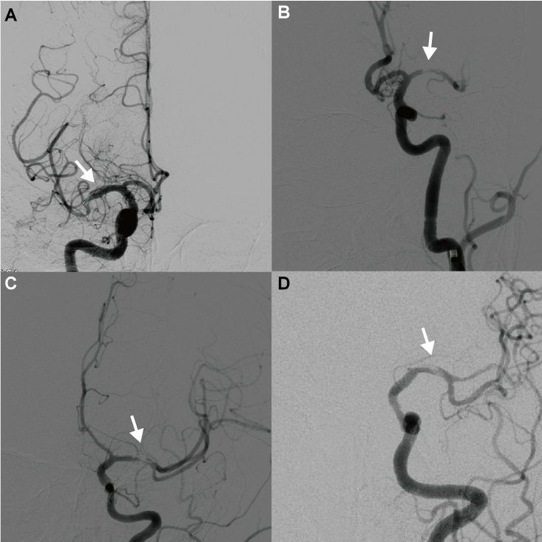
Supplementary figure. (A) The first patient shows flap in the right middle cerebral artery. We detached stent retriever because of recurrent occlusion after retrieving stent retriever. (B) and (C) The second and third patients show intima flap in the left middle cerebral artery after contact aspiration and (D) The fourth patient shows intima flap in the left middle cerebral artery after retrieving stent retriever.

