Supporting information
The R-factor (MJ·mm·ha^{–1}·h⁻¹ yr⁻¹) is a multi-annual average index that measures rainfall's kinetic energy and intensity to describe rainfall's effect on sheet and rill erosion (Wischmeier and Smith, 1978). However, in the whole Former Soviet Union and Caucasus region, meteorological stations that measure rainfall intensity and kinetic energy at short time intervals are limited. Thus, spatial interpolation of point data is not a good option. In such data-sparse regions, integrating gauge measurements with satellite-based rainfall estimates (Haregeweyn et al., 2017; Vrieling et al., 2010) could better map rainfall erosivity.
This study used the R-factor map produced based on a relationship between long-term R-factor values calculated from meteorological station data in the North Caucasus region and an erosivity index derived from a multi-source satellite rainfall product TerraClimate (Abatzoglou et al., 2018). Data of R-factor values (1961-1983 average rainfall erosivity) from 5 sub-hourly gauging stations representing different climatic zones of the study area were compiled from published sources (Larionov, 1993).
A 2018 study reported that the overall accuracy of the TerraClimate precipitation dataset is 9.1% (Abatzoglou et al., 2018). Independent studies afterwards confirmed the data set's sufficient quality (Dubey et al., 2021; Zhao et al., 2019). However, we have not found any quality assessment of the TerraClimate for the Caucasus region. To tackle this research gap, we compared measured monthly precipitation at several meteorological stations with TerraClimate. Precipitation data were obtained from NOAA NCDC climate data (Anon, 2021) using the rnoaa R package (Chamberlain, 2021).
We found that the coefficient of determination varies from 0.43 to 0.87 depending on station location (see Figure S5). The mean R² among six meteostations was 0.68, while the mean RMSE was 23.6 mm (see Table S2). Our comparison revealed that TerraClimate correlates worst with Terskol meteostation (R² = 0.43, RMSE = 39.4), located in the same Baksan River valley further upstream as the studied Gizhgit-Syr catchment. However, the prediction quality for the Shadzhatmaz meteostation, located in the neighbouring Malka River valley at the same distance from Elbrus as Gizhgit-Syr, was among the highest (R² = 0.87, RMSE = 15.4). Considering the limited number of meteorological stations and the relatively primitive nature of this comparison, these findings should be interpreted with caution. Nonetheless, they prove that the TerraClimate dataset can be used in North Caucasus regional studies, especially in the High to Low Mountain Ranges (less than 2000 m).
It was previously reported that such a proxy of rainfall intensity as the Modified Fournier Index (MFI) could better explain R-factor variability than annual rainfall amount (Fenta et al., 2017; Ferro et al., 1999). Therefore, we calculated an MFI for eight meteorological stations (cf. Figure 1 for location) based on the TerraClimate dataset as follows:
$MFI=\sum_{i=1}^{12}{\frac{{p_{i}}^{2}}{P}}$, (S1)
where, $p_{i}$ is a monthly rainfall amount (mm) for the i^{th} month, and P is annual rainfall (mm). We found that mean annual MFI values derived from TerraClimate explained 80% of the rainfall erosivity (Figure S6). We further used the following equation to estimate rainfall erosivity with a known confidence interval:
$R=-65.9+8.82·MFI$, (S2)
Using 250 m resolution SoilGrids data (Hengl et al., 2017), we calculated the K-factor map based on topsoil properties (0-30 cm depth). We used the equation suggested by Benavidez et al. (2018) to calculate the K factor in t·ha·hr·MJ⁻¹·mm⁻¹. It was initially proposed by Williams et al. (1983) and then widely used in various environments (Chen et al., 2011):
$K=0.1317×\left[0.2+0.3×{\exp\left(0.0256×Sa×\left(1-\frac{Si}{100}\right)\right)×\left(\frac{Si}{Cl+Si}\right)}^{0.3}×\left(1-\frac{0.25C}{C+exp⁡(3.72-2.95C}\right)×\left(1-\frac{0.7Sn}{Sn+\exp\left(-5.51+22.9*Sn\right)}\right) \right]$, (S3)
where Sa — sand content, %; Si — silt content, %; Cl — clay content, %; Sn is particle size parameter ($1-\frac{Sa}{100}$); C — organic matter content, %.
To assess the spatial distribution of various land use/land cover (LULC) classes during the lake's existence, we assumed that the 2021 context reflects the mean annual vegetation cover. This assumption was based on the remote sensing analysis of the Landsat archive (Buchner et al., 2020), which did not reveal any significant land-use changes during the whole study period (1989–2020). Therefore, we used the orthophoto image taken in August 2021 to map vegetation. We distinguished four LULC categories: shrubs, patchy shrubs, forest and pasture/grassland. While there were some pieces of evidence of summer pasture (i.e., livestock trails, cattle sheds, see Figure S0), we hypothesised that pasture is a prevailing LULC class. However, no widespread support management practices were found in the catchment; therefore P factor was neglected. The typical C-factor values were taken from the literature (Batista et al., 2021; Benavidez et al., 2018) and presented in Table S3.
To assess the slope length LS factor, we used a recently developed LS_{alpine} equation (Schmidt et al., 2019). The method has been designed explicitly for mountain regions and tested in the Swiss Alps. The authors propose several adaptations of existing S-factor formulas and suggest limiting the maximal flow length to 120 m (i.e., calculating L-factor with threshold):
$S_{alpine}=0.0005s^{2}+0.1795s-0.4418$ (S4)
$L_{alpine i,j}= \frac{{\left(A_{apline i,j}+D^{2}\right)}^{m+1}-A_{alpine i,j}^{m+1}}{D^{m+2}·X_{i,j}^{m}·{22.13}^{m}}$, (S5)
$A_{alpine i,j}=ifelse(A_{i,j}>100, 100, A_{i,j})$, (S6)
In these equations, $s$ is the slope steepness (%); $D$ is the cell size (m); $X_{i,j}$ equals to $\sin{α_{i,j}}+\cos{α_{i,j}}$, where $α_{i,j}$ is the aspect of the DEM cell ($i,j$); $A_{alpine i,j}$is an inlet grid cell's restraint flow accumulation (m); $m$ is the ratio of rill and interrill erosion calculated following Desmet and Govers (1995) approach:
$m= \frac{β}{β+1}$, (S7)
$β=\frac{{\sin{θ}}/{0.0896}}{0.56+3·{\left(\sin{θ}\right)}^{0.8}}$, (S8)
where $θ$ is the slope (°). We used the DTM created from UAV mapping for LS assessment (see Section 3.1).

Supporting Information. Figures

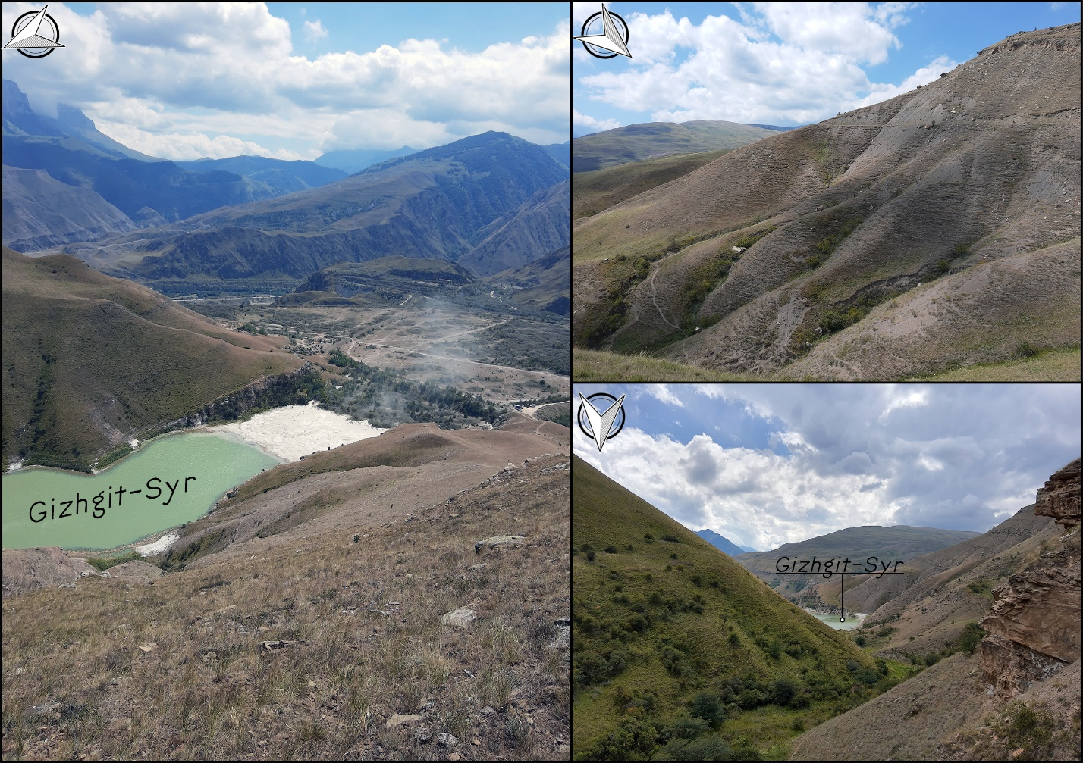
FIGURE S0. Overview photos of the Gizhgit-Syr valley

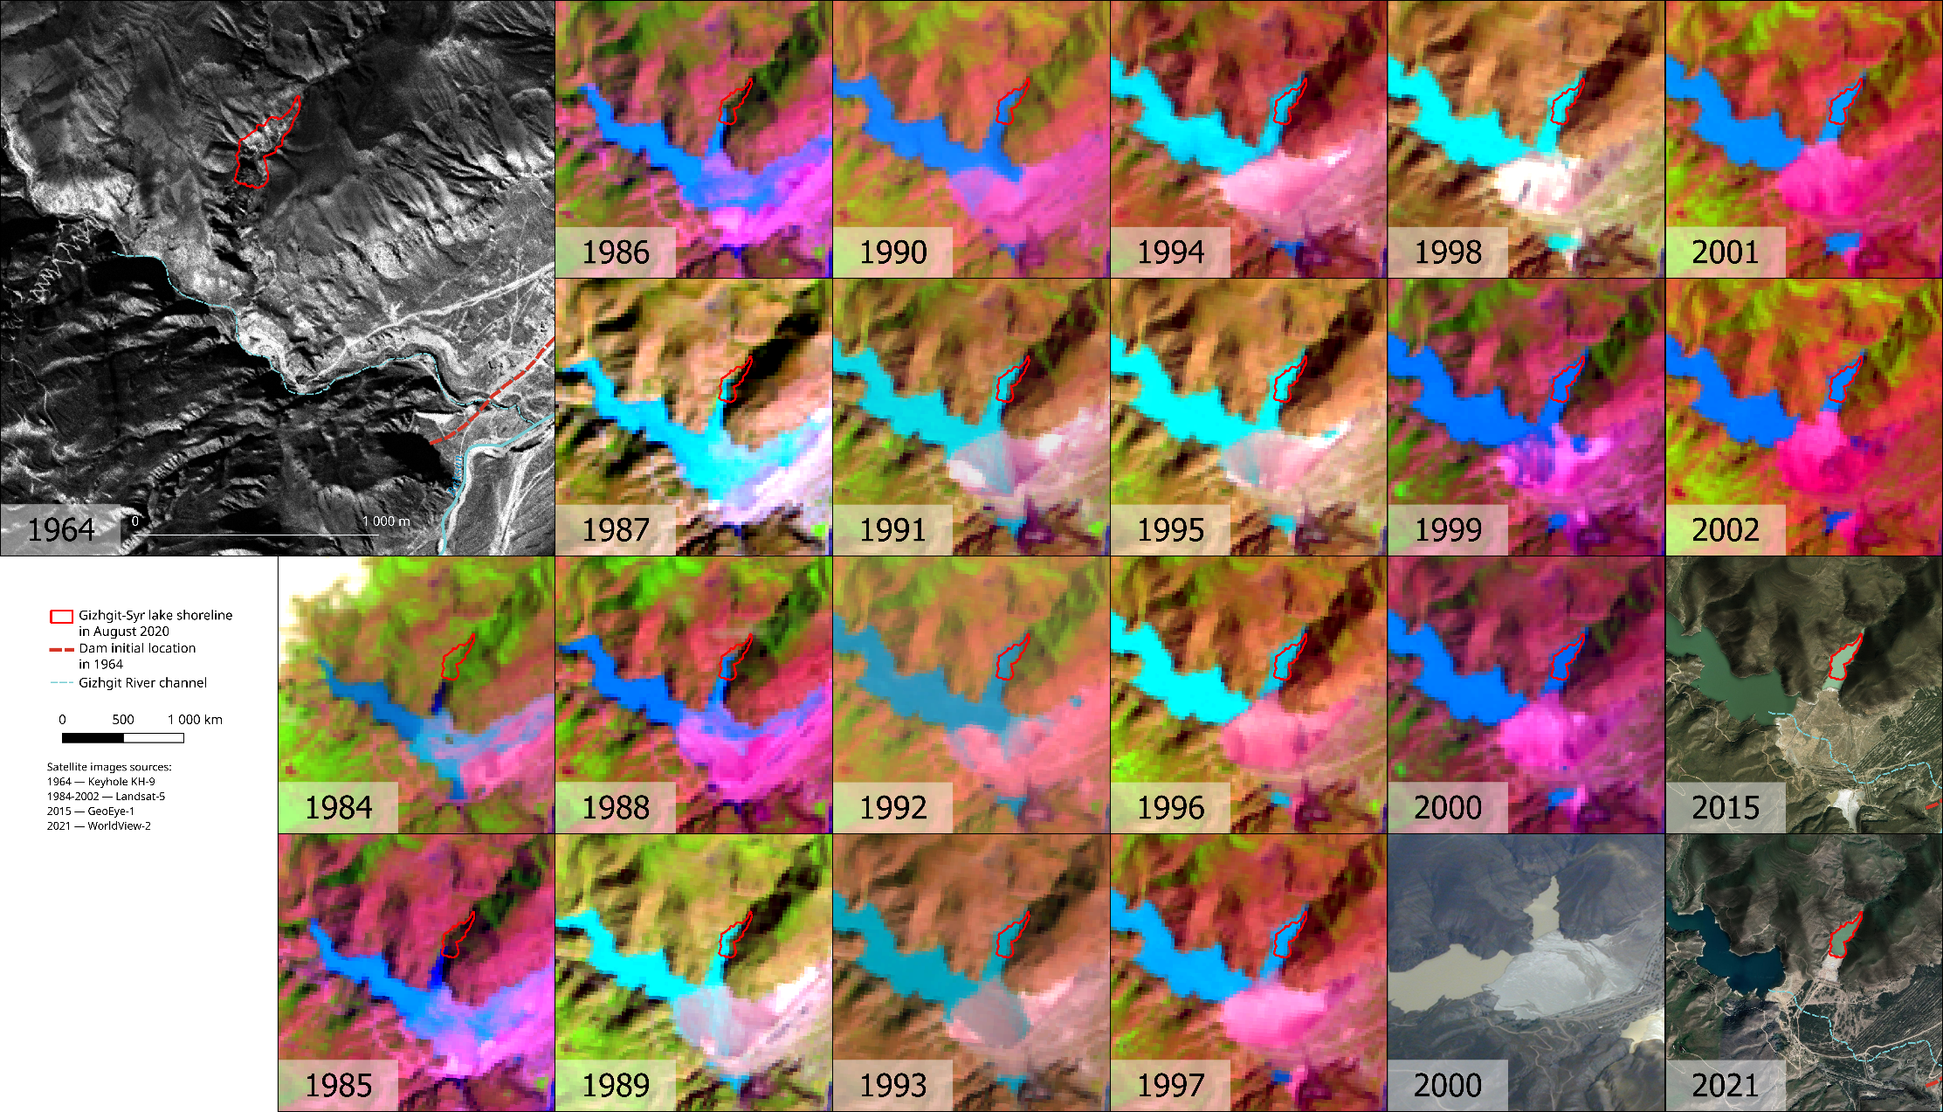
FIGURE S1. The Gizhgit-Syr valley evolution in satellite images from 1964 to 2021.

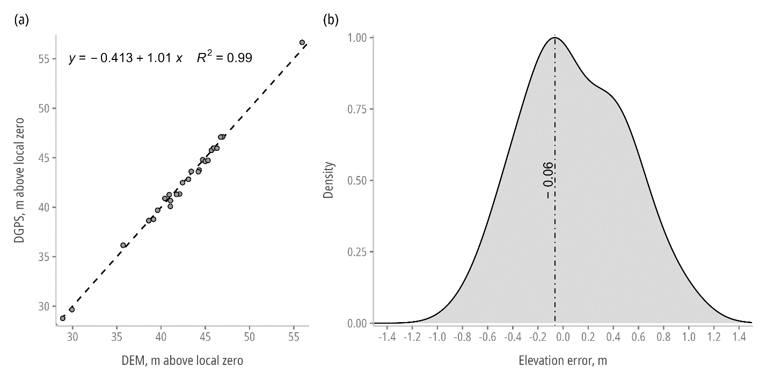
FIGURE S2. Comparison of DTM and DGPS validation points (a), and the corresponding distribution of elevation error (b). The dashed line on the left figure is a 1:1 line. The dot-dashed line on the right shows the highest density region calculated using Hyndman's (1996) algorithm.

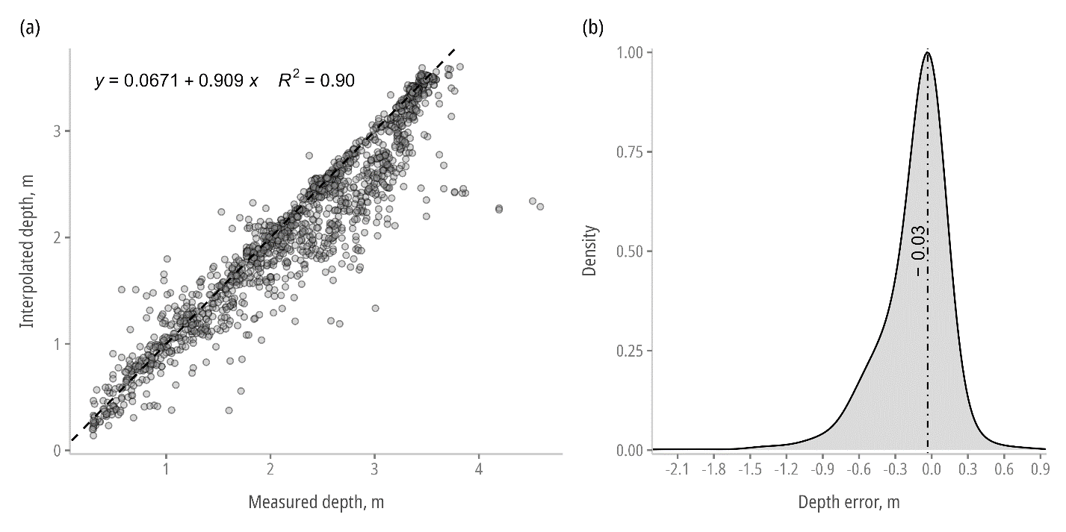
FIGURE S3. Comparison of bathymetry map and sonar points (a), and the corresponding distribution of depth error (b). The dashed line on the left figure is a 1:1 line. The dot-dashed line on the right shows the highest density region calculated using Hyndman's (1996) algorithm.

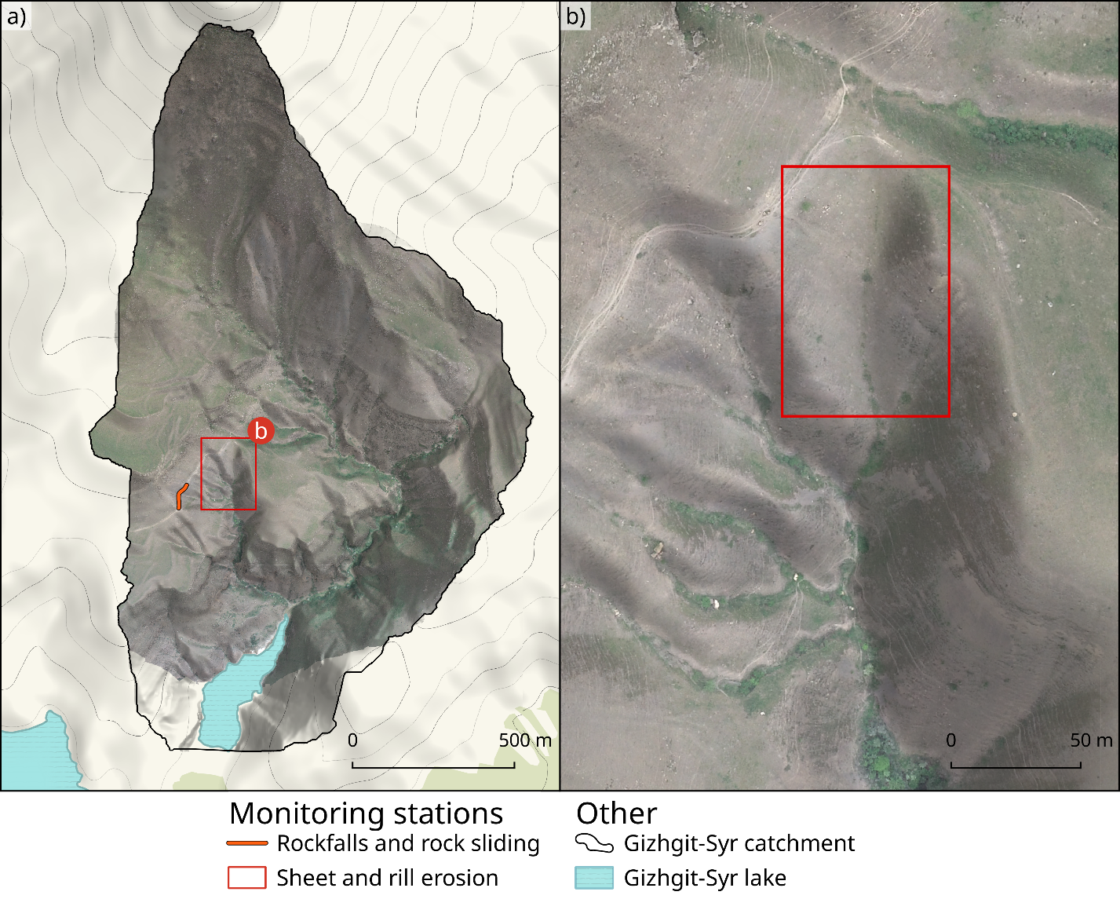
FIGURE S4. Monitoring stations locations.

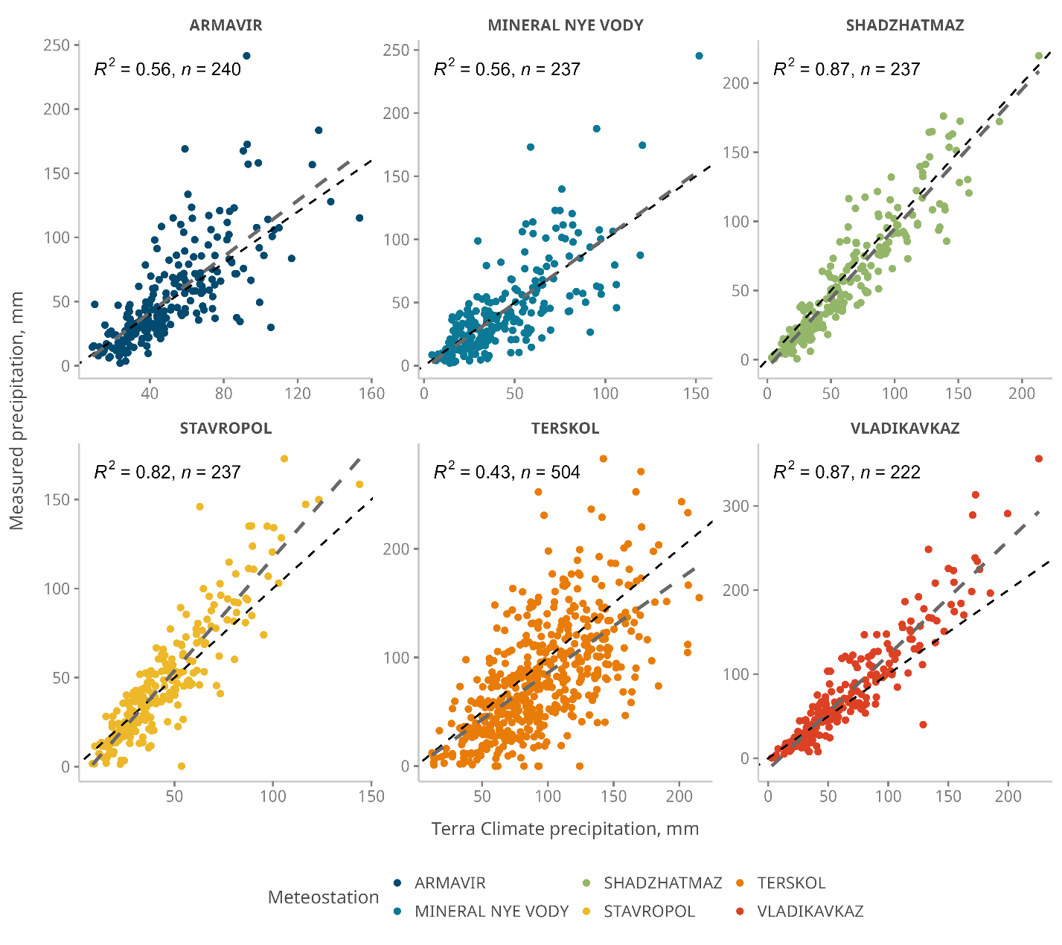
FIGURE S5. Comparison of observed precipitation at meteorological stations and TerraClimate dataset (Abatzoglou et al., 2018).

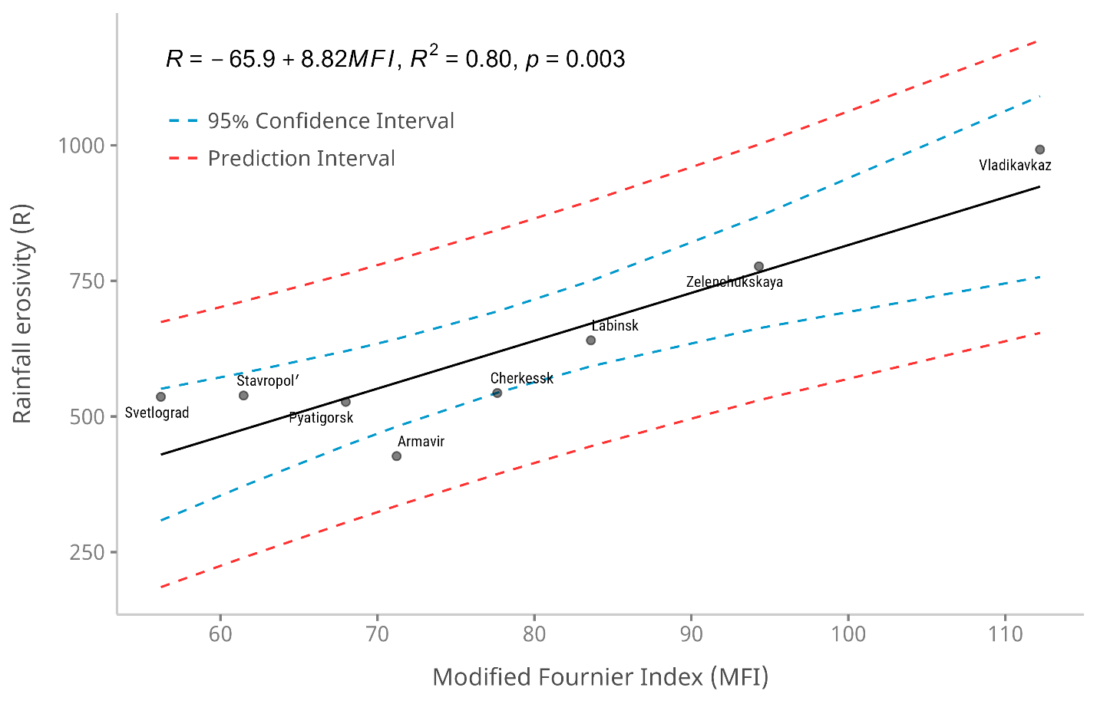
FIGURE S6. Relationship between the mean annual Modified Fournier Index (MFI) calculated based on the TerraClimate dataset (Abatzoglou et al., 2018) and mean annual rainfall erosivity (R, MJ mm ha ⁻¹ h⁻¹ yr⁻¹) from Larionov et al. (1993), both for 1961–1983 period.

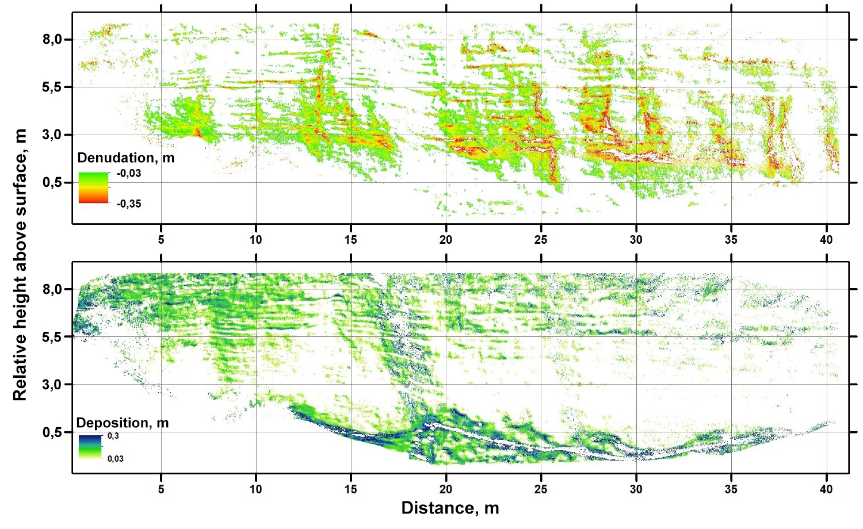
FIGURE S7. Transformation of the rock wall by rockfalls processes from August 2020 to July 2021.

Supporting Information. Tables
Table S1. Results of quantitative estimates of erosion/accumulation processes on the bare slope based on comparison of DEMs from large-scale UAV surveys
Period | Area, m² | Elevation range, m a.m.s.l. | Slope, ° | Denudation layer, cm  (erosion area average / site average) | Deposition layer, cm  (accumulation area average / site average)
15.08.2020 – 23.05.2021 | 1371 | 1470–1505 | 40,1 ± 15 | −7.6 / −4.7 | 14.1 / 5.2
23.05.2021 – 11.07.2021 | 2296 | 1476–1512 | 38 ± 15 | −10.3 / −3.4 | 15.3 / 1

Table S2. Overview of meteorological stations used in TerraClimate's quality assessment.
Station name | Elevation, m | Longitude | Latitude | Start date | End date | n | R² | RMSE
STAVROPOL | 473 | 42.02 | 45.05 | 1 Jan 2000 | Jan 2020 | 237 | 0.82 | 14.4
ARMAVIR | 159 | 41.12 | 44.98 | 1 Jan 2000 | Jan 2020 | 240 | 0.56 | 25.1
MINERAL NYE VODY | 316 | 43.1 | 44.2 | 1 Jan 2000 | Jan 2020 | 237 | 0.56 | 23.7
SHADZHATMAZ | 2070 | 42.67 | 43.73 | 1 Jan 2000 | Jan 2020 | 237 | 0.87 | 15.4
VLADIKAVKAZ | 668 | 44.65 | 43.05 | 1 Jan 2000 | 1 Jun 2019 | 222 | 0.87 | 23.3
TERSKOL | 2140 | 42.51 | 43.26 | 1 Jan 1977 | 1 Dec 2018 | 504 | 0.43 | 39.4

TABLE S3. C-factor values for each LULC class in the Gizhgit-Syr Lake basin.
LULC | C-factor
Shrub | 0.001
Patchy shrub | 0.003
Forest | 0.001
Pasture / grassland | 0.01

References
Abatzoglou JT, Dobrowski SZ, Parks SA, Hegewisch KC. 2018. TerraClimate, a high-resolution global dataset of monthly climate and climatic water balance from 1958–2015. Scientific Data 5 : 170191. DOI: 10.1038/sdata.2017.191
Anon. 2021. Global Historical Climatology Network daily (GHCNd). National Centers for Environmental Information (NCEI) [online] Available from: http://www.ncei.noaa.gov/products/land-based-station/global-historical-climatology-network-daily (Accessed 2 February 2022)
Batista PVG, Laceby JP, Davies J, Carvalho TS, Tassinari D, Silva MLN, Curi N, Quinton JN. 2021. A framework for testing large-scale distributed soil erosion and sediment delivery models: Dealing with uncertainty in models and the observational data. Environmental Modelling & Software 137 : 104961. DOI: 10.1016/j.envsoft.2021.104961
Benavidez R, Jackson B, Maxwell D, Norton K. 2018. A review of the (Revised) Universal Soil Loss Equation ((R)USLE): with a view to increasing its global applicability and improving soil loss estimates. Hydrology and Earth System Sciences 22 : 6059–6086. DOI: https://doi.org/10.5194/hess-22-6059-2018
Buchner J et al. 2020. Land-cover change in the Caucasus Mountains since 1987 based on the topographic correction of multi-temporal Landsat composites. Remote Sensing of Environment 248 : 111967. DOI: 10.1016/j.rse.2020.111967
Chamberlain S. 2021. rnoaa: “NOAA” Weather Data from R [online] Available from: https://CRAN.R-project.org/package=rnoaa
Chen L, Qian X, Shi Y. 2011. Critical Area Identification of Potential Soil Loss in a Typical Watershed of the Three Gorges Reservoir Region. Water Resources Management 25 : 3445. DOI: 10.1007/s11269-011-9864-4
Desmet PJJ, Govers G. 1995. GIS-based simulation of erosion and deposition patterns in an agricultural landscape: a comparison of model results with soil map information. CATENA 25 : 389–401. DOI: 10.1016/0341-8162(95)00019-O
Dubey S, Gupta H, Goyal MK, Joshi N. 2021. Evaluation of precipitation datasets available on Google earth engine over India. International Journal of Climatology 41 : 4844–4863. DOI: 10.1002/joc.7102
Fenta AA, Yasuda H, Shimizu K, Haregeweyn N, Kawai T, Sultan D, Ebabu K, Belay AS. 2017. Spatial distribution and temporal trends of rainfall and erosivity in the Eastern Africa region. Hydrological Processes 31 : 4555–4567. DOI: https://doi.org/10.1002/hyp.11378
Ferro V, Porto P, Yu B. 1999. A comparative study of rainfall erosivity estimation for southern Italy and southeastern Australia. Hydrological Sciences Journal 44 : 3–24. DOI: 10.1080/02626669909492199
Haregeweyn N, Tsunekawa A, Poesen J, Tsubo M, Meshesha DT, Fenta AA, Nyssen J, Adgo E. 2017. Comprehensive assessment of soil erosion risk for better land use planning in river basins: Case study of the Upper Blue Nile River. Science of The Total Environment 574 : 95–108. DOI: 10.1016/j.scitotenv.2016.09.019
Hengl T et al. 2017. SoilGrids250m: Global gridded soil information based on machine learning. PLOS ONE 12 : e0169748. DOI: 10.1371/journal.pone.0169748
Hyndman RJ. 1996. Computing and Graphing Highest Density Regions. The American Statistician 50 : 120–126. DOI: 10.1080/00031305.1996.10474359
Larionov GA. 1993. Soil erosion and deflation . Lomonosov Moscow State University: Moscow
Schmidt S, Tresch S, Meusburger K. 2019. Modification of the RUSLE slope length and steepness factor (LS-factor) based on rainfall experiments at steep alpine grasslands. MethodsX 6 : 219–229. DOI: 10.1016/j.mex.2019.01.004
Vrieling A, Sterk G, de Jong SM. 2010. Satellite-based estimation of rainfall erosivity for Africa. Journal of Hydrology 395 : 235–241. DOI: 10.1016/j.jhydrol.2010.10.035
Williams JR, Renard KG, Dyke PT. 1983. EPIC: A new method for assessing erosion’s effect on soil productivity. Journal of Soil and Water Conservation 38 : 381–383.
Wischmeier WH, Smith DD. 1978. Predicting Rainfall Erosion Losses: A Guide to Conservation Planning . Department of Agriculture, Science and Education Administration
Zhao Y, Lu Z, Wei Y. 2019. An Assessment of Global Precipitation and Evapotranspiration Products for Regional Applications. Remote Sensing 11 : 1077. DOI: 10.3390/rs11091077

