Electronic media belonging to the manuscript:

Minimally invasive metabolomics reveals a distinct uveal melanoma metabolic phenotype
Daniël P. de Bruyn^{1,2,3†}, Michiel Bongaerts^{2†}, Ramon Bonte², Jolanda Vaarwater¹, Magda A. Meester-Smoor¹, Robert M. Verdijk^{4,5,6}, Dion Paridaens^{1,4}, Nicole C. Naus^{1,3}, Annelies de Klein^{2,3}, George J.G. Ruijter², Emine Kiliç^{1,3††} & Erwin Brosens^{2,3††}, on behalf of the Rotterdam Ocular Melanoma Study (ROMS) Group
on behalf of the Rotterdam Ocular Melanoma Study (ROMS) Group
¹Department of Ophthalmology, ²Department of Clinical Genetics, ³Erasmus MC Cancer Institute, 3000 CA Rotterdam, The Netherlands, ⁴The Rotterdam Eye Hospital, 3011 BH Rotterdam, The Netherlands, ⁵Department of Pathology, Section Ophthalmic Pathology, Erasmus MC Rotterdam, 3000 CA Rotterdam, The Netherlands, ⁶Department of Pathology, Leiden University Medical Center, 2333 ZA Leiden, The Netherlands
† Shared first author, †† Shared last author

Corresponding author: E. Brosens, PhD.
Telephone number +31 643803497
Email: e.brosens@erasmusmc.nl
Address: Dr. Molewaterplein 40, 3015GD Rotterdam; P.O. Box 2040, 3000CA Rotterdam, The Netherlands.

Electronic media Content
Supplementary figure
- Sample numbers in discovery, replication and merged datasets.
- Quality control characteristics by internal standards in discovery set.
- Quality control characteristics by internals standards in replication set.
- Quality control by two-dimensionality reduction analyses.
- Assessment of Metchalizer normalization in the merged datasets.
- Assessment of technical and biological variation by using replicates in the discovery cohort and merged dataset.
- Correlation of m/z features with tumor size and differential abundance between UM-patients and control-participants.
- Pathway analysis of top-10 affected pathways in UM-patients compared to control-participants.

Supplementary table
- Patient characteristics of control-participants.
- Patient and sample characteristics of technical and biological replicates.

Supplementary Figures

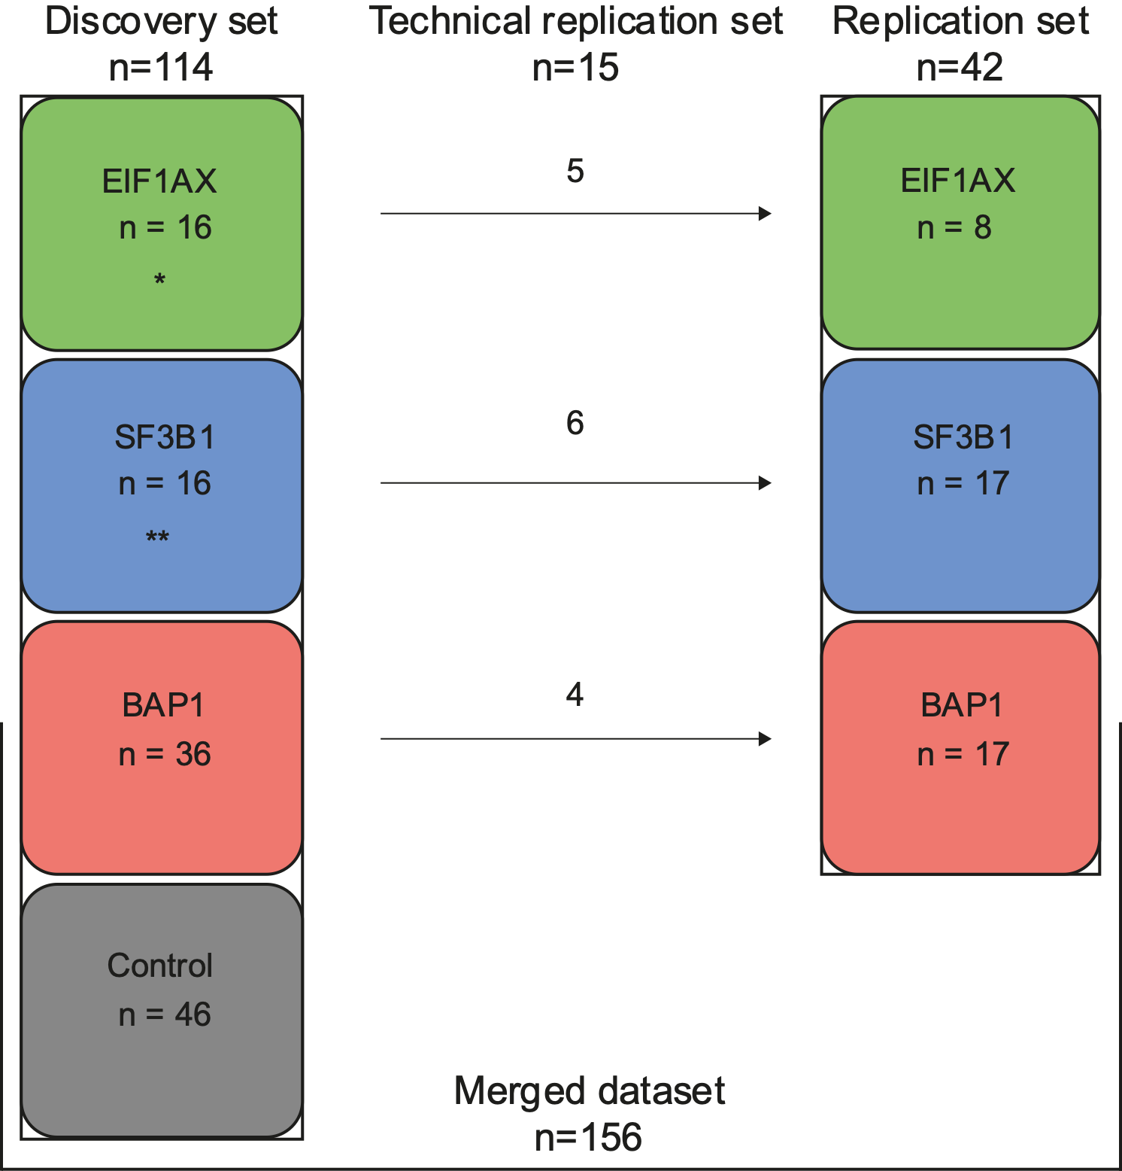

Figure S1. Sample numbers in discovery, replication and merged datasets.
156 participants enrolled in our study. Our discovery set comprised of 16 patients harboring an EIF1AX-mutated tumor, 16 patients harboring an SF3B1-mutated tumor and 36 patients harboring a BAP1-mutated tumor. Additionally, 46 control-participants were included in the discovery set. The replication set included 8 patients harboring an EIF1AX-mutated tumor, 17 patients harboring an SF3B1-mutated tumor and 17 patients harboring a BAP1-mutated tumor. To assess batch effects in the merged dataset (discovery and replication set combined), 15 samples were used as a technical replication set (see Fig. S6). These technical replicates were used in the discovery cohort for exploring differential features (and subsequent metabolites). Afterwards, in the replication cohort, these samples were only used for quality control evaluation. Two patients harboring an SF3B1-mutated tumor and one patient harboring an EIF1AX-mutated tumor had an additional plasma sample retrieved at the same time-point included in the replication set as biological replicates to assess similarity in the metabolite profiles.

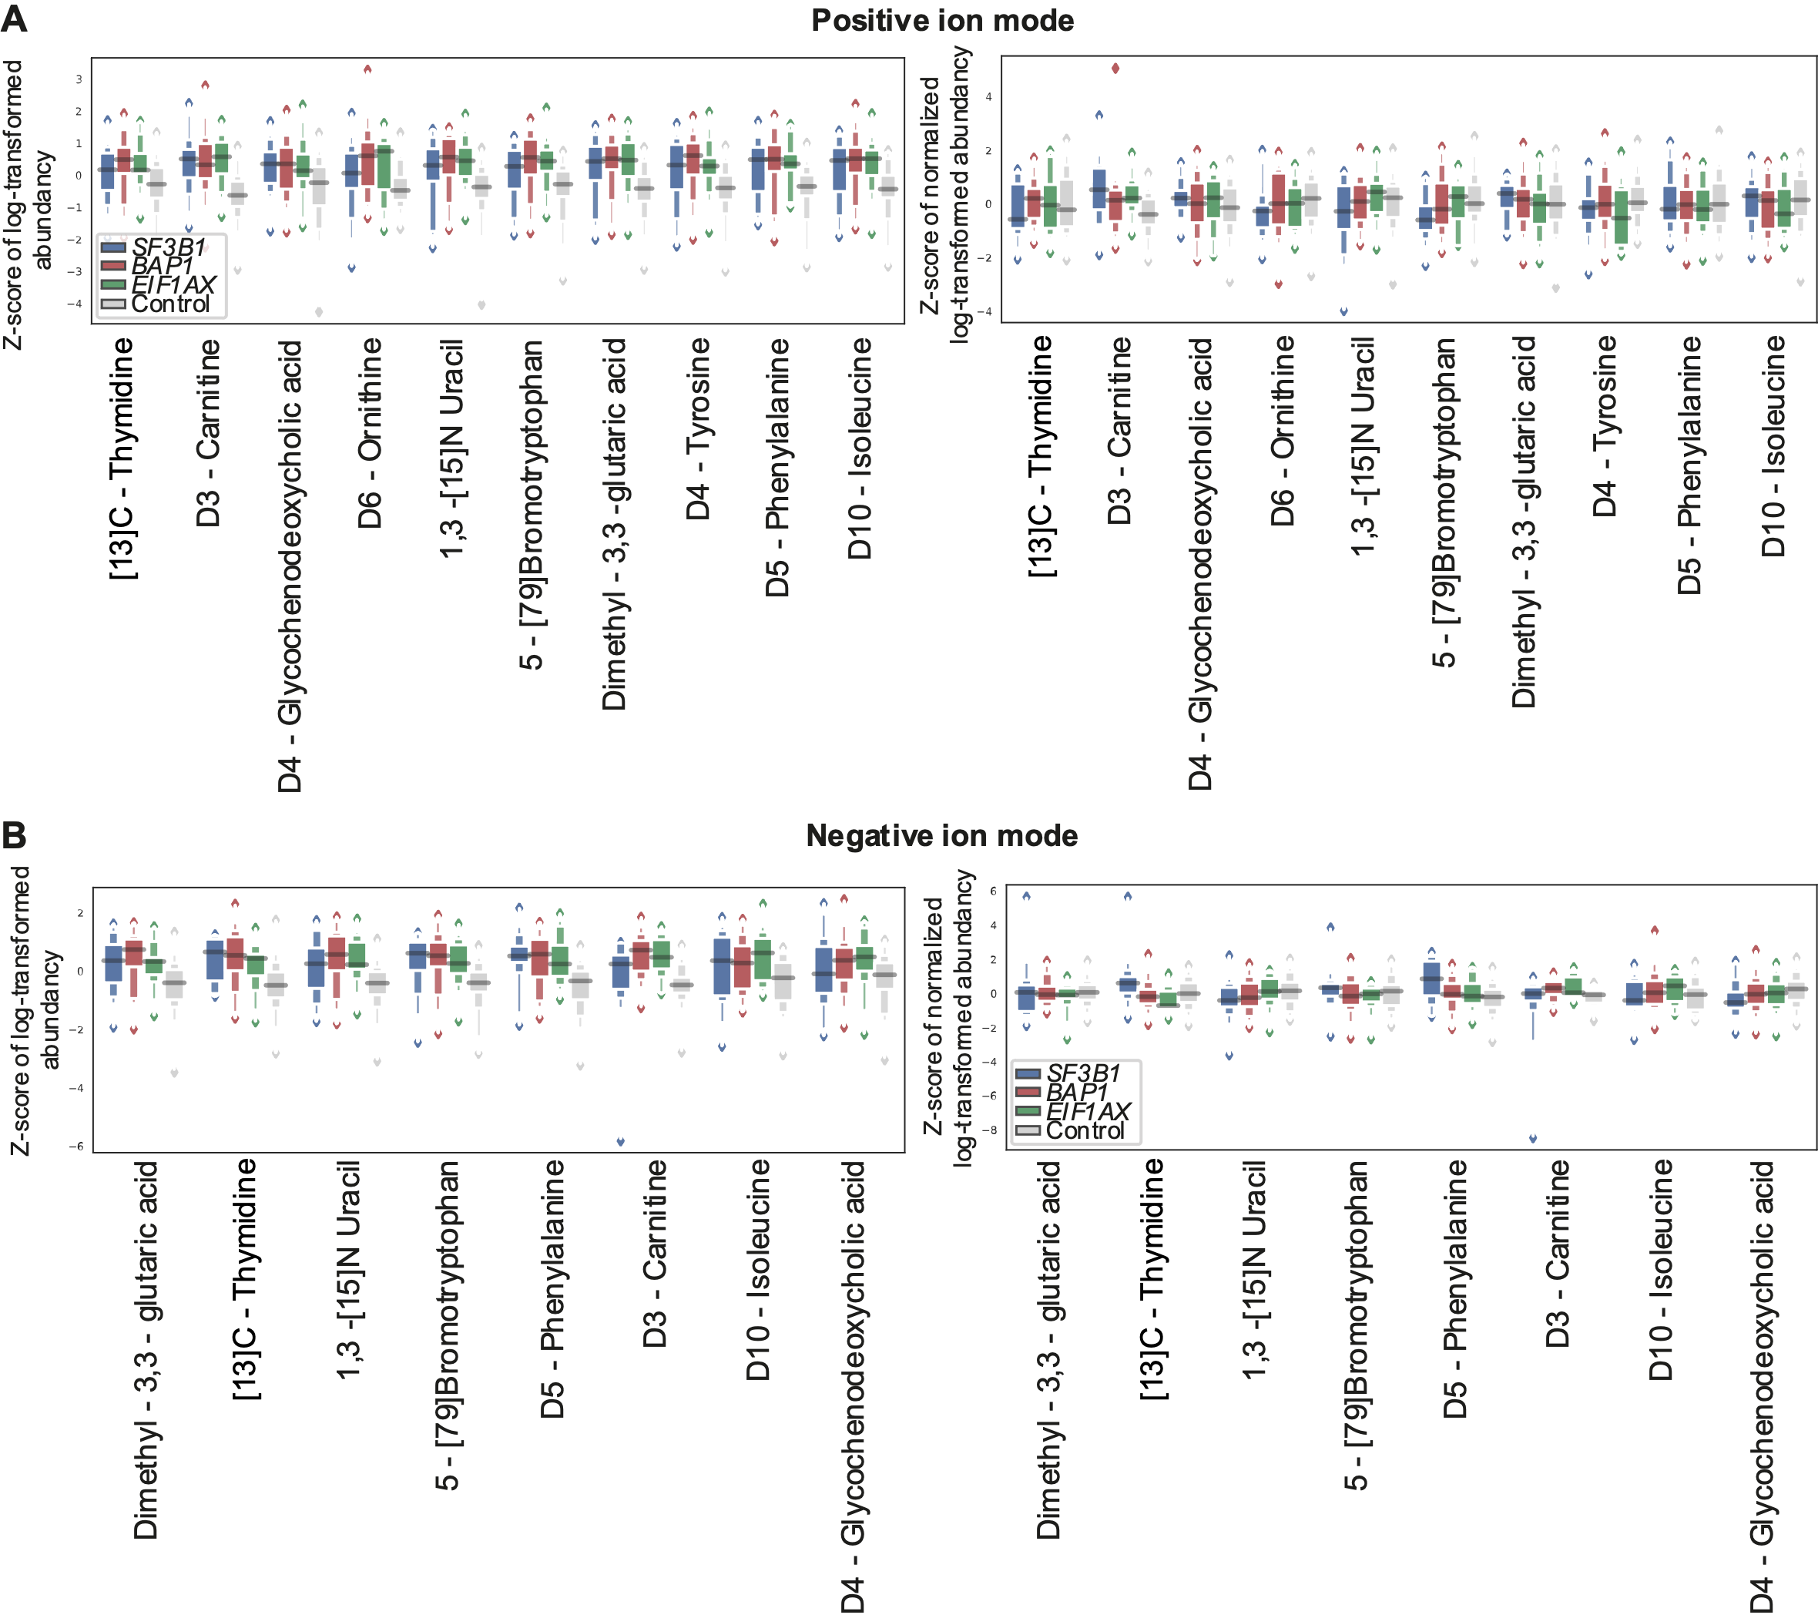
Figure S2. Quality control characteristics by internal standards in discovery set.
To eliminate technical variances, internal standards were added to each sample. These internal standards were used to normalize feature abundancies (see methods). For some groups we observe overall abundancy differences for the internal standards. Normalization reduced these group differences when looking at the normalized internal standards. Boxplots show z-scores of log-transformed abundancies of the internal standards in the discovery set in the (a) positive ion mode and (b) negative ion mode; on the left are unnormalized abundancies and the right side shows normalized abundancies.
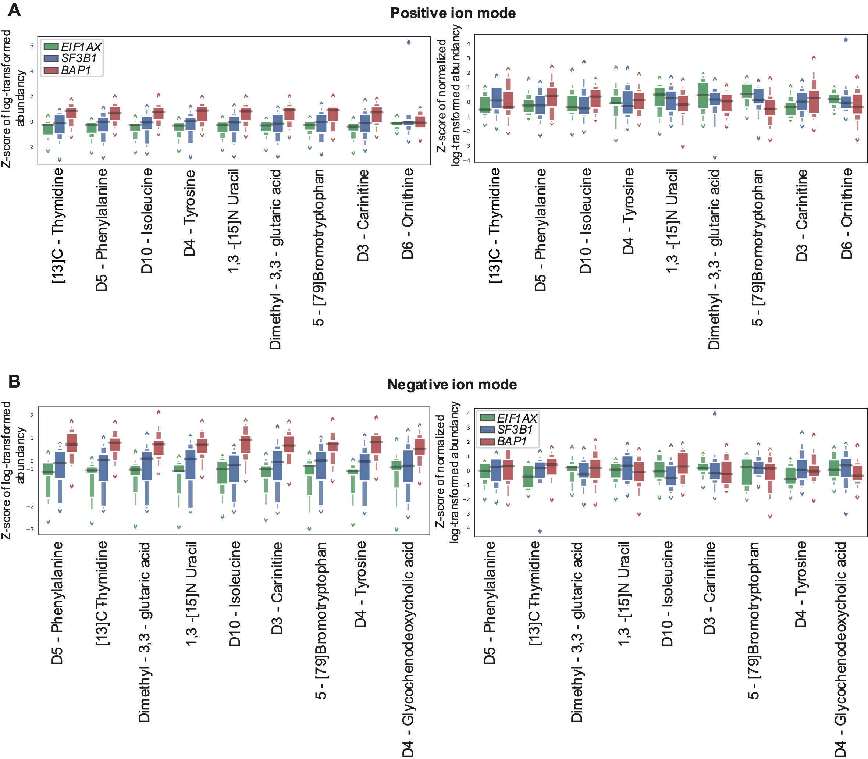Figure S3. Quality control characteristics by internals standards in replication set.
To eliminate technical variances in the replication set, internal standards were used to normalize feature abundancies. After normalization, technical differences in metabolite abundancy were reduced in the (a) positive ion mode and (b) negative ion mode.

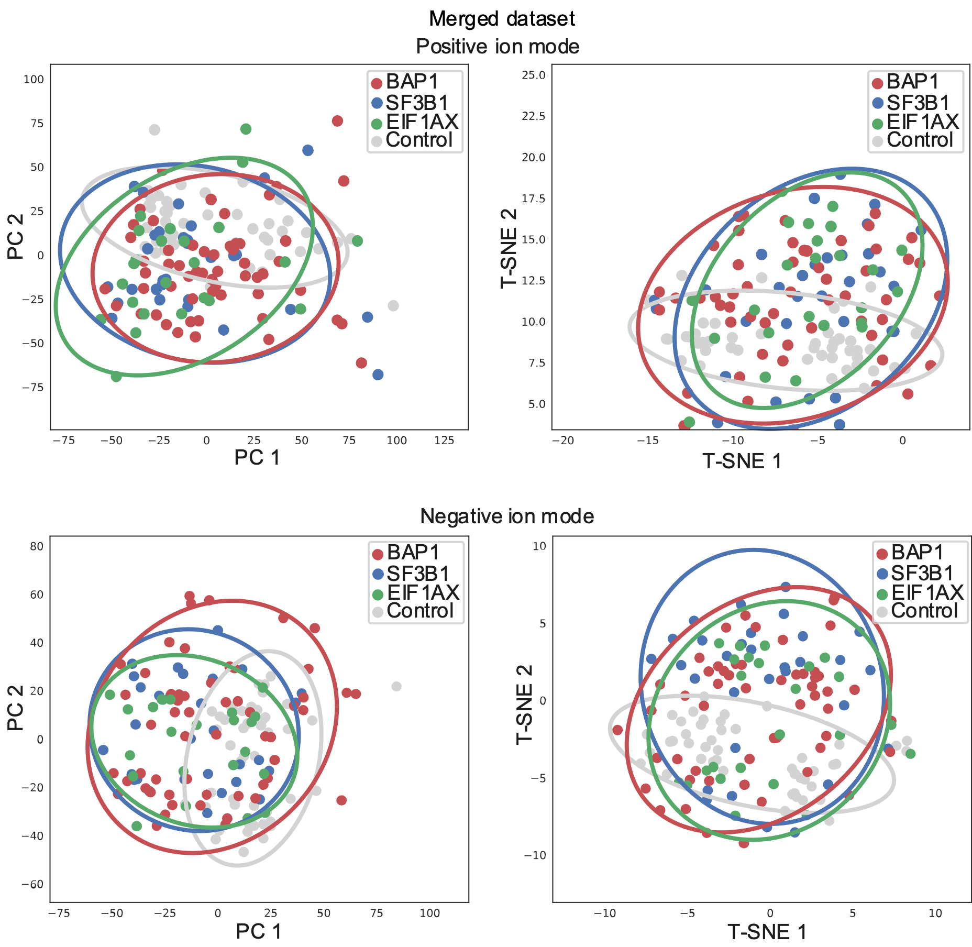
Figure S4. Quality control by two-dimensionality reduction analyses.
Unsupervised clustering by principal component analysis (PCA) and T-distributed Stochastic Neighbor Embedding (T-SNE) on all normalized feature abundancies show no deviations in (normalized) feature abundancies between plasma samples of patients with BAP1, SF3B1 or EIF1AX and control-participants in the whole cohort consisting of the discovery and replication sets (i.e., the merged dataset) in positive and negative ion modes.

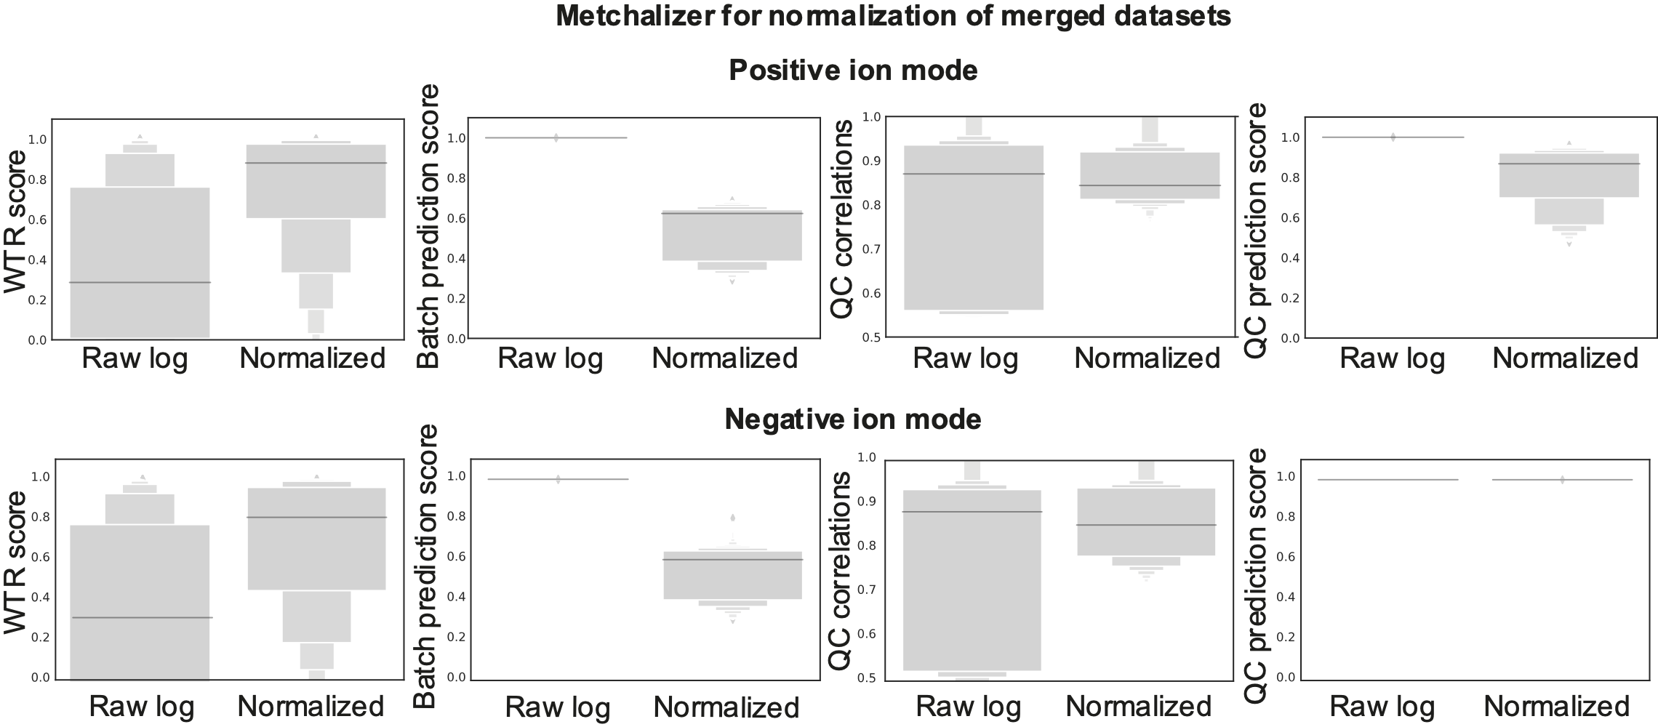Figure S5. Assessment of Metchalizer normalization in the merged dataset.
The four metrics WTR scores, Batch prediction scores, QC correlations and QC prediction scores are determined for both the log-transformed raw data and the Metchalizer normalized data. Technical replicates of the same sample were included in the replication and discovery set. Additionally, technical replicates were included in each individual dataset. Assessment of these technical replicates indicate improved normalization as they are associated with increased WTR scores, QC correlations and QC predictions scores, and with reduced batch prediction scores [33]. These metrics are determined for both ion modes.

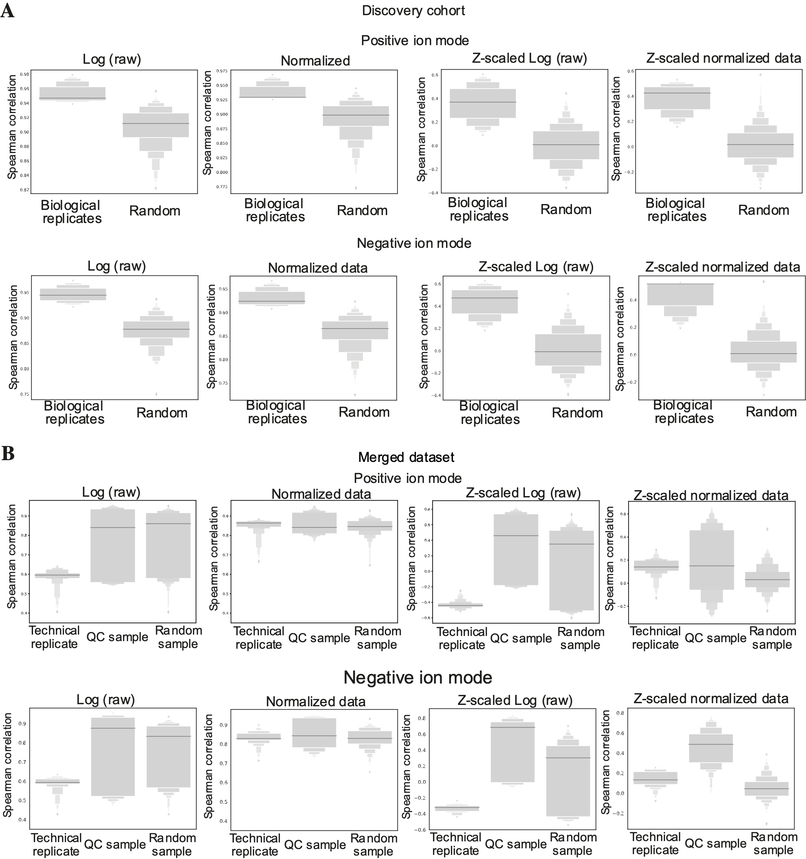Figure S6. Assessment of technical and biological variation by using replicates in the discovery cohort and merged dataset.
The Spearman correlation between two samples was determined using all features for samples in the discovery cohort and merged dataset, where abundancies were either log-transformed raw abundancies or normalized abundancies. (a) In the discovery cohort, these correlations were determined between biological replicates (two different UM-patient plasma samples retrieved at one time-point) or between a random selection of samples. For the latter we expect, and observe, lower correlation coefficients than the biological replicates. Furthermore, normalized abundancies should ideally further improve the correlation between the latter. (b) In the merged dataset, correlations were determined between technical replicates (a UM-patient sample being measured in each of the two batches), between the QC samples (same sample measured multiple times per batch and in both batches) and between a random selection of samples. The Spearman correlation of normalized feature abundancies of biological and technical replicates (both UM-patient samples and QC-samples) showed better correlation than randomly chosen samples.
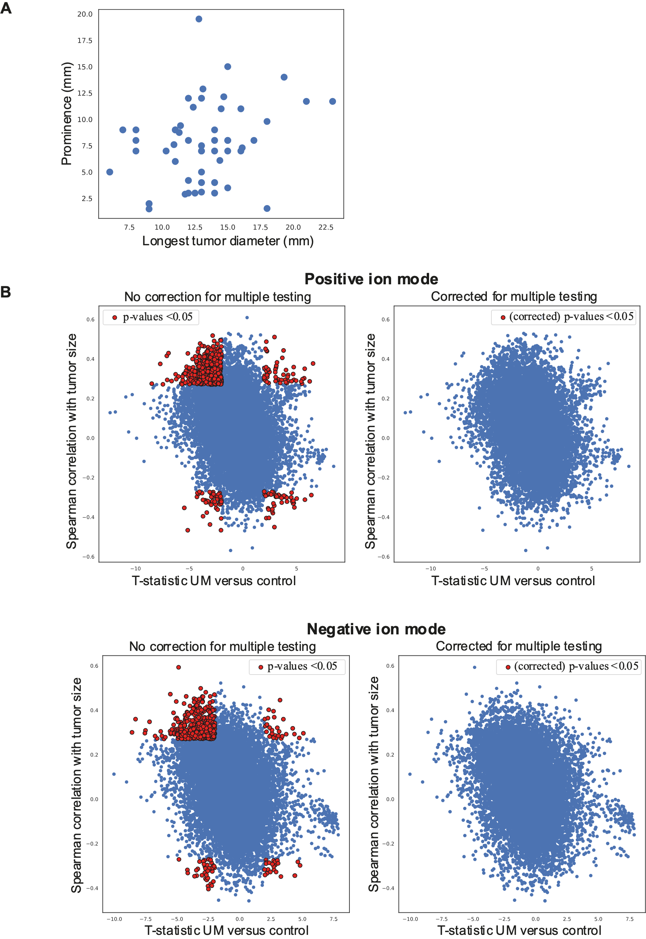
Figure S7. Correlation of m/z features with tumor size and differential abundance between UM patients and controls.
(a) Since tumor size characteristics prominence and longest tumor diameter (LTD) correlate, the first PC from PCA analysis was used as metric to correlate with feature abundance. (b) Next, the t-statistic of feature abundance in UM-patients versus control-participants was calculated. By scattering both metrics, we obtain interesting regions in each corner of the scatter plot and these features are depicted by red dots (p-value <0.05). In the top-right corner of the plot the relatively high feature abundance in UM-patients and (strong) correlation with tumor size are depicted; the bottom-left corner shows low feature abundance in UM-patients and inverse correlation to tumor size. No feature is significantly differentially abundant between UM-patients and control-participants and correlated with tumor size, after correcting for multiple testing using the Benjamini/Hochberg procedure with a family-wise error rate of 0.05.

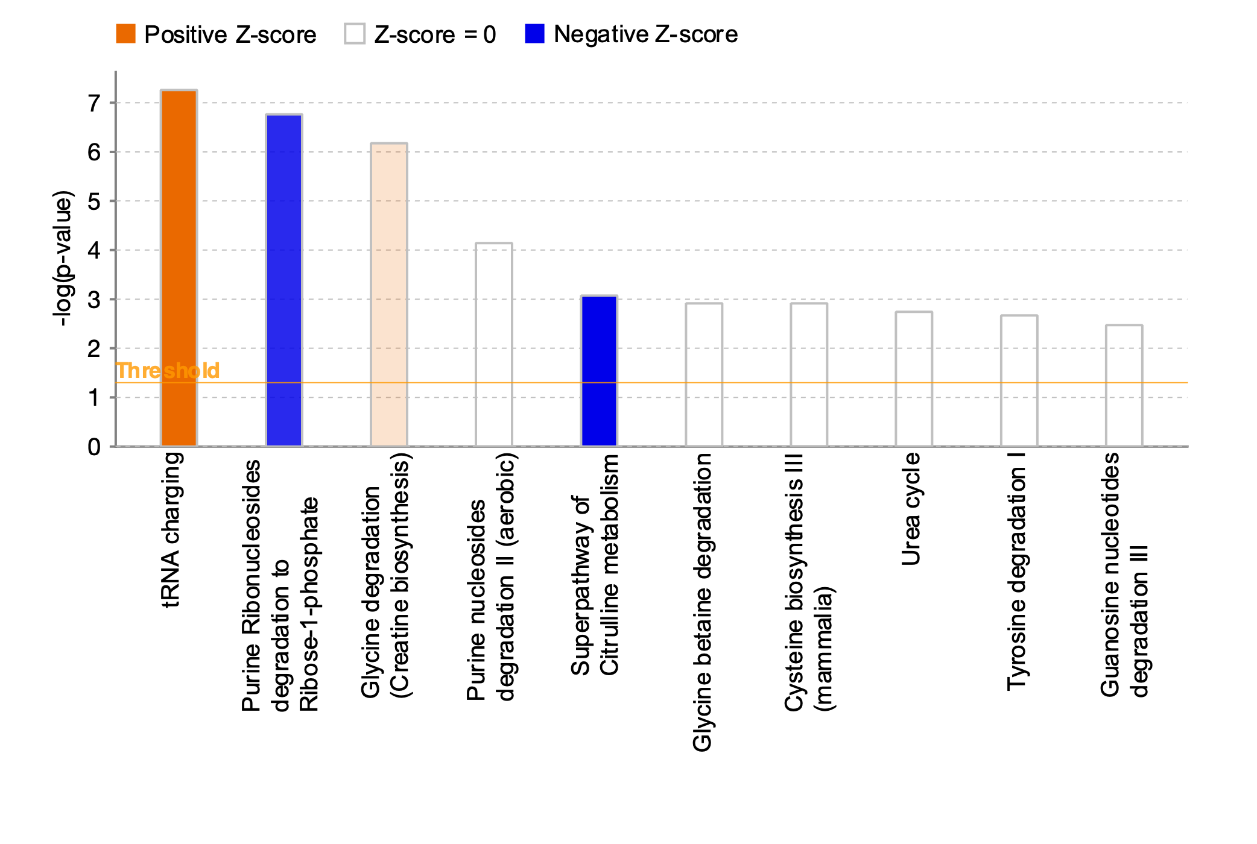
Figure S8. Pathway analysis of top-10 affected pathways in UM-patients compared to control-participants.
All metabolite annotations with a HMDB ID were pulled from both ion modes. For metabolites that were annotated in both ion modes, we selected the ion mode that had on average the highest abundancy (i.e., better signal-to-noise ratio). The fold-change between UM-patients and control-participants and the p-values from the t-test were used as input for Ingenuity Pathway Analysis (IPA). Metabolites were annotated using an in-house developed database as described previously[34]. Data was analyzed using QIAGEN IPA (QIAGEN Inc., https://digitalinsights.qiagen.com/IPA). Z-scores were obtained by calculating the Fold Change between annotated metabolite abundancy in UM-patients compared to control-participants. The p-values were obtained by t-test of differences in metabolite abundancy between UM-patients and control-participants. Upregulation of pathways is depicted in orange and downregulation is visualized by blue bars, in which color intensity correlates to the Z-score. We observed an upregulation of transfer (tRNA) charging and the use of glycine for the creatine biosynthesis. Purine ribonucleosides degradation and the super pathway of citrulline metabolism were downregulated in UM-patients.

Study ID | Sex | Age at phlebotomy (range) | Disease
11603 | Male | 76-80 | AMD
11621 | Male | 76-80 | AMD
11628 | Male | 71-75 | Cataract
11643 | Female | 61-65 | AMD
11652 | Female | 76-80 | AMD
11657 | Female | 61-65 | Cataract
11687 | Female | 86-90 | Branch retinal vein occlusion
11743 | Female | 81-85 | AMD
11794 | Male | 81-85 | Traumatic cataract
11819 | Female | 56-60 | Open angle glaucoma
11825 | Male | 61-65 | AMD
11826 | Male | 76-80 | AMD
11828 | Female | 86-90 | AMD
11900 | Female | 61-65 | Cataract
11901 | Female | 61-65 | Cataract
11932 | Male | 81-85 | AMD
11952 | Male | 71-75 | Cataract
11963 | Female | 65-70 | Cataract
11965 | Male | 81-85 | Cataract
11966 | Male | 81-85 | Cataract
11967 | Male | 96-100 | AMD
11969 | Male | 81-85 | Diabetic macular edema
11970 | Female | 56-60 | Cataract
11971 | Male | 66-70 | Cataract
11972 | Male | 81-85 | Cataract
11978 | Female | 76-80 | AMD
12156 | Male | 65-70 | AMD
12157 | Male | 65-70 | Cataract
12158 | Female | 71-75 | Cataract
12162 | Female | 61-65 | Cataract
12163 | Female | 66-70 | Cataract
12165 | Female | 81-85 | AMD
12166 | Male | 71-75 | Cataract
12167 | Male | 61-65 | Cataract
12168 | Female | 65 | AMD
12175 | Female | 88 | AMD
12178 | Female | 74 | AMD
12237 | Male | 76 | Cataract
12280 | Female | 63 | Cataract
12287 | Female | 87 | AMD
12288 | Female | 81 | AMD
12291 | Female | 77 | AMD
12292 | Male | 78 | Cataract
12293 | Female | 75 | Central retinal vein occlusion
12294 | Male | 72 | AMD
12296 | Female | 67 | Cataract
Supplementary tables

Table S1. Characteristics of control-participants.
Control-participants are included from the Combined Ophthalmic Research Rotterdam Biobank (CORRBI). These patients had blood drawn prior to surgical treatment and no systemic treatment was administered during the period of phlebotomy.Abbreviation: AMD: Age-related macular degenerati

Study_ID | Sex | Age at onset (years) | DFS (months) | Plasma retrieval | Mutation | Replication set
EOM-0147 | Male | 56,4 | 95,7 | 1998 | SF3B1 | Technical replication
EOM-0296 | Male | 66,6 | 8,2 | 2003 | BAP1 | Technical replication
EOM-0334 | Male | 65,4 | 23,7 | 2004 | BAP1 | Technical replication
EOM-0355a | Female | 72,9 | 19,4 | 2004 | EIF1AX | Technical replication
EOM-0355 | Female | 72,9 | 19,4 | 2004 | EIF1AX | Biological replication
EOM-0409 | Female | 27,3 | 154,1 | 2006 | SF3B1 | Technical replication
EOM-0464 | Female | 73,5 | 130,9 | 2008 | SF3B1 | Technical replication
EOM-0472 | Female | 66 | 143,8 | 2008 | EIF1AX | Technical replication
EOM-0485 | Male | 82,8 | 63,2 | 2008 | EIF1AX | Technical replication
EOM-0501 | Female | 57,5 | 15,8 | 2009 | BAP1 | Technical replication
EOM-0534 | Male | 66,2 | 48,5 | 2010 | BAP1 | Technical replication
EOM-0627 | Female | 71,5 | 102,3 | 2011 | EIF1AX | Technical replication
EOM-0724 | Female | 43 | 67,5 | 2014 | SF3B1 | Technical replication
EOM-0779a | Male | 47,7 | 70 | 2015 | SF3B1 | Technical replication
EOM-0779 | Male | 47,7 | 70 | 2015 | SF3B1 | Biological replication
EOM-1097a | Female | 46 | 11,3 | 2018 | SF3B1 | Technical replication
EOM-1097 | Female | 46 | 11,3 | 2018 | SF3B1 | Biological replication
EOM-1104 | Male | 59,9 | 14,3 | 2019 | EIF1AX | Technical replication

Table S2. Patient and sample characteristics of the technical and biological replication sets.
To compare metabolite profiles and evaluate batch-effects a technical replication set comprising of 15 samples was analyzed in both the discovery and replication set. Additionally, three samples were used as a biological replicate in which a different plasma sample was retrieved at the same time-point. The patients resemble their respective cohorts in metastatic free survival (MFS), age at onset and male/female ratio. These samples were retrieved and subsequently stored between 1998 and 2019.

Supplementary references

33. Bongaerts M, Bonte R, Demirdas S, Jacobs EH, Oussoren E, van der Ploeg AT, et al. Using Out-of-Batch Reference Populations to Improve Untargeted Metabolomics for Screening Inborn Errors of Metabolism. Metabolites. 2020;11(1).
34. Bonte R, Bongaerts M, Demirdas S, Langendonk JG, Huidekoper HH, Williams M, et al. Untargeted Metabolomics-Based Screening Method for Inborn Errors of Metabolism using Semi-Automatic Sample Preparation with an UHPLC- Orbitrap-MS Platform. Metabolites. 2019;9(12).

