Supplementary Information
Cellulose nanocrystal films – Effect of electrolyte and lignin addition on self-assembly, optical, and mechanical properties
Mahesh Parit^{a,b}, Zhihua Jiang* ^{a,b}
- Department of Chemical Engineering, Auburn University, 212 Ross Hall, Auburn, AL 36849, USA
- Alabama Center for Paper and Bioresource Engineering, Auburn University, 356 Ross Hall, Auburn, AL 36849, USA

d
b
c
a
e
Fig.S1. Transmission spectra of CNC films with various electrolyte concentrations (a) NaOH (b) NaCl (c) CsCl (d) CaCl₂ (e) AlCl_{3.}

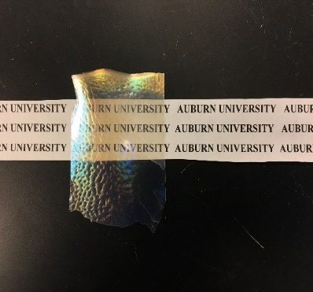
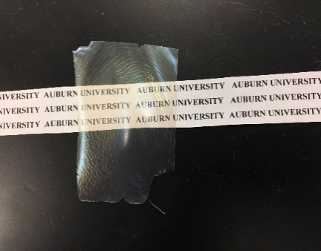
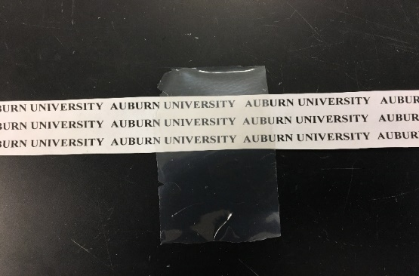
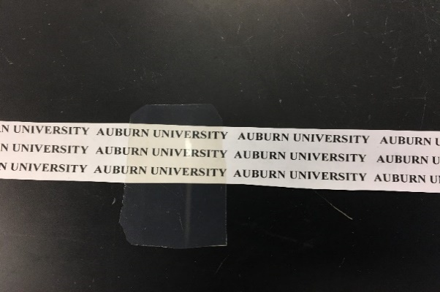
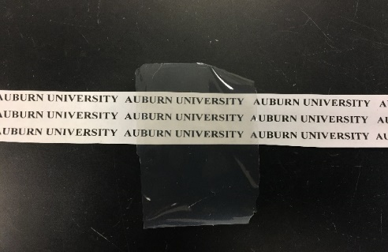
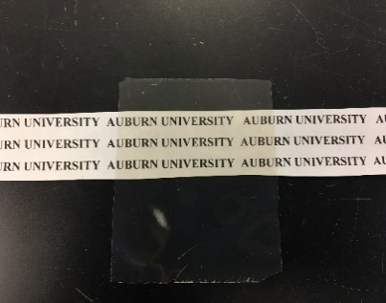
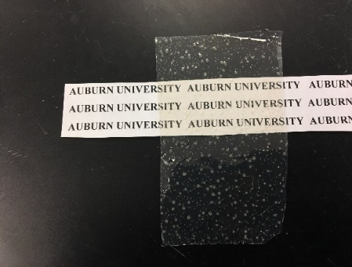
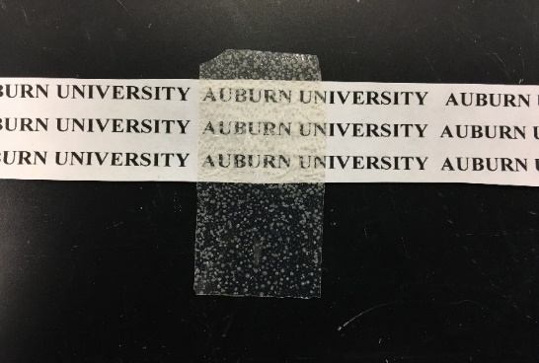
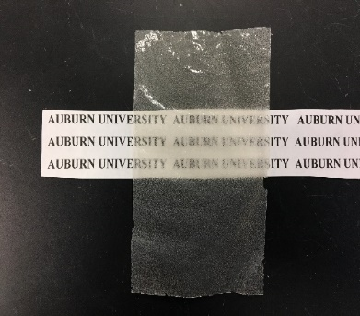
a
b
c
d
e
h
i
g
f

Fig.S2. CNC films at various NaOH concentrations (a) 0.125 mmol/g (b) 0.25 mmol/g (c) 0.375 mmol/g (d) 0.5 mmol/g (e) 0.75 mmol/g (f) 0.875 mmol/g (g) 1.75 mmol/g (h) 2.5 mmol/g (i) 3.75 mmol/g.

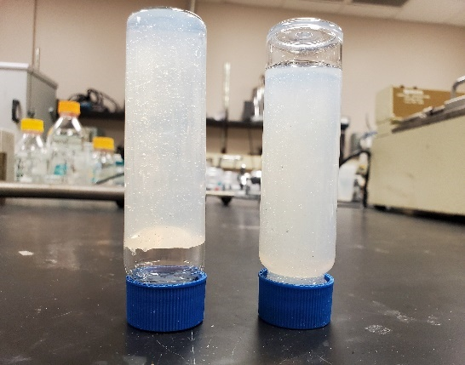
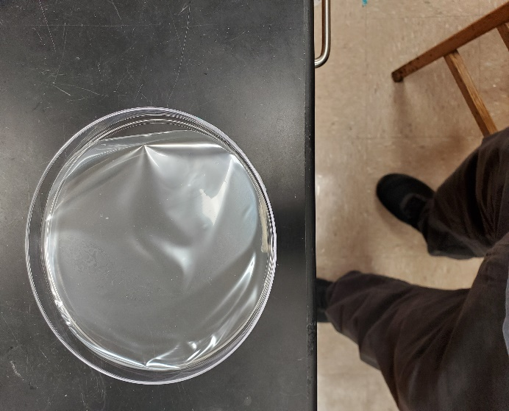
Fig.S3. (a) Dried dialyzed CNC film (b) Transmission spectra comparison of different CNC samples.
a
b
Fig.S4. 5 wt.% aqueous samples of dialyzed CNC (left) and as received CNC (right).

Fig.S5. XRD plots for pure CNC films and CNC films containing 1.25 mmol/g of various electrolytes

Fig.S6. Crystallinity of CNC films containing electrolytes at different concentrations.

Fig.S7.Crystallinity of CNC film samples added with 1.25 mmol/g electrolyte before and after dialysis.

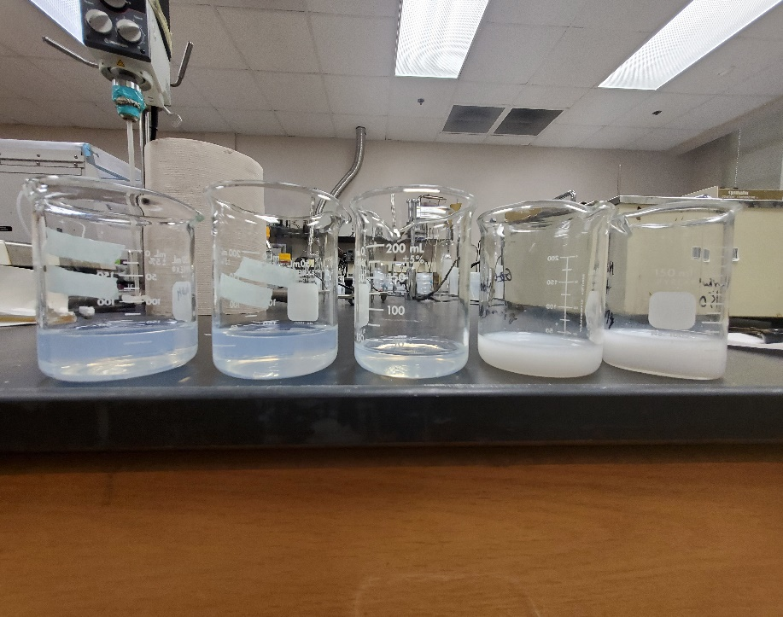

Fig.S8. Dialyzed and redispersed samples after treating with CsCl, NaCl, NaOH, CaCl₂ and AlCl₃ (from left to right).

1595 cm⁻¹
1512 cm⁻¹
1702 cm⁻¹

Fig.S9. FTIR spectra of KL and peroxide bleached KL samples.
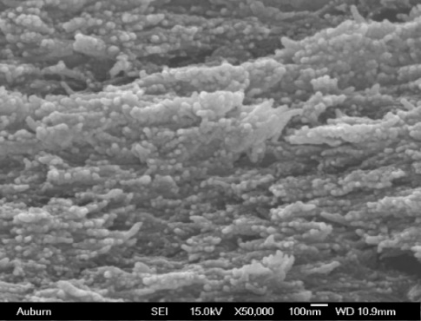
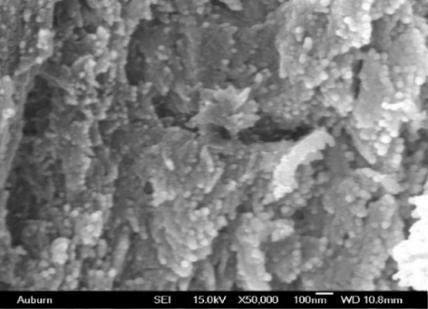
b
a

Fig.S10. Scanning electron microscopy images of the CNC/lignin film cross sections showing the lignin dispersibility in 10 wt.% CNC/PBKL150.

Table S1. Effect of H₂O₂ concentration on lignin optical properties. (%T550 nm and %UV blocking at 400 nm obtained for 0.1 wt.% lignin solution and extinction coefficient obtained using absorbance at 255 nm).

H₂O₂ Conc. (wt%) | H₂O₂/KL | %T at 550 nm | % UV blocking at 400 nm | Extinction coefficient at 255 nm (wt.%⁻¹ cm⁻¹)
0 | 0 | 31.2 | 99.7 | 223.8
50 | 0.5 | 62.5 | 99.3 | 206
150 | 1.5 | 85.5 | 93.7 | 187.3
200 | 2 | 87.6 | 90.8 | 185
400 | 4 | 90.3 | 89.8 | 175.2
600 | 6 | 91.6 | 89.4 | 157.3
1000 | 10 | 94.3 | 88.4 | 148.9

Table S2. %UV A, %UV B, %UV blocking at 400 nm and %T at 400 nm for CNC and CNC nanocomposites.
Sample | %UV A blocking | %UV B blocking | %T at 550 nm | % UV blocking at 400 nm
CNC | 19.9 | 26.6 | 86.8 | 18.8
CNC/KL (10 wt.%) | 99.9 | 100.0 | 33.4 | 99.5
CNC/4-ABA (10 wt.%) | 54.3 | 99.5 | 75.3 | 46.2
CNC/PB-KL150 (4 wt.%) | 87.5 | 99.9 | 76.1 | 66.2
CNC/PB-KL150 (10 wt.%) | 99.3 | 100.0 | 65.6 | 95.3

