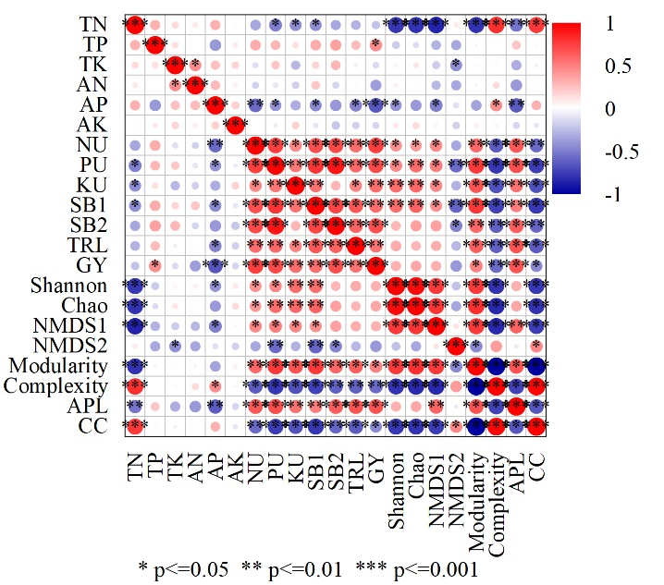
Figure S2 Correlation of plant traits, rhizosphere soil properties, and bacterial diversity under fertilization conditions
Note: TN, total nitrogen content; TP, total phosphorus content; TK, total potassium content; AN, available nitrogen content; AP, available phosphorus content; AK, available potassium content; NU, nitrogen uptake; PU, phosphorus content; KU, potassium content; SB1, shoot biomass at silking stage; SB2, shoot biomass at maturity stage; TRL, total root length; GY, grain yield; NMDS1, axe 1 of non-metric multidimensional scaling; NMDS2, axe 2 of non-metric multidimensional scaling; APL, average path length; CC, clustering coefficient.

