Supplemental materials
Fig.A.1 Overall survival for patients with different clinical T stage (cT) in ENI versus IFI group after propensity score-matched analysis.
Fig.A.2 Overall survival for patients with different clinical N stage (cN) in ENI versus IFI group after propensity score-matched analysis.
Fig.A.3 Overall survival for patients with clinical TNM stage (cTNM) in ENI versus IFI group after propensity score-matched analysis.
Fig.A.4 Overall survival for patients receiving different radiation doses in ENI versus IFI group after propensity score-matched analysis.
Fig.A.5 Overall survival for patients with hypopharyngeal invasion or not in ENI versus IFI group after propensity score-matched analysis.
Table A.1 Acute toxicity of patients with CESCC receiving dCCRT.

Fig.A.1 Overall survival for patients with different clinical T stage (cT) in ENI versus IFI group after propensity score-matched analysis.

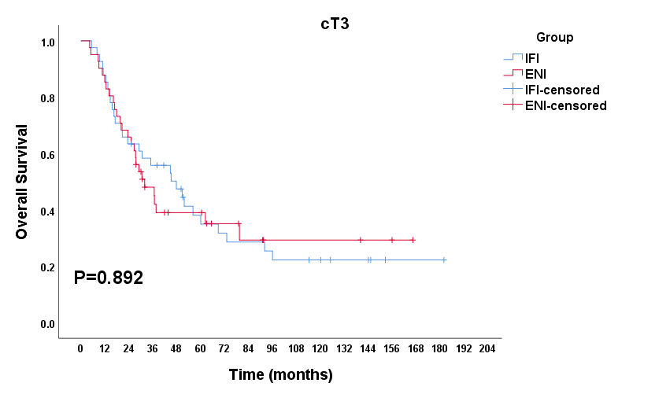
Fig.A.1.1 Overall survival for patients with cT3 in ENI versus IFI group after propensity score-matched analysis.

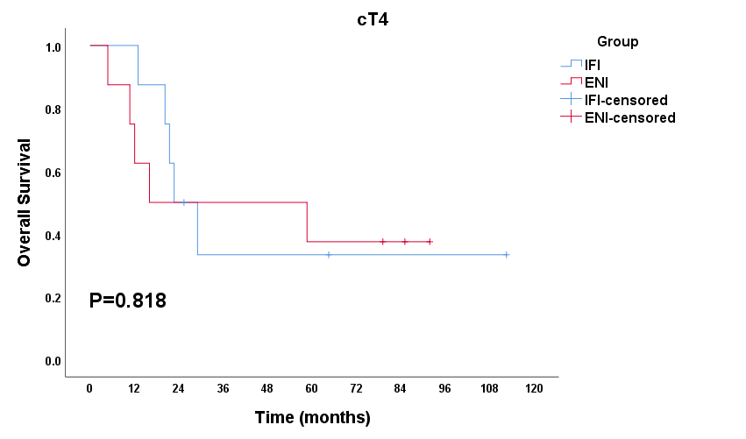
Fig.A.1.2 Overall survival for patients with cT4 in ENI versus IFI group after propensity score-matched analysis.

Fig.A.2 Overall survival for patients with different clinical N stage (cN) in ENI versus IFI group after propensity score-matched analysis.
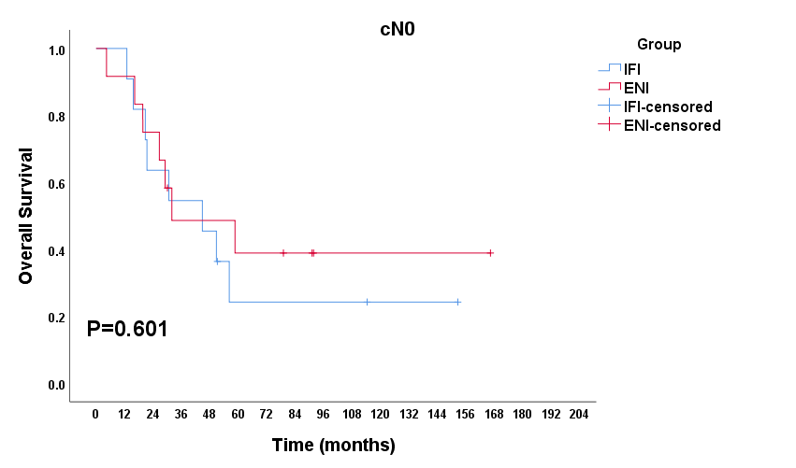
Fig.A.2.1 Overall survival for patients with cN0 in ENI versus IFI group after propensity score-matched analysis.

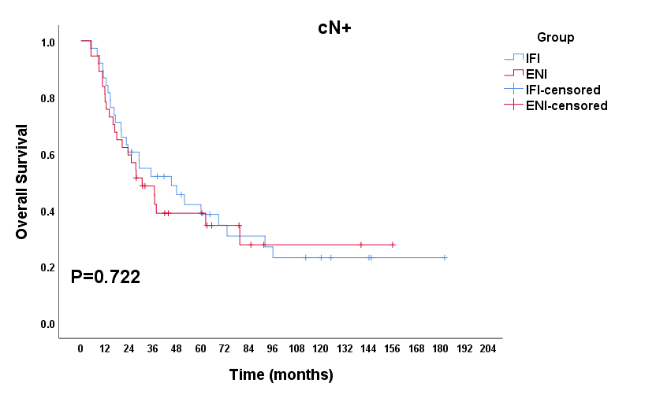
Fig.A.2.2 Overall survival for patients with cN+ in ENI versus IFI group after propensity score-matched analysis.

Fig.A.3 Overall survival for patients with clinical TNM stage (cTNM) in ENI versus IFI group after propensity score-matched analysis.

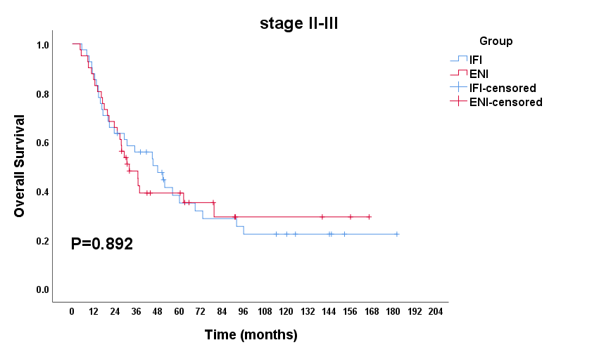
Fig.A.3.1 Overall survival for patients with stage Ⅱ-Ⅲ in ENI versus IFI group after propensity score-matched analysis.
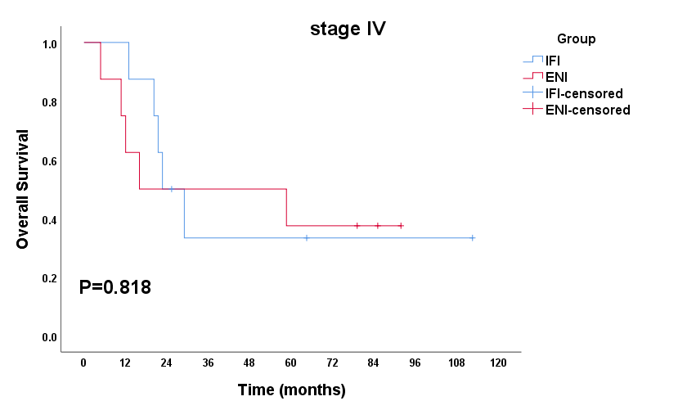
Fig.A.3.2 Overall survival for patients with stage Ⅳ in ENI versus IFI group after propensity score-matched analysis.

Fig.A.4 Overall survival for patients receiving different radiation doses in ENI versus IFI group after propensity score-matched analysis.

Fig.A.5 Overall survival for patients with hypopharyngeal invasion or not in ENI versus IFI group after propensity score-matched analysis.
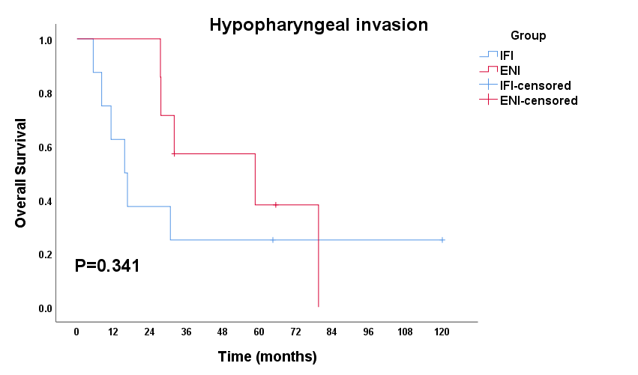
Fig.A.5.1 Overall survival for patients with hypopharyngeal invasion in ENI versus IFI group after propensity score-matched analysis.
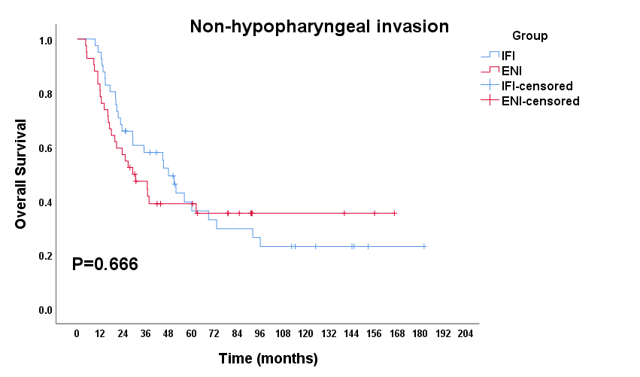
Fig.A.5.2 Overall survival for patients without hypopharyngeal invasion in ENI versus IFI group after propensity score-matched analysis.

Table A.1 Acute toxicity of patients with CESCC receiving dCCRT.
Toxicity | Group | Classification
Toxicity | Group | Grade 0  n (%) | Grade 1  n (%) | Grade 2  n (%) | Grade 3  n (%) | Grade 4  n (%)
Acute radiation esophagitis | ENI | 8 (16.3) | 9 (18.4) | 30 (61.2) | 1 (2.0) | 1 (2.0)
Acute radiation esophagitis | IFI | 7 (14.3) | 14 (28.6) | 28 (57.1) | 0 (0.0) | 0 (0.0)
Acute radiation pneumonitis | ENI | 46 (93.9) | 0 (0.0) | 2 (4.1) | 1 (2.0) | 0 (0.0)
Acute radiation pneumonitis | IFI | 47 (95.9) | 2 (4.1) | 0 (0.0) | 0 (0.0) | 0 (0.0)
Upper gastrointestinal reaction | ENI | 36 (73.5) | 5 (10.2) | 6 (12.2) | 2 (4.1) | 0 (0.0)
Upper gastrointestinal reaction | IFI | 40 (81.6) | 4 (8.2) | 5 (10.2) | 0 (0.0) | 0 (0.0)
Leukocytopenia | ENI | 20 (40.8) | 9 (18.4) | 15 (30.6) | 4 (8.2) | 1 (2.0)
Leukocytopenia | IFI | 30 (61.2) | 7 (14.3) | 8 (16.3) | 4 (8.2) | 0 (0.0)
Neutropenia | ENI | 34 (69.4) | 9 (18.4) | 2 (4.1) | 3 (6.1) | 1 (2.0)
Neutropenia | IFI | 42 (85.7) | 0 (0.0) | 5 (10.2) | 2 (4.1) | 0 (0.0)
Lymphocytopenia | ENI | 3 (6.1) | 3 (6.1) | 18 (36.7) | 24 (49.0) | 1 (2.0)
Lymphocytopenia | IFI | 1 (2.0) | 8 (16.3) | 12 (24.5) | 24 (49.0) | 4 (8.2)
Anemia | ENI | 34 (69.4) | 14 (28.6) | 1 (2.0) | 0 (0.0) | 0 (0.0)
Anemia | IFI | 33 (67.4) | 15 (30.6) | 1 (2.0) | 0 (0.0) | 0 (0.0)
Thrombocytopenia | ENI | 49 (100.0) | 0 (0.0) | 0 (0.0) | 0 (0.0) | 0 (0.0)
Thrombocytopenia | IFI | 47 (95.9) | 1 (2.0) | 1 (2.0) | 0 (0.0) | 0 (0.0)

