Hierarchical flower-like ZnO-Ag@Cellulose composite with antifouling and antibacterial properties for efficient recovery of tellurium (IV) from wastewater
Guanglei Yao ª, Xue Shao ª, Zhiwei Qiu ª, Fengxian Qiu ª*,Tao Zhang ^{a,b}*
ª School of Chemistry, Jiangsu University, Zhenjiang 212013, China
^{b} Institute of Green Chemistry and Chemical Technology, School of Chemistry and Chemical Engineering, Jiangsu University, 301 Xuefu Road, Zhenjiang 212013, Jiangsu Province, China
Results and discussion
- SEM before and after ZAC adsorption tellurium.
In order to further study the structure changes before and after adsorption, ZAC before and after adsorption tellurium are shown in Fig. S1. Compared with Fig. S1 (A), it can be seen that the structure has changed a lot, the reason may be successful adsorption of tellurium from wastewater.
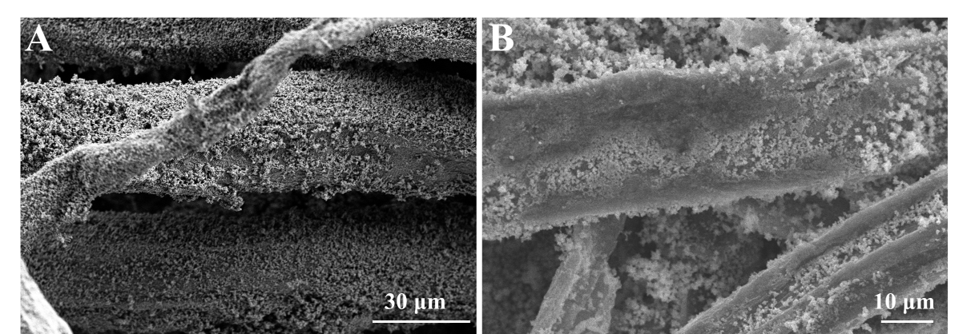
Fig. S1. SEM images of ZAC (A), tellurium adsorbed ZAC (B).
- EDS results after ZAC adsorbed tellurium.
After ZAC adsorbs tellurium, it can be clearly found from Fig. S2.that the Te element is detected by the EDS, indicating that ZAC has successfully adsorbed tellurium in wastewater.
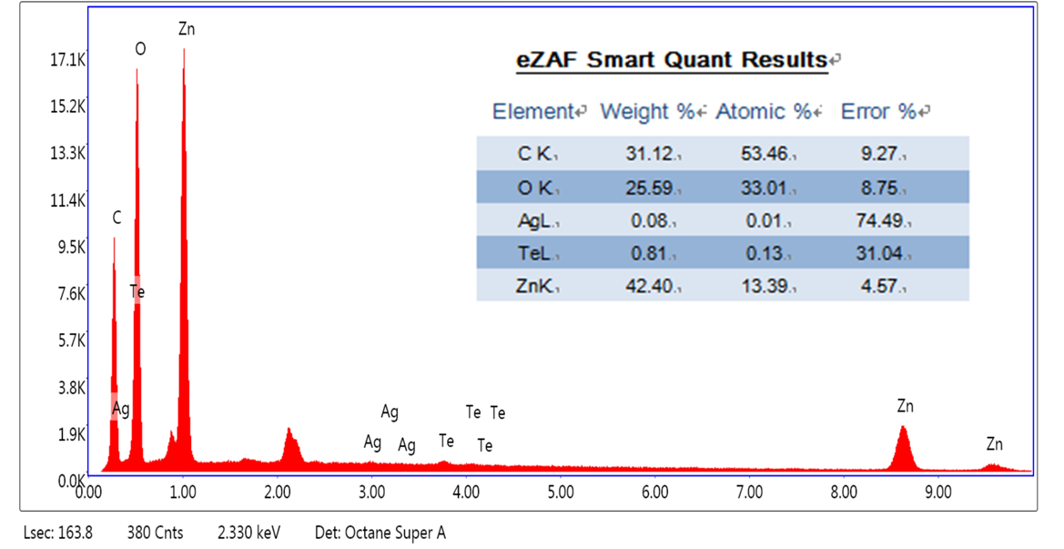
Fig. S2. EDS results after ZAC adsorbed tellurium.
- XRD patterns of ZAC before and after ZAC adsorption tellurium.
Fig. S3.shows the ZAC results before and after ZAC adsorption tellurium. Compared with before adsorption, the peak value after adsorption decreased significantly, confirming that ZAC participated in the process of tellurium adsorption.
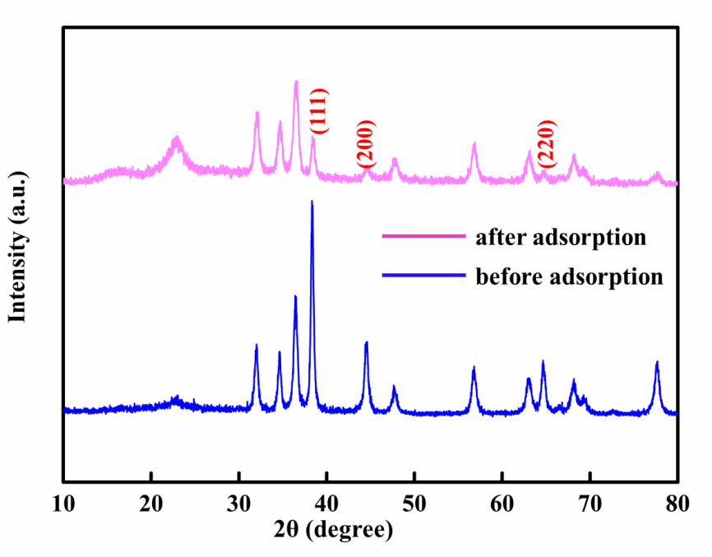
Fig. S3. XRD patterns of ZAC.
- Different models
Model | Equatios
Pseudo-first-order | $$\text{log}\left({\text{Q}}_{\text{e}}\text{-}{\text{Q}}_{\text{t}}\right)\text{=log}{\text{Q}}_{\text{e}}\text{-}\left(\frac{{\text{K}}_{\text{1}}}{\text{2.203}}\right)\text{t}$$  $$\frac{\text{t}}{{\text{Q}}_{\text{t}}}\text{=}\left[\left(\frac{\text{1}}{{\text{K}}_{\text{2}}{\text{Q}}_{\text{e}}^{\text{2}}}\right)\text{+}\left(\frac{\text{t}}{{\text{Q}}_{\text{e}}}\right)\right]$$  $${\text{Q}}_{\text{e}}\text{=}\frac{{\text{Q}}_{\text{m}}{\text{K}}_{\text{1}}{\text{C}}_{\text{e}}}{\text{1+}{\text{K}}_{\text{1}}{\text{C}}_{\text{e}}}$$  $${\text{Q}}_{\text{e}}\text{=}{\text{K}}_{\text{f}}{\text{C}}_{\text{e}}^{\frac{\text{1}}{\text{n}}}$$
Pseudo-second-order
Langmuir
Freundlich
Table S1 different model and their linearized expression

*Corresponding authors: Tel. /fax: +86 511 88791800. E-mail: zhangtaochem@163.com (T, Zhang) fxqiu@ujs.edu.cn (F, Qiu)

