Supplementary Material
Supplementary Figure 1. Identification of immune-related gene clustering groups based on the expression of immunogenic cell death prognostic genes.
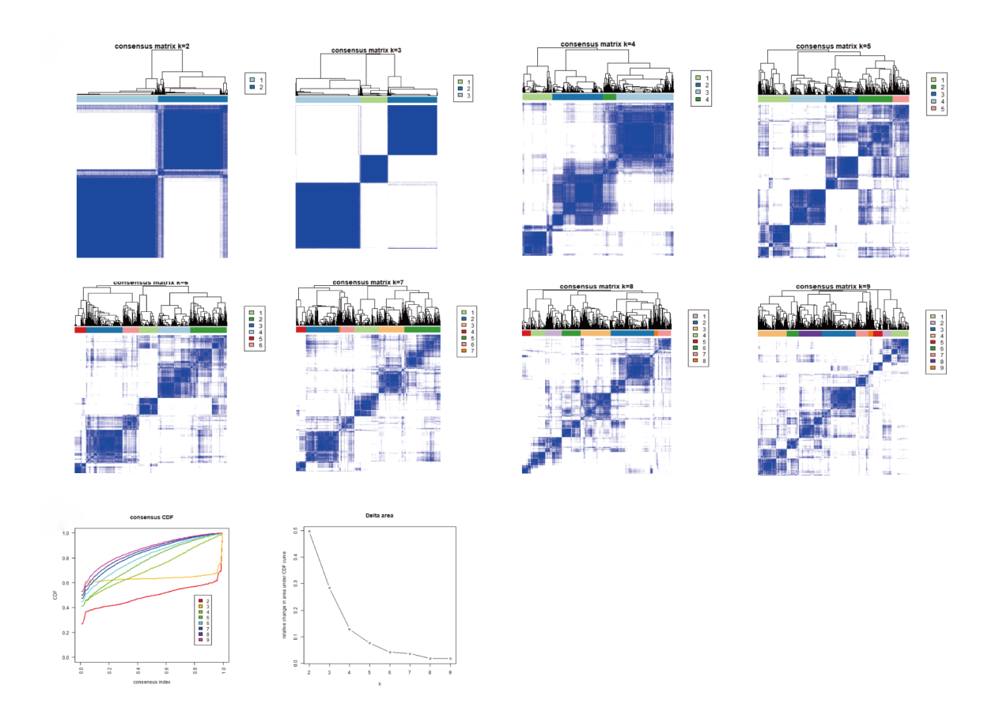
Supplementary Figure 2. Analysis of immunogenic cell death-related genes and overall survival prognosis of cervical cancer patients.

