Supporting information
The novel fluorescent probe toward yttrium(Ⅲ) and its bioimaging

Yuxin, Qin¹, Qian Meng¹, Junxiong Yao¹, Mengyu Chen,¹ Yajie Dong,¹ Dashuo Chen¹,
Shuping He¹, Cuibing Bai^{1*}, Lin Zhang¹, Biao Wei¹, Hui Miao¹, Changqing Qu^{2*}, Rui Qiao^{1*}

- Engineering Research Center of Biomass Conversion and Pollution Prevention of Anhui Educational Institutions, Anhui Provincial Key Laboratory for Degradation and Monitoring of Pollution of the Environment, School of Chemistry and Materials Engineering, Fuyang Normal University, Fuyang, Anhui Province, 236037, P. R. China
- Research Center of Anti-aging Chinese Herbal Medicine of Anhui Province, Fuyang Normal University, Fuyang, Anhui Province, 236037, P. R. China
* Corresponding Author E-mail:
baicuibing@fynu.edu.cn; qucq518@163.com; qiaorui@fynu.edu.cn

CONTEXT

Fig. S1 ( ¹H NMR and) 2

Fig. S2 (¹³C NMR spectra)... 2

Fig S3 (ESI-MS spectrum of XP)...............................................................................................3

Fig. S4 (The low limit of XP and Y³⁺)..........................................................................................3

Fig. S5 (The Job's work curve of XP-Y³⁺) 4

Fig. S6 (ESI-MS spectrum of XP+Y³⁺)........................................................................................4

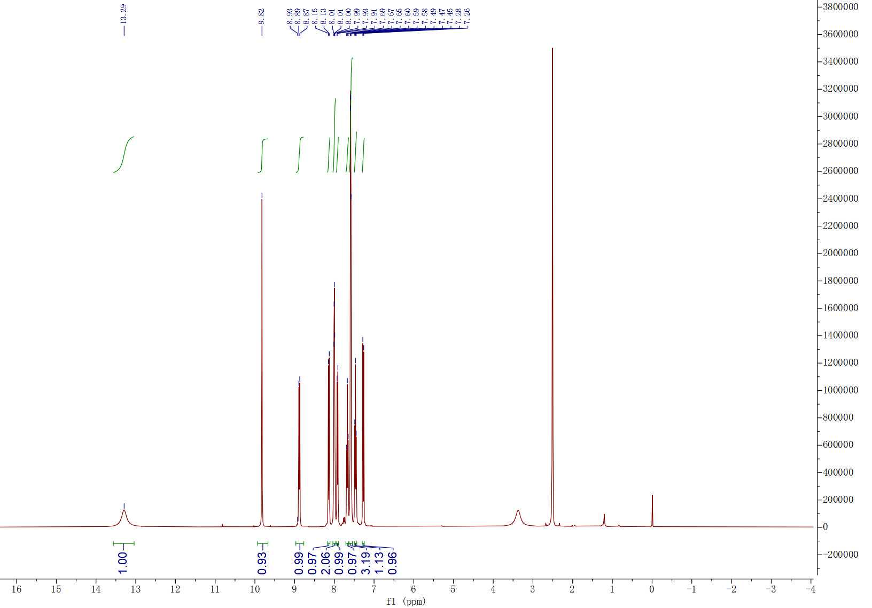

Fig. S1 ¹H NMR spectra of compound XP in DMSO-d₆

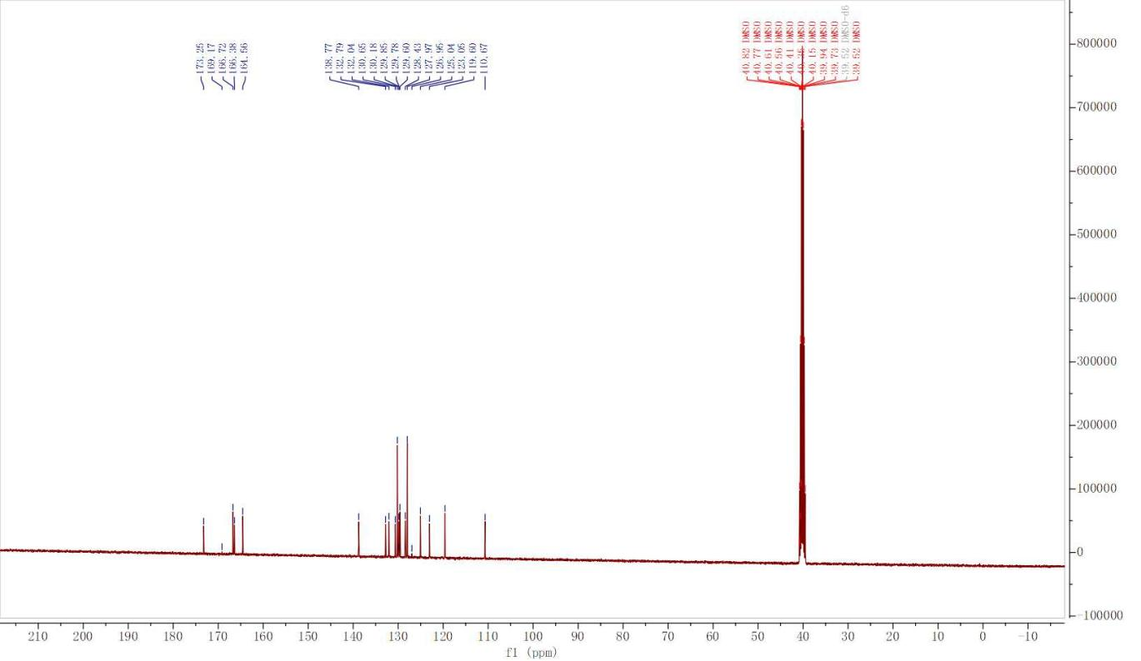
Fig. S2 ¹³C NMR spectra of compound XP in DMSO-d₆

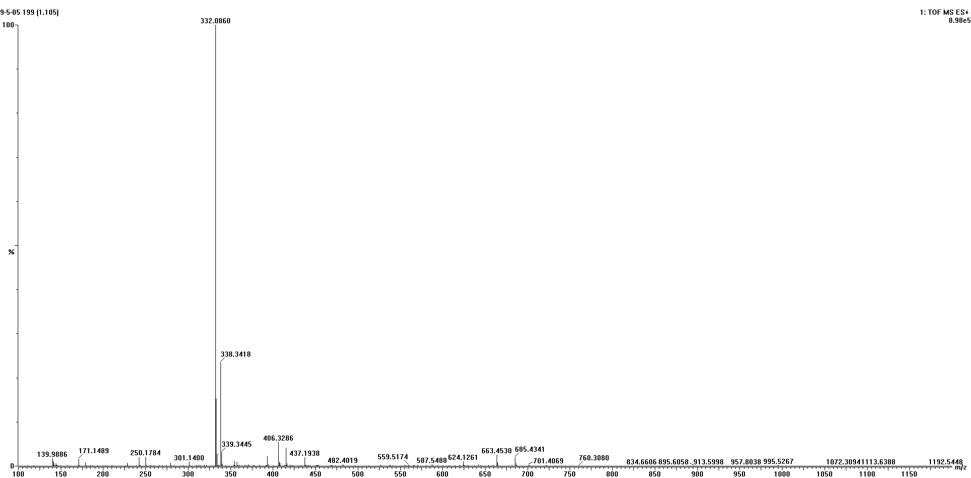
Fig. S3 ESI-MS spectrum of probe XP

Fig. S4 The fluorescence spectrum of probe XP (10 μM) and addition of different concentration of Y³⁺ in CH₃CN. LOD=3δ/K (δ=1.02488), K=1.01429×10⁷，LOD=0.30 μM.
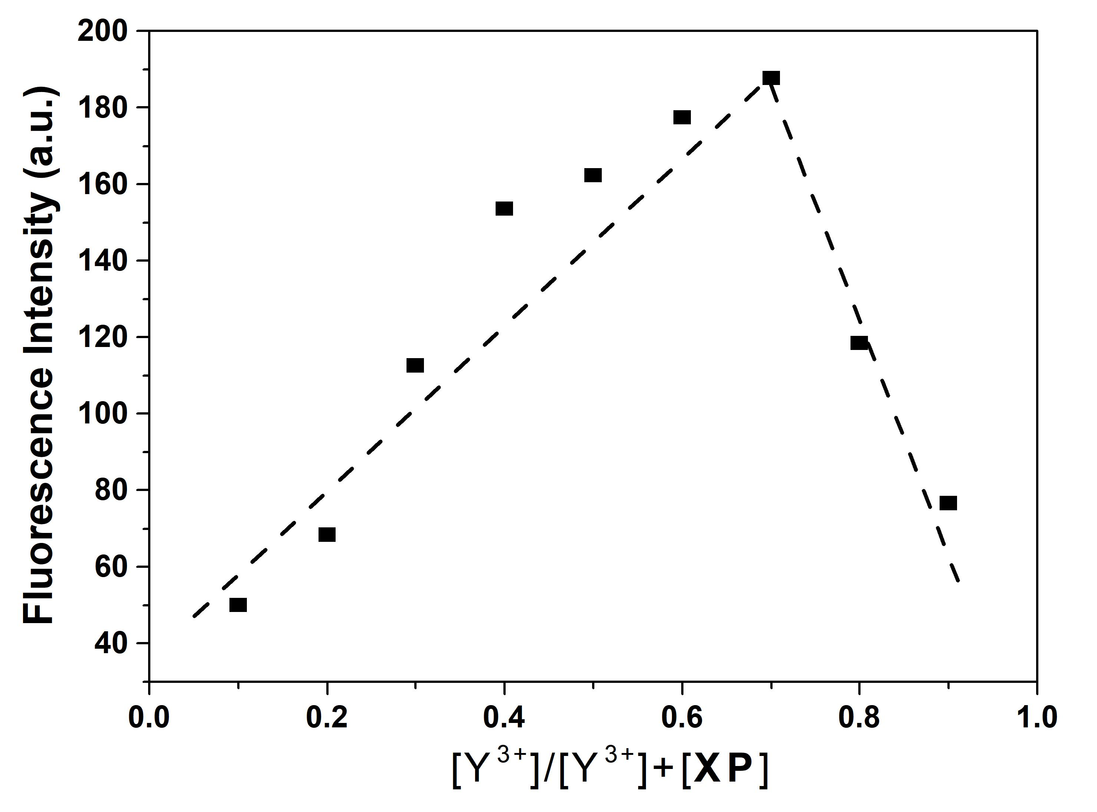
Fig. S5 The fluorescence spectrum of the Job's work curve of probe XP (10 μM) and Y³⁺ (10 μM) in CH₃CN

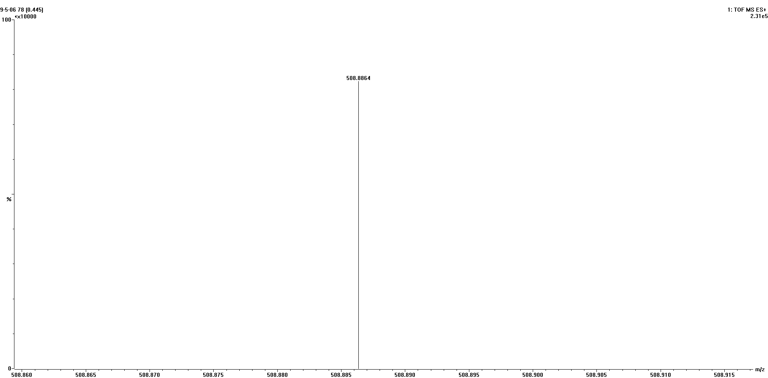
Fig. S6 ESI-MS spectrum of probe XP and Yttrium

