Supplementary Material
Table 1: ROI-to-ROI connectivity differences for the contrasts A). PTSD > Controls; and B). PTSD +DS > Controls. Only results surviving FDR-correction p-FDR > 0.05 at the cluster level are shown.
Clusters | Connections | Statistic | Effect Sizes | p-unc | p-FDR
 | A). PTSD > Controls:
Cluster 1/2 |  | F(2,144) = 9.95 | η² = 0.12 | 0.000090 | 0.021128
 | MidFG r (Middle Frontal Gyrus Right) --- SFG r (Superior Frontal Gyrus Right) | T(145) = 3.09 | dz = 0.26 | 0.002376 | 0.103761
 | FP r (Frontal Pole Right) --- MidFG r (Middle Frontal Gyrus Right) | T(145) = -2.52 | dz =-0.21 | 0.012675 | 0.477804
 | FP r (Frontal Pole Right) --- SFG r (Superior Frontal Gyrus Right) | T(145) = -2.19 | dz =-0.18 | 0.029874 | 0.477804
Cluster 2/2 |  | F(4,142) = 6.02 | η² = 0.14 | 0.000167 | 0.021128
 | TP r (Temporal Pole Right) --- pITG l (Inferior Temporal Gyrus, posterior division Left) | T(145) = 3.30 | dz = 0.27 | 0.001229 | 0.080487
 | TP r (Temporal Pole Right) --- pITG r (Inferior Temporal Gyrus, posterior division Right) | T(145) = 3.02 | dz = 0.25 | 0.002957 | 0.085180
 | TP l (Temporal Pole Left) --- pITG r (Inferior Temporal Gyrus, posterior division Right) | T(145) = 3.08 | dz = 0.25 | 0.002497 | 0.086721
 | aSTG l (Superior Temporal Gyrus, anterior division Left) --- pITG r (Inferior Temporal Gyrus, posterior division Right) | T(145) = 2.91 | dz = 0.24 | 0.004131 | 0.114666
 | aSTG l (Superior Temporal Gyrus, anterior division Left) --- pITG l (Inferior Temporal Gyrus, posterior division Left) | T(145) = 2.85 | dz = 0.24 | 0.004988 | 0.114666
 | aSTG r (Superior Temporal Gyrus, anterior division Right) --- pITG l (Inferior Temporal Gyrus, posterior division Left) | T(145) = 2.75 | dz = 0.23 | 0.006728 | 0.146892
 | TP l (Temporal Pole Left) --- pITG l (Inferior Temporal Gyrus, posterior division Left) | T(145) = 2.60 | dz = 0.22 | 0.010346 | 0.150595
 | aSTG l (Superior Temporal Gyrus, anterior division Left) --- FOrb r (Frontal Orbital Cortex Right) | T(145) = 2.54 | dz = 0.21 | 0.012004 | 0.157247
 | aSTG l (Superior Temporal Gyrus, anterior division Left) --- FOrb l (Frontal Orbital Cortex Left) | T(145) = 2.44 | dz = 0.2 | 0.016063 | 0.175357
 | aSTG r (Superior Temporal Gyrus, anterior division Right) --- pITG r (Inferior Temporal Gyrus, posterior division Right) | T(145) = 2.20 | dz = 0.18 | 0.029396 | 0.256724
 | pSTG l (Superior Temporal Gyrus, posterior division Left) --- aITG l (Inferior Temporal Gyrus, anterior division Left) | T(145) = -2.19 | dz =-0.18 | 0.030437 | 0.550574
 | B). PTSD + DS > Controls:
Cluster 1/4 |  | F(3,109) = 8.50 | η² = 0.19 | 0.000040 | 0.010139
 | CO r (Central Opercular Cortex Right) --- aMTG l (Middle Temporal Gyrus, anterior division Left) | T(111) = 4.34 | dz = 0.41 | 0.000031 | 0.002048
 | CO r (Central Opercular Cortex Right) --- MedFC (Frontal Medial Cortex) | T(111) = 3.91 | dz = 0.37 | 0.000159 | 0.006959
 | PP r (Planum Polare Right) --- MedFC (Frontal Medial Cortex) | T(111) = 4.08 | dz = 0.39 | 0.000086 | 0.011317
 | PP l (Planum Polare Left) --- SubCalC (Subcallosal Cortex) | T(111) = 3.97 | dz = 0.38 | 0.000129 | 0.016907
 | IC l (Insular Cortex Left) --- SubCalC (Subcallosal Cortex) | T(111) = 3.73 | dz = 0.35 | 0.000307 | 0.040256
 | HG r (Heschl's Gyrus Right) --- MedFC (Frontal Medial Cortex) | T(111) = 3.67 | dz = 0.35 | 0.000370 | 0.041740
 | CO r (Central Opercular Cortex Right) --- aMTG r (Middle Temporal Gyrus, anterior division Right) | T(111) = 2.79 | dz = 0.26 | 0.006284 | 0.058799
 | IC r (Insular Cortex Right) --- MedFC (Frontal Medial Cortex) | T(111) = 3.41 | dz = 0.32 | 0.000893 | 0.062763
 | CO r (Central Opercular Cortex Right) --- SubCalC (Subcallosal Cortex) | T(111) = 2.66 | dz = 0.25 | 0.008863 | 0.077408
 | HG l (Heschl's Gyrus Left) --- MedFC (Frontal Medial Cortex) | T(111) = 2.67 | dz = 0.25 | 0.008833 | 0.082651
 | PP r (Planum Polare Right) --- SubCalC (Subcallosal Cortex) | T(111) = 3.31 | dz = 0.31 | 0.001270 | 0.083206
 | PT r (Planum Temporale Right) --- MedFC (Frontal Medial Cortex) | T(111) = 2.79 | dz = 0.26 | 0.006189 | 0.109758
 | HG l (Heschl's Gyrus Left) --- SubCalC (Subcallosal Cortex) | T(111) = 2.48 | dz = 0.23 | 0.014822 | 0.112417
 | HG r (Heschl's Gyrus Right) --- SubCalC (Subcallosal Cortex) | T(111) = 2.76 | dz = 0.26 | 0.006846 | 0.114080
 | HG r (Heschl's Gyrus Right) --- aMTG r (Middle Temporal Gyrus, anterior division Right) | T(111) = 2.65 | dz = 0.25 | 0.009167 | 0.114080
 | CO l (Central Opercular Cortex Left) --- MedFC (Frontal Medial Cortex) | T(111) = 2.94 | dz = 0.28 | 0.004038 | 0.119550
 | PP l (Planum Polare Left) --- MedFC (Frontal Medial Cortex) | T(111) = 2.86 | dz = 0.27 | 0.005083 | 0.133169
 | IC l (Insular Cortex Left) --- MedFC (Frontal Medial Cortex) | T(111) = 2.56 | dz = 0.24 | 0.011799 | 0.137611
 | IC l (Insular Cortex Left) --- aMTG r (Middle Temporal Gyrus, anterior division Right) | T(111) = 2.33 | dz = 0.22 | 0.021421 | 0.174513
 | PP l (Planum Polare Left) --- aMTG l (Middle Temporal Gyrus, anterior division Left) | T(111) = 2.49 | dz = 0.24 | 0.014244 | 0.186592
 | SMA L(Supplementary Motor Cortex Left) --- MedFC (Frontal Medial Cortex) | T(111) = -2.84 | dz =-0.27 | 0.005424 | 0.194224
 | CO l (Central Opercular Cortex Left) --- SubCalC (Subcallosal Cortex) | T(111) = 2.39 | dz = 0.23 | 0.018620 | 0.199605
 | HG r (Heschl's Gyrus Right) --- aMTG l (Middle Temporal Gyrus, anterior division Left) | T(111) = 2.10 | dz = 0.2 | 0.037717 | 0.217249
 | PO r (Parietal Operculum Cortex Right) --- MedFC (Frontal Medial Cortex) | T(111) = 2.68 | dz = 0.25 | 0.008524 | 0.223340
 | SMA r (Supplementary Motor Cortex Right) --- MedFC (Frontal Medial Cortex) | T(111) = -2.07 | dz = -0.2 | 0.040877 | 0.243405
 | IC r (Insular Cortex Right) --- SubCalC (Subcallosal Cortex) | T(111) = 2.47 | dz = 0.23 | 0.015226 | 0.258018
 | IC r (Insular Cortex Right) --- aMTG r (Middle Temporal Gyrus, anterior division Right) | T(111) = 2.29 | dz = 0.22 | 0.023768 | 0.258018
 | IC r (Insular Cortex Right) --- aMTG l (Middle Temporal Gyrus, anterior division Left) | T(111) = 2.26 | dz = 0.21 | 0.025605 | 0.258018
 | PP l (Planum Polare Left) --- aMTG r (Middle Temporal Gyrus, anterior division Right) | T(111) = 2.23 | dz = 0.21 | 0.027872 | 0.260807
 | PT l (Planum Temporale Left) --- MedFC (Frontal Medial Cortex) | T(111) = 2.51 | dz = 0.24 | 0.013385 | 0.350691
Cluster 2/4 |  | F(3,109) = 7.42 | η² = 0.17 | 0.000144 | 0.018212
 | AC (Cingulate Gyrus, anterior division) --- PostCG r (Postcentral Gyrus Right) | T(111) = 3.79 | dz = 0.36 | 0.000242 | 0.031680
 | AC (Cingulate Gyrus, anterior division) --- PreCG r (Precentral Gyrus Right) | T(111) = 3.29 | dz = 0.31 | 0.001356 | 0.088416
 | AC (Cingulate Gyrus, anterior division) --- PostCG l (Postcentral Gyrus Left) | T(111) = 2.88 | dz = 0.27 | 0.004750 | 0.115306
 | AC (Cingulate Gyrus, anterior division) --- PreCG l (Precentral Gyrus Left) | T(111) = 2.49 | dz = 0.24 | 0.014243 | 0.144356
 | FO l (Frontal Operculum Cortex Left) --- PreCG l (Precentral Gyrus Left) | T(111) = -2.28 | dz =-0.22 | 0.024503 | 0.291803
Cluster 3/4 |  | F(3,109) = 6.57 | η² = 0.15 | 0.000401 | 0.031293
 | Accumbens l --- Ver45 (Vermis 4 5) | T(111) = 2.90 | dz = 0.27 | 0.004495 | 0.157818
 | Accumbens l --- Cereb45 r (Cerebelum 4 5 Right) | T(111) = 2.74 | dz = 0.26 | 0.007228 | 0.157818
 | Accumbens l --- Cereb6 r (Cerebelum 6 Right) | T(111) = 2.50 | dz = 0.24 | 0.013894 | 0.170959
 | Accumbens l --- Cereb45 l (Cerebelum 4 5 Left) | T(111) = 2.39 | dz = 0.23 | 0.018772 | 0.170959
 | Caudate r --- Cereb8 l (Cerebelum 8 Left) | T(111) = -3.19 | dz = -0.3 | 0.001827 | 0.172065
 | Accumbens r --- Cereb6 r (Cerebelum 6 Right) | T(111) = 2.39 | dz = 0.23 | 0.018372 | 0.172480
 | Accumbens r --- Cereb10 l (Cerebelum 10 Left) | T(111) = 2.19 | dz = 0.21 | 0.030744 | 0.183296
 | Accumbens r --- Ver9 (Vermis 9) | T(111) = 2.18 | dz = 0.21 | 0.031286 | 0.183296
 | Accumbens r --- Ver45 (Vermis 4 5) | T(111) = 2.09 | dz = 0.2 | 0.039271 | 0.190538
 | Accumbens r --- Cereb45 l (Cerebelum 4 5 Left) | T(111) = 2.05 | dz = 0.19 | 0.042452 | 0.198615
 | Caudate l --- Ver6 (Vermis 6) | T(111) = 2.30 | dz = 0.22 | 0.023504 | 0.228817
 | Accumbens l --- Ver6 (Vermis 6) | T(111) = 1.99 | dz = 0.19 | 0.049191 | 0.233974
 | Thalamus r --- Ver45 (Vermis 4 5) | T(111) = 2.34 | dz = 0.22 | 0.021123 | 0.460691
 | Thalamus l --- Ver45 (Vermis 4 5) | T(111) = 2.59 | dz = 0.24 | 0.010854 | 0.473951
Cluster 4/4 |  | F(3,109) = 6.40 | η² = 0.15 | 0.000495 | 0.031293
 | FOrb r (Frontal Orbital Cortex Right) --- toITG r (Inferior Temporal Gyrus, temporooccipital part Right) | T(111) = 4.89 | dz = 0.46 | 0.000003 | 0.000452
 | aITG l (Inferior Temporal Gyrus, anterior division Left) --- toITG r (Inferior Temporal Gyrus, temporooccipital part Right) | T(111) = 3.35 | dz = 0.32 | 0.001089 | 0.118557
 | aITG r (Inferior Temporal Gyrus, anterior division Right) --- toITG r (Inferior Temporal Gyrus, temporooccipital part Right) | T(111) = 3.24 | dz = 0.31 | 0.001553 | 0.203466
 | aITG l (Inferior Temporal Gyrus, anterior division Left) --- toITG l (Inferior Temporal Gyrus, temporooccipital part Left) | T(111) = 2.25 | dz = 0.21 | 0.026319 | 0.258278
 | FOrb l (Frontal Orbital Cortex Left) --- toITG l (Inferior Temporal Gyrus, temporooccipital part Left) | T(111) = 2.06 | dz = 0.19 | 0.041638 | 0.340912
 | pITG l (Inferior Temporal Gyrus, posterior division Left) --- toITG r (Inferior Temporal Gyrus, temporooccipital part Right) | T(111) = 2.24 | dz = 0.21 | 0.027225 | 0.361746
 | pITG r (Inferior Temporal Gyrus, posterior division Right) --- toITG r (Inferior Temporal Gyrus, temporooccipital part Right) | T(111) = 2.02 | dz = 0.19 | 0.046033 | 0.376899

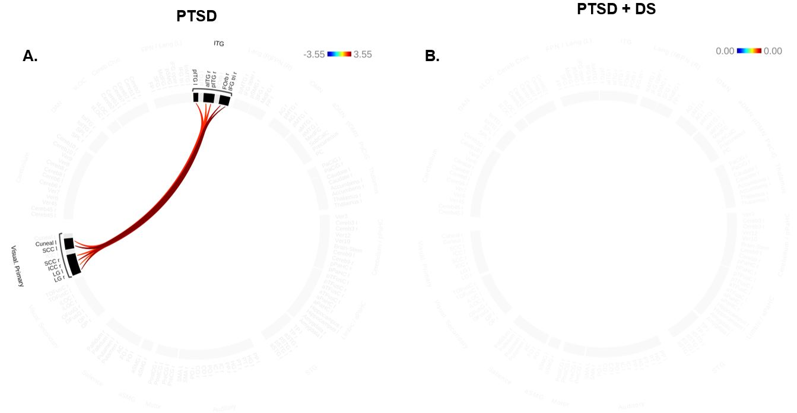
Figure 1: Differences in the temporal variance of ROI-to-ROI connectivity for the contrasts A). PTSD > Controls; and B). PTSD + DS > Controls. Note that the PTSD group shows greater temporal variance, compared to the controls, however, the PTSD + DS group does not show significantly different temporal variance in any ROI-to-ROI connections, when compared to healthy controls.

