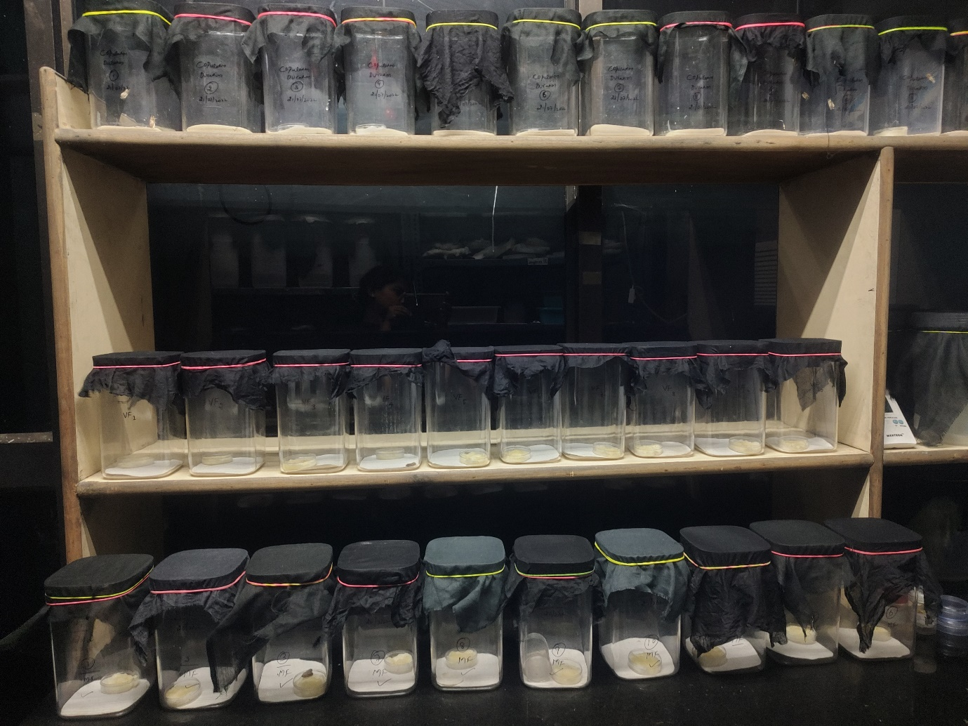
Plate 1. Experimental set up to study the effect of mating on calling behavior in virgin females, single mated females and multiple mated females of Spodoptera frugiperda
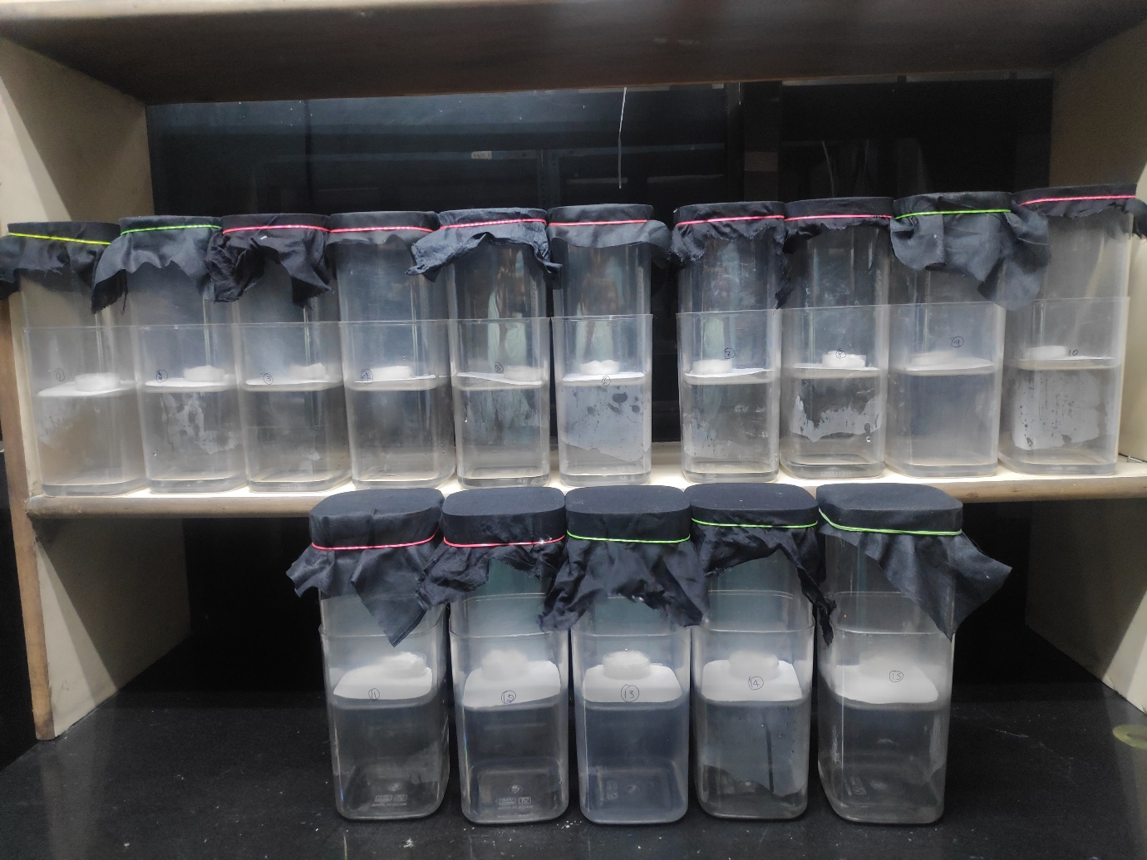
Plate 2. Experimental set up for studying copulation behavior in Spodoptera frugiperda

