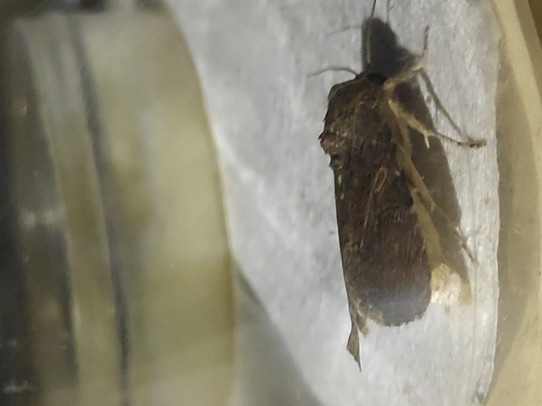

- Spodoptera frugiperda female calling posture (abdomen bent downward)

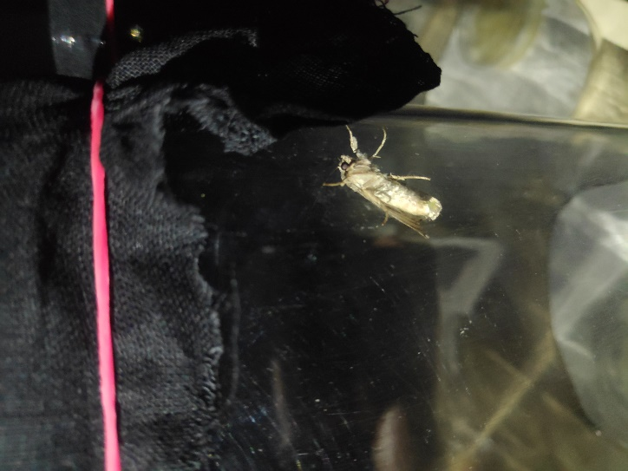

- Spodoptera frugiperda female calling posture (exposed pheromone gland)

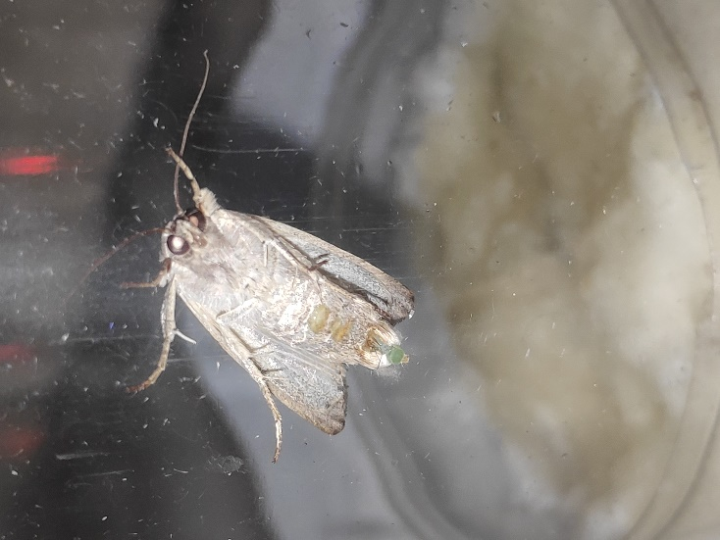

- Spodoptera frugiperda female calling posture (exposed pheromone gland)

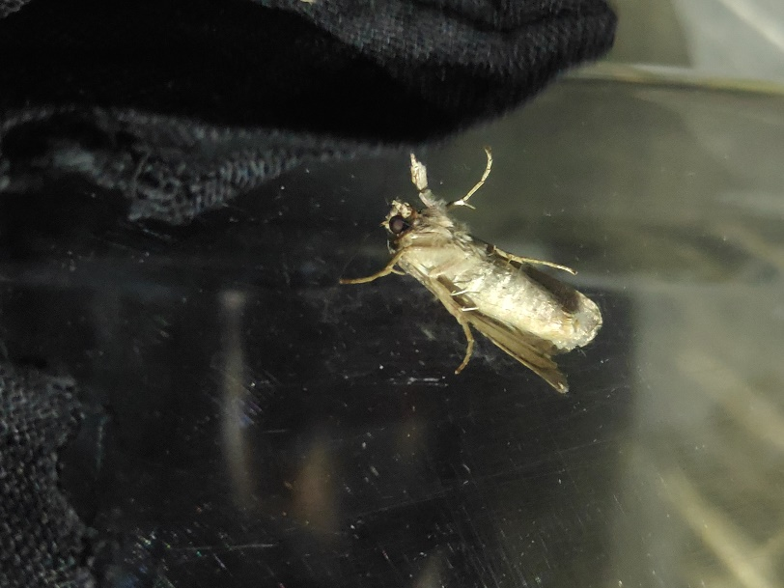

- Spodoptera frugiperda female calling posture (Released pheromone)

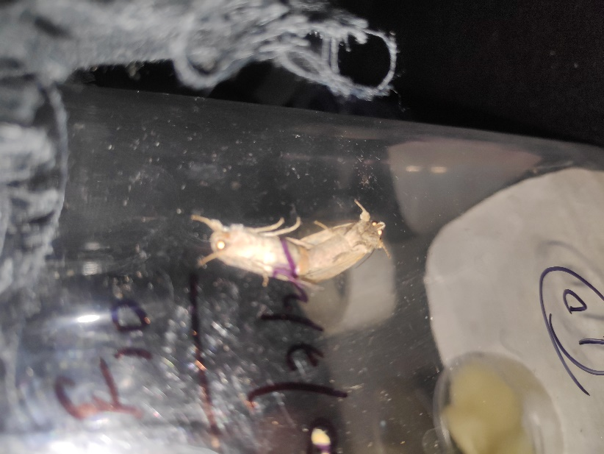

- Spodoptera frugiperda mating

