Supplementary Material

Effects of differently aged biochar to soil NH₃ volatilization, N₂O emissions and microbial diversity, and interaction
Cong Zhang ^{a,b}, Zhenhong Wang ^{a,b*}
a Key Laboratory of Subsurface Hydrology and Ecological Effects in Arid Region, Ministry of Education, Chang`an University, Xi`an, Shaanxi Province 710054, China
b School of Water and Environment, Chang`an University, Xi`an, Shaanxi Province 710054, China

*Corresponding author: Zhenhong Wang
School of Water and Environment, Chang`an University, 710054, Xi`an, China; Key Laboratory of Subsurface Hydrology and Ecological Effects in Arid Region, Ministry of Education, Chang`an University, Xi`an, China
E-mail address: w_zhenhong@126.com

List of contents
S1. Basic properties of biochar and detailed aging method
S2. Basic properties of tested soil and overview of field control test
S3. High throughput sequencing analysis project
S4. SEM-EDS images and XPS analysis of raw biochar and aged biochar
S5. Establishment of aging intensity model of biochar by PCA
S6. High throughput sequencing analysis results
S7. Display of Model fit index in SEM equation
S8. Correlation analysis of biochar with NH₃ volatilization and N₂O emissions

S1. Basic properties of biochar and detailed aging method

Basic properties of biochar
The biochar selected for this test was purchased from Lize Environmental Protection Technology Co., Ltd. (Henan, China). It is made of corn straw, an agricultural waste biomass, and its basic properties are shown in Table S1:
Table S1 Basic properties of biochar
 | pH | Ash | C | H | O | N | SSA | PV
 |  | (%) | (%) | (%) | (%) | (%) | (m²/g) | (cm³/g)
Biochar | 9.61 | 20.26 | 62.55 | 1.54 | 14.41 | 1.07 | 2.1636 | 0.009448
Note: SSA represents specific surface area and PV represents total pore volume.

Detailed aging process of biochar
Raw biochar was prepared into different aged biochar through wetting-drying cycle, freeze-thaw cycle, H₂O₂ oxidation aging, mineralization aging and biological aging. All aging processes in this test were conducted with the same batch of raw biochar, specifically:
(1) Wetting-drying cycle aging (WBC): We was first filled the plastic box (30 cm×20 cm×12 cm) with 10 cm of fresh soil and fixed the raw biochar sample in the middle of the soil with 0.075 mm nylon mesh. Next, deionized water was used to saturate the biocha sample to 100% and biochar was kept for 16 hours, then dried at 60 ℃ for 8 hours, a total of 25 cycles. After the experiment, biochar was took out, dried and stored in Ziplock bag for standby.
(2) Freeze-thaw cycle aging (FBC): The bottom of PVC cylindrical tube with a diameter of 7 cm and a height of 23 cm was filled with 2 cm of quartz sand, 2-10 cm of fresh soil and 10-20 cm of biochar sample. Quartz sand and soil were separated by glass wire mesh, and soil and biochar were separated by 0.075 mm nylon mesh. Sufficient deionized water was added to achieve a humid environment. Then, the filled cylinder was cycled in the artificial climate box and refrigerator for 50 days in the mode of 5 h (-18 ℃) + 19 h (25 ℃). After the experiment, the biochar was taken out, dried and stored in Ziplock bag for standby.
(3) H₂O₂ oxidation aging (OBC): Raw biochar and 15% H₂O₂ were put in a round bottom flask at the ratio of 1:20 (m/v), then the flask was put in a thermostatic water bath at 80 ℃ to heat for 6 hours at 120 r·min⁻¹ speed. The mixed liquid in the flask was dried in an oven at 105 ℃ to evaporate excess H₂O₂ and H₂O. After drying, the mixtures were passed through a 200 mesh screen to obtain oxidized biochar samples, and then was stored in a Ziplock bag for standby.
(4) Kaolin mineralization aging (KBC)：A background solution containing 5 mmol/L CaCl₂ (maintaining constant ionic strength) and 200 mg/L HgCl₂ (aqueous solution inhibiting biological activity) was prepared. The same amount of biochar and kaolin was added into the conical flask, and then the appropriate proportion of background solution (biochar: kaolin: background solution=1:1:5) was added, and the conical flask was incubated on a rotating oscillator at 150 rpm and 25±0.5 ℃ for 30 days. After the test, removed the background solution by filtration with 0.45 μm filter membrane. The filtered residue was then dried in an oven at 105 ℃, sieved after drying and stored in a Ziplock bag for standby.
(5) Microorganism aging biochar (MBC): ① Isolation of microbial sources in soil: First, fresh soil samples were incubated at 35 ℃ for 14 days to stimulate microbial communities. Then the soil and ultrapure water were evenly mixed, shook at 200 rpm for 2h to disperse, and then vacuum suction filtration was conducted to obtain the soil microbial inoculum. ② Preparation of nutrient solution: 6.38 g/L glucose, 40.66 g/L NH₄Cl, 4.67 g/L KH₂PO₄, 10.0 mg/L peptone, 24.0 mg/L CaCl₂, 4.0 mg/L MnSO₄, 4.0 mg/L ZnCl₂, 4.0 mg/L CuSO₄, 16.0 mg/L MgCl₂, and glucose supplement (40 μg/mg BC). ③ Biological aging: fresh biochar was added into the microbial inoculum and nutrient solution. The ratio of microbial inoculum and nutrient solution was 1:1, and the amount of biochar added was 5% weight of the two matters. The water content of biochar was kept at about 40% all the time. At the same time, biochar was required to keep moisture and ventilation, cover the surface with plastic film, and leave a small hole to ensure the respiration of microorganisms. It was also required to avoid light. The culture of biochar was put in the 35 ℃ incubator, and the moisture content was measured every three days to replenish water when moisture decreased. Glucose was supplemented once during the culture period, and the aging cycle was 90 days in total. After the completion of biological aging, the samples were dried at 105 ℃ and ground for storage.

S2. Basic properties of tested soil and overview of field control test

Basic properties of tested soil

Field control experiment was carried out in summer maize planting farmland in Yuncheng City, Shanxi Province, China (35°14′16″N，111°30′77″E) from June to September 2021. Before sowing, 0-20 cm topsoil was taken and after removing large rocks and roots, and air drying, soil sample was screened through 2 mm sieve for standby. See Table S2 for the initial nutrient content of topsoil in the test field.

Table S2 Basic properties of topsoil
Soil layer | TN | Available P | Available K | Organic matter | NH₄⁺-N | NO₃⁻-N | Bulk density | pH
(cm) | (g/kg) | (mg/kg) | (mg/kg) | (g/kg) | (mg/kg) | (mg/kg) | (g/cm³)
0-20 | 0.89 | 15.52 | 266.96 | 9.77 | 37.5 | 26.8 | 1.2 | 7.8
Notes: TN, NH₄⁺ and NO₃⁻ are total nitrogen, ammonia nitrogen and nitrate nitrogen, respectively. P and K are phosphorus and potassium, respectively.

Overview of field control test
This experiment was carried out during the northern summer corn growing period. Before the experiment, the land was plowed. In order to ensure the independence of the plot units, ridges were set around each plot to prevent water from flowing.
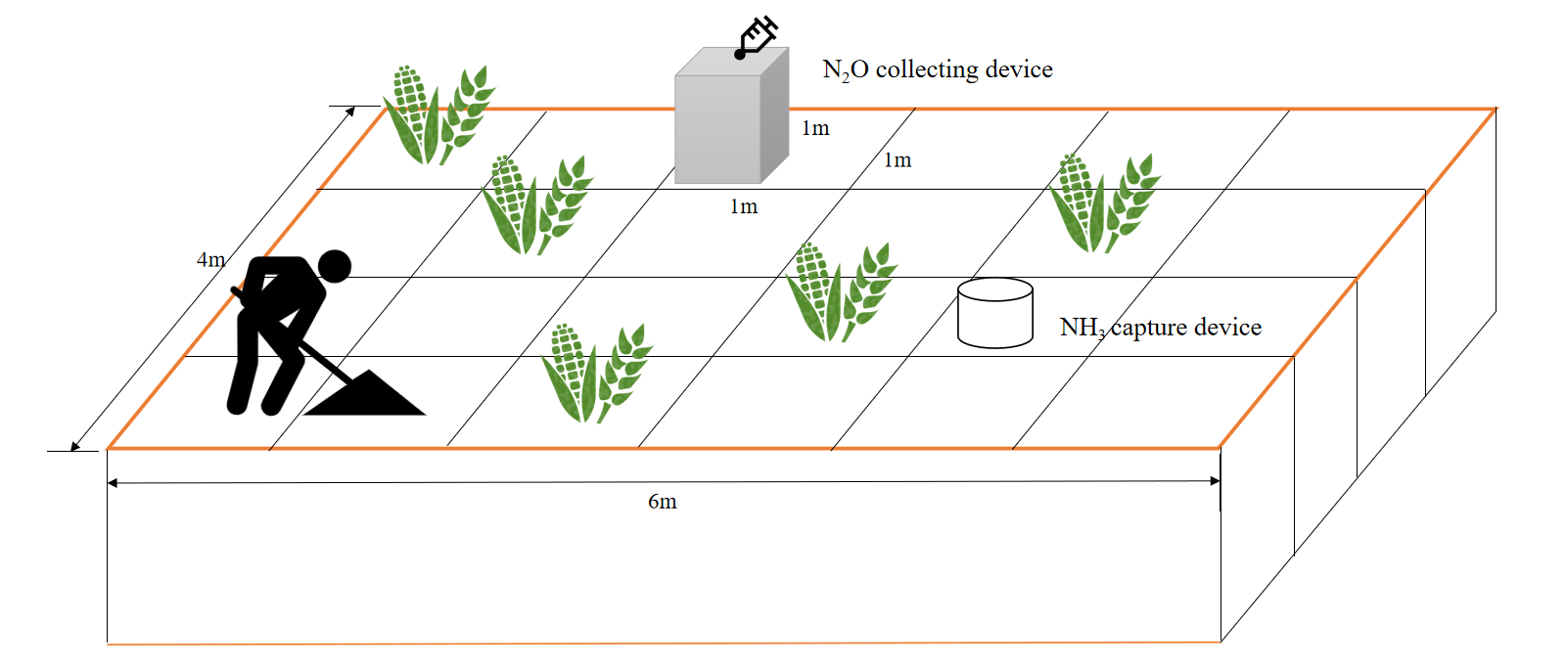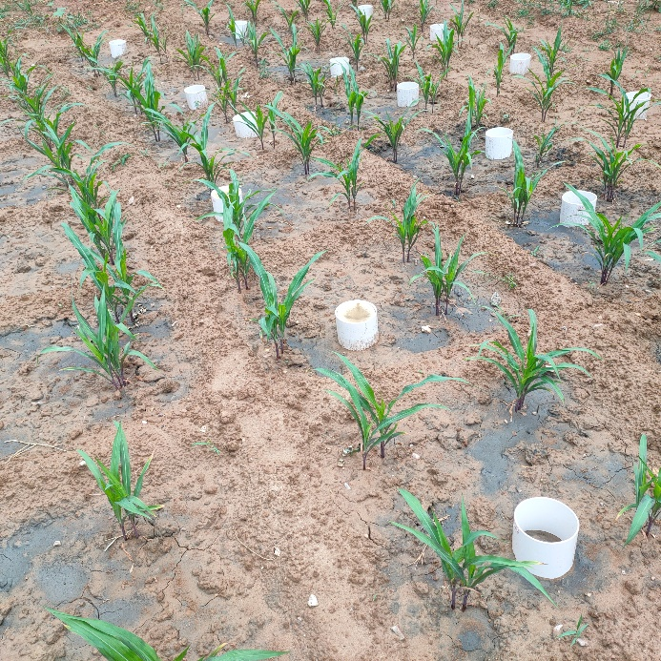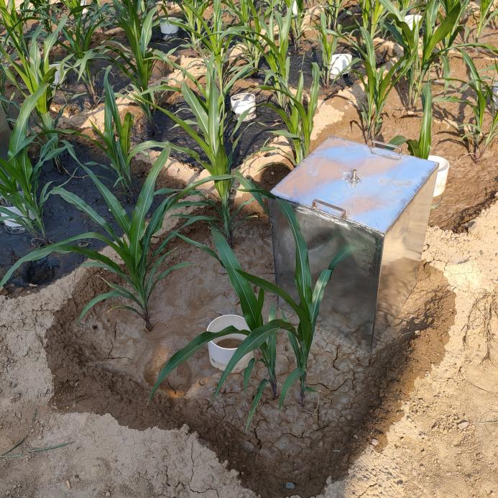
Fig. S1 Overview of field control test

S3. High throughput sequencing analysis project
This section uniformly introduces the analysis items, statistical analysis methods and basic analysis principles involved in the microbial part:
(1) Alpha diversity: In order to comprehensively evaluate the alpha diversity of microbial community, we used Chao1 and Observed species indexes to characterize the richness. The larger the Chao1, the higher the species richness in the estimated community, and the larger the Observed-species, the more OTUs are actually observed. Shannon and Simpson diversity indexes were used to comprehensively quantify the richness and evenness of the community. The higher the index value, the higher the diversity of the community. Faith's PD index represents diversity based on evolution. Pierou ` s evenness index represents the evenness, and the higher the index is, the more homogeneous the community is. Goods coverage refers to whether the results can represent the real situation of microorganisms in the sample. The higher the value, the smaller the proportion of undetected species in the sample, and vice versa. Then, Rarefaction Curve is used to evaluate the saturation of sequencing quantity or sample quantity, and verify whether the sequencing quantity can fully reflect the species diversity of the sample, and indirectly reflect the richness of species in the sample.
(2) Beta diversity: Beta diversity is also known as inter-habitat diversity. It focuses on the comparison of diversity among different habitats, that is, the difference between samples. In this study, NMDS (Nonmetric Multidimensional Scaling) is used to reduce the dimension of multidimensional microbial data, and the main trend of data change is shown by the distribution of samples on the continuous sorting axis.
(3) Species composition analysis：The specific composition of each sample at different taxonomic levels (domain, phylum, class, order, family, genus, species) is displayed to reflect the community structure of the sample at different taxonomic levels. The R software is used to draw the data into a column chart to intuitively display the number of taxons at each classification level of different samples.
(4) Species difference analysis：In order to better show the impact of different aging biochar application on the difference of soil microbial community composition, we studied which species were common and which were unique among different samples, and carried out biological information statistical analysis on OTUs at 97% similar level. In order to display the distribution trend of species abundance of each sample, heatmap was used for species composition analysis.

S4. SEM-EDS images and X-ray photoelectron spectrometer (XPS) analysis of the raw biochar and aged biochar
SEM-EDS images of biochar before and after aging
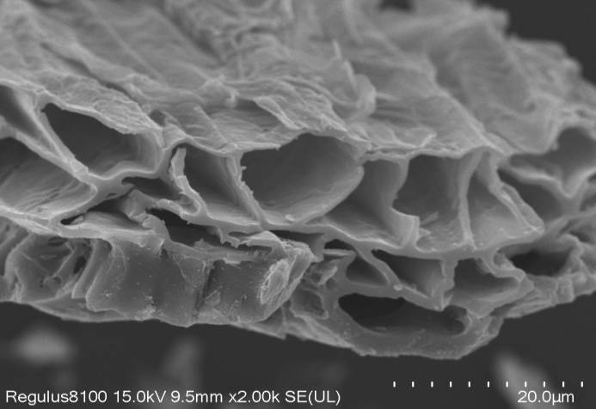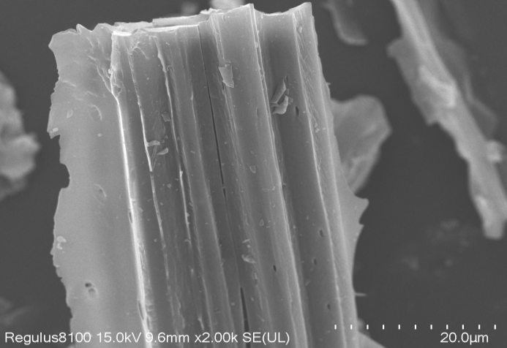
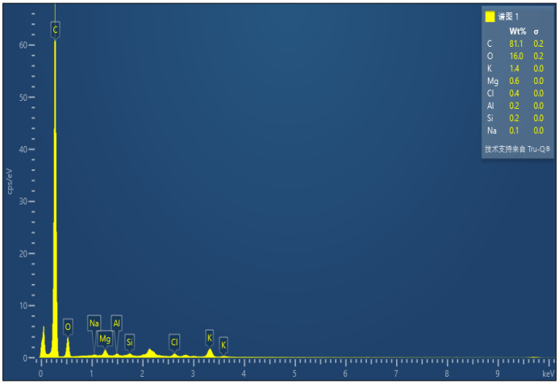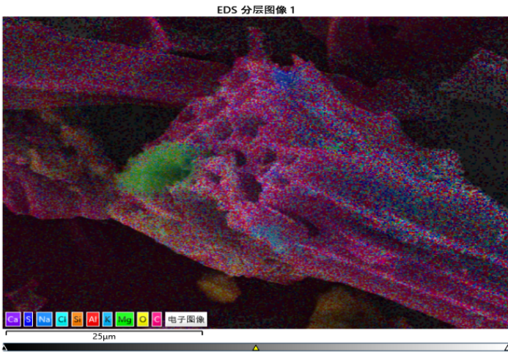
Fig. S2 SEM-EDS images of fresh biochar
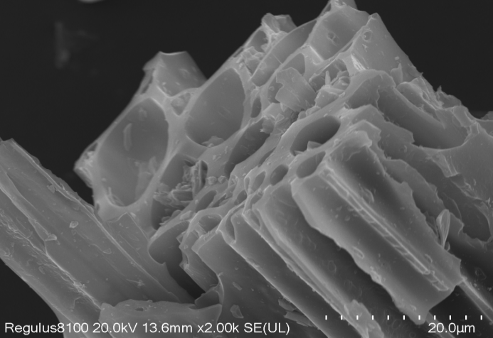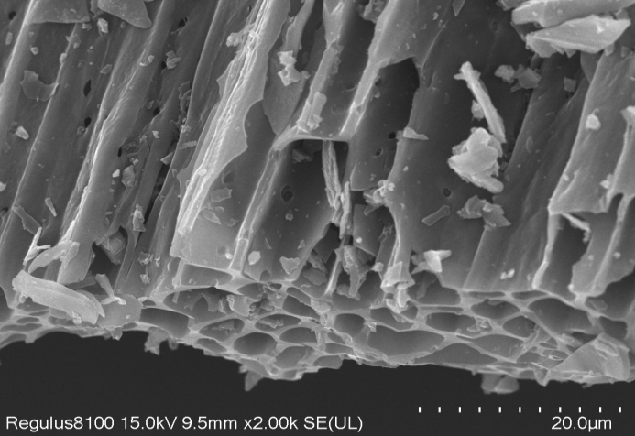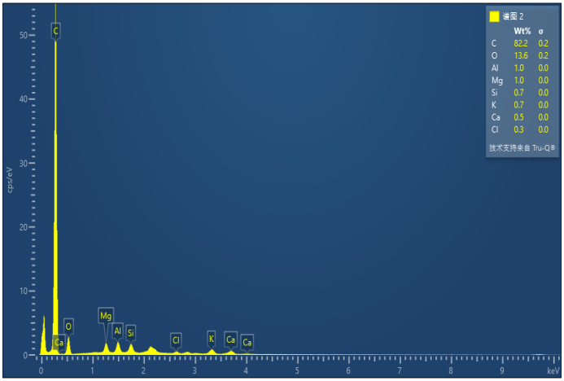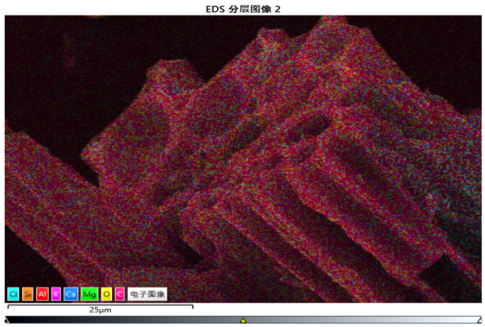
Fig. S3 SEM-EDS images of wet-dry cycle aging biochar
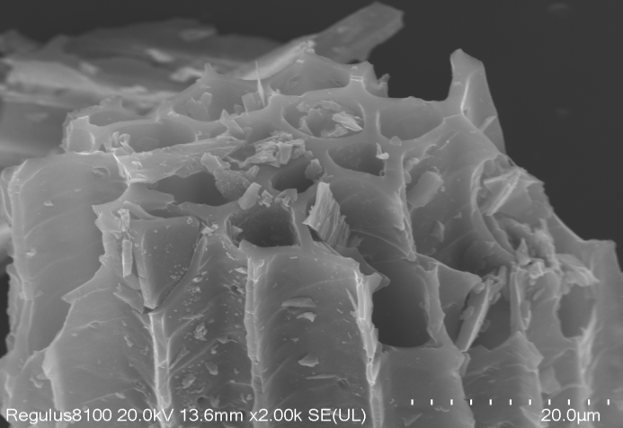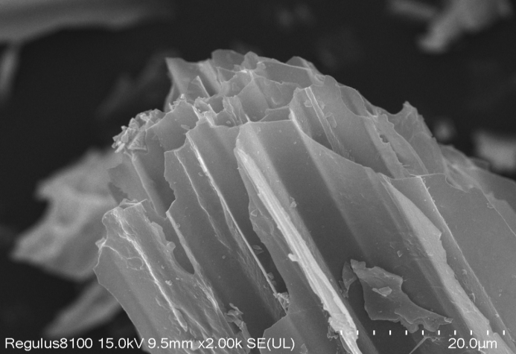
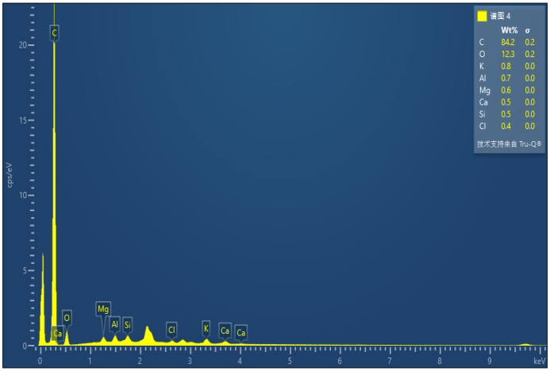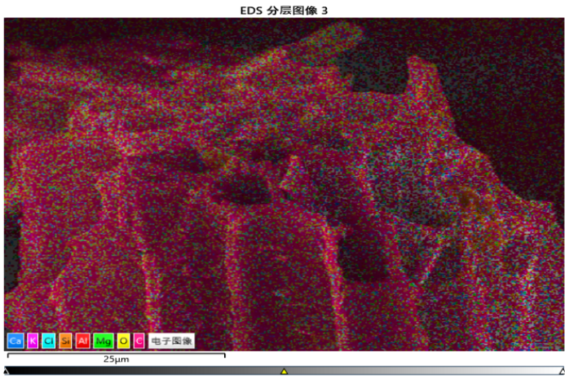
Fig. S4 SEM-EDS images of freeze-thaw cycle aging biochar
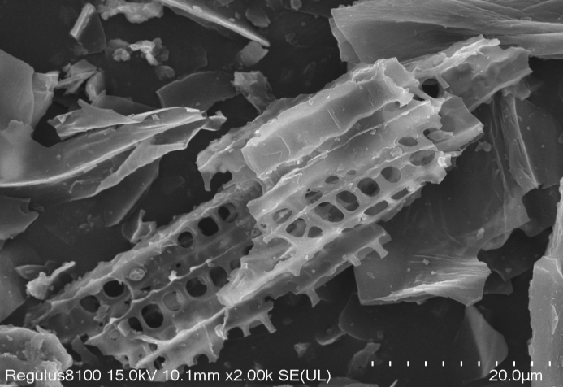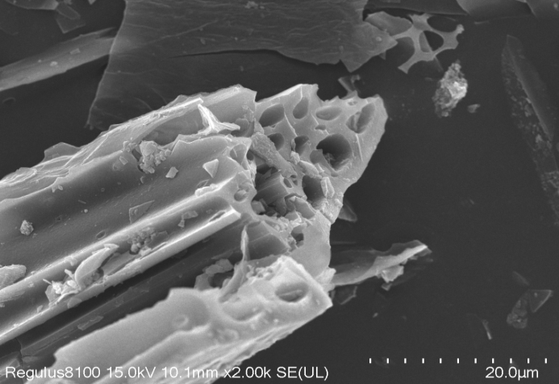
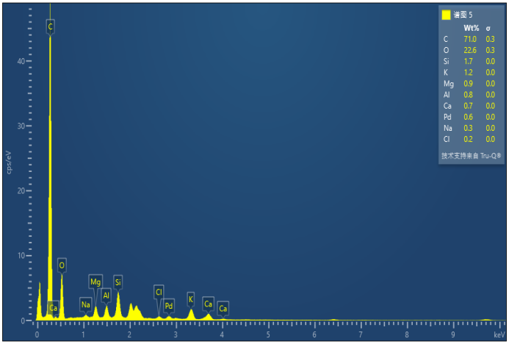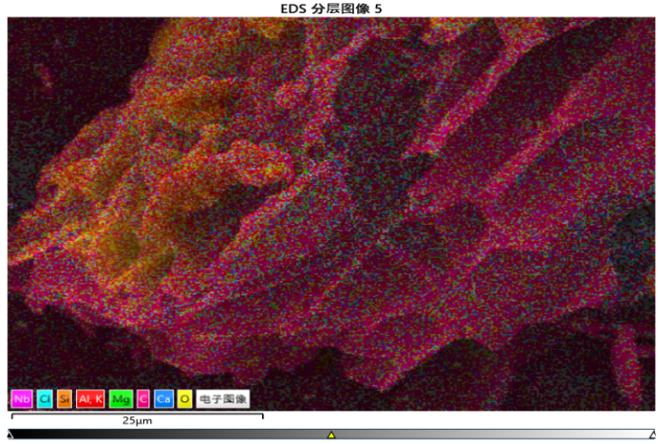
Fig. S5 SEM-EDS images of H₂O₂ oxidized biochar
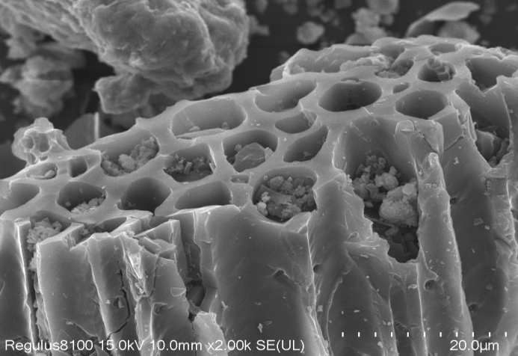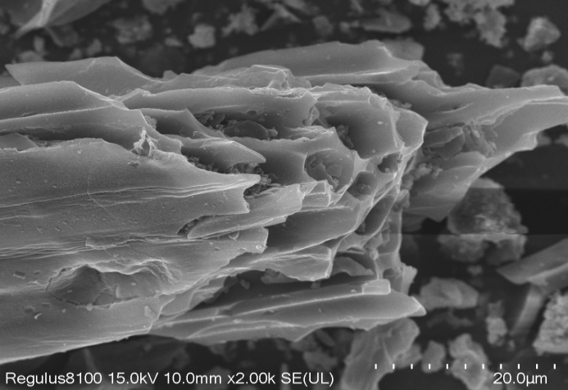
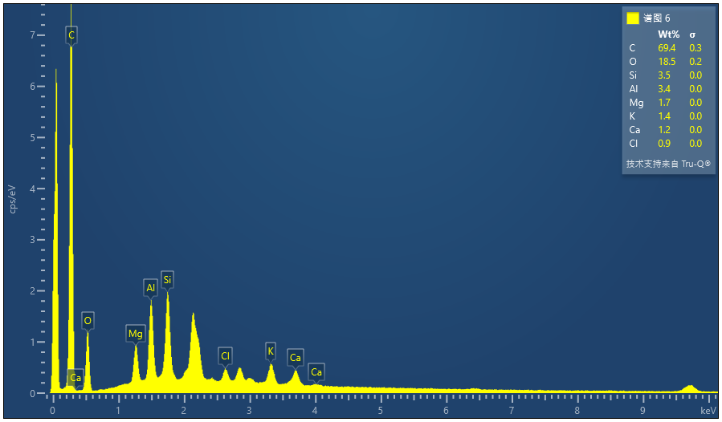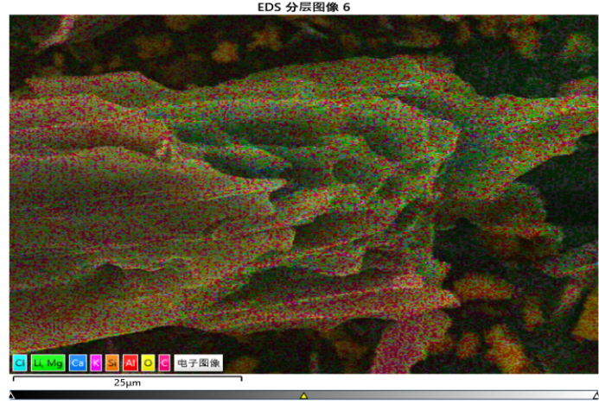
Fig. S6 SEM-EDS images of kaolin mineralized biochar
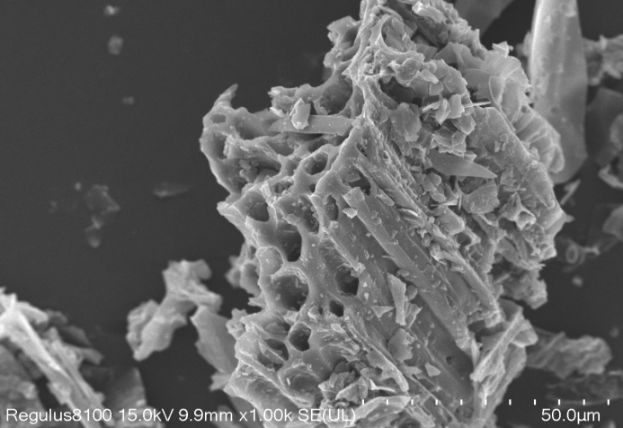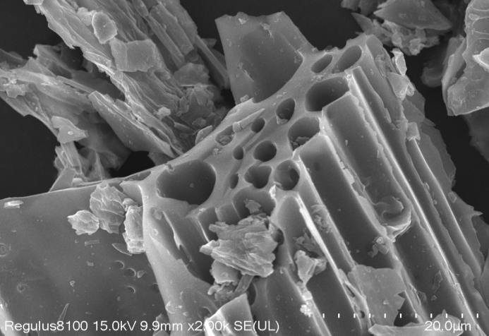
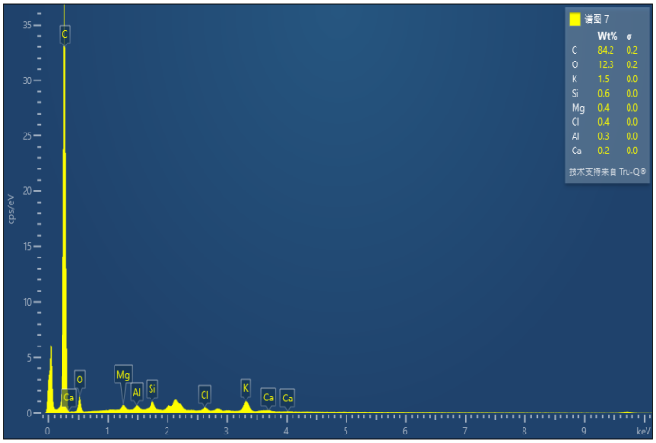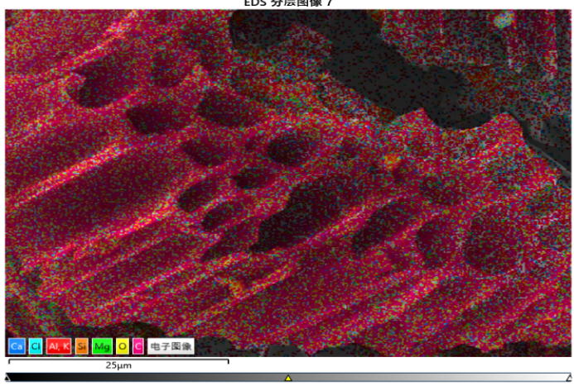
Fig. S7 SEM-EDS images of microbial culture biochar
Fig. 2-7 shows the SEM-EDS images of biochar before and after aging. The first line is SEM image, and the second line is EDS point scanning and surface scanning from left to right. Compared with raw biochar, the surface micromorphology of different aged biochar changed greatly. The surface elements of biochar were mainly composed of C, O, K, Si, Mg, Al and Cl. The content of fresh biochar element (Wt%) was: C (76.7) > O (18.8) > K (1.4) > Si (1.0) > Mg (0.7) > Al (0.5) > Cl (0.4) > Na (0.1). WBC, FBC and MBC had no obvious influence on the element composition of biochar. The content of surface elements (Wt%) of OBC was: C (74.22) > O (20.28) > Si (2.07) > Mg (0.69) > K (0.65) > Al (0.57) = Ca (0.57) > Cl (0.21). KBC was: C (68.3) > O (22.7) > Si (3.7) > Al (3.2) > K (0.7) > Mg (0.6) > Ca (0.4) > Cl (0.3). Compared with OBC, KBC had lower C content and higher O and Si content.
XPS analysis of biochar before and after aging
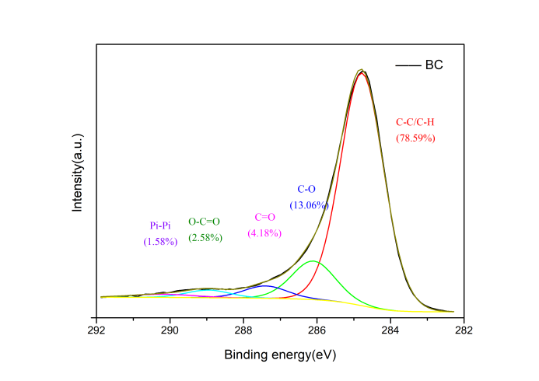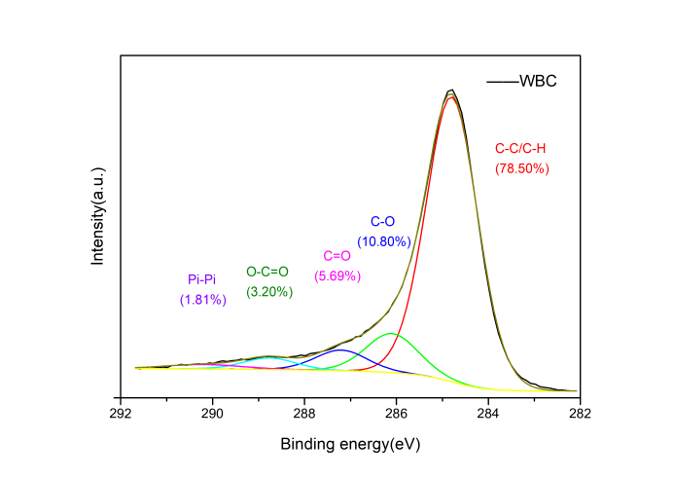
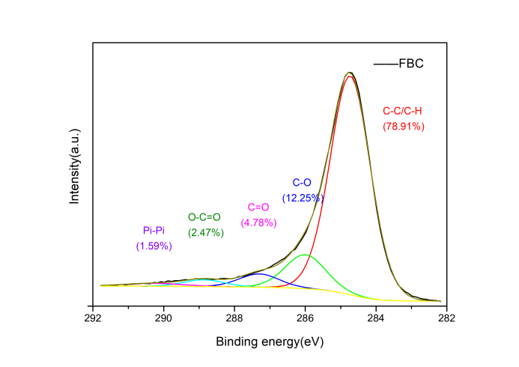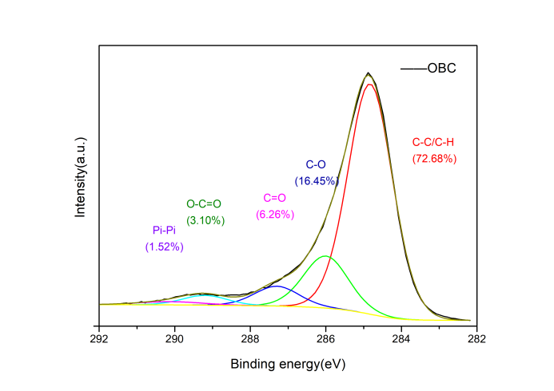
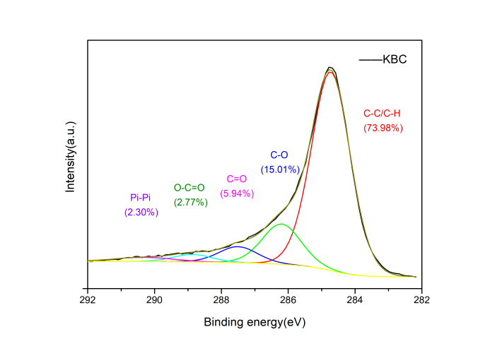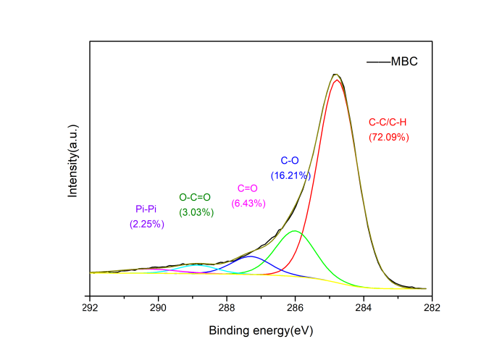
Fig. S8 XPS analysis of corn straw biochar before and after aging
The XPS spectra of Cls for biochar samples before and after aging fitted five signals：284.77±0.05 eV, 286.10±0.10 eV, 287.30±0.20 eV, 288.86±0.10 eV, 290.20±0.10 eV, which correspond to C-C/C-H bonds, C-O bonds (such as alcohol, ether, amino, amide, etc.), C=O bonds, O-C=O bonds (such as carboxyl or ester group) and Pi-Pi transitions，respectively. The oxygen functional group abundance of OBC, MBC and KBC was higher than that of BC. The C-O bonds and C=O bonds of OBC were increased by 3.39% and 2.08%, MBC by 3.15% and 2.25%, KBC by 1.95% and 1.76%, respectively. The increase of oxygen-containing functional groups led to the corresponding decrease of C-C/C-H bonds abundance. Compared with BC, OBC, MBC and KBC decreased by 5.91%, 6.5% and 4.61% respectively. However, WBC and FBC have little effect on the surface functional groups of biochar.

S5. Establishment of aging intensity model of biochar by PCA
Determine the number of principal components
The principal component extraction principle: The principal component eigenvalue greater than 1 is the principal factor. According to the extraction principle, the top four principal components were used as the information summary of biochar properties, and the cumulative variance contribution rate was as high as 97.271% which met the requirements of PCA for information loss, indicating that these principal components could comprehensively reflect the aging intensity of biochar.
Table S3 Total variance explaining biochar properties
Component | Eigenvalue | Variance contribution rate (%) | Cumulative variance contribution rate (%)
1 | 10.907 | 64.159 | 64.159
2 | 2.689 | 15.817 | 79.977
3 | 1.901 | 11.180 | 91.157
4 | 1.039 | 6.114 | 97.271
5 | 0.464 | 2.729 | 100.000
6 | 6.287×10⁻¹⁶ | 3.698×10⁻¹⁵ | 100.000
7 | 3.850×10⁻¹⁶ | 2.264×10⁻¹⁵ | 100.000
8 | 3.032×10⁻¹⁶ | 1.783×10⁻¹⁵ | 100.000
9 | 2.849×10⁻¹⁶ | 1.676×10⁻¹⁵ | 100.000
10 | 4.708×10⁻¹⁷ | 2.769×10⁻¹⁶ | 100.000
11 | 3.847×10⁻¹⁷ | 2.263×10⁻¹⁶ | 100.000
12 | -3.759×10⁻¹⁷ | -2.211×10⁻¹⁶ | 100.000
13 | -1.053×10⁻¹⁶ | -6.195×10⁻¹⁶ | 100.000
14 | -2.816×10⁻¹⁶ | -1.657×10⁻¹⁵ | 100.000
15 | -3.845×10⁻¹⁶ | -2.262×10⁻¹⁵ | 100.000
16 | -5.629×10⁻¹⁶ | -3.311×10⁻¹⁵ | 100.000
17 | -1.656×10⁻¹⁵ | -9.738×10⁻¹⁵ | 100.000

Determine the load of the principal component
Among them, the variance contribution rate of the first principal component was 64.159%, and the larger loadings were Ash, pH, C%, O%, H/C, O/C, (O+N)/C, SSA, PV, APD and C-C/C-H. The second principal component occupied 15.817%, including H%, S% and C-O. The third principal component occupied 11.18%, including C=O and O-C=O. The fourth principal component occupied 6.114%, and the load was mainly N%.
Table S4 Principal component load matrix of biochar property parameters
Index | Y₁ | Y₂ | Y₃ | Y₄
Ash | -0.908 | 0.064 | -0.398 | -0.021
pH | -0.925 | 0.279 | -0.182 | 0.175
C% | -0.817 | 0.416 | -0.281 | 0.272
O% | 0.888 | -0.217 | 0.322 | -0.231
H% | -0.047 | 0.974 | 0.025 | 0.210
N% | -0.250 | -0.049 | 0.090 | 0.960
S% | -0.232 | 0.864 | -0.252 | -0.204
H/C | 0.820 | 0.462 | 0.306 | -0.135
O/C | 0.827 | -0.331 | 0.301 | -0.325
(O+N)/C | 0.831 | -0.341 | 0.312 | -0.286
SSA | 0.935 | -0.136 | -0.006 | -0.010
PV | 0.939 | -0.184 | -0.045 | 0.041
APD | -0.790 | -0.352 | -0.489 | -0.106
C-C/C-H | -0.676 | 0.520 | -0.355 | -0.363
C-O | 0.657 | -0.665 | 0.082 | 0.244
C=O | 0.612 | -0.114 | 0.708 | 0.333
O-C=O | 0.135 | -0.150 | 0.958 | -0.009
Eigenvalue | 10.907 | 2.689 | 1.901 | 1.039
Variance contribution rate（%） | 64.159 | 15.817 | 11.18 | 6.114
Cumulative contribution rate of variance（%） | 64.159 | 79.977 | 91.157 | 97.271
Notes：SSA is specific surface area, PV is pore volume, APD is the average pore diameter.

Establish the principal component Y_{i} expression
In this study, 17 indicators of the properties of biochar were selected: Ash, pH, C%, O%, H%, N%, S%, H/C, O/C, (O+N)/C, SSA, Vt, APD, C-C/C-H, C-O, C=O, O-C=O bonds. The deviation standardization method was used to standardize these indicators. After determined the number of principal components, the principal component Yi expression was established by formula (1):
Y₁=- 0.275X₁ - 0.28X₂ - 0.247X₃ + 0.269X₄ - 0.014X₅ - 0.076X₆ - 0.07X₇ + 0.248X₈ + 0.25X₉ + 0.252 X₁₀ + 0.283X₁₁ + 0.284X₁₂ - 0.239X₁₃ - 0.205X₁₄ + 0.199X₁₅ + 0.185X₁₆ + 0.041X₁₇；
Y₂=0.039X₁ + 0.17X₂ + 0.254X₃ - 0.132X₄ + 0.594X₅ - 0.03X₆ + 0.527X₇ + 0.282X₈ - 0.202X₉ - 0.208 X₁₀ - 0.083X₁₁ - 0.112X₁₂ - 0.215X₁₃ + 0.317X₁₄ - 0.405X₁₅ - 0.07X₁₆ - 0.092X₁₇；
Y₃=- 0.29X₁ - 0.132X₂ - 0.204X₃ + 0.234X₄ + 0.018X₅ + 0.065X₆ - 0.183X₇ + 0.22X₈ + 0.218X₉ + 0.226 X₁₀ - 0.004X₁₁ - 0.033X₁₂ - 0.355X₁₃ - 0.258X₁₄ + 0.059X₁₅ + 0.514X₁₆ + 0.695X₁₇；
Y₄=- 0.021X₁ + 0.172X₂ + 0.267X₃ - 0.227X₄ + 0.206X₅ + 0.942X₆ - 0.2X₇ - 0.132X₈ - 0.319X₉ - 0.281 X₁₀ - 0.01X₁₁ + 0.04X₁₂ - 0.104X₁₃ - 0.356X₁₄ + 0.239X₁₅ + 0.327X₁₆ - 0.009X₁₇；

Establish the comprehensive index Y of aging intensity of biochar
With the variance contribution rate corresponding to each principal component as the weight, the comprehensive evaluation index Y of the properties of biochar can be obtained through formula (2):
Y=0.6596Y₁ + 0.1626Y₂ + 0.1150Y₃ + 0.0628Y₄

S6. High throughput sequencing analysis results

(1) Alpha diversity analysis
Table S5 Alpha diversity index of soil microorganisms
 | Sample | Chao1 | Simpson | Shannon | Observed-species | Coverage
Bacteria | C | 3300±313a | 0.99a | 9.31±0.67b | 2861±294b | 97.6%
Bacteria | F | 3000±667a | 0.99a | 9.58±0.23a | 2767±571c | 98.3%
Bacteria | FRBC | 3989±449a | 1.00a | 10.16±0.44a | 3488±463a | 97.3%
Bacteria | FWBC | 3961±178a | 1.00a | 10.02±0.41a | 3065±289a | 97.1%
Bacteria | FFBC | 3561±332a | 1.00a | 9.85±0.41a | 2960±112b | 97.6%
Bacteria | FOBC | 4088±632a | 1.00a | 9.97±0.32a | 3062±227b | 96.9%
Bacteria | FKBC | 3432±199a | 0.98a | 9.28±0.67b | 3470±424a | 97.6%
Bacteria | FMBC | 3553±325a | 0.99a | 9.56±0.14a | 3395±198a | 97.5%
Fungus | C | 153±75a | 0.79a | 3.61±1.65a | 150±74a | 99.9%
Fungus | F | 151±72a | 0.69a | 2.78±1.13a | 147±69a | 99.9%
Fungus | FRBC | 210±88a | 0.77a | 3.63±1.53a | 207±89a | 99.9%
Fungus | FWBC | 144±44a | 1.00a | 2.52±1.21a | 141±42a | 99.9%
Fungus | FFBC | 175±33a | 0.79a | 3.40±0.73a | 174±32a | 99.9%
Fungus | FOBC | 123±64a | 0.66a | 2.96±1.35a | 119±62a | 99.9%
Fungus | FKBC | 160±43a | 0.83a | 3.73±0.36a | 156±44a | 99.9%
Fungus | FMBC | 156±69a | 0.59a | 3.08±1.22a | 153±70a | 99.9%
N-fixing  bacteria | C | 364±83c | 0.93a | 4.13±0.27c | 255±22c | 99.88%
N-fixing  bacteria | F | 481±176a | 0.93a | 4.38±0.37a | 329±72b | 99.86%
N-fixing  bacteria | FRBC | 379±139c | 0.83b | 3.63±1.46c | 279±64c | 99.91%
N-fixing  bacteria | FWBC | 506±254a | 0.69c | 2.56±0.73c | 350±128a | 99.87%
N-fixing  bacteria | FFBC | 574±81a | 0.90a | 4.34±0.24a | 373±57a | 99.83%
N-fixing  bacteria | FOBC | 479±168b | 0.91a | 4.17±0.65a | 323±73b | 99.86%
N-fixing  bacteria | FKBC | 405±138b | 0.90a | 3.91±0.60c | 289±65b | 99.87%
N-fixing  bacteria | FMBC | 720±135a | 0.90a | 4.15±0.48b | 456±107a | 99.81%
Notes: Data are expressed as the mean ± standard deviation (n=3); Means denoted by a different letter in the same column differ significantly according to one-way ANOVA (P < 0.05).
The rarefaction curve was constructed to evaluate the sequencing depth and microbial diversity of soil samples. The curve of each sample did not rise significantly with the increase of sequencing depth, and the curve tended to be flat, indicating that the amount of sequencing data was reasonable and could basically reflect the structure and diversity information of soil microbial community in the real environment.
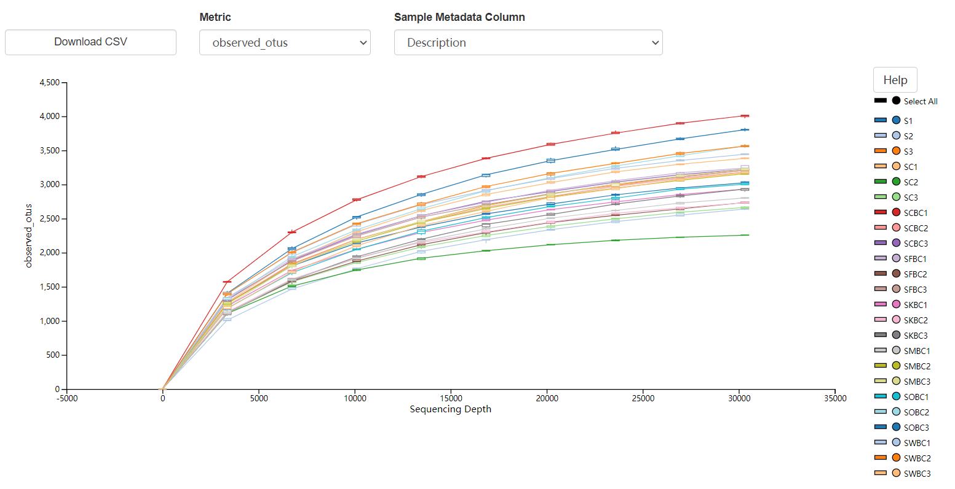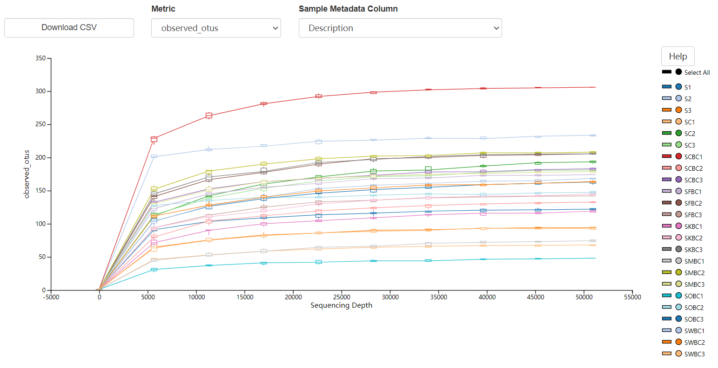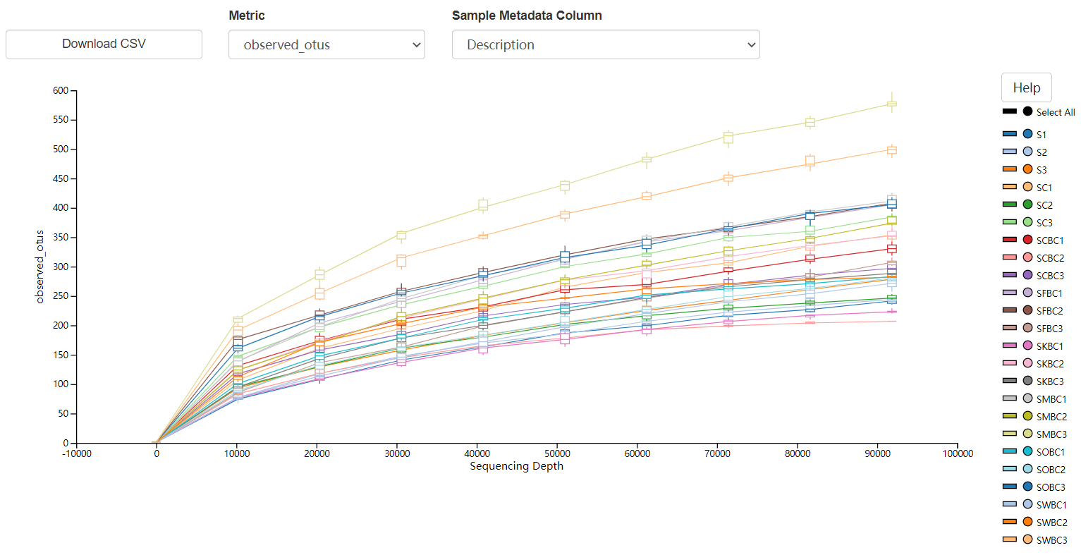
Fig.S9 Rarefaction curve of soil microorganisms
(2) Analysis of species composition at phylum and genus level
The dominant bacteria phylum were Proteobacteria, Actinobacteria, Chloroflexi, Acidobacteria and Gemmatimonadetes. The addition of biochar significantly increased the relative abundance of Proteobacteria and Actinobacteria, and decreased the abundance of Chloroflexi and Acidobacteria, but FOBC significantly increased the relative abundance of Acidobacteria. Dominant genus were Nocardioides, Sphingomonas, Saccharimonadales, Ramlibacter, Subgroup 6, Streptomyces, Halomomas, etc. Biochar application increased the relative abundance of Nocardia, Sphingomonas and Streptomyces in soil, but decreased the relative abundance of Subgroup 6.
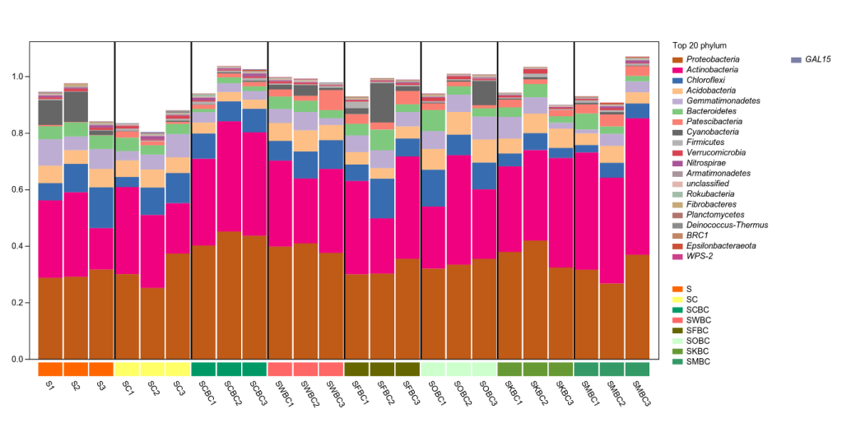
Fig.S10 Species composition of bacteria at phylum level
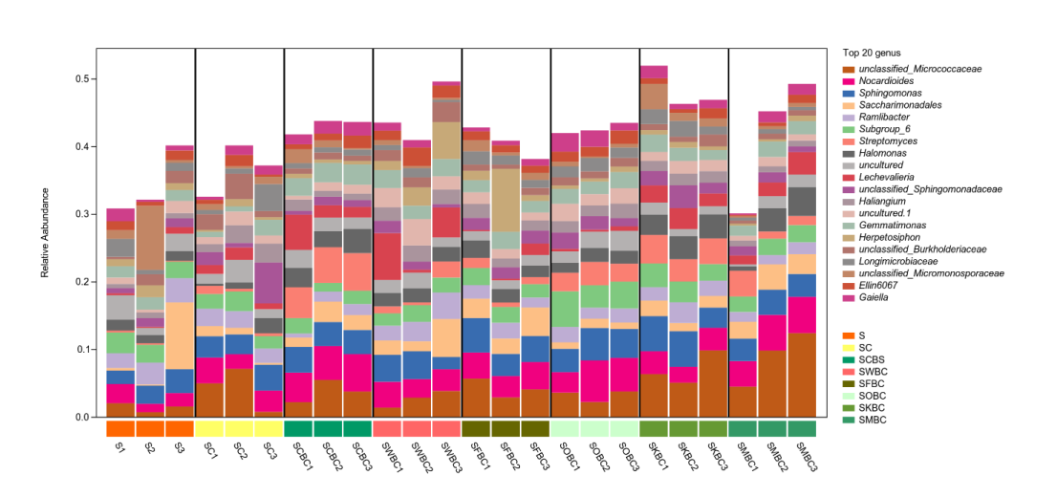
Fig.S11 Species composition of bacteria at genus level
The dominant phyla included Ascomycota, Basidiomycota, Mortierellomucota, Chytidiomycota and Glomeromycota. The application of biochar had a certain degree of fluctuation in the relative abundance of dominant fungi in soil, but the impact was not obvious. The dominant genera were Fusarium, Gibberella, Chaetomium, Mortierella, etc. The addition of biochar led to the decrease of the relative abundance of some soil fungi genus.
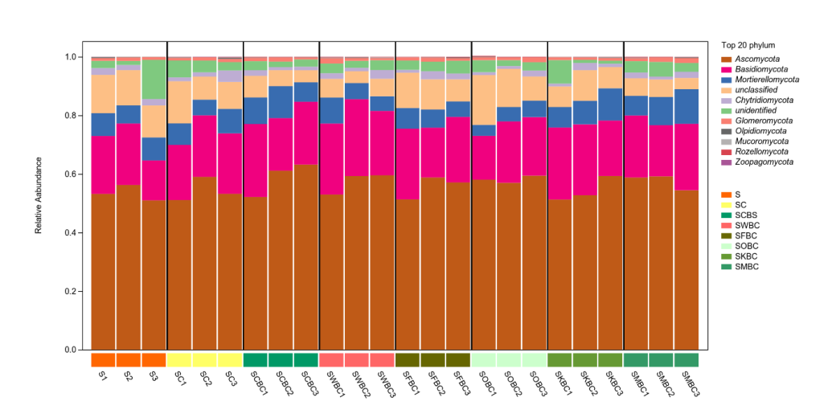
Fig.S12 Species composition of fungi at phylum level
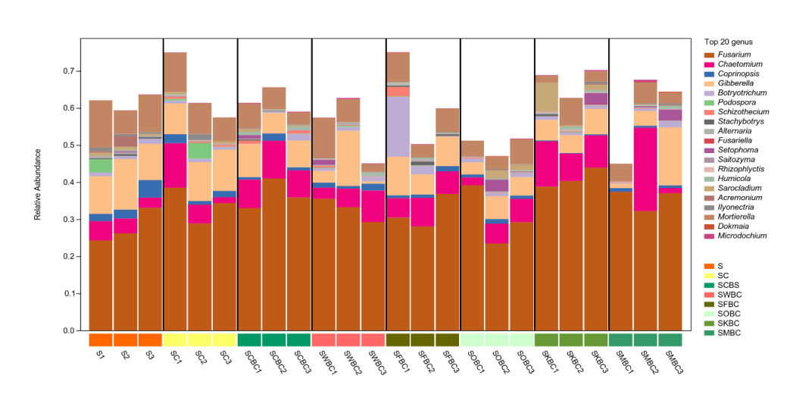
Fig.S13 Species composition of fungi at genus level
The dominant phylum of N-fixing bacteria included Proteobacteria, Firmicutes and Cyanobacteria, the relative abundance of Proteobacteria accounted for 68.72% - 86.43%, which was the absolute advantage. The application of biochar before and after aging increased the relative abundance of Proteobacteria and Cyanobacteria, and decreased the abundance of Firmicutes. Dominant genus included Azoarcus, Paraburkholderia, Bardyrhizobium, Azospirillum, Azotobacter, Klebsiella, Sinorhizobium, etc. Biochar application increased the relative abundance of Azoarcus, Paraburkholderia, and Klebsiella, the relative abundance of Bardyrhizobium, Azospirillum and Azotobacter was reduced.
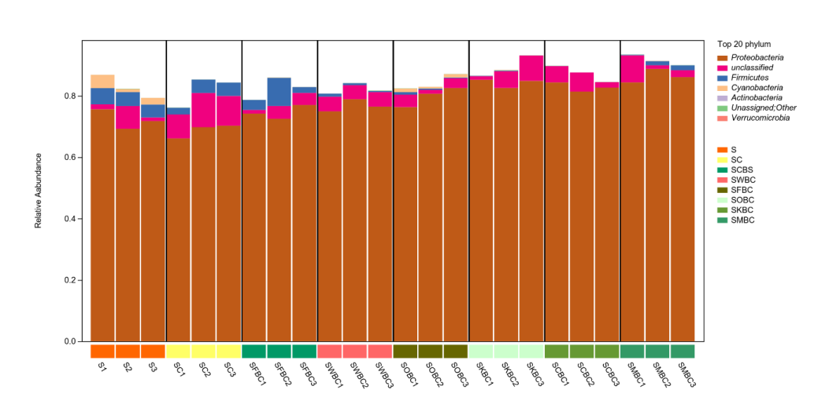
Fig.S14 Species composition of N-fixing bacteria at phylum level
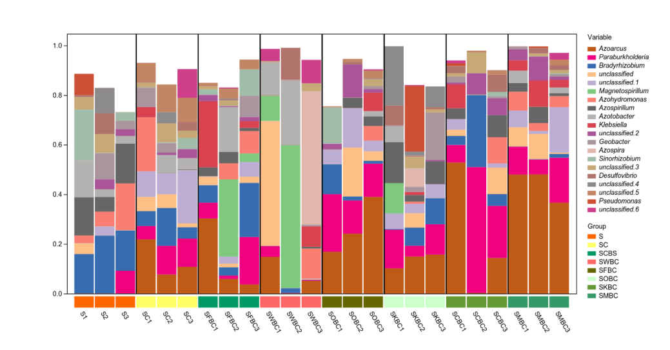
Fig.S15 Species composition of N-fixing bacteria at genus level
(3) Species composition heatmap
In order to further compare the species composition differences among the samples and display the species abundance distribution trend of the samples, the heat map was drawn by the taxon at the genus level. In the species composition of bacteria at the genus level, C and F had similar species composition, FRBC and FMBC had similar species composition, and FWBC and FFBC also had similar species composition. The composition of fungal species varied greatly among treatments. The abundance of fungal species in treatment C was higher, and the addition of biochar reduced the abundance of soil fungi. In the species composition of N-fixing bacteria at the genus level, FRBC and FMBC had a high similarity, and the species composition was relatively similar, while the similarity among other treatments was low, and the species composition varied greatly.
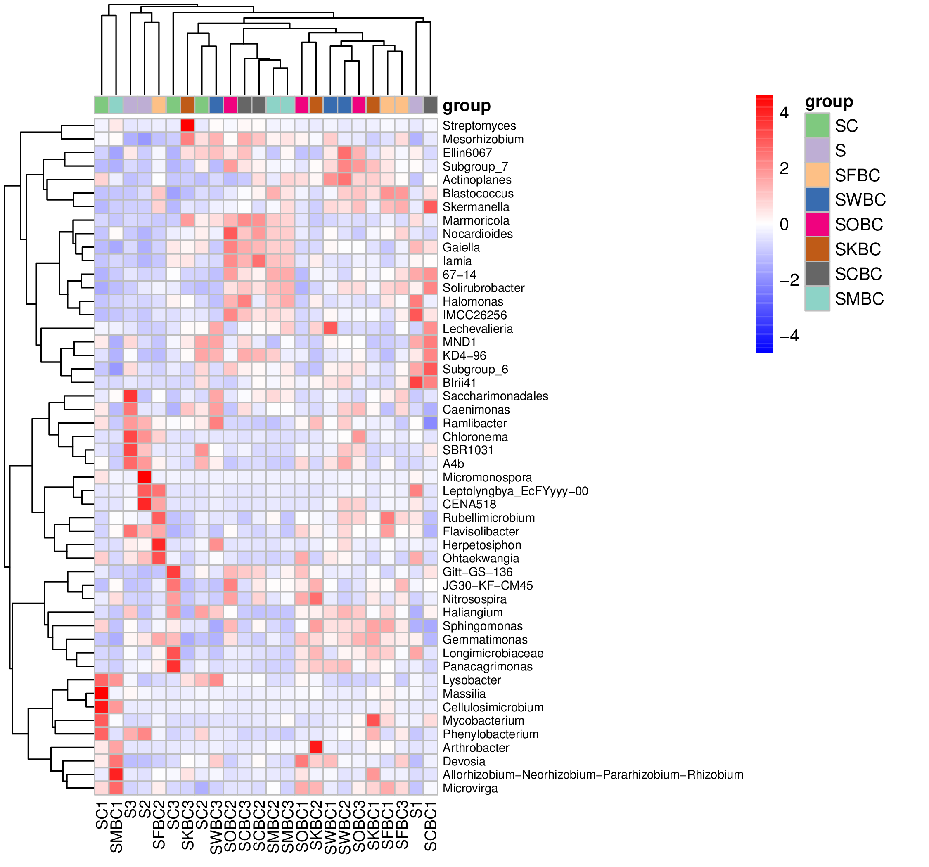
Fig. S16 Heatmap of bacterial species composition
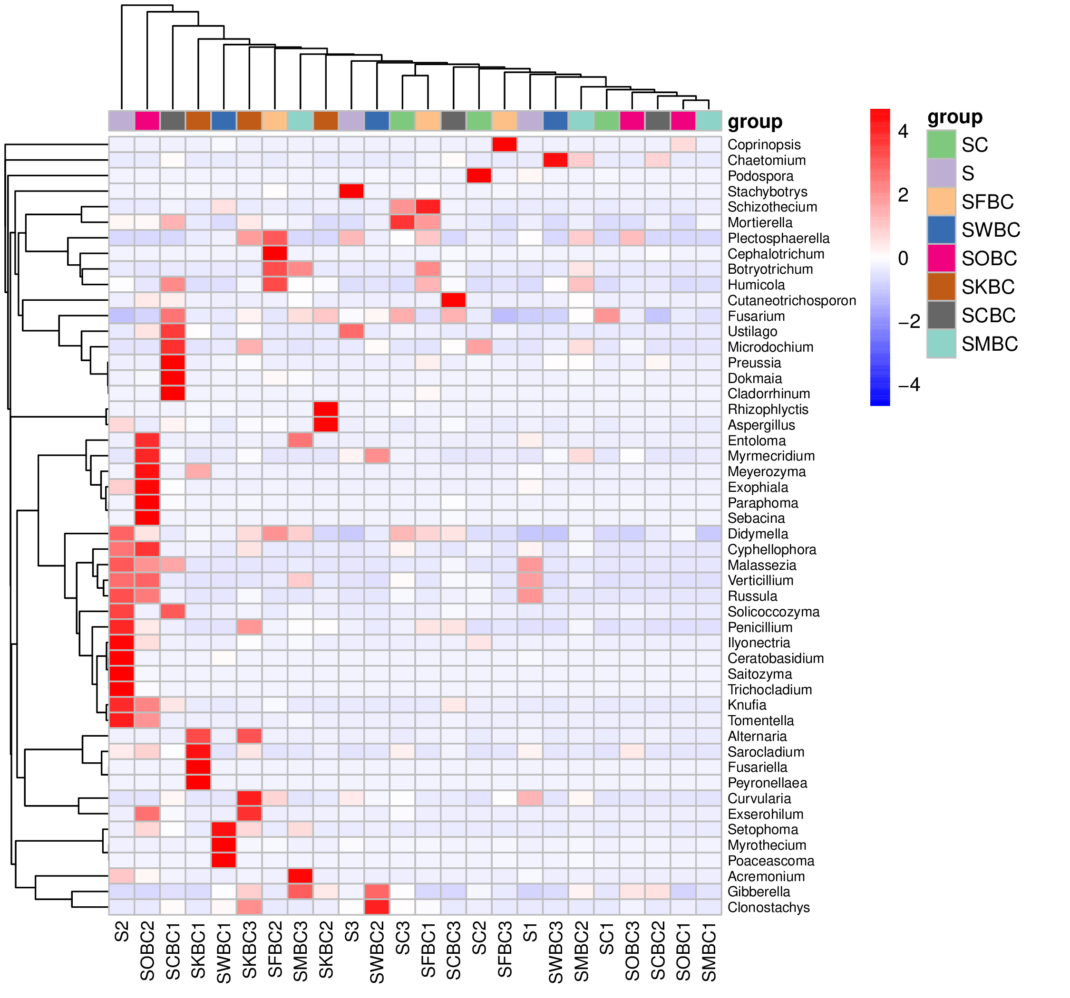
Fig. S17 Heatmap of fungal species composition
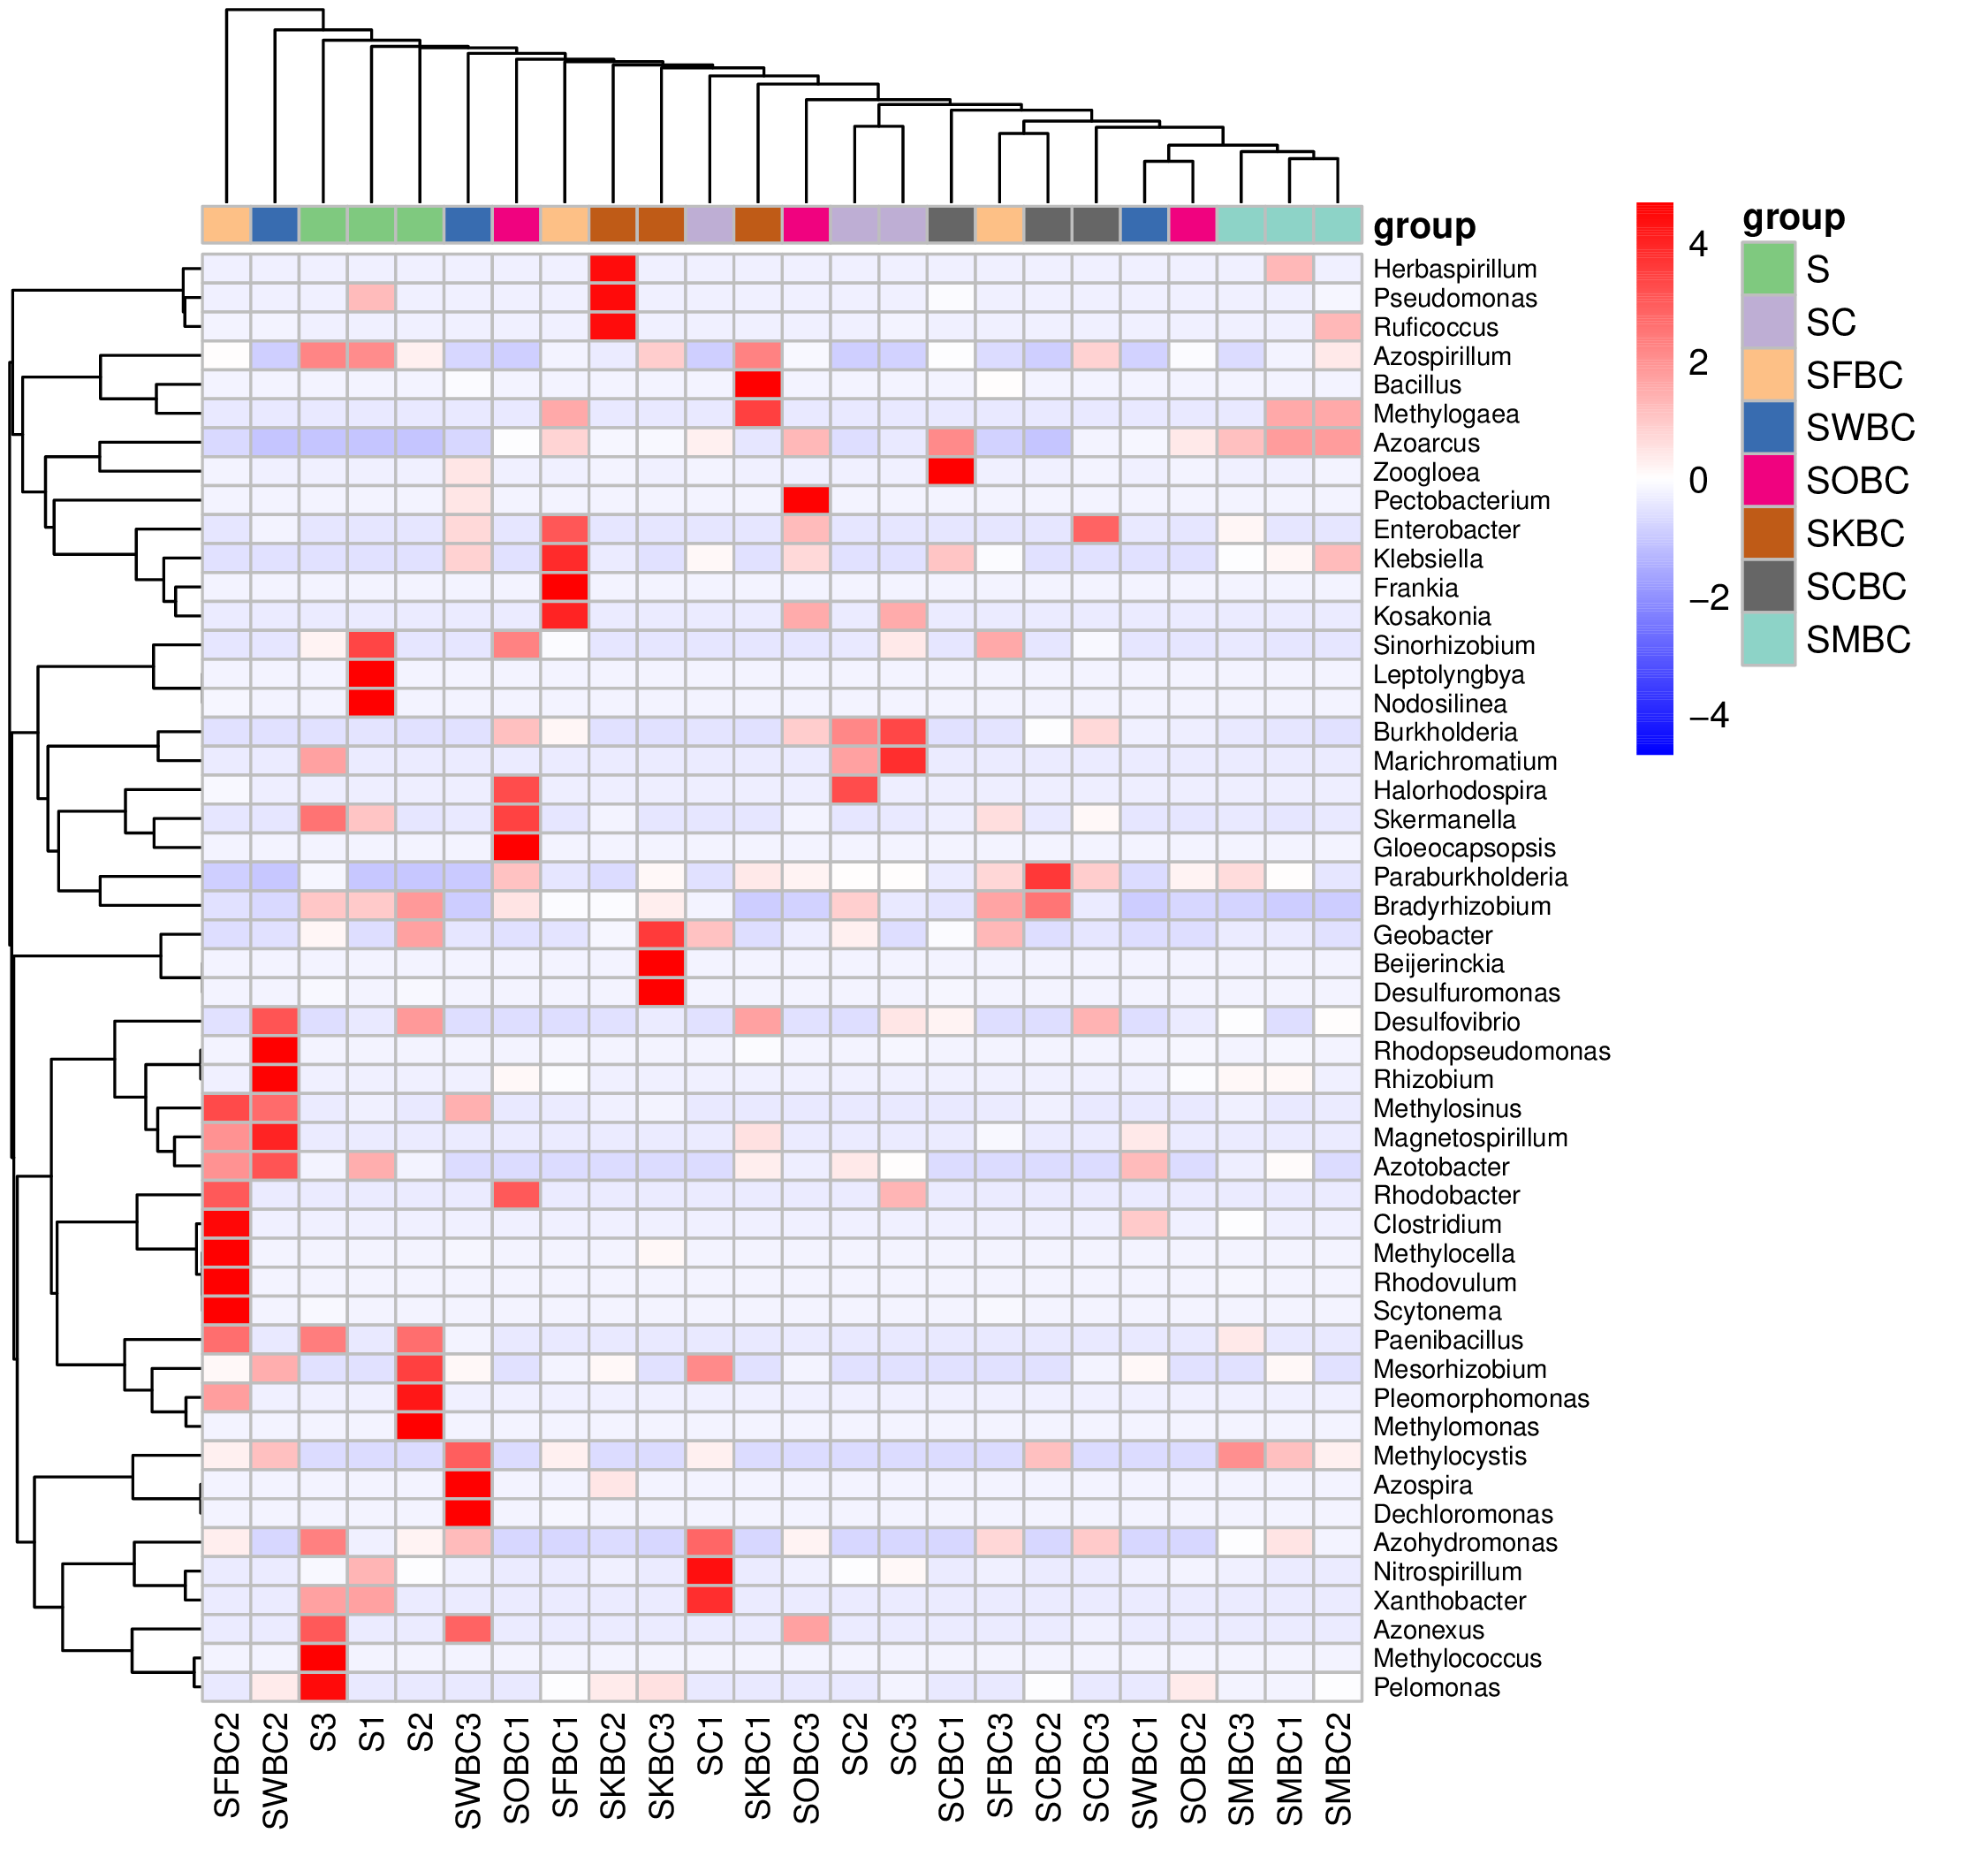
Fig. S18 Heatmap of N-fixing bacterial species composition
Note: Heatmap are drawn using the data of the top 50 abundances at the genus level. In the diagram of sample clustering, samples are clustered by UPGMA according to Euclidean distance of species composition data, and arranged according to the clustering results. In the figure, the red color block represents the higher abundance of this genus in this sample, and the blue color block represents the lower abundance of this genus in this sample than other samples.

S7. Display of Model fit index in SEM equation
Standard indicates the ideal range of the model fit index, and Goodness of fit indicates the fitting degree of the observed values of the model. The three models in this test all conformed to the standard of SEM, indicating that the model fitness is high and the model fit is ideal.
Table S6 Bacterial model fitting parameters
Results | Absolute fit measures |  | Incremental fit measures |  |  | Parsimonious fitness index
Results | X²/df | GFI | NFI | CFI | IFI | PCFI | PNFI
Standard | <2 | 0-1 | 0-1 | 0-1 | 0-1 | 0-1 | 0-1
Goodness of fit | 1.73 | 0.824 | 0.891 | 0.947 | 0.951 | 0.442 | 0.416
Table S7 Fungal model fitting parameters
Results | Absolute fit measures |  | Incremental fit measures |  |  | Parsimonious fitness index
Results | X²/df | GFI | NFI | CFI | IFI | PCFI | PNFI
Standard | <2 | 0-1 | 0-1 | 0-1 | 0-1 | 0-1 | 0-1
Goodness of fit | 1.82 | 0.836 | 0.882 | 0.938 | 0.943 | 0.438 | 0.412
Table S8 N-fixing bacteria model fitting parameters
Results | Absolute fit measures |  | Incremental fit measures |  |  | Parsimonious fitness index
Results | X²/df | GFI | NFI | CFI | IFI | PCFI | PNFI
Standard | <2 | 0-1 | 0-1 | 0-1 | 0-1 | 0-1 | 0-1
Goodness of fit | 1.62 | 0.866 | 0.856 | 0.932 | 0.940 | 0.435 | 0.400

S8. Correlation analysis of biochar with NH₃ volatilization and N₂O emissions
Person correlation analysis shows the correlation between the properties of biochar and soil NH₃ volatilization, and between the properties of biochar and N₂O emissions. The results showed that NH₃ volatilization was negatively correlated with ash content, O atom content, O/C, (O+N)/C, SSA and PV, and positively correlated with pH and C atom content. N₂O emission from soil was negatively correlated with ash content, pH, C atom content, SSA, PV and APD, and positively correlated with O atom content, H/C, O/C, (O+N)/C.
Table S9 Pearson correlation between biochar performance and soil NH₃ and N₂O emissions
 | Ash | pH | C% | O% | H% | N%
NH₃ | -0.664** | 0.688** | 0.671** | -0.656** | 0.359 | 0.070
N₂O | -0.724** | -0.677** | -0.589* | 0.723** | 0.248 | -0.108
 | H/C | O/C | (O+N)/C | SSA | PV | APD
NH₃ | -0.318 | -0.637** | -0.647** | -0.669** | -0.685** | 0.442
N₂O | 0.819** | 0.630** | 0.636** | -0.718** | -0.702** | -0.825**
Notes: SSA is specific surface area, PV is pore volume, APD is the average pore diameter. * indicates significance at p < 0.05, ** indicates significance at p < 0.01.

