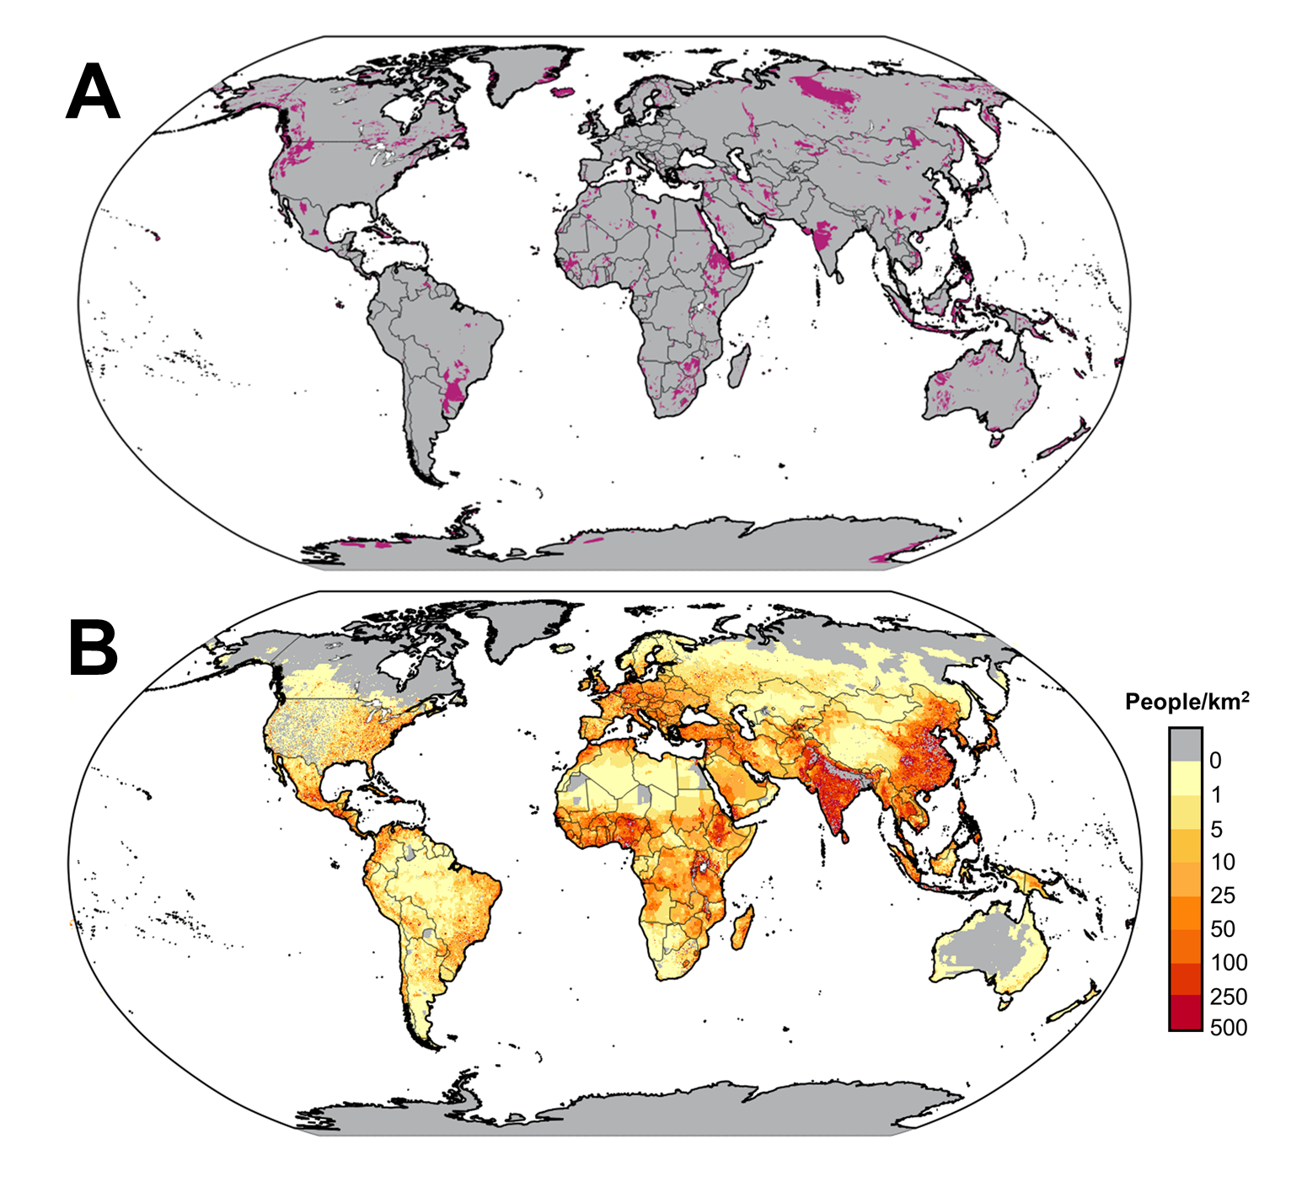
Extended Data Figure 1 | Global maps of metal-rich geology and population density. a. Global map showing generalized domains of mafic and/or ultramafic geologies, inclusive of their metamorphic equivalents. b. Global map showing total population density using a projection model for 2020 based on a “middle-of-the-road” socio-economic scenario (SSP2).

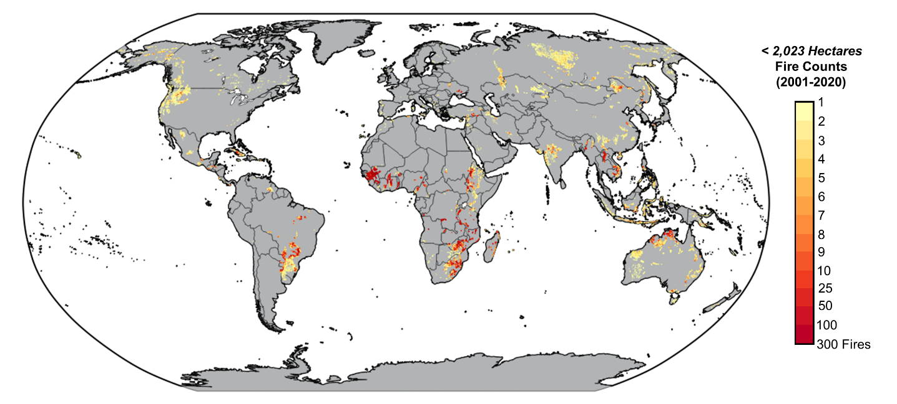
Extended Data Figure 2 | Frequency of small fires in metal-rich landscapes. Satellite-derived number of fire occurrences less than 2,023 ha within generalized mafic and ultramafic landscapes from 2001-2020.

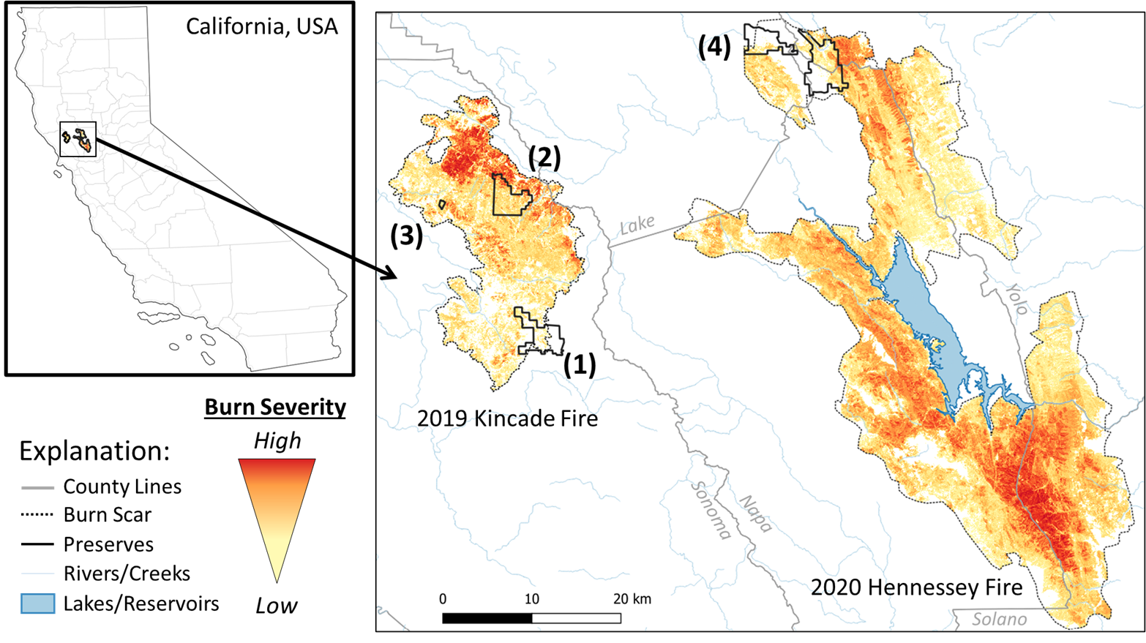
Extended Data Figure 3 | Four natural preserves within burn scars of the 2019 Kincade Fire and 2020 Hennessey Fire. 1. Pepperwood Preserve, 2. Modini Preserve, 3. White Rock Preserve, and 4. McLaughlin Natural Reserve. An initial assessment of burn severity was estimated by the absolute difference between pre- and most-fire normalized burn ratio (NBR) using Landsat 8 images. For the Kincade Fire, the NBR was calculated based on cloud-free images (LC08_L1TP_045033) from October 1-18, 2019 (pre-fire) and November 2-15, 2019 (post-fire). For the Hennessey Fire (within the LNU Lightning Complex), cloud-free images (LC08_L1TP_044033) used were acquired from August 9-21, 2020 (pre-fire) and August 25-September 5, 2020 (post-fire).

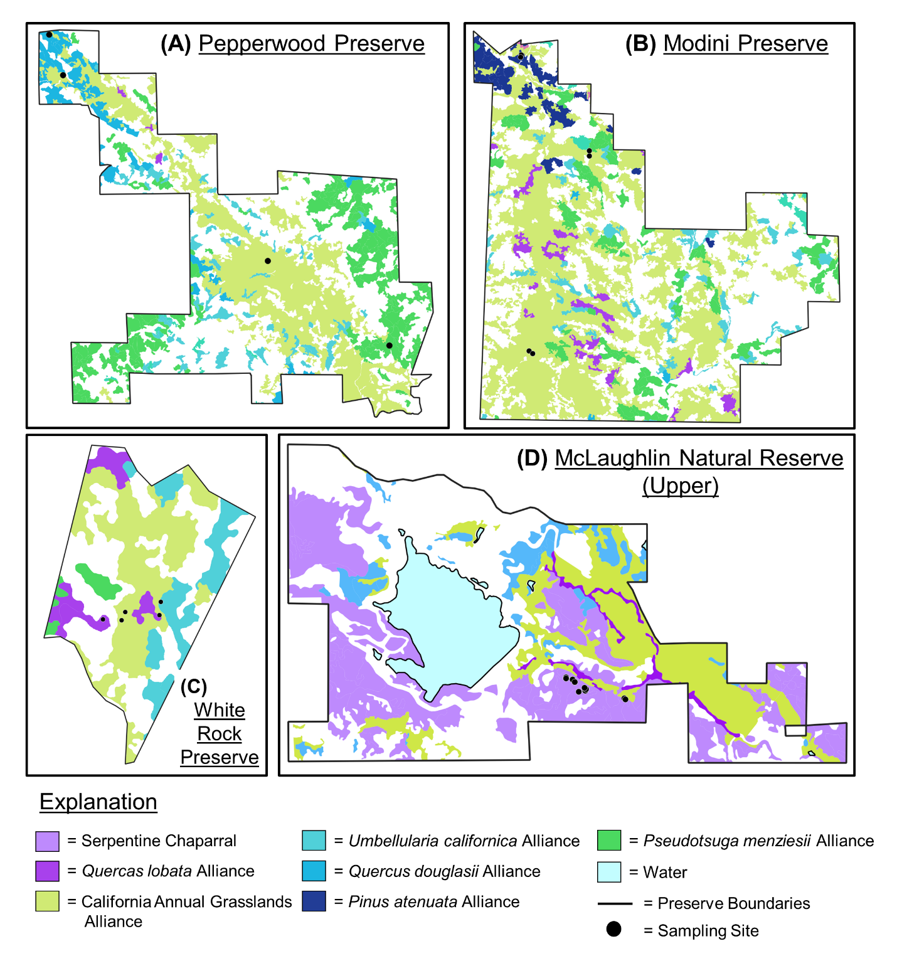
Extended Data Figure 4 | Vegetation classification at each sampling site. a. Pepperwood Preserve, b. Modini Preserve, c. White Rock Preserve, and d. McLaughlin Natural Reserve. Additional vegetation classes within regional maps that do not overlap with soil sampling sites were omitted for simplicity.

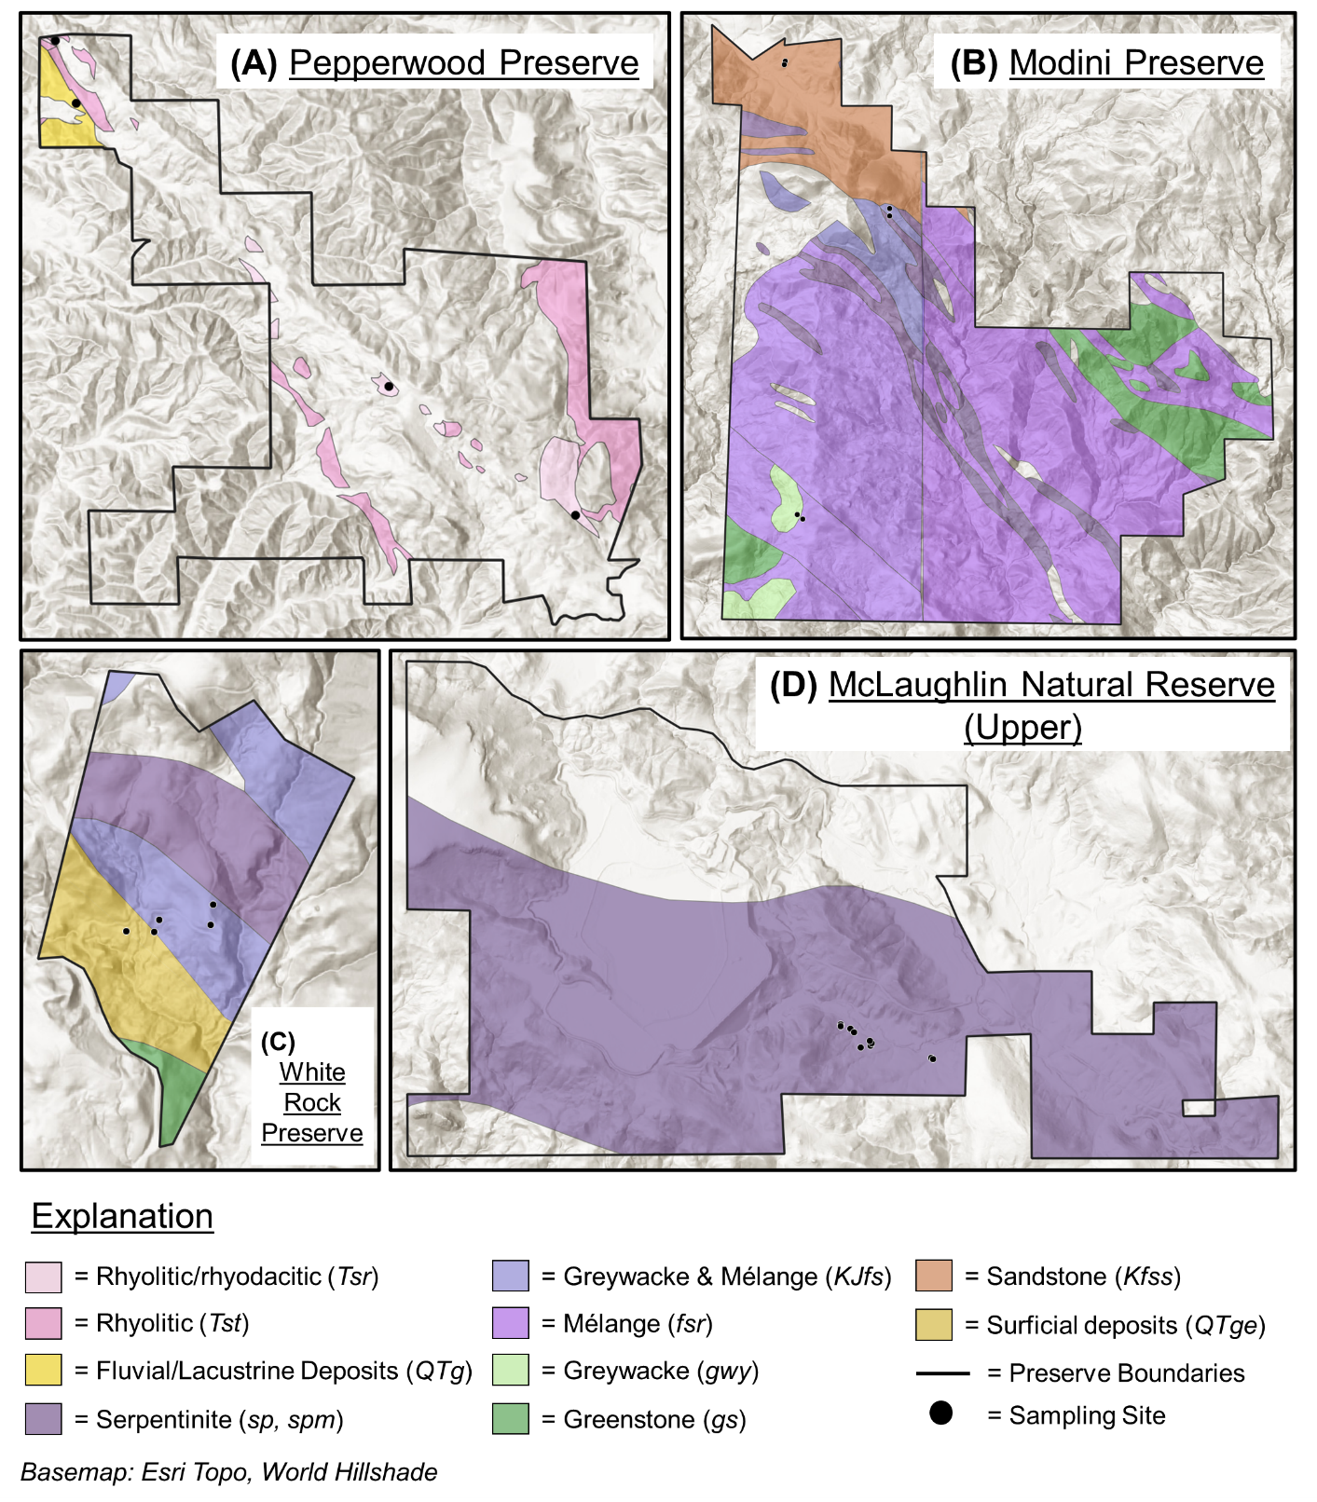
Extended Data Figure 5 | Surface bedrock geology at each sampling site. a. Pepperwood Preserve, b. Modini Preserve, c. White Rock Preserve, and d. McLaughlin Natural Reserve. Additional geologic units within regional maps that do not overlap with soil sampling sites were omitted for simplicity.

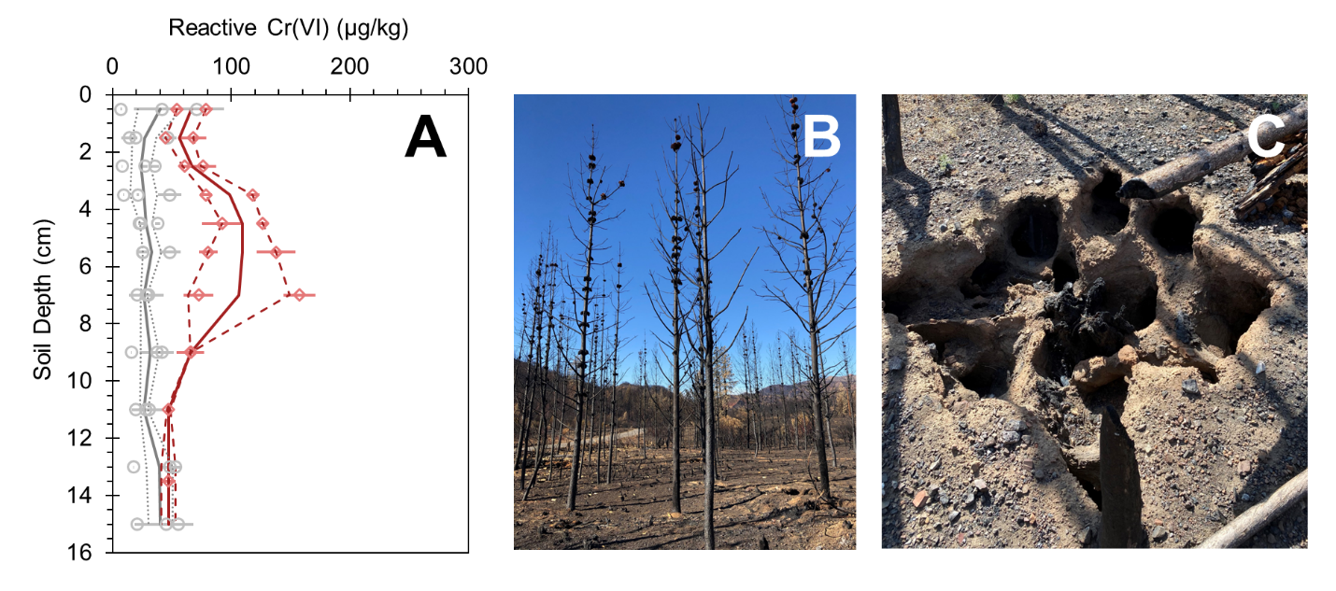
Extended Data Figure 6 | Reactive Cr(VI) concentrations within a severely burned forest. a. Average reactive Cr(VI) concentrations (µg/kg) within near surface soil profiles that were considered unburned (gray; n = 3) and experienced high burn severity (red; n = 2) in a densely vegetated knobcone pine forest. Each point represents the sample average of triplicates and error bars represent the standard error. Solid and dashed lines represent the mean (based on n soil cores) and standard error of the means, respectively. b. Photos of the burned forested area immediately after the 2019 Kincade Fire. c. An example of a completely combusted tree root system nearly one year later (September 2020).

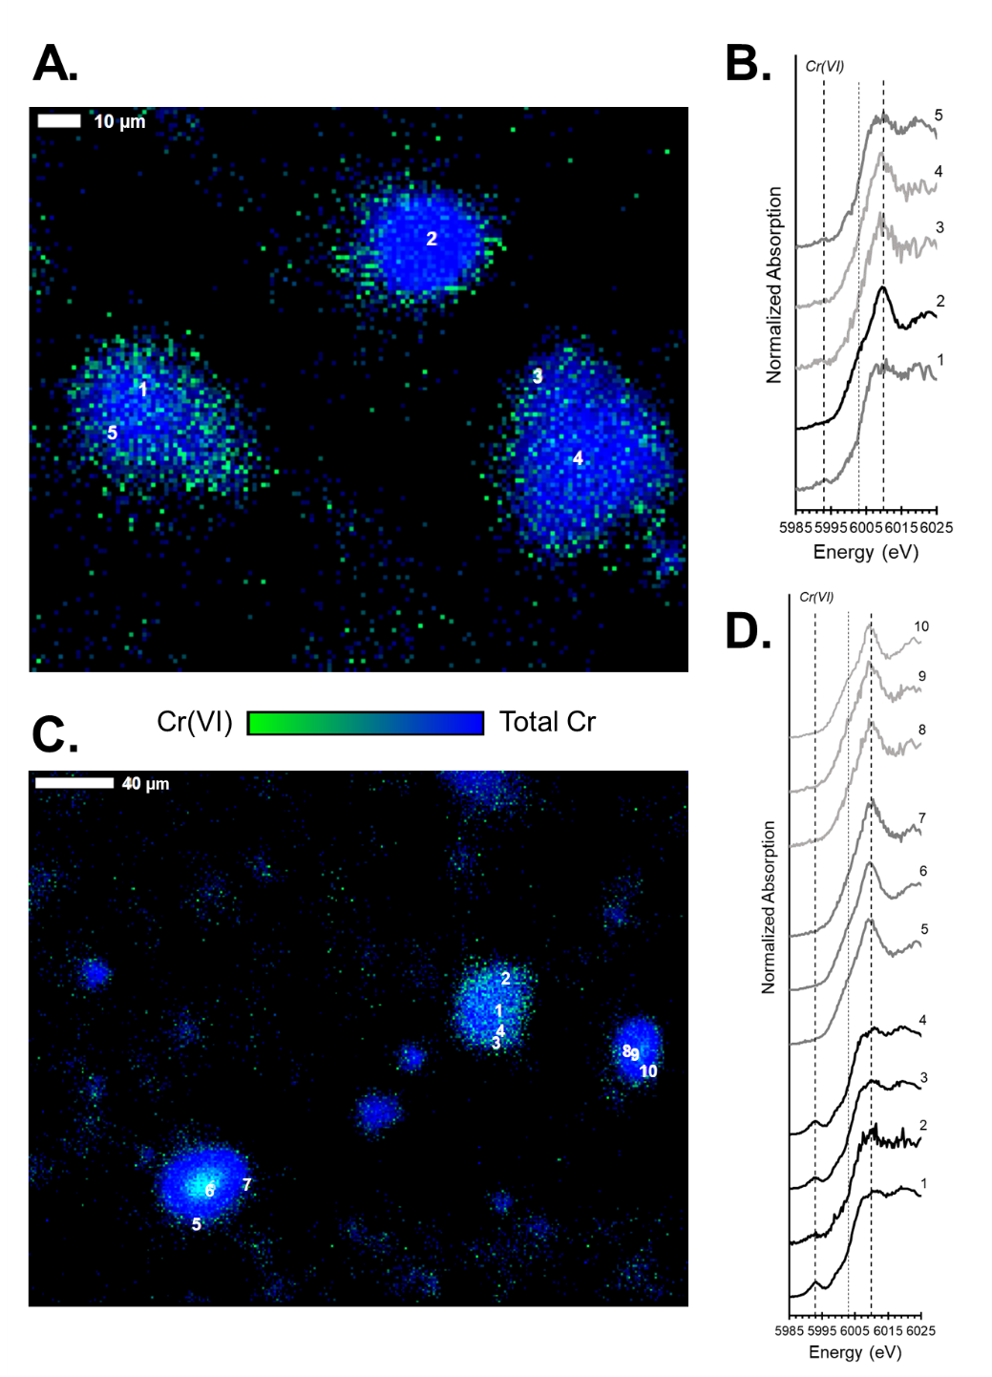
Extended Data Figure 7 | Total Cr(VI) in wind-dispersible soil and ash particles. a. and c. X-ray fluorescence maps (pixel resolution: 1 μm) showing the relative intensity of Cr(VI) (calculated as a fraction of total Cr; green) and total Cr (measured at 6010 eV; blue) in selected areas of a thin section with silt- and clay-sized soil and ash particles (< 53 μm) from a serpentine chaparral that experienced high fire severity (A7). b. and d. Normalized μ-XANES spectra (Cr K-edge) from numbered locations on Cr-bearing particles in a. and c., respectively. Dashed lines indicate energies characteristic of Cr(VI) (5993 eV), Cr(III) (6003 eV), and total Cr (6010 eV), at which μ-XRF images were also collected.

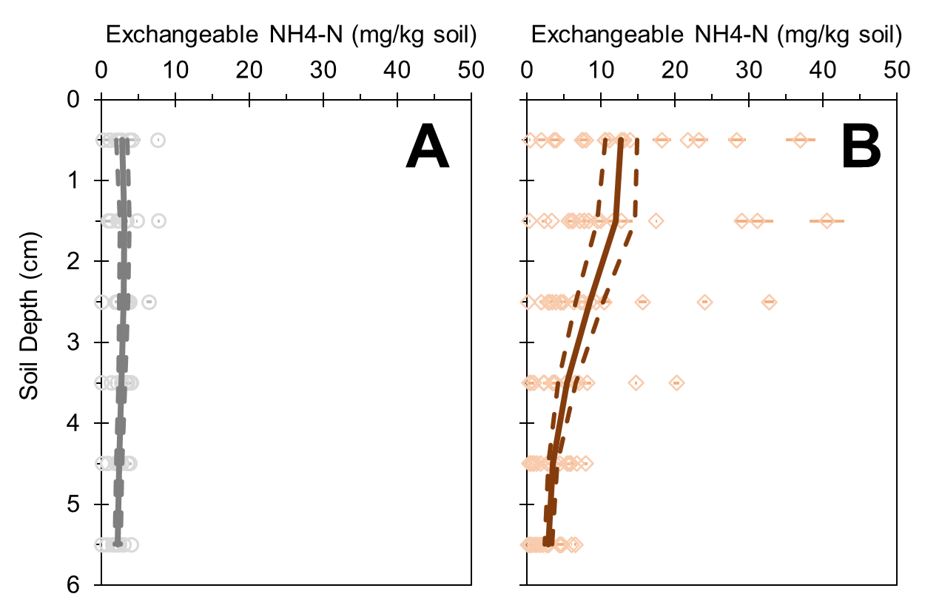
Extended Data Figure 8 | Ammonium concentrations within burned and unburned soils. Exchangeable NH₄-N concentrations (mg/kg) across depths (cm) in a. unburned (gray circles, n = 9) soil and b. burned (orange diamonds, n = 19). Each point represents the sample average of triplicates and error bars represent the standard error. The solid and dashed lines represent mean concentrations (based on n soil cores) and standard error of the means, respectively, for burned and unburned soil in the top 6-cm.

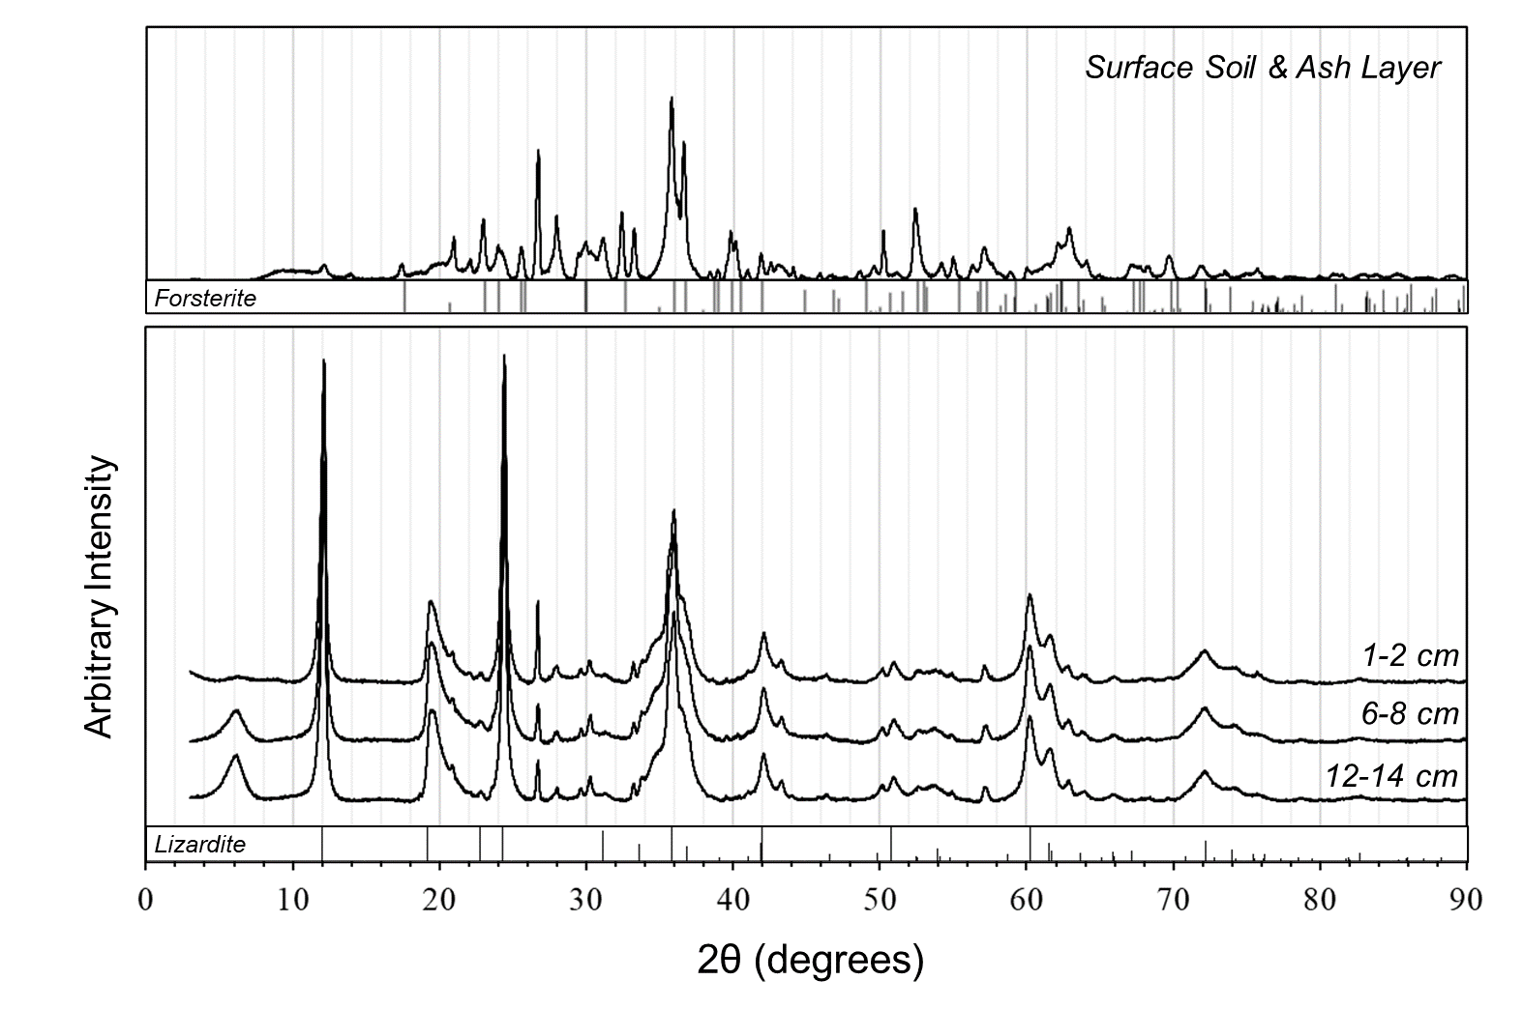
Extended Data Figure 9 | Bulk soil mineral transformations after high fire severity. X-ray diffraction pattern of bulk mineralogy from a severely burned surface soil ash layer (A7) and associated soil depth intervals (1-2 cm, 6-8 cm, and 12-14 cm) collected from a serpentine chaparral and reference lines for forsterite (PDF Card No. 64741) and lizardite (PDF Card No. 81101).
Extended Data Table 1 | Field site descriptions, including preserve location, wildfire, geology, general ecosystem type, estimated fire severity, and average total Cr (mg/kg) and reactive Cr(VI) concentrations (µg/kg) for each soil core.
 |  |  |  |  |  | Total Cr (mg/kg)^{d} |  | Reactive Cr(VI) (µg/kg)^{e}
Soil Core | Preserveª | Fire^{b} | Geology | Ecosystem | Fire Severity^{c} | Mean (0-16 cm) | ± SE (0-16 cm) | Mean (0-2 cm) | ± SE (0-2 cm) | Mean (10-16 cm) | ± SE (10-16 cm)
Fire-Affected Sites
SC1 | MLNR | 2020 | Serpentinite | Chaparral | L | 1137 | 65 | 55.54 | 0.30 | 23.12 | 2.51
SC2 | MLNR | 2020 | Serpentinite | Chaparral | L | 1711 | 119 | 105.96 | 12.69 | 19.23 | 3.61
SC3 | MLNR | 2020 | Serpentinite | Chaparral | L | 1595 | 0 | 57.57 | 14.11 | 13.25 | 0.39
SC4 | MLNR | 2020 | Serpentinite | Chaparral | M/H | 3023 | 531 | 220.30 | 24.89 | 16.87 | 2.43
SC5 | MLNR | 2020 | Serpentinite | Chaparral | M/H | 2440 | 296 | 216.00 | 23.56 | 138.15 | 17.87
SC6 | MLNR | 2020 | Serpentinite | Chaparral | M/H | 2003 | 97 | 257.33 | 31.67 | 67.96 | 3.31
SC7 | MLNR | 2020 | Serpentinite | Chaparral | M/H | 2429 | 220 | 211.42 | 14.21 | 29.46 | 3.26
M1 | WR | 2019 | Mélange^{f} | Grassland | L | 330 | 32 | 16.97 | 6.03 | 5.09 | 0.54
M2 | WR | 2019 | Mélange^{f} | Grassland | L | 404 | 30 | 79.02 | 0.18 | 8.94 | 0.43
M3 | WR | 2019 | Mélange^{f} | Grassland | L | 177 | 7 | 32.53 | 3.75 | 2.31 | 0.27
M4 | WR | 2019 | Mélange^{f} | Grassland | L | 159 | 5 | 21.84 | 2.95 | 2.89 | 0.86
M5 | WR | 2019 | Mélange^{f} | Forest | L | 354 | 32 | 57.75 | 1.19 | 28.33 | 0.88
M6 | MP | 2019 | Mélange^{f} | Grassland | L | 169 | 15 | 7.21 | 0.82 | 0.00 | 0.00
M7 | MP | 2019 | Mélange^{f} | Grassland | L | 289 | 19 | 64.94 | 21.08 | 19.85 | 2.40
M8 | MP | 2019 | Mélange^{f} | Grassland | L | 634 | 26 | 83.62 | 9.35 | 18.18 | 0.93
M9 | MP | 2019 | Mélange^{f} | Grassland | L | 164 | 3 | 2.24 | 0.23 | 13.09 | 0.84
F1 | PP | 2019 | Rhyolite | Forest | L | 102 | 7 | 5.85 | 0.50 | 3.02 | 0.22
F2 | PP | 2019 | Rhyolite | Forest | L | 124 | 2 | 23.55 | 4.81 | 3.32 | 0.22
F3 | PP | 2019 | Rhyolite | Grassland | L | 141 | 9 | 6.67 | 0.44 | 6.68 | 1.04
F4 | PP | 2019 | Rhyolite | Grassland | L | 338 | 7 | 12.87 | 2.75 | 2.44 | 0.32
SF1^{g} | MP | 2019 | Sandstone^{h} | Forest | H | 686 | 15 | 49.49 | 4.81 | - | -
SF2 | MP | 2019 | Sandstone^{h} | Forest | H | 968 | 78 | 73.47 | 5.51 | 47.25 | 0.03
Unburned Sites
SC8 | MLNR |  | Serpentinite | Chaparral |  | 4070 | 71 | 61.04 | 3.04 | 32.65 | 1.42
SC9 | MLNR |  | Serpentinite | Chaparral |  | 3162 | 253 | 38.03 | 7.81 | 8.66 | 0.15
SC10 | MLNR |  | Serpentinite | Chaparral |  | 1340 | 14 | 6.16 | 1.06 | 8.08 | 1.12
M10 | WR |  | Mélange^{f} | Grassland |  | 954 | 3 | 45.68 | 4.41 | 6.66 | 0.56
M11 | WR |  | Mélange^{f} | Grassland |  | 162 | 5 | 27.65 | 1.06 | 1.87 | 0.36
M12 | WR |  | Mélange^{f} | Grassland |  | 193 | 8 | 16.54 | 2.90 | 8.42 | 2.25
M13 | WR |  | Mélange^{f} | Forest |  | 411 | 35 | 26.21 | 2.82 | 31.33 | 0.55
M14 | MP |  | Mélange^{f} | Grassland |  | 152 | 10 | 15.37 | 3.19 | 2.27 | 0.64
M15 | MP |  | Mélange^{f} | Grassland |  | 423 | 47 | 26.70 | 0.72 | 9.33 | 0.58
M16 | MP |  | Mélange^{f} | Grassland |  | 190 | 8 | 18.20 | 1.30 | 14.72 | 0.13
F5 | PP |  | Rhyolite | Grassland |  | 125 | 4 | 4.91 | 1.67 | 0.20 | 0.10
F6 | PP |  | Rhyolite | Forest |  | 166 | 16 | 9.37 | 3.90 | 4.12 | 1.48
F7 | PP |  | Rhyolite | Forest |  | 127 | 13 | 5.22 | 0.75 | 0.18 | 0.14
SF3 | MP |  | Sandstone^{h} | Forest |  | 1199 | 63 | 10.67 | 3.50 | 43.99 | 8.16
SF4 | MP |  | Sandstone^{h} | Forest |  | 1081 | 56 | 30.74 | 11.00 | 19.48 | 0.78
SF5 | MP |  | Sandstone^{h} | Forest |  | 1518 | 54 | 58.86 | 12.08 | 43.16 | 6.49
ª MLNR = McLaughlin Natural Reserve, WR = White Rock Preserve, PP = Pepperwood Preserve, MP = Modini Preserve
^{b} 2019 = Kincade Fire, 2020 = Hennessey Fire (LNU Lightning Complex)
^{c} L = Low severity, M = Moderate severity, H = High severity
^{d} Reported as the mean (n = 3 replicate measurements) ± standard error
^{e} Reported as the mean (n = 3 replicate measurements for each depth interval) ± standard error of depth means
^{f} Mélange (KJfs, fsr) from the Franciscan Complex contains a complex blend of rocks from tectonic mixing, including greenstone, metabasaltic blueschist, greywacke
^{g} The soil depth range of core SF1 was 0-10 cm.
^{h} Based on chemical analyses, the sandstone-derived soil was consistent with typical mafic chemical properties (geologic unit: Kfss)

Extended Data Table 2 | Physicochemical characteristics of bulk soil and ash (up to 2 mm), and selected fine size fractions less than 53 µm, collected from surface layers of the burned serpentine chaparral.

 | Fire | % Sand^{b} | % Silt^{c} | % Clay^{c} | Cr | Fe | Mn | Ni | Ca | Mg | Na | K
ID | Severityª | (2-0.05 mm) | (53-2 µm) | (< 2 µm) | mg/kg | mg/g | mg/kg | mg/kg | mg/g | mg/g | mg/g | mg/g
A1 | L |  |  |  | 1147 | 64.7 | 1351 | 1528 | 15.5 | 77.3 | 4.63 | 3.76
A2 | L |  |  |  | 1532 | 69.1 | 1203 | 2530 | 10.2 | 158 | < 0.1 | 1.65
A3 | M/H |  |  |  | 1606 | 84.2 | 1480 | 3117 | 9.3 | 148 | < 0.1 | 1.54
A4 | M/H | 87.5 | 11.7 | 0.8 | 2256 | 78.9 | 1438 | 3380 | 8.7 | 159 | < 0.1 | 0.90
A5 | M/H |  |  |  | 999 | 57.7 | 1022 | 1849 | 10.2 | 125 | 2.10 | 2.48
A6 | M/H | 78.2 | 20.2 | 1.6 | 1970 | 79.2 | 1555 | 2726 | 29.9 | 174 | < 0.1 | 2.86
A7 | M/H | 85.7 | 12.9 | 1.4 | 4829 | 102 | 1543 | 2643 | 17.9 | 211 | < 0.1 | 2.29
Less than 53 µm size fraction
A4 | M/H |  |  |  | 1133 | 94.7 | 1975 | 3042 | 41.5 | 124 | < 0.1 | 3.38
A6 | M/H |  |  |  | 946 | 82.7 | 1910 | 2294 | 44.2 | 133 | < 0.1 | 4.41
A7 | M/H |  |  |  | 1643 | 105 | 2547 | 3489 | 34.0 | 189 | 2.02 | 3.91
ª L = Low severity, M = Moderate severity, H = High severity
^{b} Determined by sieve analysis
^{c} Determined by laser diffraction particle size counter

