Online-Only Supplement
Supplement to: Gao, et al. Development and validation of postoperative circulating tumor DNA combined with clinicopathological risk factors for recurrence prediction in patients with stages I-III colorectal cancer

Supplementary Figure 1 Heatmap demonstrating the mutational landscape of the primary tumors from 124 evaluable CRC patients

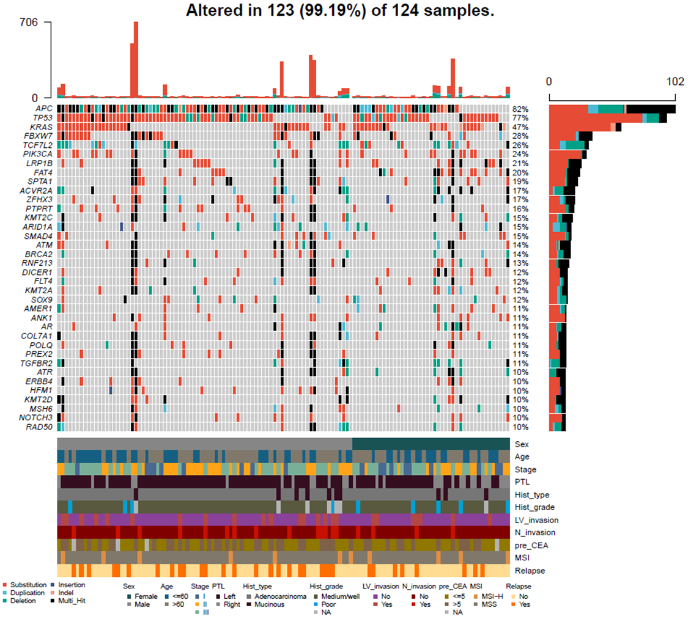
CRC, colorectal cancer; PTL: primary tumor location; LV_invasion: lymphovascular invasion; N_invasion: nerve invasion; MSI: microsatellite instability; pre_CEA, preoperative carcinoembryonic antigen.

Supplementary Figure 2 RFS outcomes of ctDNA-positive and ctDNA-negative CRC patients with different pathologic stages.

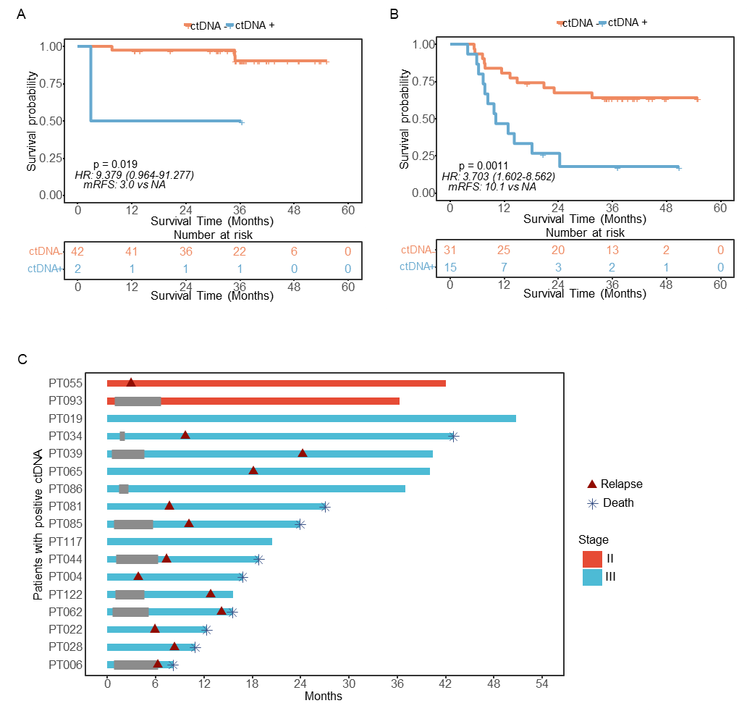
(A and B) Kaplan-Meier curves of RFS for patients stratified by postoperative ctDNA status in the subset of patients with pathologic stage II or III. (C) The clinical courses of 17 postoperative ctDNA‑positive patients.
CRC, colorectal cancer; RFS: recurrence-free survival; ctDNA: circulating tumor DNA.

Supplementary Figure 3 Evaluation of the CTCP model for predicting 1-, 3- and 4-year RFS in the discovery cohort.

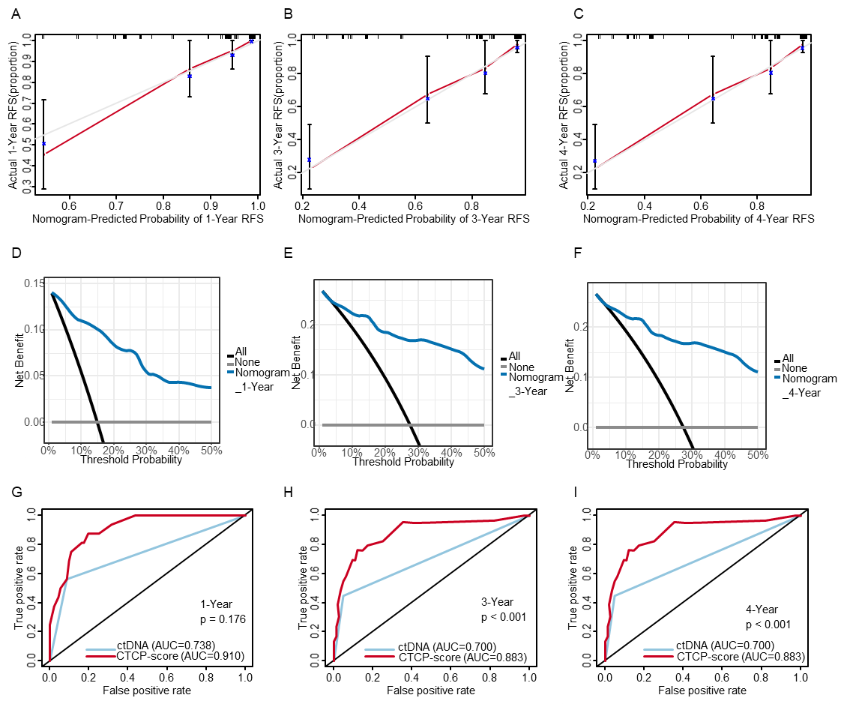
(A-C) The Calibration curves present the concordance between model prediction and actual distribution for 1-, 3- and 4-year RFS. Gray line: reference line. Red line: the prediction curve generated by the nomogram model. (D-F) The DCA curves show the net clinical benefit of the application of the CTCP model to predict 1-, 3- and 4- year RFS. (G-I) Comparison of the CTCP model with ctDNA using ROC analyses for predicting 1-, 3- and 4-year RFS.
CTCP: ctDNA and clinicopathological risk factors; RFS: recurrence-free survival; ctDNA: circulating tumor DNA; ROC: receiver operating characteristic; DCA: decision curve analysis.

Supplementary Figure 4 Evaluation of the CTCP model for predicting 1-year RFS in the validation cohort.
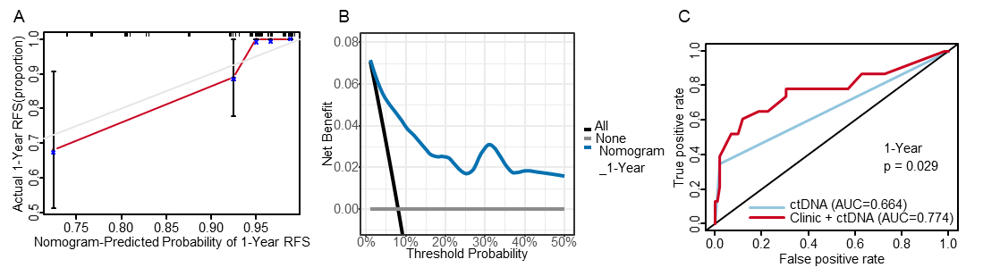
(A) The Calibration curves show the concordance between model prediction and actual distribution for 1-year RFS. Gray line: reference line. Red line: the prediction curve generated by the nomogram model. (B) The DCA curves show the net clinical benefit of the application of the CTCP model to predict 1-year RFS. (C) Comparison of the CTCP model with ctDNA using ROC analyses for predicting 1- year RFS.
CTCP: ctDNA and clinicopathological risk factors; RFS: recurrence-free survival; ctDNA: circulating tumor DNA; ROC: receiver operating characteristic; DCA: decision curve analysis.

Supplementary Table 1 The relationship analysis between postoperative ctDNA status and clinicopathological parameters

Clinicopathological parameters |  | ctDNA status |  | P value
 | Overall | negative | positive
 | (N=108) | (N=91) | (N=17)
Age
<=60 | 50 (46.3%) | 43 (47.3%) | 7 (41.2%) | 0.844
>60 | 58 (53.7%) | 48 (52.7%) | 10 (58.8%)
Sex
Male | 69 (63.9%) | 56 (61.5%) | 13 (76.5%) | 0.367
Female | 39 (36.1%) | 35 (38.5%) | 4 (23.5%)
Tumor location
Left | 80 (74.1%) | 66 (72.5%) | 14 (82.4%) | 0.584
Right | 28 (25.9%) | 25 (27.5%) | 3 (17.6%)
Histologic type
Adenocarcinoma | 98 (90.7%) | 83 (91.2%) | 15 (88.2%) | 1
Mucinous | 10 (9.26%) | 8 (8.79%) | 2 (11.8%)
Histopathological differentiation grade
Poor | 9 (8.91%) | 8 (9.30%) | 1 (6.67%) | 1
Medium/Well | 92 (91.1%) | 78 (90.7%) | 14 (93.3%)
Stage
I | 18 (16.7%) | 18 (19.8%) | 0 (0%) | <0.001
II | 44 (40.7%) | 42 (46.2%) | 2 (11.8%)
III | 46 (42.6%) | 31 (34.1%) | 15 (88.2%)
Lymphatic/vascular invasion
No | 87 (80.6%) | 76 (83.5%) | 11 (64.7%) | 0.143
Yes | 21 (19.4%) | 15 (16.5%) | 6 (35.3%)
Nerve invasion
No | 91 (84.3%) | 80 (87.9%) | 11 (64.7%) | 0.04
Yes | 17 (15.7%) | 11 (12.1%) | 6 (35.3%)
MSI status
MSS | 100 (92.6%) | 83 (91.2%) | 17 (100%) | 0.444
MSI-H | 8 (7.41%) | 8 (8.79%) | 0 (0%)
MSS: microsatellite stable; MSI-H: microsatellite instability-high.

Supplementary Table 2 The sensitivity and specificity of postoperative ctDNA status for predicting RFS at 6-48 months

Months | Sensitivity | Specificity | Positive predictive value | Negative predictive value
6 | 60.0% | 86.4% | 17.6% | 97.8%
12 | 56.3% | 91.3% | 52.9% | 92.3%
18 | 52.2% | 92.7% | 63.6% | 88.8%
24 | 49.6% | 94.7% | 73.4% | 86.5%
30 | 51.8% | 95.9% | 79.8% | 86.5%
36 | 44.7% | 93.8% | 73.0% | 81.8%
42 | 44.7% | 95.5% | 78.8% | 82.1%
48 | 44.7% | 92.3% | 68.7% | 81.6%

ctDNA: circulating tumor DNA; RFS: recurrence-free survival

Supplementary Table 3 The sensitivity and specificity of the CTCP model for predicting RFS at 6-48 months

Months | Sensitivity | Specificity | Positive predictive value | Negative predictive value
6 | 100.0% | 62.1% | 11.4% | 100.0%
12 | 87.5% | 80.4% | 43.8% | 97.4%
18 | 85.6% | 84.1% | 56.9% | 96.0%
24 | 87.5% | 88.2% | 68.4% | 96.0%
30 | 88.0% | 89.2% | 71.6% | 96.0%
36 | 76.1% | 85.4% | 66.3% | 90.4%
42 | 76.1% | 81.8% | 61.2% | 90.1%
48 | 76.1% | 84.6% | 65.1% | 90.3%

CTCP: ctDNA and clinicopathological risk factors; RFS: recurrence-free survival; ctDNA: circulating tumor DNA;

