Table 16 Damaged Members of Pre-Engineered Buildings subjected to blast loadings
Loading | Damaged Members | Remarks
Blast1 | 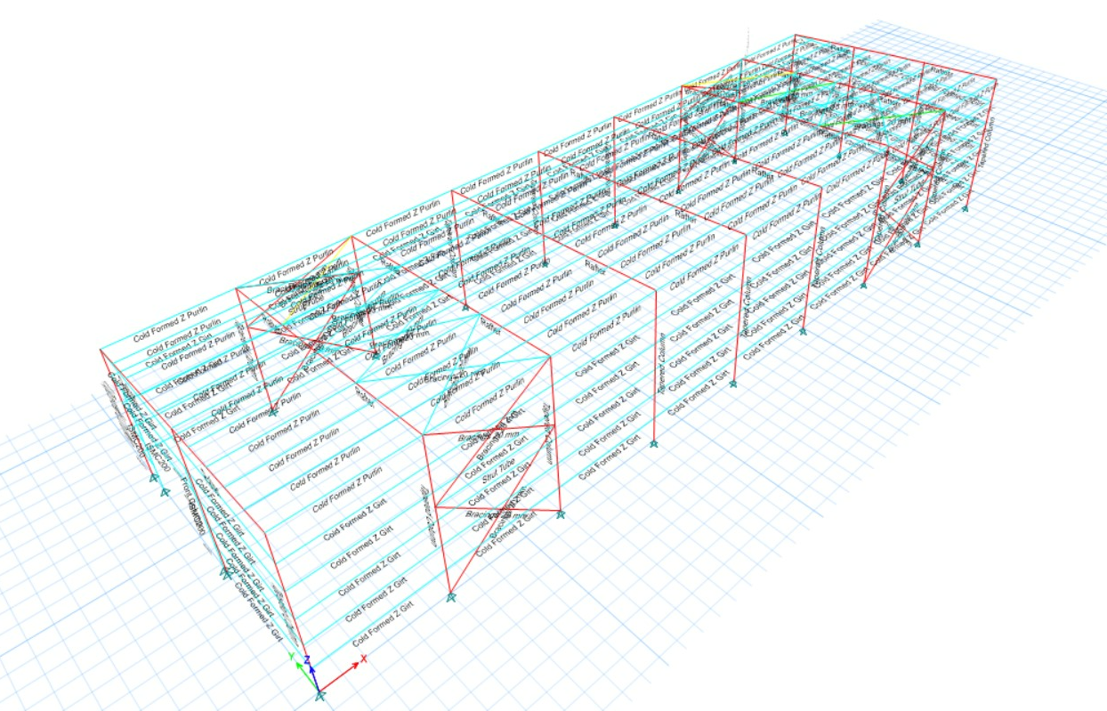 | Maximum members damaged including tapered columns, rafters and bracings
Blast2 | 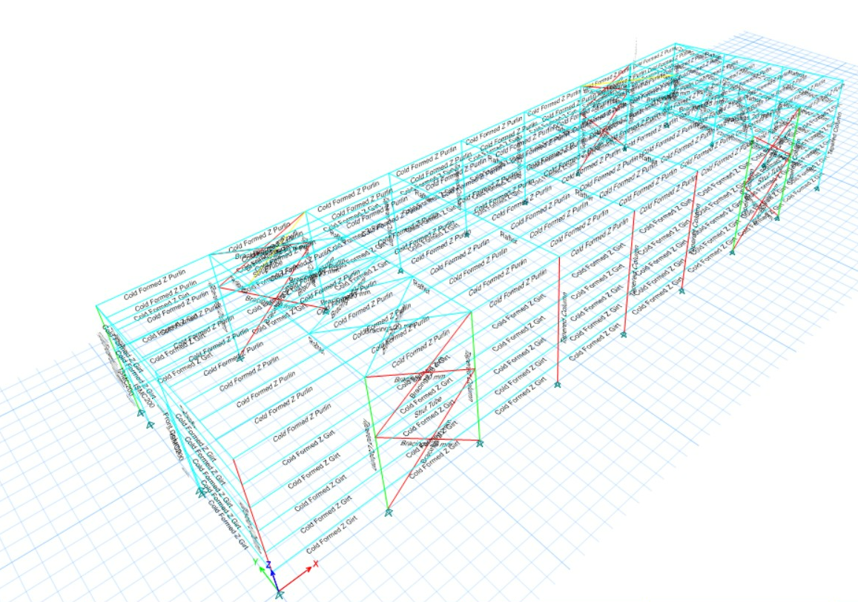 | A few bracings and tapered columns were damaged.
Blast3 | 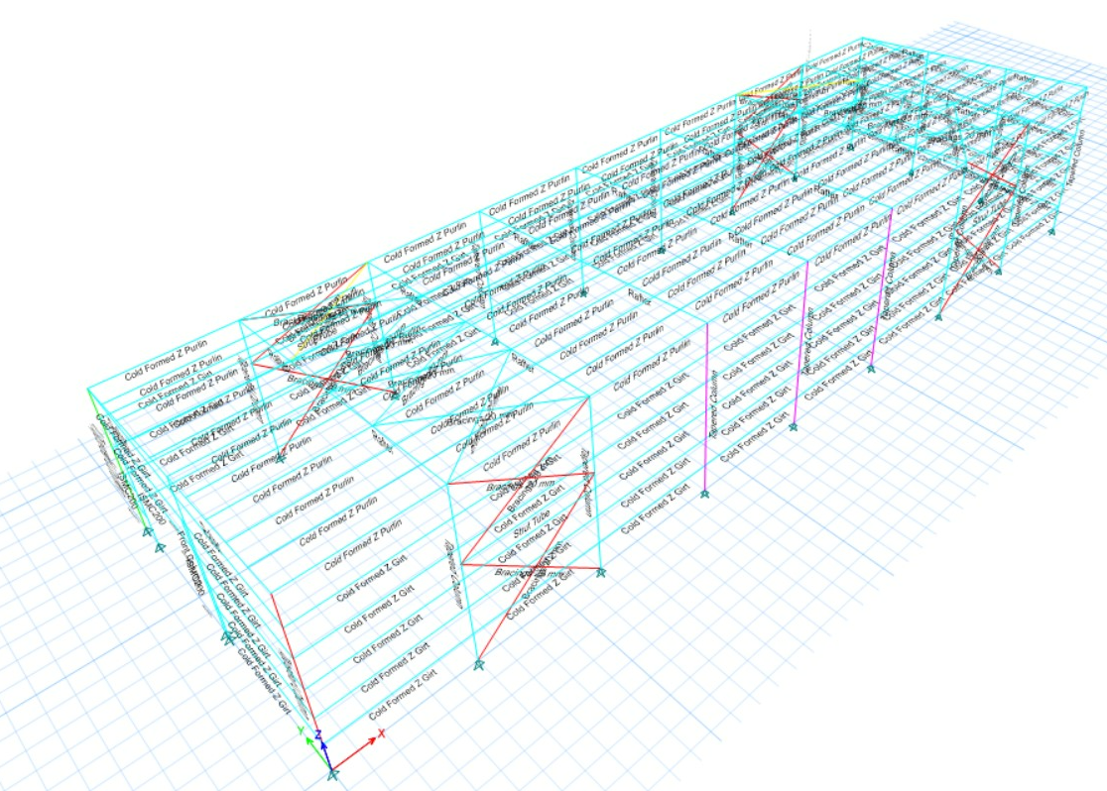 | A few bracings damaged with a few tapered columns in critical state.
Blast4 | 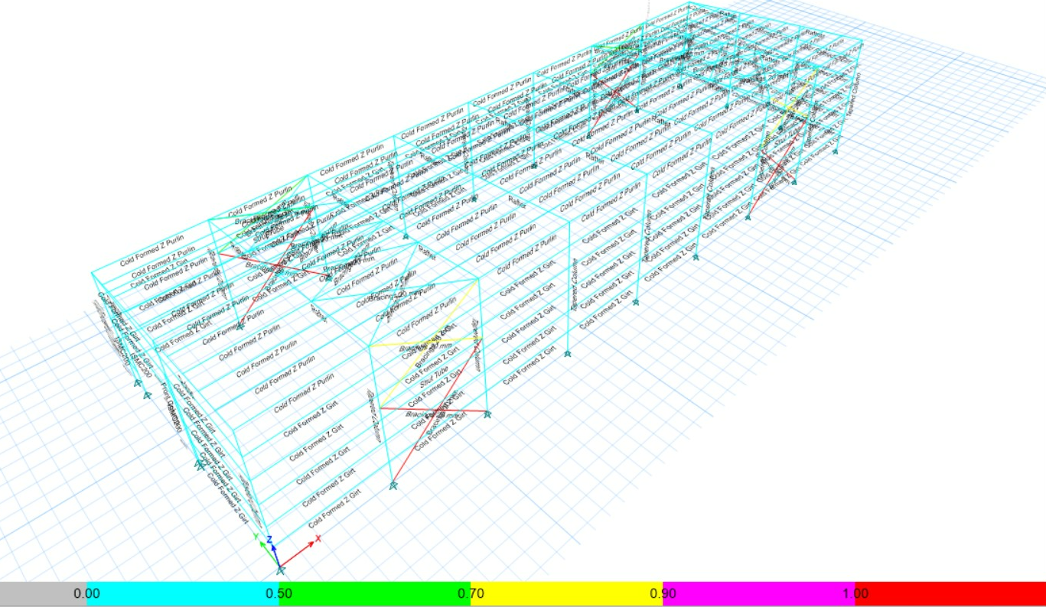 | Only few bracings got damaged.

Table 17 Damaged Members of Pre-Engineered Buildings subjected to earthquake loadings.
Loading | Damaged Members | Remarks
Imperial Valley | 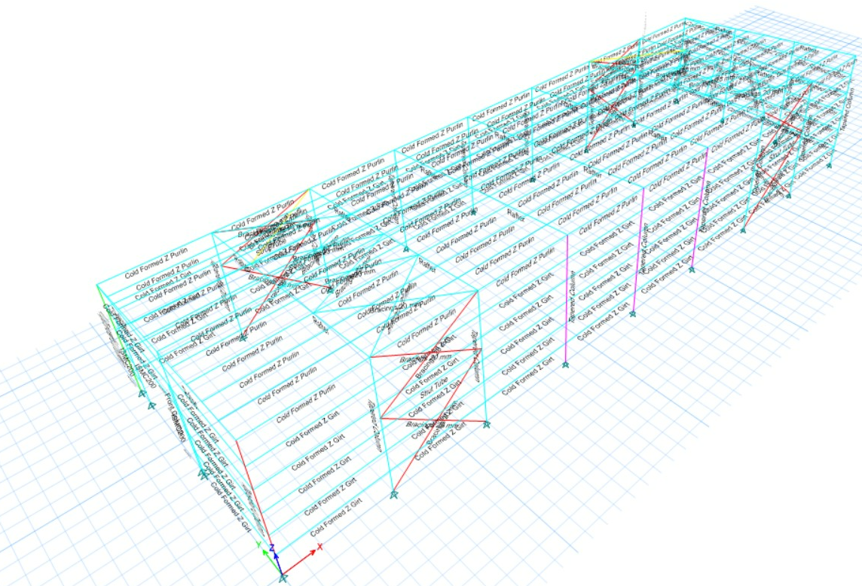 | A few bracings damaged with a few tapered columns in critical state.
Loma Prieta | 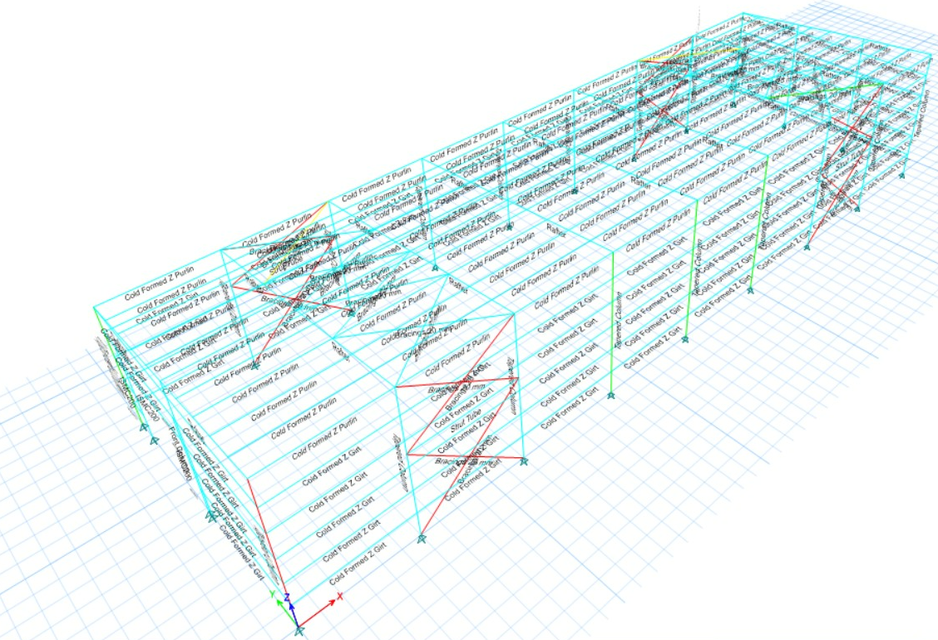 | Only few bracings got damaged.
New Zealand | 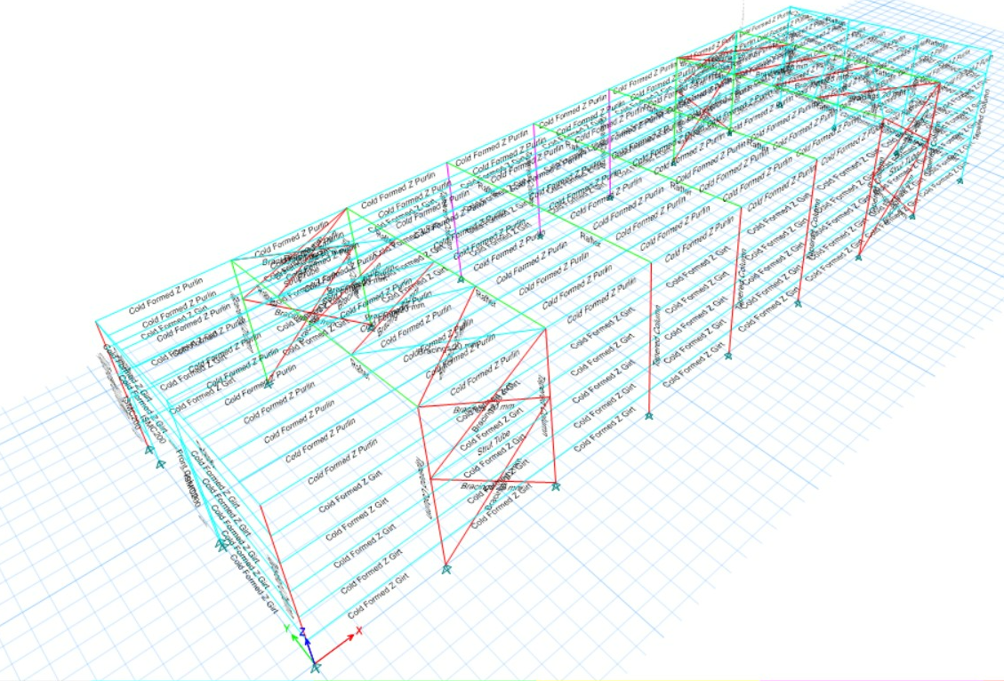 | A few bracings and tapered columns were damaged.
Northridge | 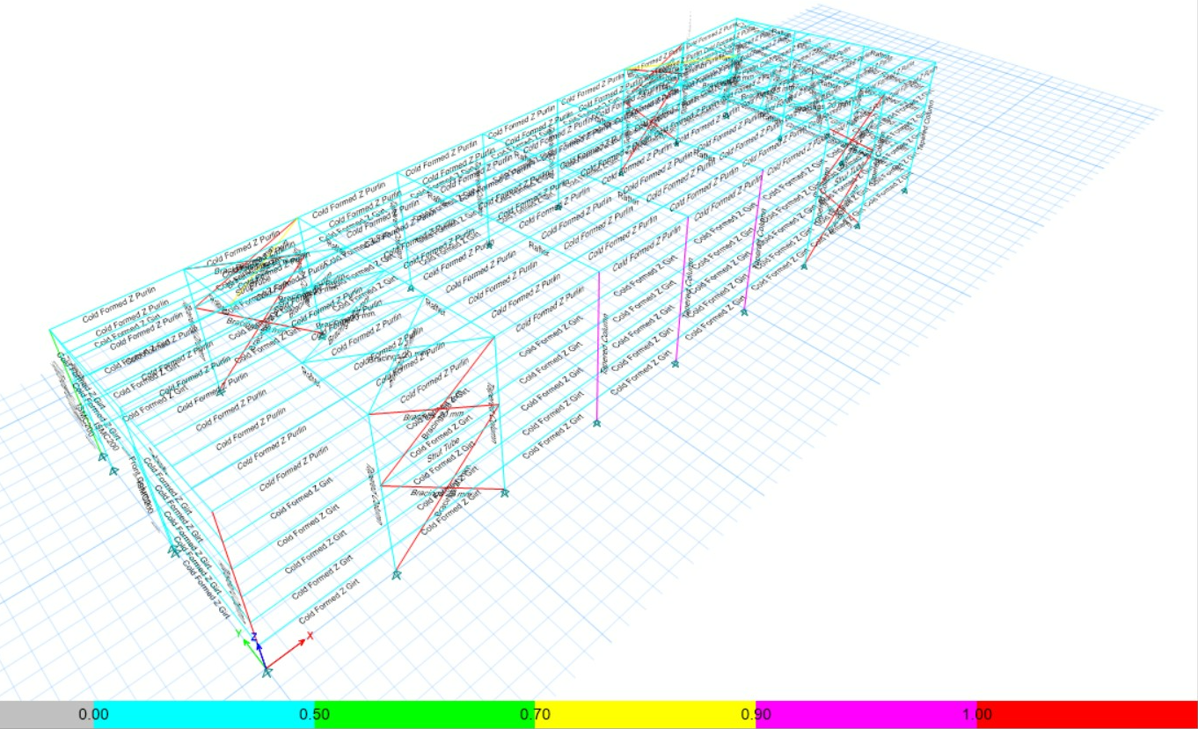 | A few bracings damaged with a few tapered columns in critical state

