Supplementary Materials
eAppendix. Detailed Methods
eTable 1. The AIC value of fitted survival models for CAR-T cell therapy
eTable 2. The value of parameters of best fitted survival models
eTable 3. Average cost in different categories
eTable 4. Risk Factors Affecting the Total Cost based on the Multiple Linear Regression
eTable 5. Treatment Regimens of salvage chemotherapy for RRMM
eFigure 1. Collection process of utility value for RRMM patients in different health status received CAR-T treatment
eTable 6. Utility and disutility for different health stages
eTable 7. Age- and sex-specific mortality rates for Chinese people in 2016
eFigure 2. Cost-effectiveness Acceptability Curve
eTable 8. Sensitivity Analysis Range of Input Parameters for the Tornado Diagram
eTable 9. Distributions for Input Parameters in Probabilistic Sensitivity Analysis

eAppendix. Detailed Methods
Model Structure
Markov models and partitioned survival models are commonly used in oncologic modeling. The latter models assume constant costs and utility over time and are impossible model multiple lines of therapy accurately. The characteristics of partitioned survival models determine that it may not be appropriate for modeling RRMM with potential clinical cure after CAR-T treatment. In contrast, Markov models are more flexible to model costs and utilities over time and successive therapies. Therefore, a Markov model was used to conduct cost-effectiveness analyses of Idecabtagene vicleucel(Ide-cel) and Ciltacabtagene autoleucel (Cilta-cel) for RRMM from the perspective of the Chinese healthcare system in this study.
This model considered four health stages: progression-free state (PFS), progression disease (PD), clinical cure and death. All patients in the model initially were in the PFS state and then could stay PFS or transit to PD or death. The patients in PD could stay in this state (PD) or transit to death. Given the cure potential of CAR-T treatment, we assumed that patient who stayed the PFS more than 5 years were considered effectively cured and moves to clinical cure health stage. Patients in clinical cured would face a very low probability of relapse and decreased lifespan compared with the general population. Patients experienced progression after treatment of salvage chemotherapy and CAR-T cell treatment would proceed another salvage chemotherapy, and palliative care if they progressed again. RRMM patients who discontinued CAR-T therapy due to AE and manufacturing failure would receive salvage chemotherapy. We also assumed that patients who were still in a PD at the end of the fifth year died by this time. Additionally, patients receiving CAR-T cell therapy could proceed second CAR-T cell therapy after progression.
The median age of RRMM patients are 61 in KarMMa and CARTITUDE-1 clinical trial. Therefore, the model focused on an intention-to-treat analysis, with a hypothetical cohort of heavily pre-treated patients with MM beginning at age 60. And we conducted a systematic review to identify the median year age of Chinese RRMM patient to received CAR-T treatment in clinical trial. The systematic review included 11 clinical trials and 23 patients and demonstrated the median age of Chinese RRMM patients are 57.8. To test the cost-effectiveness profile of younger RRMM patients, a scenario analysis that the starting age of patients entered to the model was 55. Considering the iterative development of technology, the success rate of CAR-T manufacturing would be higher and higher, even close to 100%. Therefore, we conducted another scenario analysis to test how a 100% success rate of CAR-T manufacturing affects the model results.

Curve Digitization
Kaplan-Meier curves from the evidence were digitized using the algorithm by Guyot and colleagues to impute patient-level time-to-event data ^{[1]}. We extracted data points from the digitized copies of published survival curves using WebPlot Digitizer (version 4.0) ^{[2]}, then used the extracted values, the number of surviving patients at each time interval, and maximum likelihood functions to estimate the underlying individual patient data. Values were extrapolated for five years following treatment completion. The model curves considered included the distributional forms of weibull, exponential, lognormal, log-logistic, gamma, generalized gamma and Gompertz (eTable 1 and 2). The base-case distributional form was selected separately for each curve based on best model fit using Akaike information criterion (AIC) values and visual comparison.

Calculation of the transition probability
Monthly transition probabilities were derived using the survival function with the best model fit. These steps allowed for the extrapolation of survival beyond the observed trial evidence to a time-period of approximately five years, while also keeping as close as possible to the observed trial survival signals. For the comparator, there were no published PFS curves. Therefore, the PFS curve was derived from available OS data by a proportional relationship between PFS and OS reported in previous meta-analyses ^{[3-4]}. Taking Ide-cel as an example, the calculation of the transition probability between states was as follows:
1. The OS curve of Ide-cel fitted by exp parametric model:
S_{OS}(t) = exp(scale/shape(1-exp(shape*t))
2. The PFS curve of Ide-cel fitted by log-normal parametric model:
S_{PFS}(t) = 1-NORMSDIST((LN(t)-meanlog)/sdlog)
3. The sum of the probability of cumulative PFS and the probability of cumulative PD equals the cumulative probability of overall survival:
S_{PD}(t) = S_{OS}(t)- S_{PFS}(t)
4. Then, the transition probability from progression-free survival to progression-free survival (P_{ftf}) in each cycle can first be obtained.
P_{ftf} = S_{PFS}(t+1)/ S_{PFS}(t+1)
5. In order to obtain the transition probability from progression-free survival (P_{ftp}) to progression disease, we assumed the transition probability from progression-free survival to death was exceed background death probability, then:
P_{ftp} = 1- P_{ftf} - P_{ftd}
The background death probability of Chinese patients was showed in eTable 3:
6. In order to calculate the transition probability from patients in PD in t cycle to patients in PD in t+1 cycle (Pptp), it is necessary to acknowledge that the patients in PD in t+1 cycle (N_{PD} (t+1)) consists of two parts: the patients in PFS in the t cycle (N_{PFS} (t)) transit to PD in t+1 cycle and the number of patients in PD in t cycle (N_{PD} (t)) still stay in PD in t+1 cycle, therefore:
N_{PD} (t+1) = N_{PFS} (t) *Pftd + N_{PD} (t) * Pptp
And,
Pptp = N_{PD} (t+1)/ N_{PD} (t)

Costs
The cost of CAR T-cell treatment for RRMM was derived from phase 1 open label single-institution clinical trial (ChiCTR1800017404) ^{[5]}. This clinical trial was initiated by the First Affiliated Hospital of Zhejiang University School of Medicine on July 2, 2018 and to observed the remission rate (CR and PR), total survival(OS) and disease- free survival( EFS) of BCMA-CART in the treatment of RRMM. This clinical trial enrolled RRMM patients after four or more prior lines of therapy with BCMA positive.
Patients with RRMM who received lymphodepletion chemotherapy and CAR-T cell infusion from Oct. 2018 to Dec. 2021 in this clinical trial were included to identify healthcare cost. The cost of CAR-T includes the acquisition cost of CAR-T products, costs incurred during hospitalization (including management costs of adverse reactions), follow-up costs, and secondary CAR-T treatment cost (eTable 1). In order to be consistent with the previous studies ^{[6-8]}, base treatment costs of the second CAR-T treatment only were considered and not the acquisition cost of CAR-T treatment.
Patients received CAR-T treatment in this clinical trial would assigned pre-projected following-up plans. This following-up plan consisted of comprehensive physical, blood, and bone marrow examination every 3 months in first year after infusion of the CAR-T cell products. Then the frequency changes to every three to six months in the second year, and every six to twelve months in the third year. We only collected the first year following-up cost for patient with progression-free stage. Therefore, we assumed that the follow-up costs in the second and third years were half that of the first year, and the follow-up costs in the fourth and fifth years were halved again.
Multiple linear regression was used to obtained the cost of Grade 3/4 AEs associated with Ide-cel and Cilta-cel, including cytokine release syndrome and Neurotoxicity (Table 4). Given the cost data are not orthodox, we log-transformed the data and confirmed that the data were normally distributed before regression analysis. The result of the regression analysis was showed in the table S4 and the cost for base treatment, CRS and Neurotoxicity were $11444, $4364 and $7421, respectively. Because the second CAR-T treatment had a low occurrence of adverse reactions and mild symptoms, the treatment-related adverse event costs weren’t considered in the second CAR-T treatment.
Identification the cost of salvage chemotherapy for RRMM was based on a single-center retrospective observational study was conducted from Sep. 2020 to May 2022 in First Affiliated Hospital of Zhejiang University School of Medicine. This retrospective observational study was conducted of patients with ≥ 2 outpatient visit or ≥ inpatients visit with a primary relapse and/or refractory MM diagnosis and completion of at least a treatment cycle of salvage chemotherapy. The study revealed that the vast majority of salvage chemotherapy for RRMM patients were all daratumumab-based combination therapy. Combined with clinical specialists’ inputs, we assumed that salvage therapy for RRMM was based on daratumumab-based combination therapy.
The cost of salvage chemotherapy was calculated based per each treatment cycle. We divided the cost of the salvage chemotherapy into two parts, one was the acquisition cost of chemotherapy drugs in each chemotherapy strategies (referred as ‘chemotherapy drugs costs’) (Table 3), and the other is basic treatment cost (referred as ‘basic treatment costs’) that is the total treatment cost to subtract aforementioned chemotherapy drugs cost (Table 1). The daratumumab-based combination therapy included 8 treatment regimens in our study and eTable 5 showed the costs and proportion of these treatment regimens.
All costs were extracted from the hospital information system of First Affiliated Hospital of Zhejiang University School of Medicine, which provided inpatient personal information, diagnosis, treatment process, nursing records, and hospital bills. The total costs consists of following 10 cost components: drugs, room charges, physicians, radiology examinations, oxygen supply, laboratory tests, treatment, transfusions, nursing, others (including medical consumable).

Utility
Though the KarMMa study determined health-related quality of life for patients treated according to their progression status [20], health state utility values for PFS and PD in this published study didn’t reported. Therefore, we collected the utility values of RRMM patients alongside clinical trial mentioned above (ChiCTR1800017404) using the general health EuroQol 5-dimension 5-level (EQ-5D-5L) instrument to inform the Markov model in this study. A Chinese value set was used to calculate a summary index score, with a score of 1 indicating full health, 0 indicating death, and negative scores reflecting states perceived to be worse than death. ^{[9]}
The health state utility values assessment were conduct at specified time periods: 0-1, 1-3, 3-6, 6-12 months after CAR-T cell treatment (eFigure 1). The utility values of RRMM patients received CAR-T cell treatment for the first month were collected in the inpatient, and the collection of the utility values after the first month was done in the outpatient. The PFS utility values for RRMM could be repeatedly measured in a same patient in different time periods, while the PD utility values were only measured once for the first time of progression. And the result of health state utility values assessment was showed in eTable 6.
We adopted the highest utility of PFS (0.87) and utility of PD (0.72) in clinical trial as utility value for PFS and in PD of RRMM patients after CAR-T treatment in our cost-effectiveness analysis. The utility of patient receive CAR-T treatment in first month was set as 0.66 according to our results. We assumed that the utility value of patient in PFS and PD received salvage chemotherapy were same as to that of patients received CAR-T treatment. Disutility for salvage chemotherapy was informed by the literature and experts’ opinion ^{[10]}. The utility of long-term survivor (clinical cure) was derived from previous study that reported the Chinese urban population norm scores for the EQ-5D ^{[11]}.

Sensitivity Analyses
Sensitivity Analysis Range of Input Parameters for the Tornado Diagram and Distributions for Input Parameters in Probabilistic Sensitivity Analysis were showed in Table 7 and Table 8.

eTable 1. The AIC value of fitted survival models for CAR-T cell therapy
Parametric models | Ide-cel |  | Cilta-cel |  | Salvage chemotherapy
Parametric models | OS | PFS | OS | PFS | OS
Weibull | 376.1 | 634.2 | 324.6 | 413.2 | 426.9
Log-logistic | 378.5 | 633.0 | 329.4 | 445.3 | 430.2
Log-normal | 383.3 | 628.9 | 324.1 | 410.0 | 426.3
Gompertz | 372.1 | 635.1 | 325.2 | 413.0 | 427.1
Exponential | 379.4 | 633.3 | 323.9 | 411.2 | 427.3
Gamma | 377.1 | 633.6 | 325.1 | 413.1 | 426.8
Generalized gamma | 375.7 | 630.9 | 326.2 | 411.6 | 428.1

eTable 2. The value of parameters of best fitted survival models
Survival Model | Baseline value | Distribution | Sources
Ide-cel
OS | shape = 0.0922  rate = 0.0108 | Gompertz
PFS | meanlog = 1.98  sdlog = 1.18 | Log-normal
Cilta-cel
OS | sdlog = 0.0127 | Exp
PFS | rate = 3.55  scale = 1.47 | Log-normal
Salvage chemotherapy
OS | meanlog = 1.22  sdlog = 1.00 | Log-normal
PFS | meanlog = 2.13  sdlog = 1.30 | Log-normal

eTable 3. Average cost in different categories
Average cost ($) | 1st CAR-T treatment | 2nd CAR-T treatment | Following-up cost to one-year post-infusion | Base cost for salvage chemotherapy
Total | 14666 | 9740 | 5942 | 3387
Drug | 6782 | 4352 | 95 | 1195
Room charges | 560 | 646 | 19 | 66
Physicians | 115 | 152 | 17 | 50
Radiology examinations | 427 | 347 | 2006 | 200
Oxygen supply | 206 | 228 | 1 | 62
Laboratory test | 2883 | 1826 | 3247 | 1070
Treatment | 1289 | 1079 | 110 | 223
Transfusion | 1211 | 294 | 0 | 121
Nursing | 775 | 521 | 34 | 151
Others | 381 | 297 | 415 | 236

eTable 4. Risk factors affecting the total cost based on the multiple linear regression
Variables | β (95% Cl) | P
Intercept | 9.35 | 0.001
CRS | 0.32 | 0.03
Neurotoxicity | 0.50 | 0.006

eTable 5. Treatment regimens and cost of salvage chemotherapy for RRMM
Therapeutic strategies | Regimen per treatment cycle | Proportion | Average cost ($)
DVd | Daratumumab 1000 mg on days 1,8,15,22 +  bortezomib 1.8 mg on days 1,8,15,22 +  dexamethasone 40 mg on days 1, 8,15,22 | 8% | 10228
DRd | Daratumumab 1000 mg on days 1, 8, 15, 22 + lenalidomide 10 mg on days 1-21 +  dexamethasone 40 mg on days 1, 8, 15, 22 | 10% | 10799
DPd | Daratumumab 1000 mg on days 1, 8, 15, 22 + pomalidomide 2 mg on days 1-21 +  dexamethasone 40 mg on days 1, 8, 15, 22 | 13% | 8729
DARA + IRd | Daratumumab 1000 mg on days 1, 8, 15, 22 +  ixazomib 4 mg on days 1, 8, 15, 22 +  lenalidomide 10 mg on days 1-21 +  dexamethasone 40 mg on days 1, 8, 15, 22 | 21% | 13852
DARA + VCd | Daratumumab 1000 mg on days 1, 8, 15, 22 + bortezomib 1.8 mg on days 1, 8, 15, 22 + cyclophosphamide 300 mg on days 1, 8, 15, 22 + dexamethasone 40 mg on days 1, 8, 15, 22 | 15% | 10293
DARA + VRd | Daratumumab 1000 mg on days 1, 8, 15, 22 + bortezomib 1.8 mg on days 1, 8, 15, 22 +  lenalidomide 10 mg on days 1-21 +  dexamethasone 40 mg on days 1, 8, 15, 22 | 20% | 13247
DTd | Daratumumab 1000 mg on days 1, 8, 15, 22 + thalidomide 100 mg on days 1-21 +  dexamethasone 40 mg on days 1, 8, 15, 22 | 5% | 7841
DARA + DECP | Daratumumab 1000 mg on days 1, 8, 15, 22 +  cisplatin 20mg on days d1-4 +  cyclophosphamide 400 mg on days 1-4 +  VP-16 50 mg on days 1-4 +  dexamethasone 20 mg on days 1-4 | 8% | 8076

eFigure 1. Collection process of utility value for RRMM patients in different health status received CAR-T treatment
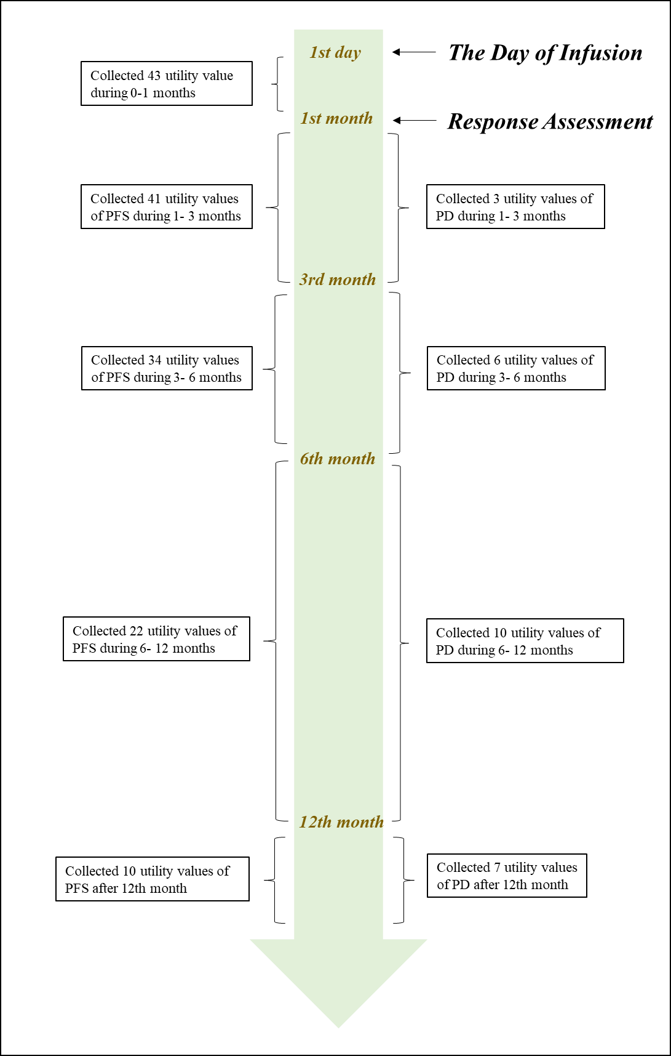

eTable 6. Utility and disutility for different health stages
Parameter | Value | Source
Health state utility for CAR-T treatment
Day 1 of infusion | 0.71 | collected in clinical trials
0 ~ 1 months of PFS | 0.66 | collected in clinical trials
1 ~ 3 months of PFS | 0.82 | collected in clinical trials
3 ~ 6 months of PFS | 0.84 | collected in clinical trials
6 ~ 12 months of PFS | 0.86 | collected in clinical trials
12 ~ months of PFS | 0.87 | collected in clinical trials
Utility of PD | 0.72 | collected in clinical trials
Utility of Clinical Cure | 0.94 | Yang Z et al. 2018
Disutility for Salvage Chemotherapy | 0.25 | Brown et al. 2013, Sullivan 2006 and experts’ opinions

eTable 7. Age- and sex-specific mortality rates for Chinese people in 2016
Age | Mortality rate (%)
Age | Overall | Male | Female
0-4 | 0.82 | 0.88 | 0.75
0 | 4.55 | 4.95 | 4.11
1 | 0.54 | 0.56 | 0.51
2 | 0.38 | 0.43 | 0.32
3 | 0.32 | 0.33 | 0.30
4 | 0.21 | 0.23 | 0.19
5-9 | 0.20 | 0.24 | 0.15
5 | 0.26 | 0.28 | 0.23
6 | 0.16 | 0.16 | 0.16
7 | 0.24 | 0.32 | 0.13
8 | 0.18 | 0.19 | 0.16
9 | 0.17 | 0.23 | 0.10
10-14 | 0.20 | 0.26 | 0.14
10 | 0.22 | 0.29 | 0.14
11 | 0.19 | 0.21 | 0.18
12 | 0.20 | 0.26 | 0.14
13 | 0.22 | 0.29 | 0.13
14 | 0.19 | 0.23 | 0.14
15-19 | 0.32 | 0.45 | 0.17
15 | 0.29 | 0.31 | 0.15
16 | 0.35 | 0.41 | 0.18
17 | 0.31 | 0.42 | 0.18
18 | 0.25 | 0.52 | 0.12
19 | 0.41 | 0.58 | 0.21
20-24 | 0.31 | 0.58 | 0.21
20 | 0.23 | 0.67 | 0.14
21 | 0.30 | 0.52 | 0.19
22 | 0.30 | 0.65 | 0.21
23 | 0.33 | 0.55 | 0.27
24 | 0.41 | 0.51 | 0.28
25-29 | 0.40 | 0.79 | 0.31
25 | 0.41 | 0.60 | 0.25
26 | 0.36 | 0.67 | 0.28
27 | 0.43 | 1.02 | 0.31
28 | 0.41 | 0.79 | 0.34
29 | 0.39 | 0.87 | 0.37
30-34 | 0.55 | 1.16 | 0.31
30 | 0.43 | 0.88 | 0.25
31 | 0.48 | 1.05 | 0.28
32 | 0.67 | 1.06 | 0.31
33 | 0.57 | 1.38 | 0.34
34 | 0.63 | 1.40 | 0.37
35-39 | 0.85 | 1.16 | 0.52
35 | 0.61 | 0.88 | 0.32
36 | 0.76 | 1.05 | 0.45
37 | 0.82 | 1.06 | 0.56
38 | 0.99 | 1.38 | 0.58
39 | 1.05 | 1.40 | 0.69
40-44 | 1.30 | 1.78 | 0.80
40 | 1.13 | 1.45 | 0.79
41 | 1.21 | 1.67 | 0.72
42 | 1.36 | 1.87 | 0.83
43 | 1.21 | 1.79 | 0.60
44 | 1.57 | 2.08 | 1.04
45-49 | 1.98 | 2.68 | 1.25
45 | 1.65 | 2.23 | 1.04
46 | 1.93 | 2.64 | 1.19
47 | 1.74 | 2.29 | 1.17
48 | 2.28 | 3.21 | 1.33
49 | 2.39 | 3.19 | 1.58
50-54 | 2.89 | 3.97 | 1.78
50 | 2.60 | 3.58 | 1.58
51 | 2.98 | 4.07 | 1.88
52 | 2.82 | 3.91 | 1.68
53 | 2.51 | 3.39 | 1.61
54 | 4.20 | 5.88 | 2.53
55-59 | 5.08 | 6.78 | 3.31
55 | 4.23 | 5.80 | 2.62
56 | 5.14 | 6.86 | 3.34
57 | 5.04 | 6.69 | 3.31
58 | 4.94 | 6.52 | 3.30
59 | 5.90 | 7.94 | 3.84
60-64 | 7.52 | 9.98 | 5.06
60 | 6.40 | 8.51 | 4.26
61 | 6.81 | 8.96 | 4.64
62 | 7.90 | 10.65 | 5.18
63 | 7.79 | 10.19 | 5.40
64 | 9.16 | 12.25 | 6.11
65-69 | 12.37 | 15.93 | 8.80
65 | 10.39 | 13.66 | 7.13
66 | 10.39 | 13.68 | 8.22
67 | 12.56 | 16.67 | 8.44
68 | 13.24 | 16.97 | 9.49
69 | 15.90 | 20.32 | 11.58
70-74 | 21.20 | 26.77 | 15.81
70 | 16.72 | 21.48 | 12.12
71 | 19.07 | 24.06 | 14.12
72 | 22.60 | 28.88 | 16.59
73 | 23.44 | 28.71 | 18.33
74 | 25.57 | 32.44 | 19.00
75-79 | 36.26 | 43.60 | 29.55
75 | 27.92 | 34.53 | 21.74
76 | 34.16 | 41.03 | 27.84
77 | 34.93 | 41.48 | 28.85
78 | 40.10 | 48.67 | 32.28
79 | 47.00 | 56.00 | 39.22

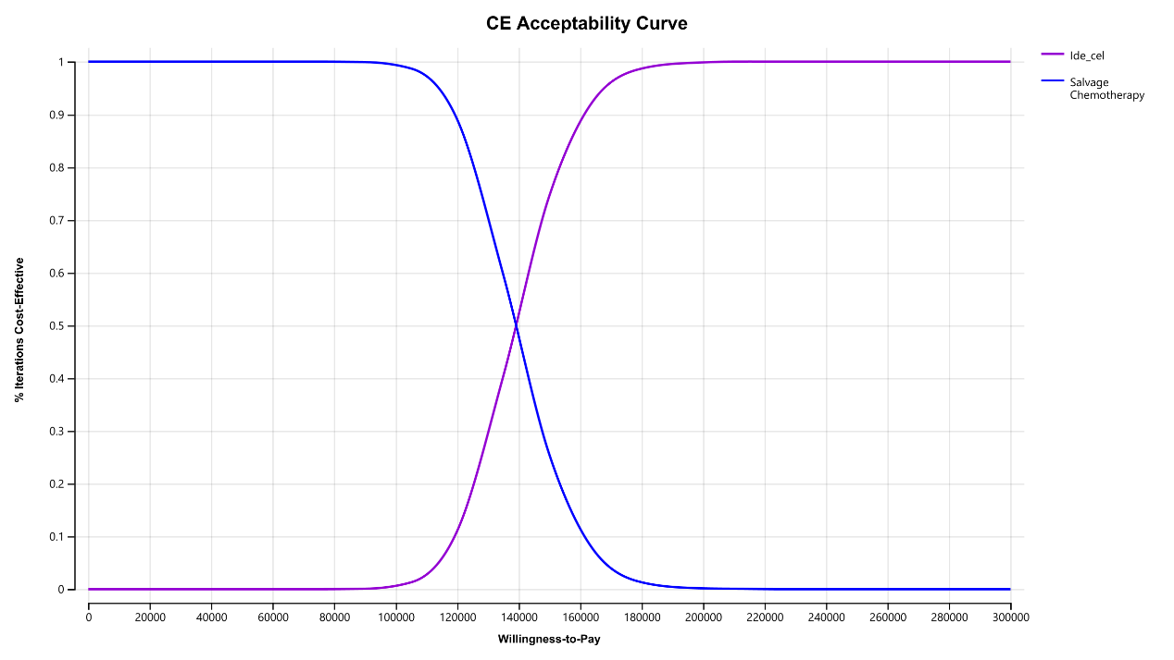
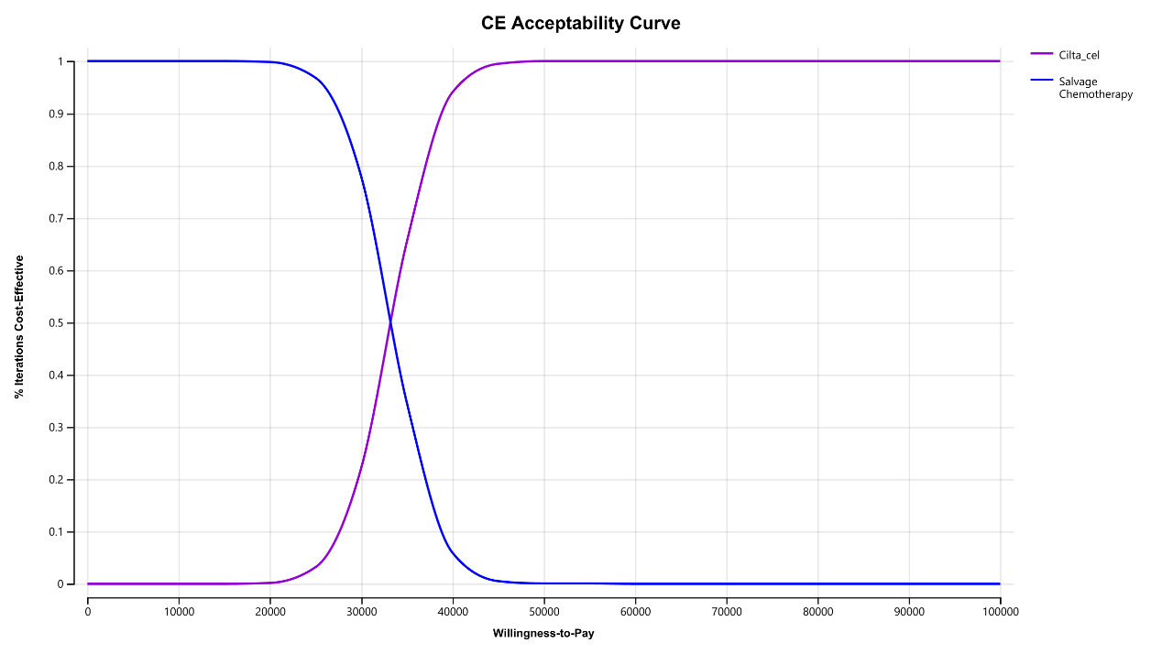
eFigure 2. Cost-effectiveness acceptability Curve

eTable 8. Sensitivity analysis range of input parameters for the tornado diagram
Input parameters | Base-case value | Low entry | High entry
Acquisition cost of CAR-T therapy | 193023 | 20000 | 300000
Acquisition cost Salvage chemotherapy | 11173 | 8938 | 13408
Base cost of CAR-T treatment | 11444 | 9155 | 13733
Cost for second CAR-T treatment | 9740 | 7792 | 11688
Monthly base cost of salvage chemotherapy treatment | 1895 | 1516 | 2274
Monthly cost of salvage chemotherapy after progression | 4253 | 3402 | 5104
Utility of PFS | 0.87 | 0.70 | 1
Utility of PD | 0.72 | 0.58 | 0.86
Utility of Clinical cure | 0.94 | 0.75 | 1
Disutility of Chemotherapy | 0.25 | 0.20 | 0.30
Discount rate per month | 0.0042 | 0 | 0.0067

eTable 9. Distributions for input parameters in probabilistic sensitivity analysis
Model input | Base-case value | Distribution | SD
Proportion of treatment continuation (%)
Ide-cel | 91.4 | Beta | 12.3
Cilta-cel | 85.8 | Beta | 11.2
Probability of CRS (grade 3 or higher) (%)
Ide-cel | 5.5 | Beta | 0.8
Cilta-cel | 5.2 | Beta | 0.8
Probability of Neurotoxicity (grade 3 or higher) (%)
Ide-cel | 3.1 | Beta | 9.2
Cilta-cel | 12.3 | Beta | 13,1
Probability of second CAR-T treatment(%)
Ide-cel | 21.9 | Beta | 2.5
Cilta-cel | 3.1 | Beta | 0.02
SMR | 2.2 | Beta | 0.42
Cost (US $)
Ide-cel | 193023 | Gamma | 5000
Cilta-cel | 193023 | Gamma | 5000
Salvage chemotherapy | 11173 | Gamma | 1465
Base cost during CAR-T treatment | 11444 | Gamma | 5676
Base cost for second CAR-T treatment | 9740 | Gamma | 7274
Monthly base cost during salvage chemotherapy treatment | 1895 | Gamma
Follow-up for CAR-T treatment
First year | 495 | Gamma | 211
First to third year | 250 | Gamma | 123
After third years | 124 | Gamma | 22
CRS | 4364 | Gamma | 2653
Neurotoxicity | 7421 | Gamma | 7623
Total cost for second CAR-T treatment | 9740 | Gamma | 5433
Salvage chemotherapy after progression | 4253 | Gamma | 1465
Palliative therapy | 3039 | Gamma | 2204
Utility
First month for CAR-T treatment | 0.66 | Gamma | 0.79
PFS | 0.82 | Gamma | 0.05
PD | 0.71 | Gamma | 0.06
Clinical cure | 0.94 | Gamma | 0.02
Disutility
Chemotherapy | 0.54 | Gamma | 0.03

References:
- Guyot P, Ades AE, Ouwens MJ, Welton NJ. Enhanced secondary analysis of survival data: reconstructing the data from published Kaplan-Meier survival curves. BMC Med Res Methodol. 2012;12:9.
- Rohatgi A. WebPlot Digitizer, Version 4.0. 2017. https://automeris.io/WebPlot-Digitizer
- Raje NS, Siegel DS, Jagannath S, et al. 3234 Idecabtagene vicleucel (ide-cel, bb2121) in relapsed and refractory multiple myeloma: Analyses of high-risk subgroups in the KarMMa Study. ASH; December 7, 2020, 2020.
- Wang B, Liu J, Zhao W-H, et al. 2304 Chimeric Antigen Receptor T cell therapy in the relapsed or refractory multiple myeloma with extramedullary disease--a single institution observation in China. ASH; December 6, 2020, 2020.
- Clinical trial: Clinical and basic research on BCMA-CAR T cells in the treatment of multiple myeloma, ChiCTR1800017404. http://www.chictr.org.cn/showproj.aspx?proj=28864
- Beinfeld M, Lee S, McQueen B, Fluetsch N, Pearson SD, Ollendorf DA. Anti B-cell maturation antigen CAR T-cell and antibody drug conjugate therapy for heavily pretreated relapsed and refractory multiple myeloma. J Manag Care Spec Pharm. 2021;27(9):1315-1320. doi:10.18553/jmcp.2021.27.9.1315
- Lin JK, Muffly LS, Spinner MA, Barnes JI, Owens DK, Goldhaber-Fiebert JD. Cost Effectiveness of Chimeric Antigen Receptor T-Cell Therapy in Multiply Relapsed or Refractory Adult Large B-Cell Lymphoma. J Clin Oncol. 2019;37(24):2105-2119. doi:10.1200/JCO.18.02079
- Furzer J, Gupta S, Nathan PC, et al. Cost-effectiveness of Tisagenlecleucel vs Standard Care in High-risk Relapsed Pediatric Acute Lymphoblastic Leukemia in Canada. JAMA Oncol. 2020;6(3):393-401. doi:10.1001/jamaoncol.2019.5909
- Luo N, Liu G, Li M, Guan H, Jin X, Rand-Hendriksen K. Estimating an EQ-5D-5L Value Set for China. Value Health. 2017;20(4):662-669. doi:10.1016/j.jval.2016.11.016
- Li X, Liu J, Chen M, et al. Health-related quality of life of patients with multiple myeloma: A real-world study in China. Cancer Med. 2020;9(21):7896-7913. doi:10.1002/cam4.3391
- Yang Z, Busschbach J, Liu G, Luo N. EQ-5D-5L norms for the urban Chinese population in China. Health Qual Life Outcomes. 2018;16(1):210. Published 2018 Nov 8. doi:10.1186/s12955-018-1036-2

