Support Information
Table.S1 The Bioconcentration coefficient (BcF) and transfer coefficient TF of different groups
 | CK | AMF | AMF+BC
BcF | 1.05 | 0.83 | 0.63
TF | 1.04 | 0.90 | 0.55

Table.S1 The α-diversity index of community
Sample | Berger-parker | chao1 | simpson | shannon_e
Blank | 0.0364 | 4525 | 0.00294 | 7.23
Control | 0.0434 | 4582 | 0.00359 | 7.3
AMF+BC | 0.0406 | 5005 | 0.00341 | 7.28
AMF | 0.041 | 4561 | 0.0033 | 7.29
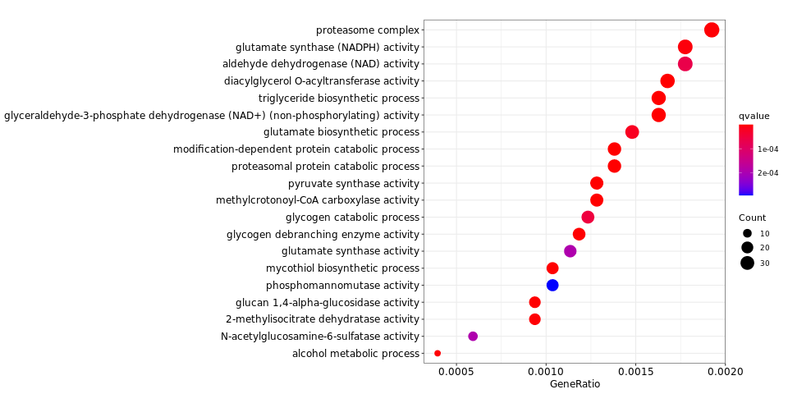
A
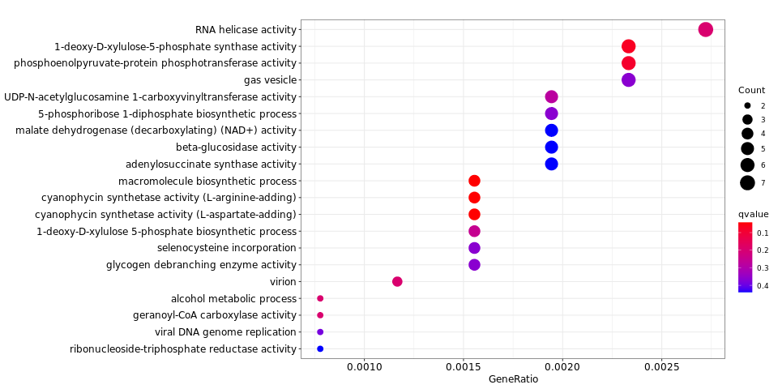
B
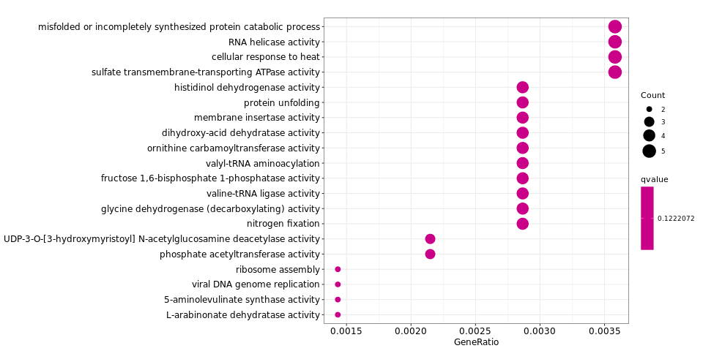
C
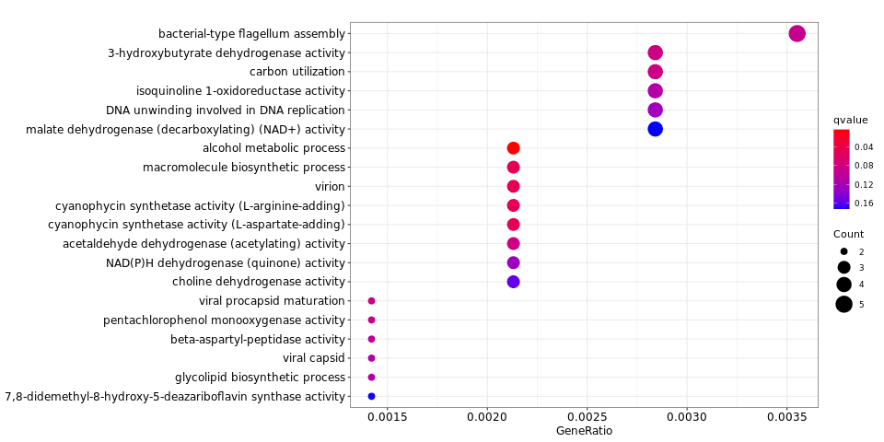
D
Figure.S2 Enrichment bubble diagram of different group
(A: blank to control; B: AMF to control; C: AMF+BC to control; D: AMF+BC to AMF)

