Supplementary Notes

1. The basic model
Let a zero-centered random variable $y$, denotes a phenotype (continuous or dichotomous). Let a $1×m$ component-wise zero-centered random vector, $X$, denotes the genotypes of $m$ SNPs. We suppose a linear regression model between $y$ and $X$ as
 | $$y=Xβ+ε, ε\sim N\left(0, σ_{ε}^{2}\right)$$ | (1)
where $β$ is an $m×1$ vector of the effect sizes and $ε$ is the residual.

Let $S=diag\left(s_{1},…,s_{m}\right)$ be the $m×m$ diagonal matrix of standard deviations of $x_{1},…,x_{m}$ and $R=\left(r_{jk}\right)=\left(r_{1},…,r_{m}\right)$ be the $m×m$ LD matrix of $X$. We have $Var\left(X\right)=SRS$ and the heritability of the phenotype accounting for the $m$ SNPs as
 | $$h_{g}^{2}=\frac{Var\left(Xβ\right)}{Var\left(y\right)}=\frac{β^{T}SRSβ}{σ_{y}^{2}}=\frac{σ_{g}^{2}}{σ_{g}^{2}+σ_{ε}^{2}}$$ | (2)
where $σ_{g}^{2}$ and $σ_{y}^{2}$ denotes the variance of the genetic component and the variance of phenotype respectively.

When studying a simple random sample of size $n$, according to (1), we have
 | $$y=Xβ+ε, ε\sim N\left(0_{n},{ I}_{n}σ_{ε}^{2}\right)$$ | (3)
where $y$ is the $n×1$ vector of the sample from $y$, $X=\left(x_{1},…,x_{m}\right)$ is the $n×m$ matrix of the sample from $x$, and $ε$ is the $n×1$ vector of the residuals. We note here that, unbold $y$ and $X=\left(x_{1},…,x_{m}\right)$ denote the population, while bold $y$ and $X=\left(x_{1},…,x_{m}\right)$ denote the sample. The components of $y$ and $y$ are i.i.d. random variables, and the row components of $X$ and $X$ are i.i.d. random vectors.

In a GWAS, the marginal linear regression model for the j-th SNP is:
$$y=b_{j}x_{j}+e_{j}, e_{j}\sim N\left(0_{n}, { I}_{n}σ_{e_{j}}^{2}\right)$$ | (4)
where $b_{j}$ and $e_{j}$ are the marginal effect and the vector of residuals respectively.

The least square estimate of $b_{j}$ and its variance are
$${\hat{b}}_{j}=\frac{x_{j}^{T}y}{x_{j}^{T}x_{j}}, Var\left({\hat{b}}_{j}\right)=\frac{σ_{e_{j}}^{2}}{x_{j}^{T}x_{j}}$$
According to the law of large numbers, $x_{j}^{T}x_{j}\underset{→}{p}ns_{j}^{2}$ as $n→∞$. Thus,
$${\hat{b}}_{j}≈\frac{x_{j}^{T}y}{ns_{j}^{2}}, Var\left({\hat{b}}_{j}\right)≈\frac{σ_{e_{j}}^{2}}{ns_{j}^{2}}$$
Then, since ${\hat{b}}_{j}$ is an unbiased estimator of $b_{j}$, according to (3), we have
$$b_{j}=E\left({\hat{b}}_{j}\right)≈\frac{E\left(x_{j}^{T}y\right)}{ns_{j}^{2}}=\frac{E\left(x_{j}^{T}Xβ\right)+E\left(x_{j}^{T}ε\right)}{ns_{j}^{2}}=\frac{E\left(x_{j}^{T}X\right)β}{ns_{j}^{2}} \\ =\frac{E\left(\left[\begin{matrix}x_{j}^{T}x_{1} & ⋯ & x_{j}^{T}x_{m}\end{matrix}\right]\right)β}{ns_{j}^{2}}=\frac{\left[\begin{matrix}r_{j1}s_{j}s_{1} & ⋯ & r_{jm}s_{j}s_{m}\end{matrix}\right]β}{s_{j}^{2}}=\frac{r_{j}^{T}Sβ}{s_{j}}$$When $m$ is large, and the marginal effect of one SNP is small, we have $σ_{e_{j}}^{2}≈σ_{y}^{2}$. Thus,
$$Var\left({\hat{b}}_{j}\right)≈\frac{σ_{e_{j}}^{2}}{ns_{j}^{2}}≈\frac{σ_{y}^{2}}{ns_{j}^{2}}$$
Thus, according to (4), we can approximate that
$${\hat{b}}_{j}\sim N\left(b_{j},\frac{σ_{y}^{2}}{ns_{j}^{2}}\right), b_{j}=\frac{r_{j}^{T}Sβ}{s_{j}}$$
Thus, let the Z-score of ${\hat{b}}_{j}$ follows a normal distribution with a unit variance:
$$z_{j}=\frac{{\hat{b}}_{j}}{SD\left({\hat{b}}_{j}\right)}=\frac{\sqrt{n}s_{j}{\hat{b}}_{j}}{σ_{y}}\sim N\left(\frac{\sqrt{n}}{σ_{y}}r_{j}^{T}Sβ,1\right)$$
And thus, $z_{j}^{2}$ follows a noncentral chi-squared distribution with one degree of freedom:
 | $$z_{j}^{2}\sim {χ^{'}}_{1}^{2}\left(λ_{j}\right), λ_{j}={\left[E\left(z_{j}\right)\right]}^{2}=\frac{ns_{j}^{2}b_{j}^{2}}{σ_{y}^{2}}=\frac{n}{σ_{y}^{2}}{\left(r_{j}^{T}Sβ\right)}^{2}$$ | (5)
where $λ_{j}$ denotes the noncentrality parameter. When all SNPs that are correlated with SNP-j have no effect, we have $λ_{j}=0$ and $z_{j}^{2}$ follows a chi-squared distribution with one degree of freedom.

2. The EHE
Let $V_{g_{j}}$ denotes the marginal heritability of the j-th SNP, according to (5), we have
$$V_{g_{j}}=\frac{Var\left(b_{j}x_{j}\right)}{Var\left(y\right)}=\frac{b_{j}^{2}s_{j}^{2}}{σ_{y}^{2}}=\frac{λ_{j}}{n}=\frac{E\left(z_{j}^{2}\right)-1}{n}$$
Thus, ${\hat{V}}_{g_{j}}={\left(z_{j}^{2}-1\right)}/n$ is an estimator of $V_{g_{j}}$. The summation of these marginal heritability estimates of all $m$ SNPs in a genomic region would be an overestimate of the regional heritability due to LD. Thus, we propose the Effective Heritability Estimator (EHE) of the heritability by applying a linear transformation of the marginal heritability to remove the LD-induced redundancy. Denote the matrix of the squared correlation coefficients of the $m$ SNPs by $Ω={\left(r_{jk}^{2}\right)}_{m×m}$ and EHE of this region is
 | $$H=1_{m}^{T}Ω^{-1}{\hat{V}}_{g}, {\hat{V}}_{g}={\left({\hat{V}}_{g_{1}},…,{\hat{V}}_{g_{m}}\right)}^{T}$$ | (6)

Then, we consider the expectation of EHE.
Proposition. A sufficient condition for EHE to be an unbiased estimate is that
for $∀i,j,k∈\left\{ i,j,k | j≠k, β_{j}≠0, β_{k}≠0\right\}$ we have $r_{jk}=0$ and $r_{ij}r_{ik}=0$.
This mathematical condition means that the true causal SNPs are independent mutually.

Proof. Let $Υ_{j}=diag\left(r_{j1}^{2},r_{j2}^{2},…,r_{jm}^{2}\right)$. We have
$$σ_{y}^{2}\left(E\left(H\right)-h_{g}^{2}\right)=1_{m}^{T}Ω^{-1}\left[\begin{matrix}β^{T}Sr_{1}^{T}r_{1}Sβ \\ ⋮ \\ β^{T}Sr_{m}^{T}r_{m}Sβ\end{matrix}\right]-β^{T}SRSβ \\ =1_{m}^{T}Ω^{-1}\left[\begin{matrix}β^{T}SΥ_{1}Sβ \\ ⋮ \\ β^{T}SΥ_{m}Sβ\end{matrix}\right]+1_{m}^{T}Ω^{-1}\left[\begin{matrix}β^{T}S\left(r_{1}^{T}r_{1}-Υ_{1}\right)Sβ \\ ⋮ \\ β^{T}S\left(r_{m}^{T}r_{m}-Υ_{m}\right)Sβ\end{matrix}\right]-β^{T}SISβ-β^{T}S\left(R-I\right)Sβ \\ =1_{m}^{T}Ω^{-1}Ω\left[\begin{matrix}β_{1}^{2}s_{1}^{2} \\ ⋮ \\ β_{m}^{2}s_{m}^{2}\end{matrix}\right]+1_{m}^{T}Ω^{-1}\sum_{j,k;j≠k}{\left[\begin{matrix}r_{1j}r_{1k}β_{j}β_{k}s_{j}s_{k} \\ ⋮ \\ r_{mj}r_{mk}β_{j}β_{k}s_{j}s_{k}\end{matrix}\right]}-1^{T}\left[\begin{matrix}β_{1}^{2}s_{1}^{2} \\ ⋮ \\ β_{m}^{2}s_{m}^{2}\end{matrix}\right]-\sum_{j,k;j≠k}{r_{jk}β_{j}β_{k}s_{j}s_{k}} \\ =1_{m}^{T}Ω^{-1}\sum_{j,k;j≠k}{\left[\begin{matrix}r_{1j}r_{1k}β_{j}β_{k}s_{j}s_{k} \\ ⋮ \\ r_{mj}r_{mk}β_{j}β_{k}s_{j}s_{k}\end{matrix}\right]}-\sum_{j,k;j≠k}{r_{jk}β_{j}β_{k}s_{j}s_{k}}$$
It is obvious that for $∀i,j,k∈\left\{ i,j,k | j≠k, β_{j}≠0, β_{k}≠0\right\}$, if $r_{jk}=0$ and $r_{ij}r_{ik}=0$, we have
$$\sum_{j,k;j≠k}{r_{ij}r_{ik}β_{j}β_{k}s_{j}s_{k}}=0 and \sum_{j,k;j≠k}{r_{jk}β_{j}β_{k}s_{j}s_{k}}=0$$
and thus we have $E\left(H\right)=h_{g}^{2}$, i.e., EHE is unbiased. ∎

Then, we consider the variance of EHE.
Let $v={\left(z_{1}^{2},…,z_{m}^{2}\right)}^{T}$ and let$D=diag\left(SD\left(z_{1}^{2}\right),…, SD\left(z_{m}^{2}\right)\right)$. We have
 | $$Var\left(H\right)=Var\left(1_{m}^{T}Ω^{-1}{\hat{V}}_{g}\right)=\frac{1}{n^{2}}1_{m}^{T}Ω^{-1}Var\left(v\right)Ω^{-1}1_{m}=\frac{1}{n^{2}}1_{m}^{T}Ω^{-1}DΡDΩ^{-1}1_{m}$$ | (7)
where $Ρ=\left(Corr\left[z_{j}^{2},z_{k}^{2}\right]\right)$ is the correlation coefficient matrix of $v$. According to Li et al. (2022), in a large sample, when either SNP-j or SNP-k has an effect, there is $Corr\left(z_{j}^{2},z_{k}^{2}\right)≈\left|r_{jk}\right|$; and it is $Corr\left(z_{j}^{2},z_{k}^{2}\right)≈r_{jk}^{2}$ when both of them have no effect and are not in LD with any causal SNP. Therefore, when the association p-value (by ECS) of an LD block is <0.05, we set the correlation as $\left|r_{jk}\right|$, or as $r_{jk}^{2}$ otherwise. Let
$$\hat{D}=diag\left(\hat{SD}\left(z_{1}^{2}\right),…, \hat{SD}\left(z_{m}^{2}\right)\right), \hat{SD}\left(z_{j}^{2}\right)=\sqrt{4z_{j}^{2}-2}$$
According to (5), we have
$$E\left({\left[\hat{SD}\left(z_{j}^{2}\right)\right]}^{2}\right)=4E\left(z_{j}^{2}\right)-2=4λ_{j}+2=Var\left(z_{j}^{2}\right)$$
Thus,
$$E\left(\hat{D}\right)=D$$
Thus, we have an estimator of $Var\left(H\right)$ as
$$\hat{Var}\left(H\right)=\frac{1}{n^{2}}1_{m}^{T}Ω^{-1}\hat{D}Ρ\hat{D}Ω^{-1}1_{m}$$

When the phenotype is dichotomous, the squared Z-scores are calculated from linear regressions or logistic regressions. Weissbrod et al. (2018) proved (in Supplemental Data) that when $n$ is large and the effect size of a SNP is small, the Z-score calculated based on a logistic regression approximately equals the Z-score calculated based on linear regression. Thus, for a dichotomous trait, we can assume that Z-scores are from linear regressions. Then, according to the equation (23) of Lee et al. (2011), we can convert the EHE of a binary trait to the liability scale as
$$H_{l}=tH, t=\frac{{\left(K\left(1-K\right)\right)}^{2}}{{\left(φ\left(Φ^{-1}\left(K\right)\right)\right)}^{2}P(1-P)}$$
where $K$ and$P$ are the frequency of affected individuals in the population and the sample respectively; $φ\left(∙\right)$ and $Φ\left(∙\right)$ denote the probability density function and the cumulative distribution of the standard normal distribution respectively. Ignoring the uncertainty from $K$, we have the variance of $H_{l}$ estimated as
$$\hat{Var}\left(H_{l}\right)=t^{2}\hat{Var}\left(H\right)$$

3. The conditional EHE
When multiple genes are in one LD block, the heritability of causal SNPs with the LD block may be detected by many genes. Therefore, we propose a conditional analysis among the proximal regions by EHE. The conditional heritability of $M$ genes is estimated iteratively from the most to the least significant genes:
$$\left\{\begin{aligned}\begin{aligned}H_{\left(1\right)}=H_{\left(1\right)} \\ H_{(2|1)}=H_{(1,2)}-H_{(1)} \\ …\end{aligned} \\ H_{(M|1,2,…,M-1)}=H_{(1,2,…,M-1,M)}-H_{(1,2,…,M-1)}\end{aligned}\right.$$
where $H_{\left(1\right)}$ is the estimated heritability of the most significant gene, $H_{(1,2)}$is the estimated heritability of the most and the second most significant genes when merged in a single region, $H_{(2|1)}$ is the heritability of the second most significant gene conditioning on the most significant region, and so on. The rank of genes can also be determined by the gene scores calculated by DESE according to third-party functional annotations of genes (Jiang et al., 2019). The variance of conditional EHE is given by
$$Var\left(H_{\left(B|A\right)}\right)=Var\left(H_{\left(A,B\right)}-H_{\left(A\right)}\right)=Var\left(H_{\left(A,B\right)}\right)+Var\left(H_{\left(A\right)}\right)-2Cov\left(H_{\left(A,B\right)},H_{\left(A\right)}\right)$$
where the variance of EHE for a single group of SNPs is given by (7). The covariance between EHE of SNPs in genes $A$ and $B$ is
$$Cov\left(H_{A},H_{B}\right)=Cov\left(\frac{1}{n}1^{T}Ω_{A}^{-1}\left(v_{A}-1\right),\frac{1}{n}1^{T}Ω_{B}^{-1}\left(v_{B}-1\right)\right) \\ =\frac{1}{n^{2}}Cov\left(1^{T}Ω_{A}^{-1}v_{A},1^{T}Ω_{B}^{-1}v_{B}\right)=\frac{1}{n^{2}}1^{T}Ω_{A}^{-1}Cov\left(v_{A},v_{B}\right)Ω_{B}^{-1}1$$
where $v_{A}$ and $v_{B}$ are the vectors of chi-squared statistics of SNPs in genes $A$ and $B$ respectively, and $Ω_{A}$ and $Ω_{B}$ are the corresponding matrices of squared LD coefficients.

4. The expectation of EHE when $β$ is considered as random effects
If we consider $β$ as a random vector with $E\left(β\right)=0$ and $Var\left(β\right)=Iσ_{β}^{2}$, according to (1) and according to the expectation of random vector's quadratic form, via the law of total variance, we have
$$σ_{g}^{2}=Var\left(Xβ\right)=E\left(Var\left(Xβ|β\right)\right)+Var\left(E\left(Xβ|β\right)\right) \\ =E\left(β^{T}Var\left(X\right)β\right)+Var\left(E\left(X\right)β\right)=tr\left(Var\left(X\right)σ_{β}^{2}\right)=σ_{β}^{2}tr\left(S^{2}\right)$$
Then, we have the heritability of the phenotype accounting for the $m$ SNPs under the random effect model as
 | $$h_{g}^{2}=\frac{Var\left(Xβ\right)}{Var\left(y\right)}=\frac{σ_{g}^{2}}{σ_{y}^{2}}=\frac{σ_{β}^{2}}{σ_{y}^{2}}tr\left(S^{2}\right)$$ | (8)

In the following, we derive the expectation of the chi-squared statistic of an SNP under the random effect model. To derive $E\left(z_{j}^{2}\right)$, we have to derive $E\left({\left[x_{j}^{T}x_{k}\right]}^{2}\right)$ first. According to (1), we have
$$E\left(x_{j}x_{k}\right)=Cov\left(x_{j},x_{k}\right)=r_{jk}s_{j}s_{k}$$
According to the covariance of two correlated chi-squared variables in Li et al. (2019), if we assume $\left[\begin{matrix}x_{j} \\ x_{k}\end{matrix}\right]\sim N\left(\left[\begin{matrix}0 \\ 0\end{matrix}\right],\left[\begin{matrix}s_{j}^{2} & r_{jk}s_{j}s_{k} \\ r_{jk}s_{j}s_{k} & s_{k}^{2}\end{matrix}\right]\right)$, we have $Cov\left(x_{j}^{2},x_{k}^{2}\right)=2r_{jk}^{2}s_{j}^{2}s_{k}^{2}$. Thus,
$$Var\left(x_{j}x_{k}\right)=E\left(x_{j}^{2}x_{k}^{2}\right)-{\left[E\left(x_{j}x_{k}\right)\right]}^{2} \\ =E\left(x_{j}^{2}\right)E\left(x_{k}^{2}\right)+Cov\left(x_{j}^{2},x_{k}^{2}\right)-r_{jk}^{2}s_{j}^{2}s_{k}^{2} \\ =s_{j}^{2}s_{k}^{2}+2r_{jk}^{2}s_{j}^{2}s_{k}^{2}-r_{jk}^{2}s_{j}^{2}s_{k}^{2}=s_{j}^{2}s_{k}^{2}\left(1+r_{jk}^{2}\right)$$
Since the row components of $\left(x_{j}, x_{k}\right)$ and $\left(x_{j}, x_{k}\right)$ are i.i.d. random vectors, we have
$$E\left(x_{j}^{T}x_{k}\right)=nE\left(x_{j}x_{k}\right)=nr_{jk}s_{j}s_{k}$$
$$Var\left(x_{j}^{T}x_{k}\right)=n^{2}Var\left(x_{j}x_{k}\right)=ns_{j}^{2}s_{k}^{2}\left(1+r_{jk}^{2}\right)$$
Thus,
$$E\left({\left[x_{j}^{T}x_{k}\right]}^{2}\right)={\left[E\left(x_{j}^{T}x_{k}\right)\right]}^{2}+Var\left(x_{j}^{T}x_{k}\right)=n^{2}r_{jk}^{2}s_{j}^{2}s_{k}^{2}+ns_{j}^{2}s_{k}^{2}\left(1+r_{jk}^{2}\right)=n^{2}s_{j}^{2}\left(r_{jk}^{2}s_{k}^{2}+\frac{s_{k}^{2}+r_{jk}^{2}s_{k}^{2}}{n}\right)$$
Then, we derive $E\left(z_{j}^{2}\right)$ as
$$E\left(z_{j}^{2}\right)=\frac{E\left({\hat{b}}_{j}^{2}\right)}{Var\left({\hat{b}}_{j}\right)}=\frac{E\left(x_{j}^{T}yy^{T}x_{j}\right)}{ns_{j}^{2}σ_{y}^{2}}=\frac{E\left(E\left(x_{j}^{T}yy^{T}x_{j}|X\right)\right)}{ns_{j}^{2}σ_{y}^{2}} \\ =\frac{E\left(x_{j}^{T}Var\left(y|X\right)x_{j}\right)}{ns_{j}^{2}σ_{y}^{2}}=\frac{E\left(x_{j}^{T}Var\left(Xβ|X\right)x_{j}\right)+E\left(x_{j}^{T}Var\left(ε|X\right)x_{j}\right)}{ns_{j}^{2}σ_{y}^{2}} \\ =\frac{E\left(x_{j}^{T}Xσ_{β}^{2}X^{T}x_{j}\right)+E\left(x_{j}^{T}σ_{ε}^{2}x_{j}\right)}{ns_{j}^{2}σ_{y}^{2}}=\frac{σ_{β}^{2}E\left(\sum_{k=1}^{m}{x_{j}^{T}x_{k}x_{k}^{T}x_{j}}\right)+nσ_{ε}^{2}s_{j}^{2}}{ns_{j}^{2}σ_{y}^{2}} \\ =\frac{σ_{β}^{2}\sum_{k=1}^{m}{E\left({\left[x_{j}^{T}x_{k}\right]}^{2}\right)}+nσ_{ε}^{2}s_{j}^{2}}{ns_{j}^{2}σ_{y}^{2}}=\frac{n^{2}s_{j}^{2}σ_{β}^{2}\sum_{k=1}^{m}{\left(r_{jk}^{2}s_{k}^{2}+\frac{s_{k}^{2}+r_{jk}^{2}s_{k}^{2}}{n}\right)}+nσ_{ε}^{2}s_{j}^{2}}{ns_{j}^{2}σ_{y}^{2}} \\ =\frac{nσ_{β}^{2}\left(1+\frac{1}{n}\right)\sum_{k=1}^{m}{r_{jk}^{2}s_{k}^{2}}+σ_{β}^{2}\sum_{k=1}^{m}{s_{k}^{2}}+σ_{ε}^{2}}{σ_{y}^{2}}=\frac{nσ_{β}^{2}\left(1+\frac{1}{n}\right)\left[\begin{matrix}r_{j1}^{2} & ⋯ & r_{jm}^{2}\end{matrix}\right]S^{2}1_{m}+σ_{β}^{2}tr\left(S^{2}\right)+σ_{ε}^{2}}{σ_{y}^{2}}$$
According to (8), we have $σ_{β}^{2}tr\left(S^{2}\right)+σ_{ε}^{2}=σ_{g}^{2}+σ_{ε}^{2}=σ_{y}^{2}$ and $\frac{σ_{β}^{2}}{σ_{y}^{2}}=\frac{h_{g}^{2}}{tr\left(S^{2}\right)}$. Thus,
$$E\left(z_{j}^{2}\right)=\frac{nσ_{β}^{2}\left(1+\frac{1}{n}\right)\left[\begin{matrix}r_{j1}^{2} & ⋯ & r_{jm}^{2}\end{matrix}\right]S^{2}1_{m}+σ_{y}^{2}}{σ_{y}^{2}}=\frac{nh_{g}^{2}\left(1+\frac{1}{n}\right)\left[\begin{matrix}r_{j1}^{2} & ⋯ & r_{jm}^{2}\end{matrix}\right]S^{2}1_{m}}{tr\left(S^{2}\right)}+1$$
When $n$ is large, we have $1+\frac{1}{n}≈1$. Thus,
 | $$E\left(z_{j}^{2}\right)≈\frac{nh_{g}^{2}\left[\begin{matrix}r_{j1}^{2} & ⋯ & r_{jm}^{2}\end{matrix}\right]S^{2}1_{m}}{tr\left(S^{2}\right)}+1$$ | (9)
Then, according to (6), (8), and (9), we have the expectation of EHE as
$$E\left(H\right)=\frac{1}{n}1_{m}^{T}Ω^{-1}E\left(v-1_{m}\right)≈\frac{h_{g}^{2}}{tr\left(S^{2}\right)}1_{m}^{T}Ω^{-1}ΩS^{2}1_{m}=h_{g}^{2}$$
When genotypes are standardized, we have $S^{2}=I$. According to (9), we have
$$E\left(z_{j}^{2}\right)≈\frac{nh_{g}^{2}\left[\begin{matrix}r_{j1}^{2} & ⋯ & r_{jm}^{2}\end{matrix}\right]1_{m}}{m}+1$$
This is the regression model of LDSC (Bulik-Sullivan et al., 2015).

5. Formula of fourth methods estimating heritability

LDSC (Bulik-Sullivan et al., 2015)
Let $Ω=\left(r_{jk}^{2}\right)$ be the matrix of squared LD coefficients. Let $v={\left(z_{1}^{2},…,z_{m}^{2}\right)}^{T}$. The diagonal elements of (8) is
 | $$E\left(v\right)≈\frac{nh_{g}^{2}}{m}Ω1+1$$ | (9)
Let $T=Var\left(v\right)$. The generalized least square estimate of $h_{g}^{2}$ is
$${\hat{h}}_{LDSC}^{2}=\frac{m1^{T}ΩT^{-1}\left(v-1\right)}{n1^{T}ΩT^{-1}Ω1}$$

LDER (Song et al., 2022)
Let the eigen decompensation of $R=UΛU^{T}$. Let $\tilde{z}=Λ^{-\frac{1}{2}}U^{T}z$. According to (8), we have
$$Var\left(\tilde{z}\right)=E\left(\tilde{z}{\tilde{z}}^{T}\right)=E\left(Λ^{-\frac{1}{2}}U^{T}zz^{T}UΛ^{-\frac{1}{2}}\right)≈\frac{nh_{g}^{2}}{m}Λ^{-\frac{1}{2}}U^{T}RRUΛ^{-\frac{1}{2}}+Λ^{-\frac{1}{2}}U^{T}RUΛ^{-\frac{1}{2}}=\frac{nh_{g}^{2}}{m}Λ+I$$
Let $\tilde{v}={\left({\tilde{z}}_{1}^{2},…,{\tilde{z}}_{m}^{2}\right)}^{T}$ be the column vector of the diagonal elements of $\tilde{z}{\tilde{z}}^{T}$, we have
 | $$E\left(\tilde{v}\right)≈\frac{nh_{g}^{2}}{m}Λ1+1$$ | (10)
where $\tilde{v}={\left({\tilde{z}}_{1}^{2},…,{\tilde{z}}_{m}^{2}\right)}^{T}$ is the column vector of the diagonal elements of $\tilde{z}{\tilde{z}}^{T}$. Let
$$\tilde{T}=Var\left(\tilde{v}\right)=diag\left(2{\left[\frac{nh_{g}^{2}Λ_{11}}{m}+1\right]}^{2},…, 2{\left[\frac{nh_{g}^{2}Λ_{mm}}{m}+1\right]}^{2}\right)$$
The weighted least square estimate of $h_{g}^{2}$ is
$${\hat{h}}_{LDER}^{2}=\frac{m1^{T}Λ{\tilde{T}}^{-1}\left(\tilde{v}-1\right)}{n1^{T}Λ{\tilde{T}}^{-1}Λ1}$$

EHE
We propose the effective heritability estimator (EHE) as
 | $$H=\frac{1}{n}1^{T}Ω^{-1}\left(v-1\right)$$ | (11)
According to (9), we have
 | $$E\left(H\right)=\frac{1}{n}1^{T}Ω^{-1}E\left(v-1\right)≈\frac{h_{g}^{2}}{m}1^{T}Ω^{-1}Ω1=h_{g}^{2}$$ | (12)

HESS (Shi et al., 2016)
Let
$${\hat{h}}_{HESS}^{2}=\frac{z^{T}R^{-1}z-m}{n}$$
Under random effect model, according to (7), we have
$$E\left(z^{T}R^{-1}z\right)=tr\left(R^{-1}R\right)+E\left(z^{T}\right)R^{-1}E\left(z\right)=m+0_{m}^{T}R^{-1}0_{m}=m$$
Then,
$$E\left({\hat{h}}_{HESS}^{2}\right)=\frac{E\left(z^{T}R^{-1}z\right)-m}{n}=0$$

If we assume $β$ as fixed effect, we have
$$E\left({\hat{b}}_{j}\right)=\frac{E\left(x_{j}^{T}y\right)}{n}=\frac{E\left(E\left(x_{j}^{T}y|X\right)\right)}{n}=\frac{E\left(x_{j}^{T}Xβ\right)}{n}=\left[\begin{matrix}r_{j1} & ⋯ & r_{jm}\end{matrix}\right]β=r_{j}^{T}β$$
According to (6), we have
$$E\left(z_{j}\right)=\sqrt{n}r_{j}^{T}β$$
Thus,
$$E\left(z^{T}R^{-1}z\right)=tr\left(R^{-1}R\right)+E\left(z^{T}\right)R^{-1}E\left(z\right)=m+nβ^{T}Rβ=m+nh_{g}^{2}$$
Then,
$$E\left({\hat{h}}_{HESS}^{2}\right)=\frac{E\left(z^{T}R^{-1}z\right)-m}{n}=h_{g}^{2}$$

Reference
Bulik-Sullivan, B.K., Loh, P.-R., Finucane, H.K., Ripke, S., Yang, J., Patterson, N., Daly, M.J., Price, A.L., and Neale, B.M. (2015). LD Score regression distinguishes confounding from polygenicity in genome-wide association studies. Nat Genet 47, 291-295. 10.1038/ng.3211.
Jiang, L., Xue, C., Dai, S., Chen, S., Chen, P., Sham, P.C., Wang, H., and Li, M. (2019). DESE: estimating driver tissues by selective expression of genes associated with complex diseases or traits. Genome Biol 20, 233. 10.1186/s13059-019-1801-5.
Lee, S.H., Wray, N.R., Goddard, M.E., and Visscher, P.M. (2011). Estimating missing heritability for disease from genome-wide association studies. Am J Hum Genet 88, 294-305. 10.1016/j.ajhg.2011.02.002.
Li, M., Jiang, L., Mak, T.S.H., Kwan, J.S.H., Xue, C., Chen, P., Leung, H.C., Cui, L., Li, T., and Sham, P.C. (2019). A powerful conditional gene-based association approach implicated functionally important genes for schizophrenia. Bioinformatics 35, 628-635. 10.1093/bioinformatics/bty682.
Li, X., Jiang, L., Xue, C., Li, M.J., and Li, M. (2022). A conditional gene-based association framework integrating isoform-level eQTL data reveals new susceptibility genes for schizophrenia. Elife 11. 10.7554/eLife.70779.
Weissbrod, O., Flint, J., and Rosset, S. (2018). Estimating SNP-Based Heritability and Genetic Correlation in Case-Control Studies Directly and with Summary Statistics. Am J Hum Genet 103, 89-99. 10.1016/j.ajhg.2018.06.002.

Suplementary Figures
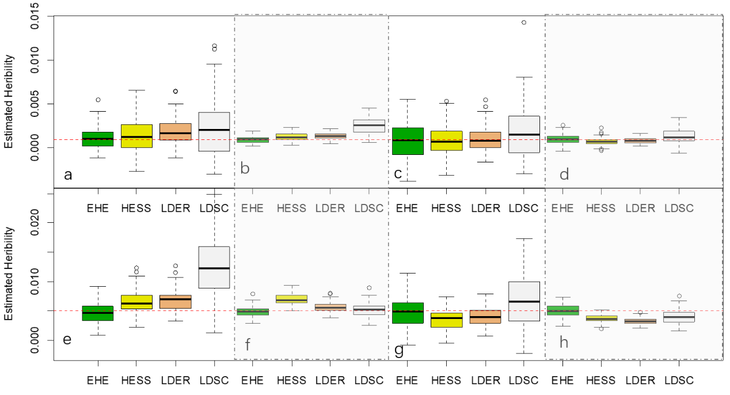
Figure S1：the boxplots of estimated heritability when there were 3 independent QTLs. The first and second column plots a),b), e), f) for binary traits; the third and fourth column plots c), d), g), h) for continuous traits; the first and third column plots for samples of size 10000; the second and fourth column plots for samples of size 50000; the first and second row plots for a region with 1000 SNPs; the first row plots for true heritability 1‰; the second row plots for true heritability 5‰. The red dashed lines mark the true heritability. Three independent QTLs were set for the continuous and liability traits.

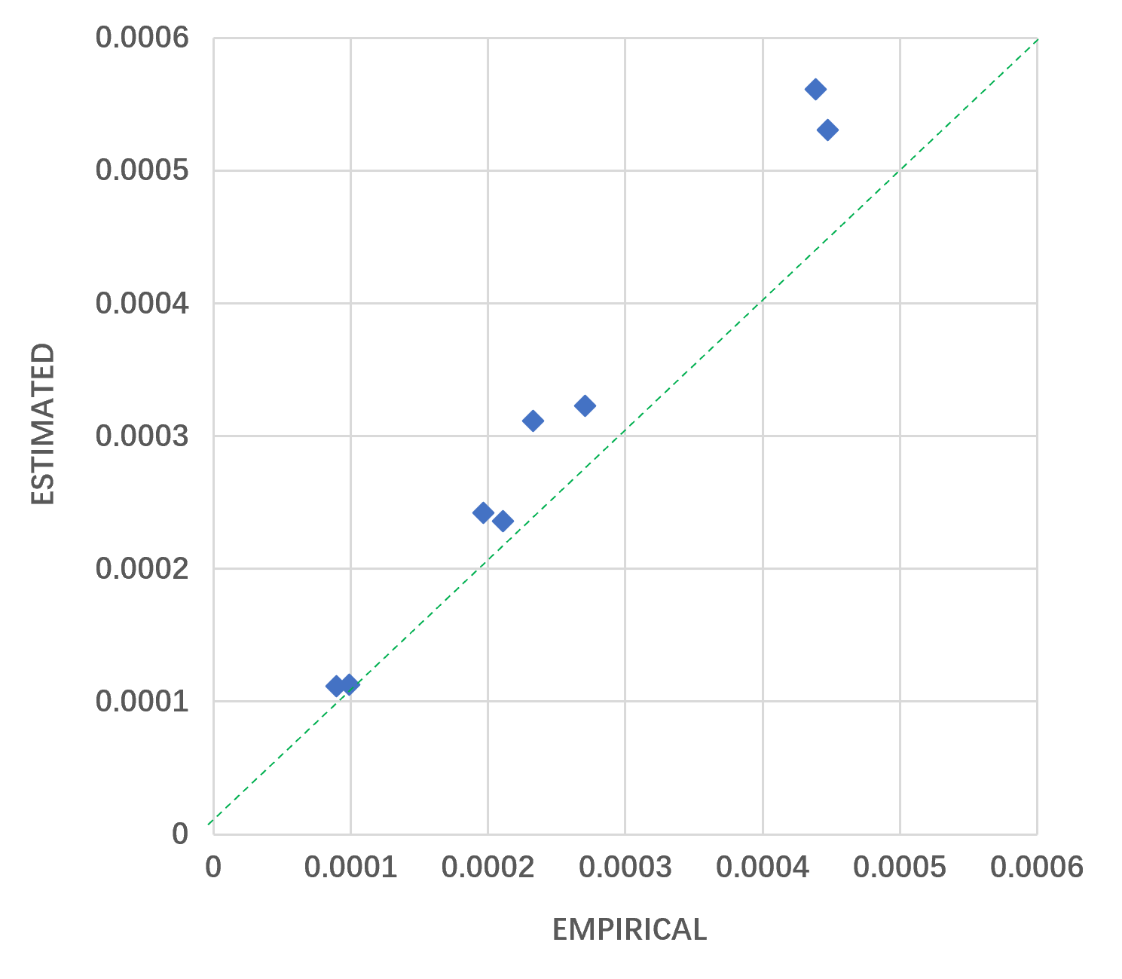

Figure S2: Scatter plot of approximated and empirical standard errors of conditional heritability in a half LD block without true causal SNPs. Each dot denotes the standard error of the estimate in scenarios of Figure X.

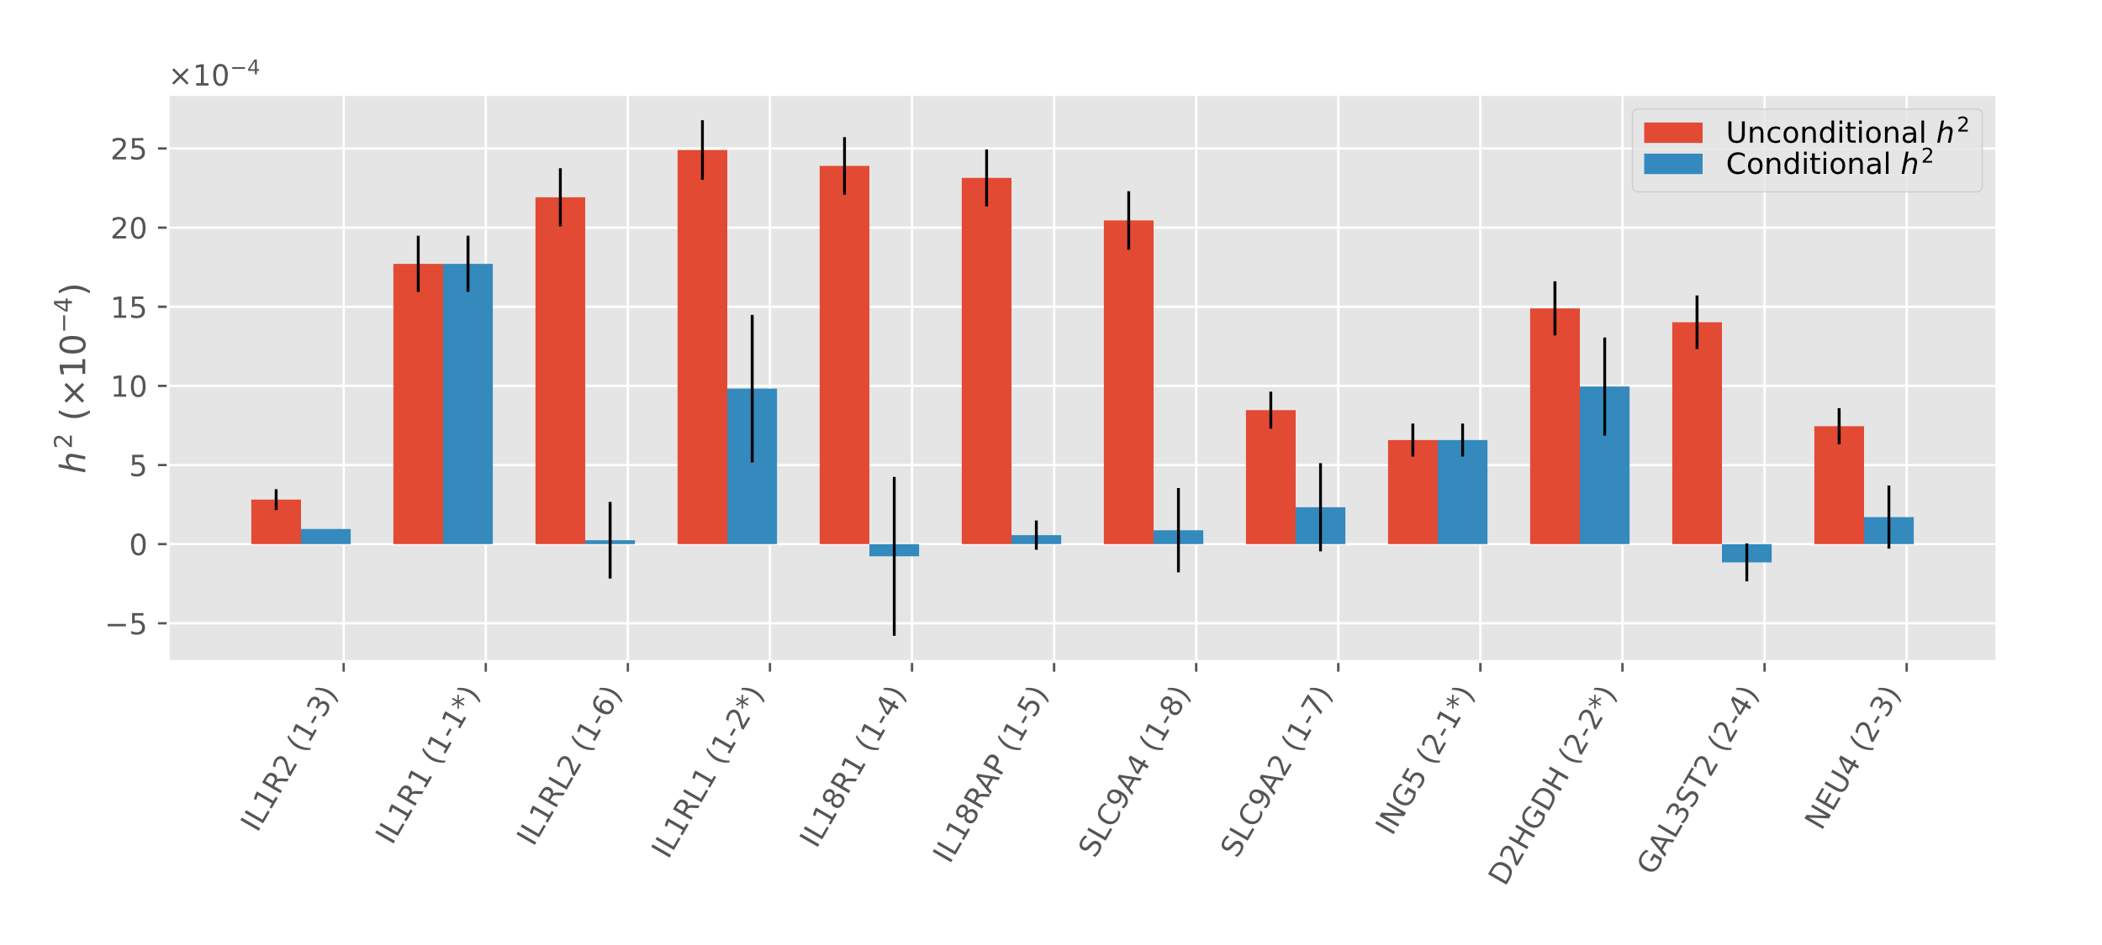
Figure S3. Unconditional and conditional heritability of asthma for protein-coding genes with unconditional ECS p<2.5E-6 on chromosome 2. Genes are ordered by coordinates. The error bars show standard errors. For each x-tick label, there are two numbers in parentheses after the gene symbol. The first one is the group number and the second one is the descending rank of the tissue selectivity score. An asterisk after the second number indicates that the cECS p<2.5E-6. For each gene group, the first gene in the ranking has equal values of unconditional and conditional heritability.

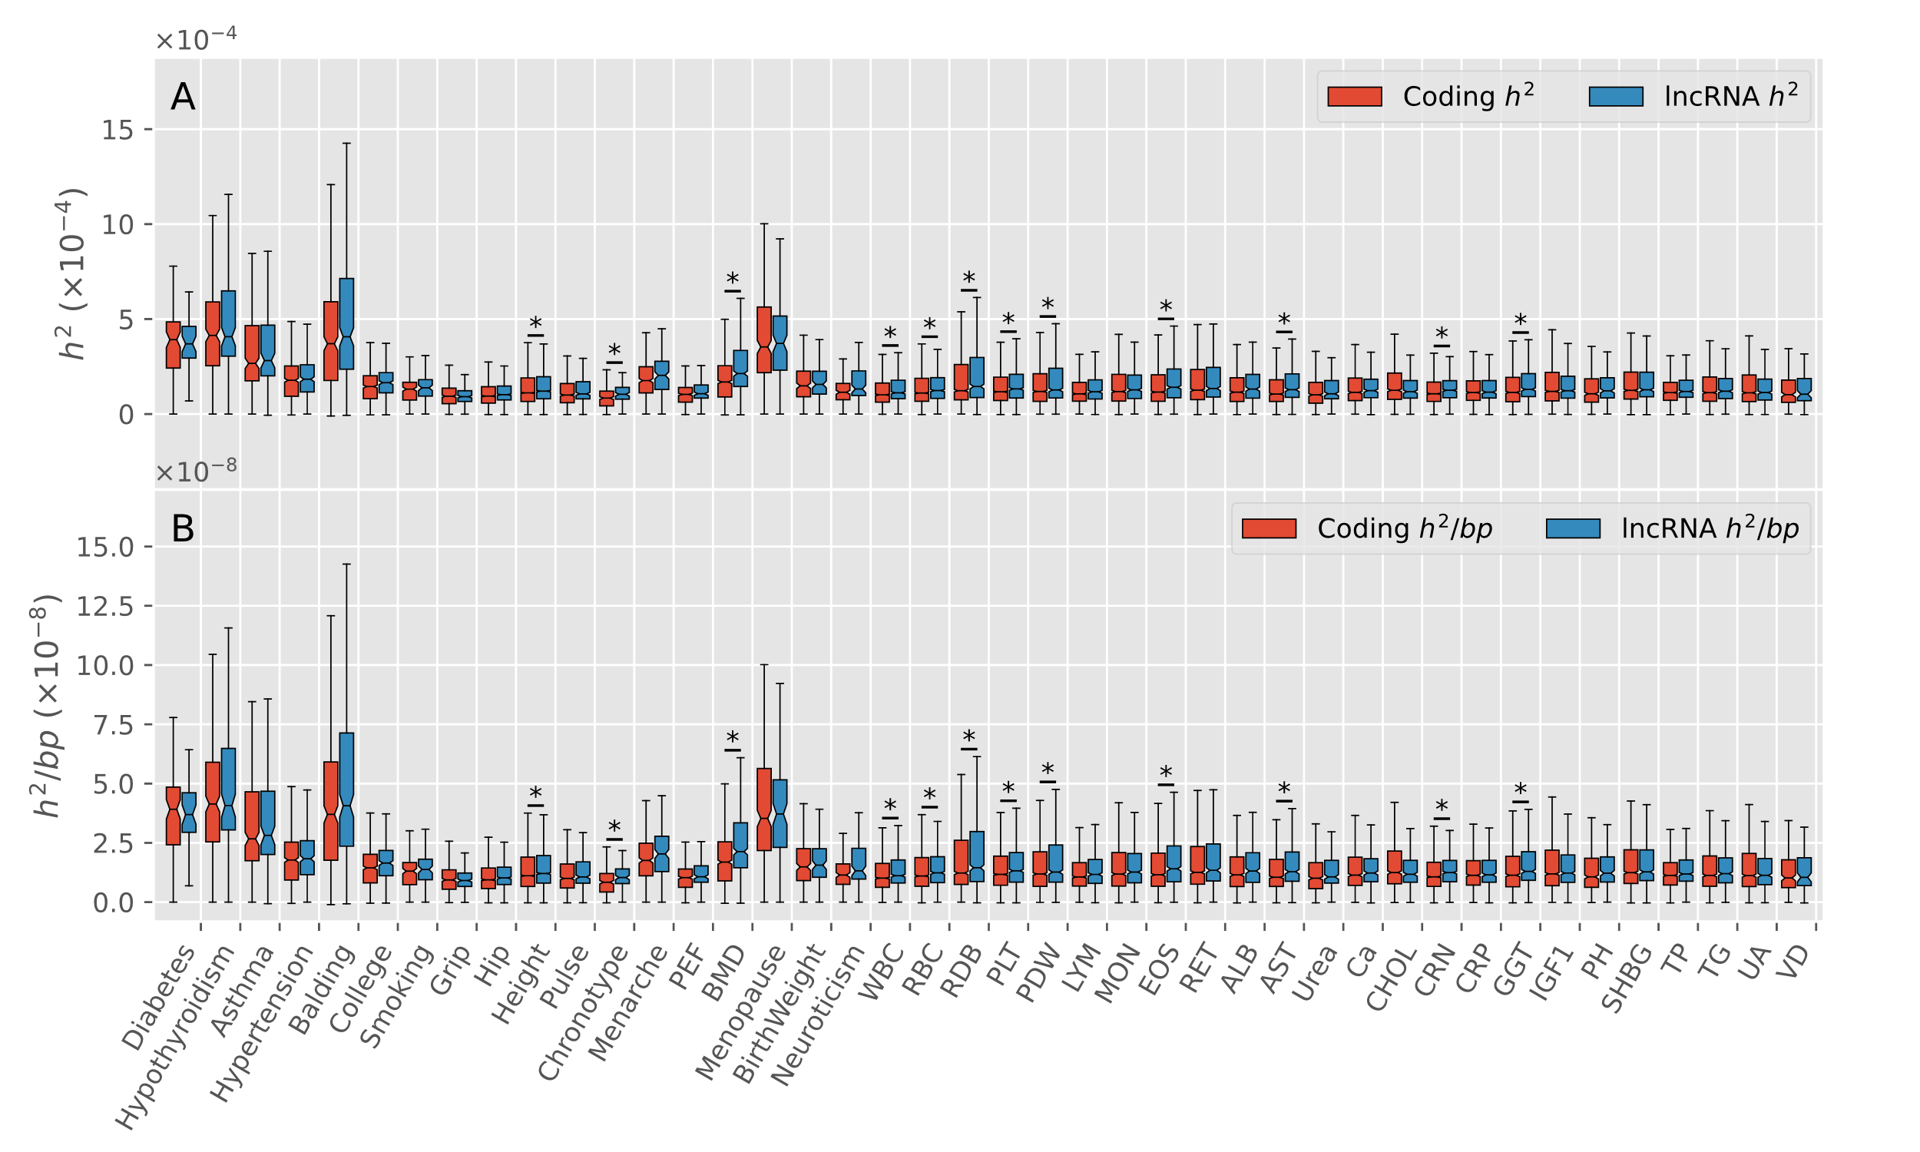
Figure S4. The heritability comparisons in 10 kb upstream regions between ECS significant protein-coding and lncRNA genes. (A) The overall comparisons for unconditional heritability. (B) The per-base pair comparisons for unconditional heritability. The whiskers extend to 1.5 times the interquartile range, and the outliers are not plotted. The notches represent the confidence interval around the median. An asterisk denotes a significant difference after Bonferroni correction (Mann-Whitney U test p<0.05/42) between protein-coding genes and lncRNA genes.

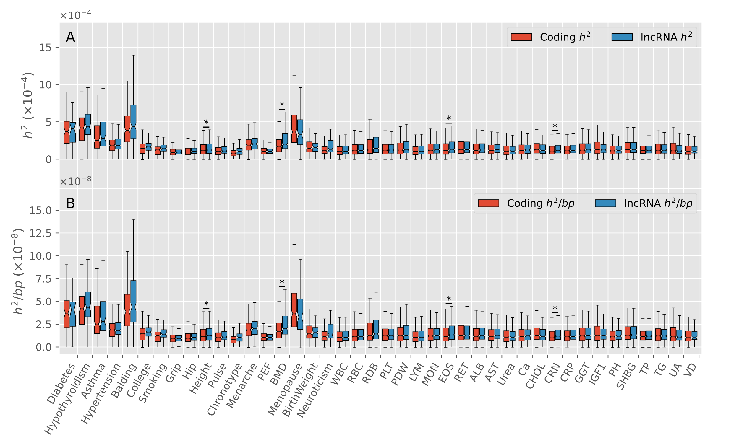
Figure S5. The heritability comparisons in 10 kb downstream regions between ECS significant protein-coding and lncRNA genes. (A) The overall comparisons for unconditional heritability. (B) The per-base pair comparisons for unconditional heritability. The whiskers extend to 1.5 times the interquartile range, and the outliers are not plotted. The notches represent the confidence interval around the median. An asterisk denotes a significant difference after Bonferroni correction (Mann-Whitney U test p<0.05/42) between protein-coding genes and lncRNA genes.

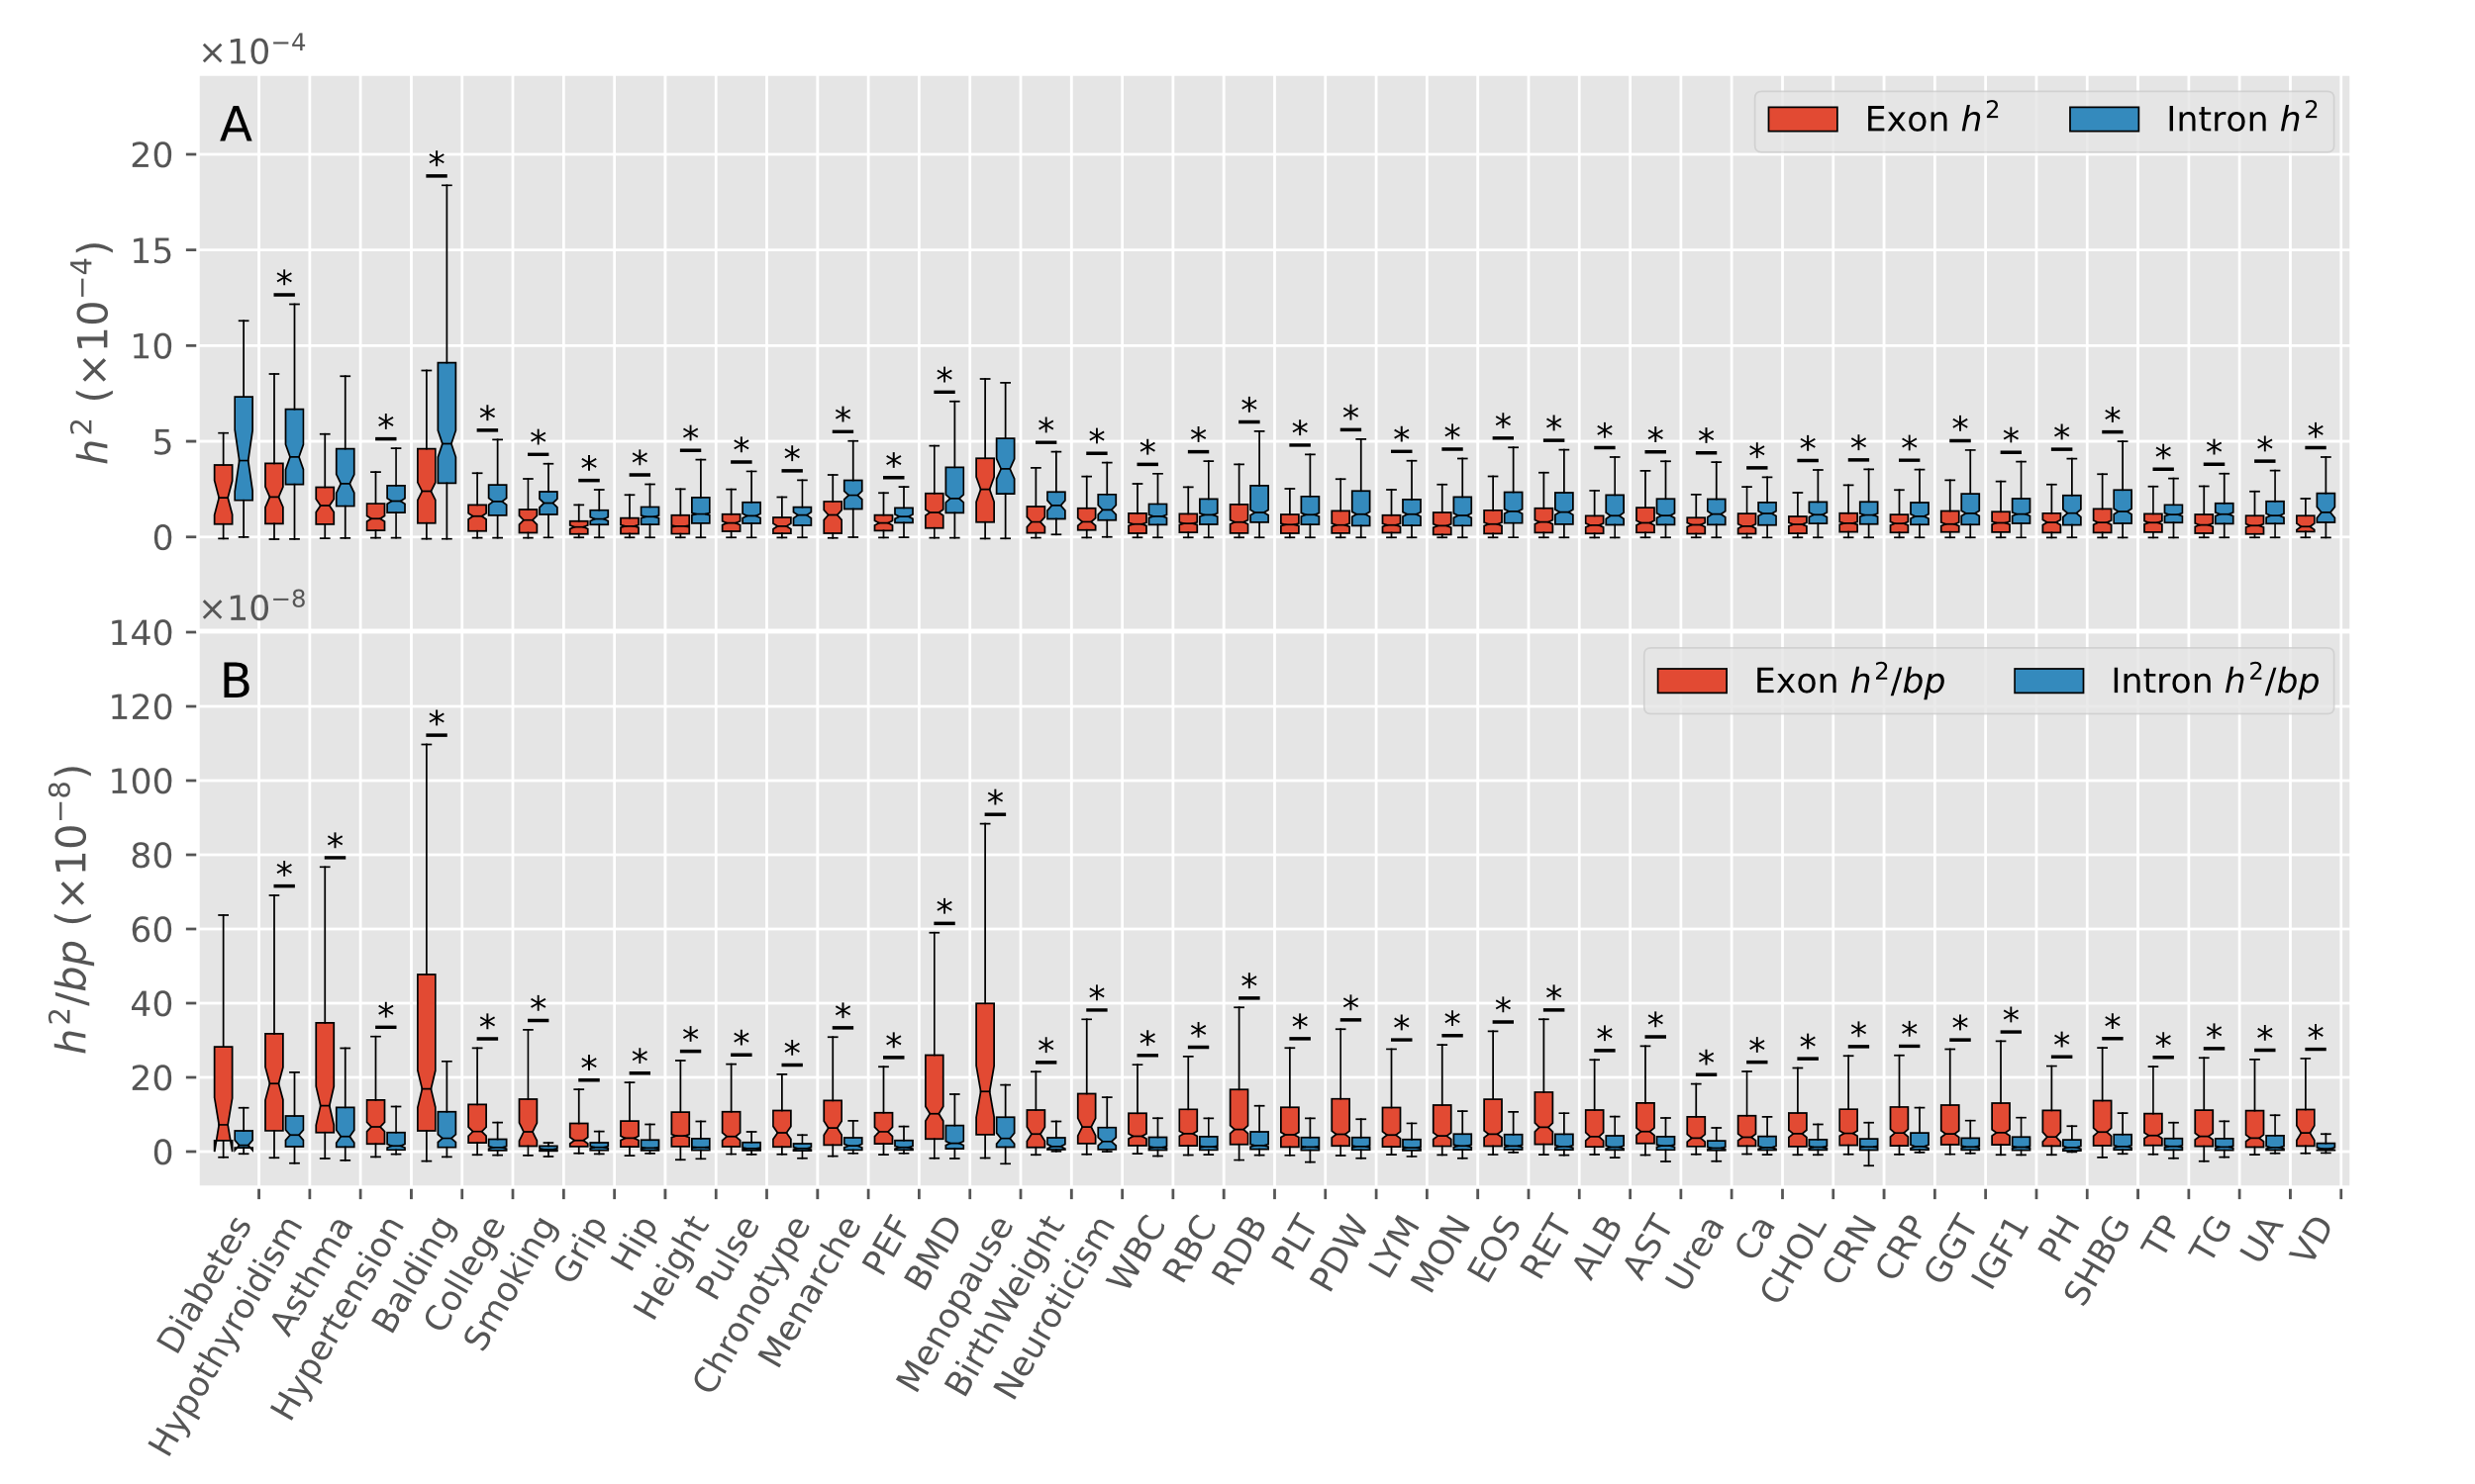
Figure S6. The heritability comparisons between exonic and intronic regions of ECS significant lncRNA genes. (A) The overall comparisons of unconditional heritability. (B) The per-base pair comparisons of unconditional heritability. The whiskers extend to 1.5 times the interquartile range, and the outliers are not plotted. The notches represent the confidence interval around the median. An asterisk denotes a significant difference after Bonferroni correction (sign test p<0.05/42) between corresponding regions.

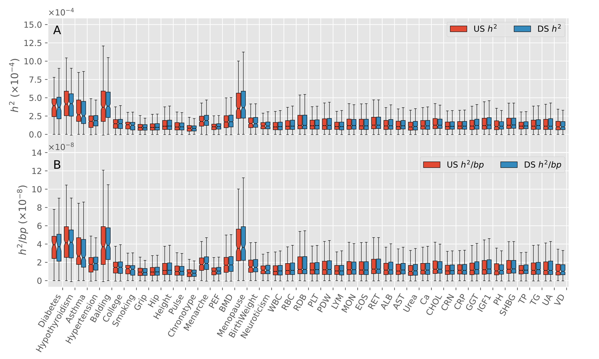
Figure S7. The heritability comparisons between 10 kb upstream and 10 kb downstream regions of ECS significant protein-coding genes. (A) The overall comparisons of unconditional heritability. (B) The per-base pair comparisons of unconditional heritability. The whiskers extend to 1.5 times the interquartile range, and the outliers are not plotted. The notches represent the confidence interval around the median. An asterisk denotes a significant difference after Bonferroni correction (sign test p<0.05/42) between corresponding regions. Abbreviations in legends: US for 10 kb upstream and DS for 10 kb downstream.

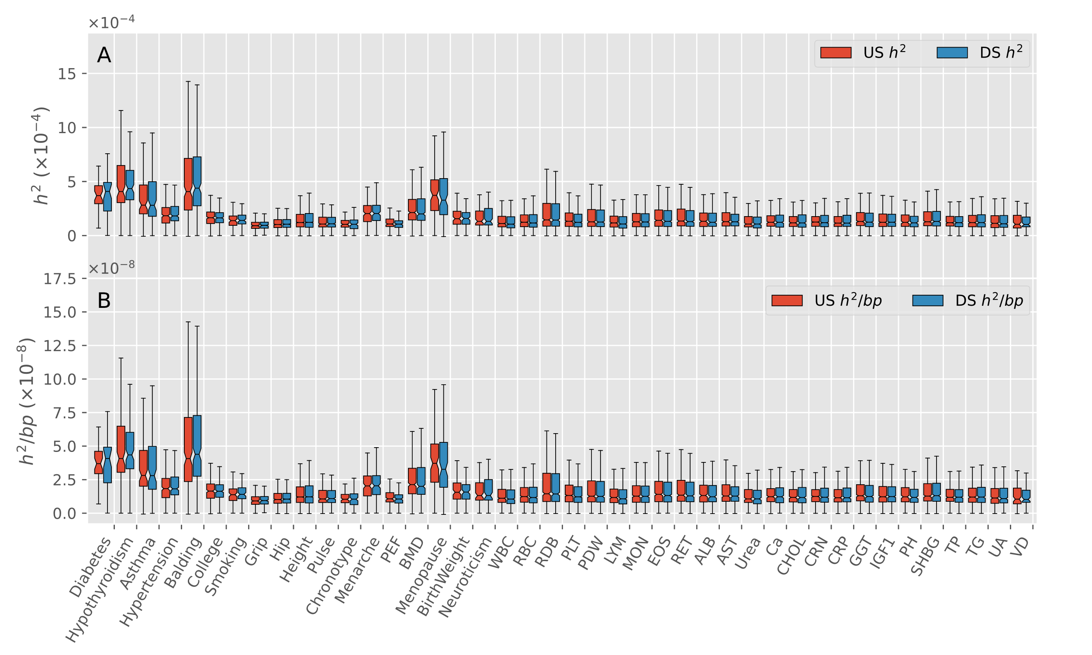
Figure S8. The heritability comparisons between 10 kb upstream and 10 kb downstream regions of ECS significant lncRNA genes. (A) Overall comparison of unconditional heritability. (A) The overall comparisons of unconditional heritability. (B) The per-base pair comparisons of unconditional heritability. The whiskers extend to 1.5 times the interquartile range, and the outliers are not plotted. The notches represent the confidence interval around the median. An asterisk denotes a significant difference after Bonferroni correction (sign test p<0.05/42) between corresponding regions. Abbreviations in legends: US for 10 kb upstream and DS for 10 kb downstream.

Suplementary Tables

Table S1. The 42 complex phenotypes analyzed in this study
ID¹ | Abbreviation | N | Prevalence² | $$h_{g}^{2}$$ | $$se(h_{g}^{2})$$ | $$h_{cdgn}^{2}$$ | $$se(h_{cdgn}^{2})$$ | Description
2443 | Diabetes | 360,192 | 0.0480 | 0.2312 | 0.0139 | 0.1838 | 0.0138 | Diabetes diagnosed by a doctor
20002_1226 | Hypothyroidism | 361,141 | 0.0487 | 0.2726 | 0.0257 | 0.2278 | 0.0231 | Self-reported hypothyroidism
6152_8 | Asthma | 360,527 | 0.1155 | 0.1803 | 0.0128 | 0.1543 | 0.0110 | Asthma diagnosed by a doctor
6150_4 | Hypertension | 360,420 | 0.2695 | 0.2854 | 0.0094 | 0.2294 | 0.0077 | Hypertension diagnosed by a doctor
2395_1 | Balding | 165,649 | 0.3204 | 0.4266 | 0.0356 | 0.2827 | 0.0240 | Balding pattern 1
6138_1 | College | 357,549 | 0.3244 | 0.3620 | 0.0078 | 0.2523 | 0.0060 | College or University degree
20116_0 | Smoking | 359,706 | 0.5423 | 0.1963 | 0.0053 | 0.1371 | 0.0041 | Smoking status
47_irnt | Grip | 359,729 |  | 0.1525 | 0.0039 | 0.1208 | 0.0033 | Right-hand grip strength
49_irnt | Hip | 360,521 |  | 0.2868 | 0.0076 | 0.2155 | 0.0064 | Hip circumference
50_irnt | Height | 360,388 |  | 0.6198 | 0.0251 | 0.5038 | 0.0228 | Standing height
102_irnt | Pulse | 340,162 |  | 0.2024 | 0.0098 | 0.1623 | 0.0088 | Pulse rate
1180 | Chronotype | 322,488 |  | 0.1522 | 0.0039 | 0.1091 | 0.0033 | Morning/evening person
2714 | Menarche | 188,644 |  | 0.2377 | 0.0089 | 0.1745 | 0.0074 | Age when periods started
3064_irnt | PEF | 329,404 |  | 0.1339 | 0.0041 | 0.1052 | 0.0033 | Peak expiratory flow
3148_irnt | BMD | 206,496 |  | 0.3821 | 0.0320 | 0.2940 | 0.0270 | Heel bone mineral density
3581_irnt | Menopause | 111,593 |  | 0.1399 | 0.0109 | 0.1373 | 0.0110 | Age at menopause
20022_irnt | Birth weight | 205,475 |  | 0.1348 | 0.0057 | 0.1179 | 0.0048 | Birth weight
20127_irnt | Neuroticism | 293,006 |  | 0.1344 | 0.0039 | 0.0983 | 0.0031 | Neuroticism score
30000_irnt | WBC | 350,470 |  | 0.2757 | 0.0166 | 0.2405 | 0.0155 | White blood cell count
30010_irnt | RBC | 350,475 |  | 0.3171 | 0.0264 | 0.2762 | 0.0254 | Red blood cell count
30070_irnt | RDB | 350,473 |  | 0.3027 | 0.0264 | 0.2912 | 0.0277 | Red blood cell distribution width
30080_irnt | PLT | 350,474 |  | 0.4024 | 0.0308 | 0.2963 | 0.0244 | Platelet count
30110_irnt | PDW | 350,470 |  | 0.3439 | 0.0423 | 0.2349 | 0.0756 | Platelet distribution width
30180_irnt | LYM | 349,861 |  | 0.2127 | 0.0120 | 0.1889 | 0.0101 | Lymphocyte percentage
30190_irnt | MON | 349,861 |  | 0.2761 | 0.0325 | 0.2261 | 0.0216 | Monocyte percentage
30210_irnt | EOS | 349,861 |  | 0.2678 | 0.0170 | 0.2346 | 0.0153 | Eosinophil count
30240_irnt | RET | 344,728 |  | 0.2855 | 0.0221 | 0.2527 | 0.0223 | Reticulocyte percentage
30600_irnt | ALB | 315,268 |  | 0.1802 | 0.0095 | 0.1602 | 0.0098 | Albumin
30650_irnt | AST | 342,990 |  | 0.1919 | 0.0164 | 0.1771 | 0.0167 | Aspartate aminotransferase
30670_irnt | Urea | 344,052 |  | 0.1506 | 0.0074 | 0.1243 | 0.0062 | Urea
30680_irnt | Ca | 315,153 |  | 0.1752 | 0.0174 | 0.1557 | 0.0172 | Calcium
30690_irnt | CHOL | 344,278 |  | 0.1832 | 0.0285 | 0.1778 | 0.0353 | Cholesterol
30700_irnt | CRN | 344,104 |  | 0.2658 | 0.0109 | 0.2273 | 0.0103 | Creatinine
30710_irnt | CRP | 343,524 |  | 0.2836 | 0.0489 | 0.2457 | 0.0497 | C-reactive protein
30730_irnt | GGT | 344,104 |  | 0.3016 | 0.0364 | 0.2714 | 0.0383 | Gamma glutamyl transferase
30770_irnt | IGF1 | 342,439 |  | 0.3177 | 0.0195 | 0.2586 | 0.0145 | IGF-1
30810_irnt | PH | 314,658 |  | 0.1598 | 0.0167 | 0.1370 | 0.0161 | Phosphate
30830_irnt | SHBG | 312,215 |  | 0.3401 | 0.0900 | 0.3103 | 0.0936 | Sex hormone binding globulin
30860_irnt | TP | 314,921 |  | 0.2178 | 0.0138 | 0.1945 | 0.0135 | Total protein
30870_irnt | TG | 343,992 |  | 0.2800 | 0.0364 | 0.2371 | 0.0347 | Triglycerides
30880_irnt | UA | 343,836 |  | 0.2854 | 0.0623 | 0.2509 | 0.0597 | Urate
30890_irnt | VD | 329,247 |  | 0.1311 | 0.0277 | 0.1103 | 0.0268 | Vitamin D
Note: ¹These are the IDs of the GWAS performed by the Neale Lab. ²Prevalence is the proportion of the affected individuals in a GWAS. The symbols $h_{g}^{2}$ and $se(h_{g}^{2})$ denote the heritability of all autosomes and its standard error calculated by LDER. The symbols $h_{cdgn}^{2}$ and $se(h_{cdgn}^{2})$ denote the heritability of all autosomal protein-coding genes and 10 kb flanking regions and its standard error calculated by LDER.

Table S2. The genetic correlation matrix of the 42 complex phenotypes analyzed in this study
ID | 2443 | 20002_1226 | 6152_8 | 6150_4 | 2395_1 | 6138_1 | 20116_0 | 47_irnt | 49_irnt | 50_irnt | 102_irnt | 1180 | 2714 | 3064_irnt | 3148_irnt | 3581_irnt | 20022_irnt | 20127_irnt | 30000_irnt | 30010_irnt | 30070_irnt | 30080_irnt | 30110_irnt | 30180_irnt | 30190_irnt | 30210_irnt | 30240_irnt | 30600_irnt | 30650_irnt | 30670_irnt | 30680_irnt | 30690_irnt | 30700_irnt | 30710_irnt | 30730_irnt | 30770_irnt | 30810_irnt | 30830_irnt | 30860_irnt | 30870_irnt | 30880_irnt | 30890_irnt
2443 |  | 0.1744 | 0.1842 | 0.4909 | -0.025 | -0.297 | -0.2208 | -0.127 | 0.4879 | -0.107 | 0.2159 | -0.078 | -0.234 | -0.1017 | 0.0978 | -0.2025 | -0.2216 | 0.1075 | 0.3511 | 0.1612 | 0.0783 | 0.0577 | 0.0989 | 0.0189 | -0.09 | 0.0505 | 0.4247 | -0.0084 | 0.1522 | 0.0763 | 0.12 | -0.2265 | -0.0336 | 0.4219 | 0.3669 | -0.0128 | -0.0619 | -0.4956 | 0.1319 | 0.4658 | 0.3735 | -0.1835
20002_1226 | 0.1744 |  | 0.03972 | 0.0903 | -0.005 | -0.11 | -0.037 | 0.0011 | 0.1303 | 0.0181 | -0.0289 | 0.058 | -0.052 | 0.0463 | -0.0289 | -0.0582 | -0.0649 | 0.1777 | 0.1012 | -0.0014 | 0.0141 | 0.0005 | 0.0104 | 0.0221 | -0.015 | 0.1212 | 0.1379 | -0.0395 | 0.0301 | -0.0276 | 0.0327 | -0.1388 | 0.1184 | 0.1273 | 0.0269 | -0.0956 | -0.0384 | -0.0894 | 0.0565 | 0.142 | 0.1404 | -0.0853
6152_8 | 0.1842 | 0.03972 |  | 0.1283 | 0.0234 | -0.103 | -0.1603 | -0.102 | 0.1448 | -0.085 | 0.085 | -0.017 | -0.07 | -0.2083 | 0.0331 | -0.1229 | -0.09141 | 0.1005 | 0.1707 | 0.001917 | 0.07428 | 0.04562 | -0.03007 | -0.1051 | -0.09532 | 0.4126 | 0.04726 | -0.114 | 0.01449 | -0.02605 | -0.004444 | -0.08063 | -0.0201 | 0.1805 | 0.08221 | -0.0958 | -0.01574 | -0.05258 | 0.04721 | 0.06659 | 0.06742 | -0.02039
6150_4 | 0.4909 | 0.0903 | 0.1283 |  | -0.044 | -0.256 | -0.1286 | -0.129 | 0.2973 | -0.126 | 0.166 | -0.065 | -0.183 | -0.1125 | 0.0587 | -0.1077 | -0.2207 | 0.0892 | 0.2232 | 0.1426 | 0.0726 | 0.065 | 0.0692 | -0.0155 | -0.0154 | 0.0425 | 0.2601 | 0.0237 | 0.1266 | 0.1126 | 0.133 | -0.2402 | -0.0261 | 0.2766 | 0.2562 | -0.0157 | -0.0407 | -0.2799 | 0.1825 | 0.2355 | 0.2684 | -0.0639
2395_1 | -0.025 | -0.0053 | 0.0234 | -0.044 |  | -0.002 | 0.018 | -0.021 | 0.0422 | 0.0786 | 0.0066 | 0.0353 | 0.0758 | -0.0119 | -0.0822 | -0.001 | 0.089 | -0.041 | -0.0161 | -0.0139 | 0.0076 | 0.0186 | -0.0061 | -0.0153 | 0.0132 | -0.0263 | -0.013 | -0.0954 | -0.0744 | -0.0443 | -0.0393 | 0.0075 | -0.0177 | 0.0302 | 0.0035 | -0.0425 | 0.034 | 0.0158 | -0.0763 | -0.0076 | -0.0142 | -0.0284
6138_1 | -0.297 | -0.1097 | -0.1032 | -0.256 | -0.002 |  | 0.3484 | 0.1291 | -0.217 | 0.2307 | -0.0919 | 0.1485 | 0.0102 | 0.2209 | -0.0061 | 0.2056 | 0.139 | -0.1985 | -0.2688 | -0.1072 | -0.0851 | -0.0773 | 0.0092 | 0.0359 | 0.0553 | 0.0289 | -0.2173 | 0.0465 | -0.0611 | -0.0919 | -0.1254 | 0.0725 | -0.0453 | -0.3448 | -0.2555 | 0.1223 | 0.0757 | 0.1569 | -0.153 | -0.2476 | -0.159 | -0.1213
20116_0 | -0.221 | -0.037 | -0.1603 | -0.129 | 0.018 | 0.3484 |  | 0.0362 | -0.167 | 0.0391 | 0.0038 | -0.077 | 0.0029 | 0.0615 | -0.035 | 0.16 | 0.0306 | -0.1279 | -0.1545 | 0.0582 | -0.0464 | -0.0224 | -0.0163 | -0.0504 | 0.0289 | -0.0297 | -0.1049 | 0.1051 | -0.0284 | 0.0016 | 0.0046 | 0.0524 | 0.0643 | -0.222 | -0.192 | 0.1136 | -0.0702 | 0.0573 | 0.0414 | -0.1042 | -0.1161 | 0.007
47_irnt | -0.127 | 0.0011 | -0.1023 | -0.129 | -0.021 | 0.1291 | 0.0362 |  | 0.0984 | 0.4868 | -0.0443 | 0.0134 | 0.1398 | 0.4704 | 0.0098 | 0.0655 | 0.2534 | -0.1751 | -0.1631 | 0.0033 | 0.0269 | -0.1105 | 0.0449 | -0.0091 | 0.0142 | -0.0654 | -0.1124 | 0.1004 | -0.0158 | 0.0069 | 0.039 | 0.0056 | 0.2307 | -0.1801 | -0.1193 | 0.1326 | -0.0533 | 0.0458 | 0.0176 | -0.1181 | -0.0235 | 0.054
49_irnt | 0.4879 | 0.1303 | 0.1448 | 0.2973 | 0.0422 | -0.217 | -0.1667 | 0.0984 |  | 0.2865 | 0.0777 | -0.026 | -0.234 | 0.0799 | 0.0446 | -0.1109 | 0.1727 | -0.0299 | 0.1241 | 0.0821 | 0.1749 | -0.0596 | 0.033 | 0.0159 | -0.0032 | 0.0402 | 0.2374 | -0.2643 | 0.0211 | 0.1061 | -0.069 | -0.2342 | 0.0845 | 0.4159 | 0.1417 | -0.1061 | -0.0704 | -0.2544 | -0.029 | 0.1643 | 0.286 | -0.1259
50_irnt | -0.107 | 0.0181 | -0.0851 | -0.126 | 0.0786 | 0.2307 | 0.0391 | 0.4868 | 0.2865 |  | -0.0838 | 0.0368 | 0.1497 | 0.3891 | -0.0988 | 0.0202 | 0.3996 | -0.0684 | -0.1855 | -0.045 | -0.0046 | -0.1524 | 0.0339 | -0.0114 | 0.0297 | 0.0087 | -0.1219 | -0.0427 | -0.0769 | 0.056 | -0.0753 | -0.1159 | 0.1191 | -0.1497 | -0.1548 | 0.0958 | 0.0076 | 0.0605 | -0.0855 | -0.1289 | -0.0103 | 0.0341
102_irnt | 0.2159 | -0.0289 | 0.085 | 0.166 | 0.0066 | -0.092 | 0.0038 | -0.044 | 0.0777 | -0.084 |  | -0.025 | -0.059 | -0.0849 | 0.0086 | -0.0304 | -0.0352 | 0.0133 | 0.143 | 0.1133 | 0.0037 | 0.0992 | 0.002 | -0.0641 | -0.0516 | -0.0159 | 0.1714 | 0.0268 | -0.0241 | -0.0307 | 0.0427 | 0.0087 | -0.0762 | 0.1825 | 0.1474 | -0.0032 | -0.1356 | -0.1456 | 0.1279 | 0.1811 | 0.1023 | -0.1442
1180 | -0.078 | 0.058 | -0.0172 | -0.065 | 0.0353 | 0.1485 | -0.0773 | 0.0134 | -0.026 | 0.0368 | -0.0254 |  | 0.0529 | 0.0618 | -0.0338 | 0.0695 | 0.0454 | 0.0242 | -0.0224 | -0.0787 | -0.0342 | -0.0186 | -0.0127 | 0.0252 | 0.0134 | 0.0148 | -0.0433 | -0.0272 | -0.077 | -0.1008 | -0.0402 | 0.0172 | 0.0229 | -0.0168 | -0.0372 | -0.0097 | -0.081 | -0.0105 | -0.0588 | -0.0041 | 0.0061 | -0.1405
2714 | -0.234 | -0.0521 | -0.0699 | -0.183 | 0.0758 | 0.0102 | 0.0029 | 0.1398 | -0.234 | 0.1497 | -0.0594 | 0.0529 |  | 0.0765 | -0.0836 | 0.0772 | 0.0731 | -0.0021 | -0.0645 | -0.0854 | -0.0564 | 0.01 | -0.015 | -0.0255 | 0.0396 | -0.046 | -0.1502 | 0.0852 | -0.0772 | -0.0393 | 0.042 | 0.1123 | 0.0297 | -0.1209 | -0.0776 | -0.0366 | -0.0091 | 0.1296 | 0.0162 | -0.1216 | -0.1283 | 0.053
3064_irnt | -0.102 | 0.0463 | -0.2083 | -0.113 | -0.012 | 0.2209 | 0.0615 | 0.4704 | 0.0799 | 0.3891 | -0.0849 | 0.0618 | 0.0765 |  | 0.0111 | 0.1338 | 0.2064 | -0.1315 | -0.1497 | -0.0096 | -0.0174 | -0.08 | 0.0014 | -0.0021 | 0.0658 | -0.0366 | -0.1276 | 0.0096 | -0.0199 | 0.058 | -0.0203 | -0.0475 | 0.1383 | -0.2043 | -0.1399 | 0.143 | -0.0652 | 0.0498 | -0.08 | -0.096 | -0.0403 | 0.0283
3148_irnt | 0.0978 | -0.0289 | 0.0331 | 0.0587 | -0.082 | -0.006 | -0.035 | 0.0098 | 0.0446 | -0.099 | 0.0086 | -0.034 | -0.084 | 0.0111 |  | 0.0143 | -0.0187 | -0.1101 | 0.0055 | 0.0694 | 0.0455 | -0.0099 | 0.049 | 0.0483 | 0.0092 | 0.0423 | 0.0752 | 0.013 | 0.0644 | 0.0856 | -0.0193 | -0.053 | 0.0211 | 0.042 | 0.0003 | 0.0155 | -0.1038 | -0.0901 | -0.0078 | 0.0091 | 0.0686 | -0.0071
3581_irnt | -0.203 | -0.0582 | -0.1229 | -0.108 | -0.001 | 0.2056 | 0.16 | 0.0655 | -0.111 | 0.0202 | -0.0304 | 0.0695 | 0.0772 | 0.1338 | 0.0143 |  | 0.11 | -0.0845 | -0.0665 | 0.0202 | -0.0003 | 0.0009 | -0.0421 | -0.0479 | 0.042 | 0.011 | -0.0728 | 0.016 | -0.0774 | -0.037 | -0.036 | 0.0478 | -0.0251 | -0.1335 | -0.0856 | 0.078 | 0.0112 | 0.0609 | 0.0006 | -0.0596 | -0.0665 | -0.0296
20022_irnt | -0.222 | -0.0649 | -0.09141 | -0.221 | 0.089 | 0.139 | 0.0306 | 0.2534 | 0.1727 | 0.3996 | -0.0352 | 0.0454 | 0.0731 | 0.2064 | -0.0187 | 0.11 |  | -0.0386 | -0.2086 | -0.0953 | 0.012 | -0.0729 | -0.0239 | 0.0456 | 0.092 | -0.0479 | -0.09 | -0.0166 | -0.0487 | -0.0491 | -0.1253 | 0.0375 | -0.0256 | -0.1143 | -0.1185 | -0.0572 | -0.0494 | 0.1081 | -0.0914 | -0.1133 | -0.1205 | -0.0347
20127_irnt | 0.1075 | 0.1777 | 0.1005 | 0.0892 | -0.041 | -0.199 | -0.1279 | -0.175 | -0.03 | -0.068 | 0.0133 | 0.0242 | -0.002 | -0.1315 | -0.1101 | -0.0845 | -0.0386 |  | 0.1019 | -0.0351 | -0.0254 | 0.0398 | -0.0373 | -0.056 | -0.0152 | -0.0414 | 0.0826 | -0.0235 | -0.0227 | -0.0301 | -0.0212 | -0.0277 | 0.0057 | 0.0534 | 0.0635 | -0.0869 | -0.066 | -0.0226 | -0.0496 | 0.1062 | 0.0342 | -0.0514
30000_irnt | 0.3511 | 0.1012 | 0.1707 | 0.2232 | -0.016 | -0.269 | -0.1545 | -0.163 | 0.1241 | -0.186 | 0.143 | -0.022 | -0.065 | -0.1497 | 0.0055 | -0.0665 | -0.2086 | 0.1019 |  | 0.1871 | 0.044 | 0.2807 | -0.0751 | -0.1499 | -0.1983 | 0.0118 | 0.1938 | -0.0902 | -0.0085 | 0.0447 | 0.1168 | -0.0964 | -0.0042 | 0.3617 | 0.199 | -0.0964 | -0.013 | -0.2619 | 0.1459 | 0.3076 | 0.2002 | -0.0694
30010_irnt | 0.1612 | -0.0014 | 0.001917 | 0.1426 | -0.014 | -0.107 | 0.0582 | 0.0033 | 0.0821 | -0.045 | 0.1133 | -0.079 | -0.085 | -0.0096 | 0.0694 | 0.0202 | -0.0953 | -0.0351 | 0.1871 |  | 0.2021 | -0.0662 | 0.1008 | -0.0775 | -0.0285 | 0.0186 | 0.0478 | -0.0468 | 0.0205 | 0.0457 | 0.0253 | -0.0412 | 0.0408 | 0.1022 | 0.0914 | 0.0263 | -0.0872 | -0.1091 | 0.0015 | 0.1547 | 0.0764 | -0.044
30070_irnt | 0.0783 | 0.0141 | 0.07428 | 0.0726 | 0.0076 | -0.085 | -0.0464 | 0.0269 | 0.1749 | -0.005 | 0.0037 | -0.034 | -0.056 | -0.0174 | 0.0455 | -0.0003 | 0.012 | -0.0254 | 0.044 | 0.2021 |  | -0.0636 | 0.082 | -0.0073 | -0.006 | 0.0542 | -0.1396 | -0.1504 | -0.0199 | 0.0248 | -0.0473 | 0.0809 | 0.0142 | 0.1191 | 0.0017 | -0.0234 | -0.0431 | -0.0482 | -0.0014 | -0.0636 | 0.0167 | -0.0026
30080_irnt | 0.0577 | 0.0005 | 0.04562 | 0.065 | 0.0186 | -0.077 | -0.0224 | -0.111 | -0.06 | -0.152 | 0.0992 | -0.019 | 0.01 | -0.08 | -0.0099 | 0.0009 | -0.0729 | 0.0398 | 0.2807 | -0.0662 | -0.0636 |  | -0.476 | 0.0027 | -0.0008 | 0.0401 | 0.0305 | 0.0262 | -0.0365 | -0.0204 | 0.1544 | 0.0826 | -0.0714 | 0.0867 | 0.12 | -0.0499 | 0.1074 | -0.0425 | 0.1568 | 0.0837 | 0.0177 | -0.0256
30110_irnt | 0.0989 | 0.0104 | -0.03007 | 0.0692 | -0.006 | 0.0092 | -0.0163 | 0.0449 | 0.033 | 0.0339 | 0.002 | -0.013 | -0.015 | 0.0014 | 0.049 | -0.0421 | -0.0239 | -0.0373 | -0.0751 | 0.1008 | 0.082 | -0.476 |  | -0.0311 | -0.0875 | 0.0019 | 0.1457 | 0.0639 | 0.0825 | 0.0146 | 0.0048 | -0.0173 | 0.0012 | 0.0563 | 0.062 | -0.0061 | -0.0098 | -0.0806 | 0.0326 | 0.1596 | 0.0783 | -0.0281
30180_irnt | 0.0189 | 0.0221 | -0.1051 | -0.016 | -0.015 | 0.0359 | -0.0504 | -0.009 | 0.0159 | -0.011 | -0.0641 | 0.0252 | -0.026 | -0.0021 | 0.0483 | -0.0479 | 0.0456 | -0.056 | -0.1499 | -0.0775 | -0.0073 | 0.0027 | -0.0311 |  | 0.0477 | 0.0596 | -0.0005 | -0.0028 | 0.0712 | -0.0084 | 0.0213 | 0.0745 | -0.0573 | -0.0666 | 0.0676 | -0.0179 | 0.0973 | -0.0262 | 0.0347 | 0.0478 | 0.0272 | -0.0056
30190_irnt | -0.09 | -0.015 | -0.09532 | -0.015 | 0.0132 | 0.0553 | 0.0289 | 0.0142 | -0.003 | 0.0297 | -0.0516 | 0.0134 | 0.0396 | 0.0658 | 0.0092 | 0.042 | 0.092 | -0.0152 | -0.1983 | -0.0285 | -0.006 | -0.0008 | -0.0875 | 0.0477 |  | 0.0557 | -0.0697 | -0.0417 | 0.0415 | -0.0356 | 0.0007 | 0.0138 | -0.0087 | -0.1317 | -0.0418 | 0.026 | 0.0343 | 0.0828 | -0.0054 | -0.0965 | -0.04 | -0.0189
30210_irnt | 0.0505 | 0.1212 | 0.4126 | 0.0425 | -0.026 | 0.0289 | -0.0297 | -0.065 | 0.0402 | 0.0087 | -0.0159 | 0.0148 | -0.046 | -0.0366 | 0.0423 | 0.011 | -0.0479 | -0.0414 | 0.0118 | 0.0186 | 0.0542 | 0.0401 | 0.0019 | 0.0596 | 0.0557 |  | -0.0143 | -0.1012 | 0.06 | -0.0121 | -0.0486 | -0.0701 | 0.0081 | 0.0564 | -0.0178 | -0.0239 | 0.1422 | 0.0114 | 0.034 | -0.047 | 0.0377 | 0.0059
30240_irnt | 0.4247 | 0.1379 | 0.04726 | 0.2601 | -0.013 | -0.217 | -0.1049 | -0.112 | 0.2374 | -0.122 | 0.1714 | -0.043 | -0.15 | -0.1276 | 0.0752 | -0.0728 | -0.09 | 0.0826 | 0.1938 | 0.0478 | -0.1396 | 0.0305 | 0.1457 | -0.0005 | -0.0697 | -0.0143 |  | 0.02 | 0.065 | 0.0594 | 0.0782 | -0.06 | 0.0097 | 0.2504 | 0.2444 | -0.054 | -0.0092 | -0.3059 | 0.0171 | 0.4095 | 0.2593 | -0.1289
30600_irnt | -0.008 | -0.0395 | -0.114 | 0.0237 | -0.095 | 0.0465 | 0.1051 | 0.1004 | -0.264 | -0.043 | 0.0268 | -0.027 | 0.0852 | 0.0096 | 0.013 | 0.016 | -0.0166 | -0.0235 | -0.0902 | -0.0468 | -0.1504 | 0.0262 | 0.0639 | -0.0028 | -0.0417 | -0.1012 | 0.02 |  | 0.1111 | 0.0122 | 0.4906 | 0.1619 | -0.1038 | -0.1874 | 0.1462 | 0.0533 | 0.0318 | -0.1194 | 0.4102 | 0.1044 | 0.0227 | 0.0221
30650_irnt | 0.1522 | 0.0301 | 0.01449 | 0.1266 | -0.074 | -0.061 | -0.0284 | -0.016 | 0.0211 | -0.077 | -0.0241 | -0.077 | -0.077 | -0.0199 | 0.0644 | -0.0774 | -0.0487 | -0.0227 | -0.0085 | 0.0205 | -0.0199 | -0.0365 | 0.0825 | 0.0712 | 0.0415 | 0.06 | 0.065 | 0.1111 |  | 0.0286 | 0.1589 | 0.1274 | 0.013 | 0.0834 | 0.3462 | -0.0501 | 0.0346 | -0.0248 | 0.2262 | 0.1118 | 0.1322 | 0.0093
30670_irnt | 0.0763 | -0.0276 | -0.02605 | 0.1126 | -0.044 | -0.092 | 0.0016 | 0.0069 | 0.1061 | 0.056 | -0.0307 | -0.101 | -0.039 | 0.058 | 0.0856 | -0.037 | -0.0491 | -0.0301 | 0.0447 | 0.0457 | 0.0248 | -0.0204 | 0.0146 | -0.0084 | -0.0356 | -0.0121 | 0.0594 | 0.0122 | 0.0286 |  | 0.0323 | -0.0381 | 0.3492 | 0.0896 | 0.0305 | 0.0224 | 0.0108 | -0.0871 | 0.0157 | 0.0717 | 0.2614 | 0.1087
30680_irnt | 0.12 | 0.0327 | -0.00444 | 0.133 | -0.039 | -0.125 | 0.0046 | 0.039 | -0.069 | -0.075 | 0.0427 | -0.04 | 0.042 | -0.0203 | -0.0193 | -0.036 | -0.1253 | -0.0212 | 0.1168 | 0.0253 | -0.0473 | 0.1544 | 0.0048 | 0.0213 | 0.0007 | -0.0486 | 0.0782 | 0.4906 | 0.1589 | 0.0323 |  | 0.1643 | -0.0578 | -0.0113 | 0.2059 | 0.0265 | -0.1233 | -0.112 | 0.368 | 0.1481 | 0.1411 | 0.0324
30690_irnt | -0.227 | -0.1388 | -0.08063 | -0.24 | 0.0075 | 0.0725 | 0.0524 | 0.0056 | -0.234 | -0.116 | 0.0087 | 0.0172 | 0.1123 | -0.0475 | -0.053 | 0.0478 | 0.0375 | -0.0277 | -0.0964 | -0.0412 | 0.0809 | 0.0826 | -0.0173 | 0.0745 | 0.0138 | -0.0701 | -0.06 | 0.1619 | 0.1274 | -0.0381 | 0.1643 |  | -0.0631 | -0.0078 | 0.1071 | -0.0289 | 0.0696 | 0.1618 | 0.0887 | 0.2162 | -0.0728 | -0.0583
30700_irnt | -0.034 | 0.1184 | -0.0201 | -0.026 | -0.018 | -0.045 | 0.0643 | 0.2307 | 0.0845 | 0.1191 | -0.0762 | 0.0229 | 0.0297 | 0.1383 | 0.0211 | -0.0251 | -0.0256 | 0.0057 | -0.0042 | 0.0408 | 0.0142 | -0.0714 | 0.0012 | -0.0573 | -0.0087 | 0.0081 | 0.0097 | -0.1038 | 0.013 | 0.3492 | -0.0578 | -0.0631 |  | -0.0136 | -0.068 | 0.0792 | -0.0536 | -0.0218 | -0.0441 | 0.0251 | 0.1857 | 0.0924
30710_irnt | 0.4219 | 0.1273 | 0.1805 | 0.2766 | 0.0302 | -0.345 | -0.222 | -0.18 | 0.4159 | -0.15 | 0.1825 | -0.017 | -0.121 | -0.2043 | 0.042 | -0.1335 | -0.1143 | 0.0534 | 0.3617 | 0.1022 | 0.1191 | 0.0867 | 0.0563 | -0.0666 | -0.1317 | 0.0564 | 0.2504 | -0.1874 | 0.0834 | 0.0896 | -0.0113 | -0.0078 | -0.0136 |  | 0.4218 | -0.2998 | -0.0705 | -0.282 | 0.1394 | 0.3281 | 0.2885 | -0.1387
30730_irnt | 0.3669 | 0.0269 | 0.08221 | 0.2562 | 0.0035 | -0.256 | -0.192 | -0.119 | 0.1417 | -0.155 | 0.1474 | -0.037 | -0.078 | -0.1399 | 0.0003 | -0.0856 | -0.1185 | 0.0635 | 0.199 | 0.0914 | 0.0017 | 0.12 | 0.062 | 0.0676 | -0.0418 | -0.0178 | 0.2444 | 0.1462 | 0.3462 | 0.0305 | 0.2059 | 0.1071 | -0.068 | 0.4218 |  | -0.0907 | 0.0014 | -0.1799 | 0.1986 | 0.3492 | 0.2705 | -0.0516
30770_irnt | -0.013 | -0.0956 | -0.0958 | -0.016 | -0.043 | 0.1223 | 0.1136 | 0.1326 | -0.106 | 0.0958 | -0.0032 | -0.01 | -0.037 | 0.143 | 0.0155 | 0.078 | -0.0572 | -0.0869 | -0.0964 | 0.0263 | -0.0234 | -0.0499 | -0.0061 | -0.0179 | 0.026 | -0.0239 | -0.054 | 0.0533 | -0.0501 | 0.0224 | 0.0265 | -0.0289 | 0.0792 | -0.2998 | -0.0907 |  | 0.0898 | -0.0874 | -0.0154 | -0.105 | -0.0514 | 0.1212
30810_irnt | -0.062 | -0.0384 | -0.01574 | -0.041 | 0.034 | 0.0757 | -0.0702 | -0.053 | -0.07 | 0.0076 | -0.1356 | -0.081 | -0.009 | -0.0652 | -0.1038 | 0.0112 | -0.0494 | -0.066 | -0.013 | -0.0872 | -0.0431 | 0.1074 | -0.0098 | 0.0973 | 0.0343 | 0.1422 | -0.0092 | 0.0318 | 0.0346 | 0.0108 | -0.1233 | 0.0696 | -0.0536 | -0.0705 | 0.0014 | 0.0898 |  | -0.0175 | 0.0019 | -0.018 | 0.0019 | 0.1175
30830_irnt | -0.496 | -0.0894 | -0.05258 | -0.28 | 0.0158 | 0.1569 | 0.0573 | 0.0458 | -0.254 | 0.0605 | -0.1456 | -0.011 | 0.1296 | 0.0498 | -0.0901 | 0.0609 | 0.1081 | -0.0226 | -0.2619 | -0.1091 | -0.0482 | -0.0425 | -0.0806 | -0.0262 | 0.0828 | 0.0114 | -0.3059 | -0.1194 | -0.0248 | -0.0871 | -0.112 | 0.1618 | -0.0218 | -0.282 | -0.1799 | -0.0874 | -0.0175 |  | -0.1358 | -0.4724 | -0.2982 | 0.1274
30860_irnt | 0.1319 | 0.0565 | 0.04721 | 0.1825 | -0.076 | -0.153 | 0.0414 | 0.0176 | -0.029 | -0.086 | 0.1279 | -0.059 | 0.0162 | -0.08 | -0.0078 | 0.0006 | -0.0914 | -0.0496 | 0.1459 | 0.0015 | -0.0014 | 0.1568 | 0.0326 | 0.0347 | -0.0054 | 0.034 | 0.0171 | 0.4102 | 0.2262 | 0.0157 | 0.368 | 0.0887 | -0.0441 | 0.1394 | 0.1986 | -0.0154 | 0.0019 | -0.1358 |  | 0.12 | 0.1773 | 8.58E-05
30870_irnt | 0.4658 | 0.142 | 0.06659 | 0.2355 | -0.008 | -0.248 | -0.1042 | -0.118 | 0.1643 | -0.129 | 0.1811 | -0.004 | -0.122 | -0.096 | 0.0091 | -0.0596 | -0.1133 | 0.1062 | 0.3076 | 0.1547 | -0.0636 | 0.0837 | 0.1596 | 0.0478 | -0.0965 | -0.047 | 0.4095 | 0.1044 | 0.1118 | 0.0717 | 0.1481 | 0.2162 | 0.0251 | 0.3281 | 0.3492 | -0.105 | -0.018 | -0.4724 | 0.12 |  | 0.3351 | -0.2554
30880_irnt | 0.3735 | 0.1404 | 0.06742 | 0.2684 | -0.014 | -0.159 | -0.1161 | -0.024 | 0.286 | -0.01 | 0.1023 | 0.0061 | -0.128 | -0.0403 | 0.0686 | -0.0665 | -0.1205 | 0.0342 | 0.2002 | 0.0764 | 0.0167 | 0.0177 | 0.0783 | 0.0272 | -0.04 | 0.0377 | 0.2593 | 0.0227 | 0.1322 | 0.2614 | 0.1411 | -0.0728 | 0.1857 | 0.2885 | 0.2705 | -0.0514 | 0.0019 | -0.2982 | 0.1773 | 0.3351 |  | -0.0759
30890_irnt | -0.184 | -0.0853 | -0.02039 | -0.064 | -0.028 | -0.121 | 0.007 | 0.054 | -0.126 | 0.0341 | -0.1442 | -0.141 | 0.053 | 0.0283 | -0.0071 | -0.0296 | -0.0347 | -0.0514 | -0.0694 | -0.044 | -0.0026 | -0.0256 | -0.0281 | -0.0056 | -0.0189 | 0.0059 | -0.1289 | 0.0221 | 0.0093 | 0.1087 | 0.0324 | -0.0583 | 0.0924 | -0.1387 | -0.0516 | 0.1212 | 0.1175 | 0.1274 | 8.58E-05 | -0.2554 | -0.0759

