Appendices
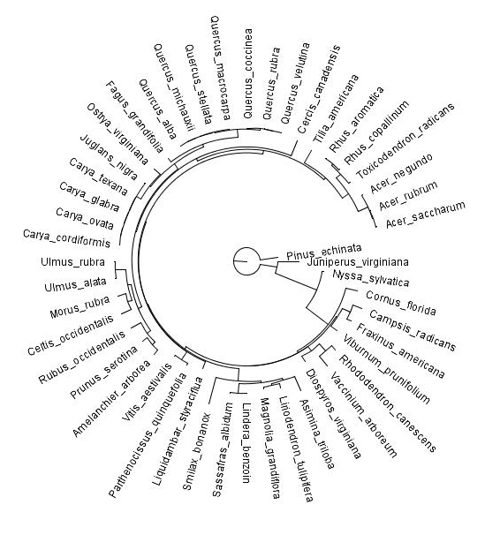
Appendix 1 Maximum phylogeny on all species observed in seedling, sapling, and tree communities both before and after the derecho.

Appendix 2 Seedling-based taxonomic and phylogenetic non-metric multidimensional scaling (TNMDS and PNMDS, respectively) ordinations for both before (Pre) and after (Post) derecho. Ordination contours based on elevation (m) are provided as well as significant vectors (see Appendix 5).
Appendix 3Sapling-based taxonomic and phylogenetic non-metric multidimensional scaling (TNMDS and PNMDS, respectively) ordinations for both before (Pre) and after (Post) derecho. Ordination contours based on elevation (m) are provided as well as significant vectors (see Appendix 5).
Appendix 4 Tree-based taxonomic and phylogenetic non-metric multidimensional scaling (TNMDS and PNMDS, respectively) ordinations for both before (Pre) and after (Post) derecho. Ordination contours based on elevation (m) are provided as well as significant vectors (see Appendix 5).

Appendix 5 Coefficient of determination (r²) values from vector analyses for seedling, sapling, and tree communities for taxonomic and phylogenetic non-metric multidimensional scaling (TNMDS and PNMDS, respectively) based on both before (Pre) and after (Post) the derecho. All significant vectors (P < 0.05) are represented in bold text.
 | Seedling |  |  |  | Sapling |  |  |  | Tree
 | TNMDS |  | PNMDS |  | TNMDS |  | PNMDS |  | TNMDS |  | PNMDS
 | Pre | Post | Pre | Post | Pre | Post | Pre | Post | Pre | Post | Pre | Post
Elevation | 0.65 | 0.69 | 0.57 | 0.57 | 0.67 | 0.51 | 0.2 | 0.22 | 0.62 | 0.66 | 0.53 | 0.57
Aspect | 0.02 | 0.01 | 0.02 | 0.03 | 0.1 | 0.18 | 0.13 | 0.04 | 0.02 | 0.04 | 0.02 | 0.01
Slope | 0.24 | 0.32 | 0.26 | 0.37 | 0.29 | 0.11 | 0.02 | 0.03 | 0.34 | 0.36 | 0.22 | 0.28
MLI | 0.09 | 0.08 | 0.08 | 0.12 | 0.19 | 0.56 | 0.16 | 0.09 | 0.24 | 0.16 | 0.23 | 0.28
MI | 0.33 | 0.25 | 0.23 | 0.23 | 0.17 | 0.26 | 0.1 | 0.09 | 0.29 | 0.3 | 0.24 | 0.29
TSI | 0.28 | 0.27 | 0.26 | 0.24 | 0.39 | 0.47 | 0.39 | 0.16 | 0.31 | 0.34 | 0.25 | 0.27
Duff Depth | 0.16 | 0.1 | 0.04 | 0.02 | 0.02 | 0.16 | 0.2 | 0.15 | 0.09 | 0.12 | 0.02 | 0.14
Soil Depth | 0.27 | 0.34 | 0.27 | 0.3 | 0.24 | 0.22 | 0.21 | 0.19 | 0.28 | 0.21 | 0.27 | 0.3
TSR | 0.44 | 0.38 | 0.75 | 0.76 | 0.13 | 0.14 | 0.41 | 0.14 | 0.33 | 0.51 | 0.29 | 0.2
PSR | 0.55 | 0.51 | 0.81 | 0.83 | 0.6 | 0.51 | 0.23 | 0.35 | 0.16 | 0.33 | 0.43 | 0.4
NRI | 0.21 | 0.3 | 0.44 | 0.46 | 0.51 | 0.03 | 0.34 | 0.04 | 0.01 | 0.01 | 0.26 | 0.27
NTI | 0.05 | 0.19 | 0.12 | 0.27 | 0.55 | 0.07 | 0.16 | 0.02 | 0.02 | 0.01 | 0.12 | 0.24

Appendix 6 Cross-validation error of CoK, IDW, and OK interpolation method of seedling, sapling, and tree communities before (2008) and after (2010) the derecho.
Spatial Interpolation | Diversity Index | Statistical Parameters | Seedling |  | Sapling |  | Tree
Spatial Interpolation | Diversity Index | Statistical Parameters | Year 2008 | Year 2010 | Year 2008 | Year 2010 | Year 2008 | Year 2010
CoK  (CoKriging) | TSR | Mean | -0.13 | 0.10 | -0.07 | -0.07 | -0.18 | -0.17
CoK  (CoKriging) | TSR | RMSE | 4.14 | 4.46 | 1.79 | 3.99 | 2.26 | 2.37
CoK  (CoKriging) | PSR | Mean | -0.05 | 0.02 | -0.01 | 0.00 | 0.00 | 0.00
CoK  (CoKriging) | PSR | RMSE | 1.17 | 1.29 | 0.15 | 0.30 | 0.18 | 0.18
CoK  (CoKriging) | NRI | Mean | 0.01 | 0.01 | -0.13 | -0.11 | -0.02 | -0.01
CoK  (CoKriging) | NRI | RMSE | 0.59 | 0.65 | 1.57 | 1.28 | 0.72 | 0.72
CoK  (CoKriging) | NTI | Mean | 0.00 | 0.02 | 0.02 | 0.02 | -0.02 | -0.02
CoK  (CoKriging) | NTI | RMSE | 0.74 | 0.75 | 0.97 | 0.80 | 0.76 | 0.73
OK  (Ordinary Kriging) | TSR | Mean | -0.16 | 0.09 | -0.07 | -0.10 | -0.08 | -0.13
OK  (Ordinary Kriging) | TSR | RMSE | 4.37 | 4.49 | 1.79 | 4.28 | 2.33 | 2.32
OK  (Ordinary Kriging) | PSR | Mean | -0.06 | -0.02 | -0.01 | -0.01 | -0.01 | 0.00
OK  (Ordinary Kriging) | PSR | RMSE | 1.26 | 1.28 | 0.15 | 0.32 | 0.19 | 0.19
OK  (Ordinary Kriging) | NRI | Mean | 0.05 | 0.06 | 0.05 | 0.02 | -0.02 | -0.03
OK  (Ordinary Kriging) | NRI | RMSE | 0.65 | 0.65 | 0.86 | 0.63 | 0.75 | 0.74
OK  (Ordinary Kriging) | NTI | Mean | 0.03 | 0.08 | 0.03 | 0.01 | -0.03 | -0.04
OK  (Ordinary Kriging) | NTI | RMSE | 0.78 | 0.76 | 0.92 | 0.79 | 0.76 | 0.72
IDW  (Inverse Distance Weighting) | TSR | Mean | -0.09 | 0.09 | -0.08 | 0.14 | -0.13 | -0.05
IDW  (Inverse Distance Weighting) | TSR | RMSE | 4.94 | 4.59 | 1.97 | 4.54 | 2.46 | 2.73
IDW  (Inverse Distance Weighting) | PSR | Mean | -0.10 | 0.06 | -0.01 | 0.00 | -0.01 | -0.01
IDW  (Inverse Distance Weighting) | PSR | RMSE | 1.38 | 1.26 | 0.17 | 0.34 | 0.19 | 0.20
IDW  (Inverse Distance Weighting) | NRI | Mean | 0.05 | 0.10 | 0.03 | 0.02 | 0.04 | 0.03
IDW  (Inverse Distance Weighting) | NRI | RMSE | 0.64 | 0.66 | 0.87 | 0.63 | 0.80 | 0.81
IDW  (Inverse Distance Weighting) | NTI | Mean | 0.05 | 0.10 | 0.00 | 0.00 | 0.02 | 0.00
IDW  (Inverse Distance Weighting) | NTI | RMSE | 0.79 | 0.77 | 0.98 | 0.84 | 0.80 | 0.74

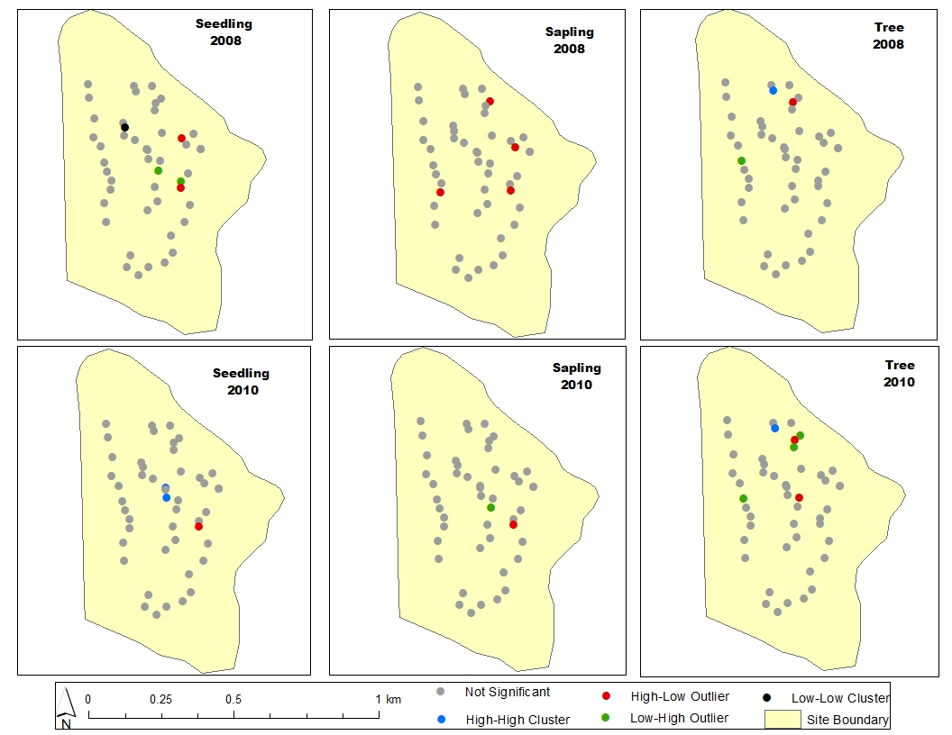
Appendix 7 Local Moran’s Analysis of taxonomic species richness (TSR: total number of species; seedlings based on 0.004 ha plots; saplings and trees based on 0.04 ha plots) to examine the nature of clustering in each stratum (seedling, sapling, and tree) before (2008) and after (2010) the derecho. High-high clustering indicates that the plots are surrounded by high median TSR values and their values are significantly higher than TSR values in neighboring plots while that inverse is true for the low-low clustering

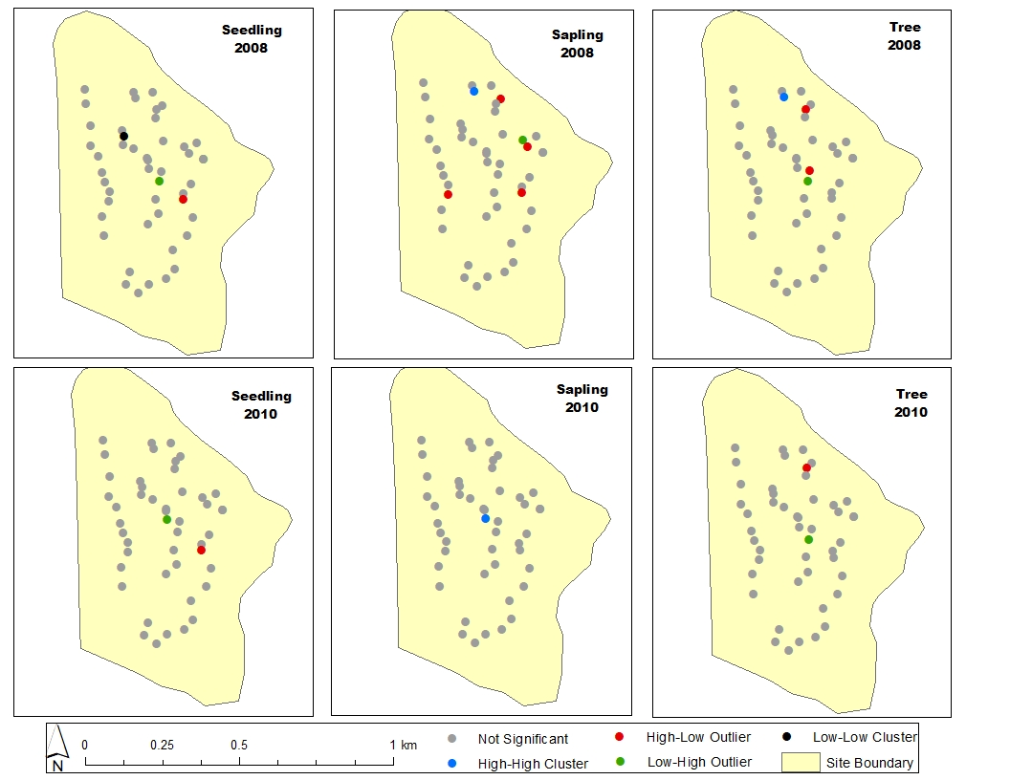
Appendix 8 Local Moran Analysis of phylogenetic species richness (PSR: MPD multiplied by TSR) to examine the nature of clustering in each stratum (seedling, sapling, and tree) before (2008) and after (2010) the derecho. High-high clustering indicates that the plots are surrounded by high median PSR values and their values are significantly higher than PSR values in neighboring plots while that inverse is true for the low-low clustering

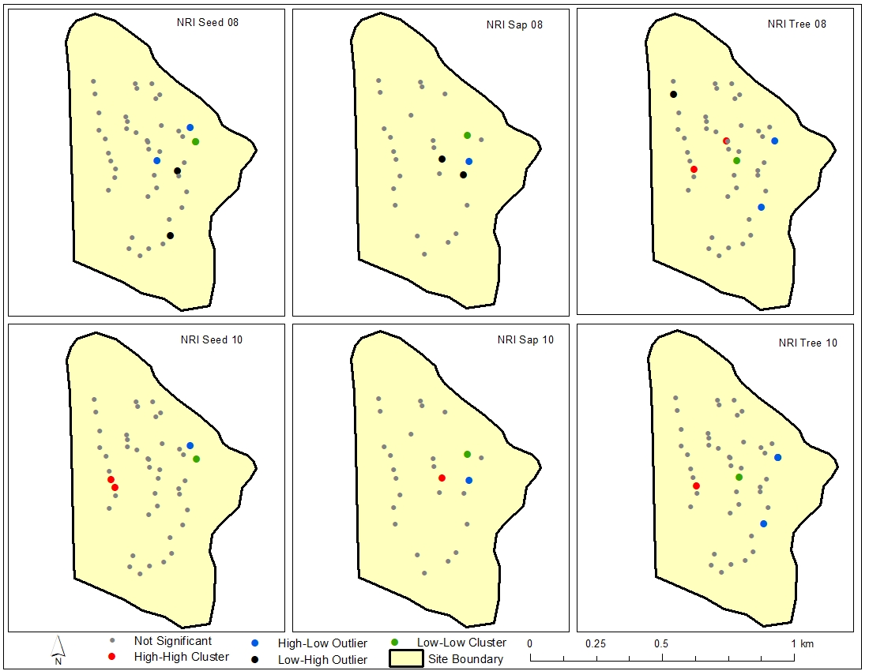Appendix 9 Local Moran Analysis of net relatedness index (NRI) to examine the nature of clustering in each stratum (seedling, sapling, and tree) before (2008) and after (2010) the derecho. High-high clustering indicates that the plots are surrounded by high median NRI values and their values are significantly higher than NRI values in neighboring plots while that inverse is true for the low-low clustering
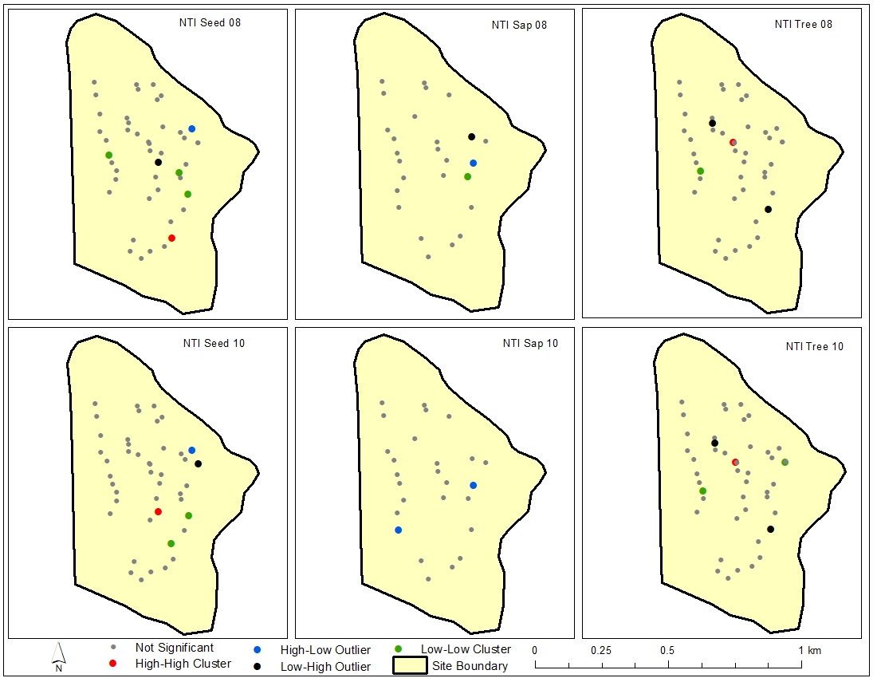
Appendix 10 Local Moran Analysis of nearest taxon index (NTI) to examine the nature of clustering in each stratum (seedling, sapling, and tree) before (2008) and after (2010) the derecho. High-high clustering indicates that the plots are surrounded by high median NTI values and their values are significantly higher than NTI values in neighboring plots while that inverse is true for the low-low clustering

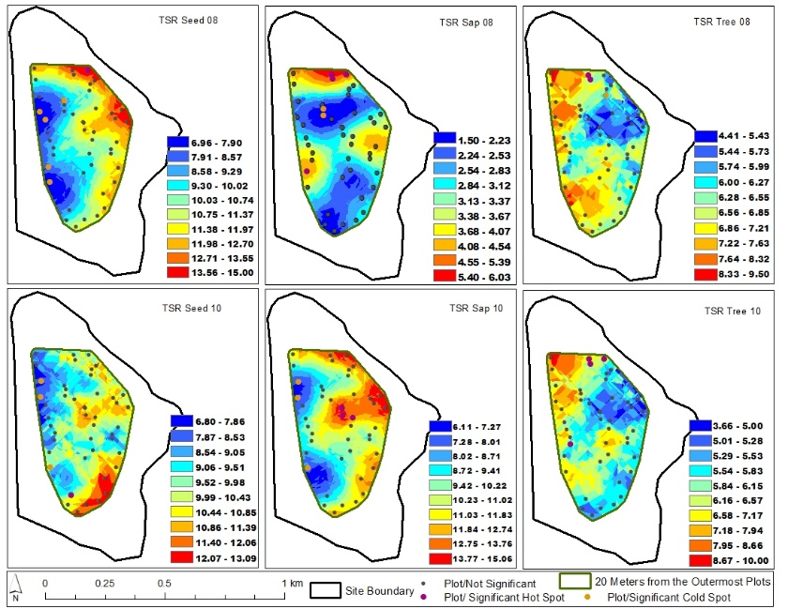
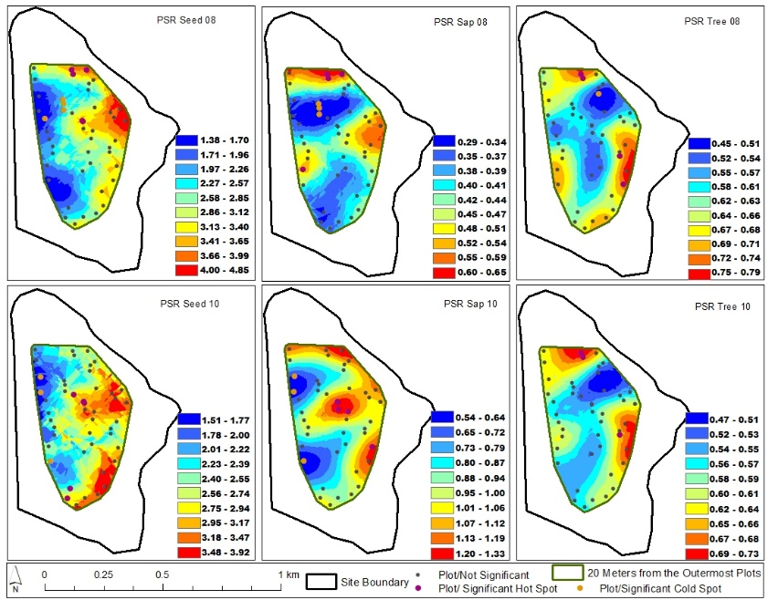
Appendix 11 Co-Kriging-based spatial interpolation of taxonomic (total number of species; seedlings based on 0.004 ha plots; saplings and trees based on 0.04 ha plots) and phylogenetic species richness (MPD multiplied by TSR; TSR and PSR, respectively) before (08) and after (10) the derecho for seedling, sapling, and tree communities.
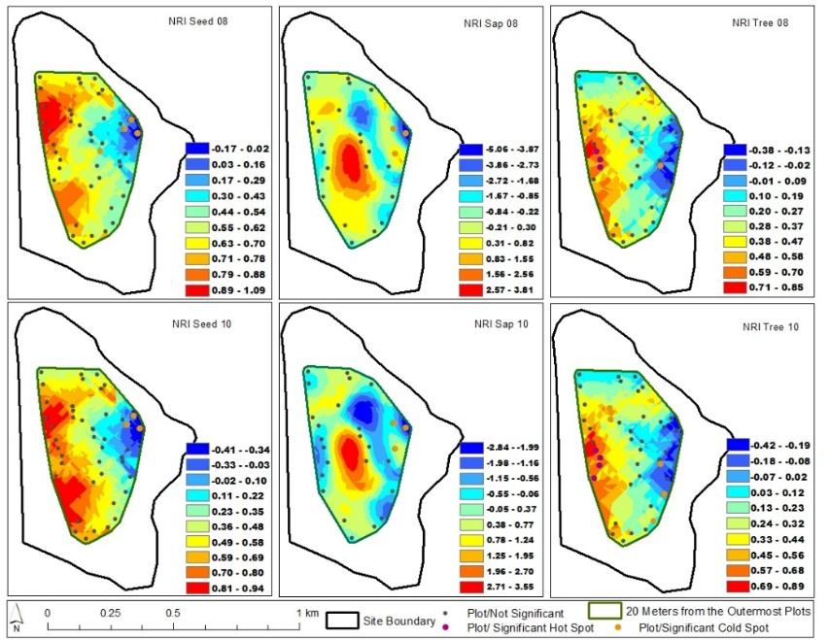
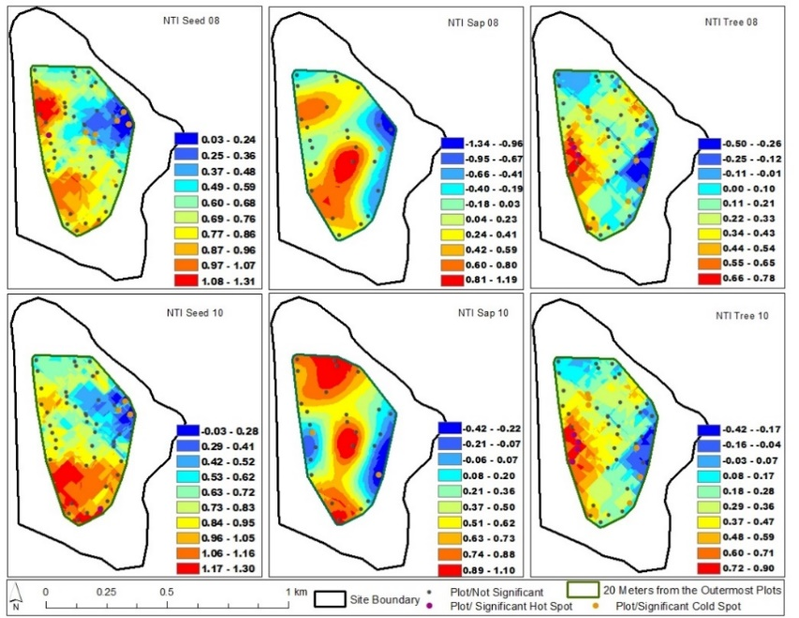
Appendix 12 Co-Kriging-based spatial interpolation of net relatedness and nearest taxon indices (NRI and NTI, respectively) before (08) and after (10) the derecho for seedling, sapling, and tree communities.

