Supplementary Figures
Supplementary Figure 1. The mRNA expression of HCC-related genes (Afp, Gpc3 and Prom1) and cell proliferation-associated genes (Ccnb1, Ccne1, Cdk6, Bub1 and Mki67) in normal liver and c-MET/sgp53 tumors. At least 3 mice in each group were assayed. Data are shown as mean ± SD. Welch’s t test: **P < 0.01, ***P < 0.001, ****P < 0.0001.

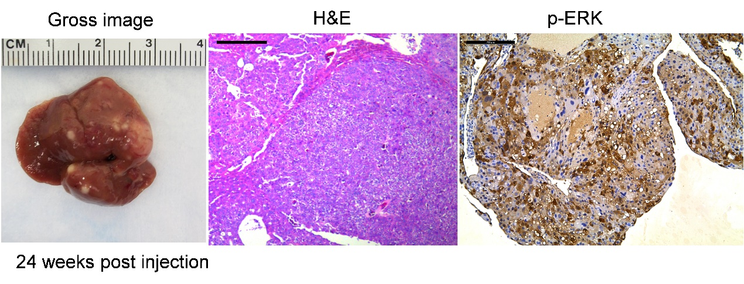
Supplementary Figure 2. Representative gross images, H&E staining, and p-ERK staining in tumor lesions from a c-MET/sgp53 mouse liver. Plasmids injection dose: 20μg pT3-EF1α-c-MET, 20μg pX330-sgp53 and 0.8μg pCMV/SB; Scale bar = 200 μm.
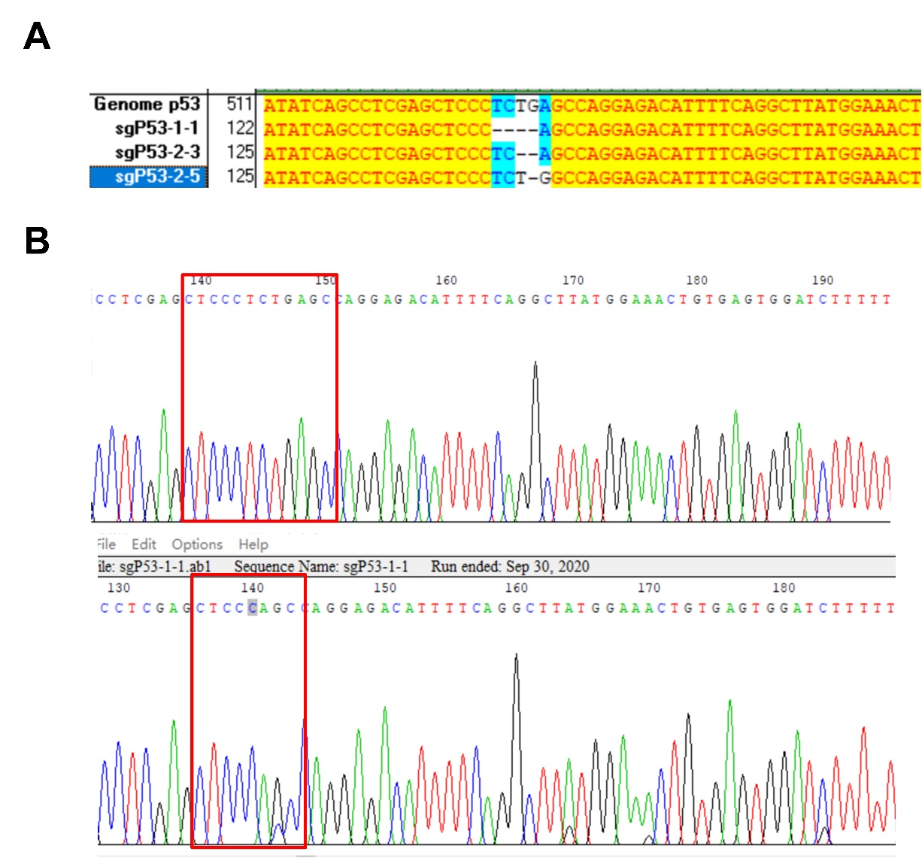
Supplementary Figure 3. Genomic sequencing and validation of Trp53 deletion in mouse HCCs. (A) The Sanger sequencing results from different clones with sgp53 induced mutation from mouse tumor nodules, confirming the nucleotide deletions of Trp53 on its genomic locus. (B) Original wild-type mouse Trp53 alleles and one of the representative nucleotide deletions of Trp53 caused by sgp53.

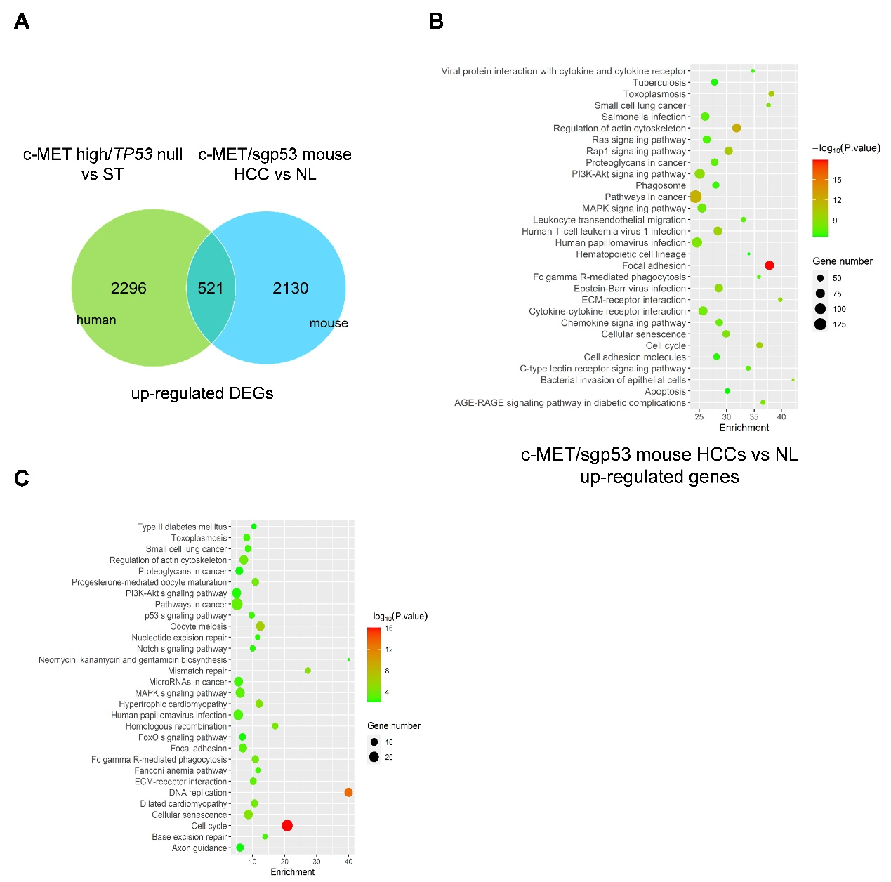
Supplementary Figure 4. The details of KEGG pathway analysis of up-regulated DEGs in the c-MET/sgp53 HCCs. (A) Numbers of overlapping up-regulated DEGs in c-MET/sgp53 HCC and c-MET-high/TP53-null human HCC. (B) KEGG analysis of up-regulated genes in the c-MET/sgp53 HCCs as compared to normal livers. (C) KEGG analysis of overlapping up-regulated DEGs in c-MET/sgp53 HCCs and c-MET-high/TP53-null human HCCs. NL, normal livers; ST, surrounding tissues; DEG, differentially expressed genes. (This figure is related to Figure 3B and C).

Supplementary Figure 5. Heatmap of MAPK pathway genes in c-MET/sgp53 mouse HCC vs normal liver.

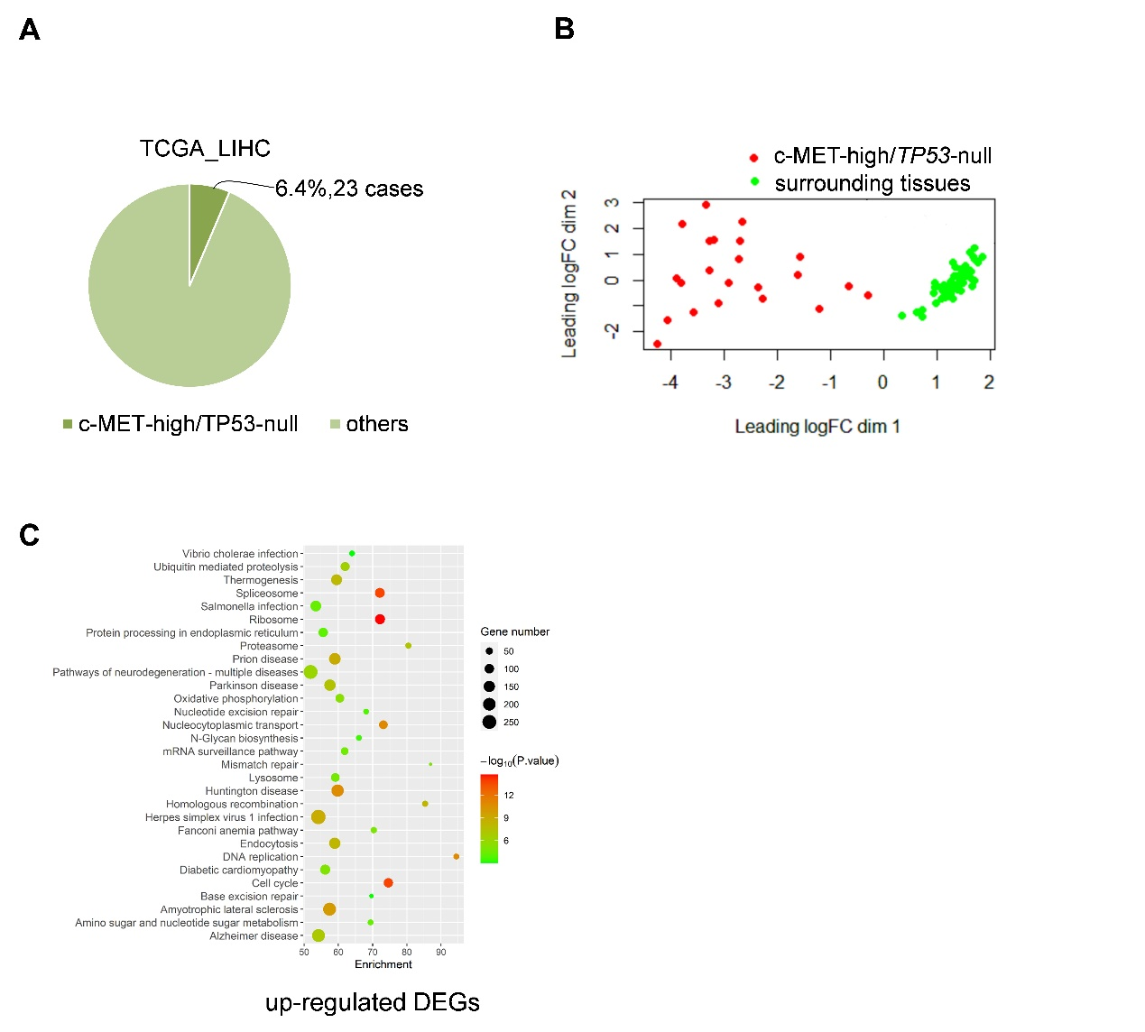
Supplementary Figure 6. A subset of human HCC samples harboring concomitant c-MET activation and TP53 deletion based on the TCGA-LIHC dataset.
(A) The number and percentage of c-MET-high/TP53-null human HCC cases in TCGA-LIHC database. (B) Genetic dissimilarity among the samples in c-MET-high/TP53-null human HCCs and surrounding tissues as demonstrated by multidimensional scaling (MDS). (C) KEGG analysis of up-regulated genes in c-MET-high/TP53-null human HCCs as compared to surrounding tissues.

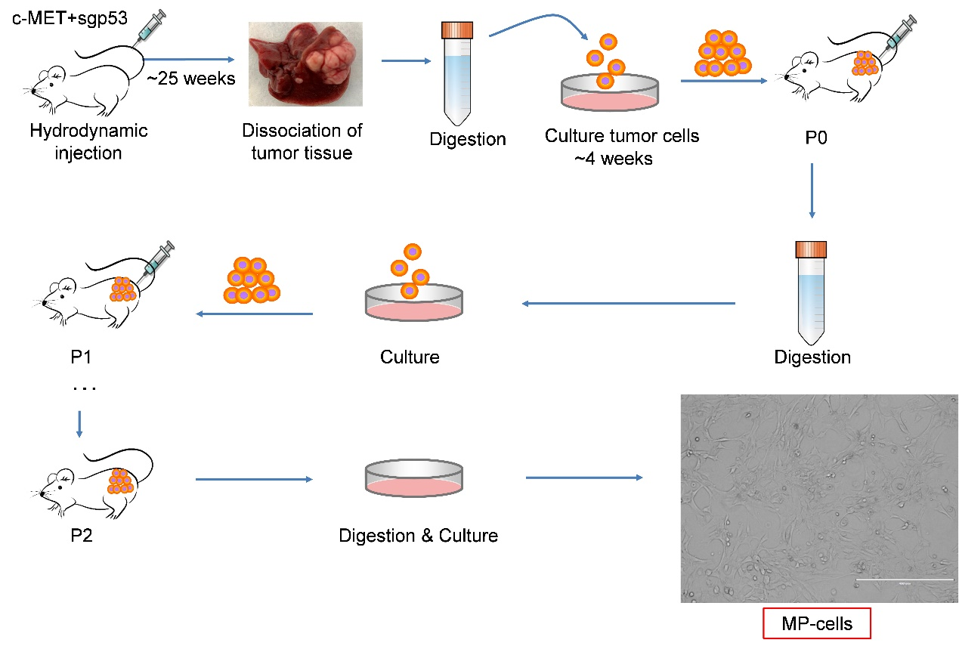
Supplementary Figure 7. Illustration of generating the stably passaged cell line from c-MET/sgp53 HCC.

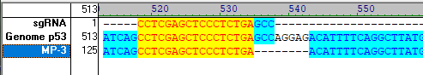
Supplementary Figure 8. Genomic sequencing and validation of Trp53 deletion in MP cells.

Supplementary Figure 9. MEK inhibitors show a higher inhibition score in TP53-null human HCC cell line.
The IC50 value of TP53-null HCC cell line (Hep3B) and other human HCC cell lines for MEK inhibitors (SCH772984, ERK2440, ERK6604 and trametinib) base on the Genomics of Drug Sensitivity in Cancer database (www.cancerRxgene.org). IC50, half maximal inhibitory concentration.

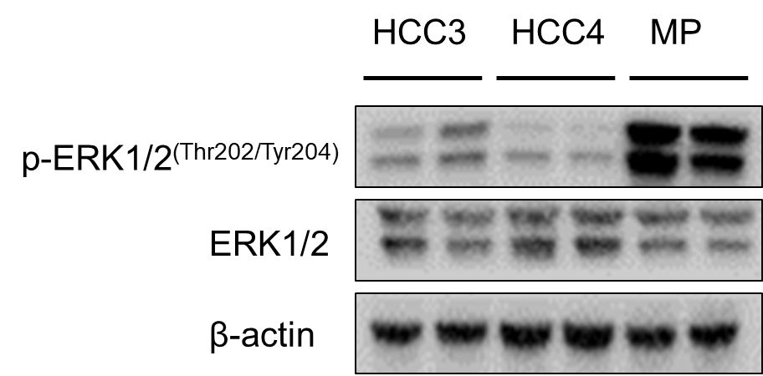
Supplementary Figure 10. Western blotting analysis of ERK signaling in MP, HCC3 and HCC4 mouse HCC cells.

