Protomer Selectivity of RAF Inhibitors Within the RAS/RAF Signalosome
James D. Vasta, Ani Michaud, Chad A. Zimprich, Rae Thomas, Jennifer Wilkinson, Aaron Crapster, Matthew B. Robers

Table of Contents

Supplementary Figure 1 3
Supplementary Figure 2 5
Supplementary Figure 3 7
Supplementary Figure 4 9
Supplementary Figure 5 11
Supplementary Figure 6 13
Supplementary Figure 7 15
Supplementary Figure 8 17
Supplementary Figure 9 19
Supplementary Figure 10 21
Supplementary Figure 11 23

Supplementary Figure 1
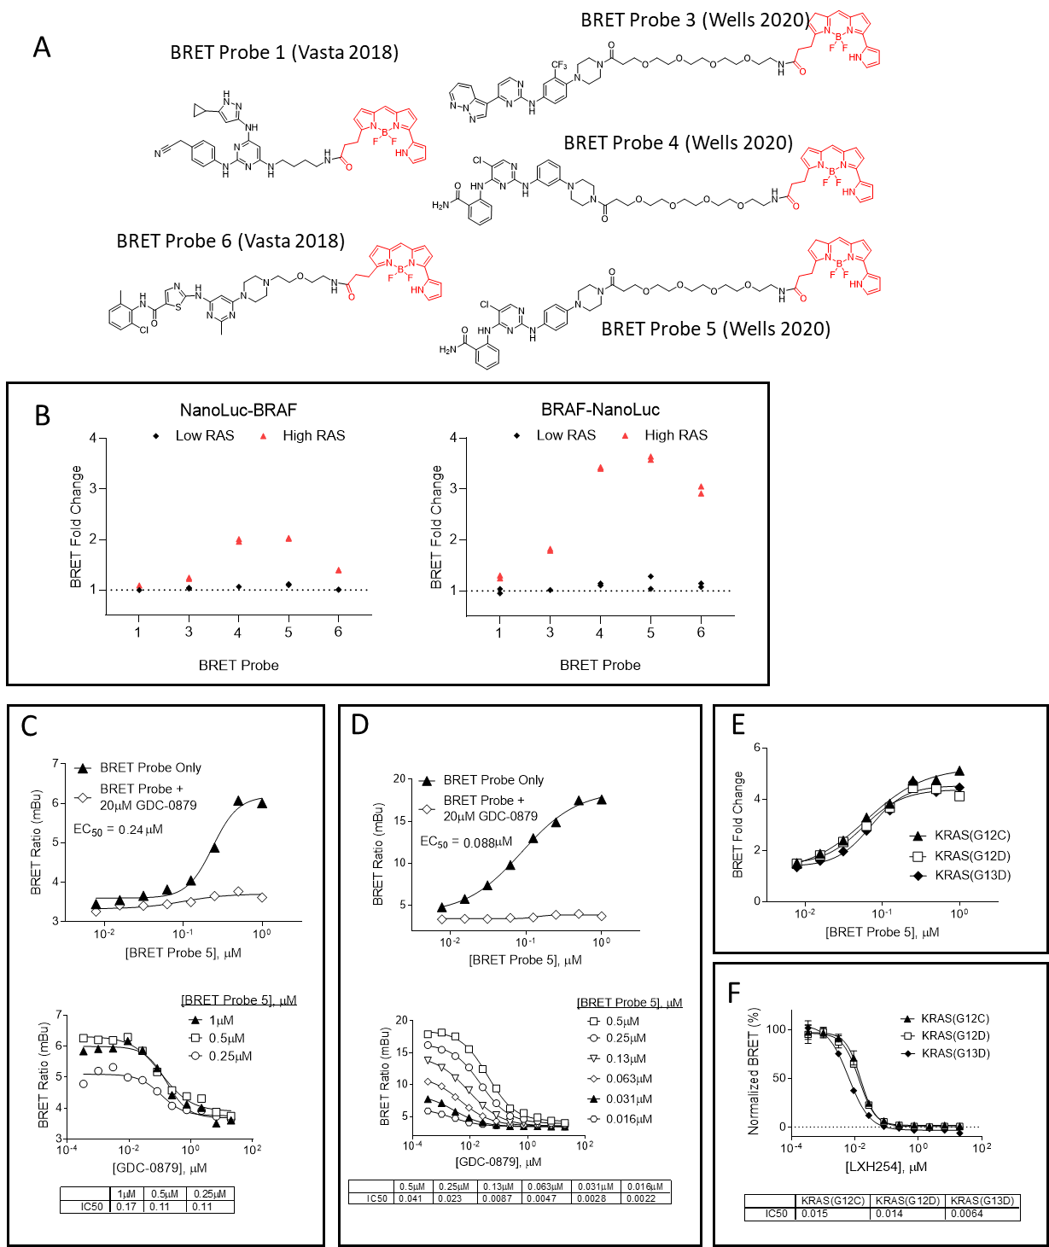

Supplementary Figure 1. Assay development for BRAF target engagement under low and high RAS conditions. (A) Structures of BRET probes used in this experiment. (B) Determination of specific BRET for the BRET probes depicted in panel A. BRET probes (1µM) were added to cells expressing either N-terminal (left panel) or C-terminal (right panel) BRAF/NanoLuc fusions under low or high KRAS(G12C) conditions in the presence or absence of 20 µM LY3009120. Specific BRET is reported as BRET fold change by normalizing the raw BRET value of the probe only samples to the raw BRET value in the presence of 20µM LY3009120. Data points are technical duplicates from a single experiment (n = 1). (C and D) Characterization of BRET for BRAF-NanoLuc with BRET Probe 5 under low RAS (C) or high KRAS(G12C) (D) conditions. Data points for probe titrations (top panels) are the mean of technical duplicates (n = 1). Data points for the GDC-0879 dilution series at varying BRET probe concentration (bottom panels) are technical singlicates (n=1). BRET probe concentrations chosen for subsequent IC₅₀ measurements are depicted in solid black (right panels). (E) The impact of different KRAS mutants on assay behavior for BRAF-NanoLuc under high RAS conditions. For the BRET probe 5 dose response (top panel), BRET fold change was calculated by normalizing the BRET value at each tracer concentration to the BRET value in the presence of 20µM GDC-0879. Individual data points from the BRET probe dose response represent technical singlicates from a single experiment (n = 1). (F) LXH254 potency was measured in each case using 31 nM BRET probe 5. Data for KRAS G13D is also shown in main Figure 1E. Individual data points from the LXH254 dose response curves are the mean ± S.D. of 4 technical replicates from a single experiment (n = 1).

Supplementary Figure 2

Supplementary Figure 2. BRAF TE for RAFi under low and high RAS conditions. BRAF-NanoLuc was co-expressed along with untagged KRAS(G12C) (high RAS) or a promoterless carrier DNA (low RAS) in HEK293 cells. The cells were treated with BRET Probe 5 and RAFi, and competition of the BRET signal was measured after a 2-hour incubation. (A−S) Target engagement potency under low and high RAS conditions for various RAFi. For RAF265 (R), individual data points are the mean ± S.E.M. of 5 independent experiments (n=5). For Regorafenib (J), individual data points are the mean ± S.E.M. of 4 independent experiments (n=4). For all other RAFi, individual data points are the mean ± S.E.M. of 3 independent experiments (n=3).

Supplementary Figure 3

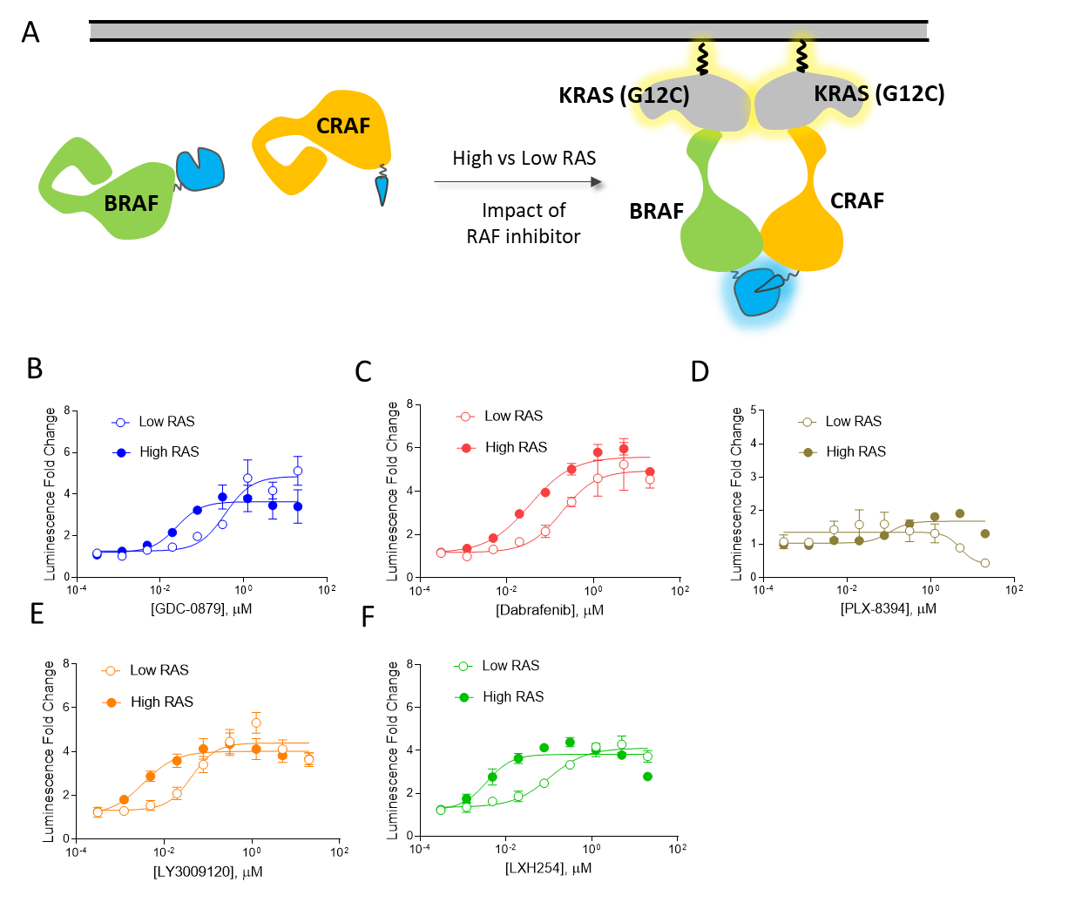

Supplementary Figure 3. Impact of RAS and RAFi on BRAF:CRAF dimerization. (A) Schematic overview of the assay. BRAF-SmBiT and CRAF-LgBiT were co-expressed along with untagged KRAS(G12C) (high RAS) or a promoterless carrier DNA (low RAS) in HEK293 cells. Luminescence was measured in the presence or absence of test compound. (B−F) Influence of RAS on induction of BRAF:CRAF dimerization in the presence of RAF inhibitors. For GDC-0879, individual data points are the mean ± S.E.M. of four independent experiments (n=4). For all other compounds, individual data points are the mean ± S.E.M. of three independent experiments (n=3).

Supplementary Figure 4

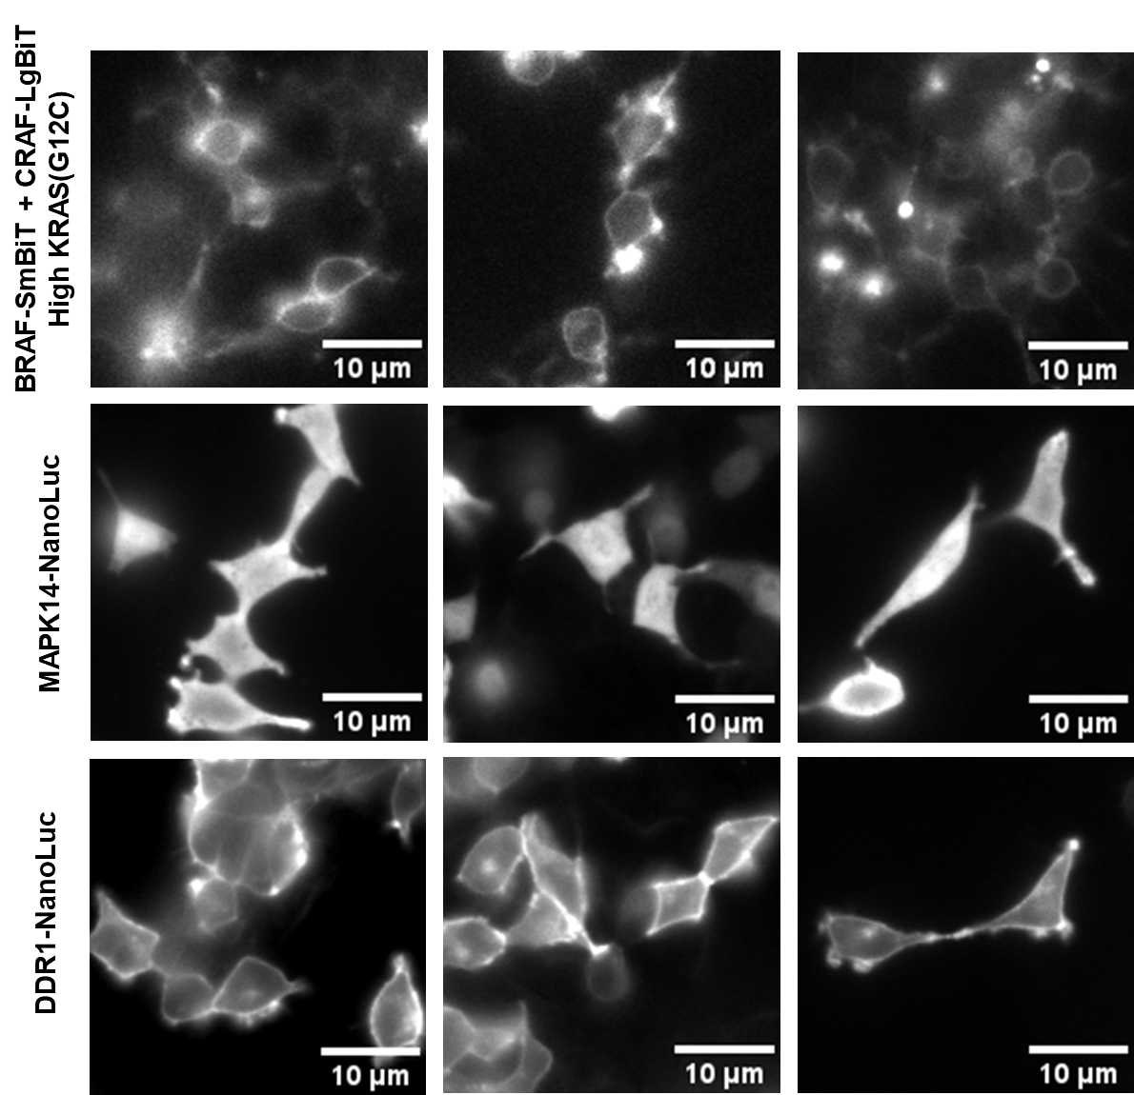

Supplementary Figure 4. Bioluminescent imaging of BRAF/CRAF heterodimers. HEK293 cells expressing BRAF/CRAF NanoBiT heterodimers under high KRAS(G12C) (top), MAPK14-NanoLuc (middle) or DDR1-NanoLuc (bottom). Corresponds to Figure 2. Data are representative of biological duplicates (n=2).

Supplementary Figure 5

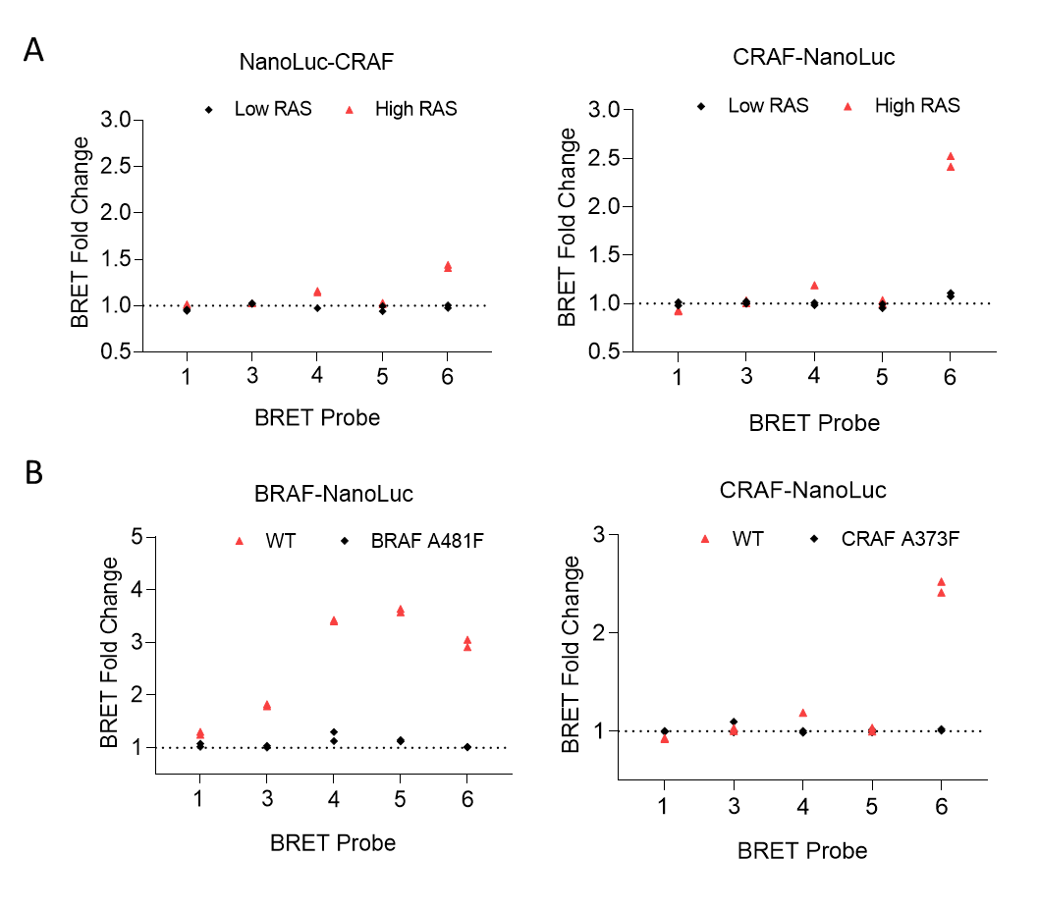

Supplementary Figure 5. Determination of specific BRET for RAF/NanoLuc fusion constructs with the BRET probe panel. BRET probes (1µM) were added to cells expressing RAF/NanoLuc fusions under low or high KRAS(G12C) conditions in the presence or absence of 20µM LY3009120. Specific BRET is reported as BRET fold change by dividing the raw BRET value of the probe only samples to the raw BRET value in the presence of 20µM LY3009120. (A) Determination of specific BRET for N-terminal or C-terminal CRAF/NanoLuc constructs. Data points are technical duplicates from a single experiment (n = 1). (B) Impact of active site-blocking mutations on specific BRET with BRAF-NanoLuc or CRAF-NanoLuc fusions under high RAS conditions. Data points are technical duplicates from a single experiment (n = 1).

Supplementary Figure 6
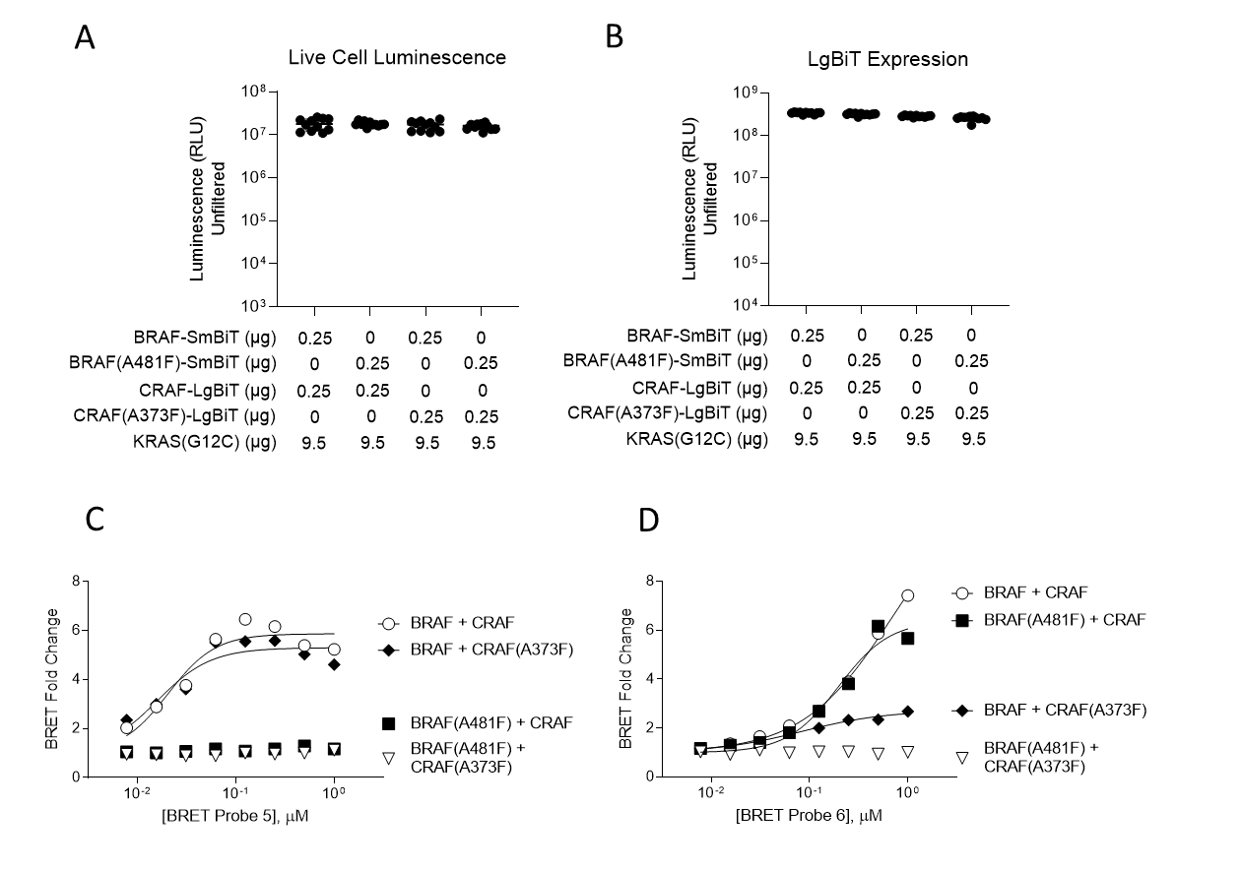

Supplementary Figure 6. Protomer-specific target engagement assay development for BRAF/CRAF heterodimers under high KRAS(G12C) conditions. BRAF-SmBiT, CRAF-LgBiT, and/or active site mutant constructs thereof were transfected into HEK293 cells under high KRAS(G12C) conditions as described in the methods. (A) Total live cell luminescence for BRAF/CRAF construct combinations. Data are the mean ± S.D. of 11 technical replicates from a single experiment (n = 1). (B) Relative LgBiT expression levels for the samples from panel A determined as the total luminescence after adding a saturating dose of HiBiT peptide under lytic conditions. Data are the mean ± S.D. of 11 technical replicates from experiments performed once (n = 1). (C and D) Characterization of specific BRET for BRET Probe 5 (C) or BRET Probe 6 (D). Data are the fold change in BRET for the BRET probe at each probe concentration where fold change is calculated by dividing the BRET for the vehicle treated samples by the BRET for the samples treated with 20µM LY3009120. Individual data points are technical singlicates (n = 1).

Supplementary Figure 7
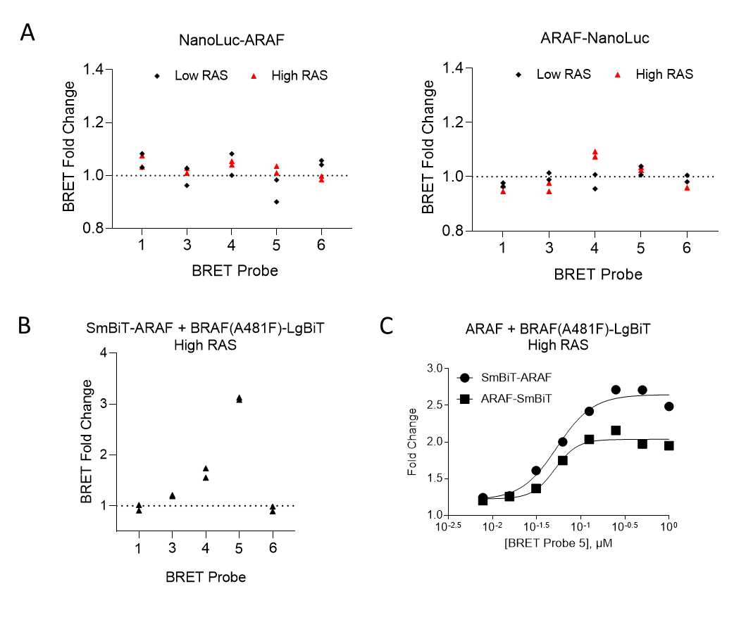

Supplementary Figure 7. ARAF protomer specific target engagement assay development for BRAF/ARAF heterodimers under high KRAS(G12C) conditions. (A) BRET probe screen for NanoLuc-ARAF (left panel) or ARAF-NanoLuc (right panel) fusions were transfected into HEK293 cells under high KRAS(G12C) conditions as described in the methods. BRET probes (1µM) were added to cells expressing ARAF/NanoLuc fusions in the presence or absence of 20µM LY3009120. Specific BRET is reported as BRET fold change by normalizing the raw BRET value of the probe only samples to the raw BRET value in the presence of 20µM LY3009120. Data points are technical duplicates from experiments performed once (n = 1). (B) BRET probe screen for the ARAF protomer within ARAF/BRAF(A481F) heterodimers. SmBiT-ARAF was co-transfected with BRAF-LgBiT under high KRAS(G12C) conditions as described in the methods. BRET probes were screened as described above in panel A. Data are technical duplicates from experiments performed once (n = 1). (C) SmBiT-ARAF demonstrated increased BRET with BRET probe 5 compared to ARAF-SmBiT. Individual data points are the mean of technical singlicates from experiments performed once (n = 1).

Supplementary Figure 8
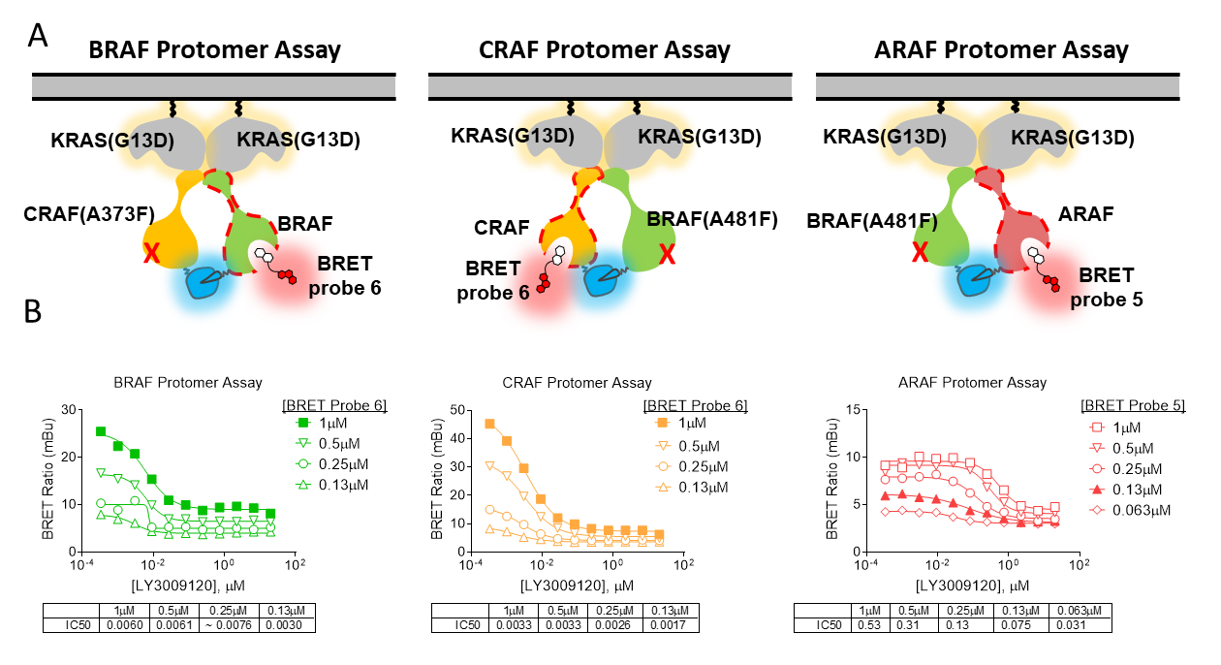

Supplementary Figure 8. RAF Protomer Assays using dimers induced by KRAS(G13D). (A) Schematic overview of the assays. RAF/NanoBiT fusions (and mutants thereof) are co-expressed in HEK293 cells along with untagged KRAS(G13D) as described in the methods. The cells are treated with BRET Probe 5 (ARAF protomer) or BRET probe 6 (B- and CRAF protomers) and RAFi, and competition of the BRET signal is measured after a 2-hour incubation. (B) Impact of BRET probe concentration on engagement potency at the RAF protomers co-expressed with KRAS(G13D). Data points for the LY3009120 dilution series at varying BRET probe concentration are technical singlicates from a single experiment (n=1). BRET probe concentrations chosen for subsequent IC₅₀ measurements are depicted in solid black.

Supplementary Figure 9
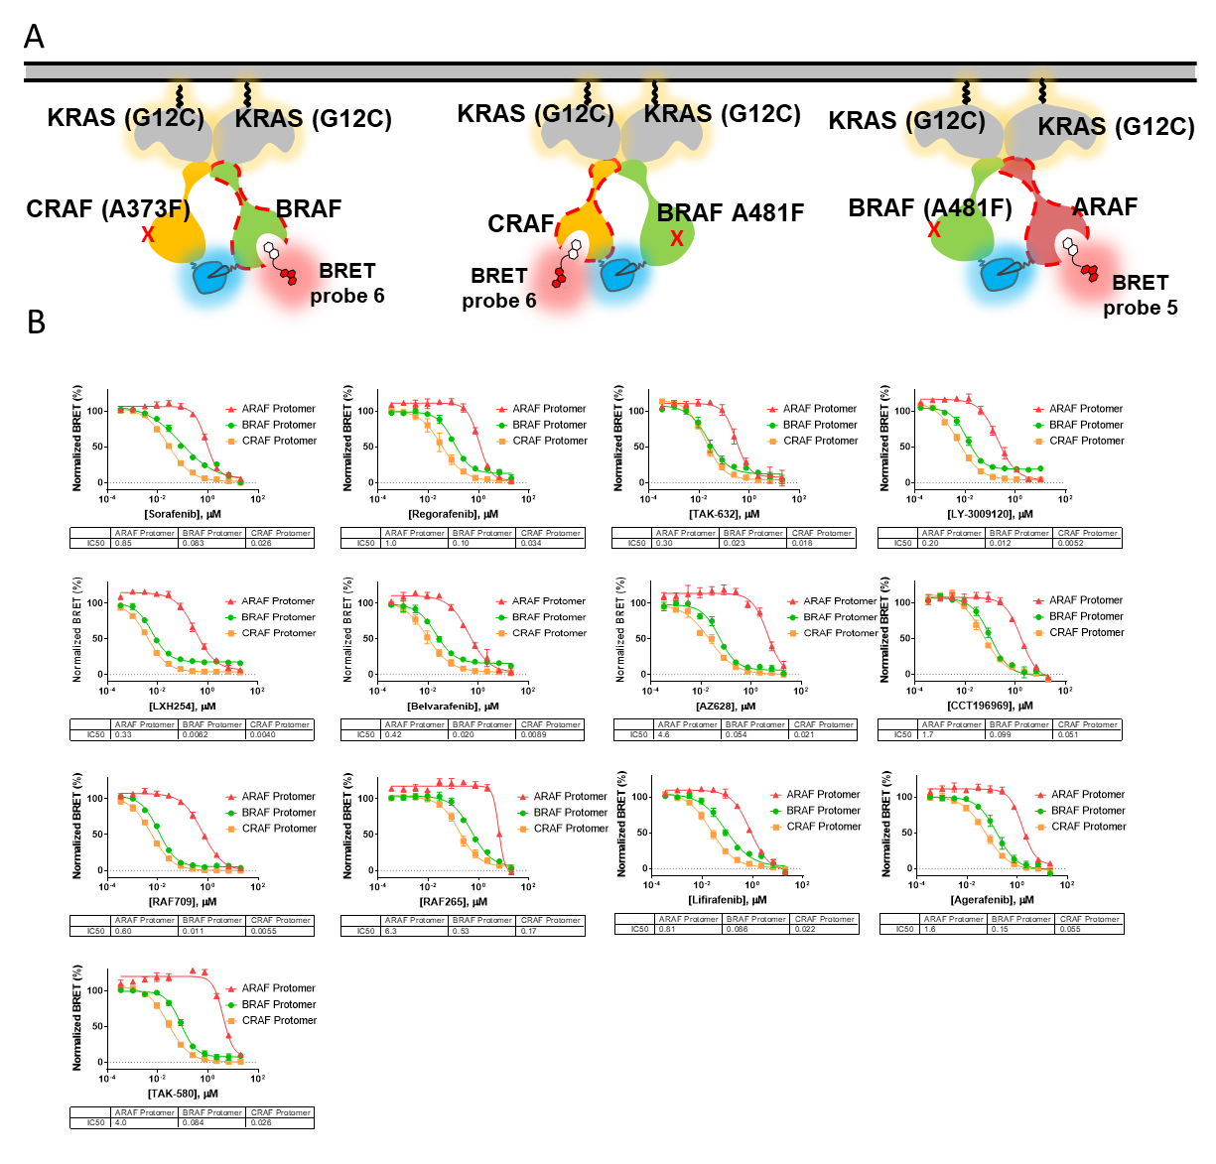

Supplementary Figure 9. Cellular BRET competition curves for RAFi within specific protomers of KRAS(G12C)-induced RAF heterodimers. (A) Schematic overview of the assay. RAF/NanoBiT fusions (and mutants thereof) were co-expressed in HEK293 cells along with untagged KRAS(G12C) as described in the methods. The cells are treated with BRET Probes 6 or 5 and RAFi, and competition of the BRET signal was measured after a 2-hour incubation. (B) Competition curves for each RAF protomer under high RAS conditions for various RAFi. For all RAFi, individual data points represent the mean ± S.E.M. from 3 independent experiments (n=3), each collected with 4 technical replicates.

Supplementary Figure 10

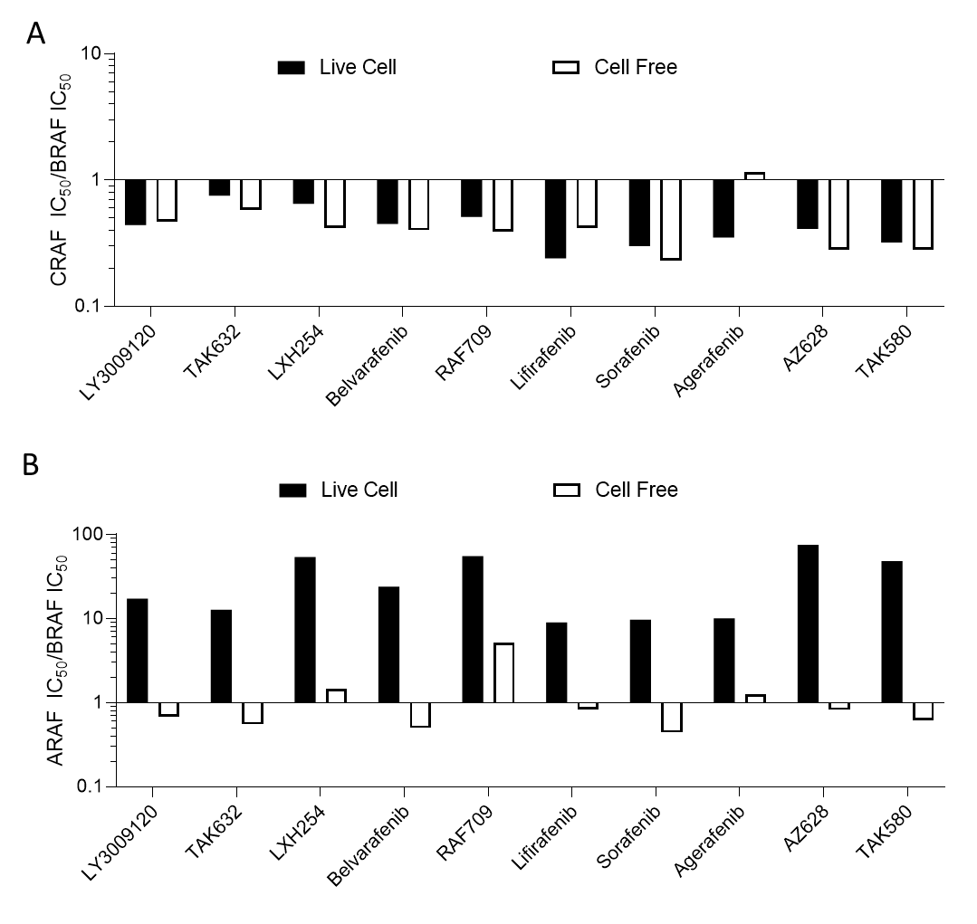

Supplementary Figure 10. Biochemical vs Cellular protomer binding selectivity for RAFi. (A) The ARAF vs BRAF (A) or CRAF vs BRAF (B) protomer selectivity ratios for select RAFi. The live cell potency values were measured using the cellular RAF protomer assays where the dimers were induced under High RAS conditions with KRAS(G12C) (see figure 2E for assay schematics) and are taken from Figure 3/Supplementary Figure 8. The cell free IC₅₀ values were determined from inhibitor dose responses measured for recombinant cascade enzyme activity assay formats using a microfluidic-based LabChip 3000 Drug Discovery System (assays performed by Nanosyn, Sunnyvale, CA; reference Extended Data Table 6). RAF709 inhibition of ARAF, data are the mean of 2 independent experiments. For all other cell free data points, data are the mean ± S.E.M. of 3 independent experiments (n = 3).

Supplementary Figure 11

Supplementary Figure 11. Inhibition of Phospho-ERK activity by RAFi in DLD1 cells. Data points are the mean of technical duplicates from a single experiment (n=1).

