SUPPLEMENTAL MATERIAL

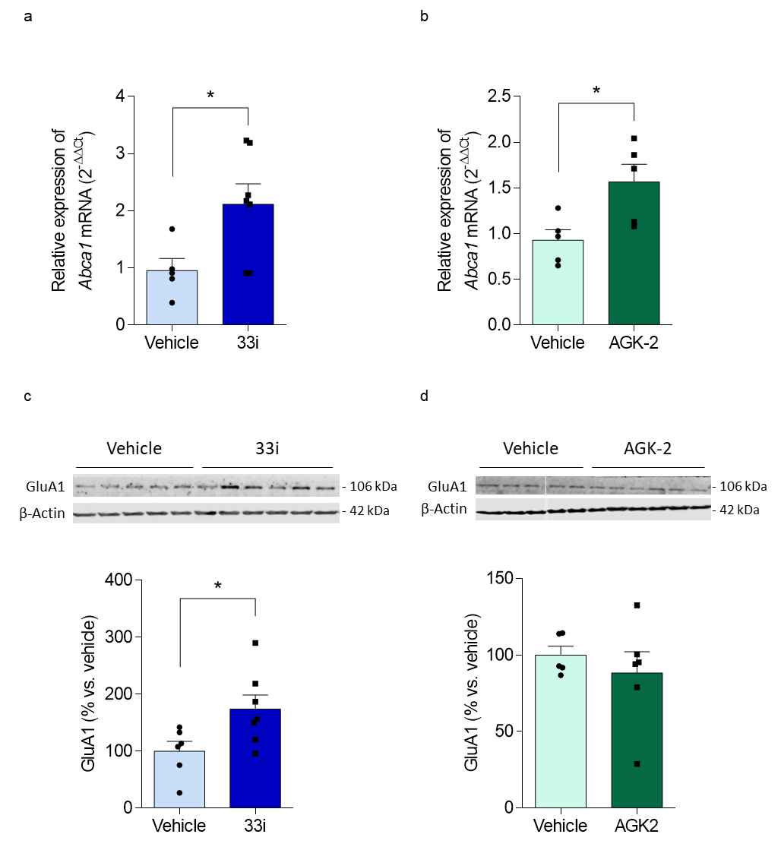

Fig. S1 Pharmacological inhibition of SIRT2 by compounds 33i and AGK-2 at central and peripheral levels. Peripheral gene expression of Abca1 after 33i (a) or AGK-2 (b) treatment. The inhibitory effect of both compounds on the SIRT2 enzyme at the periphery is evidenced by an increase in the expression of Abca1 in white adipose tissue. Hippocampal GLUA1 expression after 33i (c) or AGK-2 treatment (d). Note that only 33i treatment increases significantly the expression of GlUA1 protein in the hippocampus, confirming the inability of AGK-2 to cross the BBB (*p < 0.05 Student’s t test). β-actin was used as internal and loading control. Results are shown as mean ± SEM (n = 5-7 animals per group)
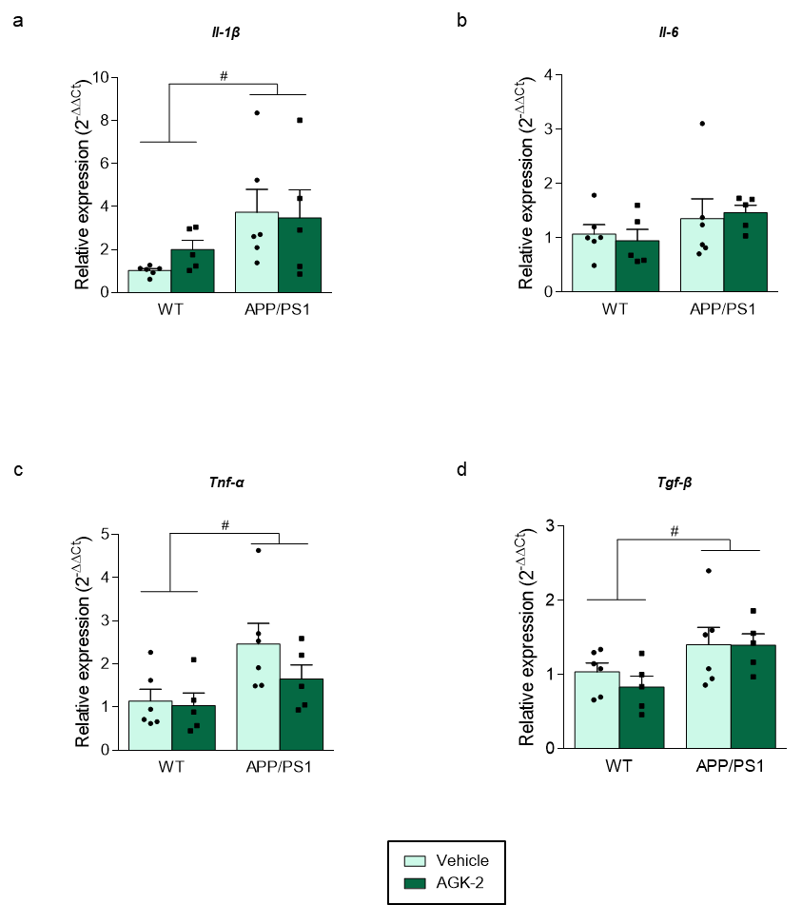

Fig. S2 AGK-2 treatment does not reduce neuroinflammation in APP/PS1 mice. Hippocampal gene expression of (a) Il-1β (F = 5.968, #p < 0.05, main effect of genotype), (b) Il-6, (c) Tnf-α (F = 7.108, #p < 0.05, main effect of genotype) and (d) Tgf-$β$ (F = 7.079, #p < 0.05, main effect of genotype). Note that no significant differences are observed between vehicle or AGK-2 treated animals. Gapdh was used as an internal control. Results are shown as mean ± SEM (two-way ANOVA, n = 5-6 animals/group)

