Supplementary Materials for “Geographically disaggregated approach to integrate low carbon technologies across local electricity networks”

Sheridan Few, Predrag Djapic, Goran Strbac, Jenny Nelson, Chiara Candelise

Supporting information are included below on: local network infrastructure, impact of PV on local networks, additional details of network upgrade savings associated with flexibility deployment at a local level, impact of low carbon technology deployment on electricity networks at a regional level, and attributions for icons featuring in assembled figures.

Local Network Infrastructure
Data on local network infrastructure are not available across GB as a whole, but the number of substations by type (ground-mounted or pole-mounted) are available per LSOA across the Southwest of England^{1,2}. Within this region, both number of meters per substation, and proportion of these which are ground-mounted, are found to correlate strongly with meter density (see Figure S1). Data from this region is used to generate an approximate function for number of ground- and pole-mounted substations by meter density based upon a locally-weighted polynomial regression. This function is used to estimate the number of ground mounted and pole mounted substations for each LSOA in GB, assuming a similar relationship between network infrastructure and meter density across the country.
Figure S1 Correlation of LSOA level meter density with (a) meters per substation, and (b) proportion of substations which are ground mounted transformers (GMT) Data from WPD Southwest region. Each point represents one LSOA, and blue line represents best fit using locally-weighted polynomial regression^{3,4}. Best fit line is used to estimate meters per substation and GMT substation proportion based upon meter density for LSOAs outside of the WPD Southwest region (see https://github.com/sheridanfew/UKLCTD).

Local network upgrade costs associated with deployment of PV alone

Figure S2a,b show the local network upgrade costs associated with integrating 2050 levels of solar PV alone in these two regions. Two key features are notable in these figures. First, there is sufficiently low PV deployment that no cost is incurred in the majority of LSOAs (in line with Figure 5a in the main text). Second, there is no clear trend in cost across either region, suggesting that costs are incurred only where a particular LSOA has exceptionally high deployment of PV.

(a) | (b)
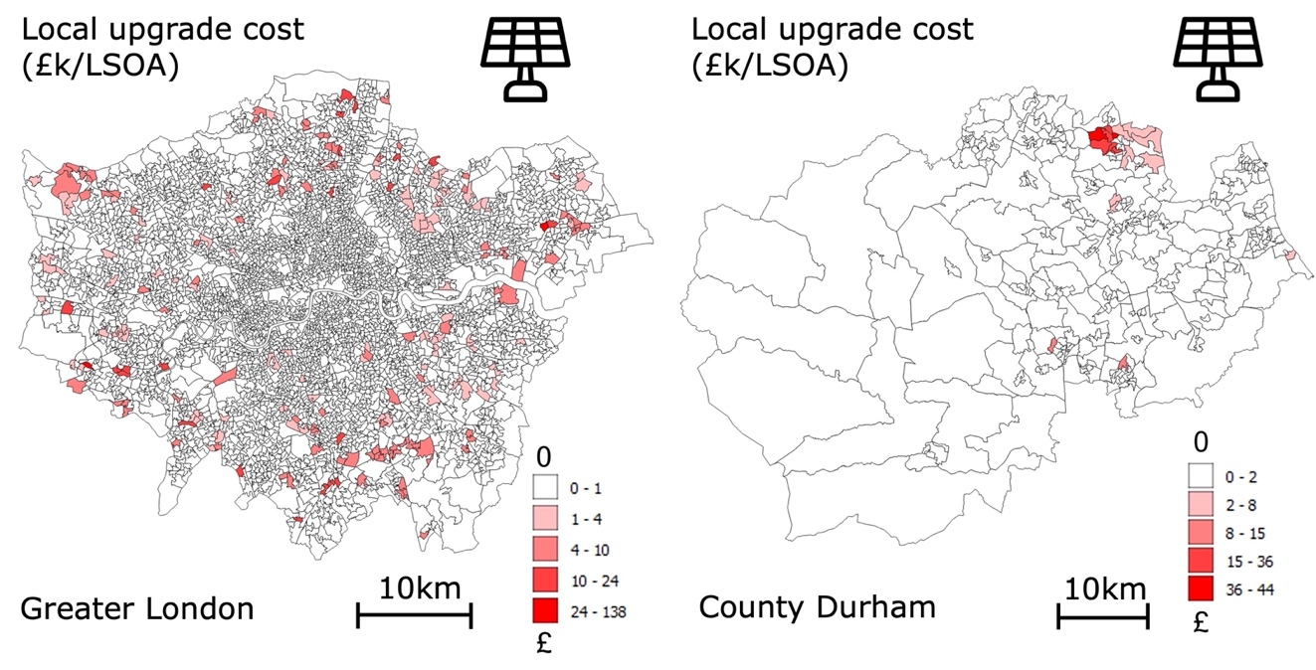
Figure S2 LSOA-level local network upgrade costs associated with deployment of PV alone, in (a) an urban area (Greater London), and (b) a more rural area (County Durham). Note difference in colour scale across figures.

Technology deployment and network infrastructure percentiles
Percentiles across LSOAs in GB for low carbon technology deployment and number of meters per substation are provided in Table S1. These are used in calculating impacts across contexts in Figure 5 in the main text.

Table S1 Percentiles across LSOAs in GB for low carbon technology deployment and number of meters per substation across ruralities
Quantity | Percentile
Quantity | 25% | 75% | 90%
EVs (vehicles per household) | 1.13 | 1.31 | 1.78
HPs (heat pumps per household) | 0.38 | 0.82 | 1.11
PV (kW per household) | 0.51 | 1.29 | 2.23
Meters per substation (Urban) | 94 | 158 | 219
Meters per substation (City) | 66 | 127 | 154
Meters per substation (Town) | 20 | 65 | 97
Meters per substation (Village) | 13 | 16 | 18

Local Flexibility Savings and Rurality, Low Carbon Technology Deployment, and Network Infrastructure
Local cost savings associated with flexibility deployment show no clear relationship with rurality, low carbon technology deployment or substation density (Figure S3, Figure S4). This suggests that it is difficult to develop general rules for where flexibility will be most beneficial, and specific details of each locations should be considered on a case by case basis.

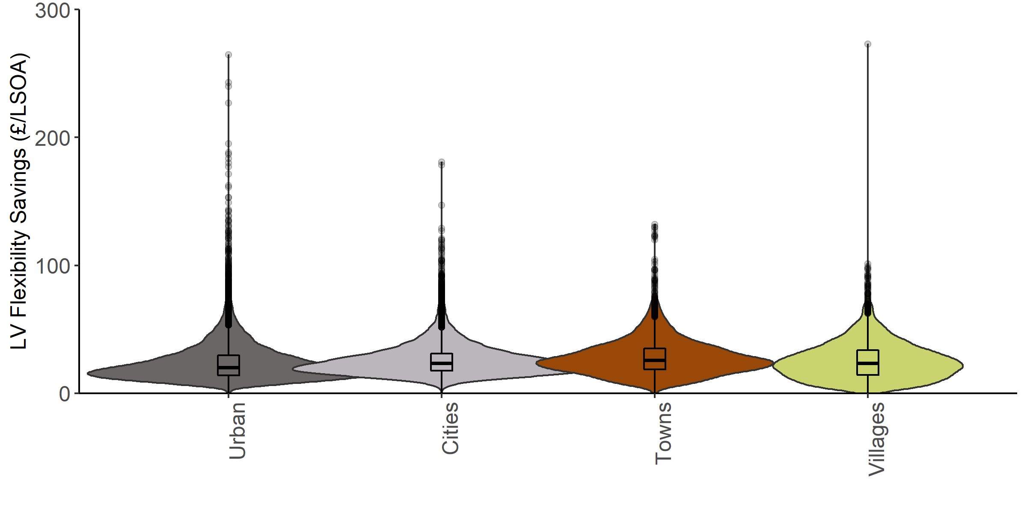
Figure S3 Local flexibility savings Violin plots showing distribution of local savings associated with flexibility across LSOAs of each rurality category
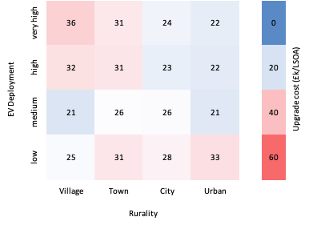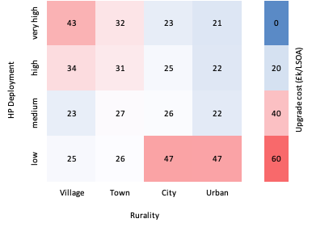
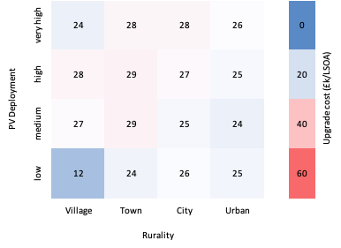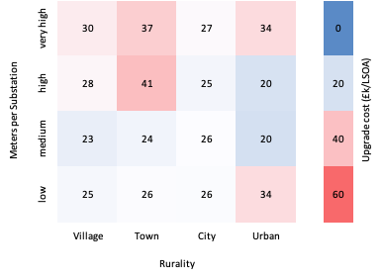
Figure S4 Local flexibility savings: combined impact of rurality, technology deployment, and network infrastructure on required local network upgrade savings Mean local network upgrade savings amongst LSOAs with low (below 25th percentile), medium (25th to 75th percentile), high (above 75th percentile) and very high (above 90th percentile) deployment of (a) EVs, (b) HPs, (c) PV, and (d) number of meters per substation. In (a,b,c) these percentiles are derived from the entire distribution across GB, whilst in (d) these percentiles are only considered across LSOAs of the same rurality.

Findings at a Regional Level

Each section of regional network (high and medium voltage infrastructure from 66 kV to 6.6 kV) typically serves 5000 – 30,000 households^{5,6} spanning multiple LSOAs through multiple local networks. As such, directly simulating impacts on regional networks over a single LSOA area is not meaningful. Instead, impacts are calculated for larger areas sharing meter density, low carbon technology deployment, and local network infrastructure of a single LSOA. Calculated costs for these larger areas are then scaled down by to estimate the contribution of each LSOA to regional upgrade costs. These costs and associated savings are presented in figures below.

Aggregated across GB (as in Figure S5), these regional costs a similar dependence on low carbon technology deployment as local costs, but are approximately four times higher. Regional costs display the opposite trend across ruralities to local network upgrade costs. This can be rationalised in terms of differences in network infrastructure. In contrast to local feeders, regional feeders are typically longer in rural areas, where clusters of buildings served by individual local networks are well separated, and shorter in urban areas, where local networks adjoin one another. The higher length of regional feeders in rural areas makes them more susceptible to overloading than shorter regional feeders in urban areas.

Figure S6 shows how, respectively and separately, the deployment of EVs, HPs, and PV (Figure S6a-c) as well as local network characteristics (Figure S6d) impact on regional network upgrade cost within each rurality. This demonstrates similar trends to local upgrade costs with EV and HP deployment. However, here higher PV deployment and lower numbers of meter per substation tends to be associated with higher costs. This is probably not a direct result of PV deployment or local network infrastructure, but because each of these correlate with rurality^{2,7}, which plays an important role in determining regional network upgrade cost, as discussed above.

In contrast with results at a local level, regional cost savings associated with flexibility is substantially higher in more rural than more urban areas (see Figure S7 and Figure S8). As such, more rural areas could represent a higher priority for more aggregated forms of flexibility.
(a) | (b)
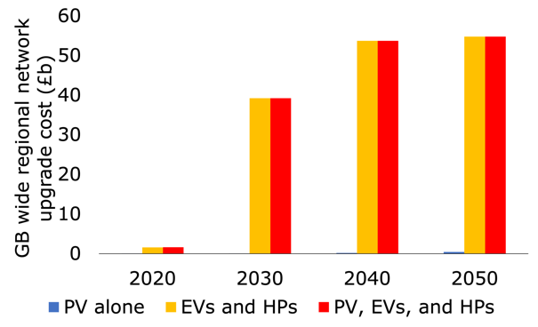 | 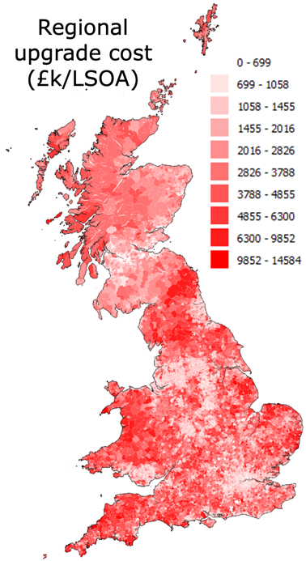
(c)
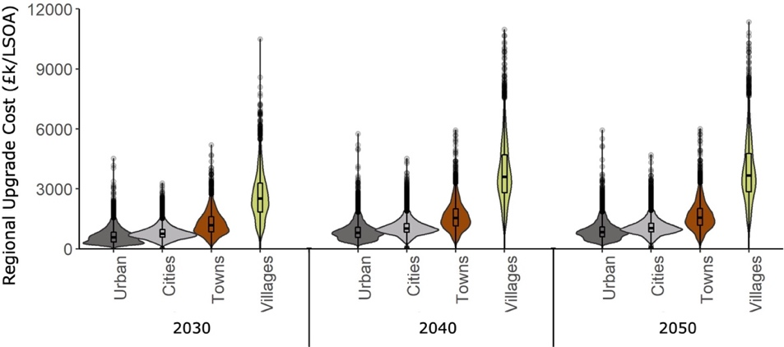
Figure S5 Costs of accommodating distributed PV, EVs, and HPs across GB in regional networks (a) regional distribution network upgrade costs to accommodate 2050 levels of PV, EV, and HP deployment mapped across GB (b) regional distribution network upgrade cost aggregated across GB across years and technology deployment scenarios, (c) violin plots showing distribution across LSOAs of regional network upgrade cost across years and ruralities for 2050 PV, EV, and HP deployment.

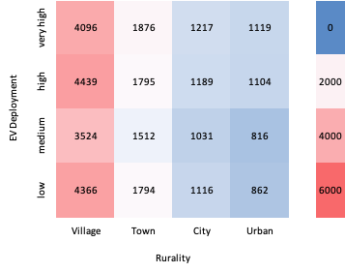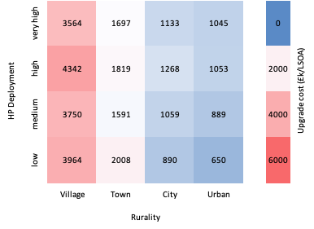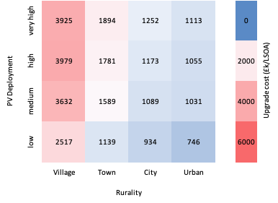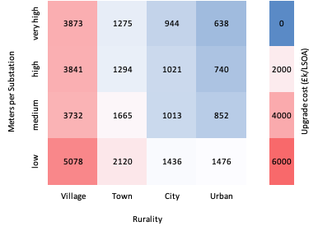
Figure S6 Combined impact of rurality, technology deployment, and network infrastructure on required regional network upgrade cost Mean total network upgrade cost amongst LSOAs with low (below 25th percentile), medium (25th to 75th percentile), high (above 75th percentile) and very high (above 90th percentile) deployment of (a) EVs, (b) HPs, (c) PV, and (d) number of meters per substation. In (a,b,c) these percentiles are derived from the entire distribution across GB, whilst in (d) these percentiles are only considered across LSOAs of the same rurality.
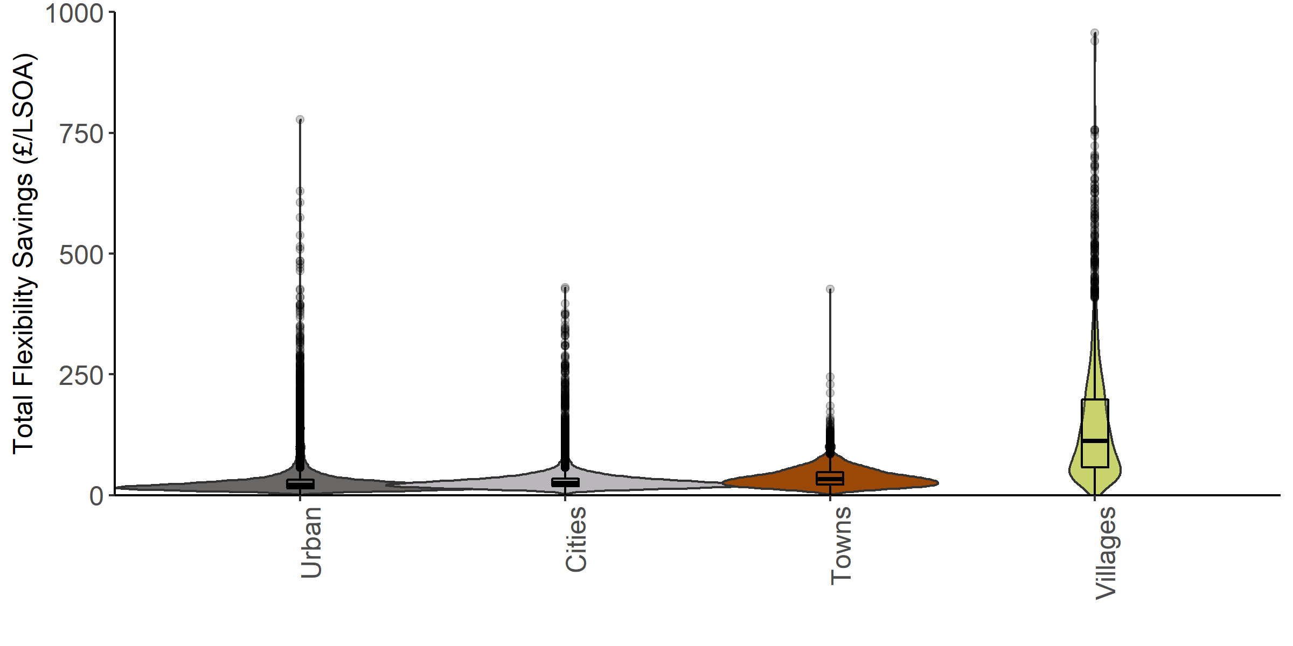
Figure S7 Total flexibility savings Violin plots showing distribution of total (local plus regional) savings associated with local flexibility deployment across LSOAs of each rurality category

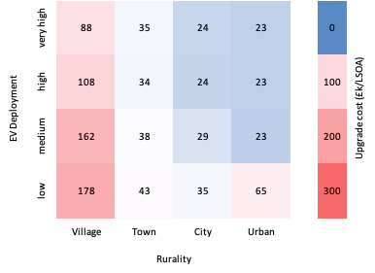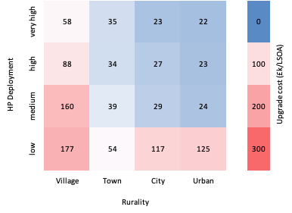
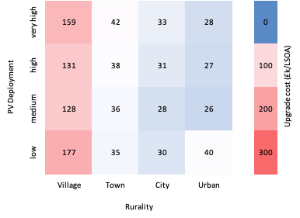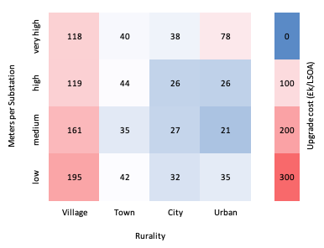
Figure S8 Total smart savings: combined impact of rurality, technology deployment, and network infrastructure on required regional network upgrade savings Mean total (local plus regional) network upgrade savings amongst LSOAs with low (below 25th percentile), medium (25th to 75th percentile), high (above 75th percentile) and very high (above 90th percentile) deployment of (a) EVs, (b) HPs, (c) PV, and (d) number of meters per substation. In (a,b,c) these percentiles are derived from the entire distribution across GB, whilst in (d) these percentiles are only considered across LSOAs of the same rurality.

Figure attribution

Assembled figures were produced using icons freely available at flaticon.com. Artist attributions are included in Table S2 below.
Table S2 Artist attributions for icons used to produce assembled figures.
Icon | Attribution
 | Dave Gandy
 | Freepik
 | Freepik
 | Freepik
 | Fjstudio
 | Freepik
 | Kosonicon
 | Creative Stall Premium
 | Pixel Perfect
 | Becris

References

1. Western Power Distribution. Data Portal. at https://dataportal2.westernpower.co.uk/.
2. Few, S., Djapic, P., Strbac, G., Nelson, J. & Candelise, C. Assessing local costs and impacts of distributed solar PV using high resolution data from across Great Britain. Renewable Energy 162, 1140–1150 (2020).
3. Cleveland, W. S. Robust locally weighted regression and smoothing scatterplots. Journal of the American Statistical Association 74, 829–836 (1979).
4. Cleveland, W. S. LOWESS: A program for smoothing scatterplots by robust locally weighted regression. The American Statistician 35, 54 (1981).
5. Speakman, L. P. Climate Change Adaptation Report Round 2 Update. (2015).
6. Energy Networks Association. Climate Change Adaptation Reporting Power Second Round. (2015).
7. Westacott, P. & Candelise, C. A novel geographical information systems framework to characterize photovoltaic deployment in the UK: Initial evidence. Energies 9, (2016).

