6. Appendix: Supplementary materials

6.1 Multicenter study

Table 4. Multicenter study using CHROMagarTM agar. Performance of R2 clone identification by the CNN model obtained by averaging the performances collected by cross validation on 5 folds. Each line represents the spectra of a MALDI-TOF mass spectrometer put in the test set (training performed on the three others) after alignment method. Spectra come from isolates that have been cultivated on CHROMagarTM agar.
 | Mean accuracy  with 95% CI | Mean f1 score clone  with 95% CI | Mean precision clone  with 95% CI | Mean recall clone  with 95% CI | Number of spectra in Train/Test¹
Myco-psl | 0.91 [0.86,0.94] | 0.89 [0.83,0.94] | 0.90 [0.80,0.95] | 0.88 [0.80,0.95] | 456/38
Bact-psl | 0.77 [0.71,0.83] | 0.62 [0.55,0.75] | 0.94 [0.83,1.0] | 0.47 [0.37,0.59] | 456/38
Saint-antoine | 0.88 [0.83,0.92] | 0.84 [0.78,0.90] | 0.89 [0.81,0.95] | 0.80 [0.71,0.88] | 456/38
Bichat | 0.81 [0.75,0.86] | 0.72 [0.64,0.82] | 0.89 [0.77,0.95] | 0.61 [0.50,0.71] | 456/38

¹Per fold in cross validation

Table 5. Multicenter study using Sabouraud-GC agar. Performance of R2 clone identification by the CNN model obtained by averaging the performances collected by cross validation on 5 folds. Each line represents the spectra of a MALDI-TOF mass spectrometer put in the test set (training performed on the three others) after alignment method. Spectra come from isolates that have been cultivated on Sabouraud-GC agar.
 | Mean accuracy  with 95% CI | Mean f1 score clone  with 95% CI | Mean precision clone  with 95% CI | Mean recall clone  with 95% CI | Number of spectra in Train/Test¹
Myco-psl | 0.88 [0.84,0.93] | 0.86 [0.80,0.92] | 0.89 [0.8,0.95] | 0.84 [0.75,0.91] | 453/38
Bact-psl | 0.93 [0.89,0.96] | 0.92 [0.87,0.96] | 0.90 [0.82,0.95] | 0.95 [0.89,0.99] | 456/38
Saint-Antoine | 0.89 [0.84,0.93] | 0.89 [0.83,0.93] | 0.83 [0.72,0.89] | 0.95 [0.89,0.99] | 453/38
Bichat | 0.89 [0.85,0.94] | 0.88 [0.82,0.92] | 0.88 [0.78,0.93] | 0.89 [0.81,0.95] | 457/37

Table 6. Multicenter study using Blood agar. Performance of R2 clone identification by the CNN model obtained by averaging the performances collected by cross validation on 5 folds. Each line represents the spectra of a MALDI-TOF mass spectrometer put in the test set (training performed on the three others) after alignment method. Spectra come from isolates that have been cultivated on Blood agar.
 | Mean accuracy  with 95% CI | Mean f1 score clone  with 95% CI | Mean precision clone  with 95% CI | Mean recall clone  with 95% CI | Number of spectra in Train/Test¹
Myco-psl | 0.92 [0.88,0.96] | 0.89 [0.86,0.96] | 0.92 [0.84,0.97] | 0.87 [0.79,0.94] | 449/36
Bact-psl | 0.86 [0.81,0.90] | 0.81 [0.74,0.88] | 0.92 [0.84,0.97] | 0.73 [0.63,0.83] | 441/39
Saint-Antoine | 0.93 [0.89,0.96] | 0.92 [0.87,0.96] | 0.89 [0.81,0.94] | 0.96 [0.91,1.0] | 443/37
Bichat | 0.96 [0.94,0.99] | 0.95 [0.91,0.99] | 0.98 [0.93,1.0] | 0.93 [0.87,0.99] | 443/37

6.2 Study of the impact of dilution and growth kinetics

6.2.1 Material and methods
The protocol described in the section 2.1.1 was not calibrated regarding the time of growth or the amount of yeast used for the extractions. In this section of the study, we wanted to establish whether or not the spectra of C. parapsilosis are stable in time and if the spectra depend on the amount of the yeast used for the protein extraction. We present here two experiments aiming at evaluating the importance of those two parameters on the quality of the classification.
Influence of the quantity of yeast was observed with 15 isolates (8 clones R2 and 7 non-clones), cultured on CHROMagarTM, and collected at exactly 48 hours of growth (Figure 9-Dilution impact). Colonies were deposited in a hemolysis tube containing 1.5 mL sterile water, in order to get the highest yeast concentration possible (D0). Then, two-fold dilutions series were performed to obtain 12 dilutions. Optical density (OD) was read when it was possible (i.e. for OD<2 arbitrary units (a.u.)) and the ninth tube (D8) corresponded to an optical density of about 1 a.u.. 300µL of all dilutions were mixed with 900µL of anhydrous ethanol and protein extraction was then performed as usual. Four replicates per dilution were deposited per target (48 deposits total per isolate). A total of 768 spectra were collected but the first levels of dilutions were too loaded with proteins, resulting in non-exploitable spectra. For this reason, the first 2 levels of dilutions were removed from the impact study, leading to a total of 640 available spectra.

Influence of the time of growth was evaluated for a dilution corresponding to an OD of about 1 a.u. Twenty isolates were selected for this evaluation (10 clones R2 and 10 non-clones). Proteins were extracted at twelve different culture time: at exactly 22, 24, 26, 28, 30, 44, 46, 48, 50, 52, 54 and 72 hours of growth, and protein extracts were deposited in quadriplicates per target, the 20 isolates being extracted in parallel and all extracts corresponding to one kinetic point being deposited on the same target (Figure 9-Growth kinetics impact). For this study, we obtained 80 spectra per growth kinetic point.
Isolates of the two experiments were grown only on CHROMagarTM media Spectra were acquired using only one MicroFlex mass spectrometer (Myco-PSL).

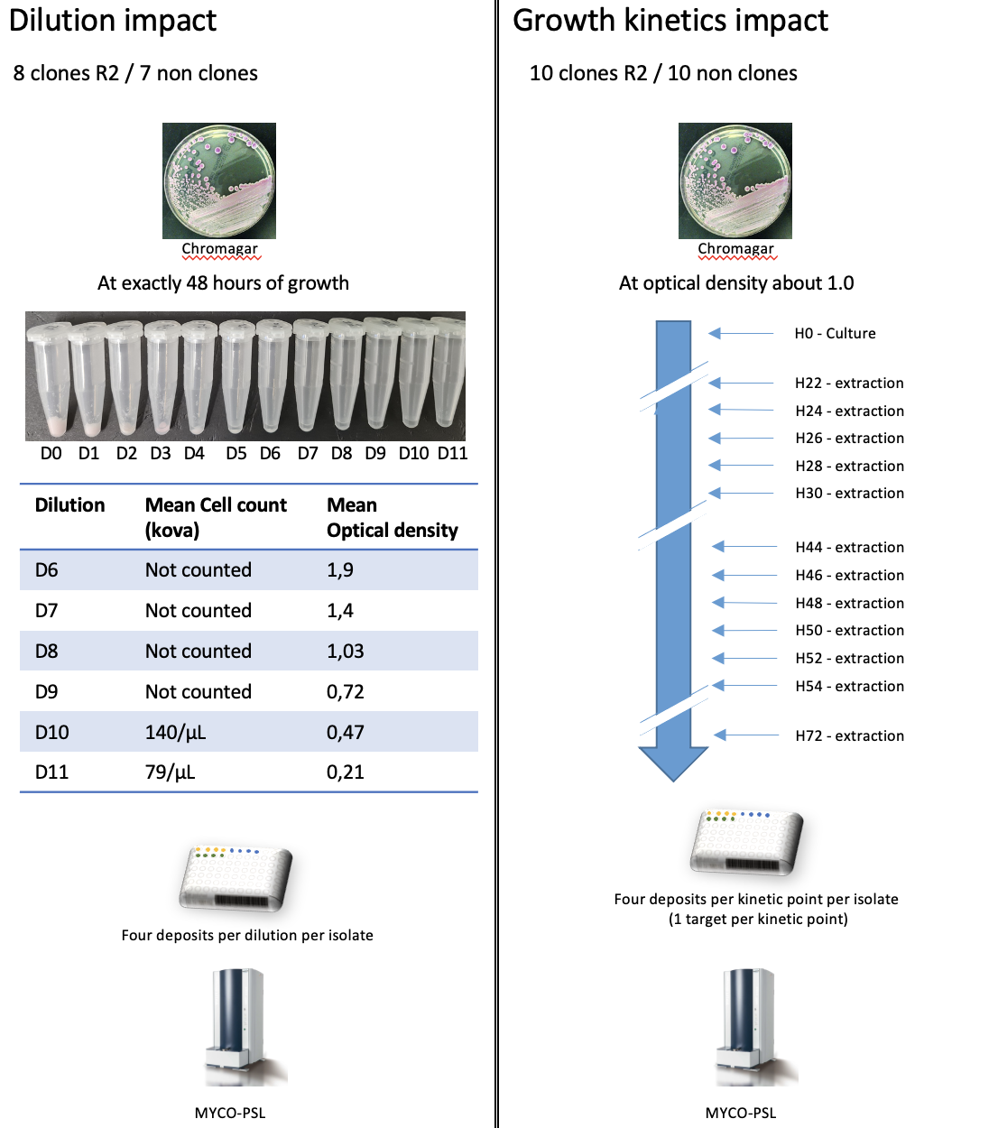
Figure 9. Study design of the dilution and the growth kinetics impact.

Data from experiments on dilution impact were sampled following the same cross-validation method as described previously. Spectra from consecutive dilutions have been pooled for the analyses.
Sampling on isolates and cross-validation technique was also made on growth kinetics raw data. The identification of clones and others by the classification system was first performed on each kinetic point (training and testing on spectra from H22 only, then H24, etc.), but also on age groups (H22-H30, H44-H72) and finally on all culture times (H22-H72 all together), in order to investigate the kinetic effect.

6.2.2 Results

Results concerning the impact of dilution levels on the classification performance are presented in Table 7. The identification results of Clone R2 varied from one dilution set to another, with better results on D4-D5 and D8-D9 levels of dilution.

Figure 10 shows the result for the impact of growth kinetics (details in Table 9). F1 scores of Clones R2 were analyzed with a view to find the optimal time of culture. The identification performances differ greatly from one growing time to another. Results concerning performances of clone’s identification taking times of culture by groups are presented in Table 10 (more details on other groups in Table 8).

On these two experimental parts, there are strong variations but no trend is observed. Note that the spectra control conditions lead to a mechanical reduction of the number of spectra present in training and validation in these experiments.

Table 7. Impact of dilution. Performance of R2 clone identification by the CNN model obtained by averaging the performances collected by cross validation on 5 folds. Each line corresponds to the dilution used in both training and validation set.
 | Mean accuracy  with 95% CI | Mean f1 score clone  with 95% CI | Mean precision clone  with 95% CI | Mean recall clone  with 95% CI | Number of spectra in Train/Test¹
D2-D3 | 0.81 [0.74,0.88] | 0.85 [0.75,0.90] | 0.85 [0.70,0.89] | 0.85 [0.77,0.94] | 96/24
D4-D5 | 0.77 [0.69,0.83] | 0.82 [0.76,0.90] | 0.73 [0.62,0.81] | 0.94 [0.85,0.98] | 96/24
D6-D7 | 0.59 [0.50,0.68] | 0.58 [0.56,0.75] | 0.46 [0.48,0.70] | 0.80 [0.65,0.86] | 96/24
D8-D9 | 0.74 [0.66,0.82] | 0.81 [0.76,0.91] | 0.77 [0.62,0.84] | 0.85 [0.71,0.90] | 96/24
D10-D11 | 0.85 [0.78,0.91] | 0.84 [0.77,0.91] | 0.92 [0.85,0.98] | 0.78 [0.68,0.88] | 96/24

Identification has been analyzed where sets were gradually restricted to see if improvement was possible by removing diversity caused by the amount of yeast (see below Table 8). Identification results were better when all levels of dilution were taken into account and also where spectra from level D8 to D11 where mixed in the set of train and test.

Table 8. Dilution impact study. Performance of R2 clone identification by the CNN model obtained by averaging the performances collected by cross validation on 5 folds. Each line corresponds to the dilution used in both training and validation set. Under sampling methods has been occurred to make proper comparisons.

 | Mean accuracy  with 95% CI | Mean f1 score clone  with 95% CI | Mean precision clone  with 95% CI | Mean recall clone  with 95% CI | Number of spectra in Train/Test¹
D3 to D11 | 0.82 [0.75,0.88] | 0.80 [0.78,0.93] | 0.93 [0.84,0.98] | 0.70 [0.63,0.84] | 96/24
D4 to D11 | 0.81 [0.74,0.88] | 0.84 [0.82,0.95] | 0.80 [0.67,0.85] | 0.89 [0.88,1.0] | 96/24
D8 to D11 | 0.86 [0.79,0.92] | 0.88 [0.81,0.94] | 0.91 [0.80,0.96] | 0.85 [0.75,0.93] | 96/24
D10 to D11 | 0.88 [0.82,0.94] | 0.85 [0.81,0.94] | 0.97 [0.94,1.0] | 0.76 [0.69,0.89] | 96/24

Figure 10. Impact of growth kinetics. F1 scores performance of R2 clone identification by the CNN model per time of culture.

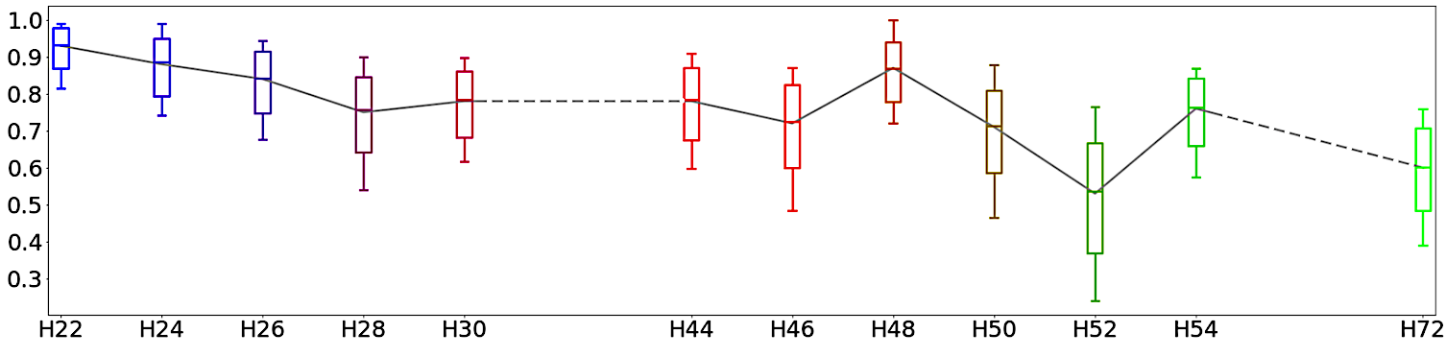

Table 9. Growth kinetics impact study. Performance of R2 clone identification by the CNN model obtained by averaging the performances collected by cross validation on 5 folds. Each line corresponds to the time of culture used in both training and validation set.
 | Mean accuracy  with 95% CI | Mean f1 score clone  with 95% CI | Mean precision clone  with 95% CI | Mean recall clone  with 95% CI | Number of spectra in Train/Test¹
H22 | 0.92 [0.86,0.98] | 0.93 [0.87,0.98] | 0.87 [0.77,0.96] | 1.0 [1.0,1.0] | 64/16
H24 | 0.89 [0.82,0.95] | 0.88 [0.8,0.95] | 0.92 [0.83,1.0] | 0.85 [0.73,0.95] | 64/16
H26 | 0.84 [0.75,0.91] | 0.84 [0.75,0.92] | 0.81 [0.68,0.92] | 0.87 [0.77,0.97] | 64/16
H28 | 0.75 [0.65,0.85] | 0.75 [0.64,0.86] | 0.74 [0.60,0.86] | 0.78 [0.63,0.90] | 64/16
H30 | 0.75 [0.65,0.84] | 0.78 [0.68,0.87] | 0.69 [0.56,0.81] | 0.90 [0.80,0.98] | 64/16
H44 | 0.75 [0.65,0.84] | 0.78 [0.68,0.87] | 0.69 [0.57,0.81] | 0.90 [0.80,0.98] | 64/16
H46 | 0.74 [0.64,0.82] | 0.73 [0.60,0.83] | 0.76 [0.62,0.89] | 0.70 [0.56,0.83] | 64/16
H48 | 0.88 [0.80,0.94] | 0.87 [0.77,0.94] | 0.94 [0.85,1.0] | 0.80 [0.67,0.91] | 64/16
H50 | 0.69 [0.59,0.79] | 0.71 [0.60,0.81] | 0.66 [0.53,0.80] | 0.77 [0.64,0.90] | 64/16
H52 | 0.61 [0.51,0.71] | 0.53 [0.37,0.67] | 0.67 [0.48,0.84] | 0.45 [0.30,0.60] | 64/16
H54 | 0.70 [0.60,0.80] | 0.76 [0.67,0.85] | 0.63 [0.51,0.75] | 0.98 [0.92,1.0] | 64/16
H72 | 0.49 [0.38,0.59] | 0.60 [0.48,0.7] | 0.49 [0.37,0.61] | 0.78 [0.63,0.91] | 64/16

Table 10. Impact of growth kinetics. Performance of R2 clone identification by the CNN model obtained by averaging the performances collected by cross validation on 5 folds. Each line represents trained and tested spectra from groups of time of culture and all time of culture for the third line.
 | Mean accuracy  with 95% CI | Mean f1 score clone  with 95% CI | Mean precision clone  with 95% CI | Mean recall clone  with 95% CI | Number of spectra in Train/Test¹
H22-H30 | 0.93 [0.91,0.96] | 0.93 [0.91,0.96] | 0.91 [0.87,0.95] | 0.95 [0.92,0.98] | 320/80
H44-H72 | 0.91 [0.89,0.94] | 0.92 [0.89,0.94] | 0.88 [0.85,0.92] | 0.96 [0.93,0.98] | 448/112
H22-H72 | 0.93 [0.91,0.95] | 0.93 [0.91,0.95] | 0.91 [0.89,0.94] | 0.95 [0.93,0.97] | 768/192

6.2.3 Discussion

The results obtained by the dilution control and growth kinetics experiments (respectively, Table 7 and Figure 10) show variations but no interpretable trend. They do not allow us to conclude about which configurations are better than others, if any. It should also be noted that in these experiments, the number of spectra present in the training set decreases sharply when the dataset is stratified. This small volume of data probably contributes to the variations and prevents any definitive conclusion. In the end, the best performances were obtained with a larger training set resulting from the mixing of all the spectra (Table 10). Moreover, mixing all times of culture in the dataset led to good results.

It is important to note that the two experiments were performed by fixing the other effects. For the dilution part, the experiment has been made with yeast cultivated at 48 hours of growth. Growth kinetics have been experimented by fixing dilution on D8 level of dilution. D8 is the level of the dilution generally used in routine activity of a mycology laboratory as for having acceptable spectra in terms of protein expression so mixing spectra from different acceptable levels of dilution allows us to have better results.

6.3 Experiment with controlled parameters

Table 11. Experiment with controlled parameters. Performance of R2 clone identification by the CNN model obtained by averaging the performances collected by cross validation on 5 folds. Each line represents spectra mass spectrometers and times of culture used in both train and validation set. Isolates have been cultivated on Sabouraud-GC agar.
Train/Test | Time of culture | Mean accuracy  with 95% CI | Mean f1 score clone  with 95% CI | Mean precision clone  with 95% CI | Mean recall clone  with 95% CI | Number of spectra in Train/Test¹
MYCO-psl/  MYCO-psl | 24H | 0.93 [0.89,0.96] | 0.91 [0.86,0.95] | 0.93 [0.86,0.98] | 0.90 [0.82,0.96] | 154/38
MYCO-psl/  MYCO-psl | 48H | 0.87 [0.82,0.92] | 0.86 [0.78,0.90] | 0.81 [0.71,0.89] | 0.90 [0.83,0.96] | 154/38
MYCO-psl/  MYCO-psl | 24H+48H | 0.91 [0.88,0.94] | 0.89 [0.86,0.93] | 0.89 [0.83,0.93] | 0.90 [0.85,0.95] | 307/77
Saint-Antoine/  Saint-Antoine | 24H | 0.88 [0.84,0.93] | 0.86 [0.79,0.91] | 0.87 [0.79,0.94] | 0.85 [0.76,0.92] | 154/38
Saint-Antoine/  Saint-Antoine | 48H | 0.90 [0.85,0.94] | 0.88 [0.81,0.93] | 0.86 [0.77,0.92] | 0.90 [0.82,0.96] | 154/38
Saint-Antoine/  Saint-Antoine | 24H+48H | 0.89 [0.86,0.92] | 0.87 [0.82,0.9] | 0.88 [0.82,0.92] | 0.86 [0.80,0.90] | 307/77
Saint-Antoine/  MYCO-psl | 24H | 0.89 [0.84,0.93] | 0.84 [0.78,0.91] | 0.91 [0.84,0.97] | 0.80 [0.69,0.88] | 154/38
Saint-Antoine/  MYCO-psl | 48H | 0.79 [0.73,0.84] | 0.74 [0.64,0.8] | 0.79 [0.66,0.86] | 0.69 [0.59,0.79] | 154/38
Saint-Antoine/  MYCO-psl | 24H+48H | 0.84 [0.80,0.87] | 0.81 [0.76,0.85] | 0.78 [0.71,0.83] | 0.85 [0.79,0.90] | 307/77
MYCO-psl/  Saint-Antoine | 24H | 0.73 [0.66,0.79] | 0.53 [0.48,0.68] | 0.62 [0.65,0.89] | 0.47 [0.36,0.58] | 154/38
MYCO-psl/  Saint-Antoine | 48H | 0.73 [0.66,0.79] | 0.52 [0.47,0.67] | 0.61 [0.64,0.88] | 0.46 [0.35,0.57] | 154/38
MYCO-psl/  Saint-Antoine | 24H+48H | 0.74 [0.70,0.79] | 0.66 [0.62,0.74] | 0.78 [0.65,0.81] | 0.57 [0.49,0.65] | 307/77
Myco & Saint Antoine (Train/Test) | 24H | 0.92 [0.90,0.95] | 0.91 [0.87,0.94] | 0.91 [0.86,0.95] | 0.91 [0.86,0.94] | 307/77
Myco & Saint Antoine (Train/Test) | 48H | 0.94 [0.91,0.96] | 0.92 [0.89,0.95] | 0.92 [0.87,0.96] | 0.93 [0.89,0.97] | 307/77
Myco & Saint Antoine (Train/Test) | 24H+48H | 0.93 [0.91,0.94] | 0.91 [0.88,0.93] | 0.92 [0.88,0.94] | 0.91 [0.87,0.94] | 614/154

