SUPPLEMENTARY MATERIAL
Supplementary Table 1: List of the 22 SNPs used for HIrisPlex oligogenic method for eye and hair colour prediction, their position, the gene where they are and their effect allele.
SNP | Chromosome | Position | Gene | Effect allele
rs11547464 | 16 | 89986091 | MC1R | A
rs885479 | 16 | 89986154 | MC1R | T
rs1805008 | 16 | 89986144 | MC1R | T
rs1805005 | 16 | 89985844 | MC1R | T
rs1805006 | 16 | 89985918 | MC1R | A
rs1805007 | 16 | 89986117 | MC1R | T
rs2228479 | 16 | 89985940 | MC1R | A
rs1110400 | 16 | 89986130 | MC1R | C
rs201326893 (Y152OCH) | 16 | 89919714 | MC1R | A
rs28777 | 5 | 33994716 | SLC45A2 | C
rs16891982 | 5 | 33987450 | SLC45A3 | C
rs12821256 | 12 | 87852466 | KITLG | G
rs4959270 | 6 | 402748 | EXOC2 | A
rs12203592 | 6 | 341321 | IRF4 | T
rs1042602 | 11 | 88551344 | TYR | T
rs1800407 | 15 | 25903913 | OCA2 | A
rs2402130 | 14 | 91870956 | SLC24A4 | G
rs12913832 | 15 | 26039213 | HERC2 | T
rs2378249 | 20 | 32681751 | ASIP/PIGU | C
rs12896399 | 14 | 91843416 | SLC24A4 | G
rs1393350 | 11 | 88650694 | TYR | T
rs312262906 (N29insA) | 16 | 89985753 | MC1R | A
rs683 | 9 | 12699305 | TYRP1 | G

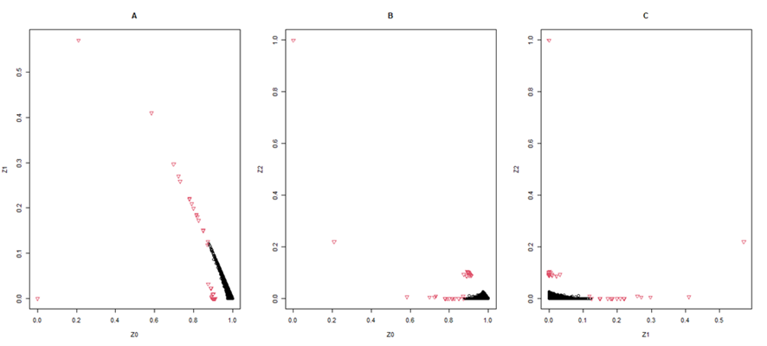
Supplementary figure 1: Plots of the different axis of the IBD calculations of the analysed individuals. A: Z0 vs. Z1; B: Z0 vs. Z2; C: Z1 vs. Z2. Black dots represent distantly related individuals and red triangles represent closely related individuals.
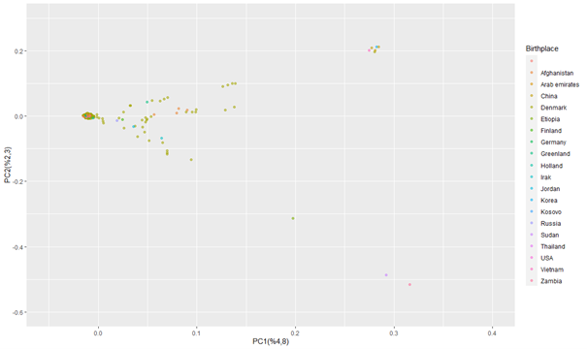
Supplementary Figure 2: PCA of the analysed 586 individuals depicted in different colours depending on the self-reported birthplace (colours explained on the right legend). The components we used for the plot and explained variance is on the axis labels.
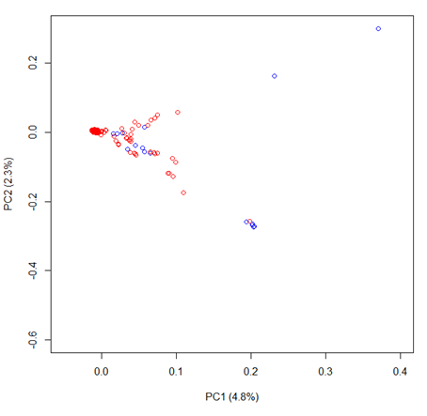
Supplementary Figure 3: Scatterplot of PC1 vs. PC2 (percentage of explained variance in the labels) for all analysed 586 individuals considering their birthplace: Denmark (red) or outside Denmark (blue) and representation of individuals born in Denmark.
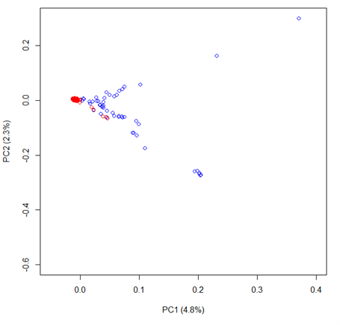
Supplementary Figure 4: Scatterplot of PC1 vs. PC2 (percentage of explained variance in the labels) for all analysed 586 individuals considering their parents birthplace: Denmark (red) or outside Denmark (blue).

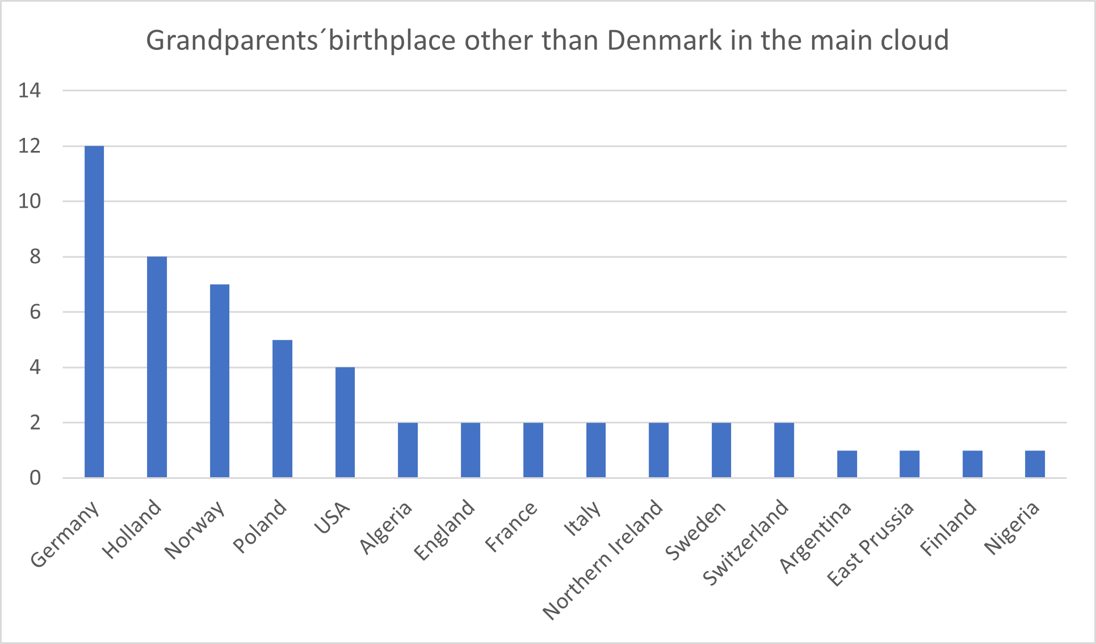
Supplementary Figure 5: Bar-plot of the birthplace of the individuals that in Figure 3 fall near the principal cloud i.e., with non-Danish grandparents.

