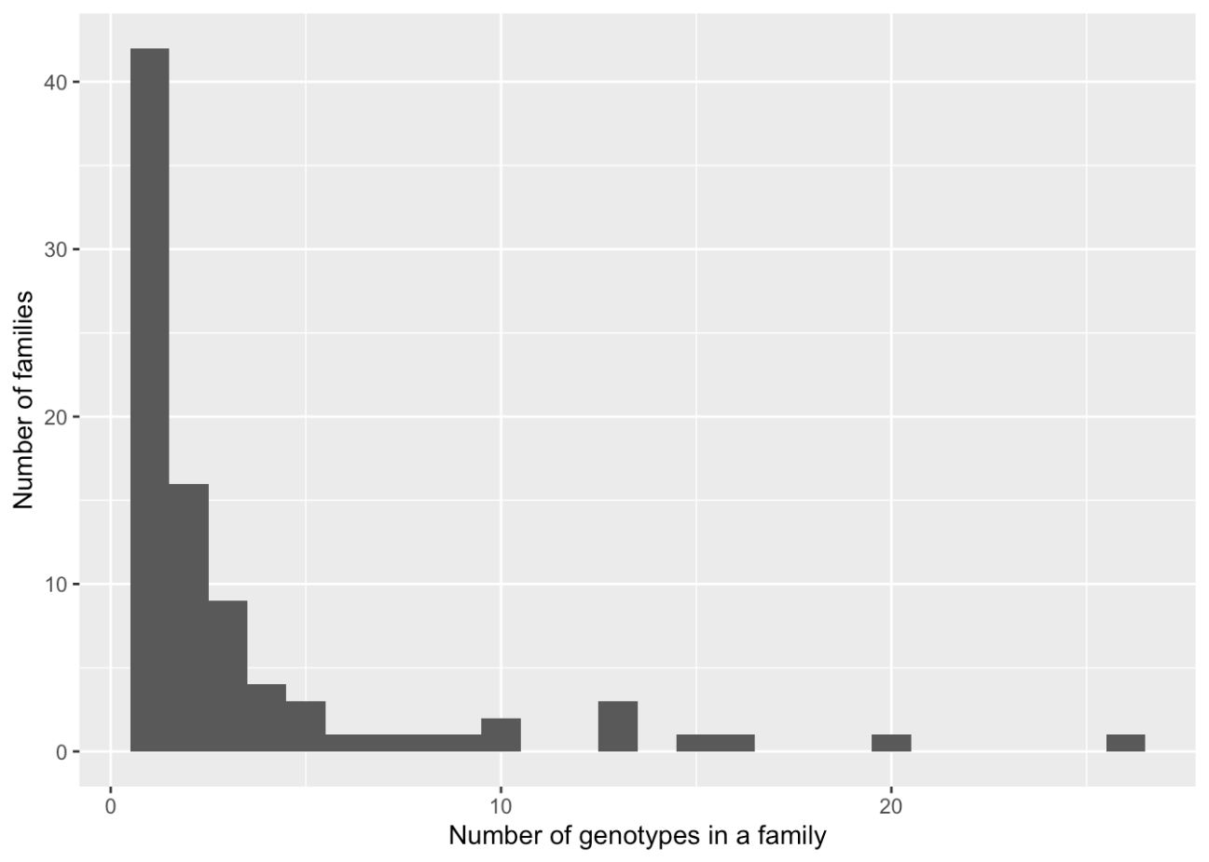
Figure S1. Histogram of the number of genotypes belonging to each family. In the present study, we tested the accuracy of genomic and pedigree-based predictions using 87 families containing 298 genotypes. Half of the families (42) contained only one genotype, while seven families contained more than 10 genotypes.

